Experiment No.: 2
1. Experiment Title:
Use var, let, const, and demonstrate basic features like template literals and destructuring; build a billing calculator with user input.
2. Software/Tools Required:
Visual Studio Code (or any text editor), Web Browser (Google Chrome/Mozilla Firefox), JavaScript
3. Experiment Program Code:
greet.js
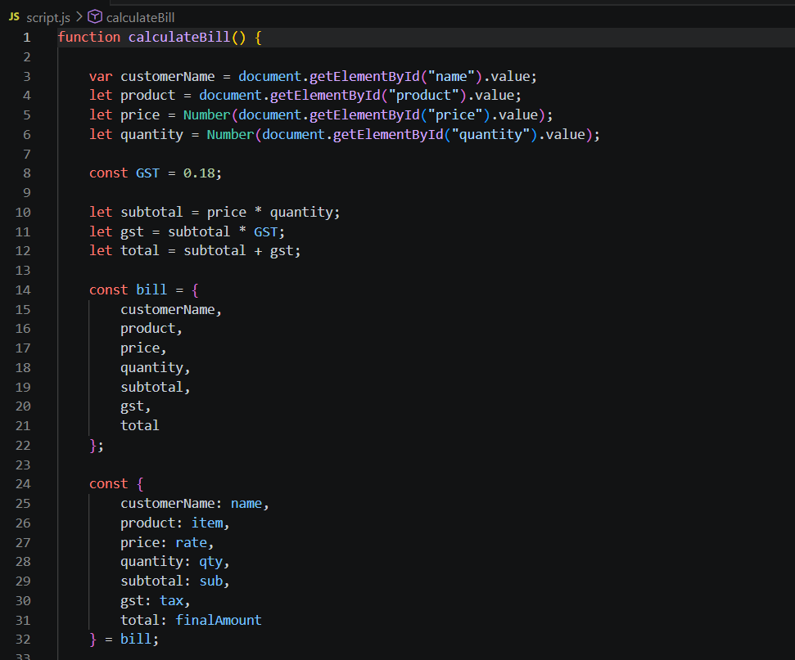
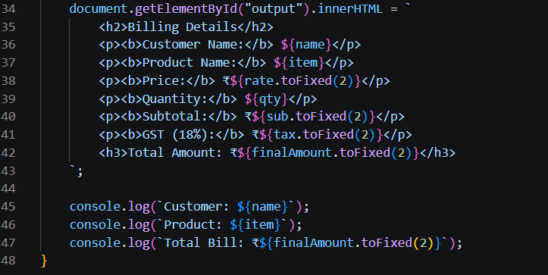
index.html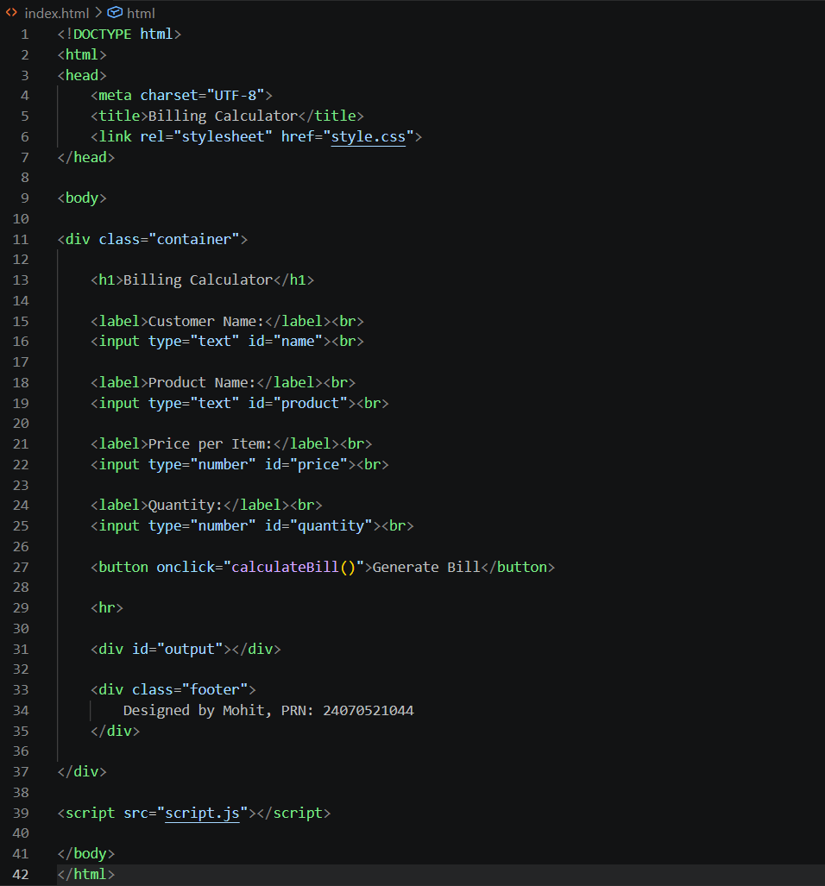

4. Output:
