**Document Scanner has 3 basic steps for detecting the document.**

To understand the working, we take the following image.

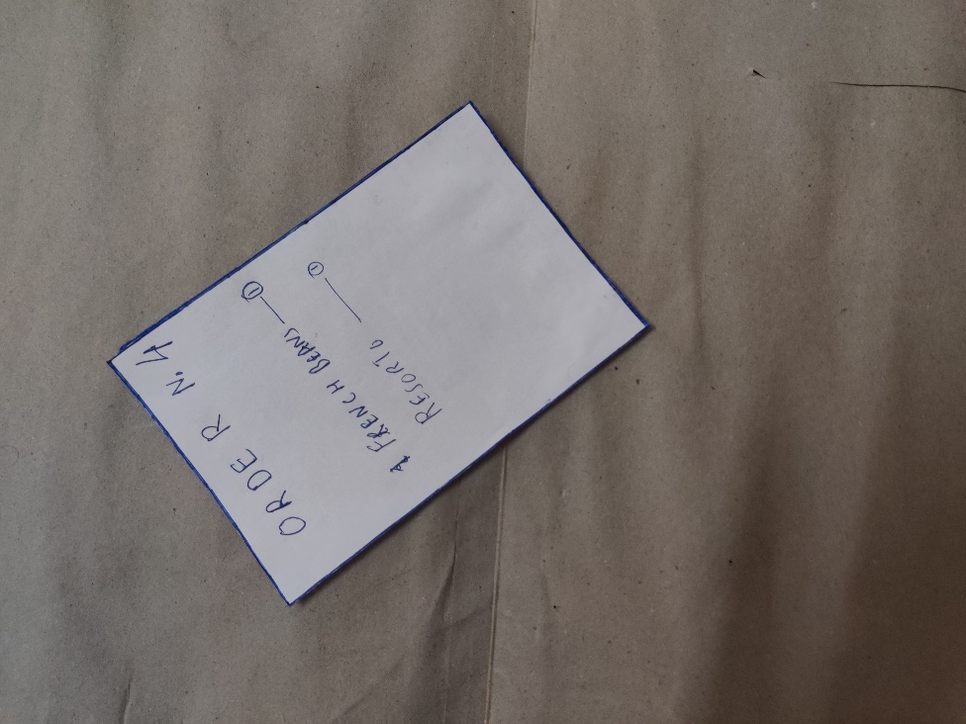

1. The First step is to apply Gaussian Blur, and then apply Canny Edge Detector.

This gives us with the following image.

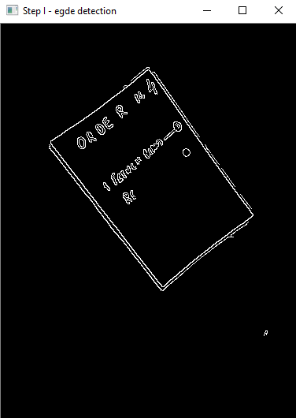

1. The second step is to find all closed contours, then loop through the largest of them. Find Approx sides of these contours, and select the one with 4 sides.

This results in following contour.

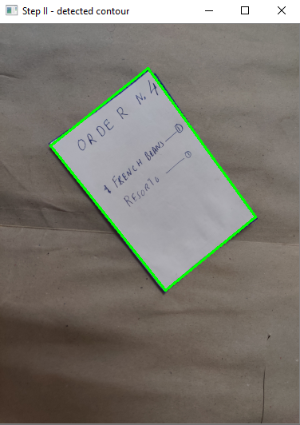

1. In the third step, we sort the corner points of the contour, and do perspective transform

For this purpose, the transform.py function is used.

It results In the following output

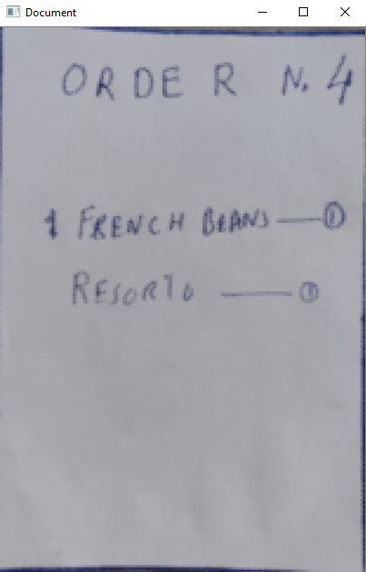 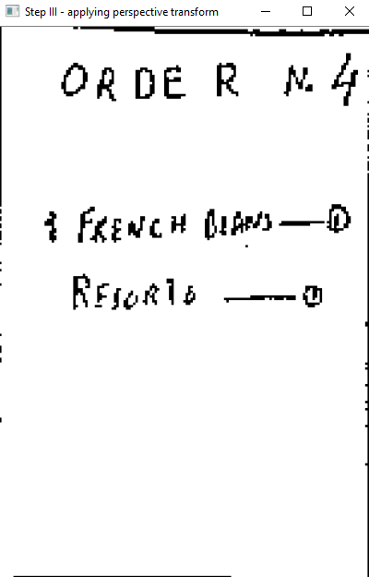

After detection, we apply local thresholding, and give it a black and white effect

This results in above image

**This Document detection has also been implemented on video.**

Following are the results for the live document detection. (*Run DocumentScannerVid.py*)

