# Teeth Temperature Measurement Interface Design

## Introduction

This project handles the structure from taking sensory data from Arduino and showcasing it simultaneously on a locally hosted webpage. It uses various technologies and languages and incorporates a structure which displays real-time sensory data on the webpage.

## Motivation

This project would be fused with a sensor, to get side temperatures of teeth in a human mouth, and keep a visual track of the temperatures. The project is to be integrated by a medical student for their project.

## Structure of Project and Modules Involved

The project and be simplified into the following 4 sections, which perform their specific roles:

* The Arduino Side
* The Processing Sketch link
* The Database
* The Front End

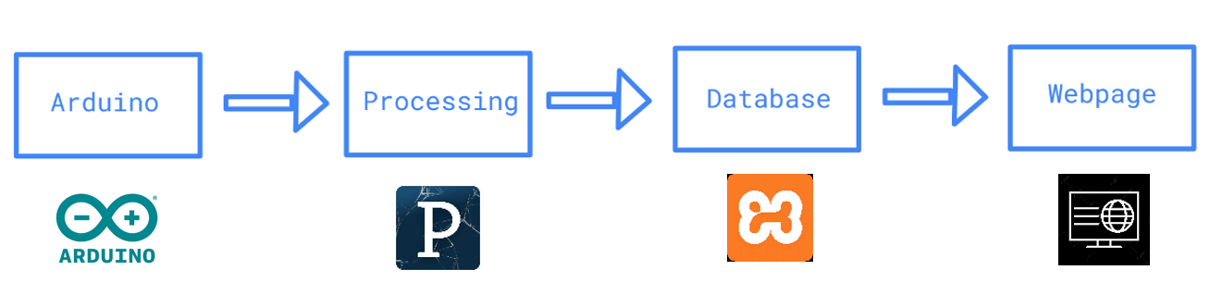

The sensory data is constantly collected on the Arduino. With one press of a button, the processing sketch in between performs necessary actions in the database and stores the sensory value. This value is later retrieved by the backend of the webpage from the database and is displayed in real-time on the screen.

### Processing Sketch

Processing 2.2.1 was used for the course of this project. One needs to download and import the MYSQL library (de.bezier.data.sql.*) and the Serial library (processing.serial.*). This sketch is responsible for taking button state and temperature values from the Arduino via serial communication. Hence while running the code, one must ensure that the Serial monitor of Arduino is turned off.

### Database

The database consists of patient information, patient teeth temperatures and a few flag variables for smoothing data transaction between Arduino and webpage.

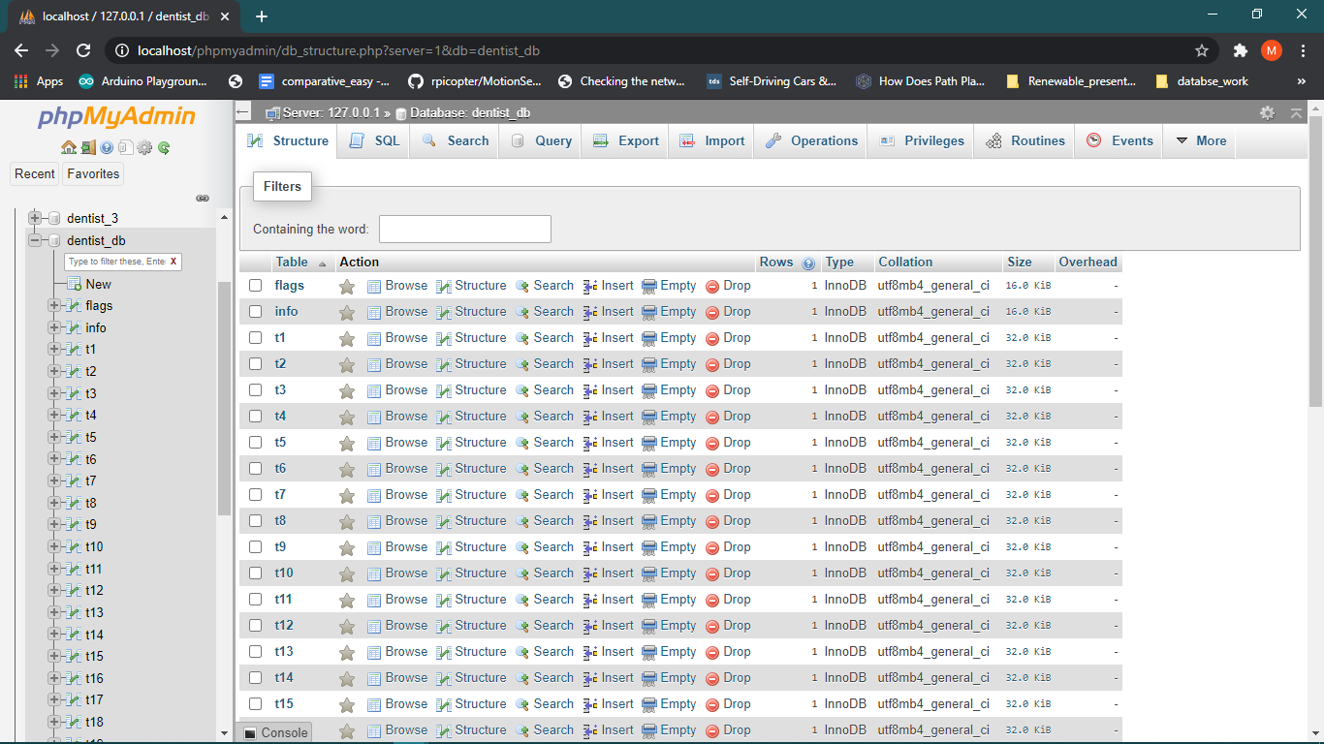

The info table consists of general data of the patients which are required by the doctor. This data is taken from the form HTML page.

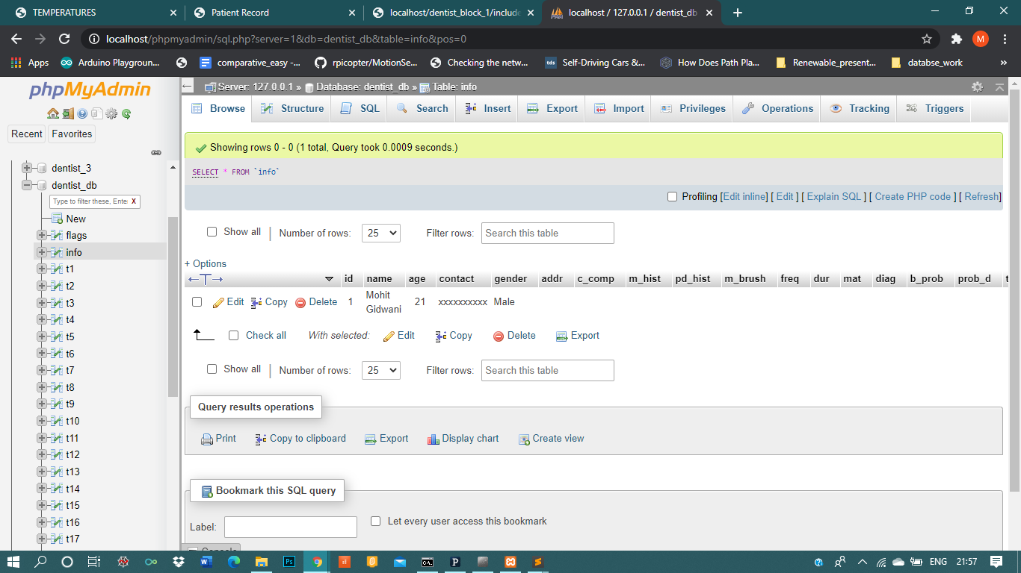

The flags table consists of a flag variable, a button variable to store button state, a side variable to find current teeth number and side of the patient and a user id to get the current patient id.

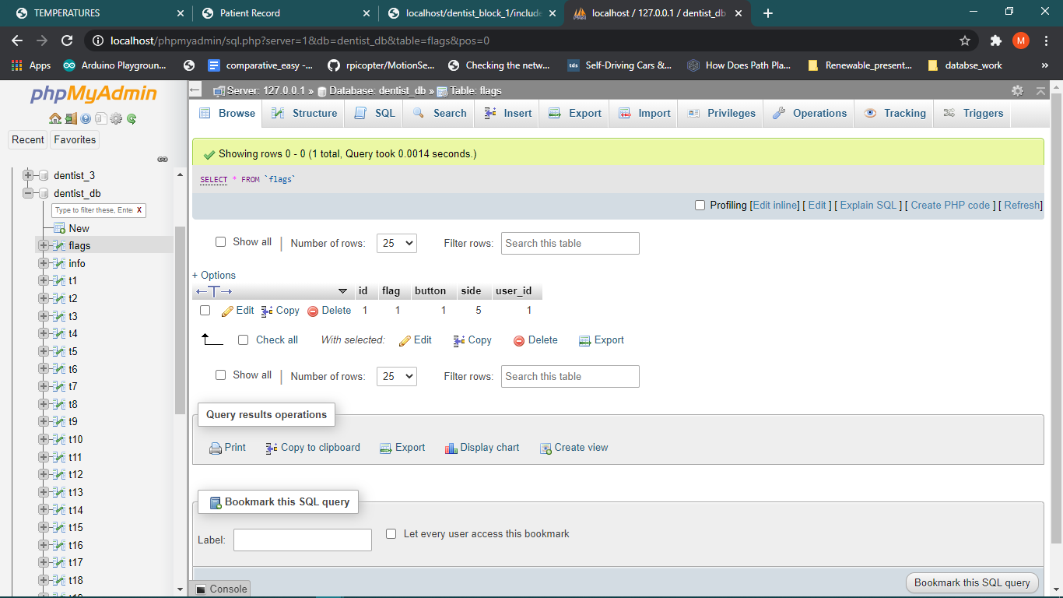

Each t1, t2, …….. t32 stores the temperatures of all 4 sides for each patients.

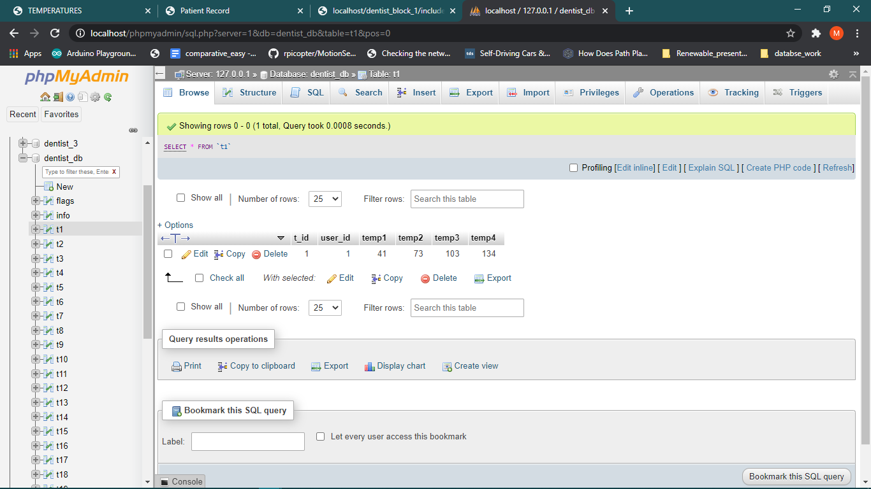

### Front End

Form Page

Form Html page takes up all the necessary information of the patient and provides a link to the temperatures page, which stores the patient info and starts registering teeth temperatures of a patient

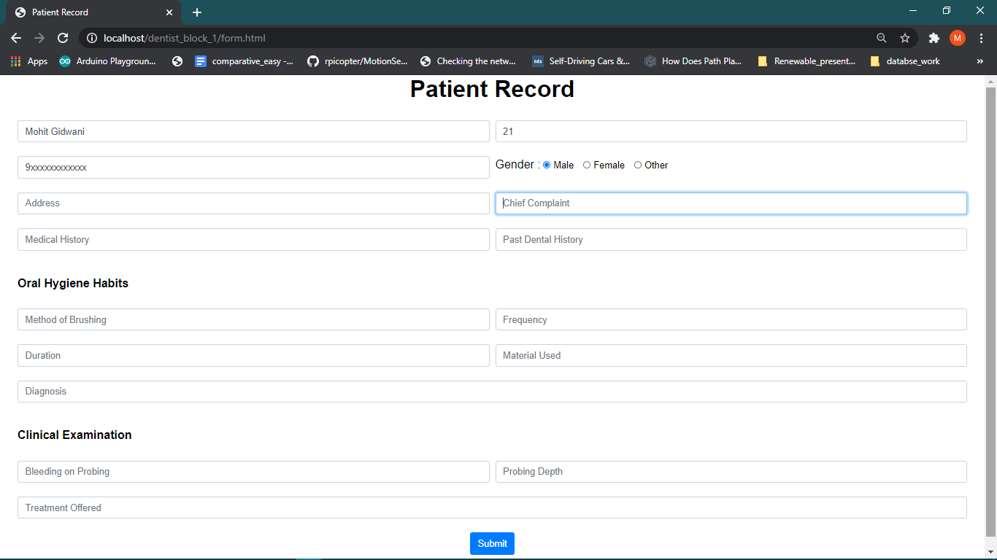

Temperatures page

This page displays the teeth temperatures in real-time. It communicates with the database and displays the teeth temperatures according to variables in flags table. This page was developed in stages to reduce the complexity and provide a more custom interface to the client.

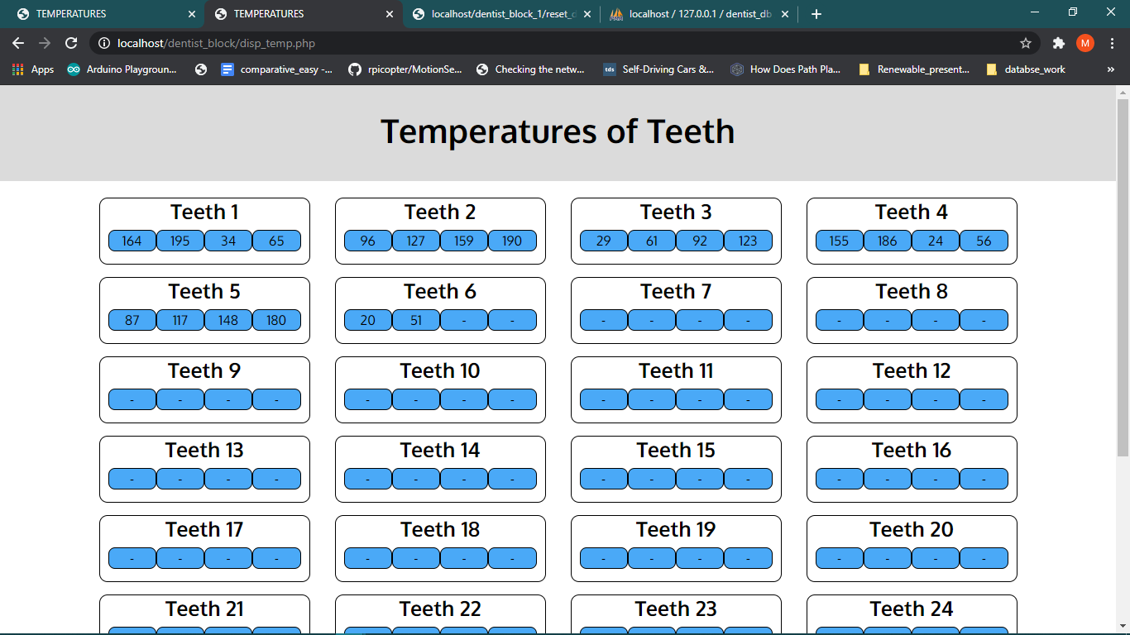

The final temperatures display.

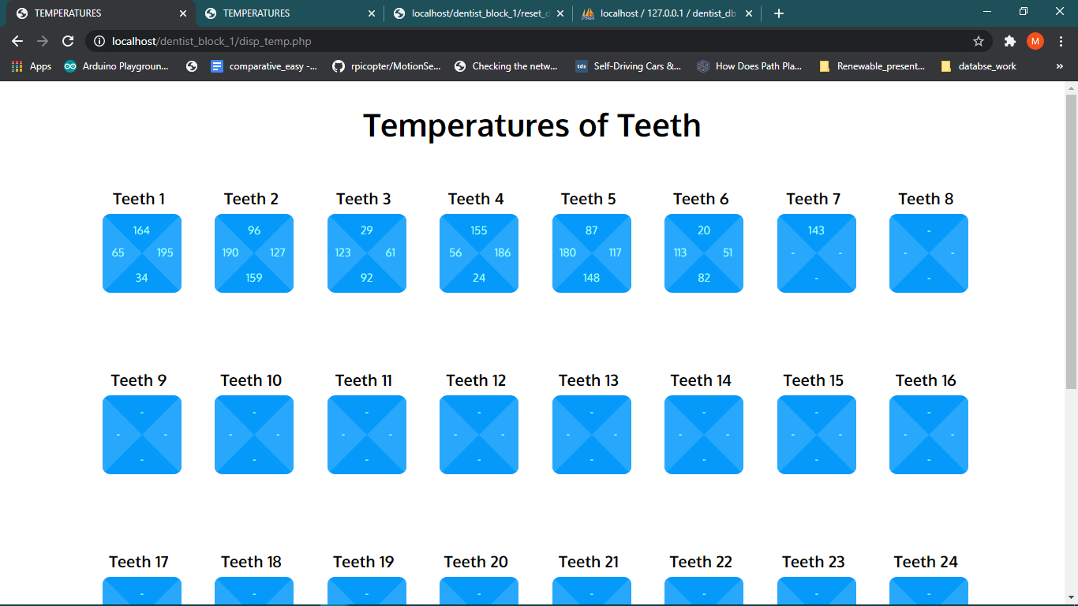

A reset database page has also been created for user convenience. You can also initialize the database by running this page.

