Steps to follow for first time:

* Go and start SQL and Apache server in XAMPP control pannel.

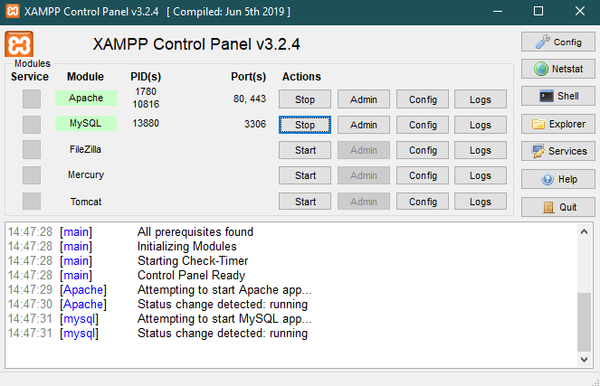

* Open Chrome-><http://localhost/phpmyadmin>
* Create a new database by the name of “dentist_db”.

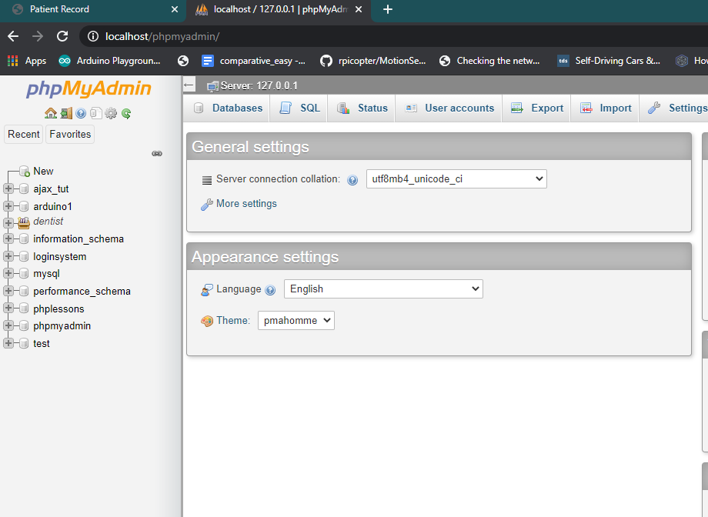 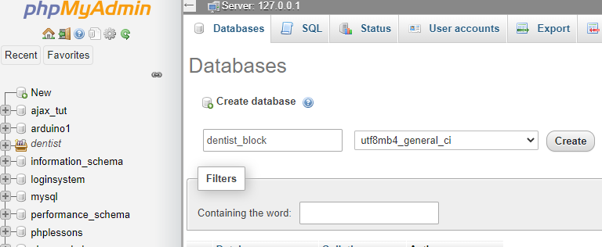

* Copy the Arduino and processing sketch to your machine.
* Place the contents of folder “xampp_htdocs_content” into “C:/xampp/htdocs” folder.

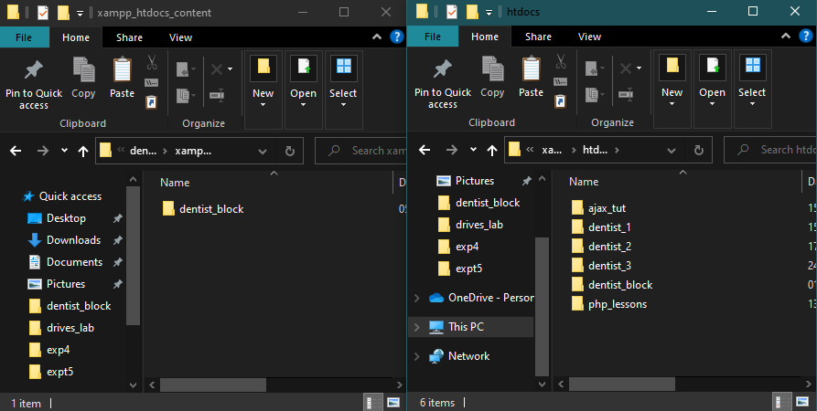

* Open Chrome-><http://localhost/dentist_block/>

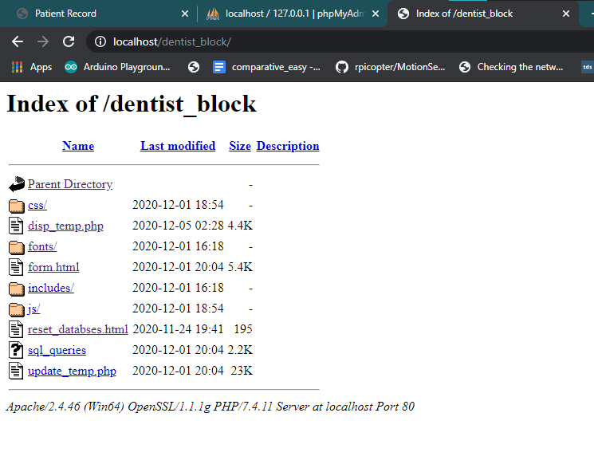

* Now open the “Reset Database file” and click on reset database button. This creates our new database and resets any existing ones.

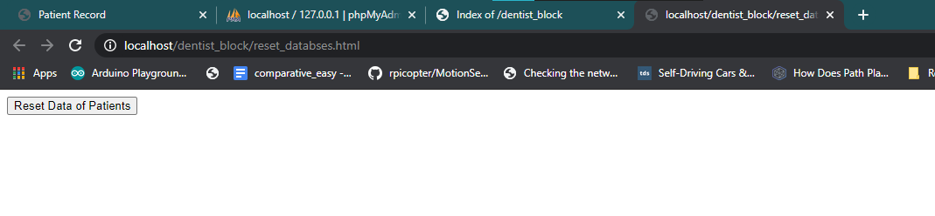

** now we follow normal steps of execution.

** also try to have an active internet while running project.

Steps to follow for each time you start:

* Start the SQL and Apache server if not started already.



* Open the Arduino sketch and processing sketch.
* Connect the Arduino to laptop, using USB type A cable.
* Run the Processing sketch.

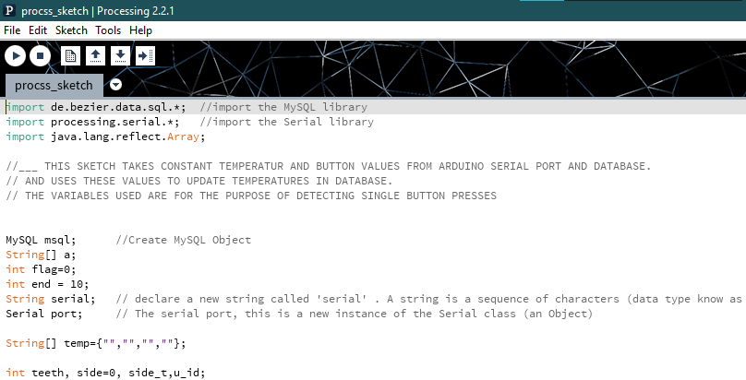

* Open Google chrome -> <http://localhost/dentist_block/form.html>



Some common errors :-

* Index out of array in processing.

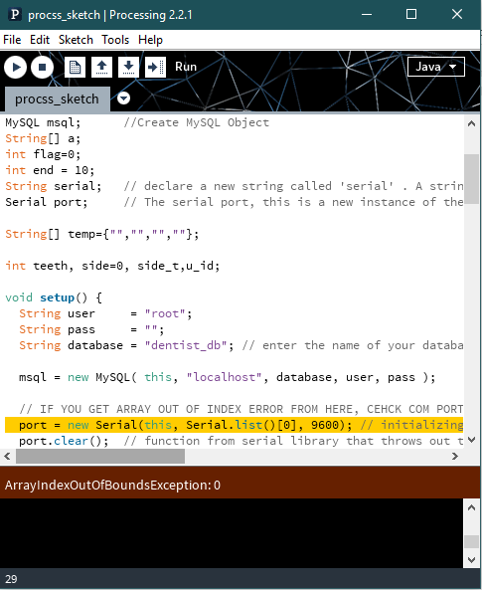

* This means the index for Arduino port is not correct. For debugging it, open Arduino and see which port are we connected to.

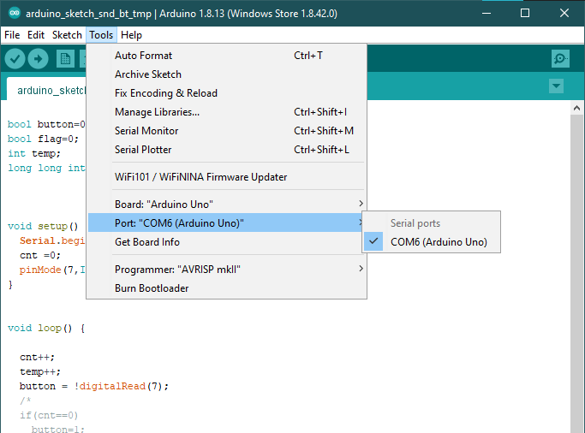

Now set the array index according to the index in port selection.

* Temperatures page not displayed properly
* We might not be connected to internet. There are a few jqueries,which require internet connection in beginning, to load. **So, connect to internet, and try to reload the form page.**