Invoice Feature

When you click on invoice link, should give a screen similar to this:

1. The bill to: will have name and email
2. Add item: will add items, qty and unit price
3. Add logo of business on the invoice
4. The invoice will be emailed to the customer
5. The invoice will have the company’s QR code at the bottom so they can scan and pay.

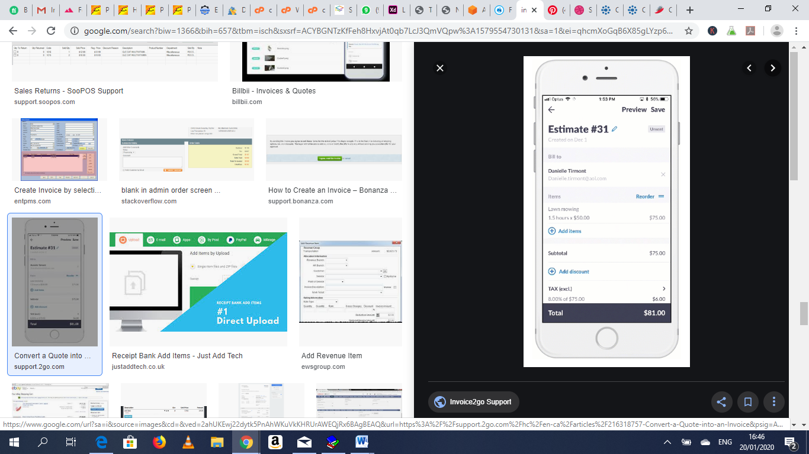

Next screen:

1. Will show sent invoices
2. Can click on the invoice and see the details.

