Data Centre Electrical Design
2N architecture for a 1 MW IT facility
Design report: load calculation, single line diagram, equipment sizing, short-circuit and protection study, reliability analysis and failure scenarios.

Prepared by | MOHIT
Date | 1 October 2026
Companion files | DC_Electrical_Design_Calcs.xlsx (all calculations, live formulas)
Status | Preliminary design for academic project use. Not for construction.

Contents
- 1. Introduction and scope
- 2. Design basis
- 3. Load calculation
- 4. Architecture and single line diagram
- 5. Equipment sizing
- 6. Cable sizing and voltage drop
- 7. Short-circuit calculation
- 8. Protection and coordination
- 9. Reliability and availability
- 10. Failure scenarios
- 11. Equipment list
- 12. Assumptions, limitations and verification

1. Introduction and scope
This report documents the electrical design of a 1 MW (IT load) data centre using a 2N architecture: two completely independent power paths, A and B, each able to carry the entire facility load on its own. The aim is to show how a design moves from a defined scenario to sized equipment, a single line diagram, fault and protection studies, and a reliability estimate.
Included: load calculation, architecture, sizing of transformers, UPS, batteries, generators and PDUs, cable and voltage-drop checks, short-circuit calculation, protection settings, availability analysis, failure scenarios and equipment list.
Not included: cooling system design, civil and structural work, fire suppression, BMS/DCIM, harmonic study, arc-flash study, and cost estimation.

2. Design basis
Parameter | Value
Racks x average load | 200 x 5 kW
IT load | 1,000 kW
Cooling / auxiliaries / losses | 400 / 60 / 40 kW
Total facility load, PUE | 1,500 kW, PUE 1.50
Redundancy | 2N (paths A and B, each sized for 100% of the load)
Utility supply | 11 kV, assumed fault level 250 MVA
LV system | 415 V, 3-phase, 50 Hz, TN-S
Power factor, growth margin | 0.90, 20%
Design ambient | 45 °C
Battery autonomy, fuel autonomy | 10 min, 24 h

Reference standards: TIA-942 and Uptime Institute Tier topology guidance (architecture); IEC 60364 and IS 732 (LV installations); IEC 62040-3 (UPS); IS 2026 (power transformers); IEC 60909 (short-circuit); IEC 60947-2 (LV breakers); ISO 8528 (generating sets); IS 3043 (earthing); IEC 61643 (surge protection); IEEE 493 (reliability data reference).
Key assumptions are listed in section 12. The utility fault level and the reliability data in particular must be replaced with real data before any detailed design.

3. Load calculation
The facility load is the IT load plus cooling, auxiliaries and losses. In a 2N design the two paths share the load equally in normal operation, but each path must be able to carry 100% of it when the other fails. Equipment is therefore sized on the failover figure plus a growth margin.
Quantity | Value | Unit
Total facility load | 1,500 | kW
Total facility apparent power | 1,667 | kVA
Each path, normal operation (50% share) | 750 | kW
Each path, normal operation | 833 | kVA
Each path, failover (100% of load) | 1,500 | kW
Each path, failover | 1,667 | kVA
Design load per path (failover + growth) | 1,800 | kW
Design apparent power per path | 2,000 | kVA
Design IT load per path (failover + growth) | 1,200 | kW

4. Architecture and single line diagram
Power flows from the 11 kV utility feeder through MV switchgear and the transformer to the LV board, then through an ATS (utility or generator) to the essential LV bus. The essential bus feeds the UPS and the mechanical load. The UPS feeds PDUs and RPPs, and each dual-corded rack takes one feed from A and one from B.
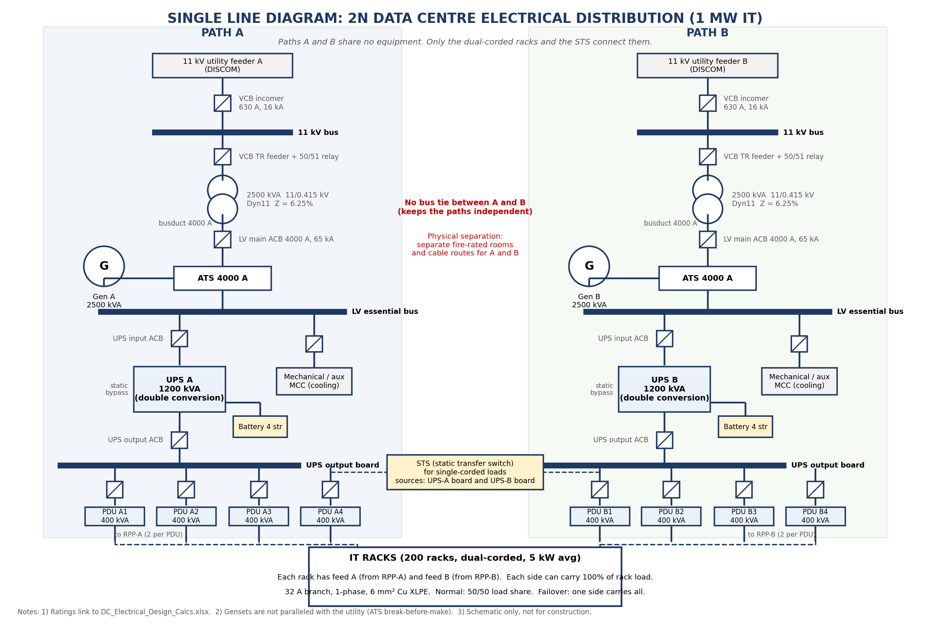
Figure 1. Single line diagram of the 2N distribution. Ratings come from the calculation workbook.

4.1 Design decisions
- Two independent paths. Paths A and B share no switchgear, transformer, UPS, generator or cable route. There is deliberately no bus tie between them.
- One ATS and one generator per path. On utility loss each path starts its own generator. N+1 gensets per path is an option in the workbook (Inputs: extra gensets).
- Double-conversion UPS with battery bridges the 10-15 s generator start and also isolates IT loads from utility disturbances.
- Dual-corded racks take A and B feeds. The few single-corded devices go through an STS.
- Physical separation. A and B equipment should sit in separate fire-rated rooms with separate cable routes; otherwise a single event removes both paths (see scenario F9).

5. Equipment sizing
Each path is sized separately; quantities in the equipment list are per path times two.
Item | Value | Unit
Transformer
Required kVA = design kVA / max loading | 2,353 | kVA
Selected transformer | 2,500 | kVA
LV full-load current | 3,478 | A
Loading: normal / failover / failover + growth | 33% / 67% / 80%
TR secondary busduct / ACB frame | 4,000 | A
UPS (per path)
Selected UPS (per path) | 1,200 | kVA
Loading: normal / failover | 42% / 83%
UPS output current at rated load | 1,669 | A
UPS input current | 1,932 | A
Battery (per UPS)
DC power at rated UPS load | 1,250 | kW
Nominal energy needed (ageing, margin, usable fraction) | 521 | kWh
Required capacity at nominal voltage | 1,085 | Ah
Strings x capacity | 4 x 300 Ah at 480 V
Installed nominal energy | 576 | kWh
Generator (per path)
Required kW = design load x harmonic/step derating | 1,980 | kW
Selected genset | 2,500 | kVA
Genset kW rating | 2,000 | kW
Loading: failover / both gensets sharing | 75% / 38%
Fuel consumption at failover load | 405 | L/h
Fuel tank per genset | 9,720 | L
PDU, RPP and rack
PDUs per path | 4 x 400 kVA (50 racks each)
PDU loading, failover | 66%
RPPs per path | 8 | nos
Rack feed current at failover (single side carries 100%) | 22.9 | A

Notes. The transformer is selected so that failover load plus 20% growth stays at or below 85% loading. UPS loading falls to about 42% in normal 2N operation, where double-conversion efficiency is lower; this is a known cost of 2N. The battery figure is a preliminary energy-based estimate and must be checked against the manufacturer's constant-power discharge table. With both gensets sharing load, each runs at about 38% of its kW rating, so scheduled load-bank testing is needed to avoid wet stacking.

6. Cable sizing and voltage drop
Cables are Cu XLPE with derating for 45 °C ambient (0.87) and grouping (0.80). Parallel runs are added until derated capacity exceeds the load current. Busduct is preferred over cables for the transformer and generator links at about 3.5 kA.
Feeder | Ib (A) | Runs x mm² | Capacity (A) | VD | Min size (mm²) | Amp / VD / SC
LV essential board to UPS input | 1,932 | 5 x 300 | 2,196 | 0.56% | 39 | OK / OK / OK
UPS output board to PDU | 556 | 2 x 185 | 640 | 0.50% | 64 | OK / OK / OK
LV essential board to mechanical MCC | 753 | 2 x 240 | 760 | 1.13% | 98 | OK / OK / OK
RPP to rack branch (1-phase) | 23 | 1 x 6 | 38 | 1.87% | 2 | OK / OK / OK
Total voltage drop from the UPS output board to the rack is 2.37% against a 5% limit. "Min size" is the adiabatic short-circuit minimum per run. The rack branch is checked against the MCB let-through energy instead of a clearing time.

7. Short-circuit calculation
A balanced three-phase fault is calculated by the impedance method with the utility source, transformer impedance, motor contribution and feeder impedances added arithmetically, which is conservative. The generator is not paralleled with the utility, so its fault contribution (about 29 kA) is lower than the utility case.
Source term | Value
Utility contribution at LV bus | 48.0 kA
Motor contribution | 3.3 kA
Total impedance at LV bus | 4.99 mΩ

Fault point | Impedance (mΩ) | Fault (kA) | Rating chosen (kA) | Check
F1 MV bus (11 kV) | - | 13.1 | 16 | OK
F2 LV essential bus (incl. motors) | 4.99 | 51.2 | 65 | OK
F3 UPS output board (on static bypass) | 5.83 | 41.1 | 50 | OK
F4 PDU incomer | 8.02 | 29.9 | 36 | OK
F5 Rack branch (phase-neutral) | 204.58 | 1.1 | 6 | OK
F6 Generator terminals | - | 29.0 | 65 | OK
The UPS output board and PDUs must be rated for the bypass fault level, not only for the lower inverter fault current, because the UPS static bypass connects them to the upstream source.

8. Protection and coordination
Starting settings for each breaker are shown below, with time grading of 0.1 s between LV devices and at least 0.3 s between the 11 kV relay and the LV main ACB.
Device | Ib (A) | Frame (A) | Ir (A) | Isd | tsd (s) | Fault (kA) | Icu (kA)
LV main ACB (TR secondary) | 3,478 | 4,000 | 3,700 | 5 x = 18,500 | 0.4 | 51.2 | 65
UPS input ACB | 1,932 | 2,500 | 2,050 | 6 x = 12,300 | 0.3 | 51.2 | 65
UPS output ACB | 1,669 | 2,500 | 1,800 | 6 x = 10,800 | 0.2 | 41.1 | 50
PDU main MCCB | 556 | 800 | 600 | 8 x = 4,800 | 0.1 | 29.9 | 36
Mechanical MCC feeder ACB | 753 | 1,000 | 800 | 6 x = 4,800 | 0.3 | 51.2 | 65
Rack branch MCB (C-curve) | 23 | 32 | 32 | 10 x = 320 | inst. | 1.1 | 6

11 kV transformer relay (51/50):
Setting | Value
Transformer MV full-load current | 131 A
51 pickup (IEC Normal Inverse) | 170 A primary, TMS 0.25
Max LV bus fault reflected to 11 kV | 1,933 A
Relay time at that fault | 0.70 s
Grading margin over LV main ACB | 0.30 s
50 pickup (instantaneous, 0.05 s) | 2,300 A primary
Transformer inrush allowance (10 x FLC) | 1,312 A

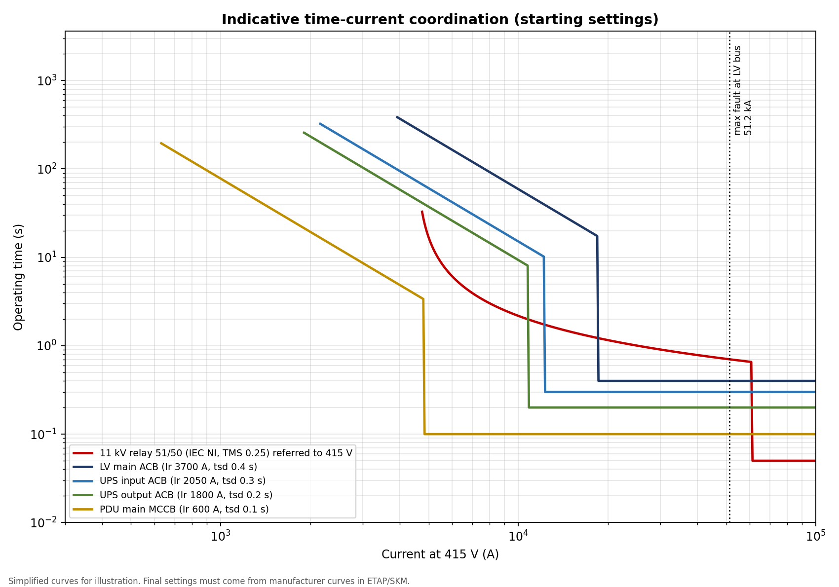
Figure 2. Indicative time-current curves for the main devices, referred to 415 V.
- Transformer: Buchholz relay, winding and oil temperature, pressure relief valve, restricted earth fault on the LV neutral.
- Generator: 27/59, 81, 50/51, 32, 87G and 64 protection plus emergency stop.
- Earthing: TN-S, solidly earthed transformer neutral, target earth resistance below 1 Ω (IS 3043).
- Surge protection: Type 1 at the LV main board, Type 2 at UPS input and PDU, Type 3 at critical rack strips.

9. Reliability and availability
Each path is modelled as a series chain of components using MTBF and MTTR figures, with the power source modelled as utility plus generator. 2N unavailability is U² + β·U, where β (1%) is a common-cause allowance for events that hit both paths.
Configuration | Availability | Hours / yr | Min / yr | Level
N: single path, no redundancy | 99.92304% | 6.74 | 404.5 | Tier II level
N+1: parallel redundant UPS, rest single path | 99.93755% | 5.47 | 328.3 | Tier II level
2N: two independent paths (this design) | 99.99917% | 0.07 | 4.4 | Tier IV level

The single path is down about 6.74 hours a year, mostly because of the transformer repair time. Redundant UPS modules alone barely help, since the rest of the chain stays single. The 2N design reaches 99.99917%, about 4.4 minutes a year. These numbers depend on illustrative component data, so use them to compare configurations, not as a guarantee. Tier classification itself depends on topology and operations, not on this figure.

10. Failure scenarios
The table lists what happens for the main failures and which limit is checked live in the workbook.
ID | Failure | System response | IT impact | Risk / mitigation and calculated check
F1 | Utility outage on both feeders | ATS senses loss, both gensets start and transfer in about 10-15 s; UPS batteries carry the load meanwhile. | None | Generators become the single source of energy. Fuel autonomy and monthly on-load tests are critical. [Gen load each = 38% of kW rating; battery = 10 min; fuel = 24 h]
F2 | Utility feeder A lost (B healthy) | Path A ATS starts Gen A; UPS A rides through on battery. | None | Path B untouched. If Gen A fails to start, see F5. [UPS-A battery autonomy = 10 min]
F3 | Transformer A internal fault | MV relay / Buchholz trips VCB. Path A LV board loses utility; ATS may start Gen A. | None (dual-corded loads stay on B) | Longest repair time in the system. Path B now runs at 100% of facility load; no redundancy until repair. [TR-B loading at failover = 67% of 2500 kVA]
F4 | UPS A module failure | UPS transfers to static bypass if available, otherwise path A output is lost. Dual-corded racks continue from B. | None | UPS B now carries all IT load. [UPS-B loading at failover = 83% (limit 100%)]
F5 | Generator A fails to start during utility outage | UPS A runs on battery until autonomy ends, then path A de-energises. | None while path B is healthy | If Gen B also fails, IT stops after battery autonomy. Mitigation: N+1 gensets, monthly testing, fuel quality management. [Battery ride-through = 10 min]
F6 | PDU A failure | Downstream racks lose A feed; B feed takes the full rack load. | None | Rack feeds on B carry 100% of rack load. [Rack feed current on B = 22.9 A vs 32 A breaker (80% rule)]
F7 | Planned maintenance of entire path A (concurrent maintainability) | Path A isolated at LV main and UPS output; B carries everything. | None | Facility is single-path during the work. Schedule in low-risk windows. [Path B loading: TR 67%, UPS 83%, PDU 66%]
F8 | Short circuit at a PDU | PDU main MCCB clears in its instantaneous / short-time zone; upstream devices stay closed by time grading. | None | Needs the coordination study to confirm selectivity. [Fault at PDU = 29.9 kA; PDU main tsd = 0.1 s, UPS output tsd = 0.2 s]
F9 | Common-cause event (fire / flood in a shared electrical room) | Both paths lost if A and B equipment share a room or cable route. | Total outage | Physical separation: separate fire-rated rooms and cable routes for A and B. This is the main 2N weakness. [Common-cause factor assumed = 1.0%]
F10 | Single-corded load while STS fails | Single-corded equipment fed through STS loses supply if the STS itself fails or if both sources fail. | Only single-corded loads | Minimise single-corded equipment; use dual-corded or rack-level ATS. [Static transfer time is typically 4-8 ms (vendor data)]

11. Equipment list
Quantities are generated from the sizing sheets. No prices are included.
# | Item | Rating / description | Per path | Total | Remarks
1 | MV switchgear panel | 11 kV VCB panel, 630 A, 16 kA / 3 s | 2 | 4 | Incomer + transformer feeder per path
2 | Distribution transformer | 2500 kVA, 11/0.415 kV, Dyn11, Z = 6.25%, ONAN | 1 | 2 | Cast resin or oil, per local practice
3 | Busduct, transformer to LV board | 4000 A busduct | 1 | 2
4 | LV main ACB | 4000 A frame, Ir = 3700 A, 65 kA | 1 | 2
5 | Automatic transfer switch (ATS) | 4000 A, 4-pole, utility / generator | 1 | 2
6 | Diesel generator set | 2500 kVA standby, 415 V, 2000 kW | 1 | 2 | Set Inputs extra gensets = 1 for N+1 per path
7 | Fuel storage tank | 9,720 L (for 24 h at failover load) | 1 | 2 | Local fire and explosives rules apply
8 | LV essential switchboard | Form 4b, incl. UPS and mechanical feeders | 1 | 2
9 | UPS | 1200 kVA / kW, double conversion, IEC 62040 | 1 | 2
10 | Battery string | 300 Ah, 240 cells (480 V), VRLA | 4 | 8 | Strings per UPS; validate with vendor tables
11 | UPS output board | With maintenance bypass | 1 | 2
12 | PDU | 400 kVA, 415/230 V, with isolation transformer or static | 4 | 8
13 | RPP (remote power panel) | 42-way, 32 A outgoing MCBs, metered | 8 | 16
14 | Cable sets, LV board to UPS input | 5 x 3 x 1C 300 mm² Cu XLPE + PE | 5 | 10 | Qty = parallel runs
15 | Cable sets, UPS output board to PDU | 2 x 3 x 1C 185 mm² Cu XLPE + PE | 8 | 16 | Qty = runs x PDUs
16 | Cable sets, LV board to mechanical MCC | 2 x 3 x 1C 240 mm² Cu XLPE + PE | 2 | 4
17 | Rack branch cables | 1-phase, 6 mm² Cu XLPE, one per rack feed | 200 | 400 | A feed and B feed for every rack
18 | Rack PDU strips | Metered, 32 A, one per feed | 200 | 400
19 | IT racks | Dual-corded racks | 200 | 200 | Shared between paths
20 | Static transfer switch (STS) | 100 A class, for single-corded loads | 2 | 2 | PLACEHOLDER quantity. Depends on single-corded device count
21 | Surge protective devices | Type 1 at LV main, Type 2 at UPS input and PDU | 3 | 6 | Sets

12. Assumptions, limitations and verification
The workbook passes all of its internal design checks:
Check | Status
Transformer loading (failover + growth) within limit | OK
UPS can carry 100% IT load after other path fails | OK
PDU can carry 100% IT load after other path fails | OK
Generator covers failover facility load | OK
Cable ampacity (all feeders) | OK
Cable voltage drop (all feeders and total) | OK
Cable short-circuit withstand | OK
Breaking capacity >= fault level (all points) | OK
Breaker frame and Ir coordination with load | OK
MV relay graded above LV main ACB | OK
Rack branch current within 80% of breaker | OK

Before this design is used beyond an academic exercise, the following must be verified:
- Utility data: the 250 MVA fault level and the supply availability are assumptions. Obtain real values from the DISCOM.
- Cable data: ampacities are indicative; use the manufacturer's tables and the real installation method.
- Battery: the energy-based estimate must be confirmed against vendor discharge tables for the chosen block and temperature.
- Reliability data: MTBF, MTTR, generator start probability and β are illustrative. Replace with IEEE 493 or vendor data.
- Short-circuit and coordination: the hand calculation should be cross-checked in ETAP, SKM or pandapower, and settings finalised from real breaker curves.
- Not covered: harmonics, arc flash, cooling electrical design, detailed layout, and cost.
Suggested next steps for the project: model the same network in pandapower to cross-check the fault levels, add an arc-flash estimate, and compare 2N with N+1 in cost and availability.

