132/33 kV Substation Design
Transformer, CT/PT, breakers, isolators, busbar, protection, earthing and single line diagram
Basic design of an outdoor 132/33 kV substation with two 50 MVA transformers, sectionalised single busbars, six 33 kV feeders and a resistance-earthed 33 kV system.

Prepared by | MOHIT
Date | 31 JULY 2026
Tools used | Excel (live formulas), Python / pandapower (short-circuit cross-check), Python (drawing and curves)
NOT used | ETAP, AutoCAD (the DXF file is generated by Python and opens in AutoCAD, LibreCAD or the AutoCAD mobile app)
Companion files | Substation_132_33kV_Design.xlsx, Substation_SLD.dxf, Substation_SLD.png
Status | Basic design for learning and portfolio use. Assumed grid data and soil resistivity. Not for construction.

Contents
- 1. Scope and design basis
- 2. Scheme selection
- 3. Power transformer and neutral earthing
- 4. Short-circuit levels
- 5. Equipment ratings (busbar, breakers, isolators, CT, PT, arresters)
- 6. Single line diagram
- 7. Protection
- 8. Earthing system
- 9. Equipment list
- 10. Assumptions, limitations and next steps

1. Scope and design basis
The design covers the electrical part of a 132/33 kV substation: scheme, transformers, short-circuit duty, switchgear and instrument transformer ratings, protection, earthing and the single line diagram. Civil design, general-arrangement layout, auxiliary AC/DC systems, SCADA and fire protection are out of scope.
Parameter | Value
Voltage levels | 132 kV (Um 145 kV) and 33 kV (Um 36 kV), 50 Hz
Supply | Two 132 kV incoming lines, grid fault level 4000 MVA max / 2500 MVA min (ASSUMED)
Load | Six 33 kV feeders of 8 MVA, diversity 0.85, growth 20%
Reliability | N-1: either transformer or either line out of service without loss of load
33 kV neutral | Earthing transformer + neutral resistor, earth-fault current limited to 300 A
Standards (reference) | IEC 62271-100 (breakers), IEC 62271-102 (isolators), IEC 61869 (CT/VT), IEC 60099-4 (arresters), IEC 60071 (insulation), IS 2026 / IEC 60076 (transformers), IEC 60909 (short circuit), IEEE 80 and IS 3043 (earthing), CBIP manuals and CEA regulations

Honest scope note: this is a basic design to show the method and the numbers. Grid data, soil resistivity and line data are assumptions. A real design needs utility data, a soil survey, a general-arrangement drawing and vendor data. The calculations were not run in ETAP.

2. Scheme selection
For a basic two-transformer substation, a sectionalised single busbar at both voltage levels gives N-1 security with the least equipment. The comparison below shows why it was chosen.
Scheme | Advantage | Limitation | Use
Single bus | Cheapest, simplest | Bus fault or maintenance loses everything | Small, non-critical
Sectionalised single bus (CHOSEN) | One section can stay in service if the other fails; bus coupler allows either transformer to supply both | Bus section faults lose half the bays; maintenance of a bus section drops its bays | Typical 132/33 kV with two transformers
Double bus | Any feeder can move to either bus; bus maintenance without outage | Extra breaker and isolators per bay, more cost and complexity | Important or large substations
One-and-a-half breaker | Highest security and flexibility | Three breakers per two circuits, most expensive | Large EHV substations
Operation: in normal operation the bus section (132 kV) and coupler (33 kV) are closed or open as the operator chooses. With the coupler open each transformer supplies its own section (lower fault level, see section 4). On loss of a transformer or a line the coupler closes and the healthy unit carries all the load.

3. Power transformer and neutral earthing
Item | Result
Connected load (6 x 8 MVA) | 48.0 MVA
Peak demand (diversity 0.85) | 40.8 MVA
Design load with 20% growth | 49.0 MVA
Selected transformer (next standard) | 50 MVA, ONAN/ONAF
Loading: normal / N-1 now / N-1 design | 41% / 82% / 98%
Rated current 132 kV / 33 kV | 219 A / 875 A
Feeder rated current | 140 A
Impedance, vector group, OLTC | 12.5% (IS 2026 typical), YNd11, +/-10% on HV in 16 steps
IEC 60909 correction factor KT | 0.972
NGR resistance (Vph / 300 A) | 63.5 ohm
Earthing transformer short-time rating (10 s) | 5,716 kVA

- Rating: one transformer must carry the whole design load (N-1). 48.96 MVA with growth needs a 50 MVA unit, which then runs at 98% in the worst case, so growth beyond 20% needs a third transformer or a 63 MVA unit.
- Cooling: ONAN/ONAF; the 50 MVA rating is the ONAF rating, with ONAN at about 60-70% of it.
- Vector group YNd11: the star HV winding with solidly earthed neutral suits the effectively earthed 132 kV system, and the delta traps third harmonics and zero-sequence on the 33 kV side.
- Neutral for 33 kV: because the LV winding is delta there is no neutral. A zig-zag earthing transformer on each bus section with a 63.5 ohm resistor limits an earth fault to 300 A (10 s rating). This reduces damage and touch-voltage hazards and still lets earth-fault relays operate. The earthing transformer also carries a 415 V winding for station supply.
- OLTC: +/-10% in 16 steps on the HV side to keep the 33 kV voltage within limits as grid and load change.
- Accessories: Buchholz relay (main and OLTC), winding and oil temperature indicators, pressure relief valve, oil level gauge, nitrogen or water-spray fire protection, bushing CTs.

4. Short-circuit levels
Fault levels are calculated per IEC 60909 on the transformer MVA base. The grid Sk'' already contains the voltage factor c; the transformer impedance is corrected with KT. The hand calculation is cross-checked against pandapower.
Fault location | Hand calculation (kA) | pandapower (kA) | Difference
132 kV bus, maximum | 17.5 | 17.5 | -
33 kV bus, coupler closed (max) | 12.92 | 12.92 | -0.0%
33 kV bus, coupler open or one transformer (max) | 7.11 | 7.12 | -0.0%
33 kV bus, coupler open (min) | 6.03 | 6.04 | -

The hand calculation agrees with pandapower to within 0.1%. The 33 kV fault level depends strongly on the bus-coupler position, so the 33 kV switchgear is rated for the coupler-closed case.
Level | Ik'' (kA) | Peak ip (kA) | Rating chosen (3 s) | Utilisation | Making capacity
132 kV | 17.5 kA | 44.5 kA | 31.5 kA | 56% | 78.8 kA
33 kV | 12.9 kA | 32.9 kA | 25.0 kA | 52% | 62.5 kA

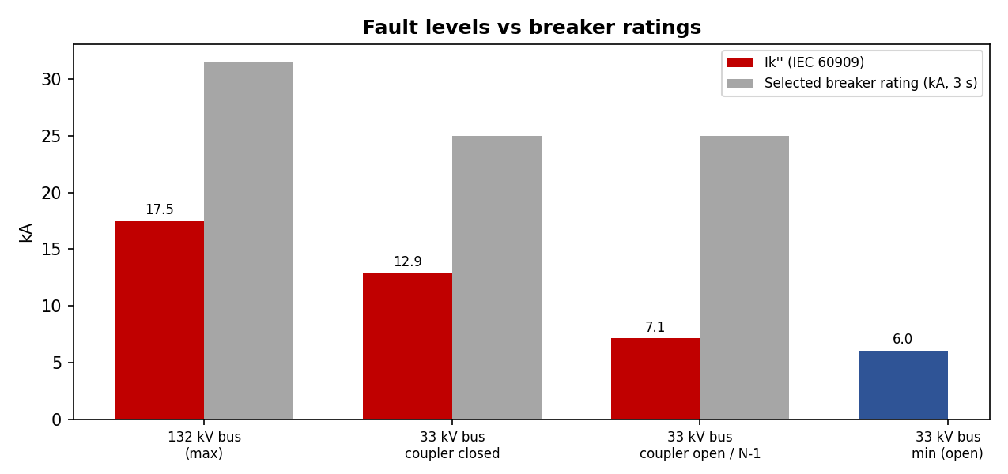
Figure 1. Fault levels against the selected breaker ratings.
The 132 kV equipment is rated 31.5 kA even though 17.5 kA would be enough on calculation: 31.5 kA is the common utility standard and leaves room for grid growth. The 33 kV equipment is rated 25 kA for the same reason. The single-line-to-ground fault at the 132 kV bus is 18.6 kA (pandapower, with the transformer zero-sequence source); it is used for the earthing design.

5. Equipment ratings

5.1 Busbars, breakers and isolators
Item | Rating | Basis
132 kV busbar | 1,250 A | (2 transformers + 1 future bay) x 218.7 A x 1.25; tubular aluminium, 31.5 kA
33 kV busbar | 1,250 A | 875 A transformer current x 1.25
132 kV line and bus-section breaker | 145 kV, 1,250 A, 31.5 kA / 3 s | Line carries both transformers; SF6 type
132 kV transformer breaker | 145 kV, 1,250 A, 31.5 kA / 3 s | 1250 A is the smallest standard rating
33 kV incomer / coupler breaker | 36 kV, 1,250 A, 25 kA / 3 s | 875 A x 1.1; vacuum type
33 kV feeder breaker | 36 kV, 630 A, 25 kA / 3 s | 140 A x 1.25
Isolators | Same voltage, current and short-time rating as the breaker in the bay | 132 kV: double-break horizontal; line isolators have an earth switch. 33 kV: centre-break
Insulation (LIWL / power frequency) | 132 kV: 650 / 275 kV. 33 kV: 170 / 70 kV | IEC 60071-1 for Um 145 kV and Um 36 kV
Surge arresters | 132 kV: 120 kV. 33 kV: 36 kV, 10 kA | 132 kV effectively earthed (0.8 x Um). 33 kV resistance-earthed, so rated at Um

5.2 Current transformers
All CTs have a 1 A secondary because of the long lead lengths in a 132 kV yard. Primary ratings are the next standard value above 1.2 times the bay rated current.
Bay | Ratio (A/1 A) | Cores (class, use)
132 kV line | 600 | PS (87B bus protection), 5P20 (21 distance), 5P20 (67N / backup), 0.2S (tariff metering)
132 kV transformer HV | 300 | PS (87T), PS (87N REF), 5P20 (51/51N), 0.5 (metering), PS (87B)
132 kV bus section | 600 | PS (87B), 5P20 (51, 50BF)
33 kV incomer | 1,200 | PS (87T), 5P20 (51/51N), 0.5 (metering)
33 kV bus coupler | 1,200 | 5P20 (51/51N)
33 kV feeder | 200 | 5P20 (50/51, 50N/51N), 0.5 (metering)
Earthing transformer neutral | 400 | 5P10 (51N)
Knee-point voltage (transformer differential, HV side): the worst external fault is a 33 kV bus fault with the coupler closed. Referred to the HV side it is 3,229 A, which is 10.8 A on the 300/1 CT secondary. With Rct 3.0 ohm, loop lead 2.2 ohm and relay 0.05 ohm, Vk >= 2 x 10.8 x 5.25 = 113 V, so a PS class CT with Vk >= 200 V is specified. All CTs must withstand 31.5 kA for 3 s (132 kV) or 25 kA for 3 s (33 kV).

5.3 Voltage transformers
- 132 kV: capacitor voltage transformers (CVT), 132/V3 kV : 110/V3 V : 110/V3 V : 110/3 V, with a metering winding 0.2 / 50 VA, a protection winding 3P / 100 VA and a residual-voltage winding. CVTs are on both lines (also used for carrier coupling) and on each bus.
- 33 kV: electromagnetic VTs on each bus, 33/V3 kV : 110/V3 V : 110/3 V, 0.5 and 3P, 100 VA.
- Burden check: connected burden is 16 VA on the 50 VA metering winding (32%) and 30 VA on the 100 VA protection winding (30%), both within the 25-100% range needed for the stated accuracy.

5.4 Electrical clearances (typical values)
Clearance | 132 kV | 33 kV | Note
Phase to earth | 1.3 m | 0.32 m | Typical air clearance for 650 / 170 kV impulse level
Phase to phase | 1.3 m | 0.4 m | Typical
Sectional (safety) clearance | 4.0 m | 2.8 m | Verify with CBIP / CEA
Ground clearance of live parts | 4.6 m | 3.7 m | Verify with CBIP / CEA
These are typical values for orientation only. The general-arrangement design must use the applicable CBIP manual, CEA regulations and the equipment vendor drawings.

6. Single line diagram
The diagram shows both 132 kV lines, the sectionalised 132 kV bus, two 50 MVA transformers, the sectionalised 33 kV bus with bus coupler, six 33 kV feeders and two earthing transformers with neutral resistors. Protection functions are shown in red.
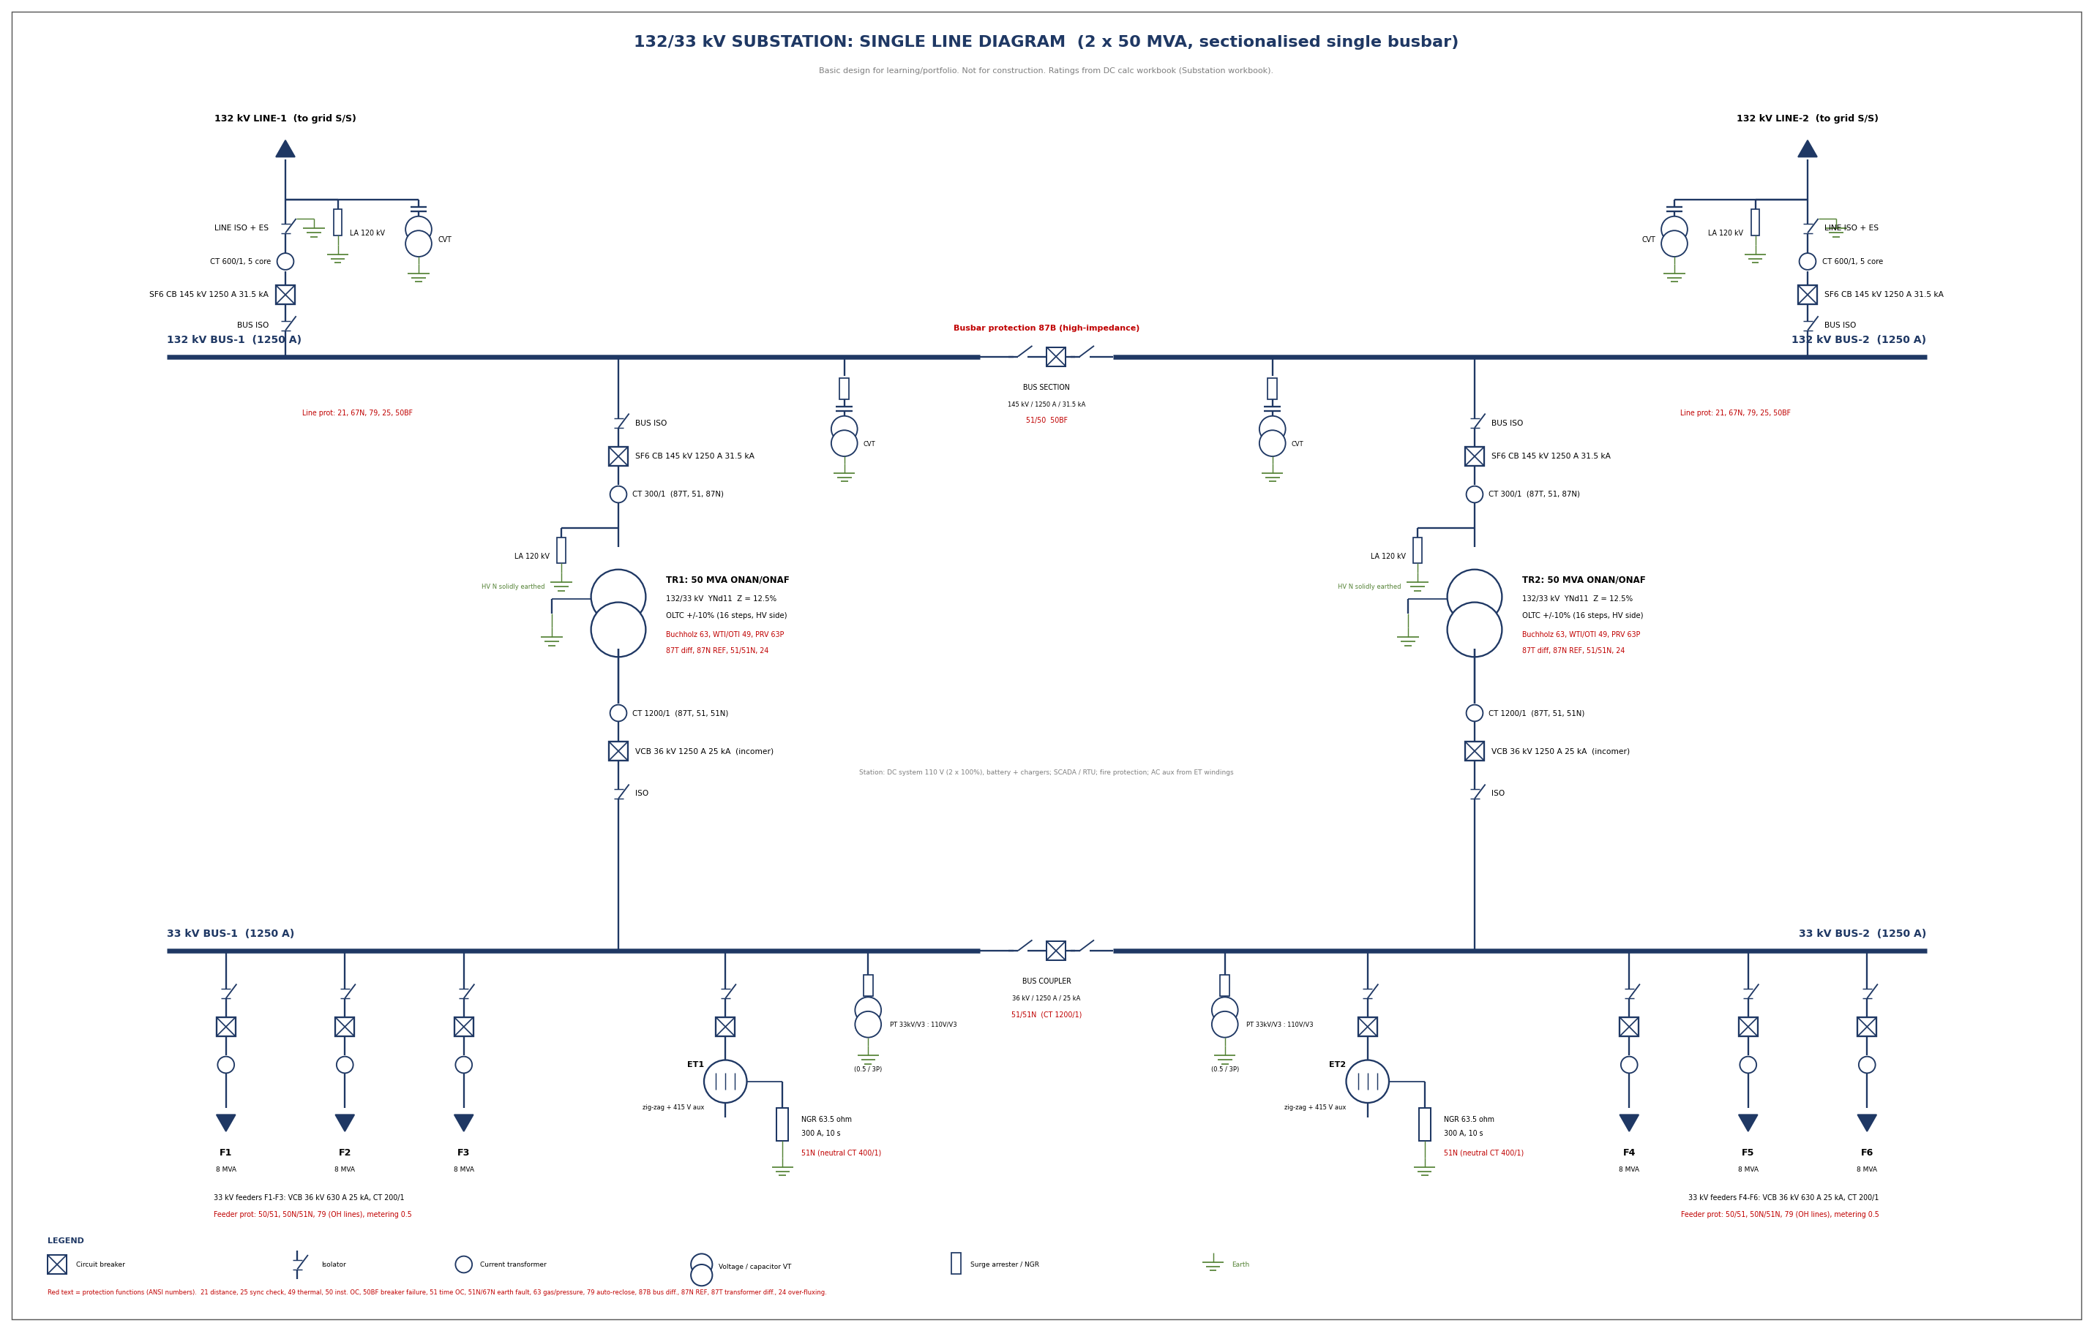
Figure 2. Single line diagram (also supplied as Substation_SLD.dxf for AutoCAD).

6.1 Bay arrangement
- Line bay: line isolator with earth switch, CVT and surge arrester on the line side, CT, SF6 breaker, bus isolator. This order puts the isolator with earth switch next to the line so that the bay can be made safe for work.
- Transformer bay (132 kV): bus isolator, breaker, CT, arrester at the transformer terminals. The HV neutral is solidly earthed.
- Transformer incomer (33 kV): CT (differential and overcurrent), vacuum breaker, isolator, bus.
- Feeder bay: isolator, vacuum breaker, CT, outgoing cable or overhead line (auto-reclose on overhead feeders).
- Earthing transformer bay: isolator, breaker, zig-zag transformer, 63.5 ohm resistor to earth, neutral CT with 51N.
- Bus section and coupler: isolator, breaker and isolator in series, with overcurrent protection.

7. Protection

7.1 Scheme
Bay / zone | Protection (ANSI numbers)
132 kV line | 21 distance (three zones, carrier-aided), 67N directional earth fault, 79 auto-reclose (single-pole), 25 synchro-check, 50BF breaker failure, 27/59 voltage, metering
Transformer | 87T biased differential, 87N restricted earth fault on the HV neutral, 51/51N HV backup, 49 thermal (WTI/OTI), 63 Buchholz (main and OLTC), 63P pressure relief, 24 over-fluxing, 50BF
132 kV bus | 87B high-impedance busbar differential per bus section
33 kV incomer | 51/51N overcurrent, 50BF; backed up by the HV 51
33 kV feeder | 50/51 overcurrent, 50N/51N earth fault, 79 on overhead feeders, 81 under-frequency load shedding
33 kV neutral (earthing transformer) | 51N on the neutral CT, graded above the feeder earth-fault relays
Bus section / coupler | 51/51N short-time overcurrent
Station | 74 trip-circuit supervision, 86 lockout relays, DC supervision, event recorder

7.2 Overcurrent and earth-fault settings
IEC Normal Inverse curves are used. Grading margin is at least 0.3 s. The feeder is graded using its IDMT element only (the instantaneous element makes real grading faster).
Relay | CT | Pickup | TMS | Other
33 kV feeder 50/51 | 200/1 | 175 A | 0.10 | Inst. 1600 A (8 x CT)
33 kV incomer 51 | 1200/1 | 1050 A | 0.20 | 1.2 x rated current
132 kV transformer 51 (backup) | 300/1 | 270 A | 0.30 | Inst. 4,200 A (above max 33 kV fault)
33 kV feeder 51N | 200/1 | 30 A | 0.10 | 10% of NGR current
Neutral 51N | 400/1 | 60 A | 0.20 | 20% of NGR current

Case | Feeder (s) | Incomer (s) | HV 51 (s) | Margin 1 (s) | Margin 2 (s)
Max 33 kV fault, coupler closed | 0.156 | 0.757 | 1.153 | 0.601 | 0.397
One transformer in service (N-1) | 0.182 | 0.718 | 1.093 | 0.536 | 0.375
Margin 1 = incomer minus feeder, margin 2 = HV relay minus incomer. All margins are above 0.3 s. The N-1 through-fault current is 8.1 times rated current, and the HV relay clears it in 1.09 s, below the 2 s thermal withstand of the transformer. For earth faults the neutral relay operates at 0.856 s against 0.297 s for the feeder, a margin of 0.559 s.
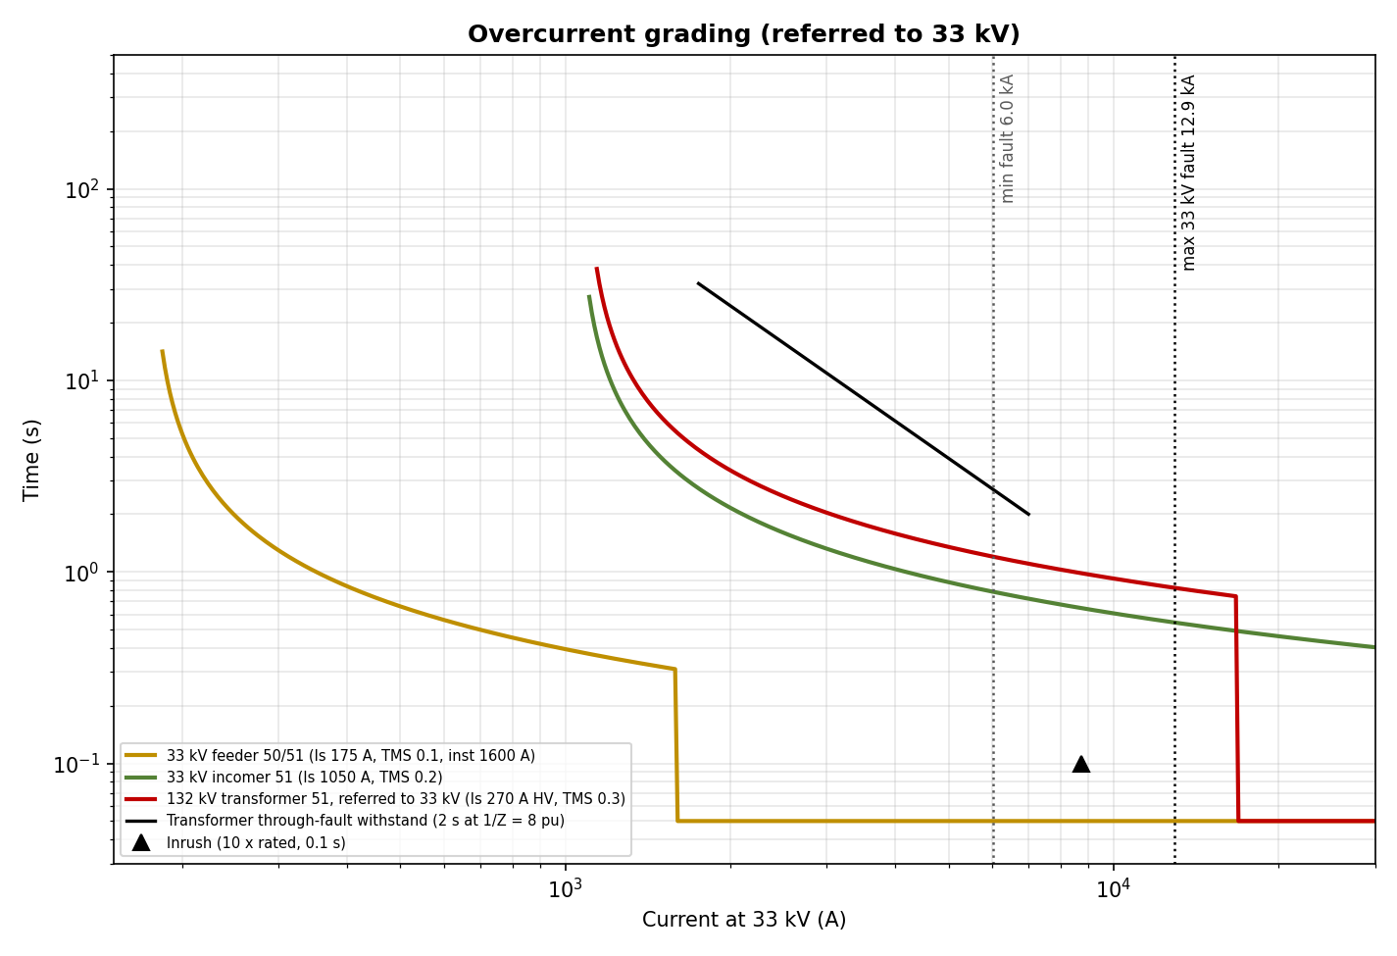
Figure 3. Overcurrent grading curves referred to 33 kV.

7.3 Transformer differential (87T)
Setting | Value
CT ratios (HV / LV) | 300/1 and 1200/1, rated secondary currents 0.729 A and 0.729 A (mismatch 1.000)
Minimum pickup | 0.2 pu
Slope 1 / slope 2 | 25% (up to 2 pu) / 50%
2nd harmonic restraint (inrush) | 15%
5th harmonic restraint (over-excitation) | 35%
Unrestrained high-set | 8 pu
Vector group compensation | Done in the numerical relay (Dyn11 phase shift and zero-sequence removal on the star side)

7.4 Line distance protection (21), worked example
For a 30 km line with 0.14 + j0.40 ohm/km and a 20 km adjacent line: line impedance 12.71 ohm, adjacent 8.48 ohm. With a 600/1 CT and 132 kV/110 V CVT the primary-to-secondary factor is 0.500. Zone 1 (80%, instantaneous) = 5.09 ohm secondary; Zone 2 (120% of line, 0.35 s) = 7.63 ohm; Zone 3 (line + 120% of adjacent, 0.8 s) = 11.44 ohm. Auto-reclose is single-pole with a 1 s dead time.

7.5 High-impedance busbar protection (87B)
The maximum through-fault current is 17,495 A, which is 29.2 A on the 600/1 CT. With Rct 4 ohm and 2 ohm loop lead the stability voltage setting is Vs = 29.2 x 6 = 175 V, so the busbar CTs must have Vk >= 350 V (class PS) and all bays must use identical ratios on the busbar core. Breaker-failure (50BF, 0.2 s) trips the whole bus section.

8. Earthing system
The earthing grid is designed to IEEE Std 80 so that the touch and step voltages stay below the tolerable limits for a 70 kg person during the worst earth fault. The fault current of 20 kA is the 132 kV single-line-to-ground current from the study (18.6 kA) rounded up.
Item | Result
Minimum conductor area (steel, 1 s) | 162 mm² (selected 900 mm² flat)
Total conductor / rod length | 1,810 m / 120 m
Grid resistance Rg | 0.73 ohm
Decrement factor Df / grid current Ig | 1.064 / 12,764 A
Ground potential rise (GPR) | 9,294 V
Tolerable touch / step voltage (70 kg) | 706 V / 2,353 V
Mesh (touch) voltage Em | 621 V
Step voltage Es | 913 V
Touch / step / resistance checks | OK / OK / OK
GPR above 5 kV | YES: use isolation / optical fibre

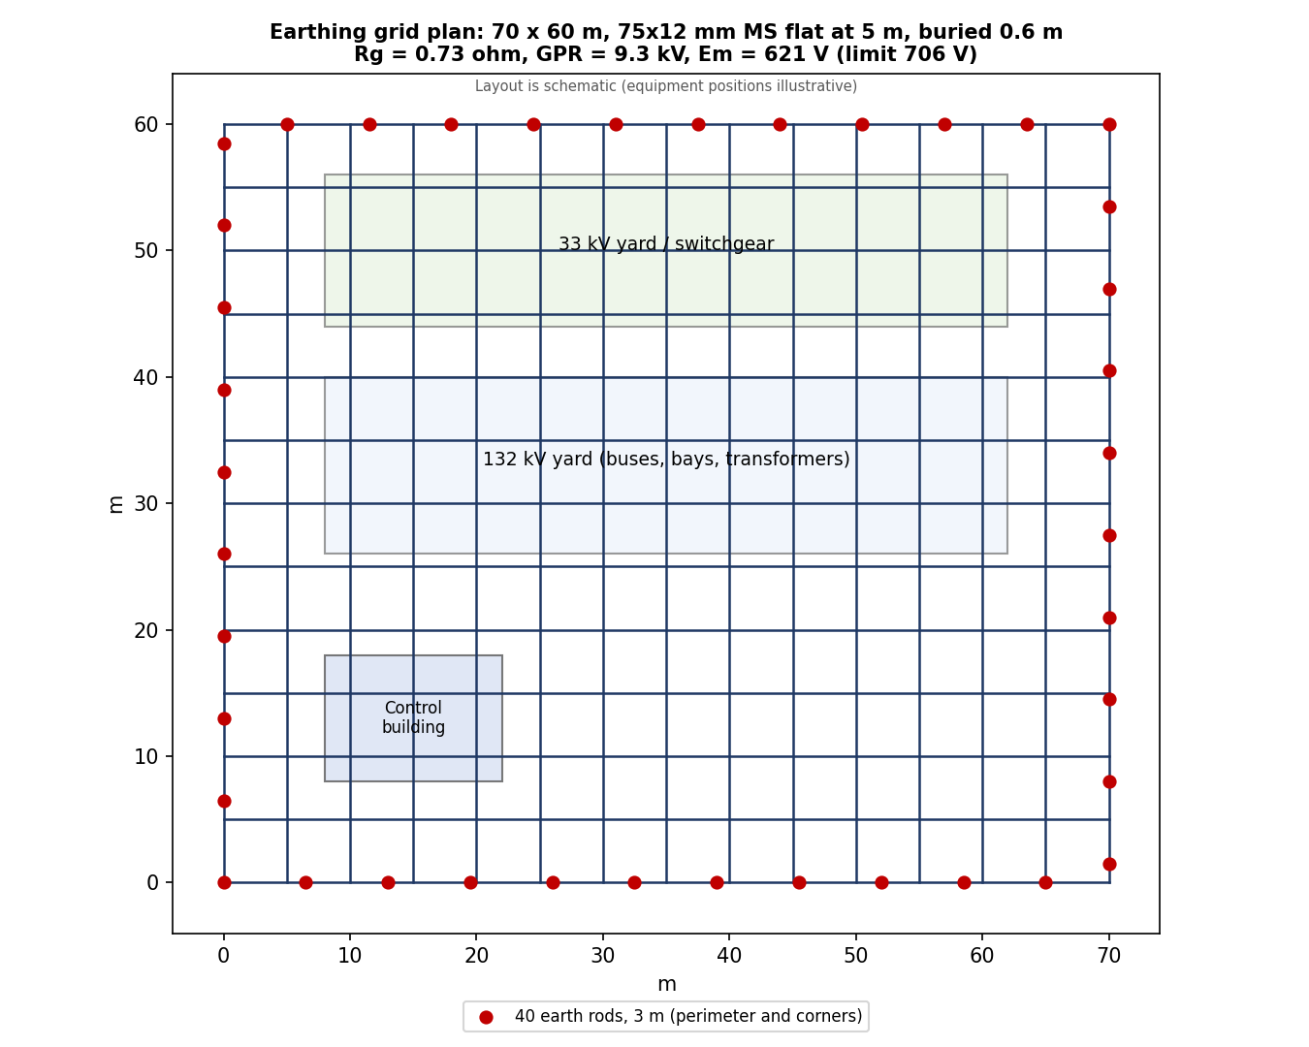
Figure 4. Earthing grid plan (schematic equipment layout).
- Conductor: 75 x 12 mm galvanised mild steel flat buried 0.6 m deep at 5 m spacing; the thermal minimum for 1 s at 20 kA is only 162 mm², so the flat has a large margin for corrosion.
- Rods: 40 rods of 3 m on the perimeter and at corners, which also help control the step voltage at the edge.
- Surface layer: 0.15 m crushed rock (3000 ohm.m) in the switchyard raises the tolerable touch voltage to 706 V.
- Equipment connections: every structure, transformer tank, neutral, arrester base and CVT earth is connected to the grid by two separate paths. Surge arresters have short, direct earth leads.
- Fence: earthed separately or bonded with a buried peripheral conductor one metre outside the fence, with the fence gates bridged.
- GPR above 5 kV: telecommunication, SCADA and metering circuits that leave the station need isolation transformers or optical fibre.
Spacing and soil resistivity matter. The grid passes at 5 m spacing for 100 ohm.m soil but fails at 7 m and at resistivity above about 150 ohm.m.
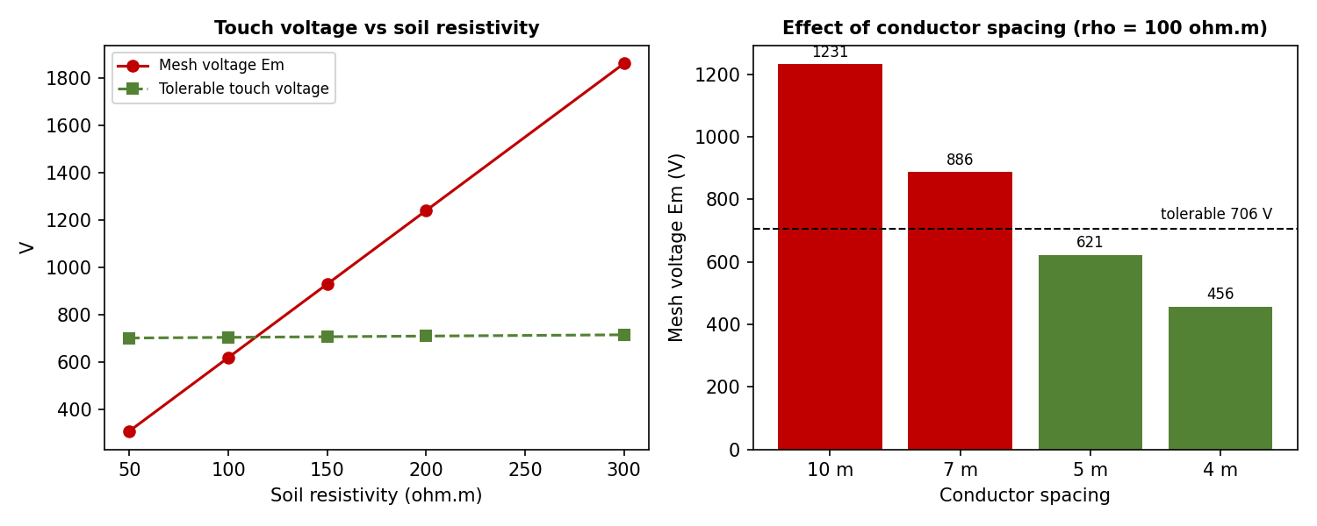
Figure 5. Effect of soil resistivity and conductor spacing on the mesh voltage.
Soil resistivity (ohm.m) | Rg (ohm) | GPR (V) | Em (V) | Tolerable touch (V) | Result
50 | 0.36 | 4,647 | 310 | 703 | PASS
100 | 0.73 | 9,294 | 621 | 706 | PASS
150 | 1.09 | 13,941 | 931 | 709 | FAIL
200 | 1.46 | 18,588 | 1,242 | 711 | FAIL
300 | 2.18 | 27,883 | 1,863 | 717 | FAIL
The soil resistivity of 100 ohm.m is an assumption. A Wenner four-pin survey of the real site is mandatory before the grid is finalised.

9. Equipment list
# | Item | Rating / description | Qty
1 | Power transformer | 132/33 kV, 50 MVA ONAN/ONAF, YNd11, Z = 12.5%, OLTC +/-10% | 2
2 | 132 kV SF6 circuit breaker | 145 kV, 1250 A, 31.5 kA / 3 s (line, bus section), 1250 A (transformer) | 5
3 | 132 kV isolator (double break), line isolators with earth switch | 145 kV, 1250 A, 31.5 kA | 8
4 | 132 kV CT (3 phase sets) | 600/1 (line, bus section), 300/1 (transformer), 4-5 cores | 5
5 | 132 kV capacitor voltage transformer (3 phase sets) | 132/V3 kV : 110/V3 V, 0.2 / 3P / 3P | 4
6 | 132 kV surge arrester (3 phase sets) | 120 kV, 10 kA, station class | 4
7 | 132 kV busbar | Tubular, 1250 A, 2 sections | 2
8 | 33 kV vacuum circuit breaker (incomer and coupler) | 36 kV, 1250 A, 25 kA / 3 s | 3
9 | 33 kV vacuum circuit breaker (feeder) | 36 kV, 630 A, 25 kA / 3 s | 6
10 | 33 kV vacuum circuit breaker (earthing transformer) | 36 kV, 630 A, 25 kA / 3 s | 2
11 | 33 kV isolator (incomers, coupler, feeders, earthing transformers, PT) | 36 kV, 1250 A | 14
12 | 33 kV CT sets | 1200/1 (incomer, coupler), 200/1 (feeder), 400/1 (neutral) | 11
13 | 33 kV voltage transformer (3 phase sets) | 33/V3 kV : 110/V3 V, 0.5 / 3P | 2
14 | 33 kV surge arrester | 36 kV, 10 kA | 8
15 | Earthing transformer (zig-zag) with 415 V aux winding | 5,716 kVA for 10 s, 300 A | 2
16 | Neutral earthing resistor | 63.5 ohm, 300 A, 10 s | 2
17 | Numerical protection relays (approximate count) | Line (21), transformer (87T, 51), feeder (50/51), bus (87B), 25, 50BF | 19
18 | Earthing grid | 70 x 60 m, 75x12 mm MS flat at 5 m spacing, 40 rods x 3 m | 1
19 | DC system | 110 V, 2 x 100% battery banks and chargers | 2

10. Assumptions, limitations and next steps
The workbook passes all of its design checks:
Check | Status
Transformer N-1 loading at design load <= 100% | OK
Breaker rating >= 132 kV fault level | OK
Breaker rating >= 33 kV fault level | OK
Hand calculation within 5% of pandapower (33 kV) | OK
CT burden / VT burden | OK
OC grading margins >= 0.3 s | OK
Transformer thermal withstand | OK
Earth-fault grading | OK
Earthing: touch voltage | OK
Earthing: step voltage | OK
Earthing: grid resistance <= 1 ohm | OK

Assumptions and limitations
- Grid data: 4000 / 2500 MVA at 132 kV is assumed. Obtain real values from the transmission utility, including zero-sequence data.
- Soil resistivity: 100 ohm.m is assumed. A site survey decides the earthing design.
- Line data and distance settings are a worked example; real settings need the actual line impedance, adjacent lines and the utility's relay-setting policy.
- Clearances and typical ratings are for orientation; the general-arrangement drawing must follow CBIP, CEA regulations and vendor data.
- Not covered: general-arrangement and civil layout, cable sizing, auxiliary AC and DC design, SCADA, fire protection, harmonics, load flow and voltage regulation studies, lightning shielding and insulation coordination in detail.
- Software: no ETAP or AutoCAD was used. Repeating the short-circuit and relay-coordination work in ETAP and redrawing the diagram in AutoCAD are the natural next steps for a job portfolio.

Suggested next steps
- Redraw the SLD in AutoCAD from the supplied DXF file and add title block and drawing numbers.
- Model the same network in ETAP (short circuit, protective device coordination, ground grid) and compare with the workbook.
- Draw a plan and sections (general arrangement), and add lightning shielding and 33 kV cable sizing.

