Computer Networks
BCSE308P

Lab experiment-6
(L55+L56)

Submitted to:
Dr. Subbulakshmi T

Submitted by:
Mohit Sangwan(24BCE1324)

Q1) Capture live network traffic and save capture files. Locate any packet and validate the checksum option available in Wireshark for IP, TCP, UDP, TLS, ICMP.
A1)
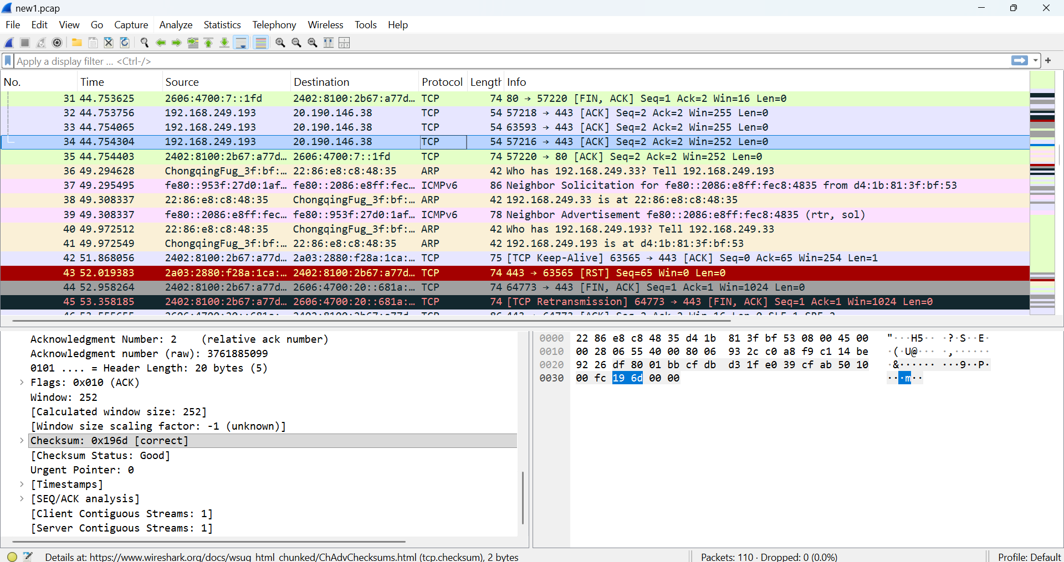
For TCP:
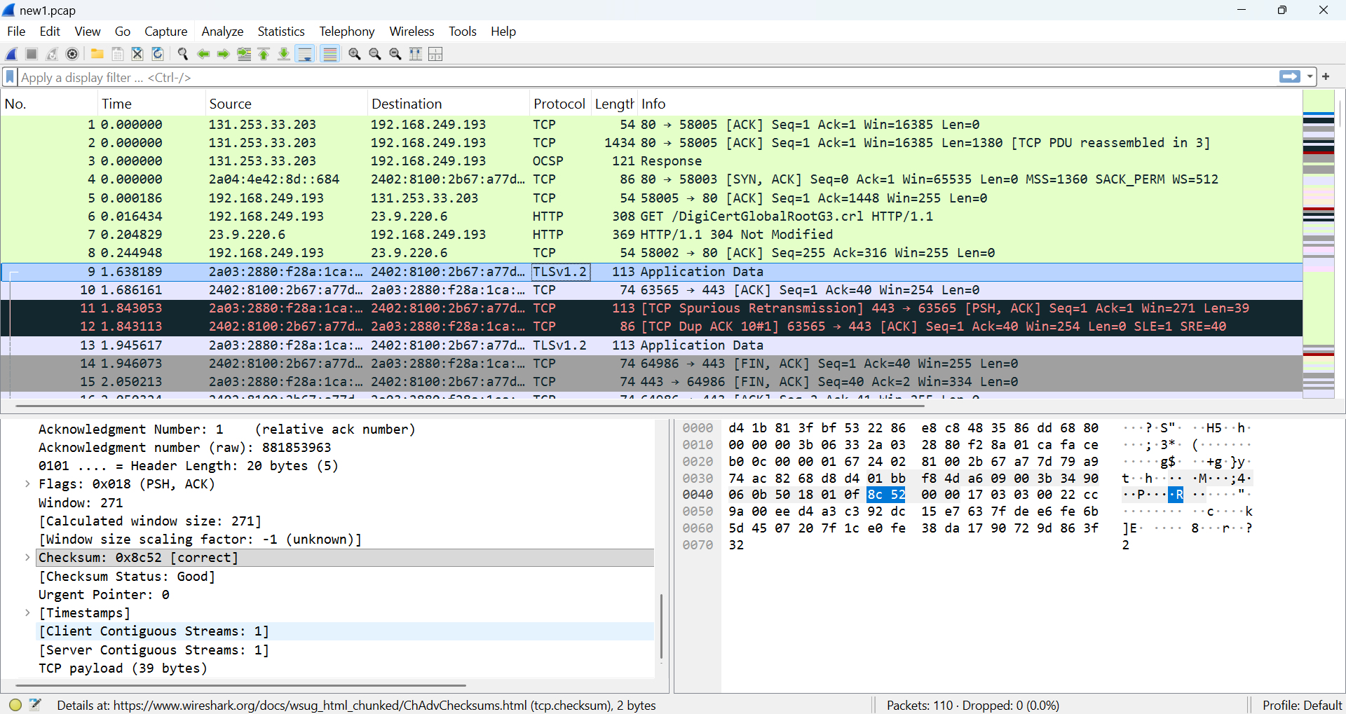
For TLS:

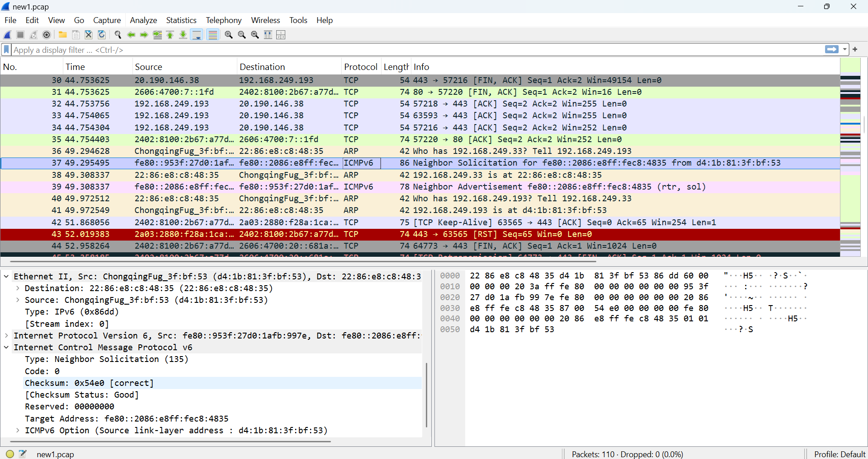
For ICMP:

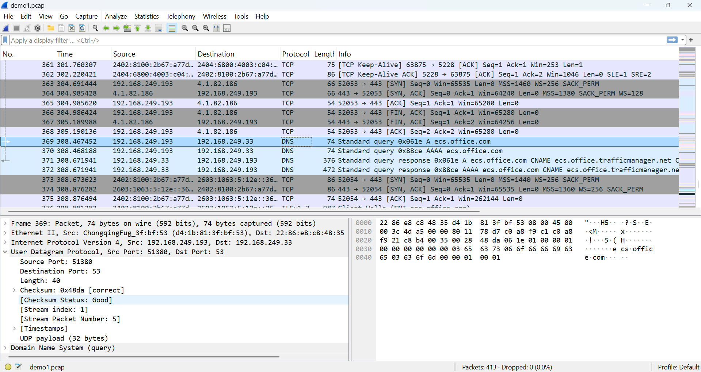
For UDP:

For IP(IPv4):
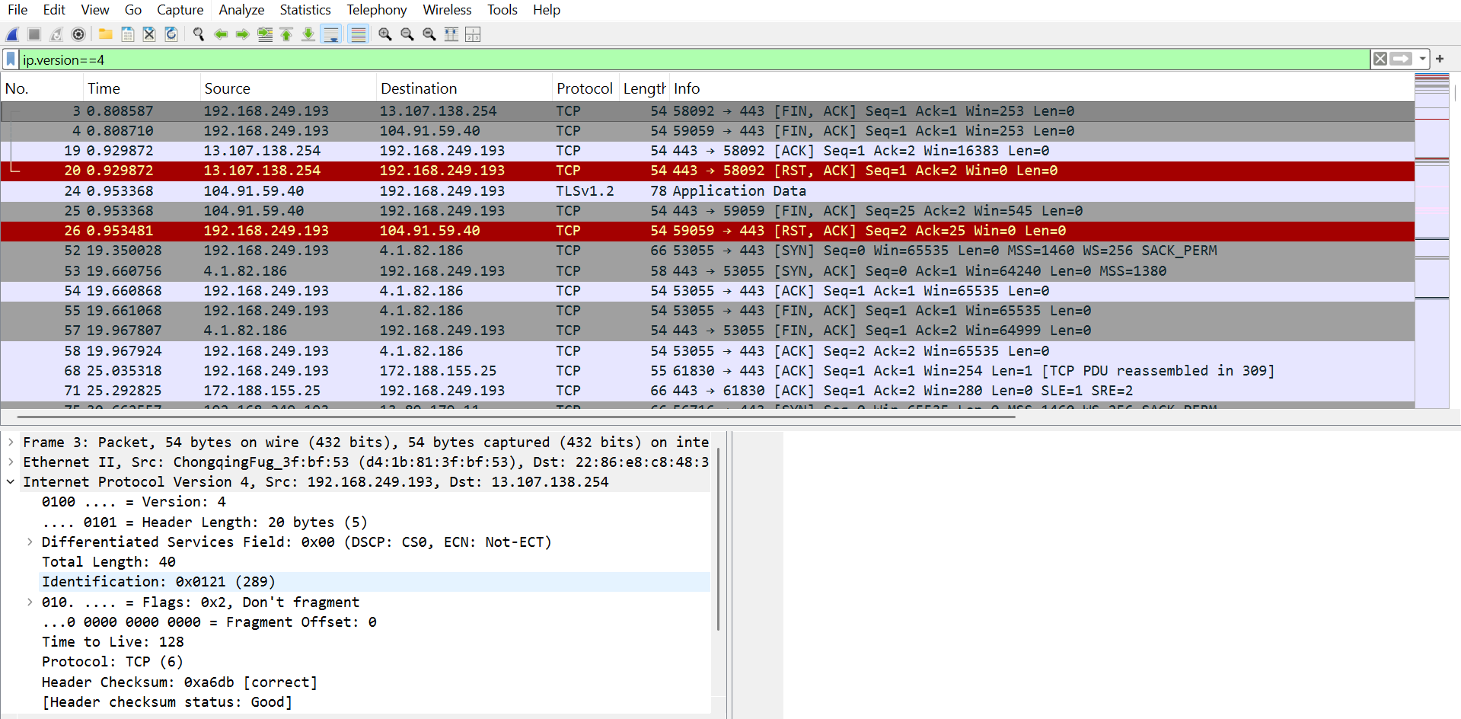
Q2) Get the packet header fields from Wireshark for a particular packet and do the calculations manually.
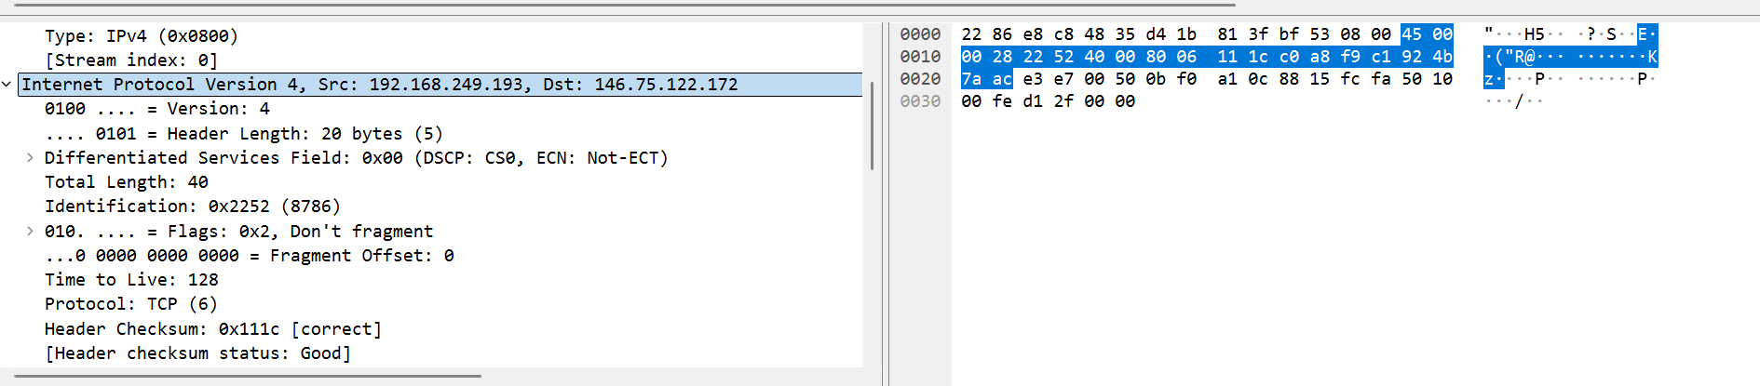
A2) Let us take for the TCP protocol:

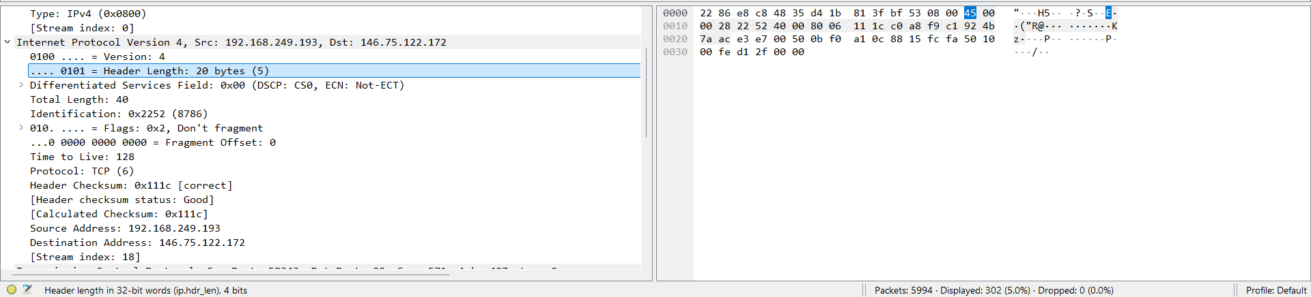
And,

Code:
# IPv4 checksum calculator
header_hex = [
0x45, 0x00, 0x00, 0x28,
0x22, 0x52, 0x40, 0x00,
0x80, 0x06, 0x00, 0x00, # checksum field set to 0x0000
0xc0, 0xa8, 0xf9, 0xc1,
0x92, 0x4b, 0x7a, 0xac
]
words = [(header_hex[i] << 8) + header_hex[i+1] for i in range(0, len(header_hex), 2)]
s = sum(words)
while s >> 16:
s = (s & 0xFFFF) + (s >> 16)
checksum = ~s & 0xFFFF
print(hex(checksum))

Output:

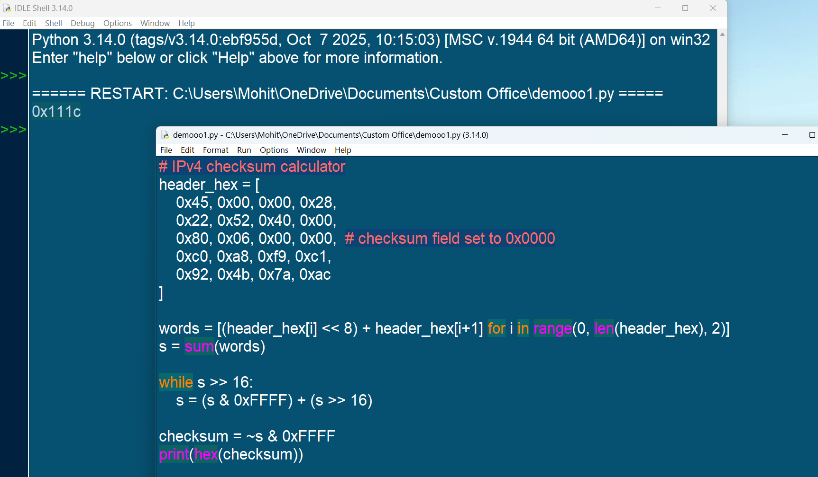
Q3) Use scapy library to get the packet header fields needed to calculate the checksum and do the checksum calculation of all the packets(TCP, UDP, TLS, IP, ICMP) in a pcap file.
A3) For TCP (code):
from scapy.all import rdpcap, IP, TCP
# Load packets from pcap file
packets = rdpcap("new2.pcap")
def calc_tcp_checksum(pkt):
if IP in pkt and TCP in pkt:
ip = pkt[IP]
tcp = pkt[TCP]
# original checksum
original = tcp.chksum
# Forced recalculation by setting checksum to None
tcp.chksum = None
recalculated = TCP(bytes(tcp)).chksum
return {
'src_ip': ip.src,
'dst_ip': ip.dst,
'sport': tcp.sport,
'dport': tcp.dport,
'original_checksum': hex(original),
'recalc_checksum': hex(recalculated),
'match': original == recalculated
}
return None
# Iterating through each packets
for i, pkt in enumerate(packets, 1):
result = calc_tcp_checksum(pkt)
if result:
print(f"\nPacket #{i}")
for k, v in result.items():
print(f"{k}: {v}")

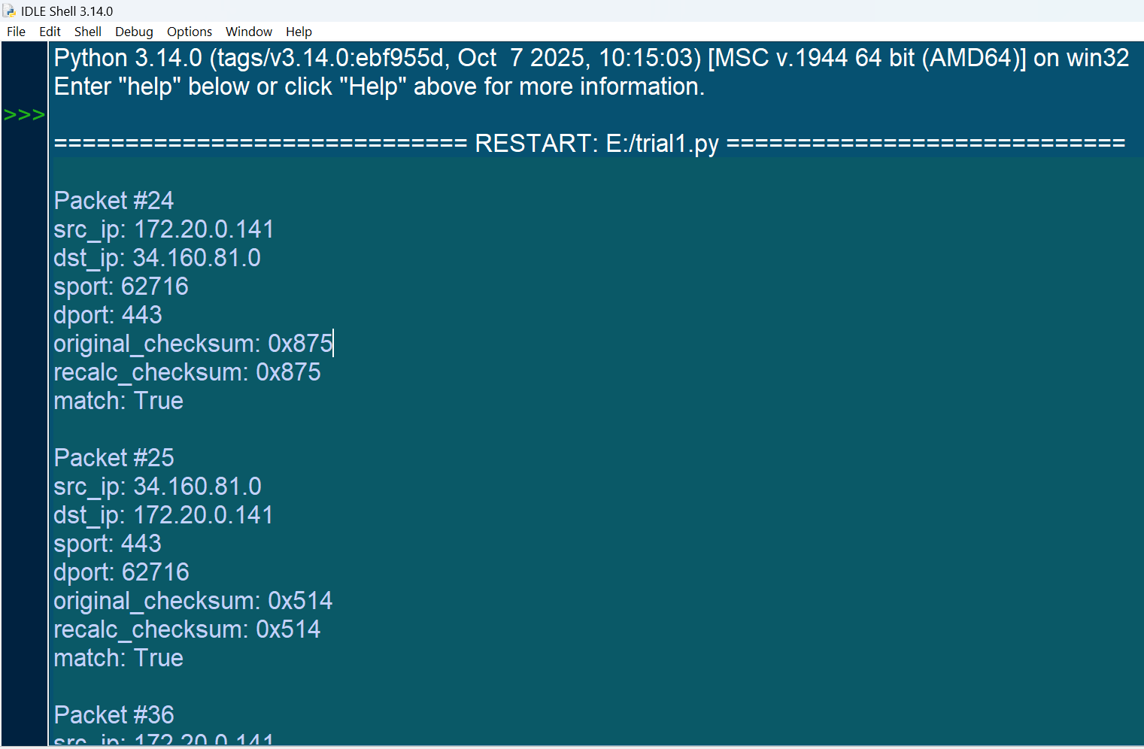
Output:

For UDP (code):
from scapy.all import rdpcap, IP, UDP
# Load packets from pcap file
packets = rdpcap("new2.pcap")
def calc_udp_checksum(pkt):
if IP in pkt and UDP in pkt:
ip = pkt[IP]
udp = pkt[UDP]
#original checksum
original = udp.chksum
# Forced recalculation by setting checksum to None
udp.chksum = None
recalculated = UDP(bytes(udp)).chksum
return {
'src_ip': ip.src,
'dst_ip': ip.dst,
'sport': udp.sport,
'dport': udp.dport,
'original_checksum': hex(original),
'recalc_checksum': hex(recalculated),
'match': original == recalculated
}
return None
# Iterating through each packets
for i, pkt in enumerate(packets, 1):
result = calc_udp_checksum(pkt)
if result:
print(f"\nPacket #{i}")
for k, v in result.items():
print(f"{k}: {v}")

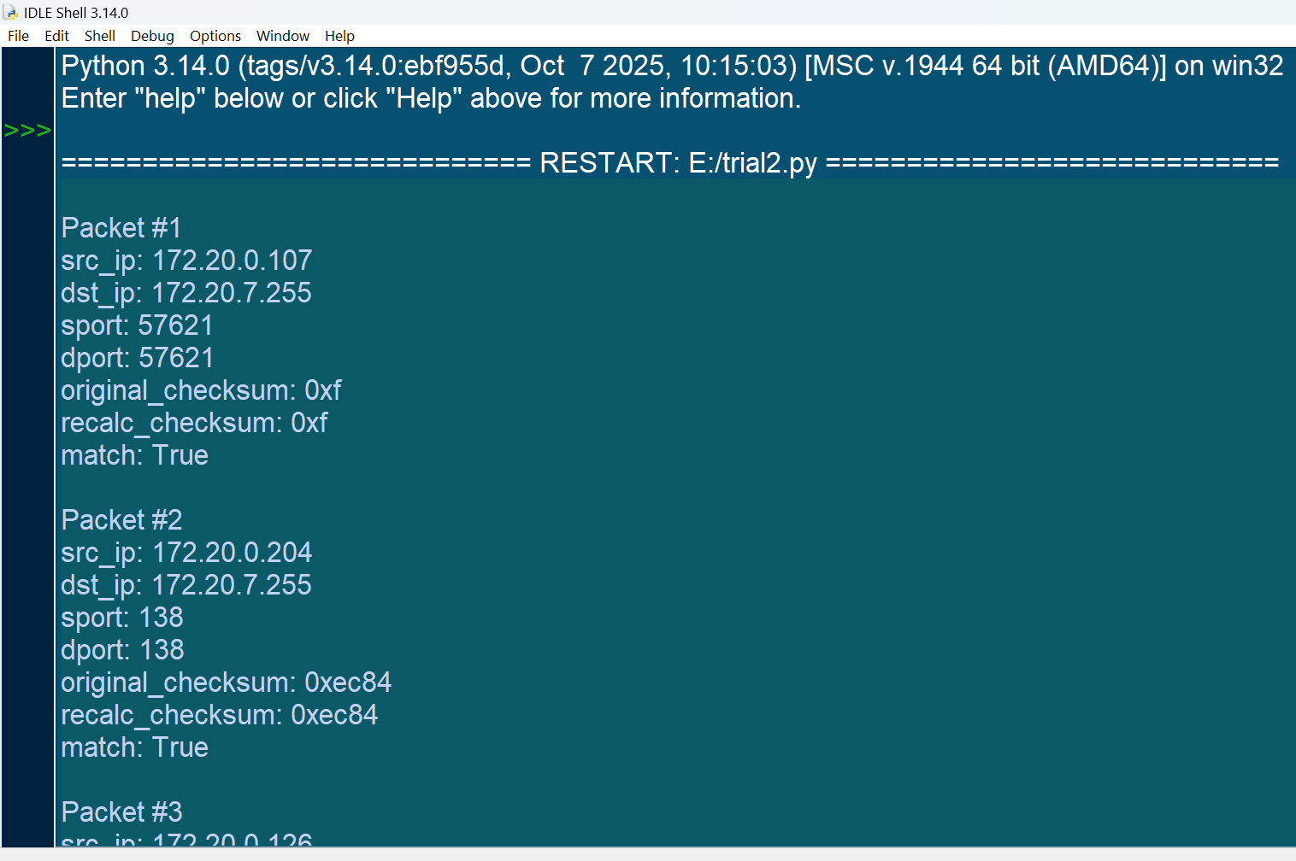
Output:

Note: new capture file (new1) was used since the new2 file did not have the required protocols for this experiment.

For ICMP (code):
from scapy.all import rdpcap, IP, IPv6, ICMP, ICMPv6EchoRequest, ICMPv6EchoReply, ICMPv6ND_NS, ICMPv6ND_NA
packets = rdpcap("new1.pcap")
def calc_icmp_checksum(pkt):
results = {}
# IPv4 ICMP
if IP in pkt and ICMP in pkt:
ip = pkt[IP]
icmp = pkt[ICMP]
original = icmp.chksum
icmp.chksum = None
recalculated = ICMP(bytes(icmp)).chksum
results['IPv4_ICMP'] = {
'src_ip': ip.src,
'dst_ip': ip.dst,
'type': icmp.type,
'code': icmp.code,
'original_checksum': hex(original),
'recalc_checksum': hex(recalculated),
'match': original == recalculated
}
# IPv6 ICMP Echo Request/Reply
if IPv6 in pkt and (ICMPv6EchoRequest in pkt or ICMPv6EchoReply in pkt):
ipv6 = pkt[IPv6]
icmpv6 = pkt[ICMPv6EchoRequest] if ICMPv6EchoRequest in pkt else pkt[ICMPv6EchoReply]
original = icmpv6.cksum
icmpv6.cksum = None
recalculated = type(icmpv6)(bytes(icmpv6)).cksum
results['IPv6_ICMP_Echo'] = {
'src_ip': ipv6.src,
'dst_ip': ipv6.dst,
'type': icmpv6.type,
'code': icmpv6.code,
'original_checksum': hex(original),
'recalc_checksum': hex(recalculated),
'match': original == recalculated
}
# IPv6 ICMP Neighbor Discovery (NS/NA)
if IPv6 in pkt and (ICMPv6ND_NS in pkt or ICMPv6ND_NA in pkt):
ipv6 = pkt[IPv6]
icmpv6 = pkt[ICMPv6ND_NS] if ICMPv6ND_NS in pkt else pkt[ICMPv6ND_NA]
original = icmpv6.cksum
icmpv6.cksum = None
recalculated = type(icmpv6)(bytes(icmpv6)).cksum
results['IPv6_ICMP_ND'] = {
'src_ip': ipv6.src,
'dst_ip': ipv6.dst,
'type': icmpv6.type,
'code': icmpv6.code,
'original_checksum': hex(original),
'recalc_checksum': hex(recalculated),
'match': original == recalculated
}
return results if results else None
for i, pkt in enumerate(packets, 1):
result = calc_icmp_checksum(pkt)
if result:
print(f"\nPacket #{i}")
for proto, fields in result.items():
print(f"{proto}:")
for k, v in fields.items():
print(f" {k}: {v}")
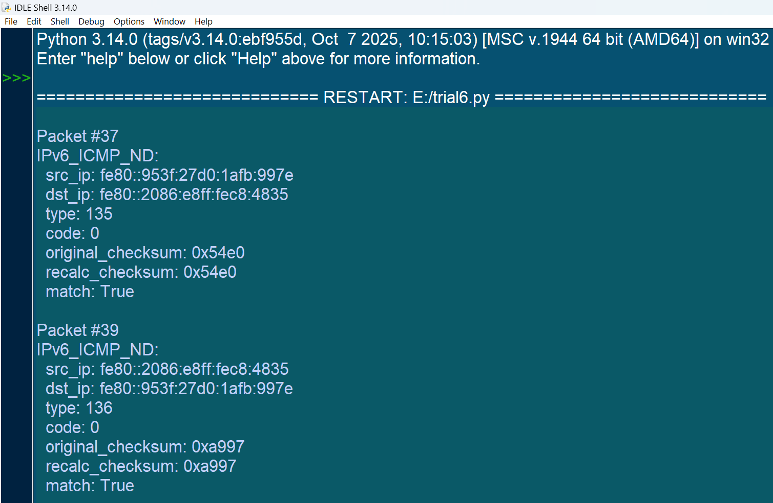
Output:

For IP (code):
from scapy.all import rdpcap, IP
packets = rdpcap("new2.pcap")
def calc_ip_checksum(pkt):
if IP in pkt:
ip = pkt[IP]
original = ip.chksum
# Forced recalculation by setting checksum to None
ip.chksum = None
recalculated = IP(bytes(ip)).chksum
return {
'src_ip': ip.src,
'dst_ip': ip.dst,
'proto': ip.proto,
'original_checksum': hex(original),
'recalc_checksum': hex(recalculated),
'match': original == recalculated
}
return None
for i, pkt in enumerate(packets, 1):
result = calc_ip_checksum(pkt)
if result:
print(f"\nPacket #{i}")
for k, v in result.items():
print(f"{k}: {v}")

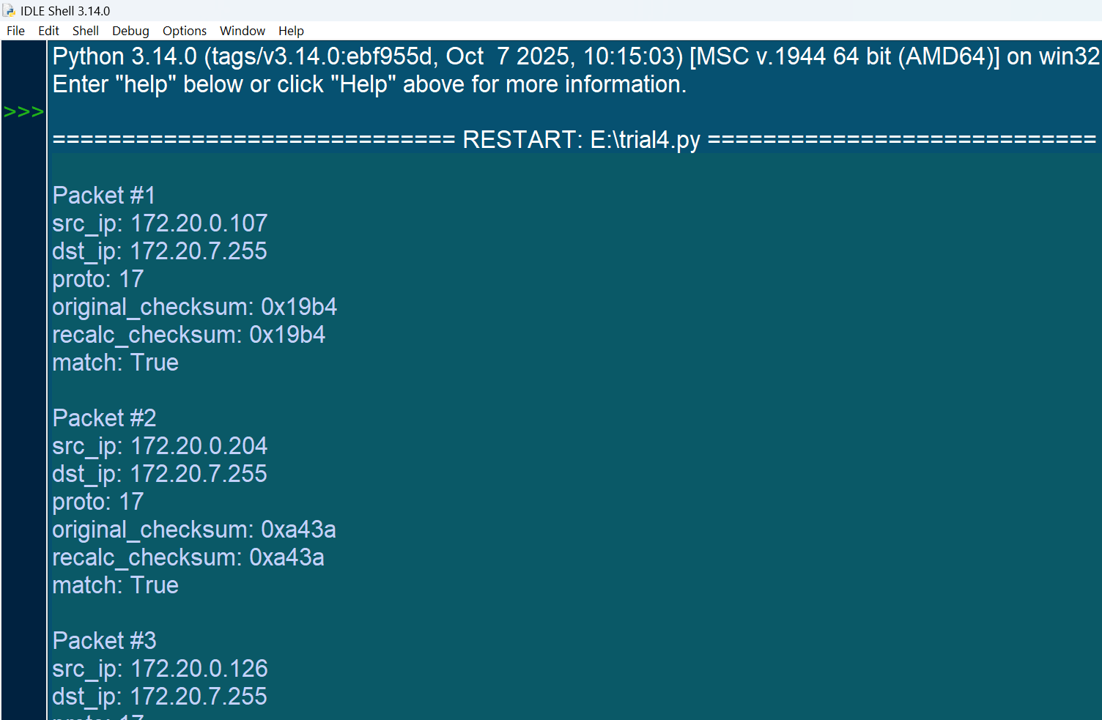
Output:

For TLS (code):
from scapy.all import rdpcap, TCP, Raw
packets = rdpcap("new1.pcap")
def extract_tls(pkt):
if TCP in pkt and Raw in pkt:
raw_data = pkt[Raw].load
# TLS record header is of 5 bytes: ContentType(1), Version(2), Length(2)
if len(raw_data) >= 5:
content_type = raw_data[0]
version = raw_data[1:3].hex()
length = int.from_bytes(raw_data[3:5], byteorder="big")
return {
'src_port': pkt[TCP].sport,
'dst_port': pkt[TCP].dport,
'content_type': content_type,
'version': version,
'length': length,
'first_bytes': raw_data[:20].hex() # showing first 20 bytes
}
return None
for i, pkt in enumerate(packets, 1):
result = extract_tls(pkt)
if result:
print(f"\nPacket #{i}")
for k, v in result.items():
print(f"{k}: {v}")

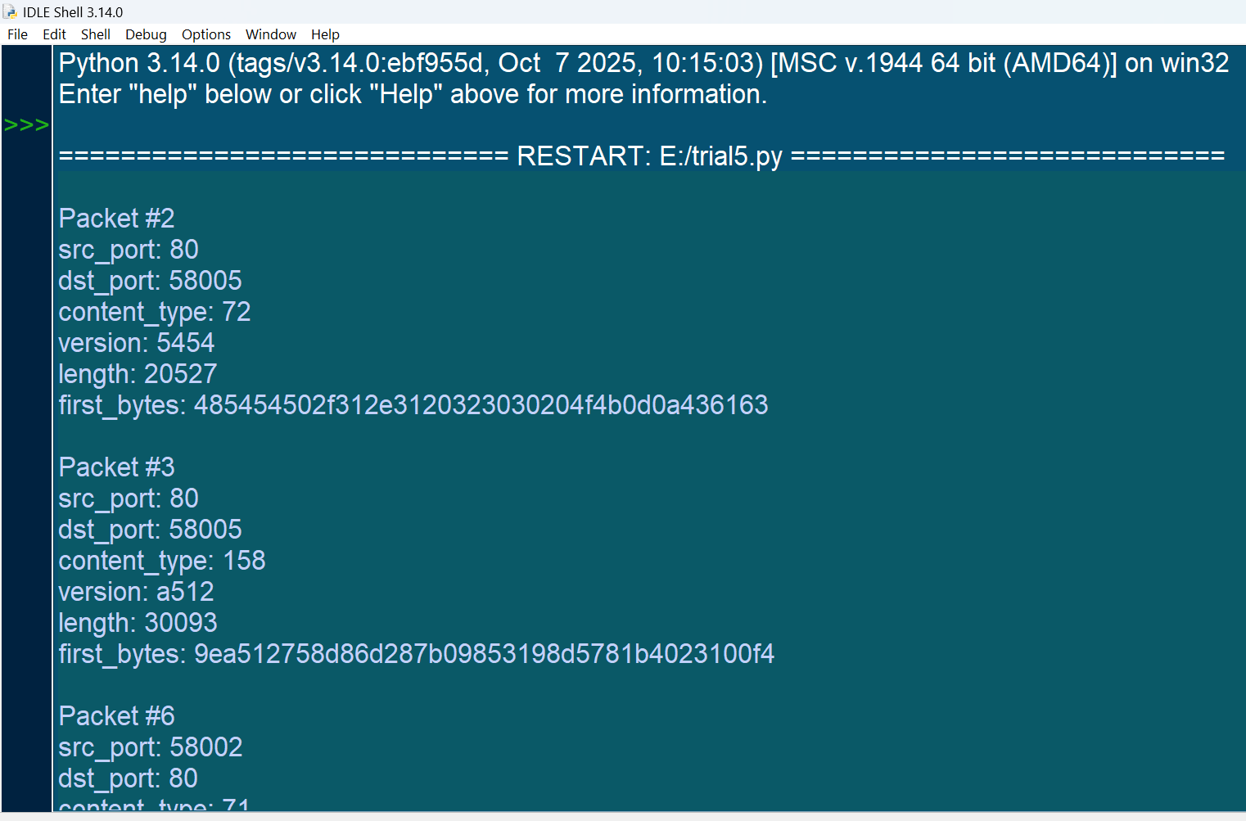
Output:

Procedure for q1(method1):
- Capture live traffic and save it using pcap file and then, note down the protocols one need to work upon.
- In the edit, preferences, select the protocol option and for the required protocols, right check the checksum validation option for that protocol and select ok.
- One can do the same method by right clicking on the selected protocol, validation and check for validate, that will show its verification status.
- Note down your observations.

Procedure for q2(method2):
- In this method we need to calculate the checksum manually, for that we can use the python code for the sum calculation with the packet header file in hex as shown in the image by grouping them in two’s
- Following the code and verifying whether the obtained result matches with the checksum already given in the Wireshark.
- Noting down the observation.

Procedure for q3(method3):
- Capture a live traffic network, save it using pcap file and using scapy library write a python code for the protocols one requires.
- The pcap file should be present in the code for which one is calculating and verifying the checksum.
- Note down the observations and verify whether the obtained result matches the given result.

Git-hub link:

