Computer Networks
BCSE308P

Digital Assignment 3

Submitted to:
Dr. Subbulakshmi T

Submitted by:
Mohit Sangwan(24BCE1324)
Network Parameter Analysis for any one network parameter using Wireshark for various traffic conditions.

In this assignment, we will analyse different network parameters using Wireshark under varying traffic conditions. The main objective is to understand how factors like latency, jitter, throughput, and packet loss behave when the network is subjected to low, normal, and high traffic.
Traffic is generated using commands, captured using Wireshark, and further analysed using Python graphs to observe the changes in performance.

Objectives:
- To analyse network parameters using Wireshark under different traffic conditions.
- To study the behaviour of latency, jitter, and throughput in low, normal, and high traffic.
- To capture and analyse network packets using Wireshark.
- To visualize network performance using graphs generated from captured data.
To begin the analysis, traffic was first generated under low traffic conditions to observe the baseline behaviour of the network.
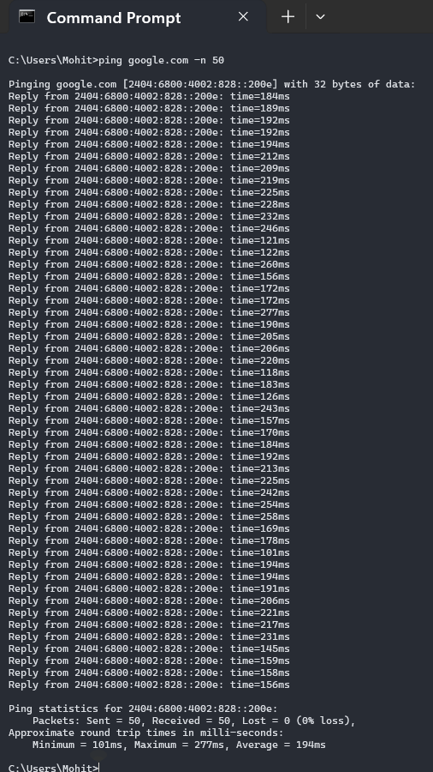

Now, the below are the captured packets:

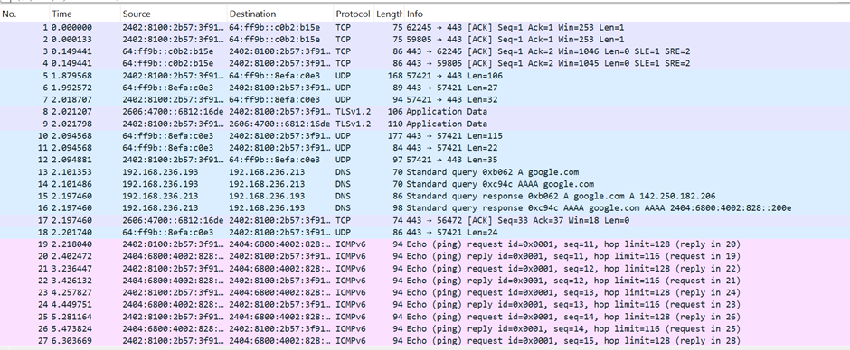
The following are the graphs of various network parameters:
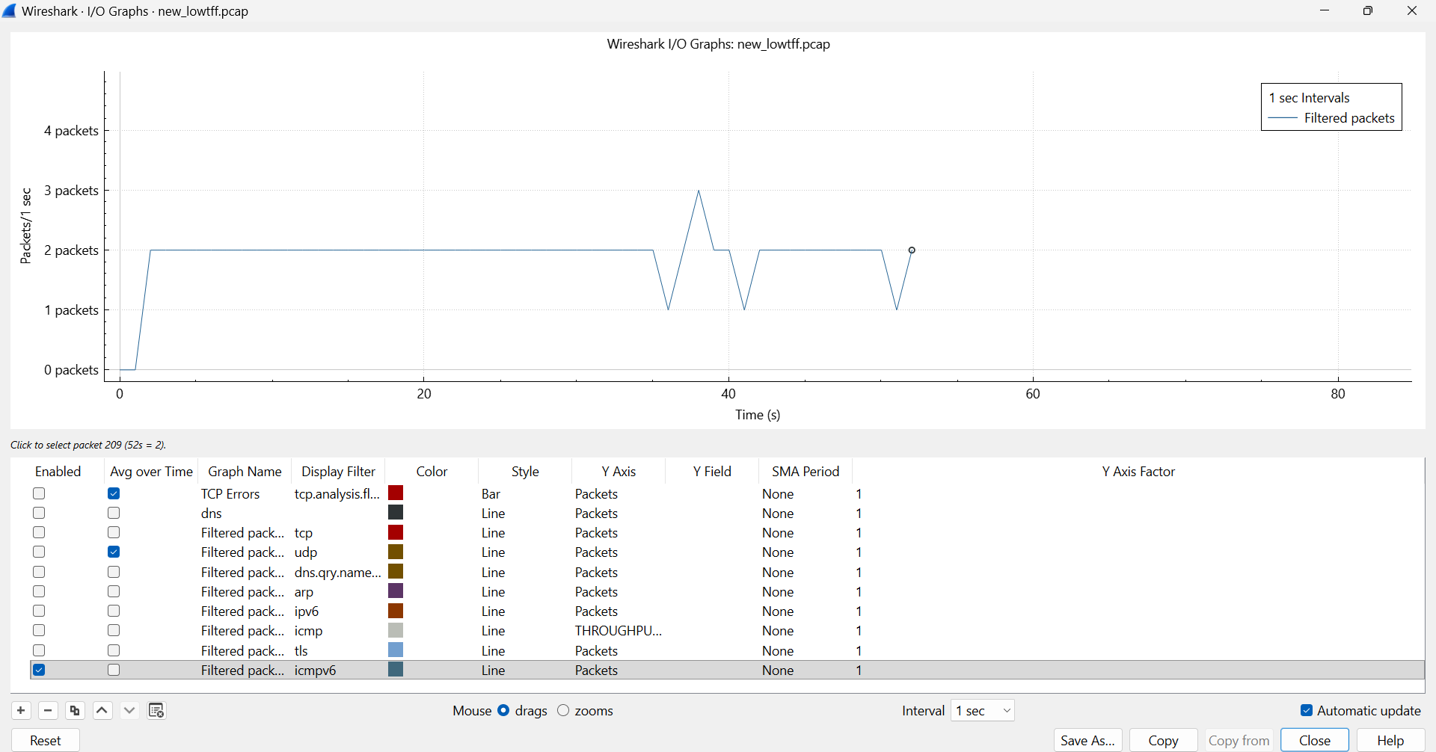
Packet rate graph:

The packet rate remains almost constant under low traffic, indicating stable network activity.
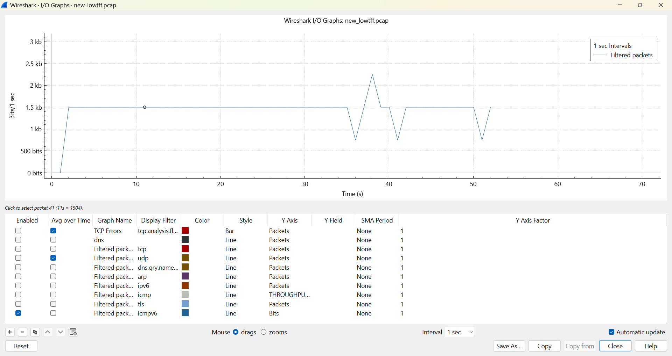
Throughput graph:

The throughput remains stable under low traffic, indicating consistent data transmission.

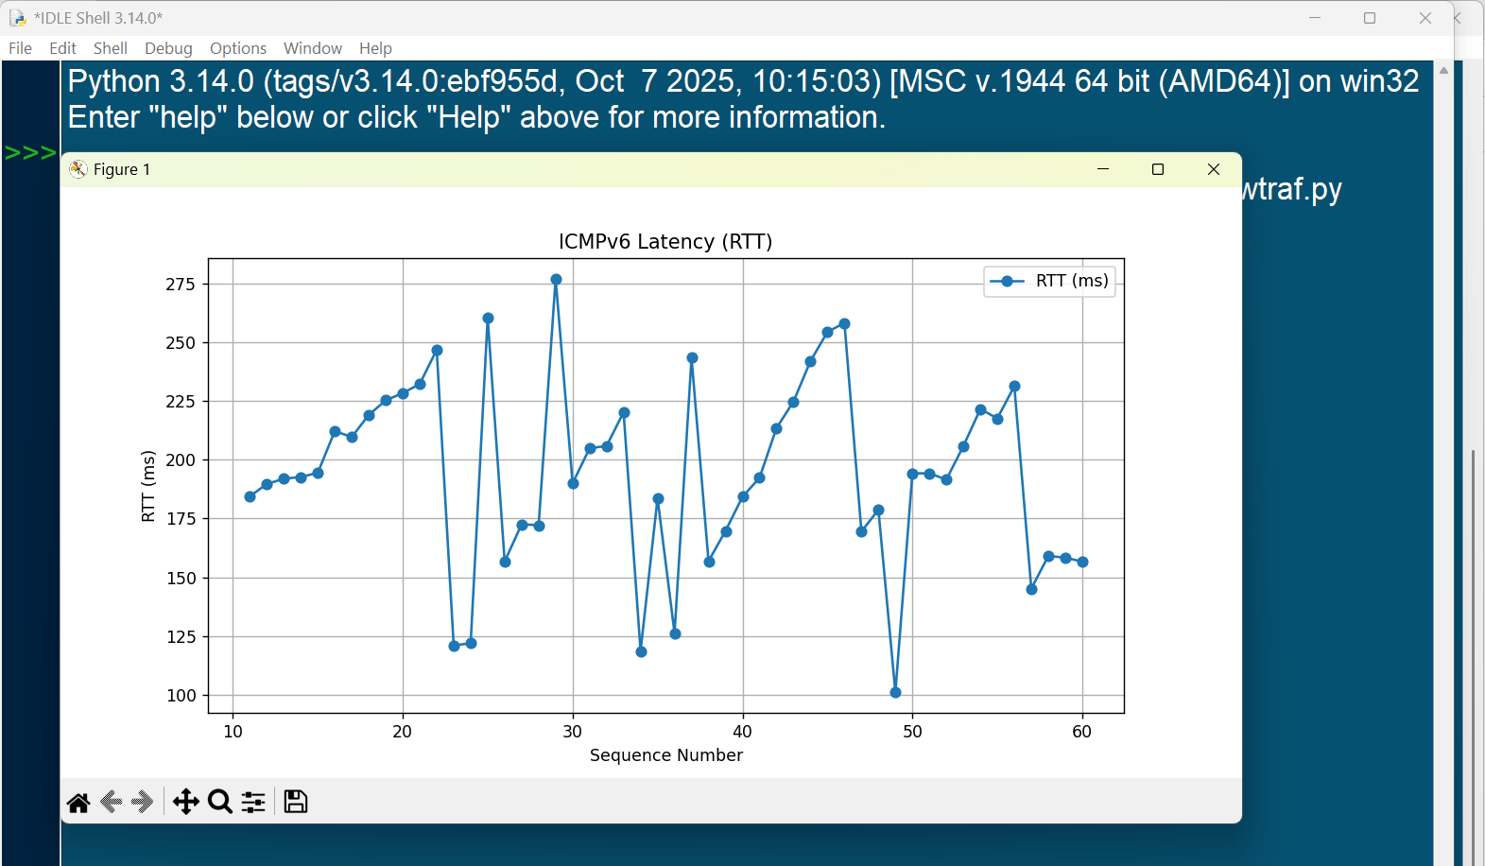
Latency graph:
Latency remains relatively stable with small variations, indicating smooth network performance under low traffic.

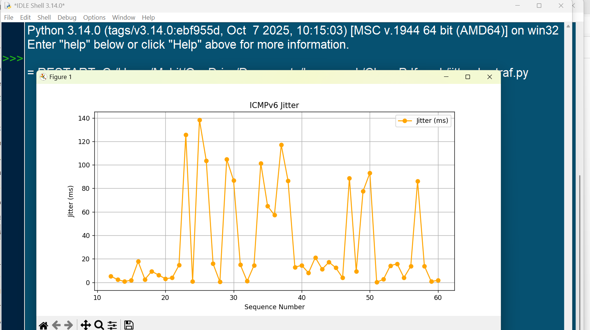
Jitter graph:

Jitter is generally low with occasional spikes, indicating mostly stable packet delivery.

The following Python code was used to calculate latency (RTT) and jitter from the captured ICMPv6 packets and to plot the corresponding graphs.
import pandas as pd
import matplotlib.pyplot as plt

# Load exported ICMPv6 CSV file
df = pd.read_csv("icmpv6.csv")

# Filter request and reply packets
requests = df[df['Info'].str.contains(r"Echo \(ping\) request", na=False)]
replies = df[df['Info'].str.contains(r"Echo \(ping\) reply", na=False)]

# Match requests and replies using sequence number
rtt_list = []
for _, req in requests.iterrows():
seq = int(req['Info'].split("seq=")[1].split(",")[0])
reply = replies[replies['Info'].str.contains(f"seq={seq}", na=False)]

if not reply.empty:
rtt = float(reply.iloc[0]['Time']) - float(req['Time'])
rtt_list.append((seq, rtt * 1000)) # Convert to milliseconds

# Create DataFrame
rtt_df = pd.DataFrame(rtt_list, columns=['Seq', 'RTT_ms'])

# Calculate jitter
rtt_df['Jitter_ms'] = rtt_df['RTT_ms'].diff().abs()

# Plot latency (RTT)
plt.figure(figsize=(10,5))
plt.plot(rtt_df['Seq'], rtt_df['RTT_ms'], marker='o', label='RTT (ms)')
plt.xlabel("Sequence Number")
plt.ylabel("RTT (ms)")
plt.title("ICMPv6 Latency (RTT)")
plt.legend()
plt.grid(True)
plt.show()

# Plot jitter
plt.figure(figsize=(10,5))
plt.plot(rtt_df['Seq'], rtt_df['Jitter_ms'], marker='o', color='orange', label='Jitter (ms)')
plt.xlabel("Sequence Number")
plt.ylabel("Jitter (ms)")
plt.title("ICMPv6 Jitter")
plt.legend()
plt.grid(True)
plt.show()
This code extracts request and reply packets, calculates the round-trip time, and determines jitter by measuring variations between consecutive RTT values.

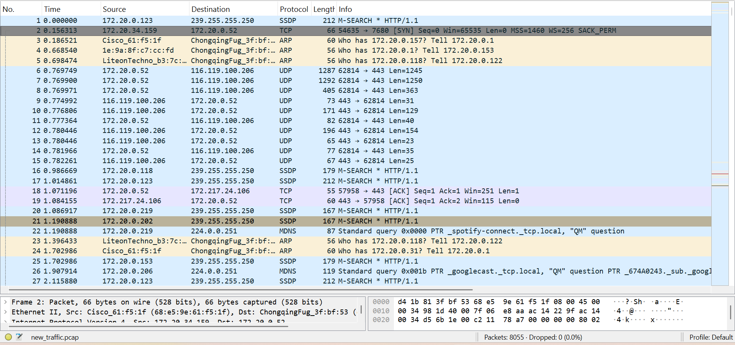
Next, normal traffic conditions were analysed to observe the network behaviour under typical usage.
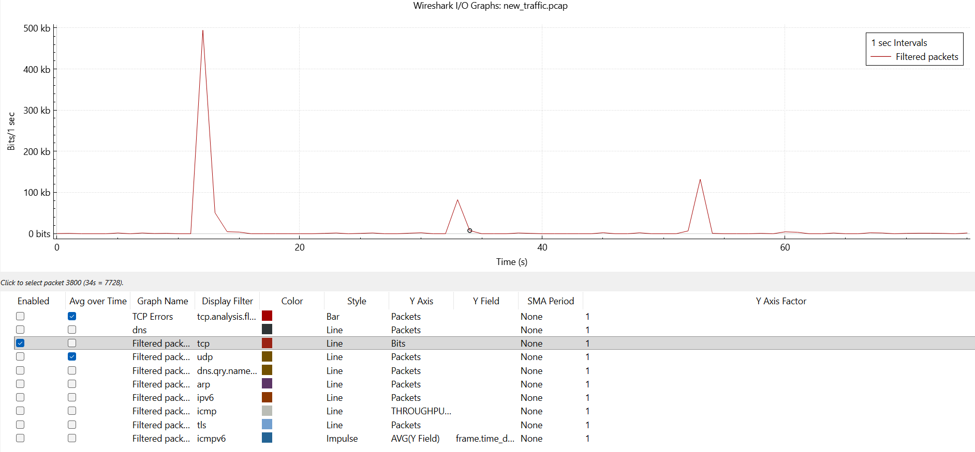
Throughput graph:

Throughput shows noticeable spikes, indicating bursts of data transmission under normal traffic.

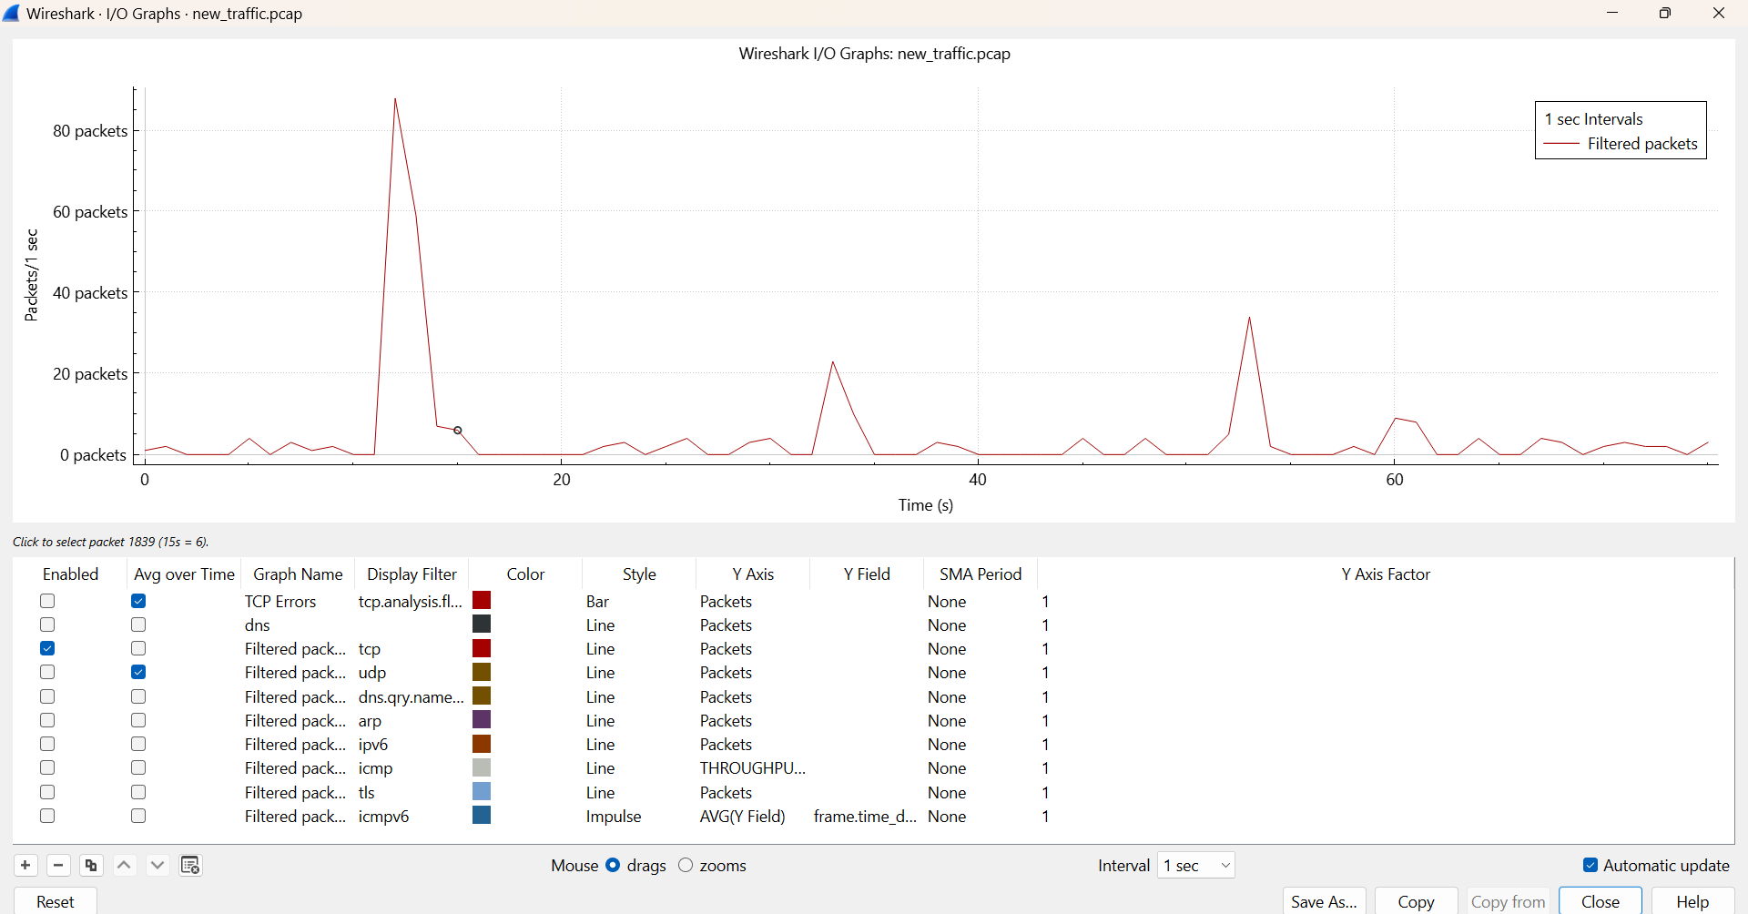
Packet rate graph:
The packet rate shows sudden spikes, indicating bursty network activity under normal traffic.
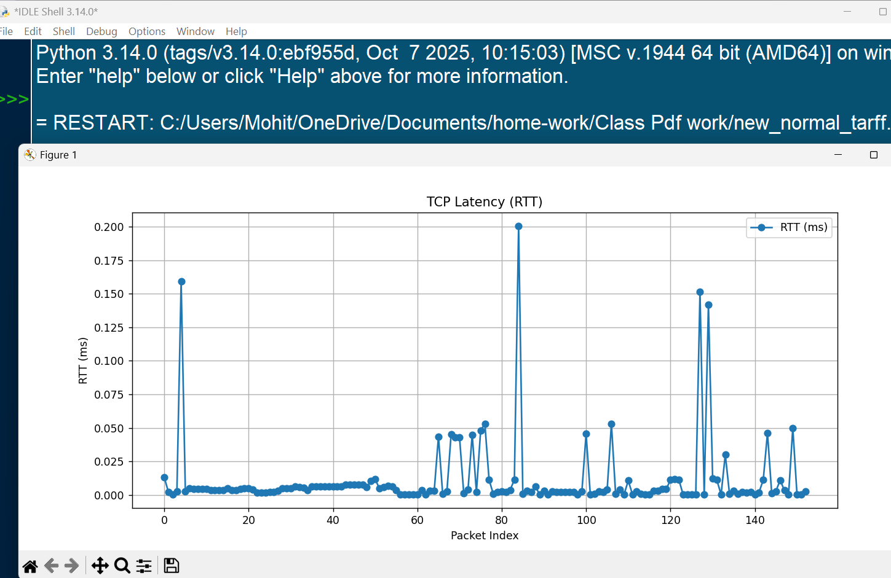
Latency graph:

Latency remains low for most packets with occasional spikes, indicating minor delays under normal traffic.

Jitter graph:
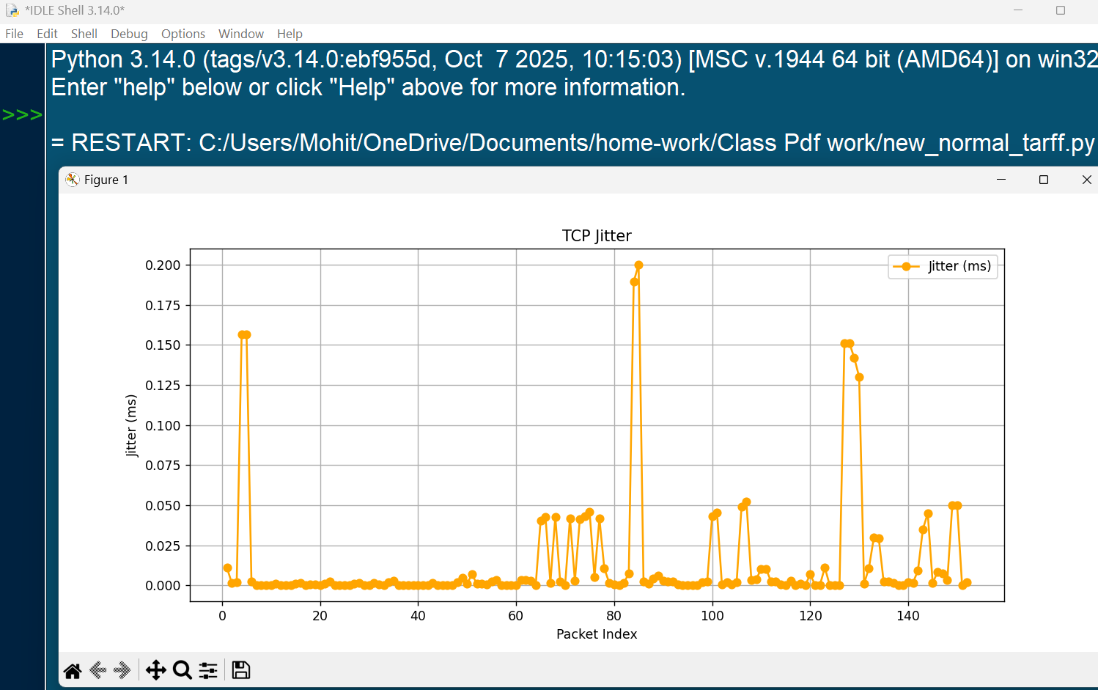

Most jitter values are close to zero, with some noticeable spikes.

The following Python code was used to calculate latency (RTT) and jitter for TCP traffic and to generate the corresponding graphs.
import pandas as pd
import matplotlib.pyplot as plt
# Load exported TCP CSV file
df = pd.read_csv("tcp1.csv")
# Column containing RTT values from Wireshark
rtt_column = "The RTT to ACK the segment was"

# Remove rows without RTT values
rtt_df = df[[rtt_column]].dropna().reset_index()

# Convert RTT values to numeric format
rtt_df['RTT_ms'] = pd.to_numeric(rtt_df[rtt_column], errors='coerce')

# Calculate jitter (difference between consecutive RTT values)
rtt_df['Jitter_ms'] = rtt_df['RTT_ms'].diff().abs()

# Plot latency (RTT)
plt.figure(figsize=(10,5))
plt.plot(rtt_df.index, rtt_df['RTT_ms'], marker='o', label='RTT (ms)')
plt.xlabel("Packet Index")
plt.ylabel("RTT (ms)")
plt.title("TCP Latency (RTT)")
plt.legend()
plt.grid(True)
plt.show()

# Plot jitter
plt.figure(figsize=(10,5))
plt.plot(rtt_df.index, rtt_df['Jitter_ms'], marker='o', color='orange', label='Jitter (ms)')
plt.xlabel("Packet Index")
plt.ylabel("Jitter (ms)")
plt.title("TCP Jitter")
plt.legend()
plt.grid(True)
plt.show()
This code extracts RTT values from TCP packets, computes jitter based on RTT variation, and visualizes both parameters using graphs.

Finally, high traffic conditions were generated to analyse network performance under heavy load and to observe the impact on various network parameters.
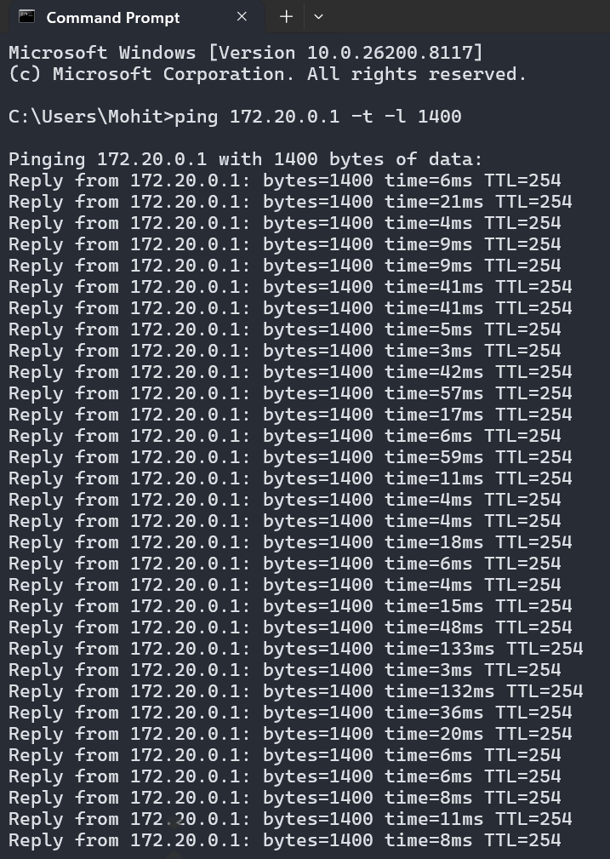

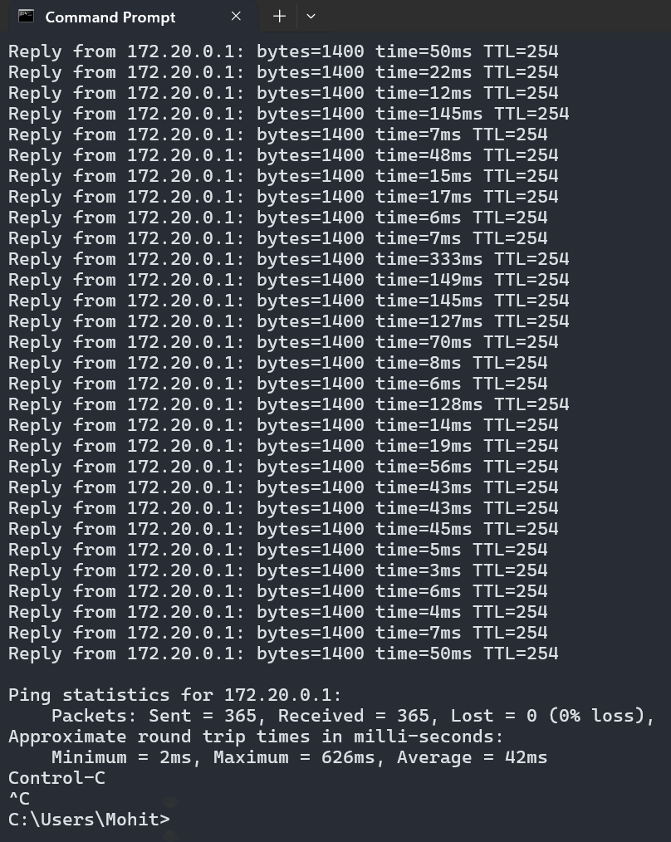

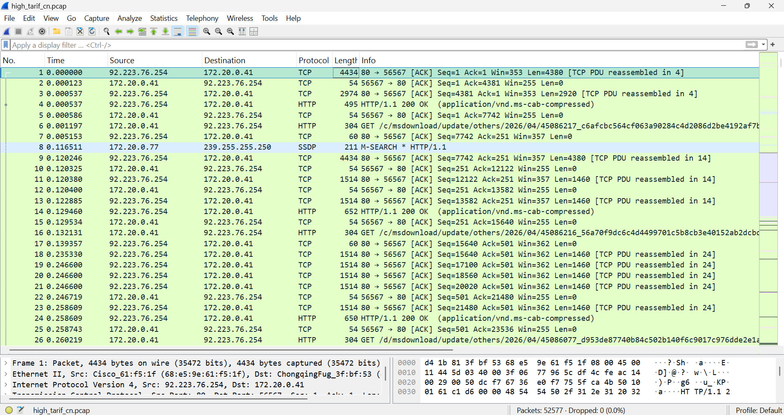
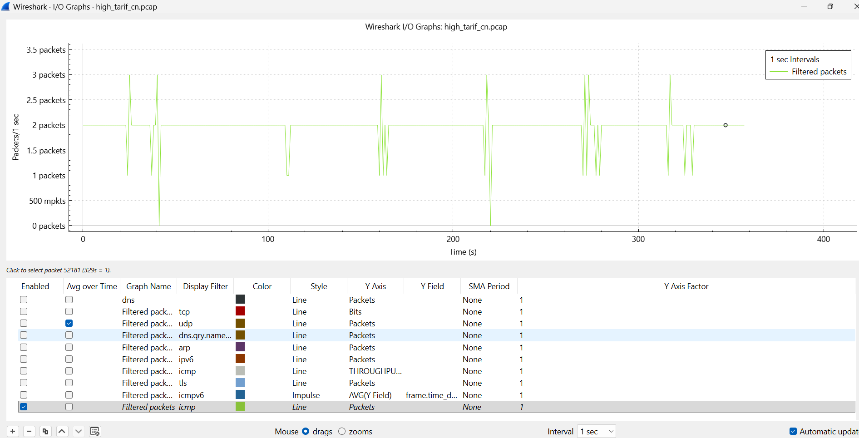
Packet rate graph:

The packet rate shows frequent fluctuations with sudden drops and spikes, indicating unstable network behaviour under high traffic.

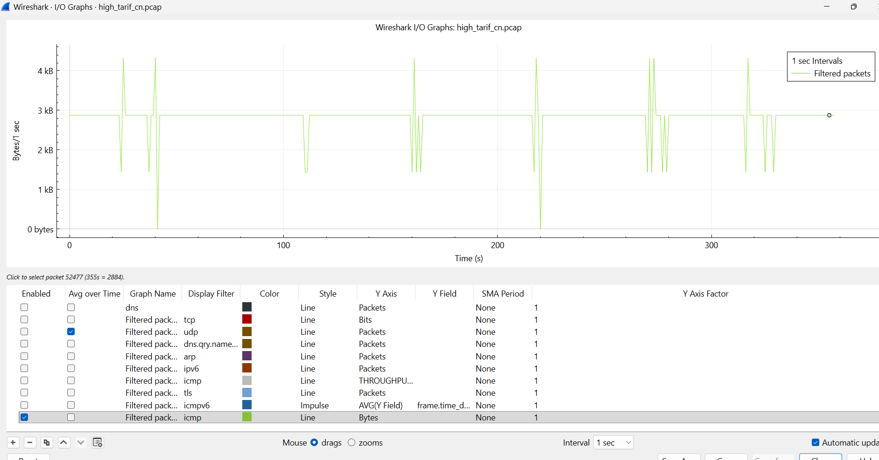
Throughput graph:
Throughput shows significant fluctuations with sudden drops and spikes, indicating unstable data transmission under high traffic.

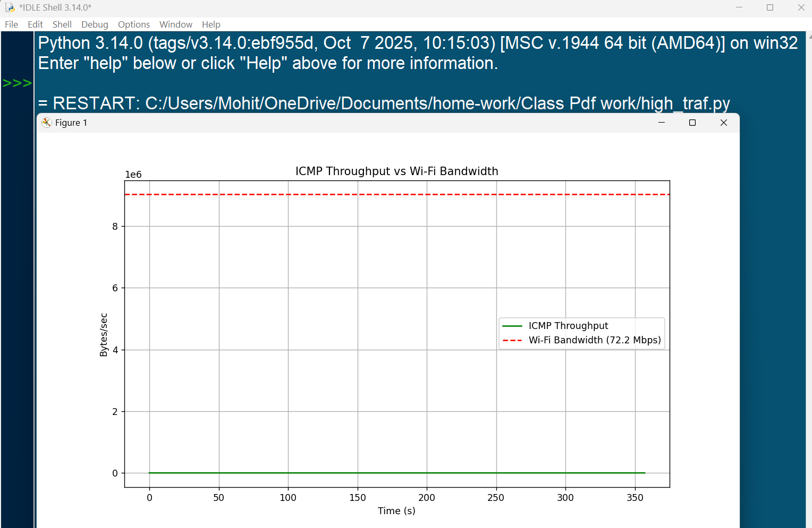
Bandwidth graph:

The throughput remains significantly below the available bandwidth, indicating inefficient utilization under high traffic.

The following Python code was used to calculate throughput over time and compare it with the available Wi-Fi bandwidth.
import pandas as pd
import matplotlib.pyplot as plt

# Load Wireshark exported CSV file
df = pd.read_csv("packets.csv")

# Convert Time column to numeric
df["Time"] = pd.to_numeric(df["Time"], errors="coerce")

# Group packets into 1-second intervals
df["Time_bin"] = df["Time"].astype(int)
throughput = df.groupby("Time_bin")["Length"].sum()

# Define bandwidth (72.2 Mbps ≈ 9,025,000 Bytes/sec)
bandwidth = 9025000

# Plot throughput
plt.figure(figsize=(10,6))
plt.plot(throughput.index, throughput.values, label="ICMP Throughput", color="green")

# Plot bandwidth reference line
plt.axhline(y=bandwidth, color="red", linestyle="--", label="Wi-Fi Bandwidth (72.2 Mbps)")

# Add labels and legend
plt.title("ICMP Throughput vs Wi-Fi Bandwidth")
plt.xlabel("Time (s)")
plt.ylabel("Bytes/sec")
plt.legend()
plt.grid(True)
plt.show()
This code calculates throughput per second from captured packets and compares it with the available bandwidth to analyse network efficiency.

Latency graph:

Latency shows significant variation with frequent spikes, indicating increased delay due to network congestion under high traffic.

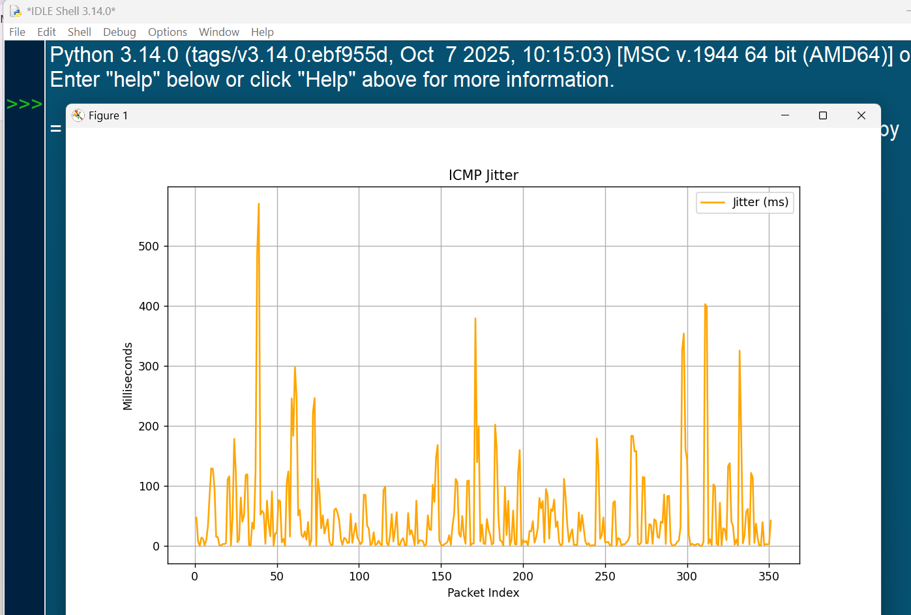
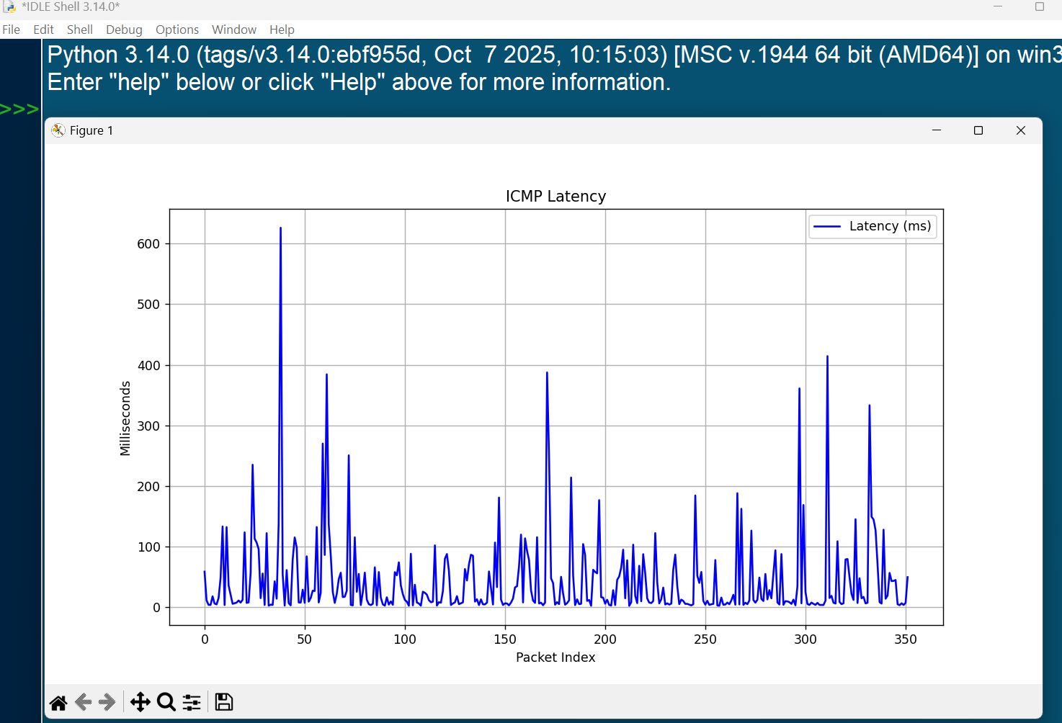
Jitter graph:
Jitter shows very high variation with frequent large spikes, indicating highly unstable packet delivery under high traffic.

The following Python code was used to calculate latency and jitter for ICMP traffic under high traffic conditions and to analyse variations in packet delay.
import pandas as pd
import matplotlib.pyplot as plt
import re

# Load packets CSV file
df = pd.read_csv("packets.csv")

# Filter ICMP packets
icmp = df[df["Protocol"] == "ICMP"]

# Separate request and reply packets
requests = icmp[icmp["Info"].str.contains("Echo (ping) request", na=False, regex=False)].reset_index(drop=True)
replies = icmp[icmp["Info"].str.contains("Echo (ping) reply", na=False, regex=False)].reset_index(drop=True)

latencies = []

# Match packets using sequence number
for i, req in requests.iterrows():
match = re.search(r"seq=(\d+/\d+)", req["Info"])
if match:
seq = match.group(1)
rep = replies[replies["Info"].str.contains(f"seq={seq}", na=False, regex=False)]

if not rep.empty:
req_time = float(req["Time"])
rep_time = float(rep.iloc[0]["Time"])
latency = (rep_time - req_time) * 1000 # Convert to ms
latencies.append(latency)

# Calculate jitter
jitter = []
if len(latencies) > 1:
jitter = [abs(latencies[i] - latencies[i-1]) for i in range(1, len(latencies))]

# Plot latency
plt.figure(figsize=(10,6))
plt.plot(latencies, label="Latency (ms)", color="blue")
plt.title("ICMP Latency")
plt.xlabel("Packet Index")
plt.ylabel("Milliseconds")
plt.legend()
plt.grid(True)
plt.show()

# Plot jitter
if jitter:
plt.figure(figsize=(10,6))
plt.plot(range(1, len(latencies)), jitter, label="Jitter (ms)", color="orange")
plt.title("ICMP Jitter")
plt.xlabel("Packet Index")
plt.ylabel("Milliseconds")
plt.legend()
plt.grid(True)
plt.show()

# Print summary statistics
if latencies:
print("Average Latency (ms):", sum(latencies)/len(latencies))
print("Max Latency (ms):", max(latencies))

if jitter:
print("Average Jitter (ms):", sum(jitter)/len(jitter))
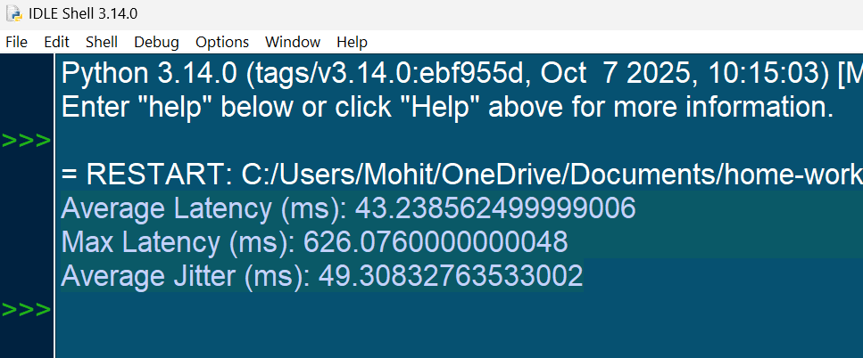

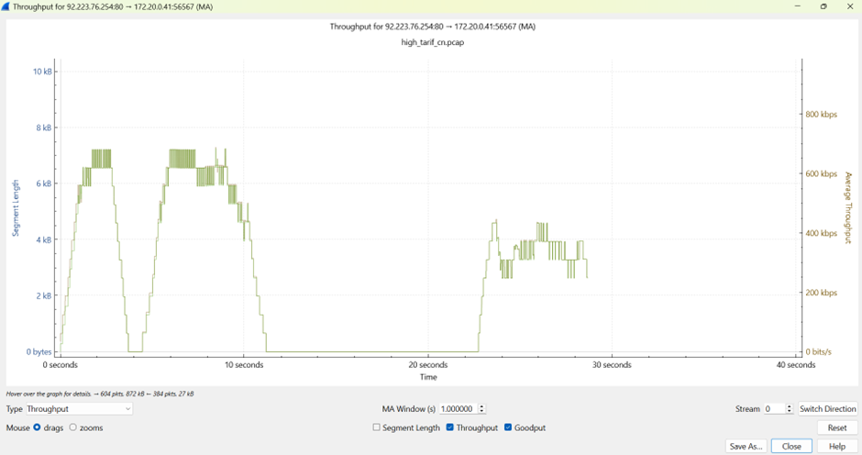
Goodput and throughput graph:

Goodput and throughput show significant variation with drops in values, indicating inefficient data transmission under high traffic.
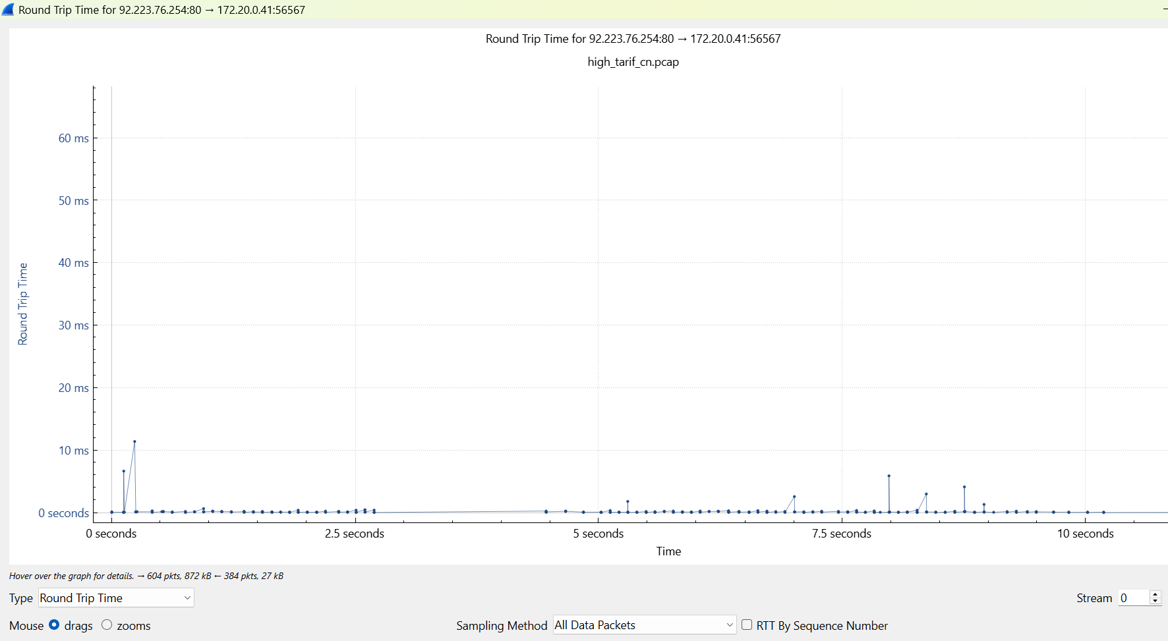
Round trip time graph:
RTT remains low for most of the duration with occasional spikes, indicating intermittent delays under high traffic.

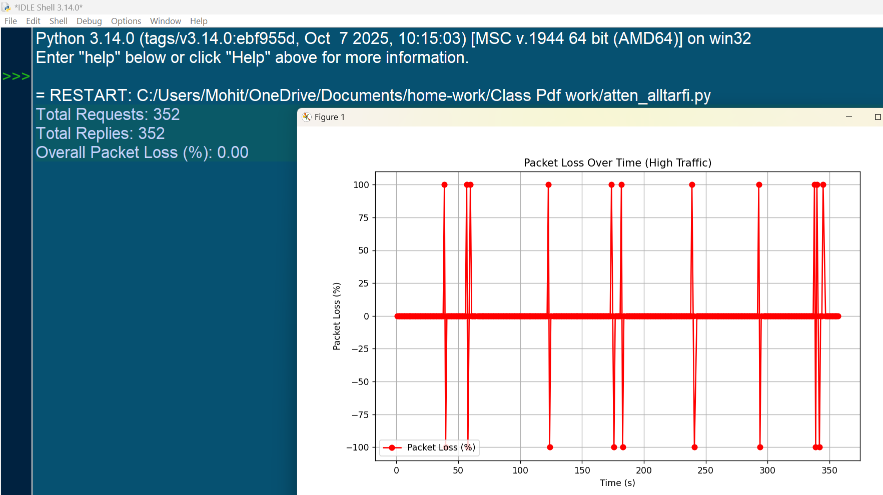
Packet loss graph:

Packet loss is mostly negligible but shows sudden spikes, indicating temporary loss of packets under high traffic.
The following Python code was used to calculate packet loss percentage and analyse its variation over time under high traffic conditions.
import pandas as pd
import matplotlib.pyplot as plt

# Load Wireshark CSV file
df = pd.read_csv("packets.csv")

# Filter ICMP packets
icmp = df[df["Protocol"] == "ICMP"]

# Separate request and reply packets
requests = icmp[icmp["Info"].str.contains("Echo (ping) request", na=False, regex=False)].reset_index(drop=True)
replies = icmp[icmp["Info"].str.contains("Echo (ping) reply", na=False, regex=False)].reset_index(drop=True)

# Count total requests and replies
num_requests = len(requests)
num_replies = len(replies)

# Calculate overall packet loss
if num_requests > 0:
packet_loss = ((num_requests - num_replies) / num_requests) * 100
print(f"Total Requests: {num_requests}")
print(f"Total Replies: {num_replies}")
print(f"Overall Packet Loss (%): {packet_loss:.2f}")
else:
print("No ICMP Echo Requests found.")

# Convert Time column to numeric
requests["Time"] = pd.to_numeric(requests["Time"], errors="coerce")
replies["Time"] = pd.to_numeric(replies["Time"], errors="coerce")

# Create 1-second time intervals
time_bins = pd.interval_range(start=icmp["Time"].min(), end=icmp["Time"].max(), freq=1)

loss_percentages = []
bin_centers = []

# Calculate packet loss for each interval
for interval in time_bins:
req_bin = requests[(requests["Time"] >= interval.left) & (requests["Time"] < interval.right)]
rep_bin = replies[(replies["Time"] >= interval.left) & (replies["Time"] < interval.right)]

if len(req_bin) > 0:
loss = ((len(req_bin) - len(rep_bin)) / len(req_bin)) * 100
loss_percentages.append(loss)
bin_centers.append((interval.left + interval.right) / 2)

# Plot packet loss over time
plt.figure(figsize=(10,6))
plt.plot(bin_centers, loss_percentages, color="red", marker="o", label="Packet Loss (%)")
plt.title("Packet Loss Over Time (High Traffic)")
plt.xlabel("Time (s)")
plt.ylabel("Packet Loss (%)")
plt.legend()
plt.grid(True)
plt.show()
This code calculates overall packet loss and analyses how packet loss varies over time by comparing ICMP request and reply packets.

Attenuation:
In addition to real-time traffic analysis, attenuation was considered as a network parameter to study its impact on performance under low, normal, and high traffic conditions. Attenuation represents signal loss in the network, which directly affects throughput, latency, and overall communication efficiency.
import numpy as np
import matplotlib.pyplot as plt

# -------------------------------
# Define Attenuation Range (dB)
# -------------------------------
attenuation = np.linspace(0, 50, 100)

# -------------------------------
# Throughput Model (Exponential Decay)
# -------------------------------
throughput = {
"Low Traffic": 100 * np.exp(-attenuation / 60),
"Normal Traffic": 100 * np.exp(-attenuation / 40),
"High Traffic": 100 * np.exp(-attenuation / 25)
}

# -------------------------------
# Goodput Model (Considering Overhead)
# -------------------------------
goodput = {
"Low Traffic": throughput["Low Traffic"] * 0.95, # 5% overhead
"Normal Traffic": throughput["Normal Traffic"] * 0.85, # 15% overhead
"High Traffic": throughput["High Traffic"] * 0.70 # 30% overhead
}

# -------------------------------
# Latency Model (Linear Increase)
# -------------------------------
latency = {
"Low Traffic": 20 + attenuation * 0.2,
"Normal Traffic": 20 + attenuation * 0.4,
"High Traffic": 20 + attenuation * 0.8
}

# -------------------------------
# Jitter Model (Increasing Variation)
# -------------------------------
jitter = {
"Low Traffic": attenuation * 0.05,
"Normal Traffic": attenuation * 0.1,
"High Traffic": attenuation * 0.2
}

# -------------------------------
# Plot Function (Reusable)
# -------------------------------
def plot_graph(ax, x, data_dict, title, ylabel):
for label, values in data_dict.items():
ax.plot(x, values, label=label)
ax.set_title(title)
ax.set_xlabel("Attenuation (dB)")
ax.set_ylabel(ylabel)
ax.legend()
ax.grid(True)

# -------------------------------
# Create Subplots
# -------------------------------
fig, axs = plt.subplots(2, 2, figsize=(12, 10))

plot_graph(axs[0, 0], attenuation, throughput, "Throughput vs Attenuation", "Throughput (Mbps)")
plot_graph(axs[0, 1], attenuation, goodput, "Goodput vs Attenuation", "Goodput (Mbps)")
plot_graph(axs[1, 0], attenuation, latency, "Latency vs Attenuation", "Latency (ms)")
plot_graph(axs[1, 1], attenuation, jitter, "Jitter vs Attenuation", "Jitter (ms)")

# Adjust layout
plt.tight_layout()
plt.show()

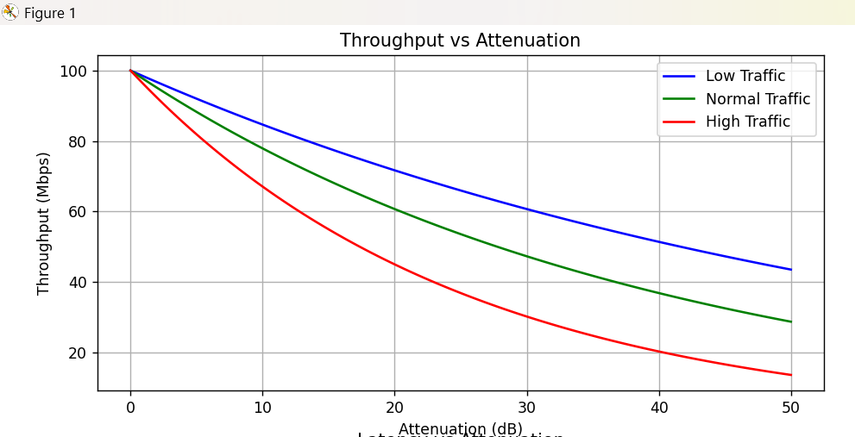
graphs:

Throughput decreases as attenuation increases, with a sharper decline observed under high traffic conditions.

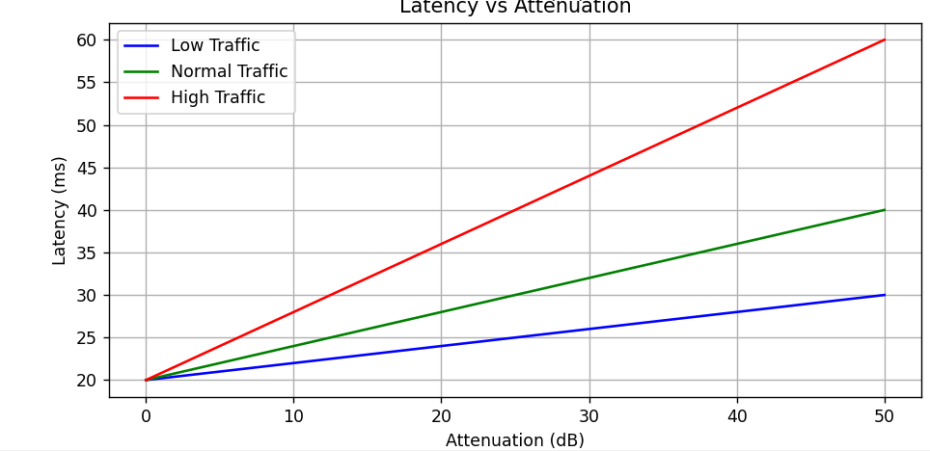
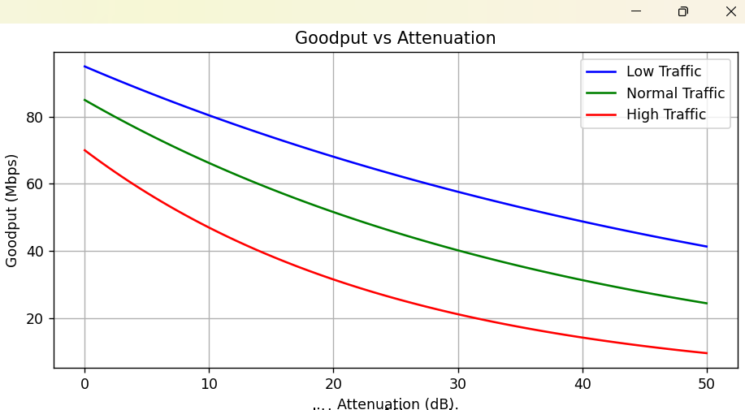
Goodput decreases as attenuation increases, indicating reduced effective data transmission due to signal loss and retransmissions.

Latency increases as attenuation increases, with higher traffic conditions showing a steeper rise in delay.
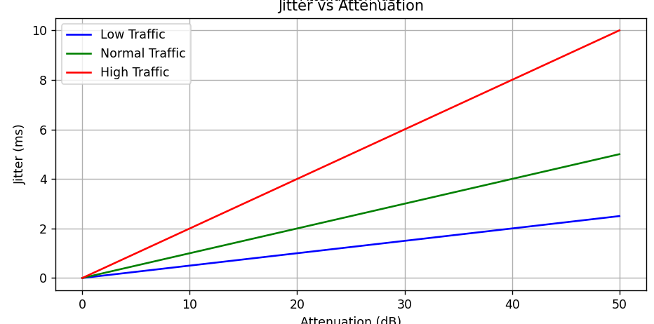
Jitter increases as attenuation increases, indicating greater variation in packet delivery time under poor signal conditions.

Conclusion:
The experiment demonstrates that network performance varies significantly with traffic conditions and attenuation. Low traffic ensures stable performance, while high traffic introduces congestion, increased delay, and packet loss. Attenuation further degrades performance by reducing throughput and increasing latency and jitter. Thus, both traffic load and signal quality are key factors affecting network efficiency.

