Computer Networks

BCSE308P

Digital Assignment 3

Submitted to:

Dr. Subbulakshmi T

Submitted by:

Mohit Sangwan(24BCE1324)

Network Parameter Analysis using Wireshark under Various Traffic Conditions

Introduction
This document presents analysis of network parameters using Wireshark under different traffic conditions.

Low Traffic
Controlled traffic generated using ping commands.
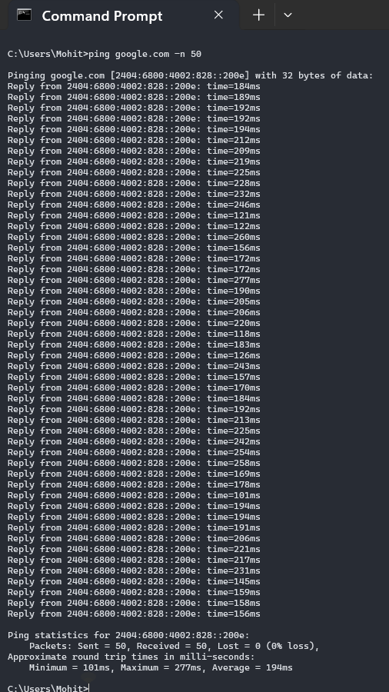
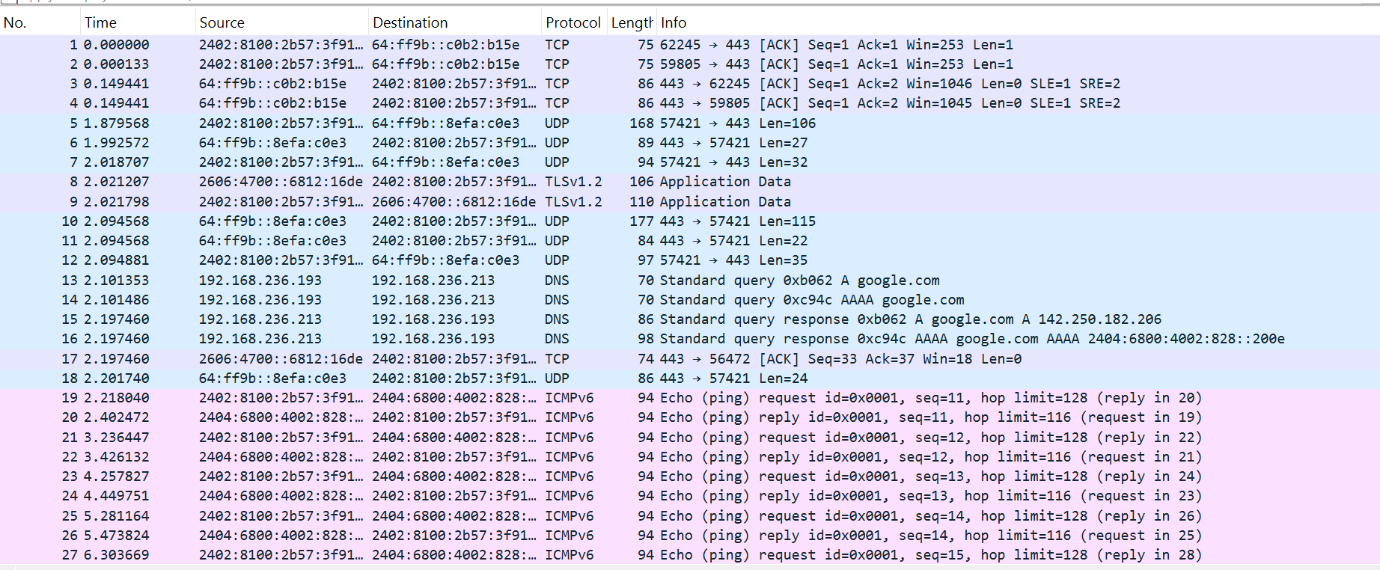
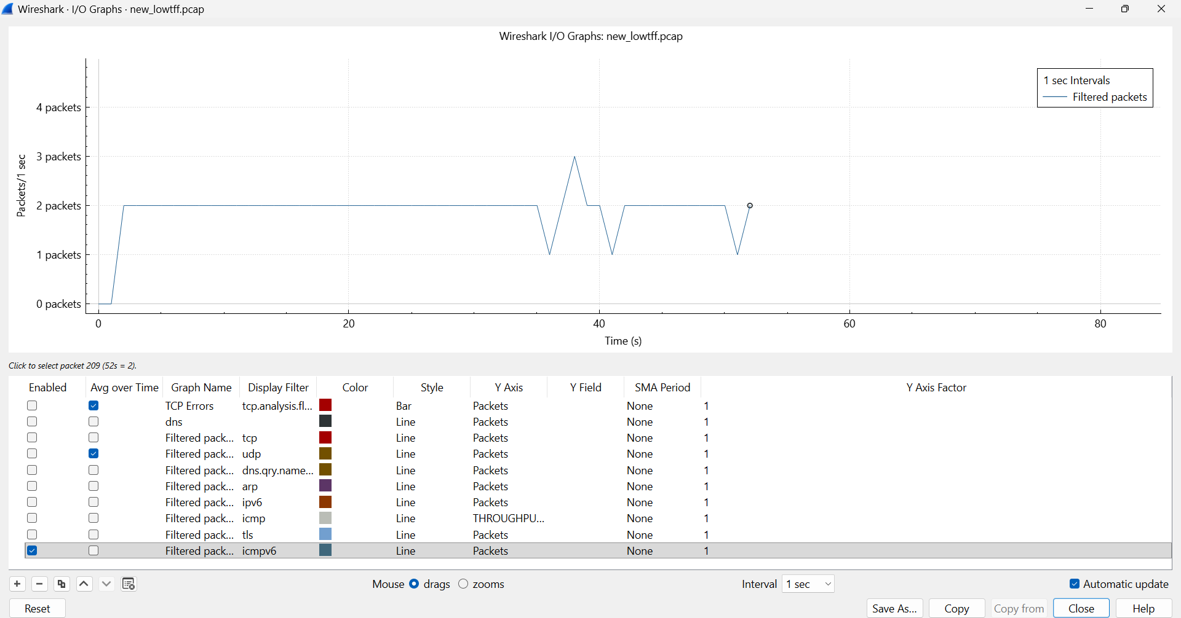
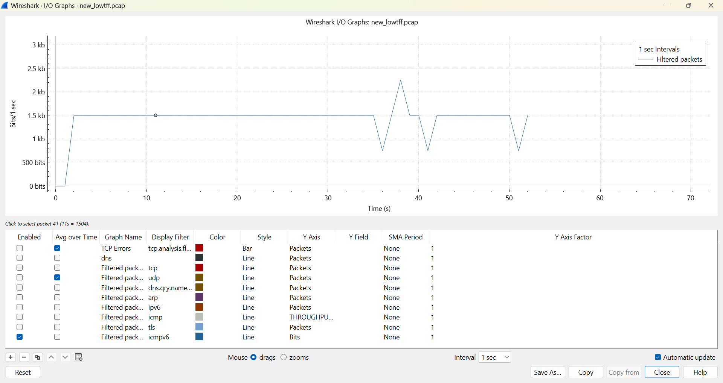
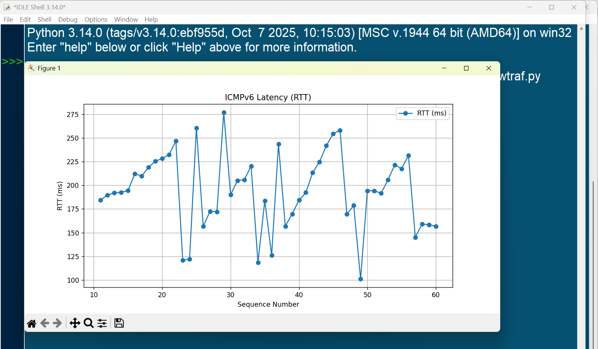
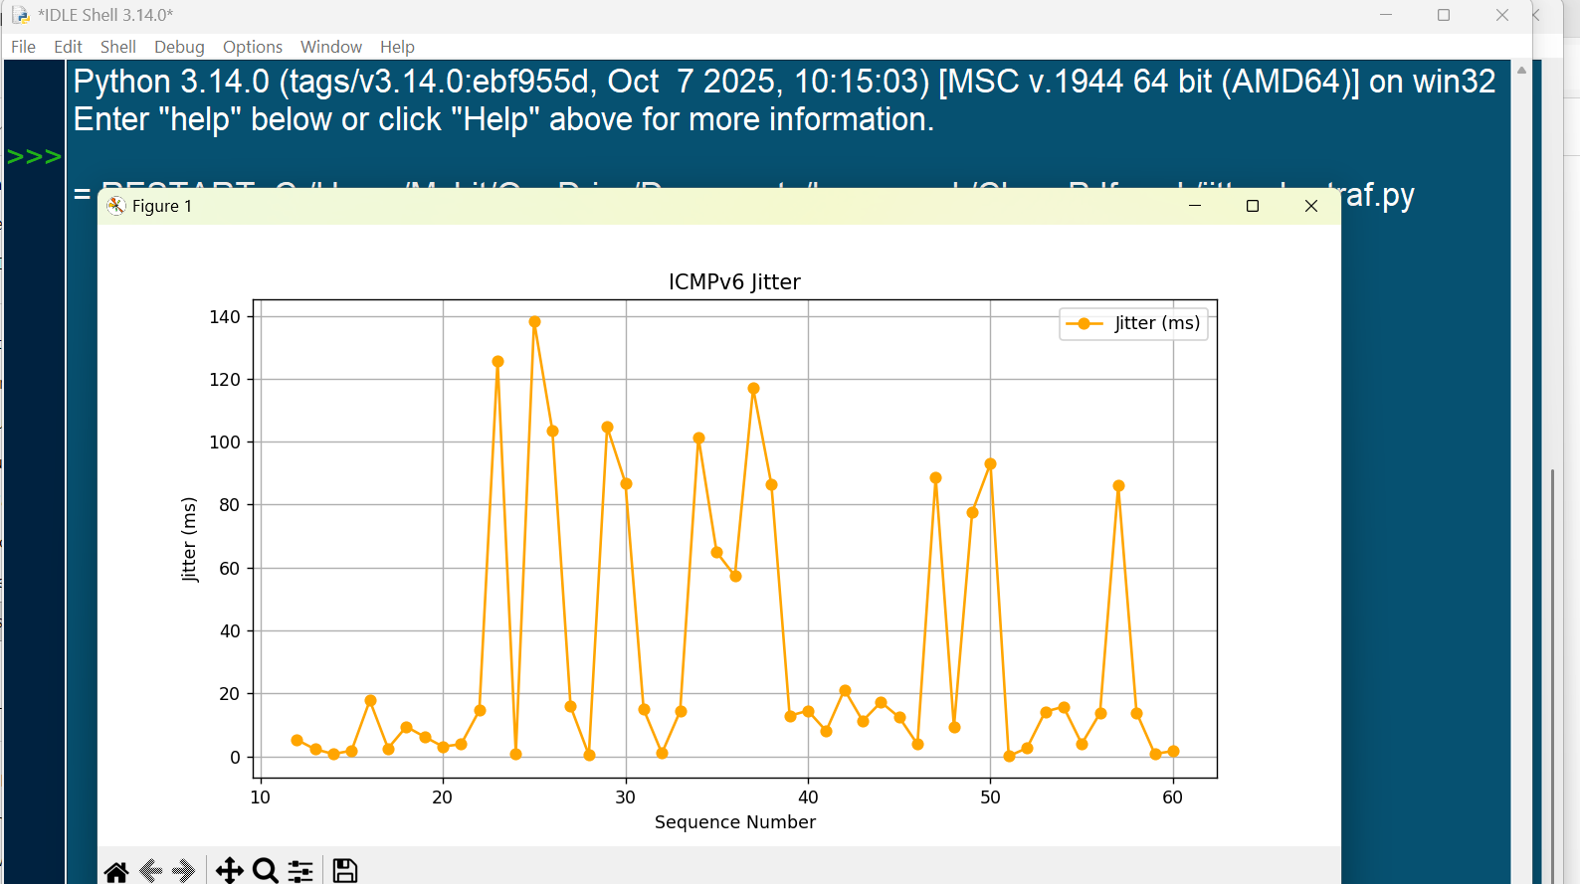

Normal Traffic
Analysis under typical traffic conditions.
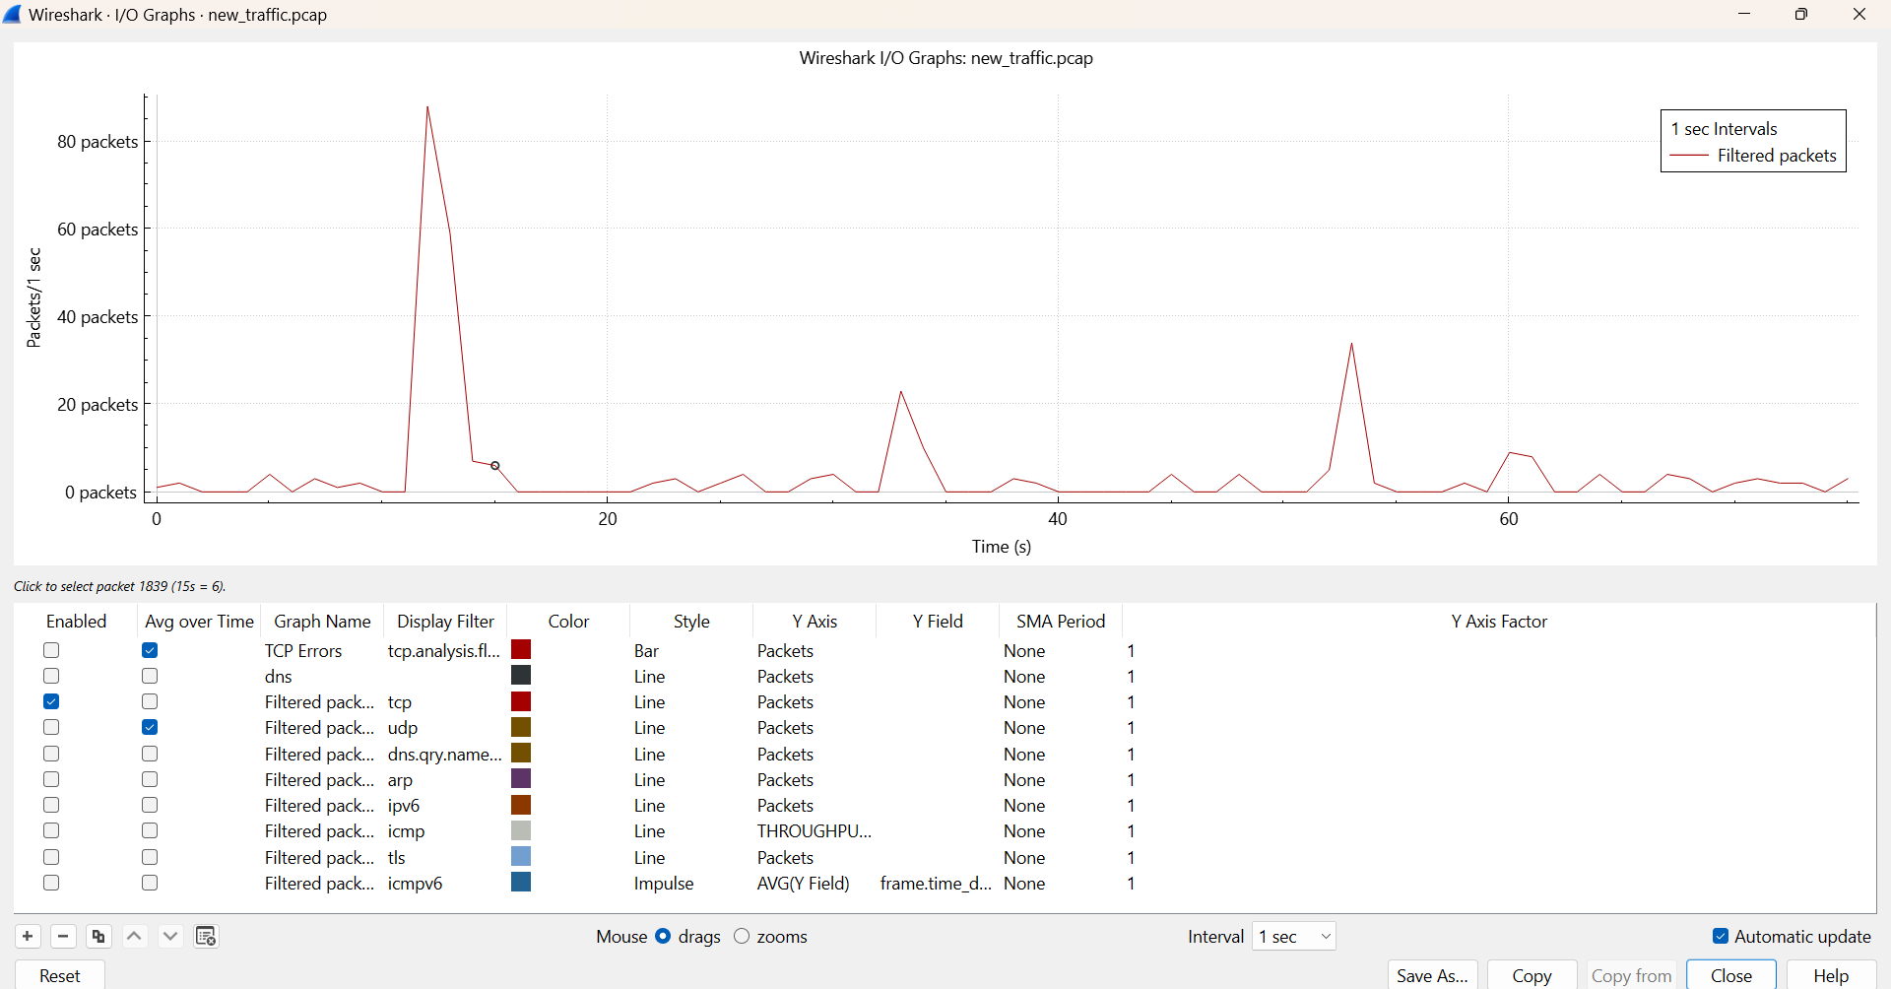
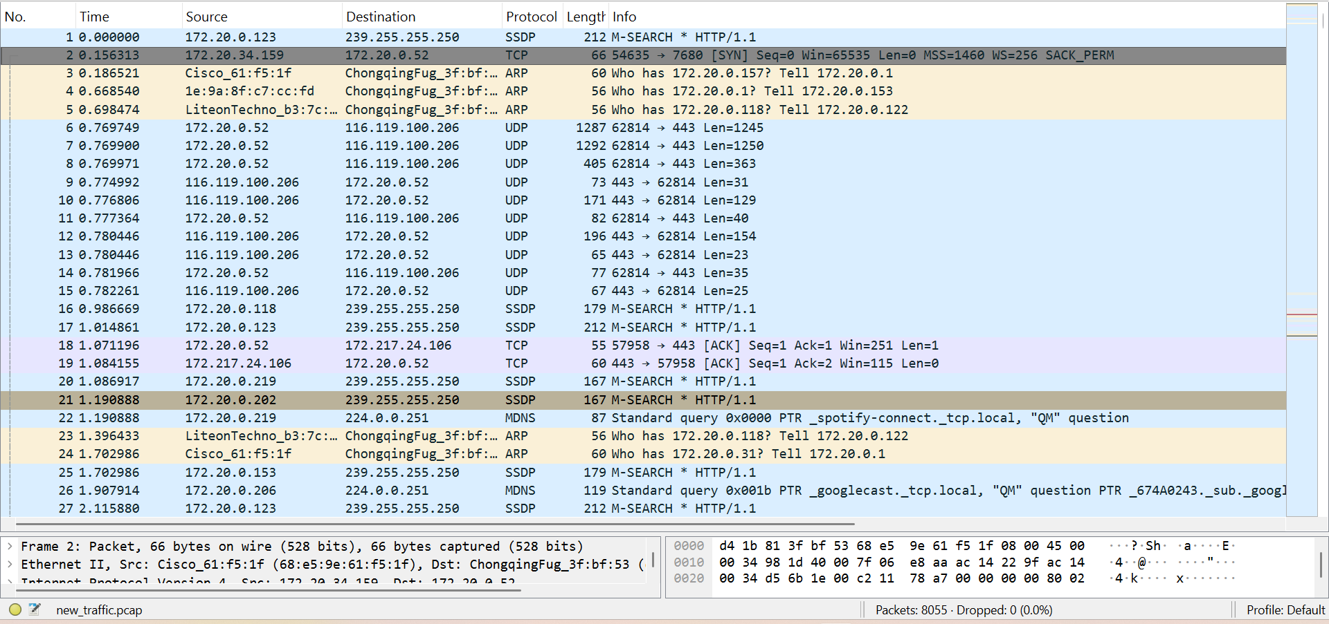
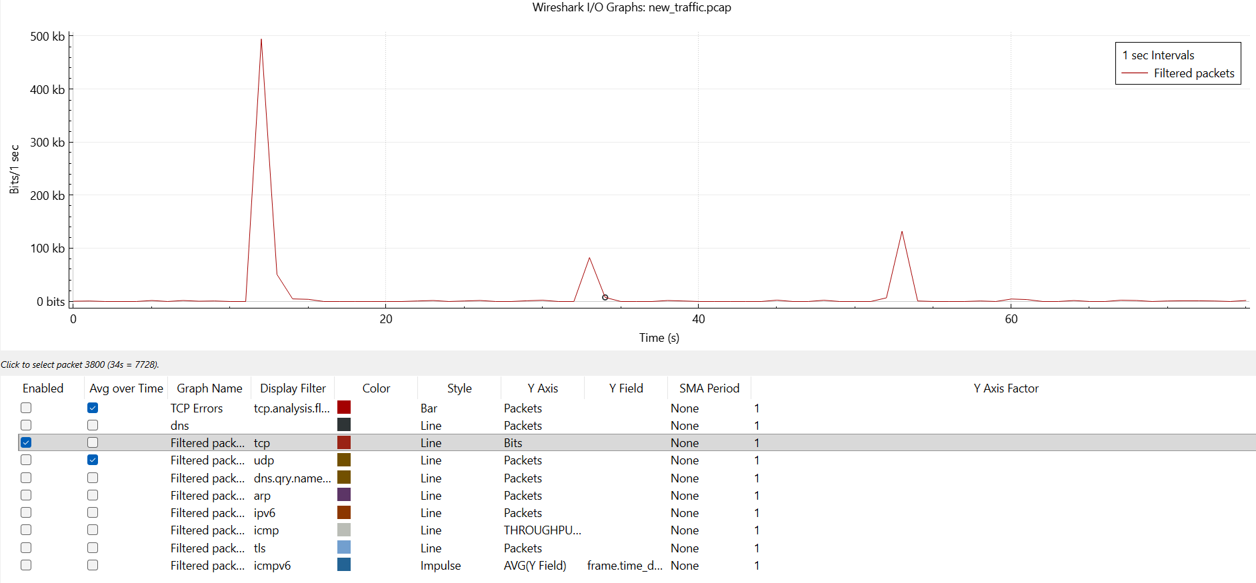
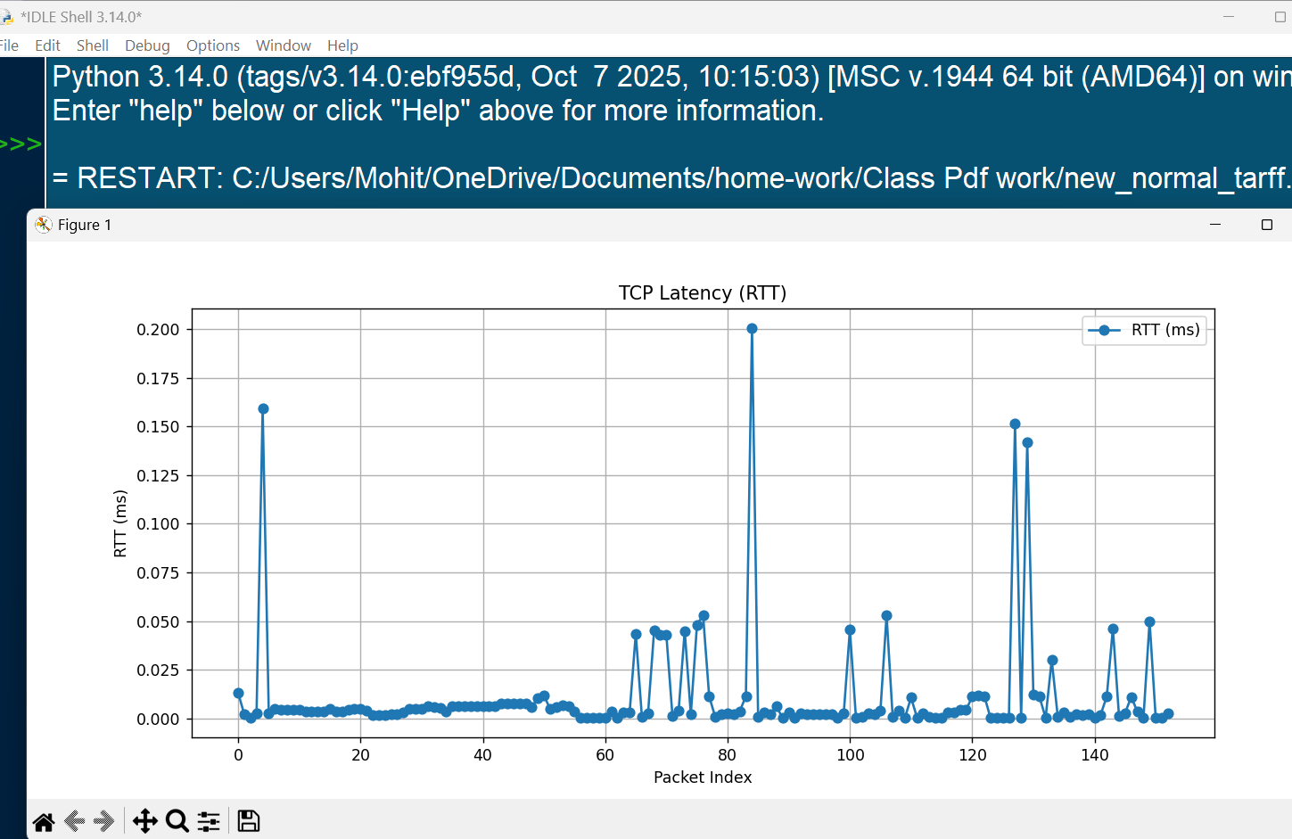
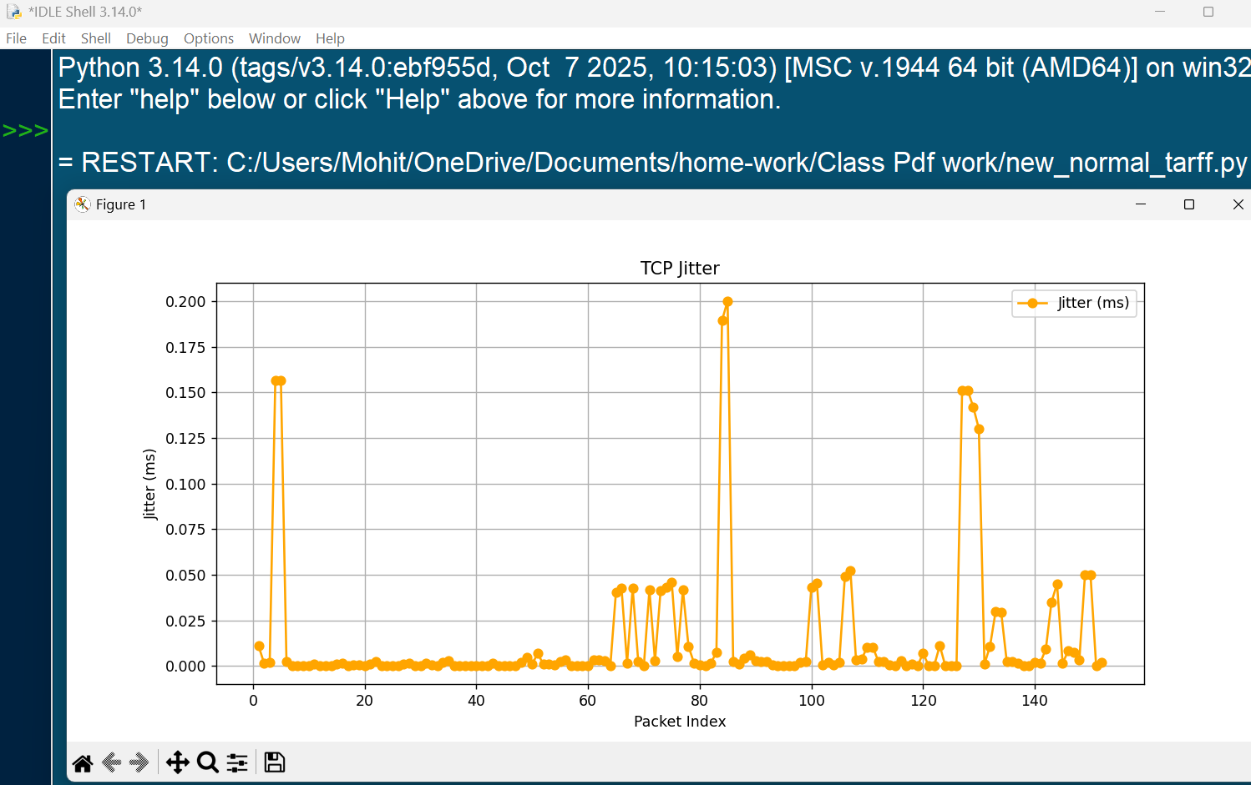

High Traffic
High load traffic generated using bulk requests.
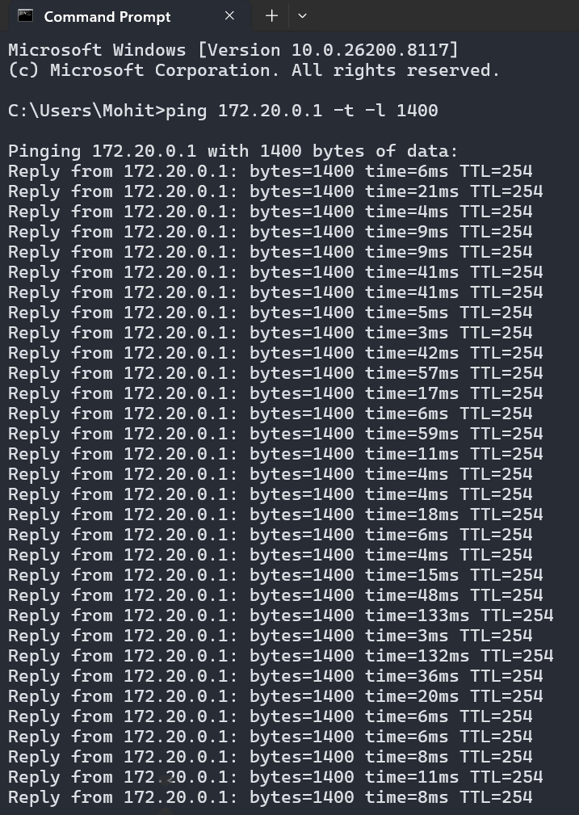
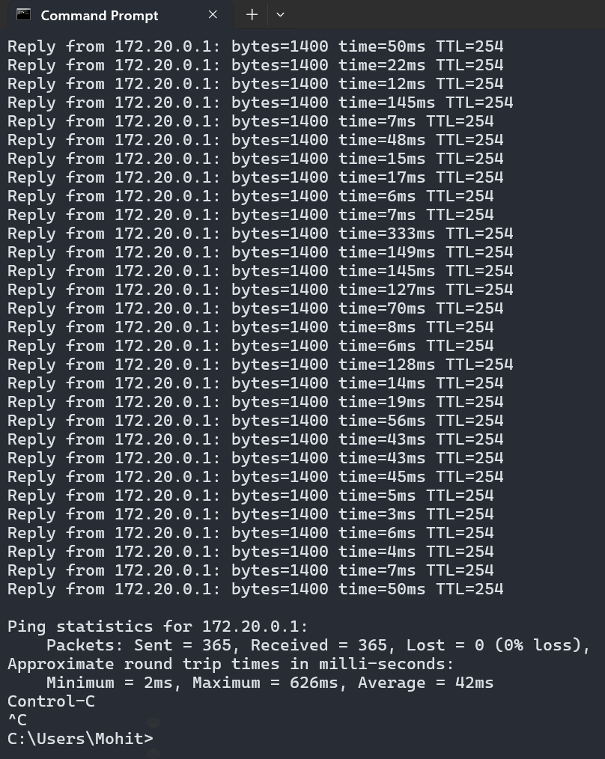
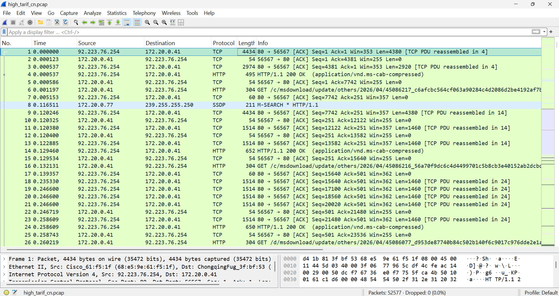
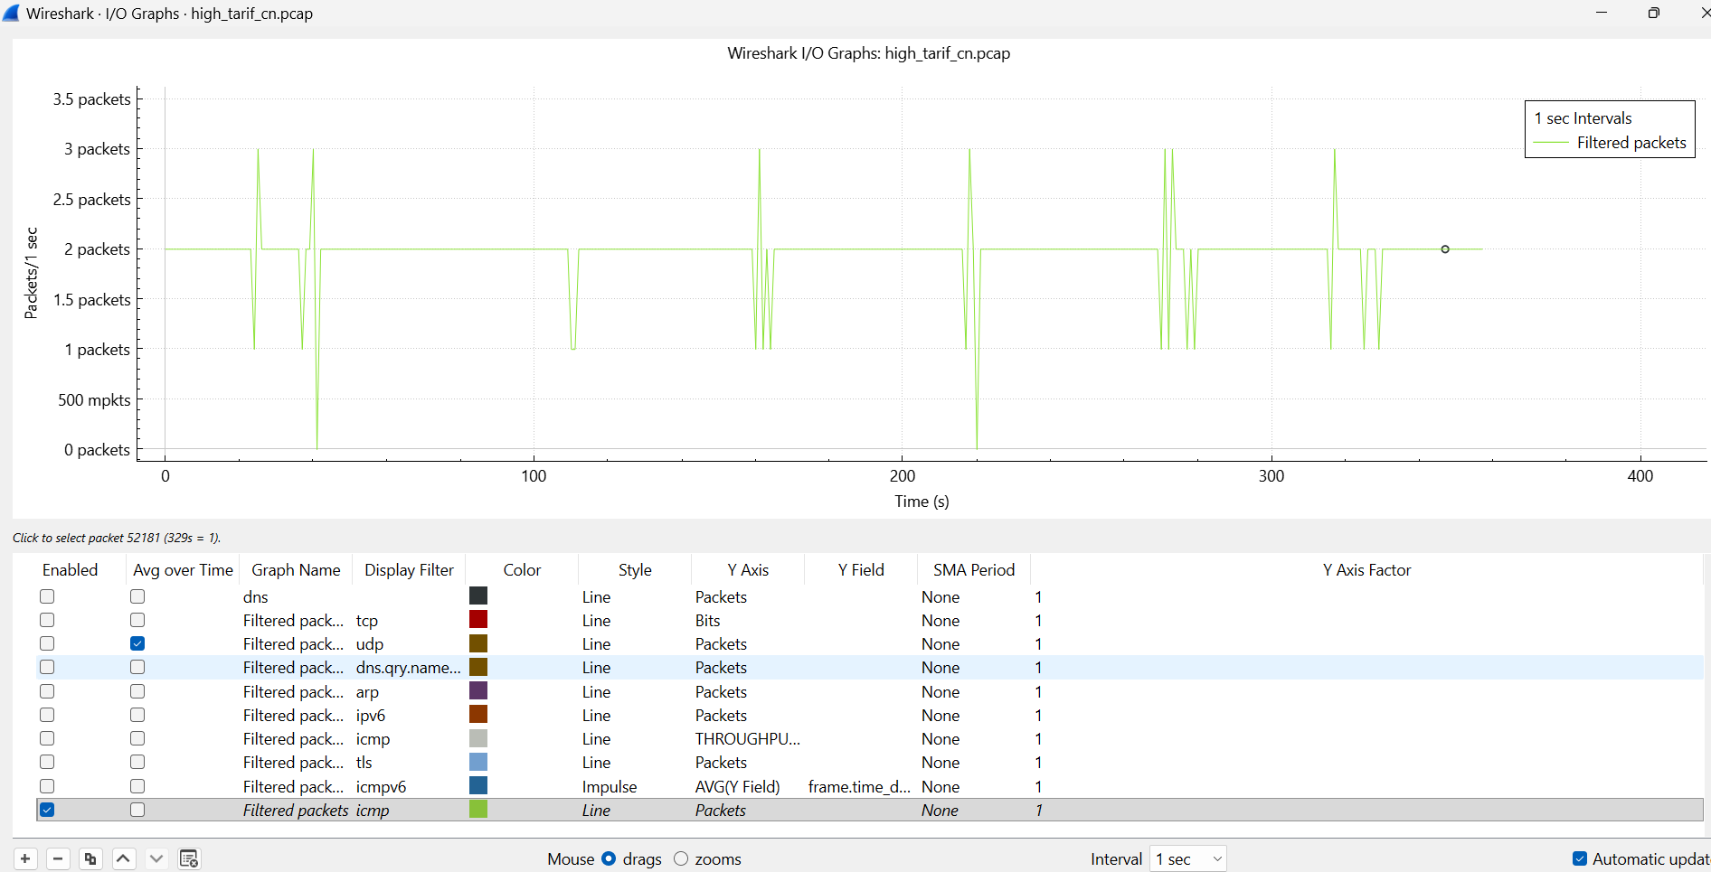
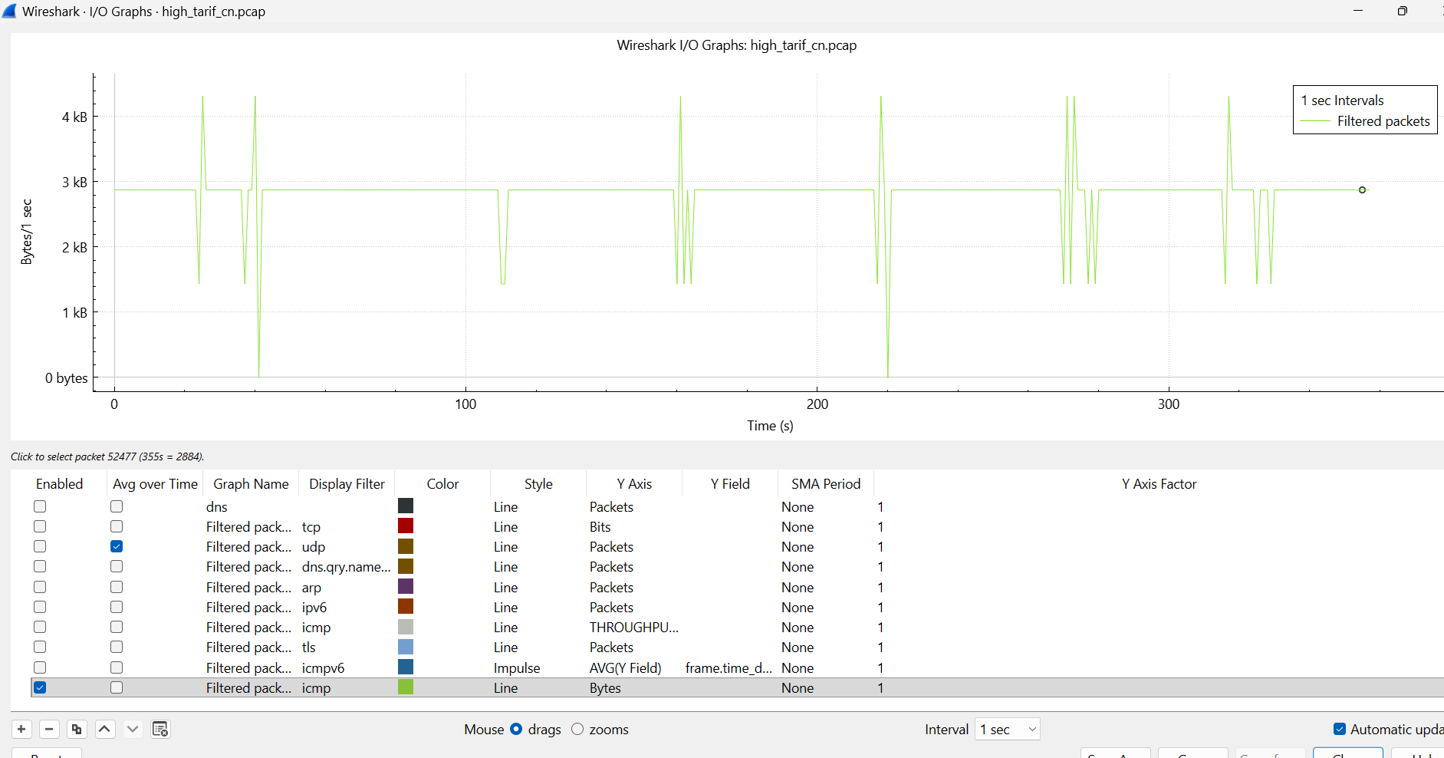
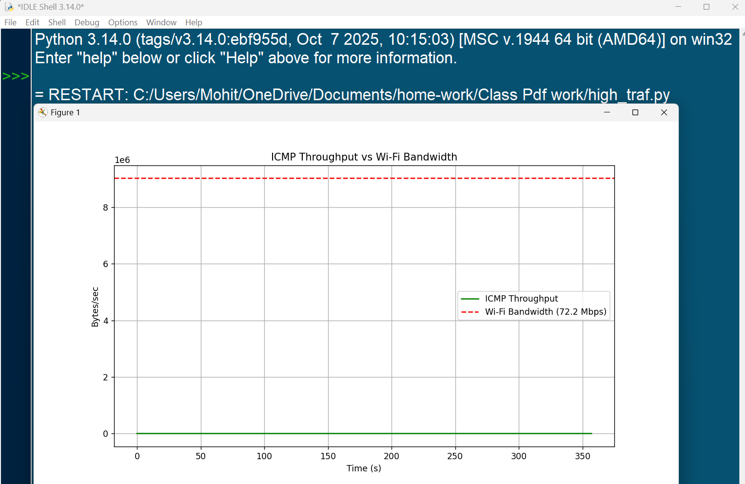
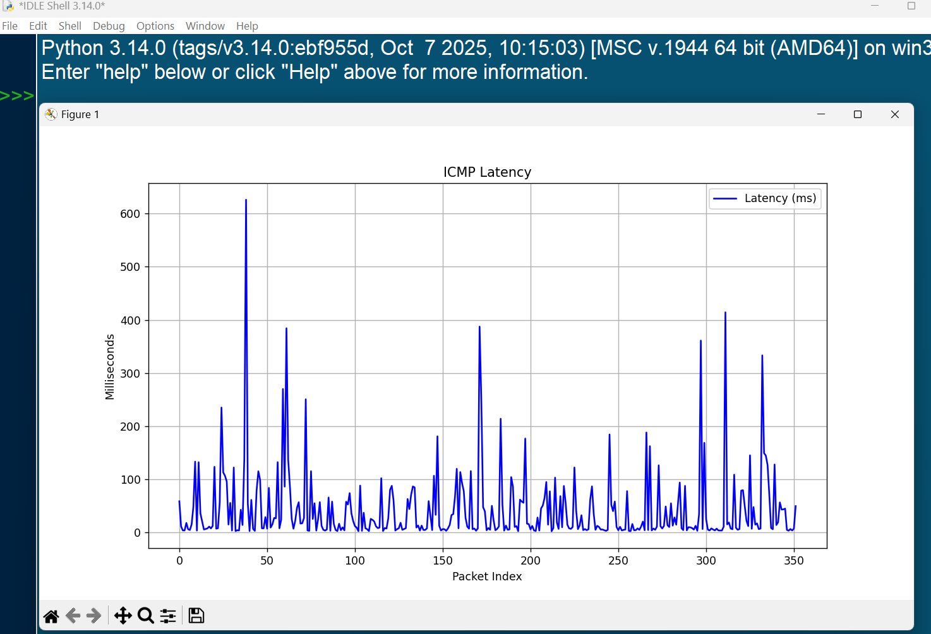
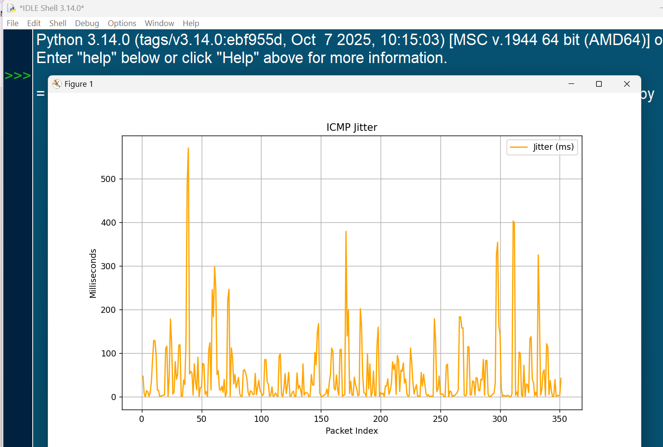
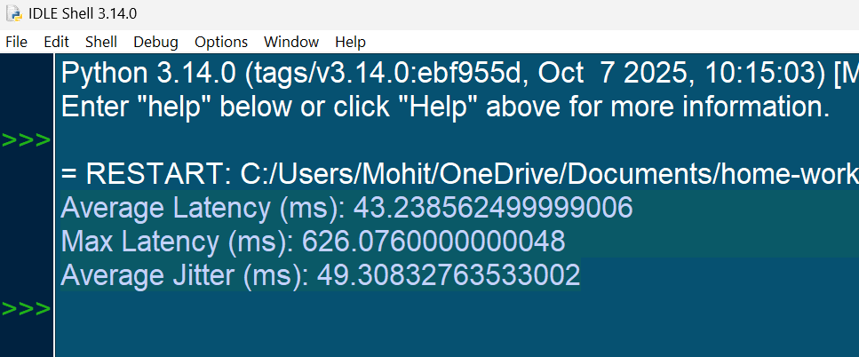
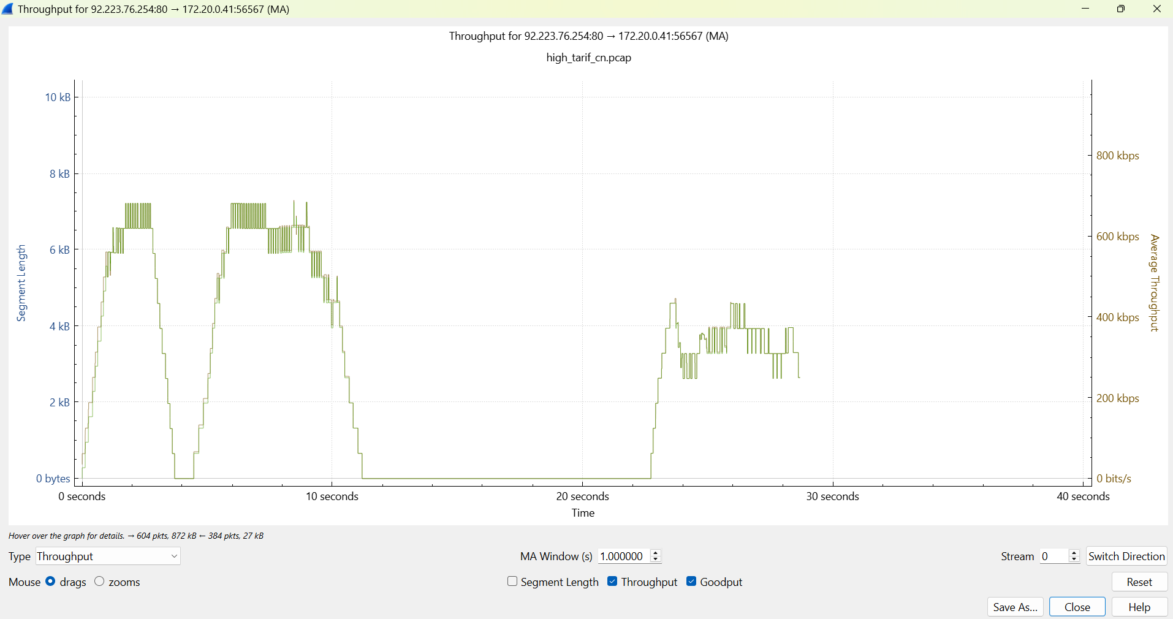
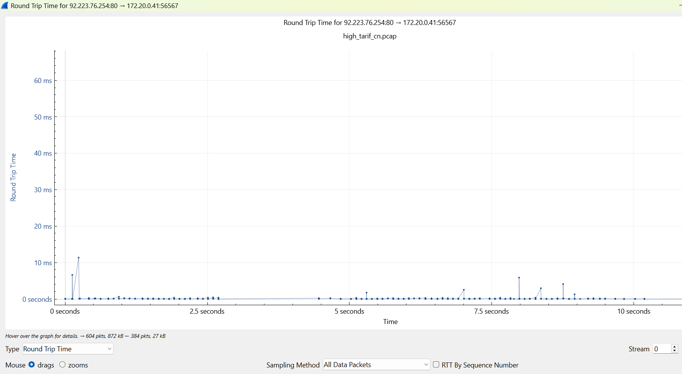
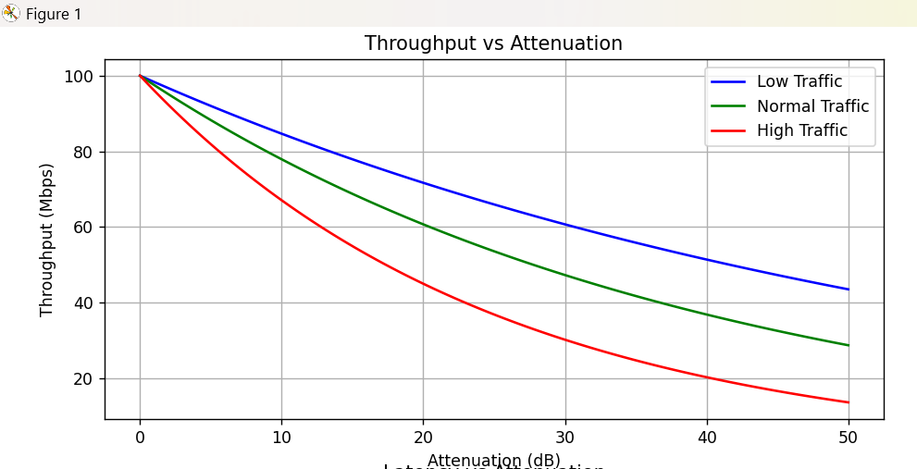
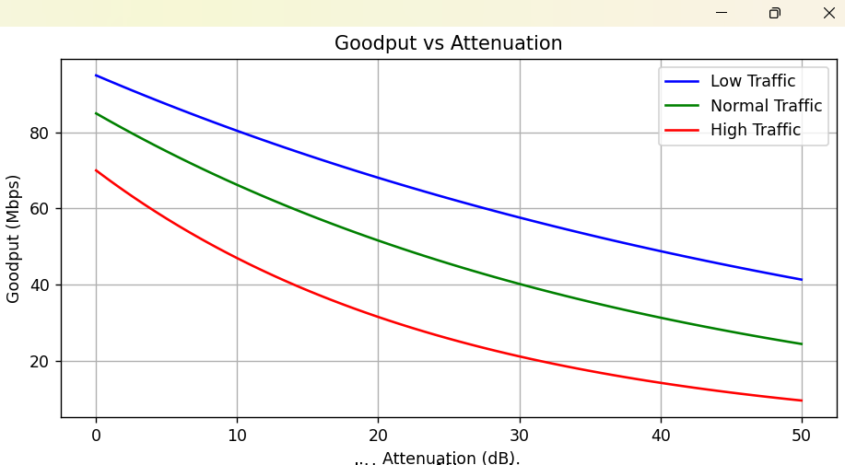
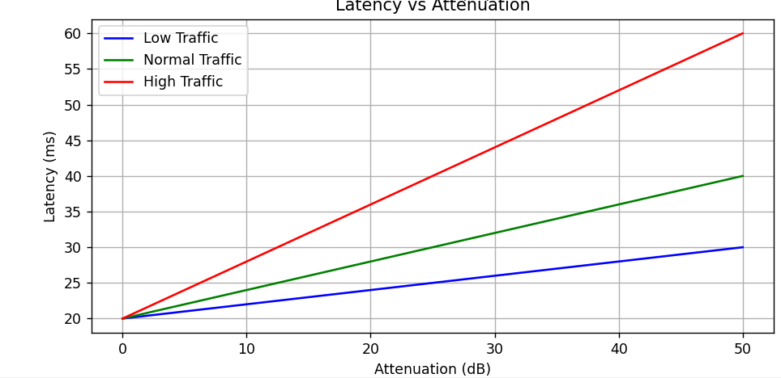
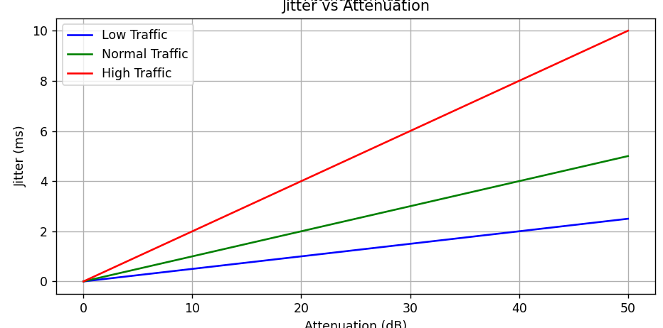
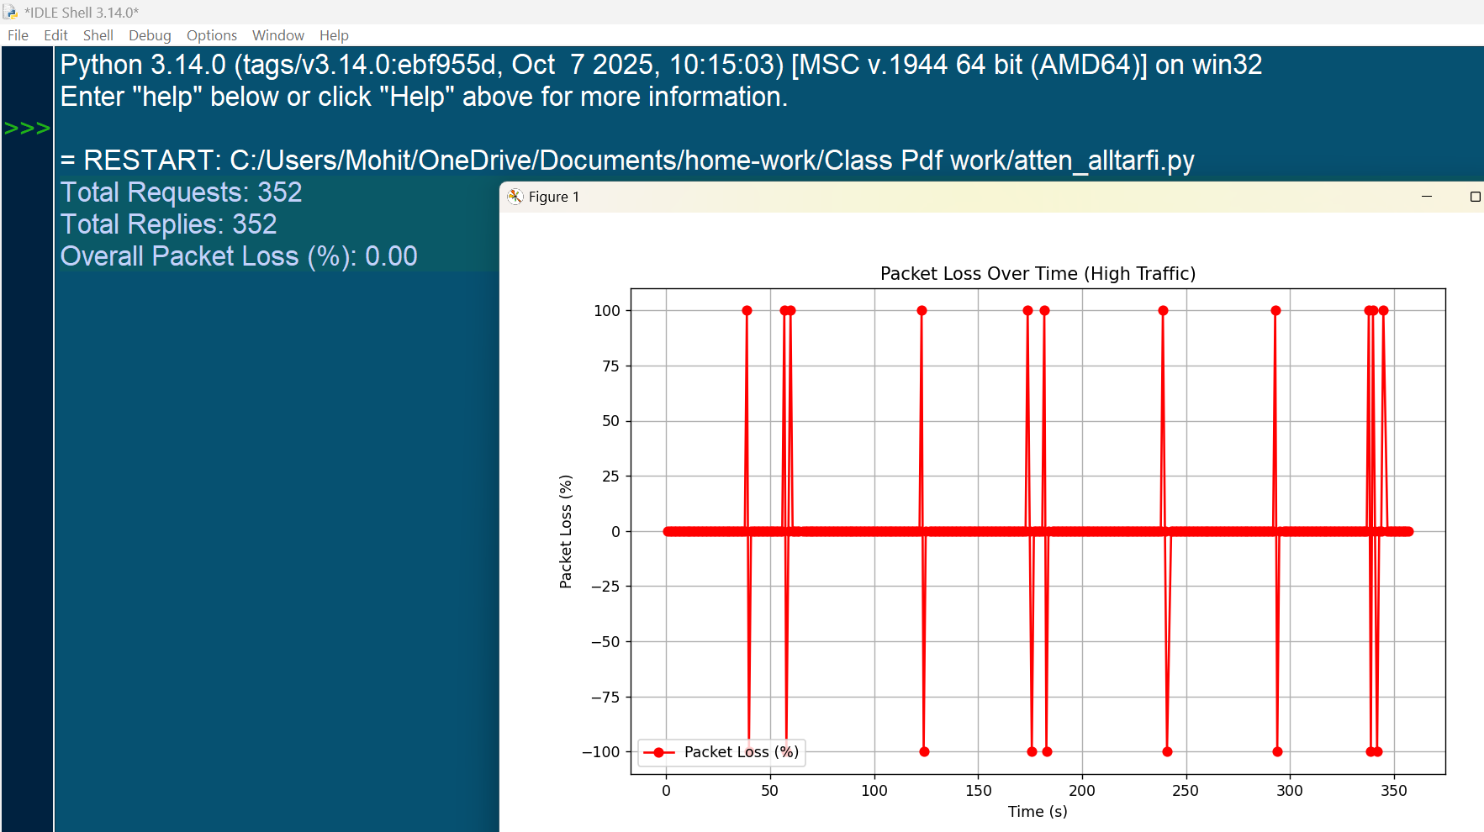

Observations and Explanations
From the low traffic graphs, it can be observed that the packet rate is stable and latency is minimal.
Throughput remains consistent under low traffic conditions indicating efficient transmission.
Jitter is very low in low traffic which indicates stable network behavior.
In normal traffic, slight variations in latency and jitter can be observed.
Throughput under normal traffic shows moderate utilization of bandwidth.
In high traffic conditions, packet rate increases significantly.
Latency increases noticeably due to congestion in high traffic.
Jitter also increases indicating instability in packet delivery.
Packet loss is observed in high traffic which affects reliability.
Throughput may drop or fluctuate due to network congestion.

Inferences
- Latency increases with increase in traffic load.
- Jitter is minimal in low traffic and increases with traffic.
- Throughput is highest when network is not congested.
- High traffic leads to packet loss.
- Network efficiency decreases with congestion.
- RTT variation is higher in high traffic.
- Low traffic ensures stable communication.
- Bandwidth utilization increases with traffic.
- Packet drops affect overall performance.
- Jitter impacts real-time applications.
- ICMP traffic shows predictable behavior.
- TCP traffic introduces variability.
- Congestion leads to retransmissions.
- Goodput decreases in high traffic.
- Delay variation increases with load.
- Packet rate correlates with traffic intensity.
- Network stability reduces under stress.
- High load affects latency significantly.
- Throughput is not always proportional to traffic.
- Proper traffic management improves performance.

Use of AI in this DA
AI tools were used to assist in generating Python scripts, analyzing graphs, and improving the overall structure of the documentation.

Conclusion
The experiment demonstrates that network parameters vary significantly under different traffic conditions. Proper monitoring of latency, jitter, throughput, and packet loss is essential for maintaining network performance.

