Certification Management Application

**Prepared By**

Mohit Jain

**Abstract**

The Certification Management Application is a salesforce-based application for the management of certifications and vouchers. The application is made using the tools such as process builder, approval process, apex triggers provided by salesforce. The application uses the following 4 custom objects:

1. Employees
2. Certifications
3. Vouchers
4. Certification Requests

The main purpose of this application is to allow the employees of an organisation to request for the certification and the respective voucher easily. The application also allows to keep track of different employees passed or failed in different certifications using the reports tool provided by salesforce. The application also leverages the power of Lightning Web Components for building the user interface for the application.

**Scope**

The application is used by 2 types of user:

1. App Admin

The app admin can:

1. Create, update and delete Certifications in the system.
2. Create, update and delete Vouchers in the system.
3. View all the Certifications requests.
4. Approve or reject the Certification requests.
5. Assign Vouchers if a Certification request is approved.
6. Provide comments if a Certification Requests is rejected.
7. App User

The app user can:

1. Create, update and delete Employees in the system.
2. Create and submit certification requests to app admin for approval on behalf of employees requesting for certifications.
3. View all the Certifications and Vouchers.
4. Update request status to passed/failed if request is approved.
5. Manage reports and dashboards.
6. Notify employee about status of request on every stage.

The Out Scope of the application are as follows:

1. The application does not include the Employee login
2. The employee can share his/her details with the app user who will create a record in employee object with the details provided by the employee.
3. Third party integrations are not included in the application.

**Objects and Fields**

1. **Employee Object** – The employee object is used to store the details of the employees in salesforce database.

**Fields & Relationships**:

* Employee Id (Auto Number)
* Employee Name (Text)
* Employee Email (Email)
* Experience (Number)
* Primary Skill (Text)
* Secondary Skill (Text)
* Comments (Text)

1. **Certification Object** – The certification object is used to store the details of the certifications in salesforce database.

**Fields & Relationships**:

* Certification Id (Auto Number)
* Certification Name (Text)
* Certification Cost (Currency)
* Comments (Text)

1. **Voucher Object** – The voucher object is used to store the details of the available vouchers in salesforce database.

**Fields & Relationships**:

* Voucher Id (Auto Number)
* Voucher Name (Text)
* Certification Object (LookUp Relationship)
* Voucher Cost (Formula((Currency))
* Validity (Date)
* Active (Boolean)
* Comments (Text)

1. **Certification Request Object** – The certification request object is used to store the details of the certification requests in salesforce database.

**Fields & Relationships**:

* Request Id (Auto Number)
* Certification Object (Master-Detail Relationship)
* Employee Object (Master-Detail Relationship)
* Voucher Object (LookUp Relationship)
* Due Date (Date)
* Status (picklist)
  1. Draft
  2. Approved
  3. Rejected
  4. Passed
  5. Failed
* Comments (Text)

**Process Builder and Approval Process**

**Process Builder**

The application uses 2 process builder for providing major functionality in the application. These 2 process builders are “Process For Requests” and “For Due Date Passed Notification”. Along with these 2 process builder some other process builder are also deployed for firing the email alerts to send emails to employee at each stage of request. These process are invocable by 2 process mentioned above. The 2 major process builder are used as follows:

**Process For Request**

This process is used to call the approval process “Approval for voucher” whenever a certification request is created in the salesforce database by the app user. This process is also used to invoke other 3 processes – “Email to employee”, “Email When Approved” and “Email When Rejected” respectively when the request is submitted for approval, when request is approved and when request is rejected. This process also makes the voucher active when request is approved and inactive when request is rejected.

**For Due Date Passed Notification**

This process is used to send the email to employee and app user when due date of a certification request is passed and the request is not yet approved to rejected by the app admin.

**Approval Process**

The application uses 1 approval process – “Approval for voucher”. This approval process is invoked as soon as a request is created. The initial action of this approval process include changing the status field of certification request object to draft indicating that the request is submitted to the app admin. The app user submits the request on employee’s behalf to the app admin and the app admin either approves or rejects the request. Upon approval, the status field is changed to “Approved” by the approval steps feature of the approval process. Upon rejection, the status field is changed to “Rejected” by the rejection steps feature of approval process.

**Validations**

**Validation Rules:**

The following validation rules are applied to maintain the consistency of the application:

* App User should not be able to raise same certification voucher request again if one already exist in the system.
* App User should not be able to add new certification voucher request in system if there is any pending request exist for that employee.
* Voucher Name must be unique and 10 chars long.
* Voucher Validity should be greater than today (the date is stored in the database).
* Request Due date should not be less than Today (the date is stored in the database).
* A Voucher should be Active for it to be applied.
* If a request has been approved and has no voucher, but a voucher is available, then it should be automatically applied.
* If an employee gets passed/failed in any certification then system should not allow to App User to raise same certification request for that employee again.

**Triggers:**

The triggers are used in maintaining the proper flow of the application and are also used in performing some validations. These triggers are written Apex programming language which is widely used in salesforce. Following triggers are used in this application:

1. **Check_Existing_Employees -** This trigger is used to restrict the app user to create request for an employee if a request already exists for the employee in pending stage.
2. **AddVoucherAutomaticallly –** This trigger is used to assign an active voucher if available to the certification requests which were initially submitted without a value in the voucher field.

**UML Diagrams**

**Class Diagram**

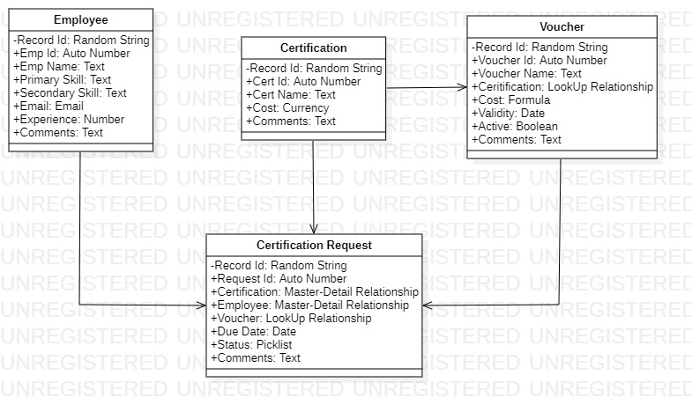

**Sequence Diagram**

1. For App Admin

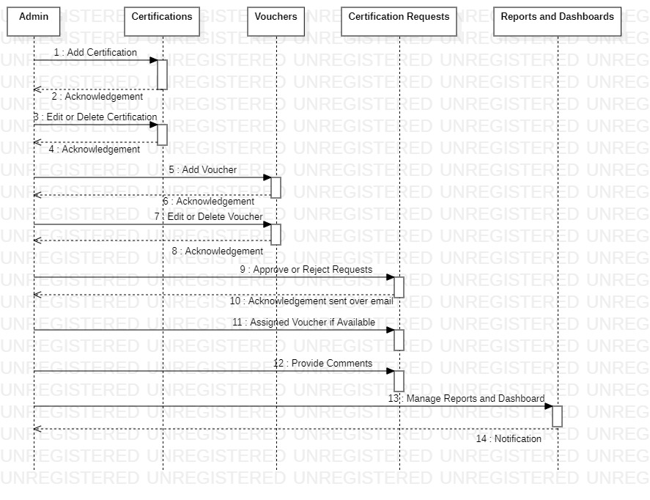

1. For App User

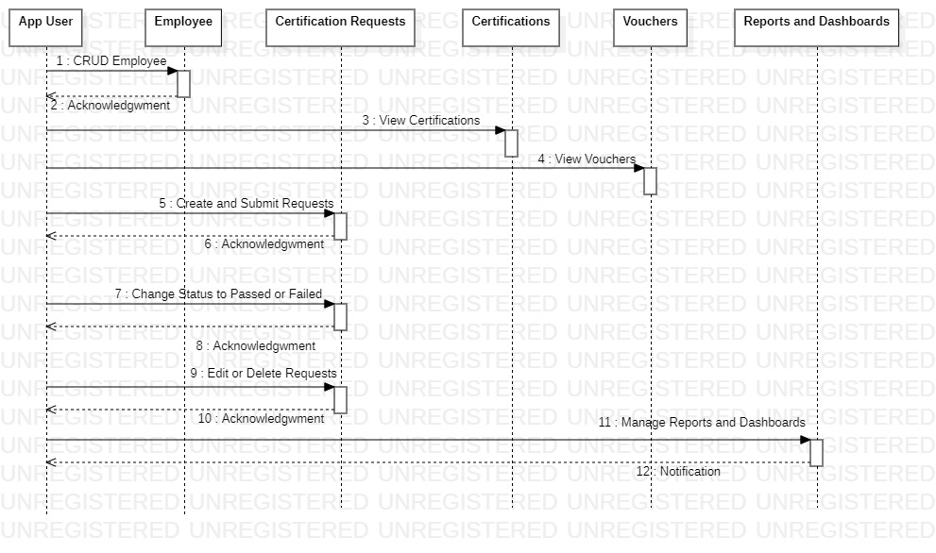

**Activity Diagram**

1. For App Admin

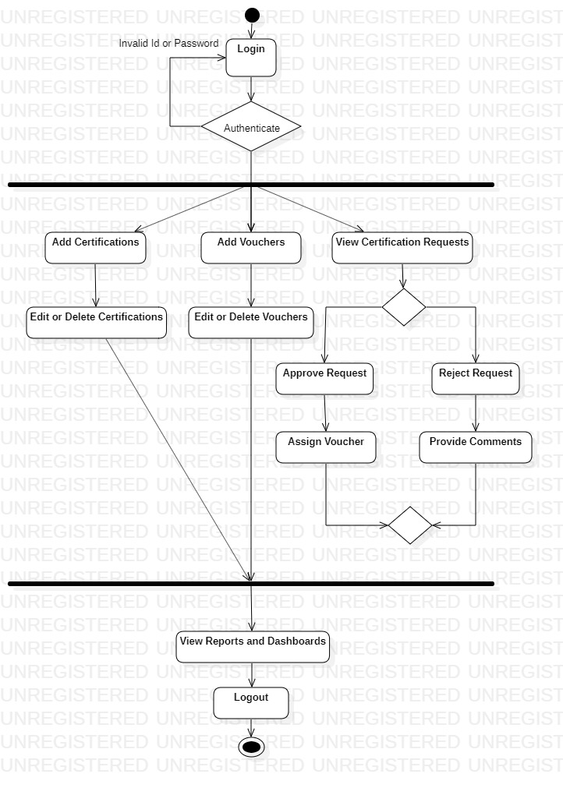

1. For App User

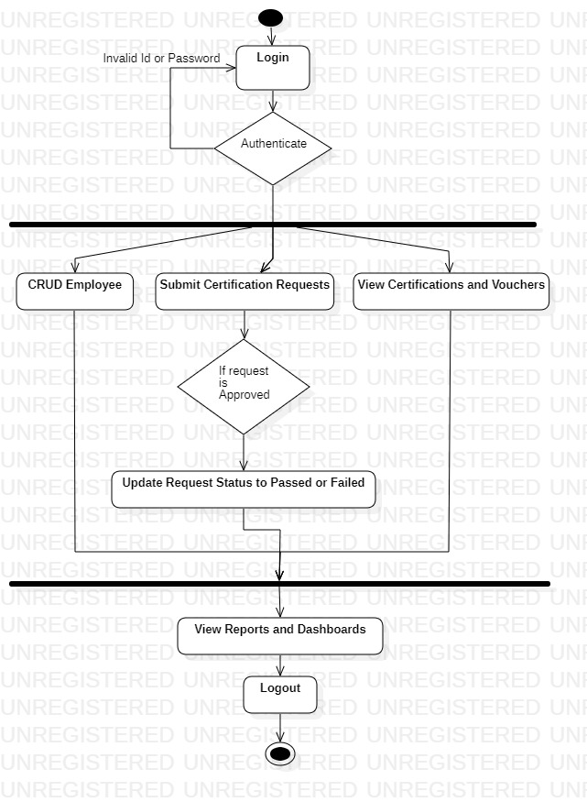

**Flow Chart**

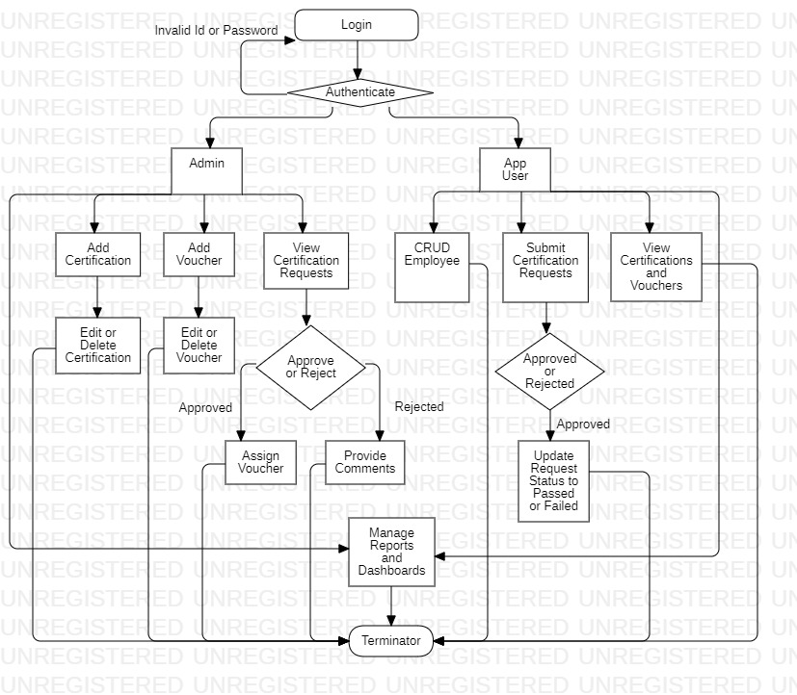

**Use-Case Diagram**

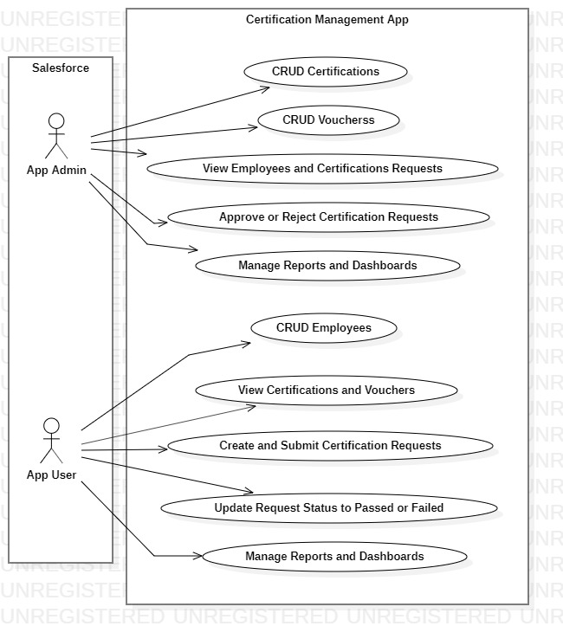

**Flow of Application**

1. The App Admin creates certification and voucher records in the system.
2. Employee mails the app user to issue certification voucher.
3. App User raises the certification request to the App Admin who in turn approves or rejects the request. The request is raised using Approval Process tool of salesforce. The Approval Process is fired as soon as a request is created.
4. The Employee is notified when request is submitted by the App User via email.
5. The App Admin also receives an email when a request is raised.
6. If the App Admin approves the request, then, the employee and the App User receives a mail to notify them about the approval.
7. The voucher will be assigned to the user when request is approved.
8. If the App Admin rejects the request, then, the employee and the App User receives a mail to tell them about the rejection.
9. The App Admin will provide some comments if the request is rejected.
10. The employee will notify the App User about the status of certification after the request is approved.
11. The App User will then change the request status to Passed/Failed based on the information provided by the employee.
12. In case due date of request is passed and request is still not approved or rejected, then, the employee and the app user will receive a mail to notify them to update the status of request.
13. The whole repeats over and over again.

**Assumptions**

* The Employee mails for a Request
* The Employee can only see his details but cannot edit them.
* Employee results are passed over by mail.
* Reports and Dashboards have the time frequency set to the Current Financial Year, and this can be changed b the viewer accordingly, to fit his/her timeline.

**User Interface**

1. Home Page

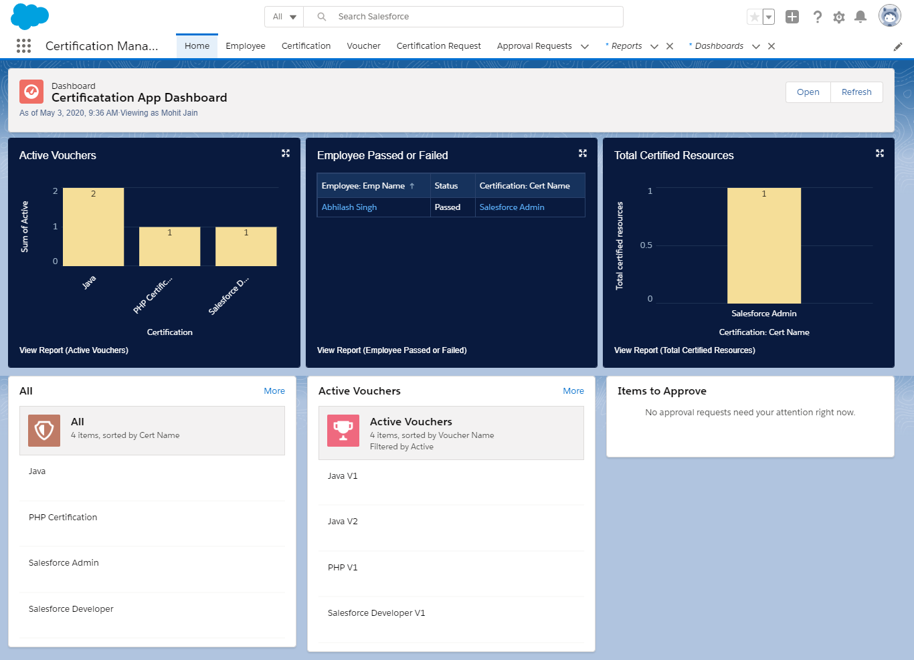

1. Employee Pages
2. Add Employee

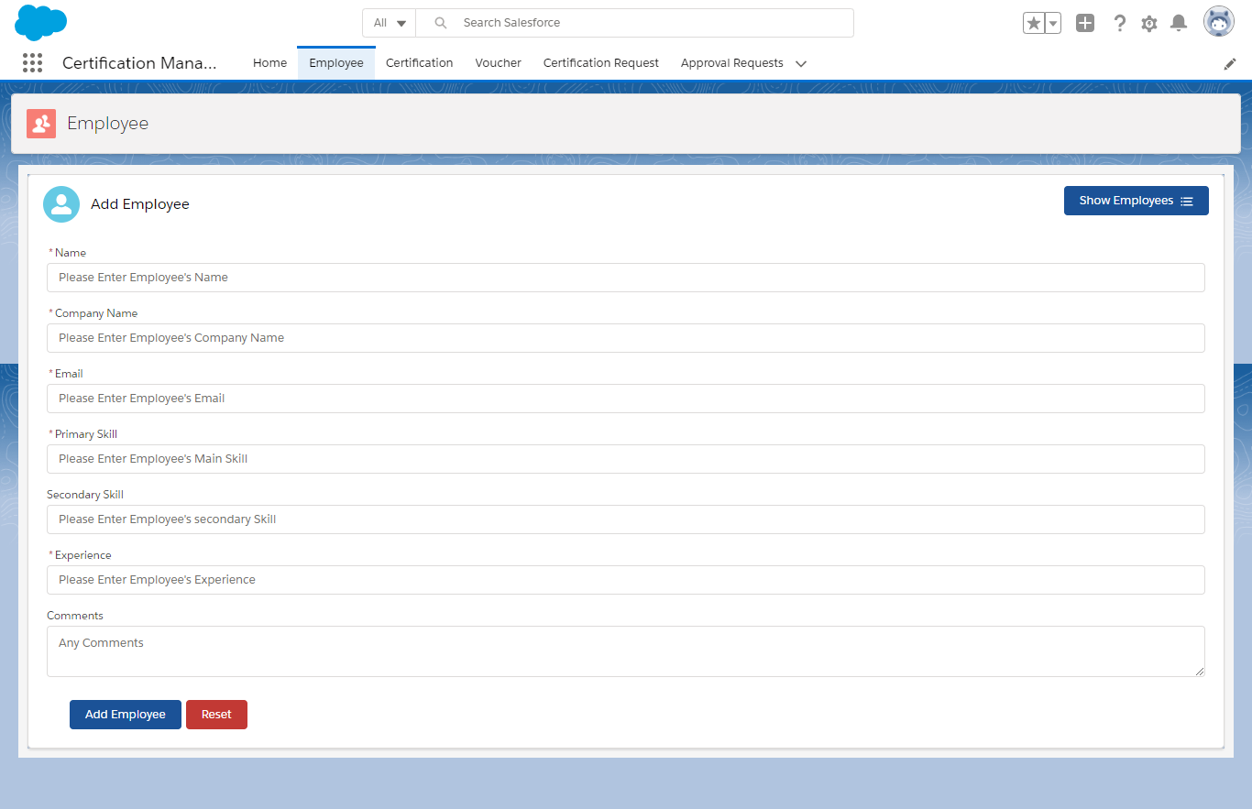

1. List of Employees

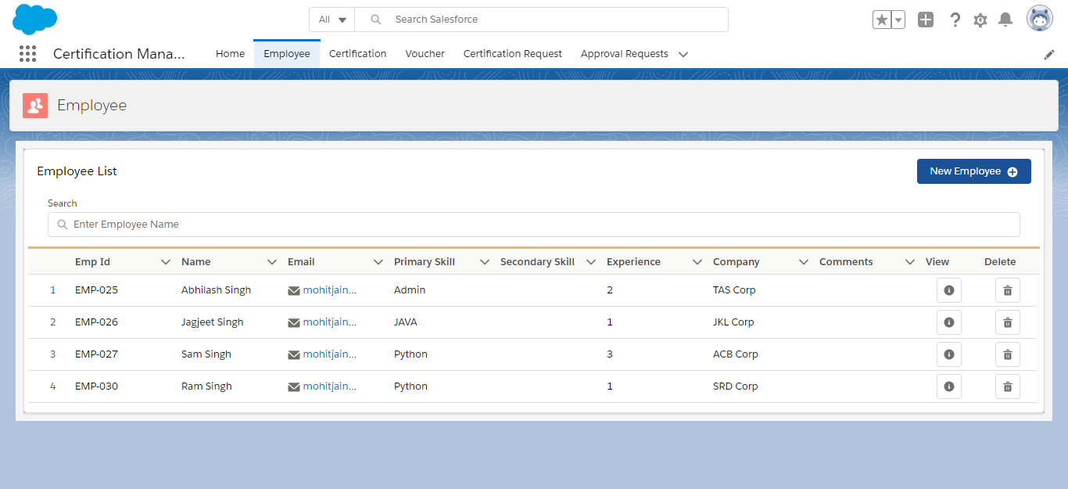

1. View Record Data

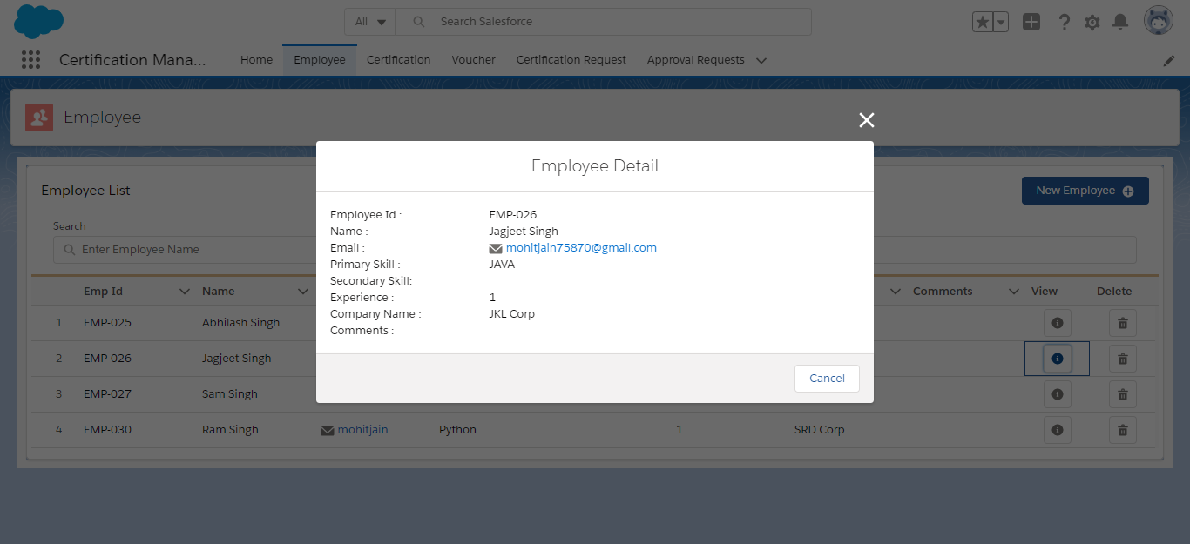

1. Certification Pages
2. Add Certification

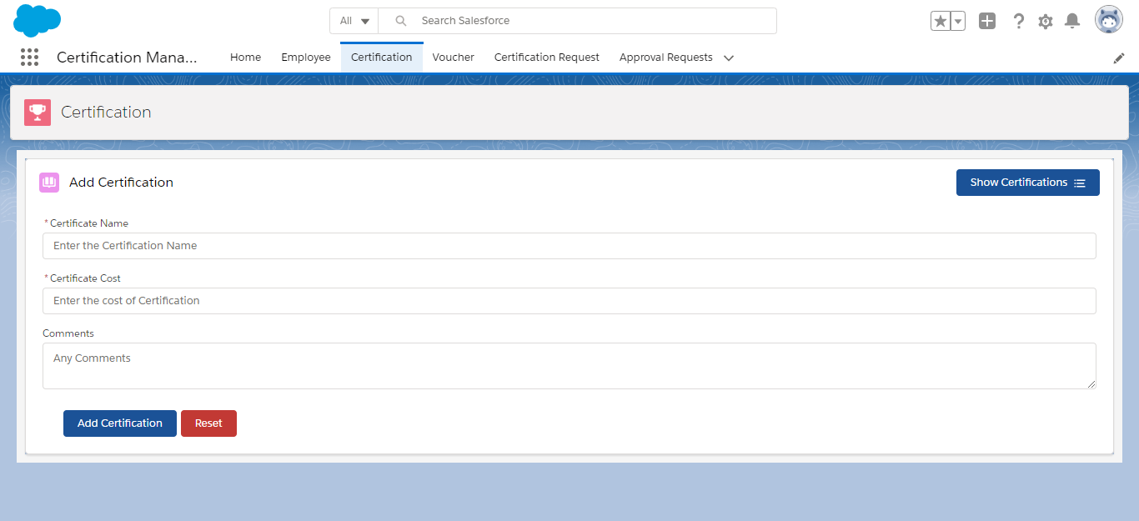

1. List of Certifications

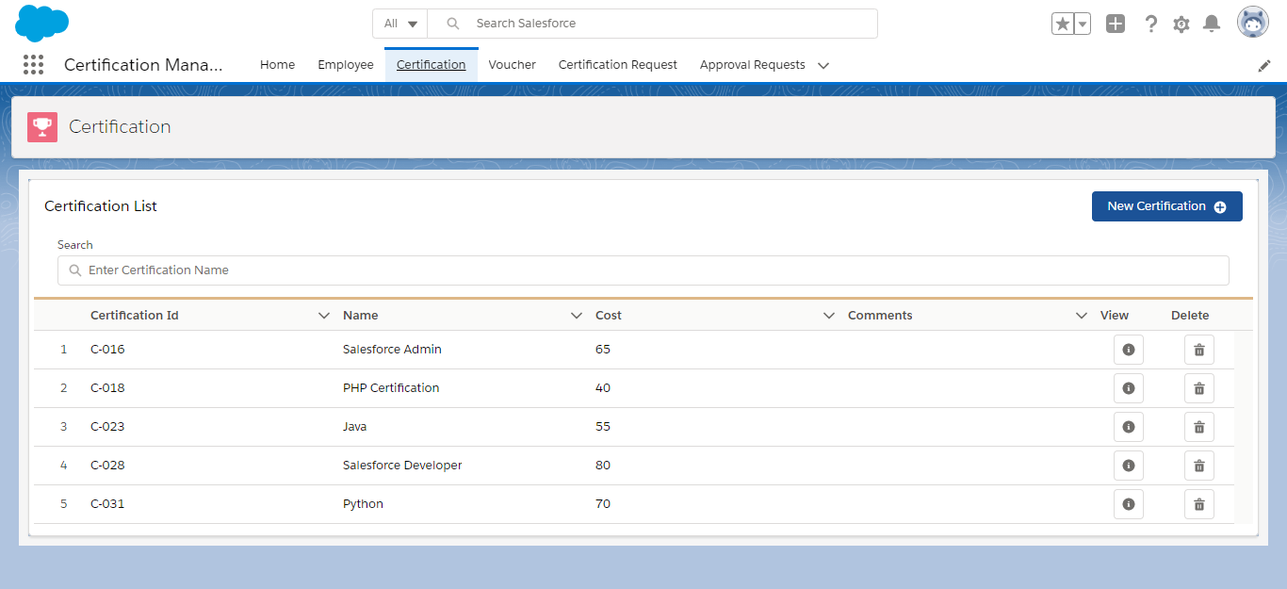

1. View Record Data

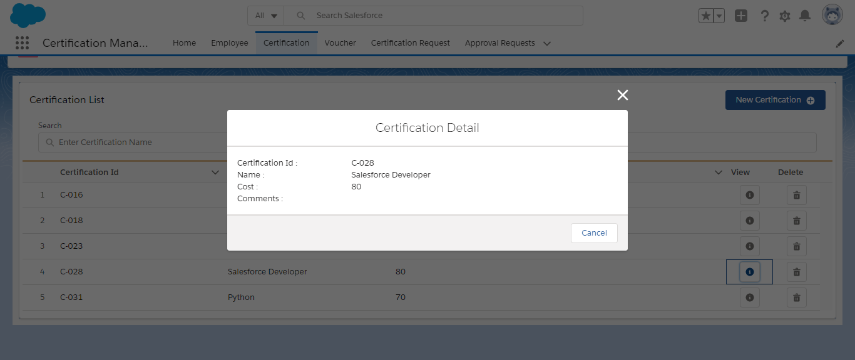

1. Voucher Pages
2. Add Voucher

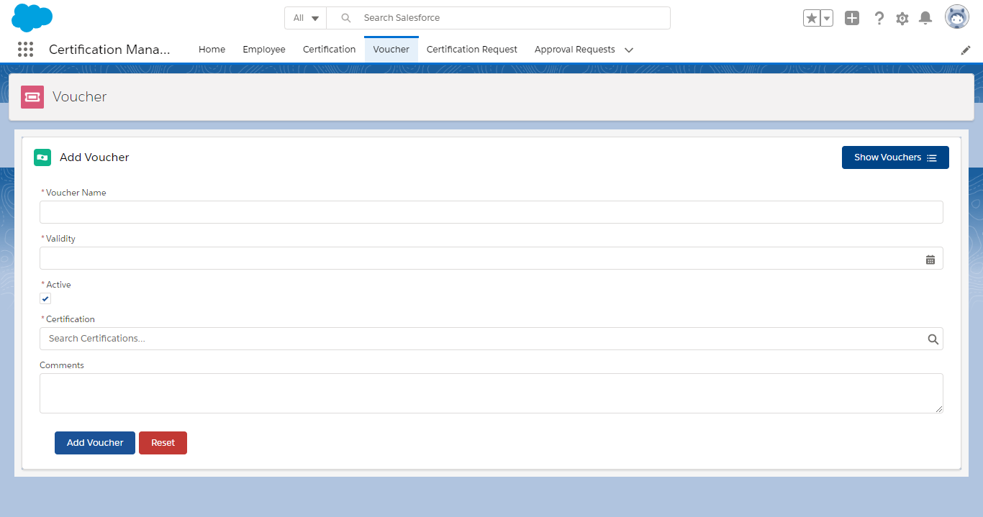

1. List of Vouchers

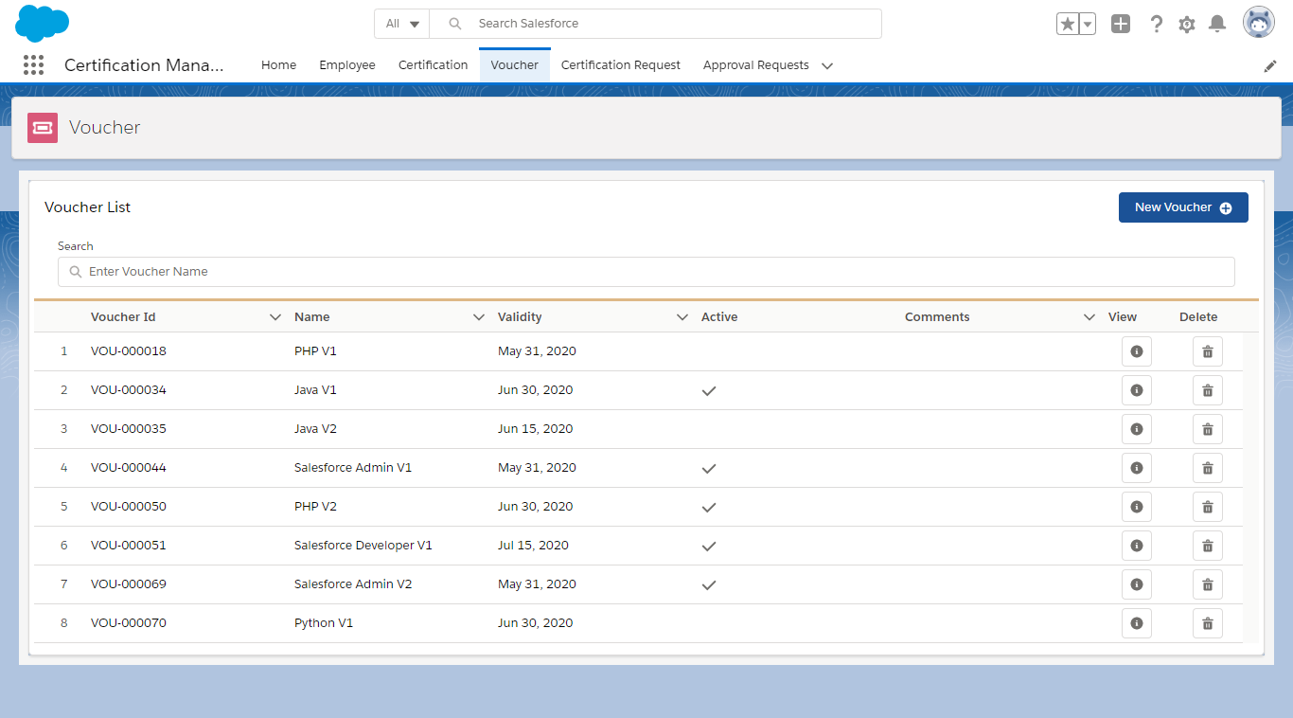

1. View Record Data

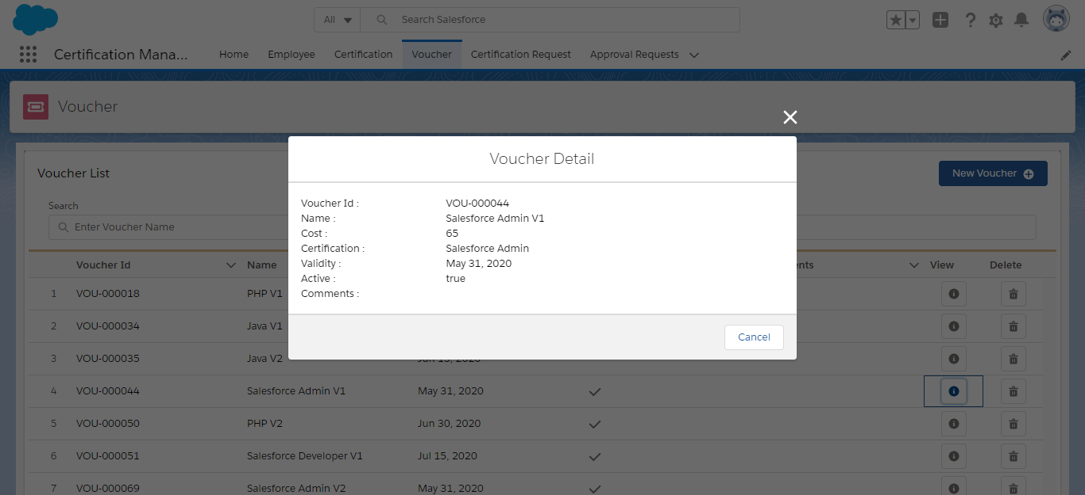

1. Certification Request Pages
2. Add Certification Request

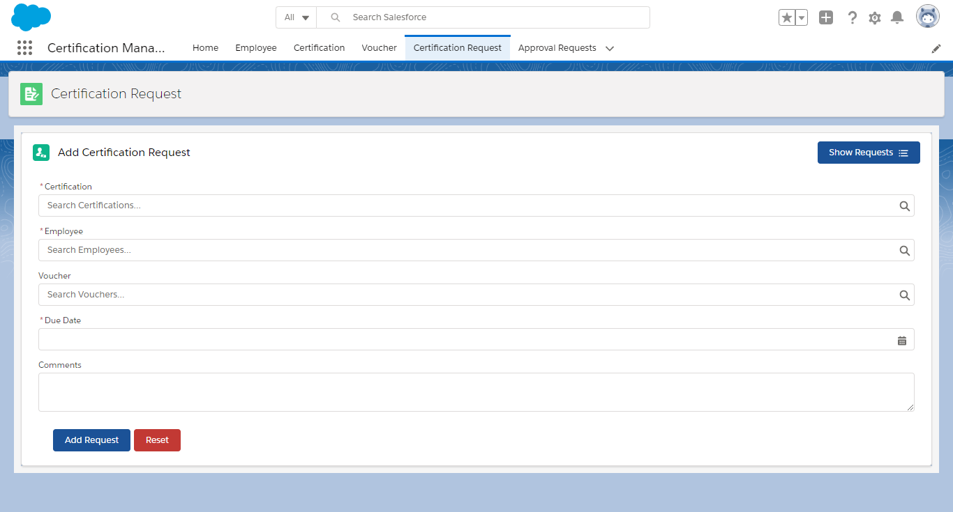

1. List of Certification Requests

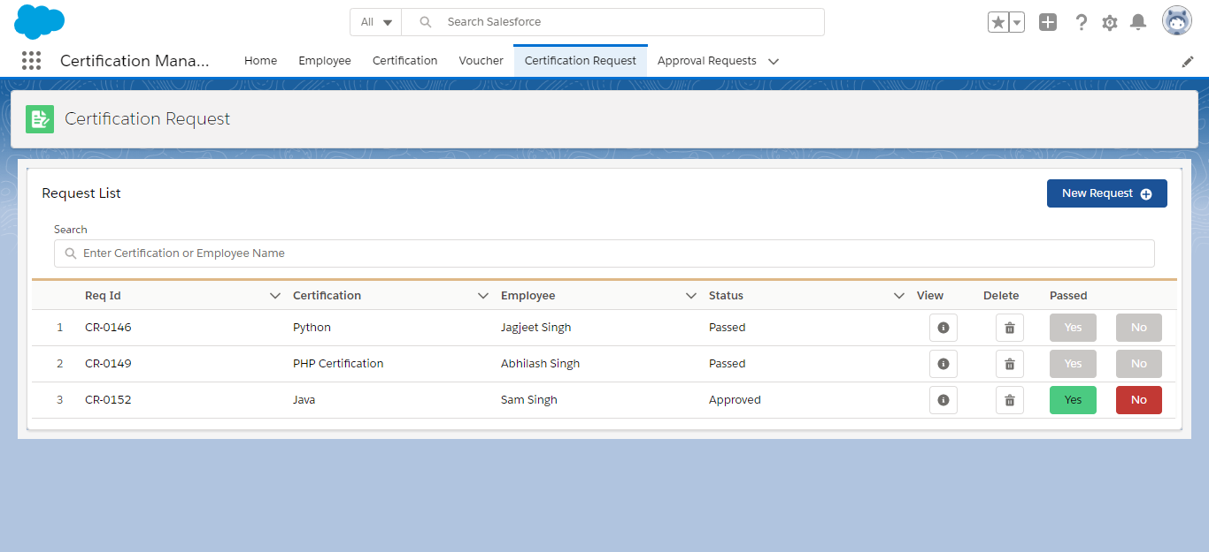

1. View Record Data

