INFORMATION RETRIEVAL ASSIGNMENT
Tokenizer Analysis and Regex Normalization
An evidence-based report on informal social-media text
Student | Enrollment No. | Registration No. | Section
Dev Kumar | 23UCS219 | 2317070 | B

Corpus | Tokenizers | Task 2 posts | Chars removed
100 posts | 3 | 100 | 340

Revised report | September 2026
Integrity note: The submitted social-media CSV does not meet every quota in the assignment brief. This report records the measured gap instead of presenting unsupported claims.

Github link : https://github.com/DevBarnwal/IR-assignment-01.git

Contents
Executive summary
1. Assignment scope and dataset audit
2. Methodology and implementation
3. Task 1 - tokenizer analysis
4. Task 2 - regex normalization
5. Discussion, limitations, and conclusion
6. Reproducibility, references, and AI usage statement

Executive summary
This report evaluates three tokenizers on 100 posts and applies a regex normalizer to a separate set of 100 repeated-character posts. The analysis is based on the CSV inputs and generated outputs in this solution folder. It preserves the useful measured findings while correcting the original report's unsupported claims about hashtags and emojis.
Bottom line: NLTK TweetTokenizer is the strongest observed option for the URL and mention structures present in this corpus, while NLTK word_tokenize produces the highest average token count. The regex pipeline is deterministic and removes 340 characters across the 100 normalization examples.

What must be fixed before final submission
- Expand the Task 1 corpus to include at least 20 hashtag posts, 20 URL posts, and 20 emoji posts.
- Re-run the analysis and regenerate the CSV files, graphs, and report after the corpus is corrected.
- Keep the compliance audit in the final report so quota satisfaction is directly checkable.

1. Assignment scope and dataset audit
The assignment asks for a performance comparison of at least two tokenizers on informal English social-media posts, with minimum coverage for hashtags, URLs, mentions, emojis, and slang or abbreviations. It also asks for a second set of 100 posts and a regular expression that normalizes repeated characters such as 'goooood' to 'good'.
The solution folder contains the required two datasets and implements both tasks. A direct audit of dataset/social_media_posts.csv was added for this revision. Counts below refer to posts containing a feature, except where occurrences are shown separately. The slang count uses a transparent heuristic over common markers such as lol, tbh, ngl, bruh, fr, and idk.
Requirement | Minimum posts | Observed posts | Observed occurrences | Status
Hashtags | 20 | 0 | 0 | Below quota
URLs | 20 | 8 | 8 | Below quota
Mentions | 20 | 22 | 23 | Meets quota
Slang/abbreviations | 20 | 51 | 68 | Meets quota
Emoji-bearing posts | 20 | 0 | 0 | Below quota
Interpretation: Mentions and slang/abbreviations meet the minimum under the audit rule. URLs, hashtags, and emoji-bearing posts do not. Therefore the current Task 1 results are useful for a partial comparison but cannot support a complete answer about hashtag or emoji preservation.

Datasets used
- dataset/social_media_posts.csv: 100 rows with columns id and post.
- dataset/repeated_char_posts.csv: 100 rows with columns id and original_post; every row contains at least one 3+ character run.

2. Methodology and implementation

2.1 Task 1 pipeline
Each social-media post is sent to NLTK word_tokenize, NLTK TweetTokenizer, and spaCy's English tokenizer. The program records token count, hashtag count, mention count, URL count, punctuation-token count, and an emoji count derived from the raw post. Results are written to output/tokenizer_results.csv and aggregate values to output/tokenizer_comparison.csv.

2.2 Task 2 pipeline
For each row in repeated_char_posts.csv, the RegexNormalizer applies the pattern below and writes the original text, normalized text, repeated-sequence count, characters removed, reduction percentage, and matched patterns to output/regex_results.csv.
Component | Implementation
Pattern | (.)\1{2,}
Replacement | \1\1
Effect | Reduce each run of 3 or more identical characters to 2 characters.
Graphs | Five PNG files in output/graphs/.

2.3 Methodological cautions
- The NLTK word tokenizer receives lowercased text, while TweetTokenizer and spaCy receive the original casing. Token-count comparisons therefore reflect both tokenization and this preprocessing difference.
- Emoji presence is counted once from the raw text and is not separately verified for each tokenizer. The current corpus contains no emoji-bearing posts, so preservation cannot be evaluated.
- Hashtag and URL preservation are inferred from tokenizer output. A stronger experiment would compare each output against feature annotations derived from the original post.

3. Task 1 - tokenizer analysis
The generated comparison table provides the following measured results for the current 100-post corpus. Average token count is computed over all rows; feature columns are summed across the corpus.
Tokenizer | Avg tokens | Hashtags | Mentions | URLs | Punctuation avg
NLTK Word | 11.08 | 0 | 23 | 0 | 0.32
NLTK Tweet | 10.63 | 0 | 23 | 8 | 0.00
spaCy | 10.93 | 0 | 23 | 8 | 0.00
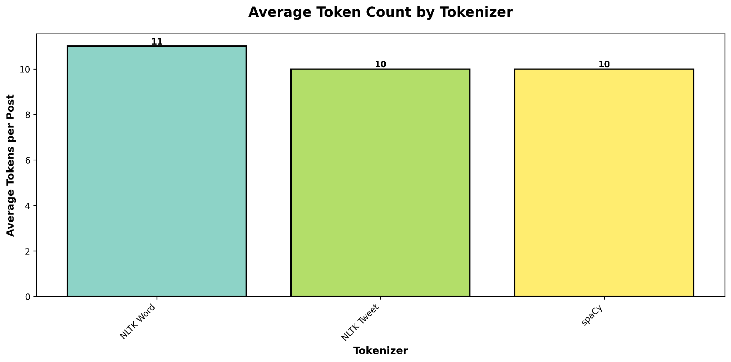
Figure 1. Average token count by tokenizer. Exact averages are reported in the table; the chart uses rounded values.

Answers to the assignment questions
Question | Evidence-based answer
Which tokenizer performs best on hashtags? | Cannot be determined from this corpus: there are 0 hashtag posts and all tokenizer totals are 0.
Which tokenizer preserves emojis correctly? | Cannot be determined from this corpus: there are 0 emoji-bearing posts and the raw-text emoji count is 0.
Which tokenizer generates the most tokens? | NLTK word_tokenize, with 11.08 average tokens per post.
What are the main strengths and weaknesses? | TweetTokenizer preserves the 8 observed URLs and 23 mentions; word_tokenize provides a useful baseline but fragments punctuation and observed URLs; spaCy is competitive for the same URLs and offers a wider NLP ecosystem.

3.1 Feature-preservation evidence
The feature charts should be read together with the dataset audit. The zero hashtag bars do not show that a tokenizer failed to preserve existing hashtags; they show that no hashtags were available to preserve. Likewise, the emoji chart describes corpus presence, not tokenizer-level preservation.
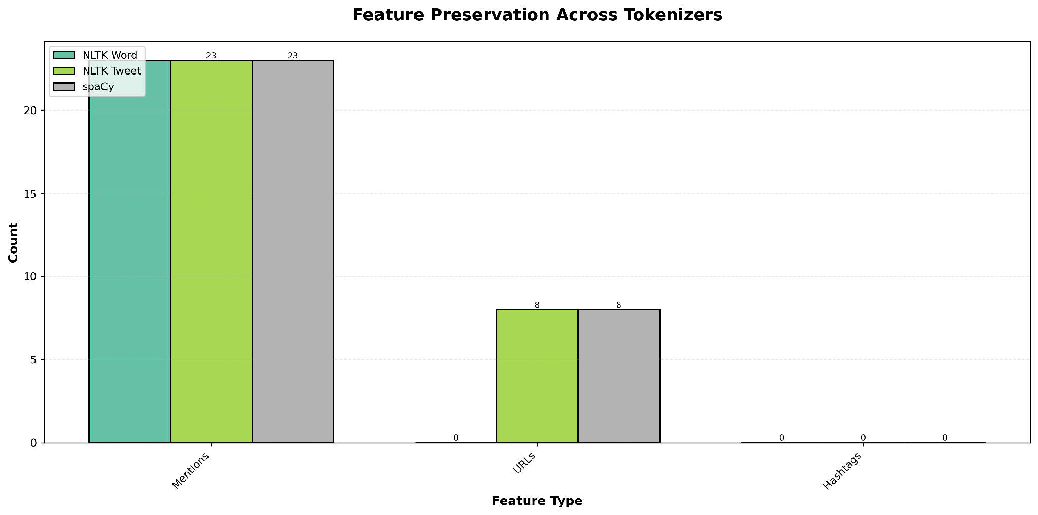
Figure 2. Multi-feature comparison for mentions, URLs, and hashtags in the current corpus.
Corpus check | Observed evidence | Implication
Hashtags | 0 posts; 0 occurrences | Hashtag preservation cannot be ranked.
Emojis | 0 posts; 0 occurrences | Emoji preservation cannot be evaluated.
URLs | 8 posts; 8 occurrences | TweetTokenizer and spaCy retain all 8; NLTK Word retains 0.
Mentions | 22 posts; 23 occurrences | All three tokenizers retain 23 mention occurrences.

4. Task 2 - regex normalization
Repeated characters can create many surface forms for the same word and reduce matching consistency during indexing. The submitted implementation uses a deterministic, language-agnostic pattern rather than a manually maintained dictionary.
Rule: The pattern (.)\1{2,} captures a character followed by at least two more copies. Replacing it with \1\1 keeps two copies, so 'goooood' becomes 'good' and 'sooooo' becomes 'soo'.

4.1 Representative transformations
Original | Normalized | Characters removed
omg this is sooooo goooood i loveeee it | omg this is soo good i lovee it | 8
noooooo way that's soooo crazyyy | noo way that's soo crazyy | 7
yessssss finally happened brooooo | yess finally happened broo | 7
i can't believe this nooooooo this is baaaaad | i can't believe this noo this is baad | 8
pleaseeeeee helpppp me i'm dyyyying | pleasee helpp me i'm dyying | 8
cooooool idea tbh pretty neeeeat | cool idea tbh pretty neeat | 6

4.2 Strengths and limitations of the rule
- Strengths: deterministic, easy to interpret, fast, and independent of a word list.
- Limitations: it does not infer the intended dictionary spelling, and it may change meaningful repetition inside identifiers, usernames, hashtags, URLs, or uppercase emphasis.
- The current assignment dataset is controlled for repeated characters; a broader evaluation should include posts with protected entities and unchanged control examples.

4.3 Task 2 results
Metric | Measured value
Posts processed | 100
Posts with repeated sequences | 100
Total repeated sequences | 133
Total characters removed | 340
Average characters removed per post | 3.40
Average reduction percentage | 8.72%
Maximum characters removed in one post | 8
Reduction distribution | 91 light (1-5 chars), 9 moderate (6-10 chars), 0 heavy
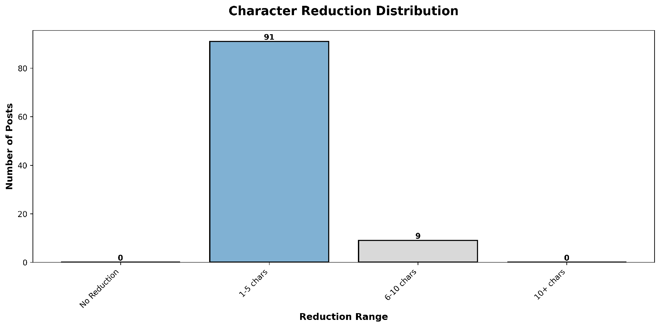
Figure 5. Distribution of characters removed by the normalization rule.
All 100 rows were processed successfully. The result is a normalization demonstration rather than a claim of semantic correctness: the pipeline reliably applies the rule, but deciding whether the normalized spelling is linguistically appropriate requires lexical or contextual evaluation.

5. Discussion, limitations, and conclusion

5.1 Strengths of the solution package
- Modular Python implementation with separate Task 1 and Task 2 modules.
- CSV exports preserve per-post results and make the analysis reproducible.
- The regex normalizer is explicit, deterministic, and easy to test.
- The revised report connects every conclusion to a measured output or an explicit limitation.

5.2 Limitations requiring attention
- The Task 1 corpus does not satisfy the assignment quotas for hashtags, URLs, or emojis.
- Emoji preservation is not a tokenizer-specific metric in the current implementation.
- The tokenizers receive different case treatment, which weakens direct comparability.
- The fixed two-character target is useful for the assignment but is not a general lexical normalizer.

5.3 Conclusion
For the current corpus, TweetTokenizer is the most useful default for preserving the observed social-media structures: it retains all 8 observed URLs and 23 mention occurrences, while producing the lowest average token count. spaCy matches the observed URL and mention totals and remains a good general-purpose option. NLTK word_tokenize is a useful baseline and produces the highest average token count at 11.08.
The regex pipeline meets the mechanical objective of normalizing repeated character runs across 100 posts, removing 340 characters with an 8.72% mean reduction. Before presenting the work as a complete answer to Task 1, the social-media dataset should be expanded to satisfy the required hashtag, URL, and emoji quotas, and the analysis should be re-run.
Recommended next step: Add at least 20 hashtag posts, 12 more URL posts, and 20 emoji posts to dataset/social_media_posts.csv while retaining the existing rows. Then regenerate output/tokenizer_results.csv, output/tokenizer_comparison.csv, and the four Task 1 graphs.

6. Reproducibility, references, and AI usage statement

6.1 Reproduction commands
From the project root, install the packages listed in code/requirements.txt and run the modules below. The spaCy script falls back to a blank English pipeline when en_core_web_sm is unavailable.
python -m pip install -r code/requirements.txt
python code/tokenizer_analysis.py
python code/regex_normalizer.py
python code/build_revised_report.py

6.2 Key project files
Path | Purpose
dataset/social_media_posts.csv | Task 1 input corpus.
dataset/repeated_char_posts.csv | Task 2 input corpus.
code/tokenizer_analysis.py | Three-tokenizer comparison and Task 1 graphs.
code/regex_normalizer.py | Repeated-character normalization and Task 2 graph.
output/*.csv | Per-post and aggregate measurements.
output/graphs/*.png | Generated visualizations.
report/report.docx | Editable source report.
report/Tokenization_and_Normalization_Report_Tasks_1-2_compressed.pdf | PDF export of the editable report.

6.3 References
- Bird, S., Klein, E., and Loper, E. Natural Language Processing with Python. O'Reilly Media.
- Honnibal, M., and Montani, I. spaCy: Industrial-Strength Natural Language Processing in Python.
- Han, B., and Baldwin, T. Lexical Normalisation of Short Text.
- NLTK documentation for word_tokenize and TweetTokenizer.
- Python documentation for regular expression operations.
- Pandas and Matplotlib documentation used for analysis and visualization.

6.4 AI usage statement
AI assistance was used for report restructuring, code and documentation review, explanation of NLP concepts, and visual organization. The dataset audit, quantitative values, CSV results, graphs, and conclusions in this revised report were checked against the local solution files. The final report explicitly identifies unsupported dataset claims and separates measured results from recommendations.

