An Internship Report
On
Web Developer Internship

Submitted To
School of Computer Science and Engineering
IILM University, Greater Noida, U.P.

In partial fulfilment of the requirement of degree of
B-Tech (CSE – Artificial Intelligence & Machine Learning)



Submitted By
MOHIT RAJPUT
Roll Number: 25SCS1003001547
Batch: 2025–2029

CANDIDATE'S DECLARATION

I, MOHIT RAJPUT, do hereby declare that the internship report titled “Web Developer Internship” has been prepared by me to fulfil the requirement of the 1-Month Web Developer Internship undertaken through Codec Technologies. The report is submitted as part of the academic requirements of the Bachelor of Technology (Computer Science and Engineering – Artificial Intelligence & Machine Learning) programme at IILM University, Greater Noida. All information and references used in this report have been appropriately acknowledged. I affirm that this report represents my work and understanding gained during the internship and has not been submitted to any other institute for any degree or diploma requirement. I shall be solely responsible for any copyright violation in this regard.

Student Name: MOHIT RAJPUT
Roll No.: 25SCS1003001547
Signature: __________________________

ACKNOWLEDGEMENT
I would like to express my sincere gratitude to everyone who supported me throughout my internship programme. I am thankful for the guidance, constructive learning environment, and practical exposure that helped me understand the concepts and workflow of modern web development.
I would like to thank Codec Technologies and the internship instructors for providing me with a structured 1-month Web Developer Internship programme. The week-wise learning modules helped me strengthen my understanding of HTML, CSS, JavaScript, responsive design, front-end frameworks, APIs, back-end development, databases, deployment concepts, testing, and debugging.
I am also grateful to IILM University, Greater Noida, and the faculty of the School of Computer Science and Engineering for their encouragement and support. Finally, I would like to thank my parents and well-wishers for their continuous motivation and support.

Student Name: MOHIT RAJPUT
Roll No.: 25SCS1003001547
Signature: __________________________

TABLE OF CONTENTS
1. Candidate's Declaration
2. Acknowledgement
3. Internship Completion Certificate / Offer Letter
4. Project Description
4.1 Introduction
4.2 Organization Profile
4.3 Problem Statement
4.4 Project Objectives
4.5 Scope of the Project
4.6 Technologies and Tools Used
4.7 System Architecture
4.8 Methodology
4.9 Project Features and Modules
4.10 Expected Outcomes
4.11 Conclusion
4.12 Certificates of Completion and Communication Proof
5. Bibliography / References

3. INTERNSHIP COMPLETION CERTIFICATE

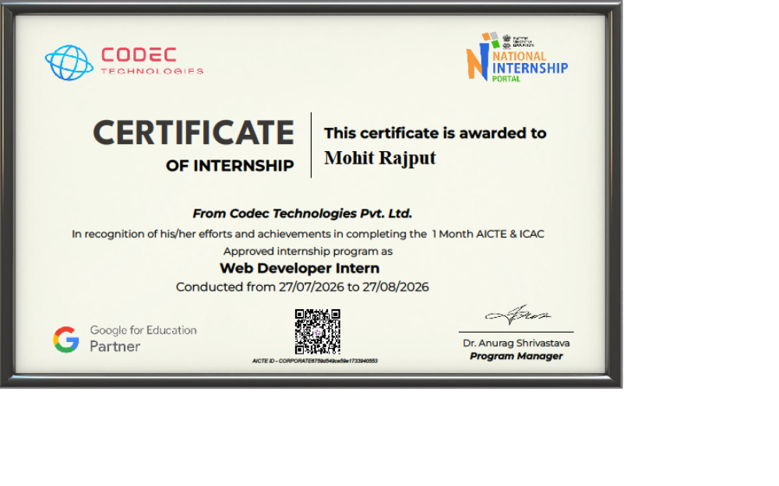
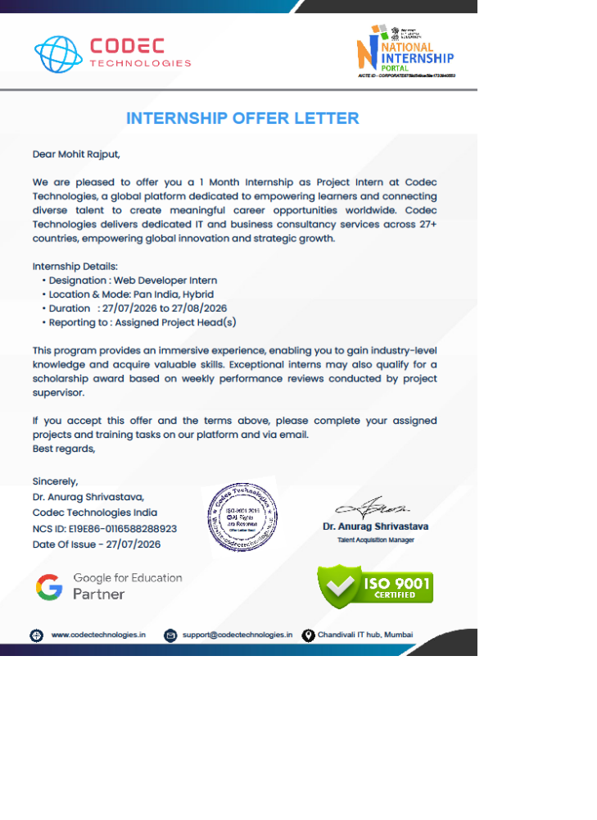
INTERNSHIP OFFER LETTER

4. PROJECT DESCRIPTION

4.1 Introduction
This report presents the work and learning undertaken during the 1-Month Web Developer Internship offered by Codec Technologies. The internship followed a structured, week-wise learning approach covering fundamental and advanced web development concepts, including HTML, CSS, JavaScript, responsive design, front-end frameworks, back-end development, databases, APIs, deployment, testing, and debugging.
The major project associated with this report is an “AI-Powered Recruitment & ATS Platform”. The project is designed as an Applicant Tracking System (ATS) with AI-based candidate screening. It focuses on helping recruiters manage candidate information, process resumes, compare applicant skills with job descriptions, rank candidates, visualize the hiring pipeline, and support interview scheduling.
The project combines modern front-end development with Python-based Natural Language Processing (NLP), a FastAPI back-end, and PostgreSQL for structured data management. It demonstrates how web technologies can be integrated with AI techniques to address a practical recruitment workflow.

4.2 Organization Profile
Codec Technologies is the organization through which the 1-Month Web Developer Internship programme was undertaken. According to the internship information provided, the programme follows a structured week-wise syllabus focused on full-stack web development concepts. The learning sequence begins with HTML, CSS, and JavaScript fundamentals; progresses to responsive design and front-end frameworks; introduces Node.js, Express, MongoDB, APIs, and deployment; and concludes with project-oriented work.
The internship provides exposure to both front-end and back-end development practices and emphasizes clean code, version control, testing, debugging, APIs, and deployment concepts. The structured format helps learners connect theoretical knowledge with practical web application development.

4.3 Problem Statement
Traditional recruitment processes can involve a large number of resumes and job applications. Manually reading every resume, comparing candidate skills with job requirements, ranking applicants, tracking hiring stages, and scheduling interviews can be time-consuming and difficult to manage. Recruiters may also find it challenging to maintain a consistent and organized view of candidates throughout the recruitment pipeline.
The problem addressed by this project is the need for a centralized Applicant Tracking System with AI-based assistance for candidate screening. The proposed platform aims to parse resumes, identify relevant information and skills, compare candidate profiles with job descriptions, generate a ranking, visualize the hiring pipeline, and support interview scheduling through an integrated web application.

4.4 Project Objectives
- To develop a centralized Applicant Tracking System for managing candidate and job application information.
- To implement resume parsing for extracting useful information from candidate resumes.
- To use AI/NLP-based processing to support candidate screening and ranking.
- To compare candidate skills with the requirements defined in job descriptions.
- To provide a hiring pipeline visualization for tracking candidate progress.
- To support interview scheduling as part of the recruitment workflow.
- To build a modern web-based interface using React.js.
- To develop API-based back-end services using FastAPI and store structured data using PostgreSQL.

4.5 Scope of the Project
The scope of the AI-Powered Recruitment & ATS Platform covers the major stages of a basic digital recruitment workflow. Recruiters can manage job descriptions and candidate applications through a centralized system. Candidate resumes can be processed to obtain relevant information for screening, and the extracted skills can be compared with the requirements of a particular job.
- Candidate profile and application management
- Resume parsing and information extraction
- AI/NLP-assisted skill identification
- Skill matching with job descriptions
- Candidate ranking based on relevant matching criteria
- Hiring pipeline visualization and stage tracking
- Interview scheduling support
- Front-end, back-end, and database integration
The project is designed as an academic internship project and proof-of-concept platform. The exact AI models, ranking algorithm, production deployment, authentication mechanisms, and external calendar integrations are implementation-dependent and are not specified in the provided project brief.

4.6 Technologies and Tools Used
Technology / Tool | Purpose
React.js | Front-end user interface and interactive dashboard development
Python (NLP) | AI-based resume analysis, skill extraction, matching, and candidate screening
FastAPI | Back-end API development and communication between the front end, AI logic, and database
PostgreSQL | Storage and management of structured candidate, job, application, and recruitment data

4.7 System Architecture
The proposed system follows a layered client-server architecture. The React.js front end acts as the user interface for recruiters. Requests are sent to the FastAPI back end, which coordinates application logic, AI/NLP-based processing, and communication with the PostgreSQL database. The AI/NLP module is used for resume parsing, skill matching, and candidate ranking.
RECRUITER / USER
↓
REACT.JS FRONT END
Dashboard • Candidate Management • Job Descriptions • Hiring Pipeline • Interview Scheduling
↓ API REQUESTS / RESPONSES
FASTAPI BACK END
Business Logic • REST APIs • Application Management • Integration Layer
↓
AI / NLP PROCESSING (PYTHON)
Resume Parsing • Skill Extraction • Job Matching • Candidate Ranking
↕
POSTGRESQL DATABASE
Candidates • Jobs • Applications • Pipeline Status • Interview Information

Architecture Explanation
- Presentation Layer: React.js provides the web interface through which recruiters interact with the system.
- API and Business Logic Layer: FastAPI handles requests, validates and processes data, and exposes application services.
- AI/NLP Layer: Python-based NLP processes resumes and compares extracted candidate skills with job requirements.
- Data Layer: PostgreSQL stores persistent and structured data related to jobs, candidates, applications, pipeline stages, and interviews.

4.8 Methodology
The project methodology is based on an iterative web application development workflow. The following phases describe the proposed implementation approach derived from the project features and stated technology stack.
Phase | Description
1. Requirement Analysis | Identify the recruitment workflow and define core requirements such as resume parsing, skill matching, ranking, pipeline tracking, and interview scheduling.
2. System Design | Define the major modules, user interactions, API structure, data flow, and database entities.
3. Database Design | Create a structured data model for candidates, jobs, applications, pipeline stages, and interview information.
4. Front-End Development | Develop the recruiter-facing interface and application views using React.js.
5. Back-End Development | Develop FastAPI services to manage application data and connect the front end with the database and AI processing layer.
6. AI/NLP Integration | Process resume content, identify relevant skills, compare them with job descriptions, and support candidate ranking.
7. Feature Integration | Integrate hiring pipeline visualization and interview scheduling into the recruitment workflow.
8. Testing and Refinement | Test individual modules and integrated workflows, identify errors, and improve usability and functionality.

4.9 Project Features and Modules

A. Resume Parsing and Candidate Ranking
This module focuses on processing submitted resumes and organizing candidate information for screening. The system can use Python and NLP techniques to identify relevant skills and information from resume content. The candidate information can then be evaluated against job requirements to support ranking.

B. Skill Matching with Job Descriptions
The skill matching module compares skills identified from candidate resumes with the skills or requirements defined in a job description. The purpose is to provide recruiters with an organized indication of how closely a candidate profile aligns with a specific role.

C. Hiring Pipeline Visualization
The hiring pipeline visualization module provides a structured view of candidates as they move through different recruitment stages. This helps recruiters track application progress and manage the overall hiring workflow.

D. Interview Scheduling
The interview scheduling module supports the organization of interview-related information within the recruitment process. It allows interview activities to be associated with relevant candidates and hiring stages.

E. Web-Based Dashboard
The React.js front end provides the user-facing interface for interacting with the system. The dashboard can serve as the central point for viewing candidates, job roles, screening results, pipeline status, and interview-related information.

4.10 Expected Outcomes
- A centralized web platform for managing the recruitment workflow.
- Improved organization of candidate and job application information.
- AI/NLP-assisted resume processing and candidate screening.
- Skill comparison between candidate resumes and job descriptions.
- Candidate ranking to assist recruiters in reviewing relevant profiles.
- A visual representation of the hiring pipeline.
- Integrated support for interview scheduling.
- Practical experience in combining React.js, Python NLP, FastAPI, and PostgreSQL in one application.

4.11 Conclusion
The AI-Powered Recruitment & ATS Platform demonstrates the application of modern web development and AI/NLP concepts to a practical recruitment problem. By combining resume parsing, skill matching, candidate ranking, hiring pipeline visualization, and interview scheduling, the project proposes a more structured approach to managing applicant data and recruitment activities.
The project also provides practical exposure to a modern full-stack architecture. React.js is used for the user interface, FastAPI supports the back-end API layer, Python enables AI/NLP-based processing, and PostgreSQL provides persistent data management. The internship learning on front-end development, APIs, back-end concepts, databases, deployment, testing, and debugging is relevant to understanding and developing such a web application.

4.12 Certificates of Completion and Communication Proof
The official Internship Completion Certificate and Internship Offer Letter, if issued, should be attached in Chapter 3 of this report. Any relevant communication proof or additional internship documentation may also be included as annexures where required by the university.

5. BIBLIOGRAPHY / REFERENCES
- Codec Technologies, “1-Month Web Developer Internship,” internship programme syllabus and project information provided for this report.
- React Documentation, React.js official documentation.
- FastAPI Documentation, FastAPI official documentation.
- Python Documentation, Python official documentation.
- PostgreSQL Documentation, PostgreSQL official documentation.
- IILM University, Greater Noida, School of Computer Science and Engineering.

