
“Navigator”

A

Project Report

submitted in partial fulfillment of the

requirements for the award of the degree of

BACHELOR OF TECHNOLOGY

in

SCHOOL OF COMPUTER SCIENCE ENGINEERING

by
Name | Roll No.
Dinanath Pandey | R970214020
Mohit Kumar Jaiswal | R111214073

under the guidance of

Mr. Chaitanya Sharma

Project Coordinator

IBMCE HEADSTART

Department of Computer Science & Engineering

School of Computer Science Engineering

University of Petroleum & Energy Studies

Bidholi, Via Prem Nagar, Dehradun, UK

June-July 2017

i


CANDIDATE’s DECLARATION

We hereby certify that the project work entitled “Navigator” in partial fulfillment of the requirements for the award of the Degree of BACHELOR OFTECHNOLOGY in COMPUTER SCIENCE AND ENGINEERING with specialization in IT INFRASTRUCTURE MANAGEMENT and submitted to the Department of Computer Science & Engineering at School Of Computer Science Engineering, University of Petroleum & Energy Studies, Dehradun, is an authentic record of our work carried out during a period from June, 2017 to July, 2017 under the supervision of Mr. Chaitanya Sharma, Project Coordinator IBMCE HEADSTART

The matter presented in this project has not been submitted by us for the award of any other degree of this or any other University

Name : Dinanath Pandey Mohit Kumar Jaiswal
Roll no : R970214020 R111214073

This is to certify that the above statement made by the candidate is correct to the best of my knowledge.

Date: 14th July 2017

Dr. Durgansh Sharma Head-Department of Systemics Program Head of B. Tech CSE (IT) School of Computer Science Engineering University of Petroleum & Energy Studies Dehradun – 248 001 (Uttarakhand)

Mr. Chaitanya Sharma

Project Coordinator

IBMCE HEADSTART

ii


ACKNOWLEDGEMENT

We wish to express our deep gratitude to our Project Coordinator Mr. Chaitanya Sharma for all advice, encouragement and constant support he has given us throughout our project work. This work would not have been possible without his support and valuable suggestions.

We sincerely thank to our respected Program Head of the Department, Mrs. Saumlya for his great support in doing our project in Area at IBMCE HEADSTART.

We are also grateful to Mr. Manish manager of IBMCE HEADSTART, for giving us the necessary facilities to carry out our project work successfully.

We would like to thank all our friends for their help and constructive criticism during our project work. Finally, we have no words to express our sincere gratitude to our parents who have shown us this world and for every support they have given us.

Name : | Dinanath Pandey | Mohit Kumar Jaiswal
Roll no : | R970214020 | R111214073

iii

ABSTRACT

Big Data is a term for data sets that are so large or complex that traditional data processing application software is inadequate to deal with them. Challenges include capture, storage, analysis, data cu ration, search, sharing, transfer, visualization, querying, and updating and information privacy.

Hadoop is a technology that deals with Big Data and complex data processing, therefore it requires high performance machine to carry out its computations. Performance of a machine depends on various physical factors such as Processor Time, Memory, Hard Drive Space, and Network Bandwidth.

The main objective of this research are utilizing the capabilities of Hadoop for mining high volumes of data and organizing it for navigation in geographical order and proposing a algorithm that is effective and light weighted in terms of the Big Data that it uses for searching the nearest tourist place which is in range of 25kms from the user city. This paper shows how Hadoop manages Big Data of 2.4 million cities and provides a tourist places within in radius of 25 km from user city by applying Haversine formula.

Keywords: Big Data, Hadoop, Navigation, Haversine formula, etc.

iv
TABLE OF CONTENTS

S.No. |  | Contents | Page No
1.Introduction |  |  | 1
1.1. | History |  | 1
1.2. | Navigator |  | 2
1.3. | Hadoop Distributed File System |  | 3
1.3.1. Name Node |  |  | 5
1.3.2. Image and Journal |  |  | 5
1.3.3. Data Nodes |  |  | 5
1.3.4. HDFS Clients |  |  | 6
1.3.5. Checkpoint Node |  |  | 7
1.3.6. Backup Node |  |  | 7
1.3.7. Upgrades and File System Snapshots |  |  | 8
1.3.8. Block |  |  | 9
1.4. | Requirement Analysis |  | 9
1.4.1 Hardware Requirements |  |  | 9
1.4.2. Software Requirements |  |  | 9
1.5. | Objectives |  | 9

2. Implementation | 10
2.1. Given Data | 10
2.2. Steps for implementation | 10
3. References | 13


CHAPTER 1

1. INTRODUCTION

1.1 HISTORY

The genesis of Hadoop was the "Google File System" paper that was published in October 2003. [1] This paper spawned another one from Google – "MapReduce: Simplified Data Processing on Large Clusters". [2] Development started on the Apache Nutch project, but was moved to the new Hadoop subproject in January 2006. [3] Doug Cutting, who was working at Yahoo! at the time, [4] named it after his son's toy elephant. [5] The initial code that was factored out of Nutch consisted of about 5,000 lines of code for HDFS and about 6,000 lines of code for MapReduce.

The core of Apache Hadoop consists of a storage part, known as Hadoop Distributed File System (HDFS), and a processing part which is a MapReduce programming model. Hadoop splits files into large blocks and distributes them across nodes in a cluster. It then transfers packaged code into nodes to process the data in parallel. This approach takes advantage of data locality, [6] where nodes manipulate the data they have access to. This allows the dataset to be processed faster and more efficiently than it would be in a more conventional supercomputer architecture that relies on a parallel file system where computation and data are distributed via high-speed networking. [7][8]

The base Apache Hadoop framework is composed of the following modules:
- Hadoop Common – contains libraries and utilities needed by other Hadoop modules;
- Hadoop Distributed File System (HDFS) – a distributed file-system that stores data on commodity machines, providing very high aggregate bandwidth across the cluster;
- Hadoop YARN – a platform responsible for managing computing resources in clusters and using them for scheduling users' applications,[9][10] and
- Hadoop MapReduce – an implementation of the MapReduce programming model for large-scale data processing.
The term Hadoop has come to refer not just to the aforementioned base modules and sub-modules, but also to the ecosystem,[11] or collection of additional software packages that can be installed on top of or alongside Hadoop, such as Apache Pig, Apache Hive, Apache HBase, Apache Phoenix, Apache Spark, Apache ZooKeeper, Cloudera Impala, Apache Flume, Apache Sqoop, Apache Oozie, and Apache Storm.[12]
Apache Hadoop's MapReduce and HDFS components were inspired by Google papers on their MapReduce and Google File System. [13]
The Hadoop framework itself is mostly written in the Java programming language, with some native code in C and command line utilities written as shell scripts. Though MapReduce Java code is common, any programming language can be used with "Hadoop Streaming" to implement the "map" and "reduce" parts of the user's program.[14] Other projects in the Hadoop ecosystem expose richer user interfaces.

1.2. NAVIGATOR

Content creation services are moving uphill with delivery models especially designed to cater to cross industry user. The business requires various types and levels of skills to capture, collect, curate for bring it to ready for consumption state. A leading content provider with world-wide user base is targeting content for travel agencies to provide meaning information about the destinations they are travelling to. The team came up with a wonderful idea to prepare content ready for exploration in EWNS directions. This could be possible only if the content is available in geocoded format. Leveraging Wikipedia content which is getting geo coded off late and can be relied upon owing to its crowdsourcing methodology. The challenge taken up requires mining high volumes of data and organizing it for navigation in geographical order. The team cracked a way to handle this complexity by leveraging the map reduce paradigm. The name of the data service is being called as the Navigator, which will allow their customer to render the content in all 4 directions based on the end user’s desire to navigate.

It is required to design & develop a framework for regular mining of “areas of interest in close vicinity” for the stream of travel agency’s customers. The list of cities that will be visited by its customer in near future is obtained from the travel portal on a periodic basis. This list becomes the seed for mining the “areas of interest in a particular city”. This framework accepts the seed file containing the list of cities and their latitude and longitudes. The big data dump of geocoded Wikipedia articles is mined to extract articles that are falling within a fixed radius, say 20 kms, of each city. The city-wise, “areas of interest (i.e. articles)” are generated in a JSON format that follows a navigational order of EWNS. Thus for a city, there will be series of searches in a single direction and the resultant entries will be organized based on their distance from the city’s latitude and longitude. The target file generated from this activity will contain geographical location (city name), geo-location parameters such as latitude and longitude, article URI and direction tag (East, West, North, South). This output is subsequently used by the agency to populate customer’s mobile app feed, so that the details of the attractions become available to customers in a timely manner along with navigation feature. Tips on creating this framework are outlined below.

The problem has twofold complexity, which needs to be addressed. First, the big data dump of Wikipedia entries is available in N-Triples (NT) format. N-Triples is a line-based, plain text format for encoding an RDF graph. The simplest triple statement is a sequence of (subject, predicate, object) terms, separated by whitespace and terminated by ‘.’ after each triple.

Second, taking geo-location parameters of the cities in seed file as a reference, determine an approximate boundary of parameters within 20 or 25 kilometers of the city in question. Consider each city’s geo-location parameters as a starting point to find the Wikipedia content about places or event locations falling next in the direction (EWNS) and is within the boundary parameters. This can be achieved by applying the Haversine formula that gives the distances between two points on a sphere from their longitudes and latitudes. The extracted data from the data dump iscaptured in the output JSON file.is required to design & develop a framework for regular mining of “places of interests” for the stream of agency’s customers.

2

The list of cities that will be visited by its customer in near future is obtained from the travel portal on a periodic basis. This list becomes the seed for mining the “places of interest”. This framework accepts the seed file containing the list of cities and their latitude and longitudes.

The big data dump of geocoded Wikipedia articles is mined to extract articles that are falling within a fixed radius, say 20 Kilometers, of each city. The city-wise, “nearby attractions (i.e. articles)” are generated in a JSON format. This output is subsequently used by the agency to populate customer’s mobile app feed, so that the details of the attractions become available to customers in a timely manner.

1.3. HADOOP DISTRIBUTED FILE SYSTEM (HDFS)
HDFS is a Java-based file system that provides scalable and reliable data storage, and it was designed to span large clusters of commodity servers. HDFS has demonstrated production scalability of up to 200 PB of storage and a single cluster of 4500 servers, supporting close to a billion files and blocks. When that quantity and quality of enterprise data is available in HDFS, and YARN enables multiple data access applications to process it, Hadoop users can confidently answer questions that eluded previous data platforms.
HDFS is a scalable, fault-tolerant, distributed storage system that works closely with a wide variety of concurrent data access applications, coordinated by YARN. HDFS will “just work” under a variety of physical and systemic circumstances. By distributing storage and computation across many servers, the combined storage resource can grow linearly with demand while remaining economical at every amount of storage.
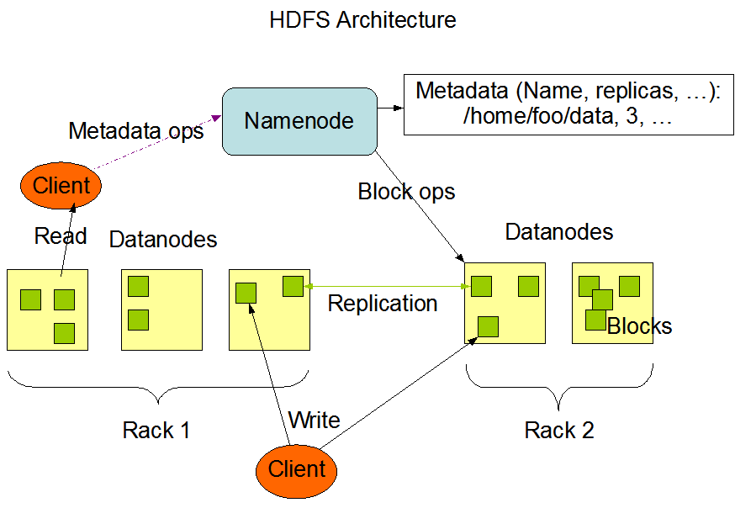Figure 1.3.1 Architecture of HDFS
3

Features of HDFS
- It is suitable for the distributed storage and processing.
- Hadoop provides a command interface to interact with HDFS.
- The built-in servers of namenode and datanode help users to easily check the status of cluster.
- Streaming access to file system data.
- HDFS provides file permissions and authentication.

Hadoop deals with Big Data and complex data processing, therefore it requires high performance machine to carry out its computations. Performance of a machine depends on various physical factors such as
- Processor time
- Memory
- Hard drive space
- Network bandwidth

Increasing the performance of the machine can be achieved in merely two ways :

- Vertical Scaling of the machine - Vertical scaling means that you scale by adding more power (CPU, RAM) to an existing machine. Vertical-scaling is often limited to the capacity of a single machine, scaling beyond that capacity often involves downtime of the system and further comes with an upper limit, beyond which scaling is not possible.
- Horizontal scaling of the machine - Horizontal scaling means that you scale by adding more machines into your pool of resources. If a cluster requires more resources to improve performance, an administrator can scale out by adding more machines to the cluster, thus multiplying the performance.

Vertical scaling does not sounds cost friendly because addition of high performing resources can be costly. As Hadoop follows a cost effective model, it uses commodity hardware which are scaled horizontally to increase the overall performance.But as it is said everything comes with a price.Whenever multiple machines are used in cooperation with one another, the probability of failures rises. Probable causes of failure may be

- Break down of switches and router may lead to partial or total network failure.
- Unexpected network congestion may cause data arrival delays at a particular point of time.
- Individual compute nodes may overheat, crash, experience hard drive failures, or run out of memory or disk space.
- Clocks may become desynchronized, lock files may not be released, parties involved in distributed atomic transactions may lose their network connections part-way through, etc.

Therefore, To incorporate multiple machines Hadoop uses a Distributed File System model known as Hadoop Distributed File System as its primary storage component. It was designed after the Google File System (GFS).

4

1.3.1. NameNode
The HDFS namespace is a hierarchy of files and directories. Files and directories are represented on the NameNode by inodes. Inodes record attributes like permissions, modification and access times, namespace and disk space quotas. The file content is split into large blocks (typically 128 megabytes, but user selectable file-by-file), and each block of the file is independently replicated at multiple DataNodes (typically three, but user selectable file-by-file). The NameNode maintains the namespace tree and the mapping of blocks to DataNodes. The current design has a single NameNode for each cluster. The cluster can have thousands of DataNodes and tens of thousands of HDFS clients per cluster, as each DataNode may execute multiple application tasks concurrently.

1.3.2. Image and Journal
The inodes and the list of blocks that define the metadata of the name system are called the image. NameNode keeps the entire namespace image in RAM. The persistent record of the image stored in the NameNode’s local native filesystem is called a checkpoint. The NameNode records changes to HDFS in a write-ahead log called the journal in its local native filesystem. The location of block replicas are not part of the persistent checkpoint.
Each client-initiated transaction is recorded in the journal, and the journal file is flushed and synced before the acknowledgment is sent to the client. The checkpoint file is never changed by the NameNode; a new file is written when a checkpoint is created during restart, when requested by the administrator, or by the CheckpointNode described in the next section. During startup the NameNode initializes the namespace image from the checkpoint, and then replays changes from the journal. A new checkpoint and an empty journal are written back to the storage directories before the NameNode starts serving clients.
For improved durability, redundant copies of the checkpoint and journal are typically stored on multiple independent local volumes and at remote NFS servers. The first choice prevents loss from a single volume failure, and the second choice protects against failure of the entire node. If the NameNode encounters an error writing the journal to one of the storage directories it automatically excludes that directory from the list of storage directories. The NameNode automatically shuts itself down if no storage directory is available.
The NameNode is a multithreaded system and processes requests simultaneously from multiple clients. Saving a transaction to disk becomes a bottleneck since all other threads need to wait until the synchronous flush-and-sync procedure initiated by one of them is complete. In order to optimize this process, the NameNode batches multiple transactions. When one of the NameNode’s threads initiates a flush-and-sync operation, all the transactions batched at that time are committed together. Remaining threads only need to check that their transactions have been saved and do not need to initiate a flush-and-sync operation.
1.3.3. DataNodes
Each block replica on a DataNode is represented by two files in the local native filesystem. The first file contains the data itself and the second file records the block’s metadata including checksums for the data and the generation stamp.

5
The size of the data file equals the actual length of the block and does not require extra space to round it up to the nominal block size as in traditional filesystems. Thus, if a block is half full it needs only half of the space of the full block on the local drive.
During startup each DataNode connects to the NameNode and performs a handshake. The purpose of the handshake is to verify the namespace ID and the software version of the DataNode. If either does not match that of the NameNode, the DataNode automatically shuts down.
The namespace ID is assigned to the filesystem instance when it is formatted. The namespace ID is persistently stored on all nodes of the cluster. Nodes with a different namespace ID will not be able to join the cluster, thus protecting the integrity of the filesystem. A DataNode that is newly initialized and without any namespace ID is permitted to join the cluster and receive the cluster’s namespace ID.
After the handshake the DataNode registers with the NameNode. DataNodes persistently store their unique storage IDs. The storage ID is an internal identifier of the DataNode, which makes it recognizable even if it is restarted with a different IP address or port. The storage ID is assigned to the DataNode when it registers with the NameNode for the first time and never changes after that.
A DataNode identifies block replicas in its possession to the NameNode by sending a block report. A block report contains the block ID, the generation stamp and the length for each block replica the server hosts. The first block report is sent immediately after the DataNode registration. Subsequent block reports are sent every hour and provide the NameNode with an up-to-date view of where block replicas are located on the cluster.
During normal operation DataNodes send heartbeats to the NameNode to confirm that the DataNode is operating and the block replicas it hosts are available. The default heartbeat interval is three seconds. If the NameNode does not receive a heartbeat from a DataNode in ten minutes the NameNode considers the DataNode to be out of service and the block replicas hosted by that DataNode to be unavailable. The NameNode then schedules creation of new replicas of those blocks on other DataNodes.
Heartbeats from a DataNode also carry information about total storage capacity, fraction of storage in use, and the number of data transfers currently in progress. These statistics are used for the NameNode’s block allocation and load balancing decisions.
The NameNode does not directly send requests to DataNodes. It uses replies to heartbeats to send instructions to the DataNodes. The instructions include commands to replicate blocks to other nodes, remove local block replicas, re-register and send an immediate block report, and shut down the node.
These commands are important for maintaining the overall system integrity and therefore it is critical to keep heartbeats frequent even on big clusters. The NameNode can process thousands of heartbeats per second without affecting other NameNode operations.
1.3.4. HDFS Clients
User applications access the filesystem using the HDFS client, a library that exports the HDFS filesystem interface.

6
Like most conventional filesystems, HDFS supports operations to read, write and delete files, and operations to create and delete directories. The user references files and directories by paths in the namespace. The user application does not need to know that filesystem metadata and storage are on different servers, or that blocks have multiple replicas.
When an application reads a file, the HDFS client first asks the NameNode for the list of DataNodes that host replicas of the blocks of the file. The list is sorted by the network topology distance from the client. The client contacts a DataNode directly and requests the transfer of the desired block. When a client writes, it first asks the NameNode to choose DataNodes to host replicas of the first block of the file. The client organizes a pipeline from node-to-node and sends the data. When the first block is filled, the client requests new DataNodes to be chosen to host replicas of the next block. A new pipeline is organized, and the client sends the further bytes of the file. Choice of DataNodes for each block is likely to be different.
Unlike conventional filesystems, HDFS provides an API that exposes the locations of a file blocks. This allows applications like the MapReduce framework to schedule a task to where the data are located, thus improving the read performance. It also allows an application to set the replication factor of a file. By default a file’s replication factor is three. For critical files or files which are accessed very often, having a higher replication factor improves tolerance against faults and increases read bandwidth.
1.3.5. Checkpoint Node
The NameNode in HDFS, in addition to its primary role serving client requests, can alternatively execute either of two other roles, either a CheckpointNode or a BackupNode. The role is specified at the node startup.
The CheckpointNode periodically combines the existing checkpoint and journal to create a new checkpoint and an empty journal. The CheckpointNode usually runs on a different host from the NameNode since it has the same memory requirements as the NameNode. It downloads the current checkpoint and journal files from the NameNode, merges them locally, and returns the new checkpoint back to the NameNode.
Creating periodic checkpoints is one way to protect the filesystem metadata. The system can start from the most recent checkpoint if all other persistent copies of the namespace image or journal are unavailable. Creating a checkpoint also lets the NameNode truncate the journal when the new checkpoint is uploaded to the NameNode. HDFS clusters run for prolonged periods of time without restarts during which the journal constantly grows. If the journal grows very large, the probability of loss or corruption of the journal file increases. Also, a very large journal extends the time required to restart the NameNode. For a large cluster, it takes an hour to process a week-long journal. Good practice is to create a daily checkpoint.
1.3.6. Backup Node
A recently introduced feature of HDFS is the BackupNode. Like a CheckpointNode, the BackupNode is capable of creating periodic checkpoints, but in addition it maintains an in-memory, up-to-date image of the filesystem namespace that is always synchronized with the state of the NameNode.
The BackupNode accepts the journal stream of namespace transactions from the active NameNode, saves them in journal on its own storage directories, and applies these transactions to its own namespace image in memory.
7
The NameNode treats the BackupNode as a journal store the same way as it treats journal files in its storage directories. If the NameNode fails, the BackupNode’s image in memory and the checkpoint on disk is a record of the latest namespace state.
The BackupNode can create a checkpoint without downloading checkpoint and journal files from the active NameNode, since it already has an up-to-date namespace image in its memory. This makes the checkpoint process on the BackupNode more efficient as it only needs to save the namespace into its local storage directories.
The BackupNode can be viewed as a read-only NameNode. It contains all filesystem metadata information except for block locations. It can perform all operations of the regular NameNode that do not involve modification of the namespace or knowledge of block locations. Use of a BackupNode provides the option of running the NameNode without persistent storage, delegating responsibility of persisting the namespace state to the BackupNode.
1.3.7. Upgrades and Filesystem Snapshots
During software upgrades the possibility of corrupting the filesystem due to software bugs or human mistakes increases. The purpose of creating snapshots in HDFS is to minimize potential damage to the data stored in the system during upgrades.
The snapshot mechanism lets administrators persistently save the current state of the filesystem, so that if the upgrade results in data loss or corruption it is possible to rollback the upgrade and return HDFS to the namespace and storage state as they were at the time of the snapshot.
The snapshot (only one can exist) is created at the cluster administrator’s option whenever the system is started. If a snapshot is requested, the NameNode first reads the checkpoint and journal files and merges them in memory. Then it writes the new checkpoint and the empty journal to a new location, so that the old checkpoint and journal remain unchanged.
During handshake the NameNode instructs DataNodes whether to create a local snapshot. The local snapshot on the DataNode cannot be created by replicating the directories containing the data files as this would require doubling the storage capacity of every DataNode on the cluster. Instead each DataNode creates a copy of the storage directory and hard links existing block files into it. When the DataNode removes a block it removes only the hard link, and block modifications during appends use the copy-on-write technique. Thus old block replicas remain untouched in their old directories.
The cluster administrator can choose to roll back HDFS to the snapshot state when restarting the system. The NameNode recovers the checkpoint saved when the snapshot was created. DataNodes restore the previously renamed directories and initiate a background process to delete block replicas created after the snapshot was made. Having chosen to roll back, there is no provision to roll forward. The cluster administrator can recover the storage occupied by the snapshot by commanding the system to abandon the snapshot; for snapshots created during upgrade, this finalizes the software upgrade.
System evolution may lead to a change in the format of the NameNode’s checkpoint and journal files, or in the data representation of block replica files on DataNodes. The layout version identifies the data representation formats, and is persistently stored in the NameNode’s and the DataNodes’ storage directories.
8

During startup each node compares the layout version of the current software with the version stored in its storage directories and automatically converts data from older formats to the newer ones. The conversion requires the mandatory creation of a snapshot when the system restarts with the new software layout version.

1.3.8. Block
Generally the user data is stored in the files of HDFS. The file in a file system will be divided into one or more segments and/or stored in individual data nodes. These file segments are called as blocks. In other words, the minimum amount of data that HDFS can read or write is called a Block. The default block size is 64MB, but it can be increased as per the need to change in HDFS configuration.

1.4. REQUIREMENT ANALYSIS

1.4.1. Hardware Requirements

- 8 GB RAM

- 1 TB Hard Disk

1.4.2. Software Requirements

- Windows 7 and above

- CentOS

- Virtual Machine
- Eclipse

1.5. Objectives

To find the closest city within a range of user from the given city.

9
CHAPTER 2

2. Implementation
2.1 Given Data
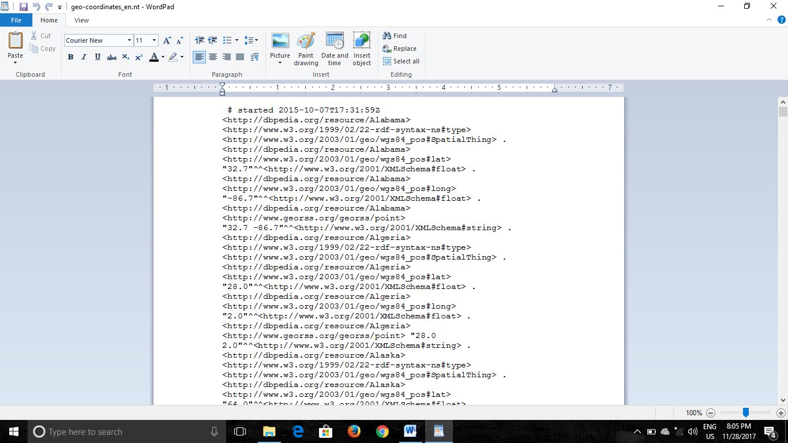
Fig 2.1.1 Given Data

2.2 Steps For Analysis

Step-1 Create 3 files for converting data into structured data
- FileMain.java
- FileMapper.java
- FileReducer.java

Step-2 Create JAR file for above project say PROJ1.jar at location /home/Cloudera/Desktop/PROJECT/Convert/NAVIGATOR/PROJ1.jar.

Step-3 Put Geo-Coordinates.en.nt file into hdfs from local system.
Hdfs dfs –put /home/Cloudera/Desktop/PROJECT/geo_coordinates_en.nt/user/Cloudera/Mohit.

Now, file is present in hdfs at location /user/Cloudera/Mohit/

Step-4 Pass the JAR file to the data present in HDFS
Hadoop jar /home/Cloudera/Desktop/PROJECT/Convert/NAVIGATOR/PROJ1.jar Convert.FileMain /user/Cloudera/Mohit/geo_coordinates_en.nt / user/Cloudera/Mohit/convertOutput.

Step-5 Open HIVE. Create a table to store structured data into hive warehouse directory.

Step-6 Now upload the structured file from HDFS from user/Cloudera/Mohit/convertOutput/part-r-0000 to the table citydata. “load data inpath user/Cloudera/Mohit/convertOutput/part-r-00000 into table project.citydata;”

10
Step-7 Now create indexing on the basis of longitude.

Step-8 Now join the table city data and longitudeIndex on the basis of longitude. By creating new table.

Step-9 Now apply dynamic partitioning on the basis of INDEX. And after that insert the data into new table named citypartition.

Step-10 Now create a table for storing the seed file from user which contains user city data on which we have to find the closest vicinity.

Step-11 Now create Jarfiles for Haversine UDF, PartUDF and DirectionUdf.

Step-12 add jars and create temporary functions to use them in queries.

Step-13 Now Implement Nested Query
select usercity,city,lat1,long1,direction(lat2,long2,lat1,long1) as diection, distance
from(
select usercity,city,lat1,long1,lat2,long2,d
from(
select usercity,city,lat1,long1,lat2,long2,distance(lat1,long1,lat2,long2) as d,value
from (
select a.city as usercity,part(a.longitude,0) as p,part(a.longitude,-1) as pleft,part(a.longitude,1) as pright , a.latitude as lat2 , a.longitude as long2 , b.city as city , b.latitude as lat1, b.longitude as long1 , b.value as value
from last b , user a
)f
where value = p or value=pleft or value=pright
) s

where d <= 25
)th;

Step-14 Store the output in table named CitywithDirection.

11
Now, After implementing following queries desired output will be

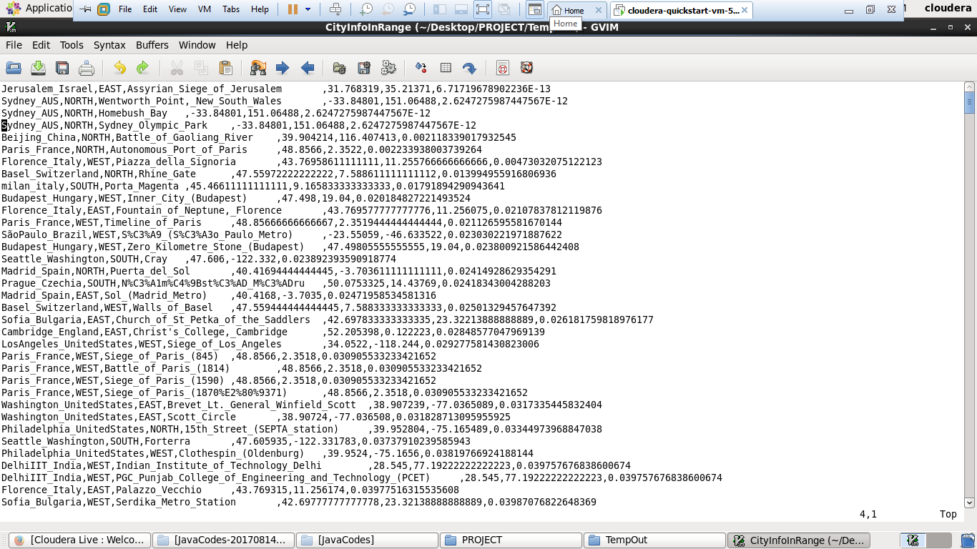
Fig 2.1.1 Output Screen

Step-15 Convert it into J-SON format

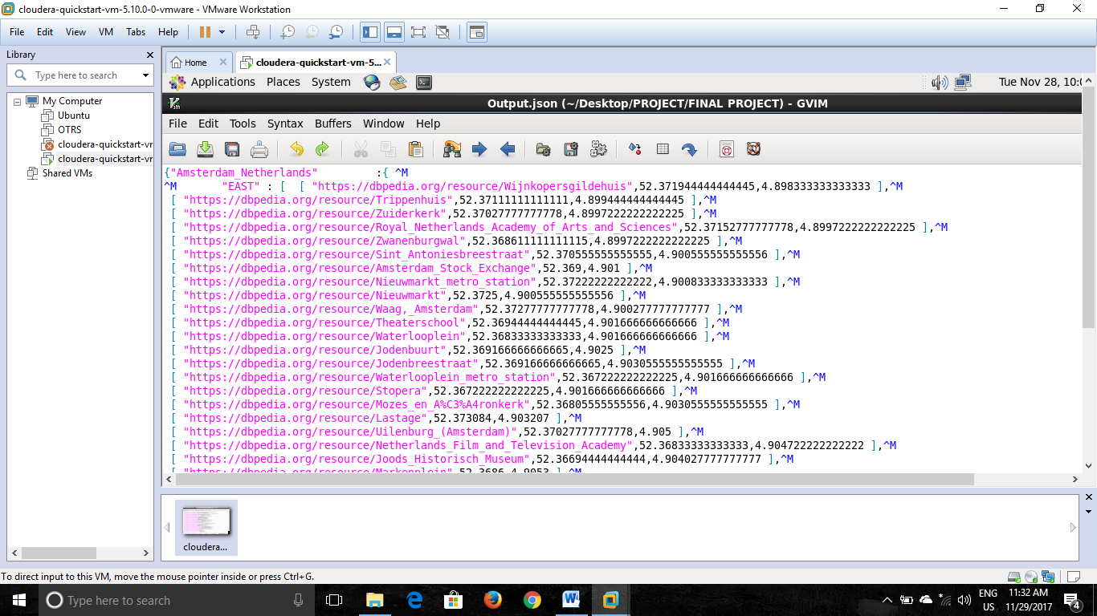
Fig 2.1.2 After converting into JSON

CHAPTER 3

REFERENCES

- "Hadoop Releases". apache.org. Apache Software Foundation. Retrieved 2017-06-05.
- “Welcome to Apache Hadoop!". hadoop.apache.org. Retrieved 2017-06-05
- "Google Research Publication: The Google File System". Retrieved 2017-06-09
- Data Science and Big Data Analytics: Discovering, Analyzing, Visualizing and Presenting Data. John Wiley & Sons. 2014-12-19. p. 300. ISBN 9781118876220. Retrieved 2017-06-29
- "Continuuity Raises $10 Million Series A Round to Ignite Big Data Application Development Within the Hadoop Ecosystem". finance.yahoo.com. Marketwired. 2012-11-14. Retrieved 2017-07-01.

13



