**Brief Description on Libraries to be used**

We will basically require libraries for two functionalities

1. Taking input interactively from the user (in the form of co-ordinates and labels of the input)
2. Displaying output in a graphical format (The 2D diagrams/ 3D object)

1.For the first purpose of input, we simply need a set of buttons and textboxes to take input and store in variables. For this purpose GTK + toolkit seems perfect. It is a multi-platform toolkit to create simple graphical user interfaces. It has a comprehensive collection of widgets and interfaces like:

-Windows (normal window or dialog, about and assistant dialogs)

-Displays (label, image, progress bar, status bar)  
-Buttons and toggles (check buttons, radio buttons, toggle buttons and link buttons)

- Numerical (horizontal or vertical scales and spin buttons) and text data entry (with or without completion)

- Multi line text editor and Menus.

And many more…

We will be using the above mentioned features to design our input screen.

Something like (customized for our input sets):  
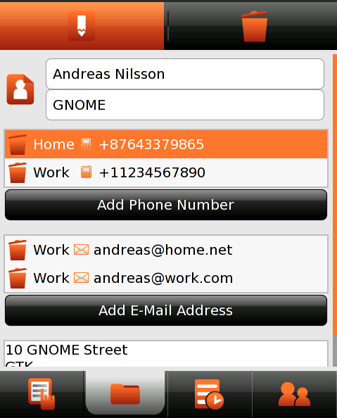

Reference that we will be using to design the input interface on GTK +: <https://developer.gnome.org/gtk-tutorial/stable/>

2.For the output, we need to produce 3D and 2D graphical objects on the screen, based on the output that we have got. For this purpose the library that we found right for it is OpenGL. Its a widely used cross-platform API, for rendering 2D and 3D graphic vectors. It has also been extensively used for designing CAD models previously. The main features of Open GL that we will be using is:

Drawing 2D polygons from vertices:  
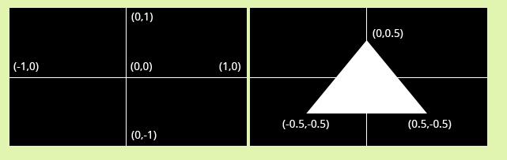

Giving depth and constructing 3D objects:  
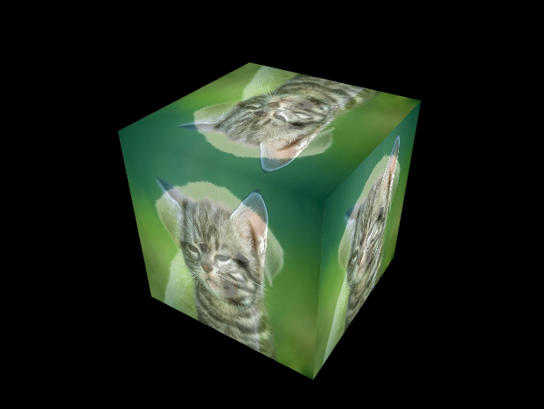

Reference that we will be using to design the output interface using OPenGL:

<https://open.gl/drawing>

In case we fail to construct 3D objects, we will simply display the co-ordinates of the 3D/2D object using GTK+.