Requirement Analysis
1. First screeen:
- Serarch box along with a search button .It will take a stock name and direct us to the analysis page of that articular stock
-three drow down menues, one each for country , stock exchange and sector.This menues will be used to narrow down our search of stocks.
accrding to given credentials.
-This will be followed by a table listing 25 major stocks which will be having coulmns for stock details like bid price,ask price etc.Each stock on clicking will ,
direct us to the analysis page of that stock.

2. Second analysis page
-It will contain the stock details on the top
- The dropdownmenu will have option for a period of one week,one month,three month, six month and one year

EBR Diagram

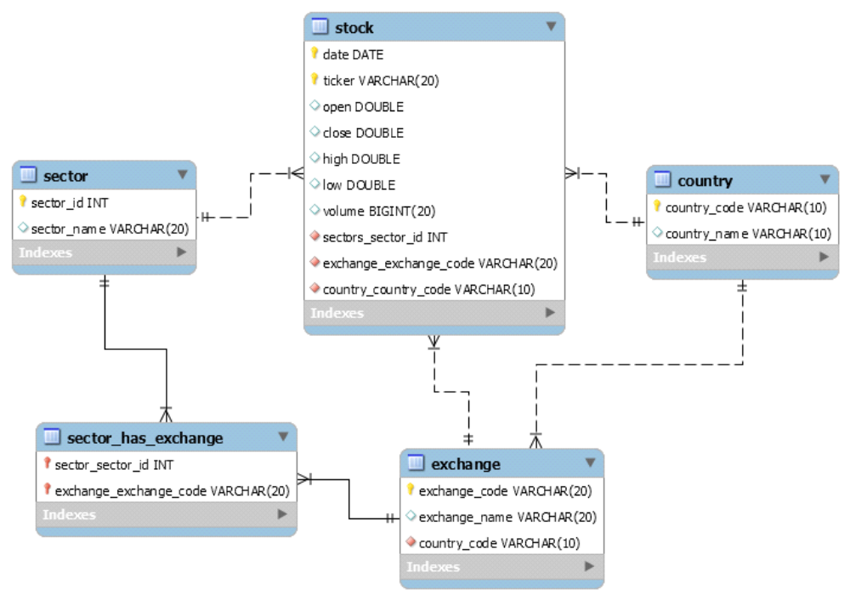

Class Diagram

