Product Design

|  |  |
| --- | --- |
| **Team** | **<49, Fine-Grained Data Visualisation , Team Memebers→ Mohit Chandra, Yash Verma, Nikhil Gogate>** |

# Design Model

|  |  |
| --- | --- |
| **Contour Graph 3D** | Class state   * This class is responsible for taking input dataset from user and plotting the graph   Class behavior   * Input from User * Analysis of dataset and conversion (if required) * Output the 3-D contour graph |
| **Live Streaming data analysis** | Class state   * This class is responsible for analysis twitter tweets and plotting a bar graph   Class behavior   * Input from Twitter tweets * Analysis of Hash tags of the tweets * Output the bar graph on the no. of times hash tag used |
| **3-D Modeling using Delaunay Triangulation** | Class state   * This class is responsible for taking input dataset from user and plotting the graph   Class behavior   * Input from User * Analysis of dataset and conversion (if required) * Output the 3-D contour graph |

.

|  |  |
| --- | --- |
| **Covex Hull Creater** | Class state   * This class is responsible for taking input dataset from user and creating a convex hull out of the random points.   Class behavior   * Input from User * Analysis of dataset in terms of skyline points. * Output the convex hull. |
| **Landscape visulization**  **(extended version of contour)** | Class state   * This class is resposible for taking input dataset from user and creating landscape with hills,rivers,valleys.   Class behavior   * Input from User * Analysis of dataset by performing operations on it such as smoothing,trimming and distributing. * Output the Landscape with hills,river,valleys. |
|  |  |

# Sequence Diagram(s)

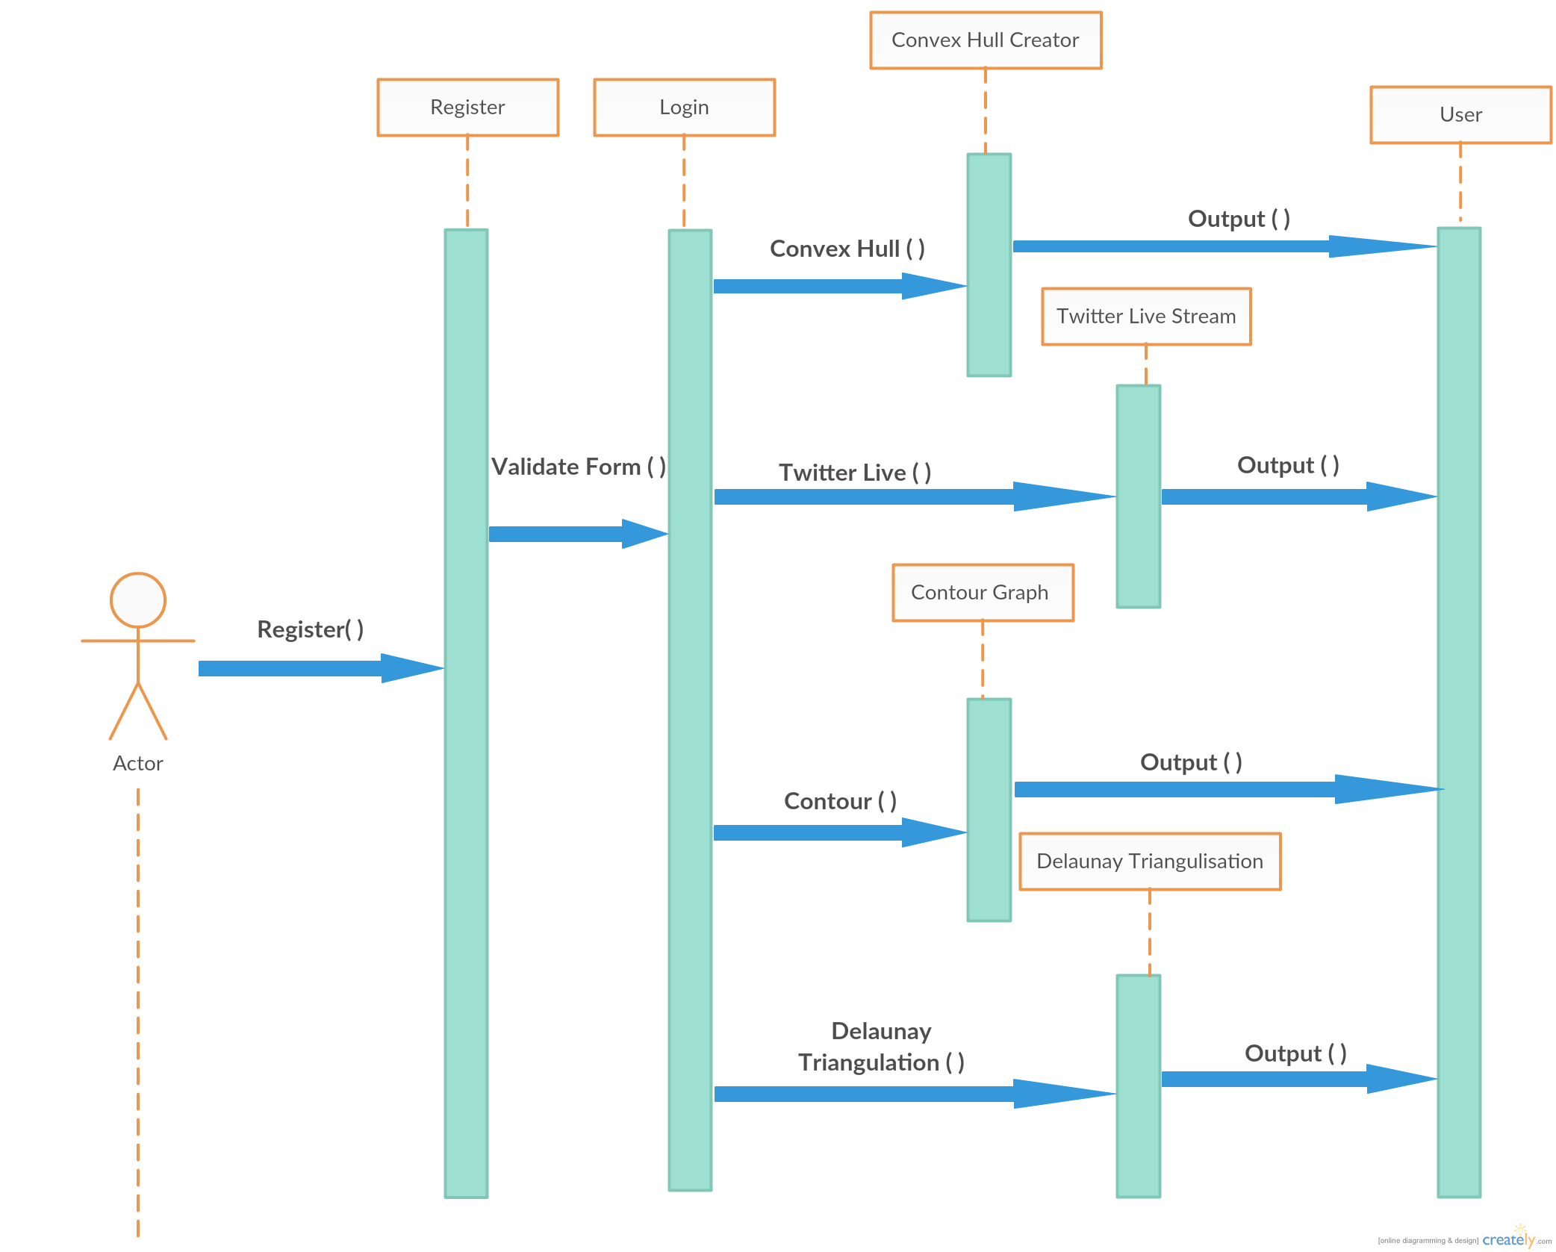

# Design Rationale

1) Our First Design Included only Contour Visualisation and no other functionality . Then we expanded our idea into several other fields where visualisation can be applied.

2) The idea of a offline application integrated with modules was also a part of modified design.

3) Further modification of design now allows the user to share their creations with others.

4) Made Landscape visualization with hills,rivers,valleys.

5) Landscape visualization will be hosted on online server as different module from offline app.