Pinblooms – Magento Extension

Pinblooms_CustomerDiscount:-

The CustomerDiscount extension work for the discount on the basis of customer.
Requirements:-
- Discount applied on the basis of option and value set by admin from customer page.
- Discount successfully applied show a value of this in the order view page.
- Also shows this value in the admin order view page.
- Rest of functionality will work as default magento

Steps 1:- Install extension
- Download the Extension
- Unzip (Pinblooms_CustomerDiscount) in the app/code/ directory
- Run the command for upgrade and deploy
Steps 2:-
- In the admin on the customer view page.Please add discount and save and also please see screenshots of that.
Stores >> Customers>> All Customer >>Select the customer
Click on the Account Information and save the customer
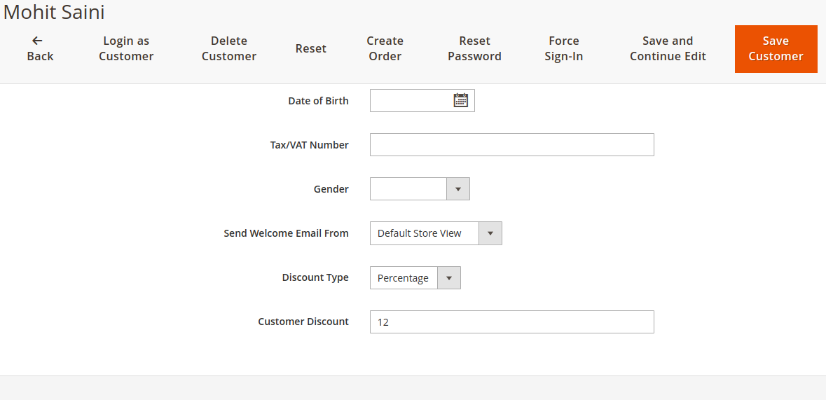

Steps 2:- Please order from frontend.

Steps 3:- Order View page Frontent & backend :

Login Customer :
Go to My Order Page and check the discount amount:

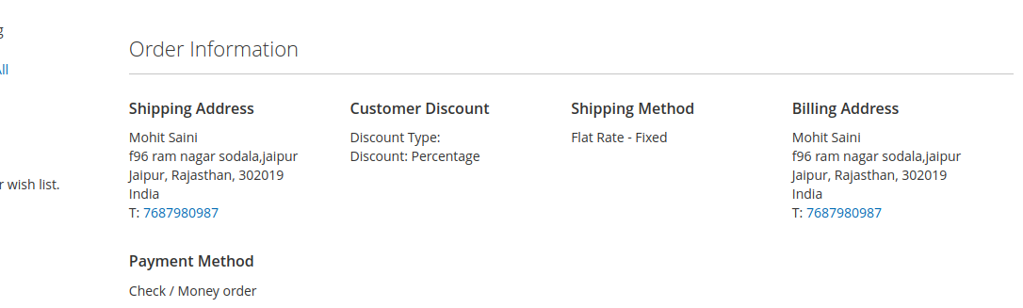

In the admin in order view page section:
