**ML-Assignment – 1**

**Name: Mohit Kulkarni**

**Uta ID: 1002031021**

**Pre-processing Visualization of all the Datasets and Weka classification using Naïve-Bayes and Naïve-Bayes-Python implementation outputs:**

**Hayes-Roth-Dataset-Visualization:** 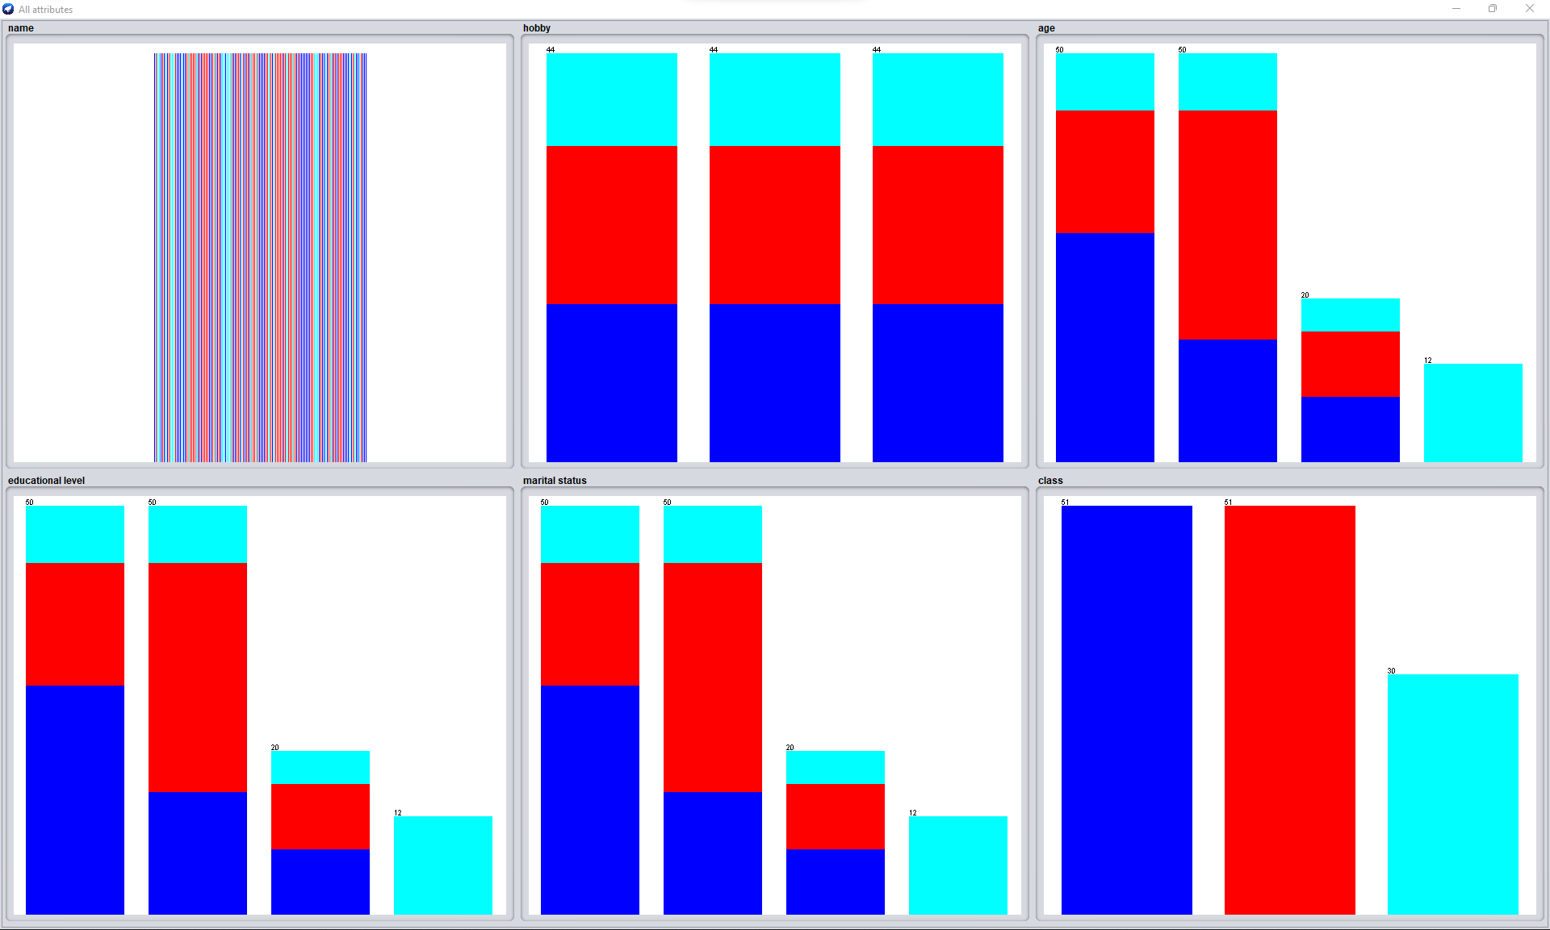

**Hayes-Roth-Dataset-class-weka:**

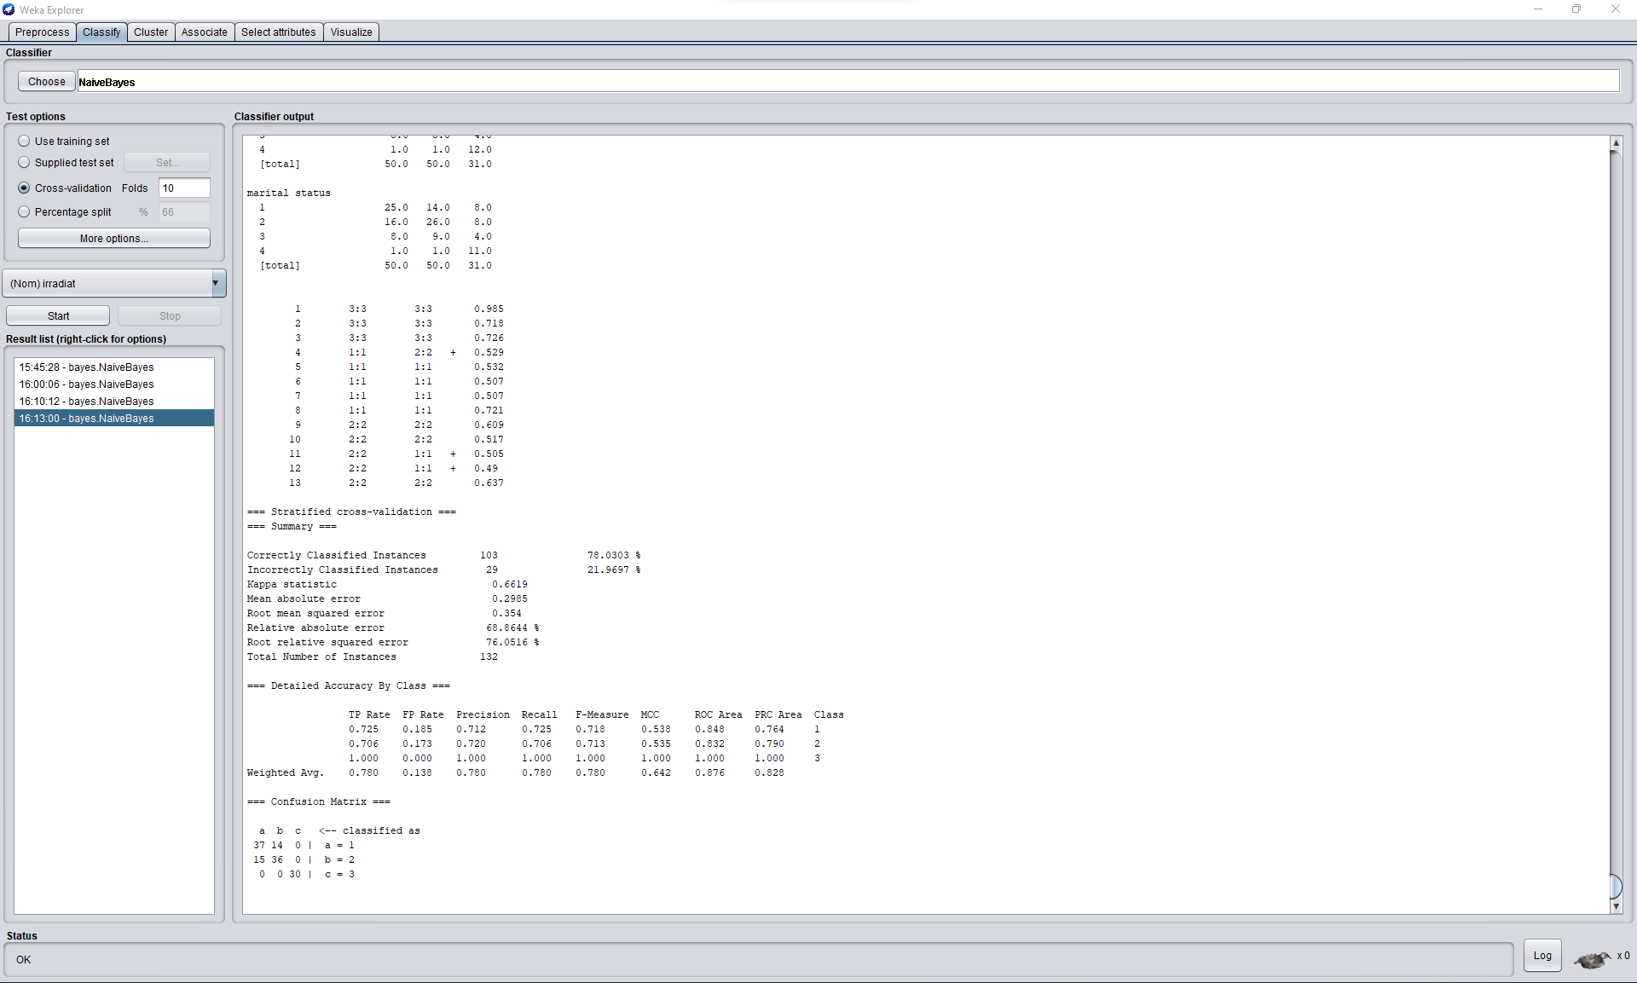

**Hayes-Roth-Dataset-Python:**

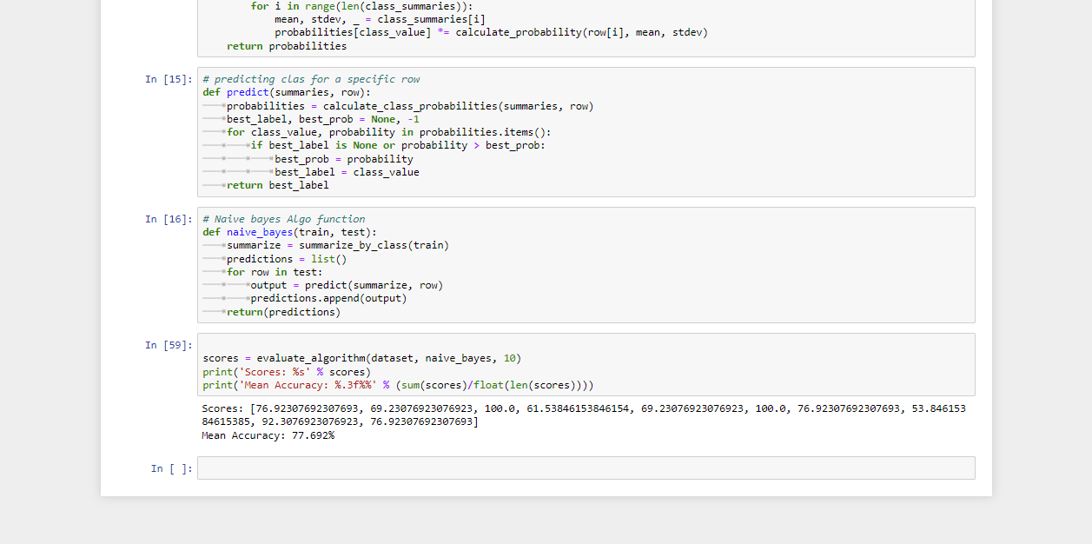

**Car-Evaluation-Dataset-Visualization:**

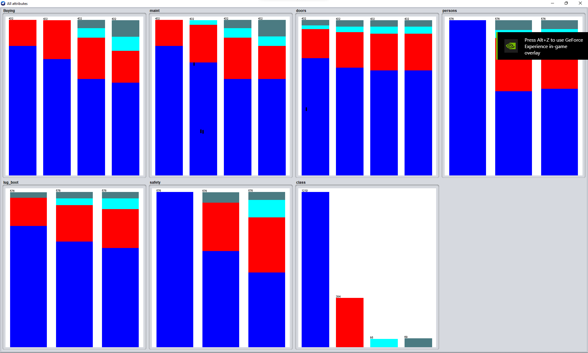

**Car-Evaluation-Weka:**

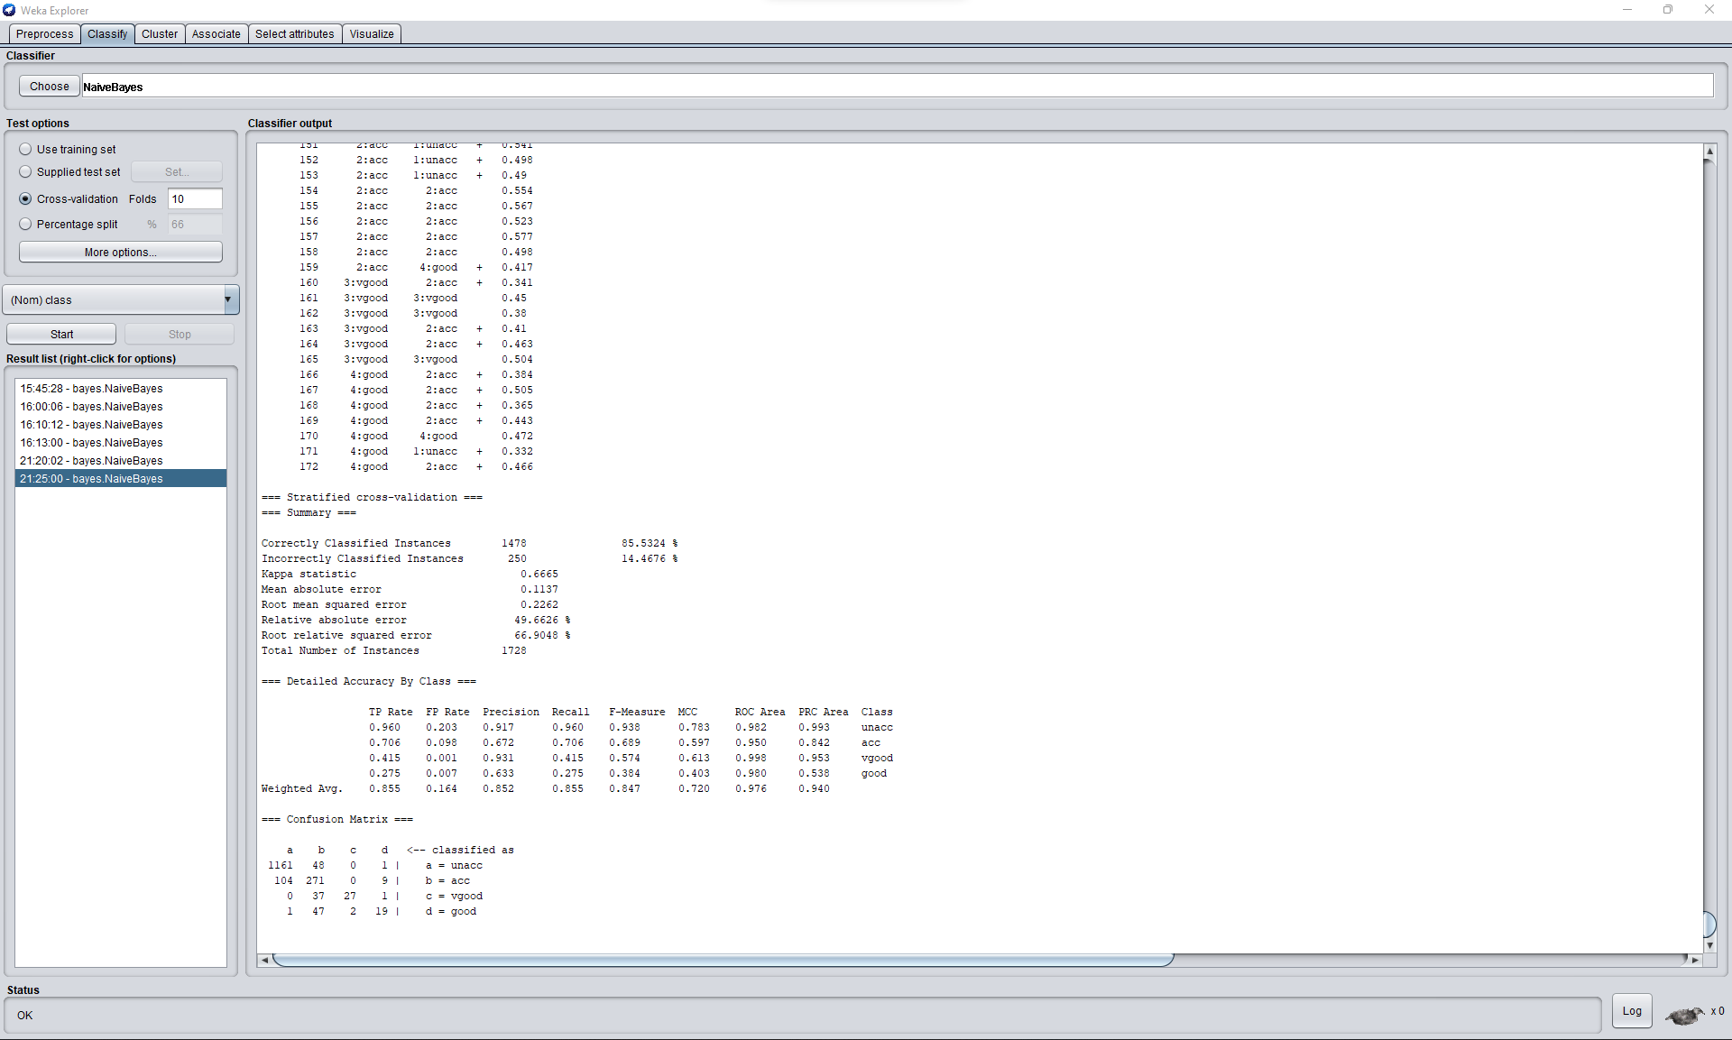

**Car-Evaluation-Python:**

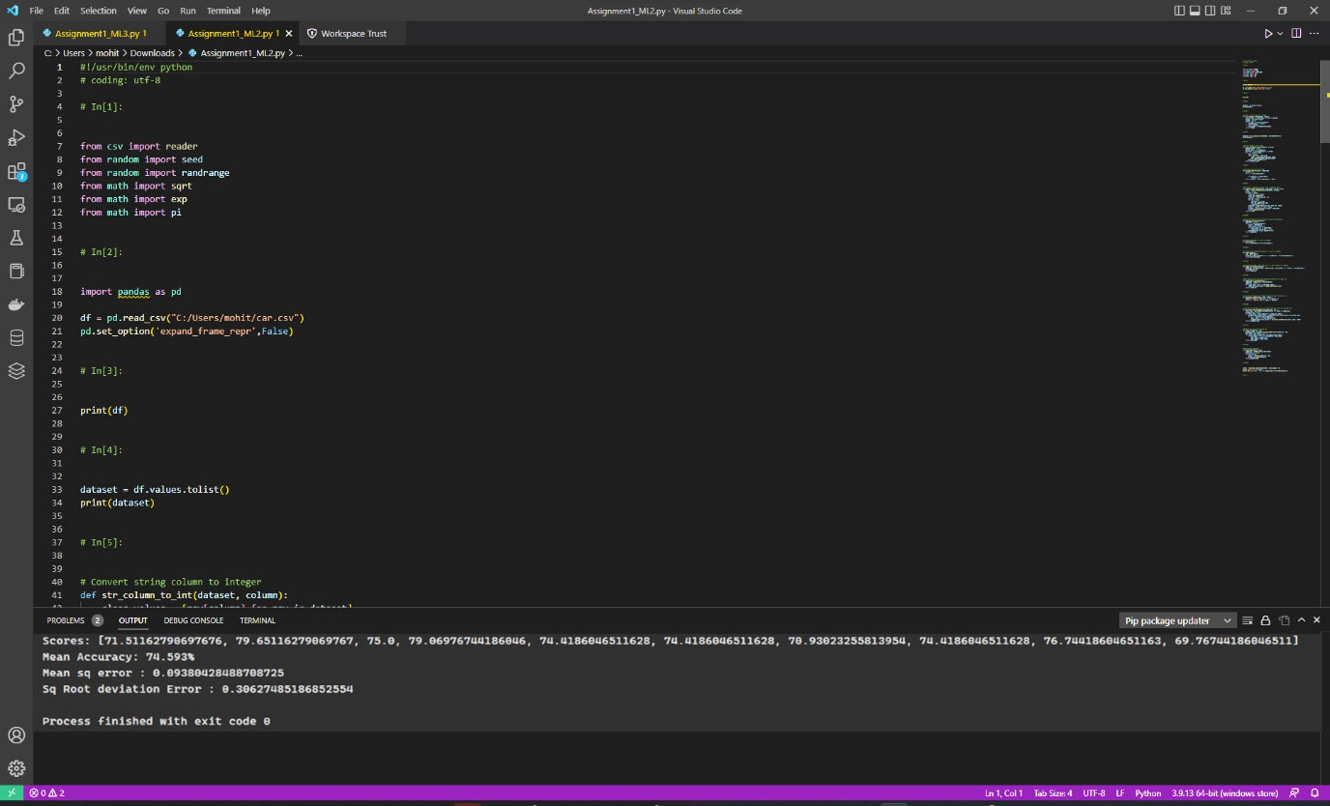

**Breast-cancer-Dataset-Visualization:**

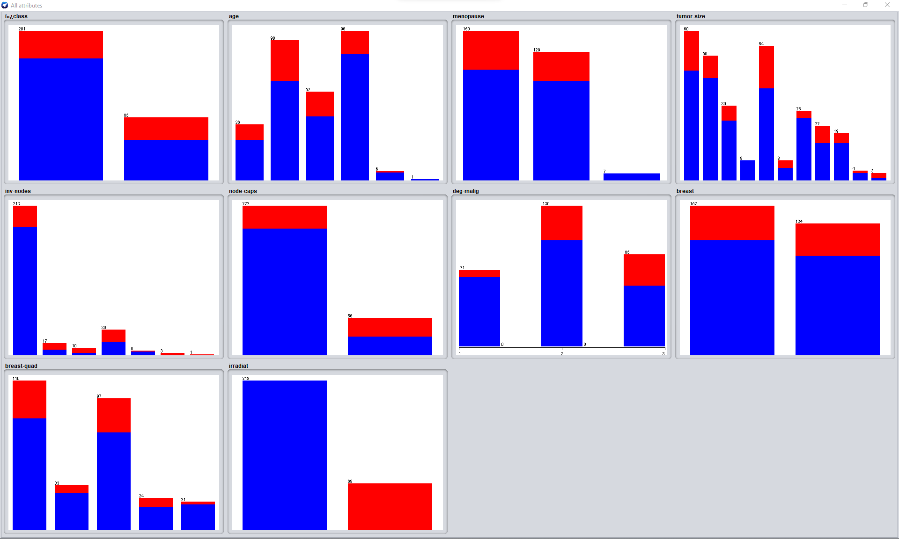

**Breast-Cancer-Weka**

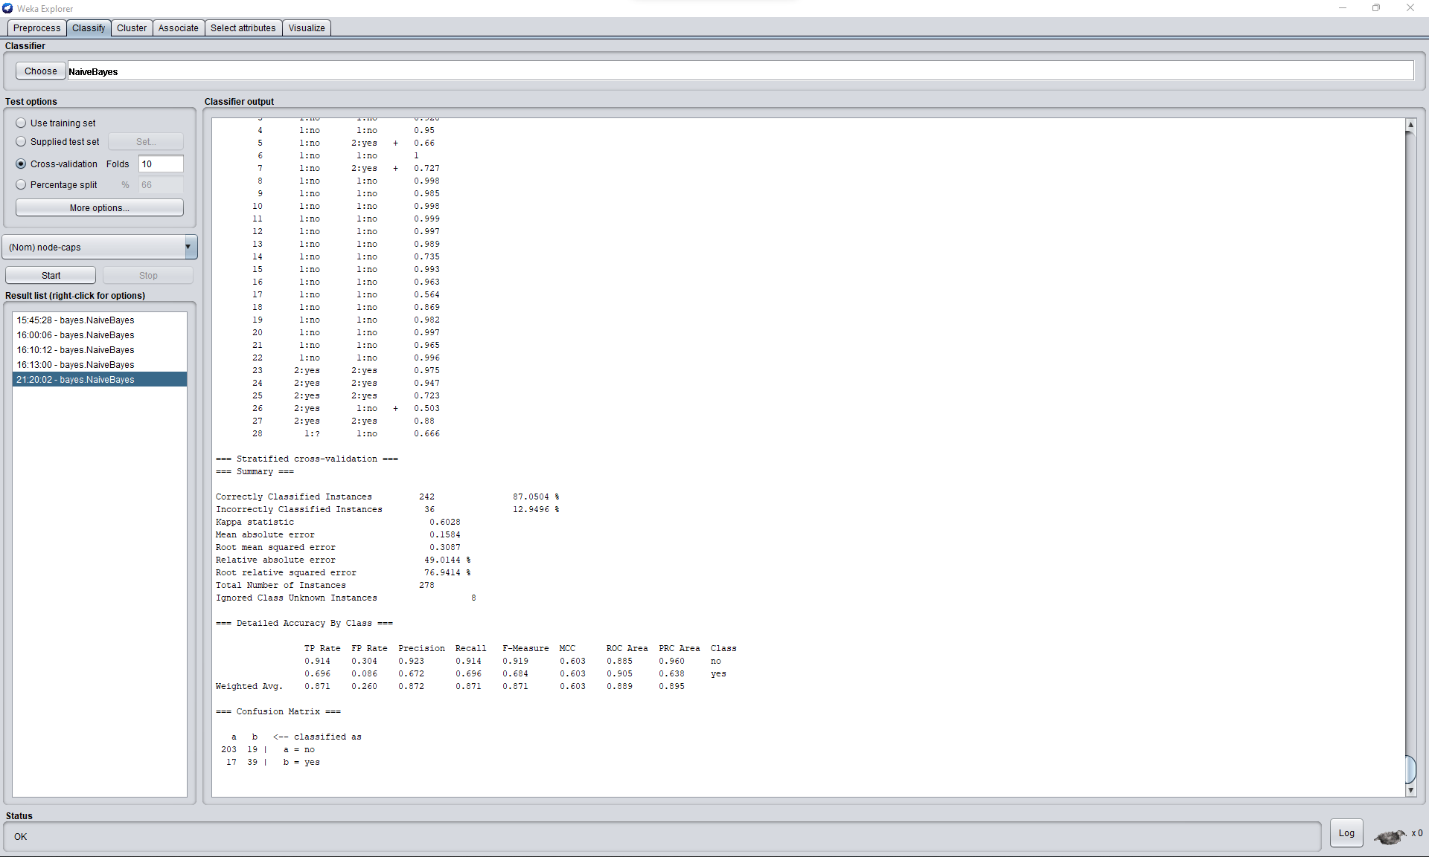

**Breast-Cancer-Python:**

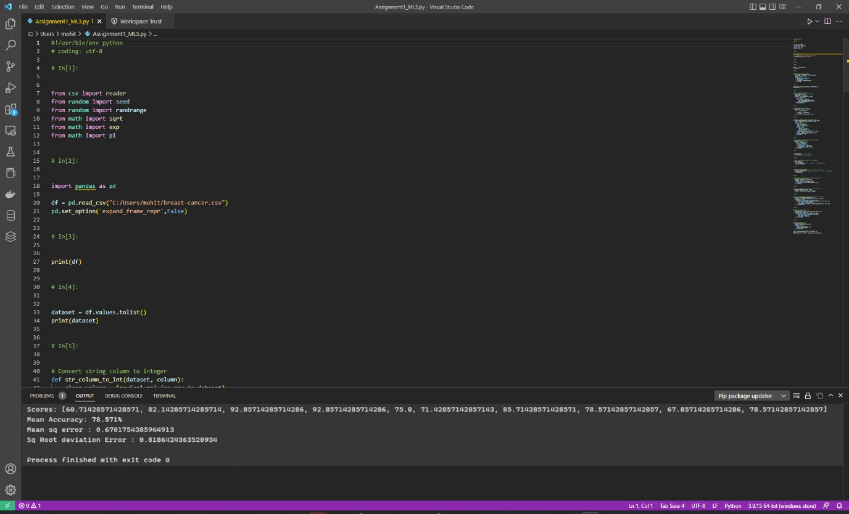

**Conclusion:-**

**Hayes-Roth-Dataset:**

1. **Accuracy obtained from Weka software is 78.0303%**
2. **Accuracy obtained from Naïve Bayes Implementation is 77.692%**
3. **When we are considering k-fold classification for 10 folds we have 132 instances in the dataset Weka accuracy and Naïve bayes implementation accuracy is nearly Same so we accept Ho Hypothesis as the values of both the implemetation are same.**

**Car-Evaluation-Dataset:**

1. **Accuracy obtained from Weka software is 85.5324%**
2. **Accuracy obtained from Naïve Bayes Implementation is 78.571%**
3. **When we are considering k-fold classification for 10 folds we have 1728 instances in the dataset Weka accuracy and Naïve bayes implementation accuracy is Different so we accept Ha Hypothesis as the values of both the implementation are different.**

**Breast-Cancer-Dataset:**

1. **Accuracy obtained from Weka software is 87.050%**
2. **Accuracy obtained from Naïve Bayes Implementation is 78.571%**
3. **When we are considering k-fold classification for 10 folds we have 278 instances in the dataset Weka accuracy and Naïve bayes implementation accuracy is different so we accept Ha Hypothesis as the values of both the implementation are different.**

**Reference:**

1. [**https://machinelearningmastery.com/naive-bayes-classifier-scratch-python/**](https://machinelearningmastery.com/naive-bayes-classifier-scratch-python/)
2. [**https://www.youtube.com/watch?v=vz_xuxYS2PM&t=1540s&ab_channel=edureka%21**](https://www.youtube.com/watch?v=vz_xuxYS2PM&t=1540s&ab_channel=edureka%21)
3. [**https://medium.com/@rangavamsi5/na%C3%AFve-bayes-algorithm-implementation-from-scratch-in-python-7b2cc39268b9**](https://medium.com/@rangavamsi5/na%C3%AFve-bayes-algorithm-implementation-from-scratch-in-python-7b2cc39268b9)