**Custom Equipment Measurement Sheet**

Facility :

Name :

DOB :

Eval Date :

ATP :

PT/O :

1. Top of head to buttocks _____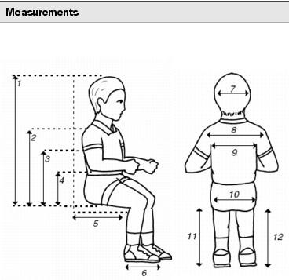
2. Top of shoulder to buttocks _____
3. Axilla to buttocks _____
4. Elbow to buttocks _____
5. Seat depth _____
6. Foot length _____
7. Head width _____
8. Shoulder width _____
9. Axilla width _____
10. Hip width _____
11. Left lower leg length _____
12. Right lower leg length _____

**Height_______ Weight________**

Primary Ins :

Secondary Ins :

Diagnosis :

Hx of skin breakdown? _____ At risk for skin breakdown? _______________________

Explain________________________________________________________________

Current Equipment: Serial #:

______________________________________________________________________

______________________________________________________________________

Evaluation notes:

______________________________________________________________________

______________________________________________________________________

______________________________________________________________________

______________________________________________________________________

______________________________________________________________________

______________________________________________________________________

______________________________________________________________________

____________________________________________________________________________________________________________________________________________

______________________________________________________________________

______________________________________________________________________

______________________________________________________________________

Requested Equipment: **width: depth: STF**:

WC type, model _____________________________________________________

Color____________________ Joystick R L ___________________

Rear wheels, tires_______________________ Casters______________________

Anti tips Yes Transit option Yes

Footplates________________________ Heel loops/calf strap ___________________

Footrest Hangers ______________________________________________________

Foot positioning components _____________________________________________

Wheel lock type___________________________________________ Extensions

Armrest Desk Full ______________________________________________

Power seating options________________________________________________

Hip belt________________________________ **Notes:**

Shoulder harness________________________

Cushion_______________________________

Backrest_______________________________

Headrest_______________________________ Hardware__________________

Thoracic Laterals ________________________ Hardware__________________

Adductors _____________________________ Hardware__________________

Abductor_______________________________ Hardware__________________

Specialty controls________________________

Tray__________________________________

Stander accessories:

Gait trainer access:

Other equipment, details:  
______________________________________________________________________

______________________________________________________________________

______________________________________________________________________

____________________________________________________________________________________________________________________________________________

______________________________________________________________________

______________________________________________________________________

______________________________________________________________________

______________________________________________________________________

______________________________________________________________________