**ASSIGNMENT 1**

# PROBLEM 1

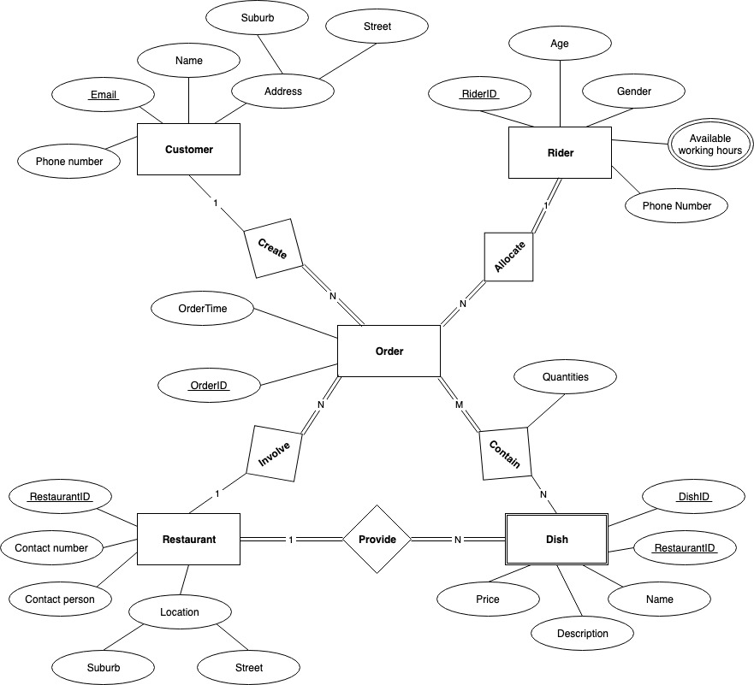

# PROBLEM 2

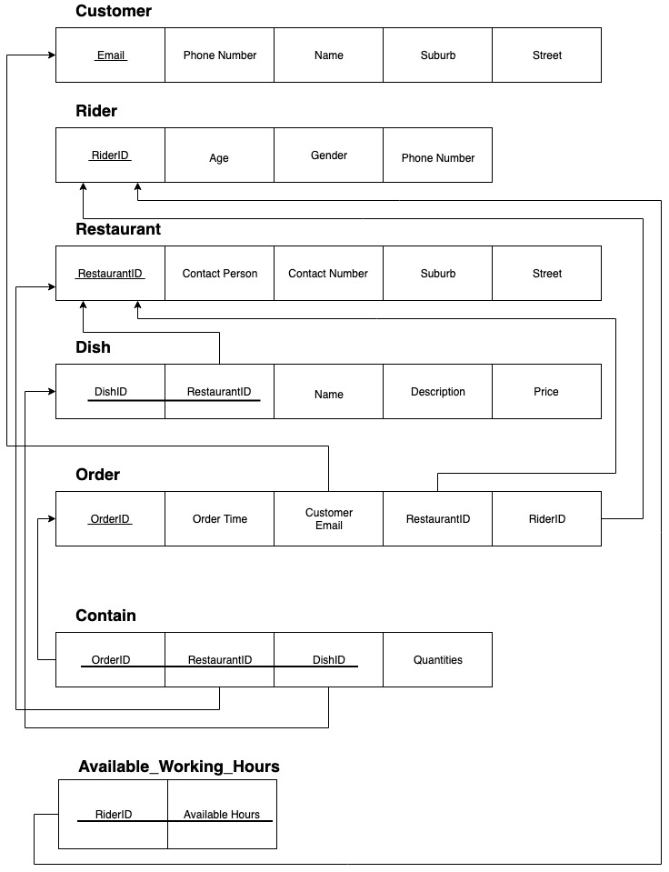

# PROBLEM 3

A ← σ name=’Taylor Swift’ (Artist)

B ← σ role=’composer’ (SongCreating)

C ← σ genre=’pop’ (GenreOfSong)

D ← Song

⇒ **π{title}( D ⋈ C ⋈ B ⋈ A )**



A ← σ name=’Taylor Swift’ or name=’Ed Sheeran’ (Artist)

B ← σ role=’composer’ (SongCreating)

C ← Song

⇒ **π{title}( C ⋈ B ⋈ A )**



A ← σ Name=’Universal Music Group’ (Company)

B ← JoinIn

C ← σ gender=’female’ (Artist)

D ← SongCreating

E ← σ genre=’hip-hop’ (GenreOfSong)

F ← σ genre=’pop’ (GenreOfSong)

X ← π{Artist.name} ( F ⋈ D ⋈ C ⋈ B ⋈ A )

Y ← π{Artist.name} ( E ⋈ D ⋈ C ⋈ B ⋈ A )

⇒ **X − Y**

A ← Artist

B ← SongCreating

C ← GenreOfSong

E ← σ name=’Taylor Swift’ (Artist)

X ← π{name,sID}( C ⋈ B ⋈ A ) ÷ π{sID}( C )

Y ← π{name}( B ⋈ A ⋈ ( π{sID}( B ⋈ A ))) − π{name}( E )

⇒ **X ∩ Y**