PROJECT NO. : 36
DESIGN AND IMPLEMENTATION OF DSPIC CONTROLLED MATRIX CONVERTER FOR INDUCTION MOTOR DRIVE

A PROJECT REPORT
Submitted in partial fulfillment of the
requirements for the award of the degree
of
BACHELOR OF TECHNOLOGY
in
ELECTRICAL ENGINEERING

Submitted By:
PRINCE JAIN PRIYA CHAUHAN
08115062 08115063
Guided By:
DR. PRAMOD AGARWAL

DEPARTMENT OF ELECTRICAL ENGINEERING
INDIAN INSTITUTE OF TECHNOLOGY ROORKEE
ROORKEE – 247 667 (INDIA)
MAY, 2012

CANDIDATE’S DECLARATION
We hereby certify that the work which is presented in this project entitled “Design and Implementation of DSPIC Controlled Matrix Converter for Induction Motor Drive” in partial fulfillment for the award of the degree Bachelor of Technology (Electrical) submitted to the Department of Electrical Engineering, I.I.T. Roorkee, is an authentic record of our own work carried out during the period from August 2011 to May 2012 under the guidance of Dr. Pramod Agarwal, Department of Electrical Engineering, I.I.T. Roorkee.
The matter embodied in the project report to the best of our knowledge has not been submitted for the award of any other degree elsewhere.

Dated: May 22, 2012
Prince Jain Priya Chauhan
08115062 08115063
CERTIFICATE
This is to certify that the project work entitled ‘Design and Implementation of DSPIC Controlled Matrix Converter for Induction Motor Drive’ done by Prince Jain and Priya Chauhan, students of Bachelor of Technology, Department of Electrical Engineering, IIT Roorkee, is a record of the bona fide work carried out by them under our supervision and guidance for the partial fulfillment of the requirement of their Bachelor of Technology degree. The matter embodied in this project has been carried out in the Electrical Engineering Department at IIT Roorkee, Roorkee -247667, during August’ 2011 to May’ 2012. Their performance was excellent. I wish them success in all their future endeavors and research.

Dr. Pramod Agarwal
Professor
Department of Electrical Engineering
IIT Roorkee

ACKNOWLEDGEMENTS

We wish to express our deep sense of gratitude and sincere thanks to our guide Dr. Pramod Agarwal, Prof. Electrical Engineering Department, IIT Roorkee, for being helpful and a great source of inspiration. His keen interest and constant encouragement gave us the confidence to complete our work. We wish to extend our sincere thanks for his excellent guidance and suggestions for the successful completion of our project work. We are thankful to all our friends for their continuous support and help during different stages of our project work.

Prince Jain
08115062
Priya Chauhan
08115063

Synopsis
In the present study, a 3-Ø AC to AC matrix converter is made. Venturini Modulation technique is implemented using dsPIC 30F4013 controller kit for controlling MOSFET switches of 3-Ø matrix converter. Thus, variable frequency and magnitude is generated at the output.
Matrix converter is a 3x3 array of 9 bi-directional semiconductor switches that connects directly the three phase source to the three phase load without using any Dc-link or large energy storing element, and therefore is called an all-silicon solution. This converter has several advantages over conventional methods such as sinusoidal input and output currents, operation at unity power factor, regeneration capability.
There are various Modulation methods used to control matrix converter like Venturini Modulation, Space Vector Modulation scheme. In this report, the results are based on Venturini Modulation Technique.
dsPIC is a hybrid of Micro-controller and digital signal processor. Venturini Modulation Technique is implemented in this controller and the timing sequences and periods of the various switches are calculated. The gate pulses of the 9 MOSFET switches are thus switched on for the time period calculated. For synchronizing the input waveform with the controller algorithm, Zero Crossing detector circuit is used along with the quad pulses generated for the same purpose. The input waveforms are sampled to get the desired output frequency and voltage. The hardware is designed and implemented for the V/f control of induction motor.

Table of Contents

Certificate 2
Acknowledgement 3
Synopsis 4
Table of contents 5
List of abbreviations used 7
List of figures 8
Chapter 1 INTRODUCTION 10
Chapter 2 HISTORY 11
2.1 Static AC/ AC Power Frequency Conversion 11
2.1.1 Indirect AC/ AC Power Frequency Conversion 11
2.1.2 Direct AC/ AC Power Frequency Conversion 13
Chapter 3 BACKGROUND CONCEPTS AND THEORY 15
3.1 Fundamentals of Matrix Converter 15
3.1.1 Topology 16
3.1.1 Performance of Matrix Converter 18
3.2 Modulation Techniques of Matrix Converter 20
3.2.1 Venturini Modulation Method 21
3.3 dsPIC Controller Basics 23
3.4 Practical Constraints 25
3.4.1 Bidirectional Switch Realization 25
3.4.2 Current Commutation 27
3.4.3 Input Filter 29
3.4.4 Power Circuit Protection 29
3.4.5 Semiconductor Losses 29
Chapter 4 EXPERIMENTAL SETUP 31
4.1 Snubber Circuit 31
4.1.1 Working 31
4.1.2 Circuit Diagram 31

4.1.3 Testing 32
4.2 Driving Circuit 33
4.2.1 Working 33
4.2.2 Circuit Diagram 33
4.2.3 Testing 33
4.3 Zero Crossing Detector Circuit 34
4.3.1 Working 34
4.3.2 Circuit Diagram 36
4.3.3 Testing 36
4.4 Controller Interfacing Circuit 36
4.5 dsPIC 30F4013 37
4.6 Over Current Protection: Fuses 40
4.7 Load 40
4.8 Operating Instructions 40
Chapter 5 RESULTS AND DISCUSSION 42
5.1 Zero Crossing Detector Pulses 42
5.2 Quad Pulses 44
5.3 Switch Pulses per Output Phase 45
5.4 R Load 45
5.4.1 Output Voltage 45
5.4.2 Output Current 46
5.5 R-L Load 46
5.5.1 Output Voltage 46
5.5.2 Output Current 47
Chapter 6 CONCLUSIONS AND FUTURE WORK/ IMPROVEMENT 48
References 50
Appendix 1 52
Appendix 2 59

List of abbreviations
AC: Alternating Current
DC: Direct Currrent
DB-VSI: Diode Bridge Voltage Source Inverter
etc: Etcetera
PWM: Pulse Width Modulation
VSI: Voltage Source Inverter
SPWM: Sinusoidal Pulse Width Modulation
SVM: Space Vector Modulation
Ph: phase
Hz: hertz
KHz: Kilohertz
dsPIC: Digital Signal Peripheral Interface Controller
RISC: Reduced Instruction Set Computing
CPU: Central Processing Unit
RAM: Random Access Memory
DSP: Digital Signal Processing
I/O: Input/ Output
IDE: Integrated Development Environment
ICD: In-circuit Debugger
IGBT: Insulated Gate Bipolar Transistor
MOSFET: Metal Oxide Silicon Field Effect Transistor
CRO: Cathode Ray Oscilloscope
LED: Light Emitting Diode
IC: Integrated Circuit
R: Resistance
C: Capacitance
L: Inductance
ZCD: Zero Crossing Detector
List of Figures

2.1 AC/ AC indirect power frequency converter, with intermediate DC-link stage
(a) Diode rectifier-PWM VSI converter (b) PWM rectifier-PWM VSI converter 12
2.2 Three phase to three phase cyclo-converter 14
3.1 Schematic circuit of a three-phase to three-phase matrix converter 15
3.2 Basic power circuit of matrix converter 17
3.3 General form of switching pattern 17
3.4 Output voltage waveforms generated by a VSI and a matrix converter 19
3.5 Matrix converter input current and harmonic spectrum. Switching frequency is 2 KHz 20
3.6 Matrix converter input line-to-neutral voltage, instantaneous input current
and its average value. Switching frequency is 2 kHz 20
3.7 Illustrating maximum voltage ratio of 50% 23
3.8 Variables used for pulse generation on the output phase 23
3.9 dsPIC 30F4013 chip with pin names 24
3.10 Bidirectional Switches 25
3.11 Diode bridge bidirectional switch 26
3.12 Common Emitter Bidirectional Switch 26
3.13 Common Collector Bidirectional Switch 27
3.14 (a) Two phase to single phase matrix converter
(b) Equivalent representation of the switches in (a) 28
3.15 Clamp circuit as common protection for all Matrix Converter Bidirectional switches 29
4.1 Snubber Circuit Diagram 31
4.2 Snubber Circuit 31
4.3 The turn-off waveform at the drain of the MOSFET switch 32
4.4 Driving Circuit 34
4.5 Driving Circuit Diagram 34
4.6 Zero Crossing Detector Circuit 35
4.7 Zero Crossing Detector circuit diagram 35
4.8 Controller Interfacing IC pin diagram 37
4.9 MICROCHIP - DM300018 - KIT DSPICDEM 2 Demo Board 37
4.10 Flow Chart of Algorithm Implemented by dsPIC Controller 38
5.1 Three phase output voltage waveforms from the transformers:
R phase: orange, Y phase: pink, B phase: green 42
5.2 The comparator output along with its corresponding phase voltage waveform for R phase 42
5.3 The comparator output along with its corresponding phase voltage waveform for Y phase 43
5.4 The comparator output along with its corresponding phase voltage waveform for B phase 43
5.5 The output pulsed waveforms of the three comparators:
R phase: orange, Y phase: pink, B phase: green 43
5.6 The output of the comparators along with the two mono-shots generating IC’s per phase:
Orange: output of comparator; Blue: output of first 74121 mono-shot IC;
Pink: output of second 74121 mono-shot IC 44
5.7 Final output of the zero crossing detector circuit 44
5.8 Quad Pulses; Orange: R phase; Pink: Y phase; Green: B phase 45
5.9 Switch gate pulses for output 1; Orange: R phase; Blue: Y phase; Pink: B phase 45
5.10 Output1 phase voltage for R load 46
5.11 Output1 line current for R load 46
5.12 Output1 phase voltage for R-L Load 46
5.13 Output1 line current for R-L Load 47
5.14 Output1 line current for reduced inductance in R-L Load 47

C h a p t e r 1
INTRODUCTION
There are numerous applications where variable voltage with variable frequency is needed, particularly in the fields of adjustable speed drives. With the advent of numerous power electronic devices of high voltage and current ratings, the speed control of drives has seen huge development. In industries there is more and more acceptance of induction motors as variable speed machines. Simple construction, robustness, easy maintenance and cheap price of induction motor are making it an attraction for high power application.
The only shortcoming of induction motor is the difficulty in speed control. To have a proper speed control with wide range and at high efficiency, a variable frequency supply is needed. This requirement makes the conversion of AC to AC difficult. Traditionally, a variable frequency supply is obtained from a voltage source inverter fed from a DC link or a Cyclo-converter. Both these methods can control the output voltage and frequency.

C h a p t e r 2
HISTORY
Various methods has been implemented in past to generate a variable frequency and voltage output. Two of the most frequently used methods, their advantages and limitations are discussed in this chapter.
  - STATIC AC/AC POWER FREQUENCY CONVERTER
In general, the conversion of an input ac power at a given frequency to an output power at a different frequency can be obtained with different systems, employing rotating electrical machinery, nonlinear magnetic devices or static circuits containing controllable power electronic switches. Restricting the analysis of AC/AC power frequency conversion to static circuits, the available structures can be divided in “direct” and “indirect” power conversion schemes.
An indirect scheme consists of two or more stages of conversion and an intermediate Dc-link stage is always present. A typical example of two stages indirect AC/DC/AC power frequency conversion is the diode-bridge rectifier-inverter structure, in which an AC power is firstly converted to a DC power (diode rectifier), and then converted back to an AC power at variable frequency (inverter). In direct conversion schemes a single stage carries out the AC/AC power frequency conversion [13].
    - INDIRECT AC/AC POWER FREQUENCY CONVERTER
In Fig. 2.1 two indirect schemes are shown. The scheme is shown in Fig. 2.1 (a) represents the well-known Diode-Bridge Voltage Source Inverter (DB-VSI) topology that is today the preferred solution in AC drive technology, especially in the low- and medium-power range.
The diode-bridge converts the electrical power from AC to DC, realizing along with the DC-link filter the rectification stage, while the voltage source inverter converts DC back to AC with variable amplitude and frequency voltages, carrying out what is usually named inversion stage.
This is a very popular and consolidated conversion scheme. It is reliable solution with low production costs, simple to implement and with high performance modulation strategies available (Pulse Width Modulation, Space Vector Modulation, etc.). But it has also some drawbacks. The input AC currents drawn by the diode-bridge rectifier contain a large amount of harmonics that produces distortion of the input line voltages, having a negative impact on the performance of sensitive loads and equipments connected to the same supply. These current harmonics cause additional harmonic losses on the utility system and may excite electrical resonance, leading to large over voltages.
The greater use of this type of power electronicsconverter scheme that has been experienced in the last years has raised the problem of the utility power quality and serious concern [13].

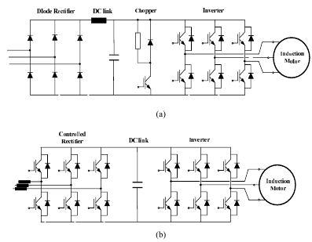
Fig. 2.1 AC/AC indirect power frequency converter, with intermediate DC-link stage a) Diode rectifier-PWM VSI converter. b) PWM rectifier-PWM VSI converter [13].
As the current direction in a diode rectifier cannot reverse, some mechanism must be implemented to handle an eventual energy flow reversal. As during an electromagnetic braking of the motor, in order to avoid that the DC-bus voltage can reach destructive levels. In the DB-VSI conversion scheme such mechanisms are always dissipative ones and hence they can be effectively employed only when the energy to dissipate is low.
The DC-link capacitor represents another weak point of the indirect conversion scheme, particularly for those using electrolytic capacitors. These capacitors have a high energy storage capability but also a high temperature sensitivity which reduces their lifetime determining higher maintenance costs of the conversion system. It should be noted that the electrolytic capacitor have by far the shortest lifetime of any element, active or passive, used in power converters.
The topology of the indirect conversion scheme (b), shown in Fig. 2.1, differs from (a) for the rectification stage, where the diode-bridge rectifier is replaced by PWM-controlled rectifier. This solution makes possible for the conversion system a bidirectional power flow from the main to the motor, which might become attractive for those medium and high power range applications in which regenerative operations and speed reversals are involved in steady state operating conditions, as in hoisting applications like elevators and cranes. Moreover, a PWM-controlled rectifier allows for a strong reduction of the input currents harmonic distortion content, due to the high switching frequency of the rectifier, and a consequent reduction of the filtering components required.
But there are also some disadvantages. The cost is higher, due to a higher number of power semiconductor devices, the combined control of the PWM-controlled rectifier and inverter is quite complicated. In addition, the reliability problem related to the reduced lifetime of the DC-link capacitor holds. For the reasons, the other indirect conversion scheme is scarcely employed.
Advantages:
- Simple construction
- Simple algorithms to implement on it are available
- A wide range of algorithms like SPWM and SVM can be implemented with ease.
Disadvantages:
- Requirement of large energy storing devices like capacitors and inductors, making the system bulky and prone to ageing.
- Input currents harmonics distorts the voltage at the input end which affects the performance of other loads connected to the same terminals.
- Regeneration is inherently dissipative because the current cannot flow in the reverse direction through the diodes in the rectifier portion.

    - DIRECT AC/AC POWER FREQUENCY CONVERTER
Direct static AC/AC power frequency converters basically consist of an array of static power switches connected directly between the input and output terminals. The basic operating principle is to piece together an output voltage waveform with the desired fundamental component from selected segments of the input voltage waveforms. The most-known example of this type of power frequency converter probably is the classical Cyclo-converter, proposed in early 1930s.
Advantages:
Cyclo-converters have following over Dc-link converters:
- Lower commutation and conduction losses.
- More compact power circuit design.
- Inherent bidirectional power flow capability.
Disadvantages:
- Upper limit of output frequency is low.
- Voltage transfer ratio is low:
$$\frac{V_{omax}}{V_{imax}} = r_{max }= (\frac{m}{π})sin(\frac{π}{m})$$
- Large number of Thyristors is needed in the circuit (18 for 3 ph).
- Poor input power factor.
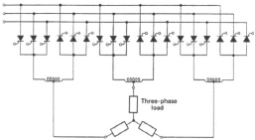

Fig. 2.2 Three phase to three phase Cyclo-converter [13]
Many of the above limitations of naturally commutated Cyclo-converters can be overcome with forced-commutation Cyclo-converter. By introducing semiconductor devices with self-turn off capability it is possible to implement more sophisticated control algorithms that use high switching frequency and allow the output frequency to be higher than the input frequency, the input power factor and the input/output voltage transfer ratio can also be improved.
So, from the above discussion in this chapter, it can be said that direct AC/AC power frequency converters are better in operation and efficiency as compared to indirect AC/AC power frequency converter. Matrix converter is also a robust method of direct AC/AC power frequency converter that we are going to discuss in the next chapter. It can also be noted that Matrix converter is much better in operation not only as compared to indirect AC/AC power frequency converter but also better than Cyclo-converter in terms of frequency range of operation and input displacement factor and harmonics.

C h a p t e r 3
BACKGROUND CONCEPTS AND THEORY
In this chapter, basic concepts related to the operation of Matrix converter, its properties, and methods of control, comparative analysis is done. The controller which is executing the control strategy is also introduced. Also, some practical constraints which may arrive during the implementation of the Converter are also discussed and possible solutions are suggested.
3.1 MATRIX CONVERTER BASICS
A Cyclo-converter is a direct AC/AC converter. The matrix converter is nothing but a three-phase forced commutated Cylco-converter. It has a voltage source of fixed magnitude and frequency as input and which outputs a voltage which is having variable magnitude and variable frequency. It can have ‘m’ number of inputs and ‘n’ numbers of outputs. Each output line is connected to one of the m inputs and connection to the appropriate input will give rise to desired output voltage. In general, there is m x n number of switches any of the m switches connected to one output line is switched on to connect it to one of the input terminals. Most commonly used configuration is the 3 x 3 matrix converter. A 3 ph to 3 ph matrix converter is schematically represented below:

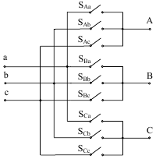
Fig. 3.1 Schematic circuit of a three-phase to three-phase matrix converter [1]
Matrix converter which was proposed first in 1976 attempts to control the speed of three phase machines and can render operation in all four quadrants with low harmonic contents in the input currents and with high power factor [1]. Matrix converter has many advantages over the converters.

Advantages: [1]
- Simple and compact power circuit due to absence of large energy storage elements.
- Generation of output voltage with arbitrary amplitude and frequency.
- Sinusoidal input and output currents.
- Operation at unity input power factor.
- Bidirectional power flow.
- 4-quadrant operation.
- High reliability.
- Harmonic reduction.
Limitations: [1]
- Lack of bidirectional switches.
- Lower voltage transfer ratio.
- Sensitive to power disturbances as they will transmit directly to output side of the converter.
- No freewheeling paths, it is difficult to reliably commutate current from one switch to another.
- Input power factor cannot be lower than output power factor.
3.1.1 TOPOLOGY
Matrix converter, in general, is a single stage converter with a matrix of m x n bidirectional power switches, designed to connect m-phase voltage sources to n-phase load. The matrix converter of 3 x 3 switches connects a three phase source to three phase load. In the basic topology of the matrix converter is shown in fig. 3.2, $V_{si }i=\left\{A, B, C\right\},$are the source voltages, $i_{si }i=\left\{A, B, C\right\},$are the source currents, $V_{jn }, j=\left\{a, b, c\right\},$ are the load voltages with respect to neutral n, and $i_{j} ,j=\left\{a, b, c\right\},$are the load currents. Additionally, other auxiliary variables has been defined to be used as a basis of the modulation and control strategies: $V_{i }i=\left\{A, B, C\right\},$ are the matrix converter input voltages $i_{i },i=\left\{A, B, C\right\},$are the converter input currents [1].
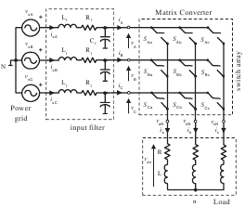

Fig. 3.2 Basic power circuit of matrix converter [1]

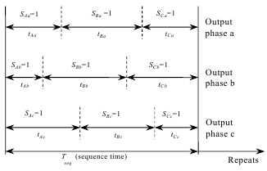
Fig. 3.3 General form of switching pattern [1]
Each switch $S_{ij }, i=\left\{A, B, C\right\}, j=\left\{a, b, c\right\},$ can connect or disconnect phase i the supply to phase j of the load and, with a proper combination of the conduction states of these switches, arbitrary output voltages $V_{jN }$ can be synthesized. Each switch is characterized by a switching function, defined as follows:
$S_{ij }(t)$ = 0 if switch $S_{ij }$ is open
$S_{ij }(t)$ = 1 if switch${ S}_{ij }$is closed … (3.1)
Two basic switching state rules must be followed;
- Two different input lines should not be connected to same output line. This results in short circuit of the supply.
- None of the output lines should be disconnected. This results in open circuit of the load which may cause overvoltage as the load is inductive load [1].
These conditions can be stated in more compact form as follows:
$$\sum_{i=A, B, C}{S_{ij }\left(t\right)=1;|=\left\{a, b, c\right\} …(3.2)}$$
Applying Kirchhoff’s voltage law to switch array, it can be easily found that:
$$\left[\begin{matrix}V_{aN}(t) \\ V_{bN}(t) \\ V_{cN}(t)\end{matrix}\right]=\left[\begin{matrix}S_{Aa}(t) & S_{Ba}(t) & S_{Ca}(t) \\ S_{Ab}(t) & S_{Bb}(t) & S_{Cb}(t) \\ S_{Ac}(t) & S_{Bc}(t) & S_{Cc}(t)\end{matrix} \right]\left[\begin{matrix}V_{AN}(t) \\ V_{BN}(t) \\ V_{CN}(t)\end{matrix}\right] …(3.3a)$$
$$V_{o}\left(t\right)= S\left(t\right).V_{in}\left(t\right) …(3.3b)$$
It is worth noting that equation (3.3) is valid only if (3.2) holds. Otherwise, these equations are inconsistent with physical element distribution of fig. 3.1. Applying Kirchhoff’s current law to the switch array, it is found that:
$$\left[\begin{matrix}i_{A}(t) \\ i_{B}(t) \\ i_{C}(t)\end{matrix}\right]=\left[\begin{matrix}S_{Aa}(t) & S_{Ab}(t) & S_{Ac}(t) \\ S_{Ba}(t) & S_{Bb}(t) & S_{Bc}(t) \\ S_{Ca}(t) & S_{Cb}(t) & S_{Cc}(t)\end{matrix} \right]\left[\begin{matrix}i_{a}(t) \\ i_{b}(t) \\ i_{c}(t)\end{matrix}\right] …(3.4a) \\ I_{in}\left(t\right)= S^{T}\left(t\right).I_{o}\left(t\right) …(3.4b)$$
Equation (3.3) and (3.4) are the basis of all modulation methods which consists in selecting appropriate combinations of open and closed switches to generate the desired output voltages. It is important to note that the output voltages $V_{jn }, j=\left\{a, b, c\right\},$ are synthesized using the three input voltages $V_{i }i=\left\{A, B, C\right\}$ and that the input currents $i_{i },i=\left\{A, B, C\right\}$ are the results from the connection of output lines to the supply. Output currents $i_{j} ,j=\left\{a, b, c\right\}$ which are sinusoidal if the load has a low pass frequency response.
3.1.2 PERFORMANCE OF MATRIX CONVERTER
A qualitative analysis of some performance parameters is carried out.
- Output voltage:
Since no energy storage components are present between the input and output side of the matrix converter, the output voltages have to be generated directly from input voltages. Each output voltage waveform is synthesized by sequential piecewise sampling of the input voltage waveforms. The sampling rate has to be set much higher than both input and output frequencies, and the duration of each sample is controlled in such a way that the average value of the output waveform within each sample period tracks the desired output waveform [5]. As consequence of the input-output direct connection, at any instant, the output voltages have to fit within the enveloping curve of the input voltage system. Under this constraint, the maximum output voltage the matrix converter can generate without entering the over-modulation range is equal to √3/2 of the maximum input voltage: this is an intrinsic limit of matrix converter and it holds for any control law [5], [6].
Entering in the over-modulation range, thus accepting a certain amount of distortion in the output voltages and input currents, it is possible to reach higher voltage transfer ratio [7]-[9].
In fig. 3.4 the output voltage waveform of a matrix converter is shown and compared to the output waveform of a traditional voltage source inverter (VSI). The output voltage of a VSI can assume only two discrete fixed potential values, those of the positive and negative DC-bus. In the case of the matrix converter the output voltages can assume either input voltages a, b or c and their value is not time-invariant: the effect is a reduction of the switching harmonics [6].

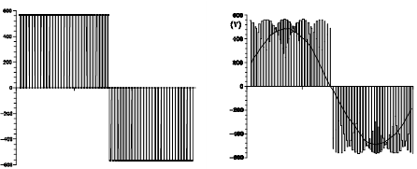
- VSI b) Matrix Converter
Fig. 3.4 Output voltage waveforms generated by a VSI and a matrix converter [10]

- Input current:
The input current of the matrix converter is the result of connection of the output phase with the input lines. Depending on which output phase is connected to the input line the instantaneous input currents are obtained. It is a piecewise sampling of the output current which composes the input current. Since the load is acting as a low pass filter, the output current is almost sinusoidal, but the input current which is composed of different output currents at different instants is rich in harmonics. Particularly the harmonics of the frequency of sampling frequency will have magnitude almost equal to the fundamental. Hence an input filter is essential to filter out these components. But in VSI, even lower order harmonics have significant magnitude. So, it needs heavier filters. Because matrix converter needs these filters, it is not an all-silicon converter to the strictest sense of the expression.
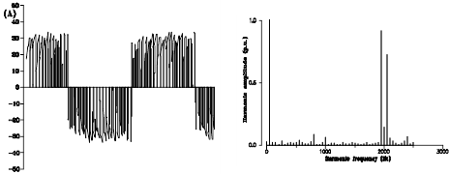

Fig. 3.5 Matrix converter input current and harmonic spectrum. Switching frequency is 2 KHz [10].
- The input power factor control:
The input power factor control capability is another attractive feature of matrix converters, which holds for most of the control algorithms proposed in literature. Despite of this common capability it is worth noting that a basic difference exists with respect to the load displacement angle dependency.

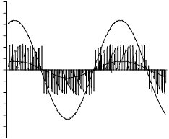
Fig. 3.6 Matrix converter input line-to-neutral voltage, instantaneous input current and its average value. Switching frequency is 2 kHz [10].
3.2 MODULATION TECHNIQUES OF MATRIX CONVERTER
Modulation is used to generate the gate signals to the switches of a converter at opportune moments to get the desired output voltage from a fixed supply having fixed magnitude and frequency. There are different modulation techniques:
- Venturini method
- Space vector modulation
The principle used in Venturini Modulation Method and its implementation is discussed in the following topics.
3.2.1 VENTURINI MODULATION METHOD
This method was proposed by A. Alesina and M. Venturini in the 1980’s. In this method the desired instantaneous output voltage is synthesized from the three available input voltages. The time average of the three input voltages applied to the output terminals is equal to the desired value of the output voltage. Within the sampling period, the times from which the output line is to be connected to the input line is calculated from the known values of the inputs and the desired value of the output. Accordingly the appropriate switches are gated.
Switch $S_{ij}$ (the switch connecting $i^{th}$input with $j^{th}$output) is turned on for $t_{ij}$ time so that the average voltage at the output terminal within the sampling time is equal to the desired value. This can be expressed mathematically as in following equation. The first letters in the subscript of t are the input phases and the second ones are the outputs [4].
$${\overline{V}}_{jN}\left(t\right)= \frac{t_{Aj}v_{A }\left(t\right)+ t_{Bj}v_{B }\left(t\right)+ t_{Cj}v_{C }\left(t\right) }{T} ;j=\left\{a, b, c\right\} …(3.5)$$
In the above equation $V_{jN}\left(t\right)$ is the arithmetic mean of the output voltage over the sampling period. Using this strategy a high frequency switched output waveform is generated. Clearly, sampling time T=$t_{Aj}+ t_{Bj}+ t_{Cj}$. The duty cycle of the switches are defined in the equation below:
$$m_{Aj}= \frac{t_{Aj}}{T}, m_{Bj}= \frac{t_{Bj}}{T}, m_{Cj}= \frac{t_{Cj}}{T} …(3.6)$$
Writing the voltage equation of each of the output phases I the form of a matrix we get:
$$\left[\begin{matrix}V_{aN}(t) \\ V_{bN}(t) \\ V_{cN}(t)\end{matrix}\right]=\left[\begin{matrix}m_{Aa}(t) & m_{Ba}(t) & m_{Ca}(t) \\ m_{Ab}(t) & m_{Bb}(t) & m_{Cb}(t) \\ m_{Ac}(t) & m_{Bc}(t) & m_{Cc}(t)\end{matrix} \right]\left[\begin{matrix}V_{AN}(t) \\ V_{BN}(t) \\ V_{CN}(t)\end{matrix}\right]$$
$$V_{o}\left(t\right)= N\left(t\right).V_{i}\left(t\right) …(3.7)$$
Where $V_{o}\left(t\right)$ is the low frequency output vector, ${V_{o}\left(t\right)=\left[\begin{matrix}V_{a}(t) & V_{b}(t) & V_{c}(t)\end{matrix}\right]}^{T}$ and $V_{i}(t)$ is the instantaneous input voltage, ${V_{i}\left(t\right)=\left[\begin{matrix}V_{a}(t) & V_{b}(t) & V_{c}(t)\end{matrix}\right]}^{T}$ and M (t) is the low frequency transfer matrix of the matrix converter.
Similarly the input current being synthesized from the output currents, we have:
$$i_{i}\left(t\right)= M^{T}\left(t\right).i_{o}\left(t\right) …(3.8)$$
Where ${i_{i}\left(t\right)=\left[\begin{matrix}i_{A}(t) & i_{B}(t) & i_{C}(t)\end{matrix}\right]}^{T}$ is the low frequency input current vector, ${i_{o}\left(t\right)=\left[\begin{matrix}i_{a}(t) & i_{b}(t) & i_{c}(t)\end{matrix}\right]}^{T}$ is the instantaneous output current vector $M^{T}\left(t\right)$ is the transpose of $M\left(t\right).$
Let the input voltage be of the form:
$$v_{i}\left(t\right)=\left[\begin{matrix}v_{A}(t) \\ v_{B}(t) \\ v_{C}(t)\end{matrix}\right]=\left[\begin{matrix}V_{i}cos⁡(ω_{i}t) \\ V_{i}cos⁡(ω_{i}t+2π/3) \\ V_{i}cos⁡(ω_{i}t+4π/3)\end{matrix}\right] …(3.9)$$
The low-pass nature of the load, the output current will be a near sinusoid. Therefore the output current can be expressed as:
$$i_{o}=I_{om}\left[\begin{matrix}cos⁡(ω_{o}t+∅_{o}) \\ cos⁡(ω_{o}t+∅_{o}+2π/3) \\ cos⁡(ω_{o}t+∅_{o}+4π/3)\end{matrix}\right] …(3.10)$$Where $ω_{o}$is the output frequency in rad per sec.
The modulation matrix M in equation (4.3) and (4.4) should be such that the output voltage is:
$$v_{o}={qV}_{im}\left[\begin{matrix}cos⁡(ω_{o}t) \\ cos⁡(ω_{o}t+2π/3) \\ cos⁡(ω_{o}t+4π/3)\end{matrix}\right] …(3.11)$$
$$i_{i}={qcos\left(∅_{o}\right)I}_{om}\left[\begin{matrix}cos⁡(ω_{i}t+∅_{i}) \\ cos⁡(ω_{i}t+∅_{i}+2π/3) \\ cos⁡(ω_{i}t+∅_{i}+4π/3)\end{matrix}\right] …(3.12)$$
Here ‘q’ is the input to output transformation ratio. There are two basic solutions. The solution in one equation yields$∅_{i}=∅_{o}$, giving same displacement at the input and output ports, whereas the solution in other yields$∅_{i}={-∅}_{o}$, giving reverse displacement factor. Combining the two solutions provides the means for input displacement factor control [4].
$$M_{1}=\frac{1}{3}\left[\begin{matrix}1+2qcos⁡(ω_{m}t) & 1+2qcos⁡(ω_{m}t-2π/3) & 1+2qcos⁡(ω_{m}t-4π/3) \\ 1+2qcos⁡(ω_{m}t-4π/3) & 1+2qcos⁡(ω_{m}t) & 1+2qcos⁡(ω_{m}t-2π/3) \\ 1+2qcos⁡(ω_{m}t-2π/3) & 1+2qcos⁡(ω_{m}t-4π/3) & 1+2qcos⁡(ω_{m}t)\end{matrix}\right]$$${where ω}_{m}=ω_{o}-ω_{i}$ … (3.13)
$$M_{1}=\frac{1}{3}\left[\begin{matrix}1+2qcos⁡(ω_{m}t) & 1+2qcos⁡(ω_{m}t-2π/3) & 1+2qcos⁡(ω_{m}t-4π/3) \\ 1+2qcos⁡(ω_{m}t-2π/3) & 1+2qcos⁡(ω_{m}t-4π/3) & 1+2qcos⁡(ω_{m}t) \\ 1+2qcos⁡(ω_{m}t-4π/3) & 1+2qcos⁡(ω_{m}t) & 1+2qcos⁡(ω_{m}t-2π/3)\end{matrix}\right]$$
${where ω}_{m}={-(ω}_{o}+ω_{i})$ … (4.10)
To calculate the duty cycles using the above equations is difficult. So, the duty cycles are calculated using the following equation which is found out with displacement factor as unity.
$$m_{Kj}=\frac{i_{Kj}}{T}=\frac{1}{3}\left[1+\frac{2v_{k}v_{j}}{V_{im}^{2}}\right] for K=A, B, C and j=a, b, c …(4.11)$$
In this method voltage ratio is limited to 50%.
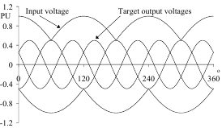

Fig. 3.7 illustrating maximum voltage ratio of 50% [5]
The duty cycle of each switch is calculated from the equation (4.11). Next the time for which the switches should be on are calculated from equation (4.2) for a particular output line, only one of the lines should be connected to it. So, switches $S_{Aj}, S_{Bj} and S_{Cj}$ are turned on for periods $t_{Aj}, t_{Bj} and t_{Cj}$ one after the other. These instants are shown in fig. 4.3. Here the sampling time is considered to 1ms.
In Venturini method, as the output voltages are derived from direct contact of the outputs and the inputs, it is obvious that the desired output voltage should always be within the profile of the input voltages. This sets a limit to the maximum output voltage that can be obtained using this method to 50% of the input.

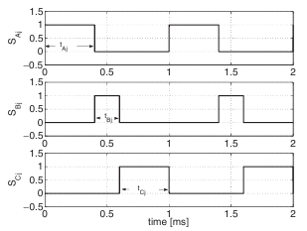
Fig. 3.8 Variables used for pulse generation on the output phase
3.3 DSPIC CONTROLLER BASICS:
It is a microcontroller used for the implementation of Venturini modulation technique. The time period of switching of various switches is calculated and gates are operated for the calculated time period. The features of the controller are given below:
- High-Performance Modified RISC CPU
- Up to 48 Kbytes on-chip Flash program space
- 2 Kbytes of on-chip data RAM
- Up to 33 interrupt sources:
- 8 user selectable priority levels
- 3 external interrupt sources
- 4 processor traps
DSP Features:
- Two 40-bit wide accumulators with optional saturation logic
- 17-bit x 17-bit single cycle hardware fractional/integer multiplier
Peripheral Features:
  - High current sink/source I/O pins: 25 mA/25 mA
  - Up to five 16-bit timers/counters; optionally pair up16-bit timers into 32-bit timer modules
  - Up to four 16-bit Capture input functions
  - Up to four 16-bit Compare/PWM output functions

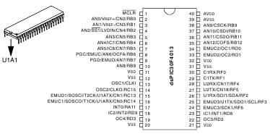

Fig. 3.9 dsPIC 30F4013 chip with pin names [11]
MPLab IDE software is developed by Microchip. This also contains the dsPIC30F4013 specific configuration files. In this software, the code is written in C language. MPLAB C30 compiler is used to compile the program and convert C code in hexadecimal. MPLAB ICD (in-circuit debugger) is used to burn the hexadecimal code in the controller.

3.4 PRACTICAL CONSTRAINTS
3.4.1 BIDIRECTIONAL SWITCH REALIZATION
Matrix converter being an ac converter needs to conduct current in both directions as well as block voltages in both directions when necessary. Unfortunately, there is no single device available today which can serve the above needs. So, these properties of the switches are obtained by combining more than one switch. This result in more complexity and higher losses associated with the switches both during switching and when the devices are ON. In fig (3.10), the switches are classified into four categories depending upon the direction of conduction and their capability to block voltages. [2] It shows:
- Switches with bidirectional operations featured by 4 basic operations.
- Switches without direction operations featured by 2 basic operations.
Two different states of gate G (1: charged 0: uncharged. Indexed v: forward r: reverse) leads in the case of topology with two transistors/gates to four different states of a bidirectional switch.
- Forward blocking reverse blocking-that is interruption. (G_{v} : 0; G_{r} :0)
- Forward conducting reverse blocking-that is ideal diode. (G_{v} : 1; G_{r} :0)
- Forward blocking reverse conducting-that is ideal reverse diode. (G_{v} : 0; G_{r} :1)
- Forward conducting reverse conducting-that is bidirectional close. (G_{v} : 1; G_{r} :1)

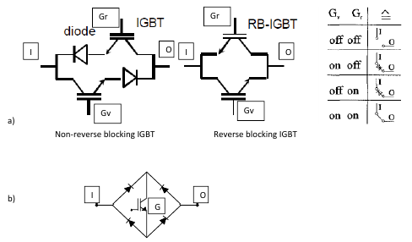

Fig. 3.10 Bidirectional Switches [3]
3.4.1.1 Diode Bridge Bidirectional Switch Cell:
The diode bridge bidirectional switch cell arrangement consists of an insulated gate bipolar transistor (IGBT) at the center of a single-phase diode bridge arrangement as shown in fig (3.11). The main advantage is that both current directions are carried by the same switching device, therefore, only one gate driver is required per switch cell. Device losses are relatively high since there are three devices in each conduction path. The direction of current through the switch cell cannot be controlled. This is a disadvantage, as many of the advanced commutation methods described later require this [1].
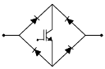

Fig. 3.11 Diode bridge bidirectional switch [1]
3.4.1.2 Common Emitter Bidirectional Switch Cell
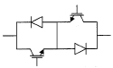
The common emitter bidirectional switch cell arrangement consists of two diodes and two IGBTs connected in anti-parallel as shown in fig (3.12). The diodes are included to provide the reverse blocking capability. There are several advantages in using this arrangement than diode bridge bidirectional switch cell arrangement. The first is that it is possible to independently control the direction of the current. Conduction losses are also reduced since only two devices carry the current at any one time. One possible disadvantage is that each bidirectional switch cell requires an isolated power supply for the gate drivers, but both devices can be driven with respect to the same voltage-the common emitter point [1].

Fig. 3.12 Common Emitter Bidirectional Switch [1]

3.4.1.3 Common Collector Bidirectional Switch Cell
The common collector bidirectional switch cell arrangement is shown in fig (3.13). The conduction losses are the same as for the common emitter configuration. An often-quoted advantage of this method is that only six isolated power supplies are needed to supply the gate drive signals. However, in practice, other constraints such as the need to minimize stray inductance mean that operation with only six isolated supplies is generally not viable. Therefore, the common emitter configuration is generally preferred for creating the matrix converter bidirectional switch cells [1].
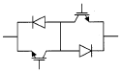

Fig. 3.13 Common Collector Bidirectional Switch [1]
3.4.2 CURRENT COMMUTATION
Current commutation in matrix converter is more complicated than that in voltage source inverters. This is due to the absence of any freewheeling path in matrix converters. The two rules which should be followed to turn on the switches make the process more difficult since there is no switch that can turn off and on instantaneously. Matrix converter requires an instantaneous switching OFF of the outgoing device and instantaneous switching ON of the incoming device. If there is a delay between switching on and switching off, then rule 2 is violated. Again an overlap period between the incoming and outgoing switch will cause short circuit of the supply.
3.4.2.1 Dead-Time Current Commutation:
In this method the outgoing device is turned off first and then only the incoming device is turned on. Apparently, there is a momentary open circuit of the load terminal at this time. Now, the load current is carried by the snubber circuit connected across the switches. This causes increased complexity in the design of the snubber circuit and additional losses. Moreover the sizes of the clamping devices increase making the converter more bulky.
3.4.2.2 Overlap Time Current Commutation:
Here, the incoming device is turned on before the outgoing device is turned off. So, it appears that there is a short period of short circuit of the supply. The extra line inductance prevents the current from acquiring dangerous values. These inductances have a detrimental effect in causing sluggish rise and fall in current as well as an increase in the volume of the converter.
3.4.2.3 Semi Soft Current Commutation:
Overlap time commutation can be used when the incoming and outgoing devices are controlled independently, preventing a short circuit of the supply. Zero current commutation can also be obtained if the turning on of the incoming switch reverse biases the outgoing one. There is a 50% chance of achieving this during the switching process and therefore is named ‘semi soft switching’ [1].
- Four Step Semi-Soft Current Commutation
In this strategy, the direction of the current through the conducting device is sensed first. Then decision is taken to switch off that portion of this device which is not conducting. Now, that half of the incoming device which will carry current in the same direction as before is switched on. There is no short circuit of the supply at this stage since the incoming device is unable to carry current in the reverse direction. When the current transfer is complete, the outgoing device is turned off completely. Now gate signals are given to both the devices of the incoming switch.
Fig (3.14(a)) shows the actual bidirectional switches made of transistors and diodes. Correspondingly, the fig (3.14(b)) gives a simplified representation of the electronic devices acting as bidirectional switches.
Taking reference from fig (3.14(a)) the transistor S1_{r}, S1_{d}, S2_{r}, and S2_{d} are respectively represented by SW1A, SW1B, SW2A and SW2B in fig (3.14(b)).
To illustrate, fig (3.14(b)) is referenced. It is assumed that SW1 is ON at the instant considered. The direction of load current at the time of change over indicates SW1A is conducting current. Since SW1B is not conducting, its gate signal is removed. Next, as the load current should continue in the same direction, and SW2 should now conduct, SW2A is now gated. When the transfer of current is over, it is time to switch off SW1A. Now it is safe to turn on SW2B so that SW2 can carry current in both the directions [1].

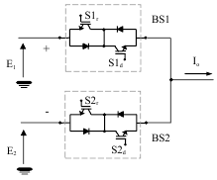

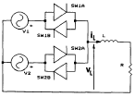

Fig. 3.14(a) Two phase to single phase matrix converter (b) Equivalent representation of the switches in (a) [2]
3.4.3 INPUT FILTER
As discussed earlier, the input currents have considerable switching harmonics. These harmonics are not desirable and should be removed so that the supply is not polluted by them. Input filters serve this purpose. Care should be taken during the design of the filters so that it does not consume much reactive power, it is not too bulky and does not draw power from the load. Again the filter should not cause a large voltage drop.
3.4.4 POWER CIRCUIT PROTECTION
A matrix converter lacks in the availability of a freewheeling path. So, the necessary delay between the turning OFF and on of two switches has to be dealt with in a different way. In VSI’s this part is done by the feedback diodes. In matrix converter, the load current during this time is carried by the snubber circuits. So the snubber circuit has to be designed accordingly.
Additionally, when the switches are turned off during fault conditions (like over current) there might be an excessive overvoltage in the load. This effect can be mitigated using clamping device as shown in fig (3.16).

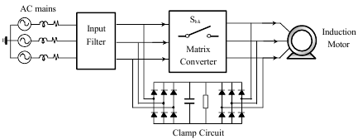
Fig 3.15 Clamp circuit as common protection for all Matrix Converter Bidirectional switches [1]
3.4.5 SEMICONDUCTOR LOSSES
Due to the unavailability of suitable bidirectional devices, the switches are fabricated using two or more devices. This leads to more switching loss and conduction loss. Moreover, the switching losses are proportional to the switching frequency. In case of the combination of the diode bridge and the IGBT, we see in any path there are three devices in series. The loss in any device is the product of the on-state voltage and current. So the losses in this case are more. [1]
So far we have understood the concepts of Matrix converter, its control algorithms and its constraints. So, to implement this matrix converter, we shall take care of all the practical constraints and chose circuit elements such that we can achieve such high sampling rate (1 KHz). The Venturini algorithm is built on the controller and Matrix converter’s 9 switches are controlled as per this strategy. We shall also try to optimize the results for 25Hz output frequency with voltage transfer ratio as 0.5

C h a p t e r 4
EXPERIMENTAL SETUP AND CIRCUITS INVOLVED

Now, actually the Matrix converter is to be realized. Various components are used for this, say snubber circuit for over-current and over-voltage, driver circuit for isolation, controller and some interfacing circuitry. The working of all these components is discussed in this chapter. Also the Venturini Modulation Technique Algorithm is explained.

  - SNUBBER CIRCUIT
Snubber circuit is a simple energy absorbing circuit used to eliminate voltage spikes caused by circuit inductance when a switch opens. The objective of using a snubber circuit is to eliminate the voltage transient and ringing that occurs when the matrix converter switches open by providing an alternate path for current flowing through circuit
The snubber circuit used here is shown in fig (4.1). This snubber is used for voltage clamping because during switch turn off, a large voltage is developed at the drain terminal of the MOSFET. Also a varistor is used to check rate of rise of current (di/dt).
4.1.1 CIRCUIT DIAGRAM
The drain of the MOSFET is connected to the positive (+) end of the diode bridge rectifier while the source is connected at the negative (-) end of the diode bridge rectifier. The supply is given at one AC input of the bridge and the load is connected to the other AC terminal. The snubber circuit is connected as shown in fig (4.1).
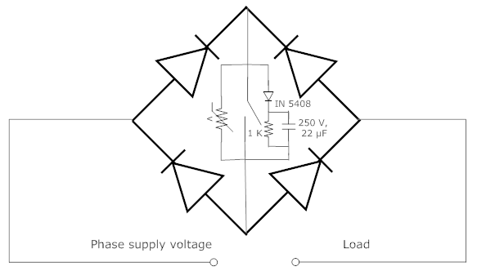
The three switches of each output corresponding to R phase are connected with the same wire coming from R phase of the 3 phase supply. Similarly, the corresponding the Y phase switches and B phase switches are connected to the Y and B phase of the supply. Each output is connected to all the 3 phases.

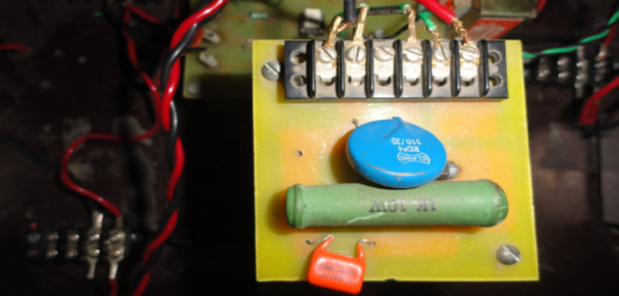
Fig 4.1 Snubber Circuit Diagram Fig. 4.2 Snubber Circui
4.1.2 WORKING
In the clamp mode the purpose of the snubber is to clamp the voltage during turn-off at the drain of the MOSFET. The parallel RC circuit may be returned to ground or to a voltage other than ground (i.e., input voltage if the drain can go above input voltage) since this will reduce the power dissipation in the resistor. The MOSFET switch itself will have to sustain the peak power dissipation during turn-off. The value of the capacitor, C CLAMP, and resistor, R CLAMP, is based on the energy stored in the parasitic inductance, as this energy must be discharged into the RC network during each cycle. The voltage across the capacitor and resistor sets the clamp voltage, V CLAMP. The turn-off waveform at the drain of the MOSFET switch is as shown in fig (4.3).
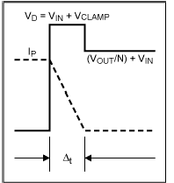
The RC time constant of the clamp should be chosen much larger than the switching period of the MOSFET. The series diode used in the clamp should be able handle the peak currents and must be a fast turn-on type. It is important to minimize the ripple, V_{ipple}, superimposed on V CLAMP to keep the MOSFET drain voltage close to the clamp voltage.

Fig 4.3 The turn-off waveform at the drain of the MOSFET switch [12]
4.1.3 TESTING
The testing of the module containing snuuber circuit diode bridge rectifier and the MOSFET is done. A single phase auto-transformer and resistive load is used additonally for the testing of individual switch module. The output of the module is connected to a resistive load andd the input supply is given through the single phase auto-transformer. The power scope terminals are connected across the input and output of the bridge rectifier and waveform is noted on the CRO. As the supply is increased through auto-transformer, the CRO show the exact input waveform when the switch is off. As soon as the gate pulse is given the voltage across the input and output teerminals become zero. This shows that the switch module is working perfectly fine.
During the testing it was also observed that sometimes output waveform is not as desired. It was mainly because one or many of the switches are not working. When they were tested individually they were either short circuited or open circuited whether the gate pulse is given or not. If the switch is shot chircuited, it means the recitifier brigde is short cicuited else the MOSFET is damaged .
  - DRIVING CIRCUIT
Driving circuit is required to generate gate pulses for the MOSFET switches. This circuit generates a regulated 12 V voltage supply with the help of a transformer, diode rectifier circuit and 7812 voltage regulator IC. MCT2E is an electronic device designed to provide electrical isolation between input and output side. This opto-coupler IC (MCT2E) is used to isolate the signal pulses coming from the micro controller and the signal pulses going to the MOSFETs. The input to the driving circuit (FD) (fig (4.5)) comes from dsPIC controller and the output of this driving circuit is used to trigger the MOSFET switches of the matrix converter.
    - CIRCUIT DIAGRAM
In this circuit, a step down transformer is used which generates 15 V AC output at its secondary terminals. This is passed through a bridge rectifier circuit which converts this AC to DC and this voltage is regulated to 12 V with the help of 7812 voltage regulator. The gate of the MOSFET takes current from this supply only whenever the pulses are given. There is an opto-coupler IC that separates this 12 V supply form the 5 V pulses coming from the Microcontroller. The input of the opto-coupler IC is coming though a transistor whenever the gate pulse is given by the microcontroller. The other end of the opto-coupler IC operates a transistor which turns ON and OFF with the gate pulses. There is a 12 V zener diode connected at the output.
4.2.2 WORKING
In the opto-coupler IC there is basically an LED and a phototransistor whenever the FD is made active the transistor T1 is turned ON and the collector terminal is apparently connected to the ground. Thus, the LED is forward biased and emits light. This light falls on the base of the phototransistor present in the opto-coupler. This turns ON the phototransistor and the pin 5 (collector terminal of phototransistor) is apparently grounded. This turns OFF the transistor T2 and the voltage at the collector of this transistor becomes 12 V that is the output of the driving circuit going to the gate of the MOSFET switch.

    - TESTING
For testing this driving circuit first the output of the step down transformer is checked. It should come out to be 30 V_{p-p}. Next, the output of the voltage regulator IC is checked it should be 12 V dc. Now, the pulses are given at the FD terminal of the driving circuit using a function generator at 1 KHz frequency. It is checked at the output that 12 V, 1 KHz square wave is obtained.
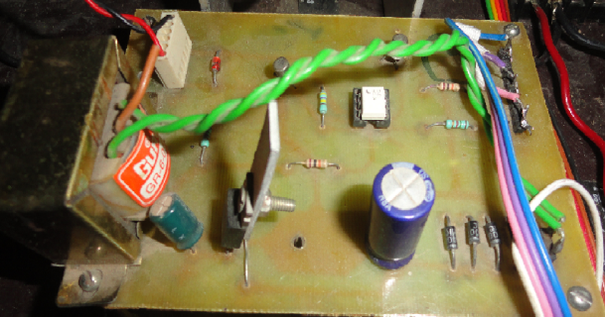

Fig 4.4 Driving Circuit

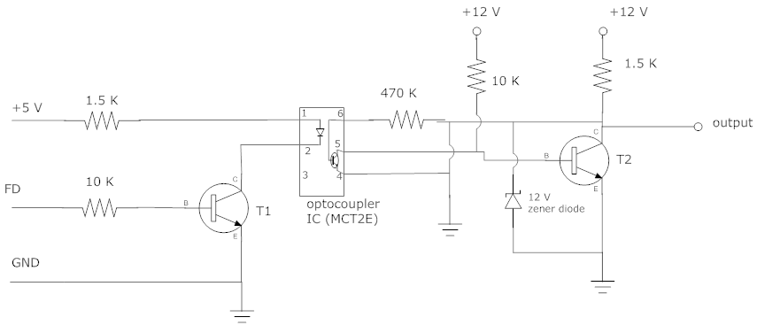
Fig 4.5 Driving Circuit Diagram

  - ZERO CROSSING DETECTOR CIRCUIT
A zero crossing detector literally detects the transition of a signal waveform from positive to negative and negative to positive, providing a narrow pulse at each transition. Per phase there are two pulses so for 3 phases there shall be 6 pulses in one full cycle. This is done in 3 stages. First the input signal of each phase is fed to a comparator circuit as shown in fig (4.7).
4.3.1 CIRCUIT DIAGRAM
Here, zero crossing detector circuit is made using comparator IC LM 339 [17]. Whenever, the signal is negative the comparator output is high. This is same for all the three phases. The output of the comparator goes to 74121 IC [15] used to generate mono-shots. Two 74121 IC’s are required per phase. One IC gives high to low pulse whenever the output of the comparator shows a transition from high to low. The other IC gives a high to low pulse whenever the output of the same comparator shows a transition from low to high. The resistance and capacitor connected to each mono-shot decides the time period of pulse. The output of six such 74121 IC’s for the three phases is sent to a NAND gate which gives pulses, corresponding to the zero crossing of the 3 phases, as its output. These pulses correspond to the zero crossing (positive to negative) of the three phases. 74LS30 IC [16] is used here which is 8 input NAND gate IC.
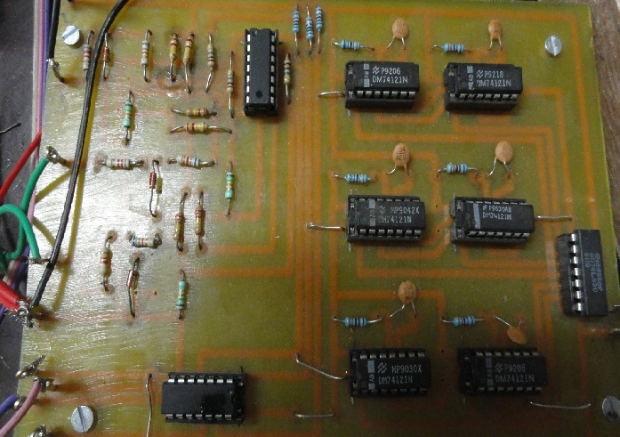

Fig. 4.6 Zero Crossing Detector Circuit

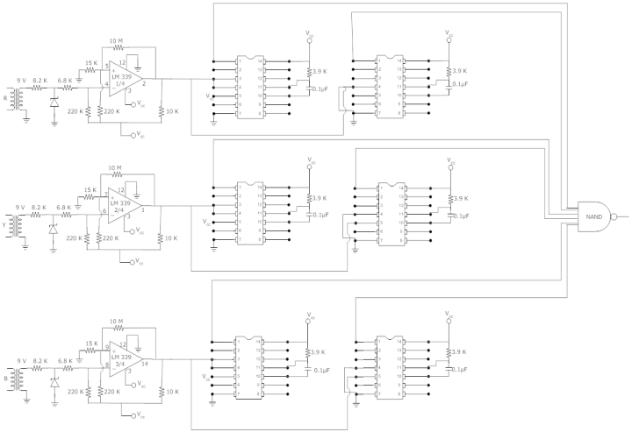
Fig. 4.7 Zero Crossing Detector circuit diagram

4.3.2 WORKING
Positive feedback comparator is used. 220 K resistor between V_{cc} and the input pins of the comparator; 10 K resistor between V_{cc} and output pin are the pull-up resistors. Pull-up resistors are used in electronic logic circuits to ensure that inputs to logic systems settle at expected logic levels if external devices are disconnected or high-impedance. Suppose the output of the comparator is high (+5 V). Thus, the voltage at the positive input pin of the comparator is 7.5 mV. The voltage output of the comparator remains high till the input to the negative input pin of the comparator is less than 7.5 mV. The moment, the input to the negative pin of the comparator becomes greater than 7.5 mV, the output of the comparator becomes low (0 V). Thus, the voltage at the positive pin of the comparator is 0 V. The moment, the input to the negative pin becomes less than 0 V (negative half cycle), the output of the comparator becomes high and the voltage at the positive pin of the comparator again becomes 7.5 mV.
The output of the comparator is fed to two mono-shots, one for generating mono-shots for positive transition and the other for negative transition. The time constant t=R*C decides the time period for which the pulse should be active. This goes to the NAND gate for generating 6 pulses per input cycle.
4.3.3 TESTING
During the testing the comparator output is checked with respect to the input waveform of the corresponding phase. The waveforms are shown in fig (5.2). The mono-shot outputs corresponding to the comparator output of 1 phase is shown in fig (5.6). Thus, it is also tested that the mono-shots are generating pulses, one for positive and the other for the negative transition of the comparator output waveform.
4.4 CONTROLLER INTERFACING CIRCUIT
This circuit is specifically designed to interface the controller pins with the driver circuit and Zero crossing detector. The 9 signals for the driving circuit come from the 9 digital pins of the microcontroller. Also the Zero crossing pulses generated are taken in from an interrupt pin of the microcontroller. The Quad pulses generated for the synchronization purpose are also taken as input from the 3 digital pins of the microcontroller. All this pin interfacing with the corresponding circuit is done by this interfacing circuit only.
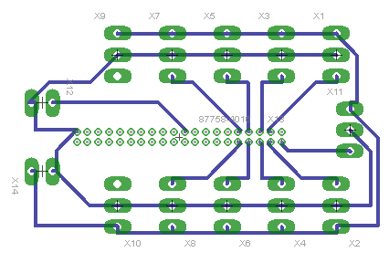

Fig 4.8 Controller Interfacing IC pin diagram

  - dsPIC30f4013 MICROCONTROLLER

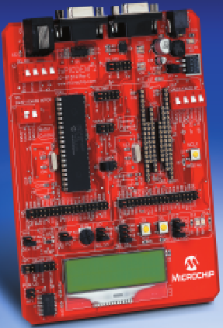

Fig. 4.9 MICROCHIP - DM300018 - KIT DSPICDEM 2 Demo Board [11]
Venturini Modulation technique for calculating the time periods of switching of various switches is implemented using the Micro-Controller dsPIC30F4013. The flowchart of the algorithm is shown in fig (4.10).

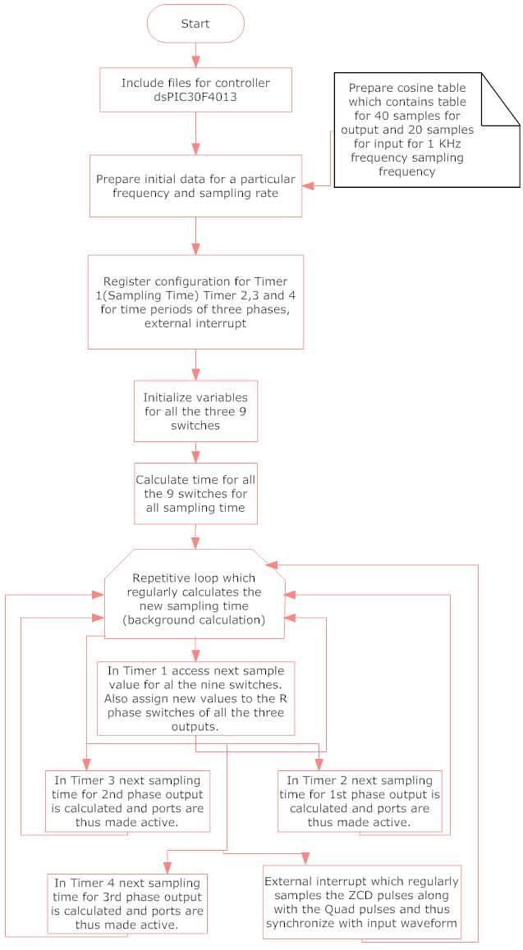
Fig. 4.10 Flow Chart of Algorithm Implemented by dsPIC Controller
In the starting of the program, first all the header files are included. One header file is dedicated to provide reference for the keywords of specific Microcontroller (dsPIC30F4013). Also, the header files for math functions are included.
The duty cycles are calculated using the equation (4.11) which is found out with displacement factor as unity.
Two cosine tables are prepared which contains the values $\cos\left(ω_{i}t\right),\cos\left(ω_{i}t-\frac{2π}{3}\right)$ $and cos⁡(ω_{i}t-4π/3)$ for input and $\cos\left(ω_{o}t\right),\cos\left(ω_{o}t-\frac{2π}{3}\right)and cos⁡(ω_{o}t-4π/3)$ for output. The table for the input (50 Hz) contains 20 samples per phase for 1 KHz frequency sampling rate. The table for the output (25 Hz) contains 40 samples per phase for 1 KHz frequency sampling rate.
The variables for the time periods of various switches are initialized. Their initial value is set to zero. In the main program, the registers for the various special functions are initialized namely for timer 1, timer 2, timer 3 and timer 4; and external interrupt.
In the main program, the foreground calculation for the switching time period of all the 9 switches is done for all the sampling time instants in one cycle of the output. This calculation is performed only once in the entire operation. These values are store in variables created for each switch. Thus, each variable contains 40 samples for 25 Hz output frequency and 1 KHz sampling rate.
The background calculation is performed in loop. The program leaves this loop whenever the interrupt comes. The interrupt may be from timer 1, timer 2, timer 3 or timer 4; or external interrupt. After executing these subroutines the program again enters into the loop and performs some of the background calculations for calculating the switching time periods of the various switches.
In timer 1 interrupt subroutine, the port pins corresponding to the gate pulses of R phase of the three outputs is made active. The new time periods of the 9 switches at that particular sampling time is accessed and assigned to the switching time variables of the 9 switches. Now, the pre-scalar for timer 2, timer 3 and timer 4 are assigned the corresponding values for output 1, output 2 and output 3 calculated for their R phase switch. Timer 1 interrupt arrives at regular intervals of 1 millisecond as set according to the configuration registers for timer 1.
In timer 2 interrupt service routine, the output 1 is connected to the Y phase and is disconnected with R and B phase when it arrives at odd intervals. Also, the pre-scalar is set as per the time of the switch accessed for output 1 corresponding to Y phase. When the interrupt arrives at even intervals, the output one is connected to B phase and is disconnected with R and Y phase. The output 1 remains connected to B phase for the remaining time period till 1 millisecond is over.
Similarly, timer 3 interrupt service routine for output 2 and timer 4 interrupt service routine for output 3 behaves in the same way as timer 2 for output 1.
The program enters into the external interrupt subroutine whenever the low to high pulses are detected at the external interrupt 0 pin of the microcontroller. These pulses are generated by the zero crossing detector circuit. As there are 6 pulses in one cycle of the input waveform so, six interrupts are generated in 20 milliseconds (50 Hz) frequency. The quad pulses generated are read in this subroutine and the checking is done for synchronizing. As soon as the synchronizing sequence is detected in the interrupt service routine timer sampling variable (T_{o}) is reset or set to zero.
  - OVER CURRENT PROTECTION : FUSE
For protecting the circuit from over-current 5A fuses has been used at the input supply of Matrix converter. These fuses are made using a 5A fuse wire. Whenever the line current exceeds 5A, the fuse wire burns out and disconnects the respective supply from the Matrix converter. This fuse is very important for the protection of switches. These switches are made of Mosfet and diode bridge. These elements cannot bear high current. This high current may be there because of commutation overlap and short time short circuit of the two phases. So, these fuses protect the circuit elements from any damage.
  - LOAD
The Matrix converter is connected to different loads for examining the output line current and phase voltages. First, the R load is connected in star mode configuration and then the inductor in series with the resistance is in star configuration. Three 10W, 300 ohms rheostat has been used as a resistive load and an additional variable inductor is used for performing RL load testing.
4.8 OPERATING INSTRUCTIONS
a) All the circuit components are powered up
- Single phase AC supply to driver circuit
- 5V DC supply to Zero Crossing Detector circuit
- 12 supply to micro-controller kit though 12V adapter
- Three phase AC supply to 3 transformers connected as input to comparator in ZCD circuit.
- Three phase AC supply through three phase Auto-transformer to the fuse board (5A)
- From fuse board to three phase input of Matrix converter (R, Y, B).
b) Power Scope is connected across the neutral and one output phase.
c) An ammeter is also to be connected at one of the input line of the supply.
d) Current sensor is connected in the output line of one of the loads. It is also observed on the CRO.
e) The input supply o the matrix converter is slowly increased through autotransformer to 5 percent of the supply voltage.
f) It should be noted that supply current in one of the line should not increase more than 5A.
g) Next, for performing testing at RL load. RL load is connected in Star configuration.
h) Power scope is connected between the neutral and one output phase.
i) The supply is again increased to 5 % of the supply though auto-transformer input current should not increase more than 5A.
j) Output voltage is examined through power scope while output current is observed through sensor in the CRO.
The whole experimental setup is arranged and proper connections are made with utmost care so that no short circuit occurs. After making all the interconnections, the observations are recorded. There are some waveforms which explain the concepts that we discussed in chapter3. The output is waveform is observed at R and R-L load.

C h a p t e r 5
RESULTS AND DISCUSSION

5.1 ZERO CROSSING DETECTOR PULSES
- The three phase input supply is given to the three transformers, one for each phase in the zero crossing detector. The output of these transformers is checked for detecting the phase sequences of R, Y and B phase.
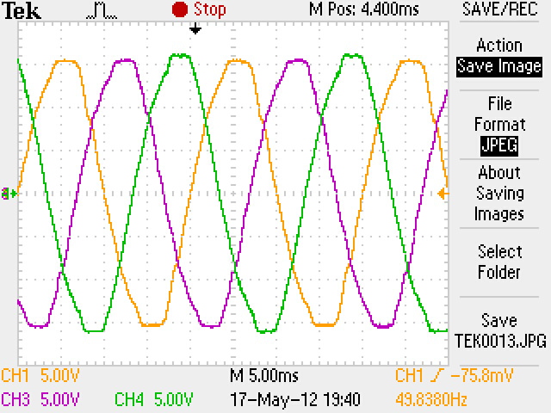
Fig. 5.1 Three phase output voltage waveforms from the transformers: R phase: orange, Y phase: pink, B phase: green.

- The output of the transformer is fed to the comparator. The output is low for positive half cycle and high for the negative half cycle of the input waveform for all the three phases.

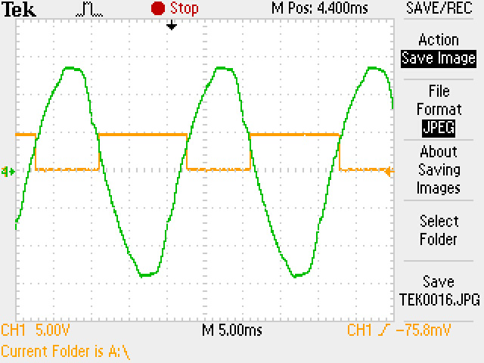
Fig. 5.2 The comparator output along with its corresponding phase voltage waveform for R phase
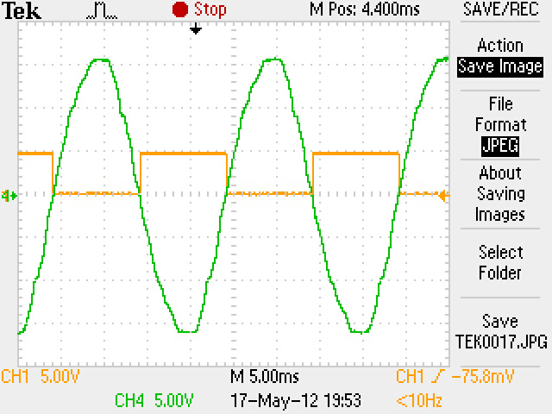
Fig. 5.3 The comparator output along with its corresponding phase voltage waveform for Y phase

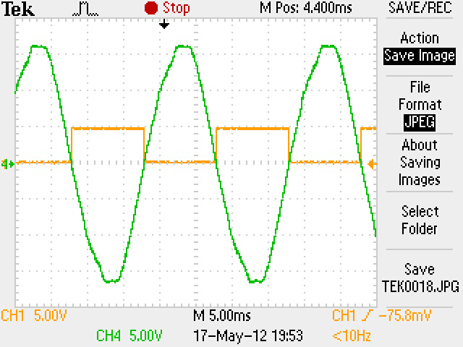
Fig. 5.4 The comparator output along with its corresponding phase voltage waveform for B phase

Simultaneous output of the three comparators is shown in fig (5.5).
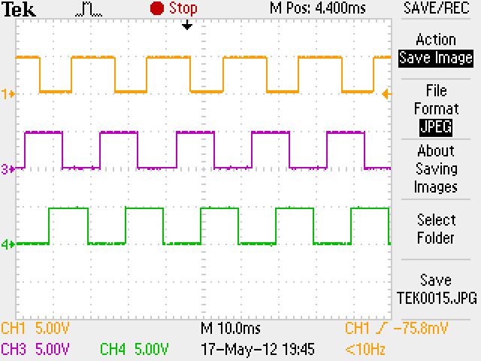
Fig. 5.5 The output pulsed waveforms of the three comparators: R phase: orange, Y phase: pink, B phase: green.

- The output of the comparator is passed through the two mono-shots. One mono-shot generates active low pulse for low to high transition while the other mono-shot generates active low pulse for high to low transition.
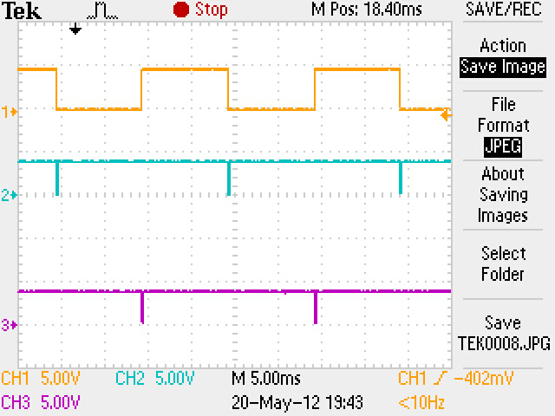
Fig. 5.6 The output of the comparators along with the two mono-shots generating IC’s per phase: Orange: output of comparator; Blue: output of first 74121 [15] mono-shot IC; Pink: output of second 74121 mono-shot IC
- The output of the 6 mono-shots is fed to the 8-input NAND gate. The 6 inputs to the NAND gate come from the 6 mono-shots which generate mono-shots at 60° interval.

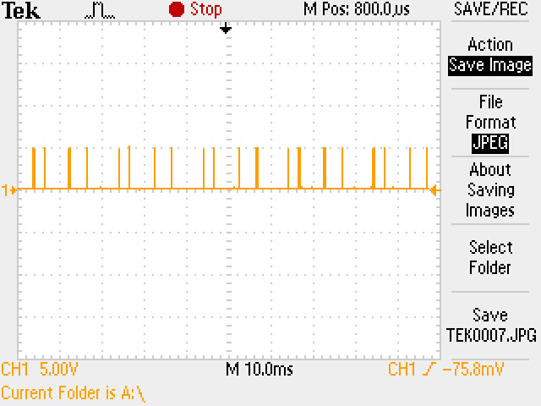
Fig. 5.7 Final output of the zero crossing detector circuit

5.2 QUAD PULSES
The output of the three comparators is given to the AND gate 7408 IC [14] to generate the quad pulses as shown in fig (5.8)
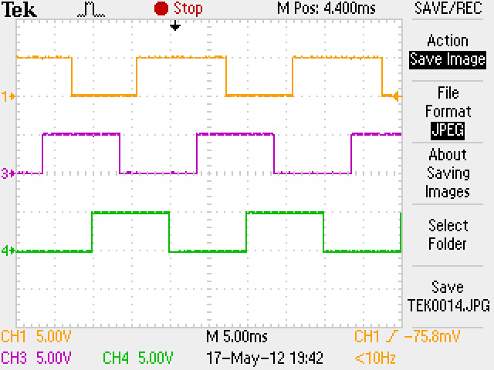
Fig. 5.8 Quad Pulses; Orange: R phase; Pink: Y phase; Green: B phase

5.3 SWITCH PULSES PER OUTPUT PHASE
In fig (5.9), the gate pulses of the 3 switches corresponding to the three phases for output 1 are shown. These pulses are generated at the rate of 1 KHz. The time period of each switch for output 1 is calculated in the controller as per Venturini Modulation Method and thus gate pulses are made active for the calculated time of three switches corresponding to each phase.
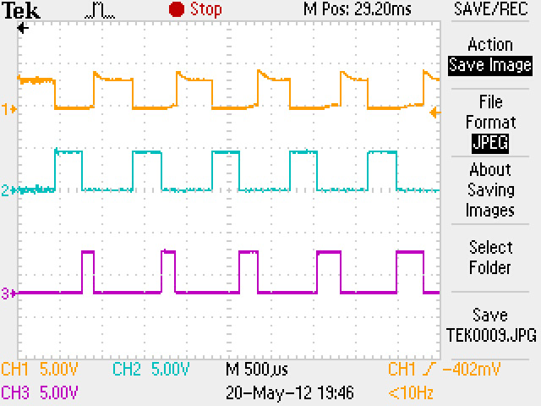
Fig. 5.9 Switch gate pulses for output 1; Orange: R phase; Blue: Y phase; Pink: B phase
5.4 R LOAD
5.4.1 OUTPUT VOLTAGE
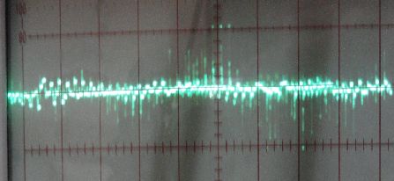
Fig. 5.10 Output1 phase voltage for R load

5.4.2 OUTPUT CURRENT
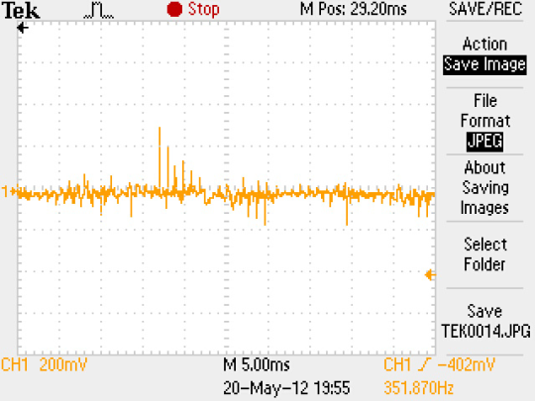
Fig. 5.11 Output1 line current for R load

5.5 R-L LOAD
5.5.1 OUTPUT VOLTAGE
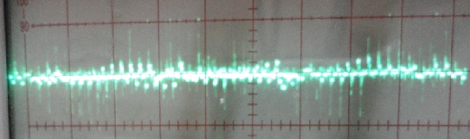
Fig. 5.12 Output1 phase voltage for R-L load

5.5.2 OUTPUT CURRENT
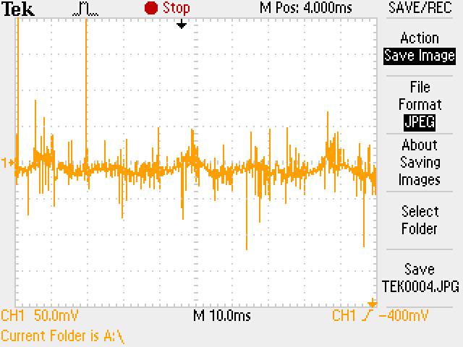
Fig. 5.13 Output1 line current for R-L load

As the inductance decreases, the current peaks increase as shown below.
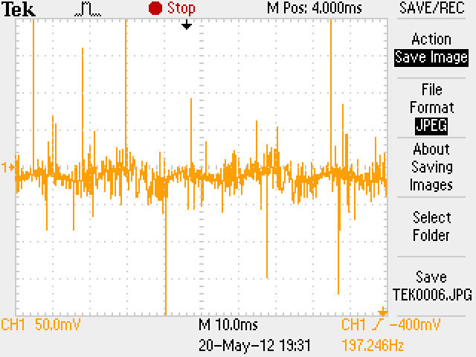
Fig. 5.14 Output1 line current for reduced inductance in R-L load

C h a p t e r 6
CONCLUSIONS AND FUTURE WORK/ IMPROVEMENT

In this setup, for controlling 3 phase induction motor, a variable frequency and voltage supply is to be generated. This is done here with the help of Matrix converter. Venturini Modulation Technique is implemented.
Keeping voltage transfer ration to be 0.5 and output frequency to be 25 Hz, the algorithm is run in controller. The time periods of switching of the 9 switches is calculated at the rate of 1 KHz. After every 1 millisecond, the switches are assigned new time periods for which they should be closed. For each output, each phase is connected one by one so that the sum of time period of phase switches is 1 millisecond.
The testing has been performed successfully at pure resistive load and the R-L load. By seeing the output it can be concluded that the output phase voltage is sampled at 1 KHz that is 20 samples in input phase cycle. The output current is also measured with the help of a current sensor which comes out in the range of 0-1 A. It is also noticed that in the case of R-L load by decreasing the line inductance the peaks in the current increases thus the current distortion increases.
Matrix converter has one inherent limitation that the supply distortion is reflected in the output. This had also been observed in fig (5.10) and fig (5.12).
While doing the testing it has been observed that the input current increases very rapidly with the increase in source voltage (by 3 phase auto-transformer). By increasing the input voltage by 5% only the input line current reaches to 3-4 A while the output current is only in milli-amperes. So it can be concluded that there is short time short circuit in the matrix converter switches. This short circuit occurs mainly because of the improper commutation of the MOSFET switch. It can also be said that due to the very high sampling rate it has been difficult for the snubber circuit to commutate the MOSFET with specified time and thus any of the 2 phase are connected to an output simultaneously.
Because of this short time short circuit and sharp current rise at very low voltages we are unable to achieve sufficiently high output voltage to run the induction motor.
As part of future work, another Modulation technique such as Space Vector Modulation can be implemented. The snubber design also needs to be improved so that it can take on fast switching time required for the algorithm. This is method of generating variable frequency and voltage at the output is very efficient, though it contains harmonics but only higher order harmonics are there which consume less of the power. Also they distort the output waveform to a lesser extent. As compare to VSI or Cyclo-converter.
This method is limited just because of the hardware limitations and the complex calculations needs to be performed at hardware level. Driving induction motor with this converter shall result in very fine speed control.
Also, feedback system can be implemented along with this which itself senses the required torque and thus calculates the speed requirement of the machine and thus generates required output voltage and frequency. As this further increases the calculation so improved speed processor may be required.

REFERENCES

[1] P.Wheeler, J. Rodriguez, J Clare, L. Empringham and A. Weinstein, “Matrix Converters: A technology review”, IEEE Transactions on Industrial Electronics, 49, pp. 276-288, 2002b.
[2] N. Burany, “Safe control of four-quadrant switches,” in Conf. Rec. IEEE-IAS Annu. Meeting, 1989, pp. 1190-1194.
[3] Marcus Ziegler, Wilfried Hofmann, “Semi-natural two steps commutation strategy for Matrix Converters” PESC, pp. 727-731, Fuknokal, JAPAN 1998.
[4] J. Rodriguez, “A new control techniques for AC-AC converter”, in proceedings of IFAC control in Power Electronics and Electrical Drives Conference, Lausanne (Switzerland), 1983, pp. 203-208.
[5] A. alesina and M. Venturini, “Analysis and design of optimum amplitude nine-switch direct AC-AC converters,” IEEE Trans. Power Electron., vol. PE-4, no. 1, pp. 101-112, Jan. 1989.
[6] P. Nielsen, “The matrix converter for an induction motor drive,” Industrial Ph.D. project EF493, ISBN 87-89179-14-5, 296 pages, Aalborg University, Denmark,1996.
[7] P.D. Ziogas, S.I. Khan, and M.H. Rashid, “Analysis and Design of Forced Commutated Cycloconverter Structures with Improved Transfer Characteristics,” IEEE Transactions on Industrial Application, vol. IE-33, No. 3, August 1986, pp. 271-280.
[8] J. Chang, D. Braun, “High-frequency AC-AC converter using 3- in-1 IBPMs and adaptive commutation,” Proceedings of IEEE/PESC’99, vol. 1, pp. 351 –357, 1999.
[9] J. Mahlein, O. Simon, M. Braun, “A Matrix Converter with Space Vector Control Enabling Overmodulation,“ Proceedings of EPE’99, CD-ROM, paper 394, pp. 1-11, 1999.
[10] P.K. Sen, N. Sharma, A.K.Shrivastava, D. Kumar, D. Singh and K.S. Verma,”Carrier Frequency Selection of three phase matrix converter” in International Journal of Advances in Engineering & Technology, July 2011, Vol. 1,Issue 3,pp.41-54.
[11] MicroChip dsPIC30F4013, “High-Performance Digital Signal Controllers”, 2004 Microchip Technology Inc.

[12] MAXIM Application Note 848, “Snubber Circuits Suppress Voltage Transient Spikes in Multiple Output DC-DC Flyback Converter Power Supplies”, Copyright © by Maxim Integrated Products,Nov 12 2001.
[13] Marco Matteini, “Control Techniques for Matrix Converter Adjustable Speed Drives”, PhD Thesis, pp. 2-7, University of Bologna, Italy, 1998-2001
[14] Fairchild Semiconductor DM7408, “Quad 2-INPUT AND gates”, Copyright © by Fairchild Semiconductor Corporation DS006489, March 1998.
[15] Fairchild Semiconductor DM74121, “One-Shot with Clear and Complimentary Outputs”, Copyright © by Fairchild Semiconductor Corporation DS006538, June 1989, Revised November 1999.
[16] Hitachi, Ltd. Semiconductor & Integrated Circuits HD74LS30, “8-INPUT positive NAND gate”, Copyright ' Hitachi, Ltd., 1999
[17] MOTOROLA LM339, “Quad Single supply comparators”, Copyright © by Motorola, Inc. 1996, Rev2

APPENDIX 1

MICROCONTROLLER CODE

#include "p30f4013.h"
#include "math.h"
int count=0;

#define R PORTFbits.RF1
#define Y PORTFbits.RF3
#define B PORTFbits.RF5

#define Rp1 LATBbits.LATB3
#define Rp2 LATBbits.LATB7
#define Rp3 LATBbits.LATB5
#define Yp1 LATBbits.LATB0
#define Yp2 LATBbits.LATB1
#define Yp3 LATBbits.LATB2
#define Bp1 LATBbits.LATB4
#define Bp2 LATBbits.LATB6
#define Bp3 LATBbits.LATB8

#define ST 0.001
int zcd=0;
unsigned int Tms=0;Tms1=0,Tms2=0,Tms3=0;
int Ti=0,To=0;
int a=0;
int i,j=0;
int M[4][4];
int VbyF =5;
float q=5.0;
int Fi=50;
int Fo=25;
int x;
float Wi;
float Wo;
float COSi[4][21]= {
0,0,0,0,0,0,0,0,0,0,0,0,0,0,0,0,0,0,0,0,0,
0,0.9510,0.8090,0.5877,0.3090,0.0, -0.3090, -0.5877, -0.8090, -0.9510, -1.0, -0.9510, -0.8090, -0.5877, -0.3090, 0.0, 0.3090, 0.5877, 0.8090, 0.9510, 1.0,
0,-0.2079, 0.1045, 0.4067, 0.6691, 0.8660, 0.9781, 0.9945, 0.9135, 0.7330, 0.5, 0.2079, -0.1045, -0.4067, -0.6691, -0.8660, -0.9781, -0.9945, -0.9135, -0.7330, -0.5,
0,-0.7431,-0.9135, -0.9945, -0.9781, -0.8660, -0.6691, -0.4067, -0.1045, 0.2079, 0.5, 0.7431, 0.9135, 0.9945, 0.9781, 0.8660, 0.6691, 0.4067, 0.1045, -0.2079, -0.5
};
float COSo[4][41]={0,0,0,0,0,0,0,0,0,0,0,0,0,0,0,0,0,0,0,0,0,0,0,0,0,0,0,0,0,0,0,0,0,0,0,0,0,0,0,0,0,
0,0.9876, 0.9510, 0.8910, 0.8090, 0.7071, 0.5877, 0.4539, 0.3090, 0.1564, 0.0, -0.1564, -0.3090, -0.4539, -0.5877, -0.7071, -0.8090, -0.8910, -0.9510, -0.9877, -1.0, -0.9876, -0.9510, -0.8910, -0.8090, -0.7071, -0.5877, -0.4539, -0.3090, -0.1564, 0.0, 0.1564, 0.3090, 0.4539, 0.5877, 0.7071, 0.8090, 0.8910, 0.9510, 0.9876, 1.0,
0,-0.3583, -0.2090,-0.0523, 0.1045, 0.2588, 0.4067, 0.5446, 0.6691, 0.7771, 0.8660, 0.9335, 0.9781, 0.9986, 0.9945, 0.9659, 0.9135, 0.8386, 0.7431, 0.6293, 0.5, 0.3583, 0.2090, 0.0523, -0.1045, -0.2588, -0.4067, -0.5446, -0.6691, -0.7771, -0.8660, -0.9335,-0.9781, -0.9986, -0.9945, -0.9659, -0.9135, -0.8386, -0.7431, -0.6293, -0.5,
0,-0.6293, -0.7431, -0.8386, -0.9135, -0.9659, -0.9945, -0.9986, -0.9781, -0.9335, -0.8660, -0.7771, -0.6691, -0.5446, -0.4067, -0.2588, -0.1045, 0.0523, 0.2079, 0.3583, 0.5,0.6293, 0.7431, 0.8386, 0.9135, 0.9659, 0.9945, 0.9986, 0.9781, 0.9335, 0.8660, 0.7771, 0.6691, 0.5446, 0.4067, 0.2588, 0.1045, -0.0523, -0.2079, -0.3583, -0.5
};

int Wave11[41];
int Wave12[41];
int Wave13[41];
int Wave21[41];
int Wave22[41];
int Wave23[41];
int Wave31[41];
int Wave32[41];
int Wave33[41];

void initialize_ports();
void initialize_ADC();
void initialize_ExtInterrupt();
void initialize_timer();
void initialize_timer2();
void initialize_timer3();

void switch_time();

void __attribute__((__interrupt__)) _T1Interrupt( void );
void __attribute__((__interrupt__)) _T2Interrupt( void );
void __attribute__((__interrupt__)) _T3Interrupt( void );
void __attribute__((__interrupt__)) _T4Interrupt( void );
void __attribute__((__interrupt__)) _INT0Interrupt(void);
void __attribute__((__interrupt__)) _ADCInterrupt(void);
float k;

int main (void)
{

for(j=1; j<41; j++)
{
i=0;

if(i<21)
i= i+1;
else
i=0 ;

Wi= i*ST*Fi; Wo= j*ST*Fo;
Wave11[j]= 600.0+(unsigned int)(600*(COSi[1][i]*COSo[1][j]));
Wave12[j]= 600.0+ (unsigned int)(600*(COSi[1][i]*COSo[2][j]));
Wave13[j]= 600.0+ (unsigned int)(600*(COSi[1][i]*COSo[3][j]));
Wave21[j]= 600.0+ (unsigned int)(600*(COSi[2][i]*COSo[1][j]));
Wave22[j]= 600.0+ (unsigned int)(600*(COSi[2][i]*COSo[2][j]));
Wave23[j]= 600.0+ (unsigned int)(600*(COSi[2][i]*COSo[3][j]));
Wave31[j]= 600.0+ (unsigned int)(600*(COSi[3][i]*COSo[1][j]));
Wave32[j]= 600.0+ (unsigned int)(600*(COSi[3][i]*COSo[2][j]));
Wave33[j]= 600.0+ (unsigned int)(600*(COSi[3][i]*COSo[3][j]));
}

initialize_ports();

initialize_timer();

initialize_timer2();

initialize_timer3();

initialize_timer4();

initialize_ExtInterrupt();

while(1)
{
}
return 0;
}

void initialize_ports()
{
LATB=0;
TRISB=0x0200;
LATAbits.LATA11=1;
TRISAbits.TRISA11=1;

LATFbits.LATF1=1;
TRISFbits.TRISF1=1;
LATFbits.LATF3=1;
TRISFbits.TRISF3=1;
LATFbits.LATF5=1;
TRISFbits.TRISF5=1;

}
void initialize_timer()
{
T1CON = 0x0000;
PR1 = 1800; //Period Register, PR1, set to maximum count
IFS0bits.T1IF = 0; //Clear the Timer1 Interrupt Flag
IEC0bits.T1IE = 1; //Enable Timer1 Interrupt Service Routine
T1CONbits.TON=1; //Start Timer 1
x= 6500;
}

void initialize_timer2()
{
T2CON = 0x0000; //Timer1 set up to count on instruction cycle
IFS0bits.T2IF = 0; //Clear the Timer1 Interrupt Flag
IEC0bits.T2IE = 1; //Enable Timer1 Interrupt Service Routine
}

void initialize_timer3()
{
T3CON = 0x0000; //Timer1 set up to count on instruction cycle
IFS0bits.T3IF = 0; //Clear the Timer1 Interrupt Flag
IEC0bits.T3IE = 1; //Enable Timer1 Interrupt Service Routine
}
void initialize_timer4()
{
T4CON = 0x0000; //Timer1 set up to count on instruction cycle
IFS1bits.T4IF = 0; //Clear the Timer1 Interrupt Flag
IEC1bits.T4IE = 1; //Enable Timer1 Interrupt Service Routine
}

void initialize_timer5()
{
T5CON = 0x0030; //Timer1 set up to count on instruction cycle
//edge with 1:64 prescaler applied initially.
PR5 = 65000; //Period Register, PR1, set to maximum count
IFS1bits.T5IF = 0; //Clear the Timer1 Interrupt Flag
IEC1bits.T5IE = 1; //Enable Timer1 Interrupt Service Routine
T5CONbits.TON=1; //Start Timer 1
}

void initialize_ADC()
{
ADCON1bits.FORM = 0;
ADCON1bits.SSRC = 0;
ADCON1bits.ASAM = 1;

ADCON2bits.SMPI = 15;

ADCON3bits.SAMC = 1;
ADCON3bits.ADCS= 40;

ADCHS = 0x0009;

ADPCFG = 0xFFFF;
ADPCFGbits.PCFG9 = 0;

ADCSSL=0x0000;
IFS0bits.ADIF = 0;
//Set the A/D interrupt enable bit
IEC0bits.ADIE = 1;
//Turn on the A/D converter
//This is typically done after configuring other registers
ADCON1bits.ADON = 1;
}

void initialize_ExtInterrupt()
{
IFS0bits.INT0IF = 0; /*Reset INT0 interrupt flag */
IEC0bits.INT0IE = 1; /*Enable INT0 Interrupt Service Routine */
}

void __attribute__((__interrupt__)) _T1Interrupt( void )
{
a=a+1;

M[1][1]= Wave11[a];
M[1][2]= Wave12[a];
M[1][3]= Wave13[a];
M[2][1]= Wave21[a];
M[2][2]= Wave22[a];
M[2][3]= Wave23[a];
M[3][1]= Wave31[a];
M[3][2]= Wave32[a];
M[3][3]= Wave33[a];

if(a == 40)
{
a=0; Ti=0;
}

Yp1=0; Yp2=0; Yp3=0;
Bp1=0; Bp2=0; Bp3=0;
Rp1=1; Rp2=1; Rp3=1;
PR2= M[1][1];
PR3= M[1][2];
PR4= M[1][3];

T2CONbits.TON=1; T3CONbits.TON=1; T4CONbits.TON=1;

IFS0bits.T1IF = 0 ; // Interrupt flag reset

}

void __attribute__((__interrupt__)) _T2Interrupt( void )
{

if(Tms1==1)
{
Tms1=0;
Rp1=0;
Yp1=0;
Bp1=1;
T2CONbits.TON=0;
}
else
{
Rp1=0;
Bp1=0;
Yp1=1;
PR2= M[2][1];
Tms1=1;
}

IFS0bits.T2IF = 0 ;

}

void __attribute__((__interrupt__)) _T3Interrupt( void )
{
if(Tms2==1)
{
Tms2=0;
Rp2=0;
Yp2=0;
Bp2=1;
T3CONbits.TON=0;
}
else
{ Rp2=0;
Bp2=0;
Yp2=1;
PR3= M[2][2];
Tms2=1;
}

IFS0bits.T3IF = 0 ;

}

void __attribute__((__interrupt__)) _T4Interrupt( void )
{
if(Tms3==1)
{
Tms3=0;
Rp3=0;
Yp3=0;
Bp3=1;
T4CONbits.TON=0;
}
else
{
Rp3=0;
Bp3=0;
Yp3=1;
PR4= M[2][3];
Tms3=1;
}

IFS1bits.T4IF = 0 ;
}
void __attribute__((__interrupt__)) _T5Interrupt( void )
{
for(j=1; j<41; j++)
{
if(j<21)
i= j;
else
i=j-20 ;

Wi= i*ST*Fi; Wo= j*ST*Fo;
Wave11[j]=(600)*(1+ 0.2*q*(cos(Wi *6.28))*(cos(Wo*6.28)));
Wave12[j]=600*(1+ 0.2*q*(cos(Wi *6.28))*(cos((Wo-(1/3))*6.28)));
Wave13[j]=(600)*(1+ 0.2*q*(cos(Wi *6.28))*(cos((Wo-(2/3))*6.28)));
Wave21[j]=(600)*(1+ 0.2*q*(cos((Wi-(1/3)) *6.28))*(cos(Wo*6.28)));
Wave22[j]=(600)*(1+ 0.2*q*(cos((Wi-(1/3)) *6.28))*(cos((Wo-(1/3))*6.28)));
Wave23[j]=(600)*(1+ 0.2*q*(cos((Wi-(1/3)) *6.28))*(cos((Wo-(2/3))*6.28)));
Wave31[j]=(600)*(1+ 0.2*q*(cos((Wi-(2/3)) *6.28))*(cos(Wo*6.28)));
Wave32[j]=(600)*(1+ 0.2*q*(cos((Wi-(2/3)) *6.28))*(cos((Wo-(1/3))*6.28)));
Wave33[j]=(600)*(1+ 0.2*q*(cos((Wi-(2/3)) *6.28))*(cos((Wo-(2/3))*6.28)));
}

IFS1bits.T5IF = 0 ;
}

void __attribute__((__interrupt__)) _ADCInterrupt(void)
{
q = ADCBUF9/409;
Fo= Fi*q/10;
IFS0bits.ADIF = 0;
}

void __attribute__((__interrupt__)) _INT0Interrupt(void)
{
if(R==0)
{
if(Y==1)
{
if(B==0)
{

if(Ti==1)
{
Ti=0;
a=0;
}
else
{
Ti=1;
}

}
}
}

IFS0bits.INT0IF = 0; //Clear the INT0 interrupt flag or else
}

APPENDIX 2

PIN DIAGRAMS OF ICs USED

  - 7408 IC (AND gate)

2.) MCT2E (opto-coupler IC)

3.) 74LS30 I (8 input NAND gate) with the function table

4.) 74121 Mono-shot IC

5.) LM 339 IC (internal block diagram): Comparator IC

