**PROJECT NO. : 28**

**Development of AC/DC Bidirectional Converter**

**A PROJECT REPORT**

*Submitted in partial fulfillment of the*

*requirements for the award of the degree*

*of*

**BACHELOR OF TECHNOLOGY**

*in*

**ELECTRICAL ENGINEERING**

Submitted By:

**RAHUL JANGID**

**MOHIT TIBREWAL**

**NIMIT JAIN**

Guided By:

**DR. PRAMOD AGARWAL**

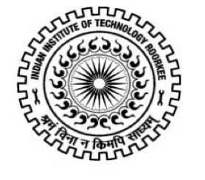

**DEPARTMENT OF ELECTRICAL ENGINEERING**

**INDIAN INSTITUTE OF TECHNOLOGY ROORKEE**

**ROORKEE – 247 667 (INDIA)**

**MAY, 2014**