INDIAN INSTITUTE OF TECHNOLOGY ROORKEE

CANDIDATE’S DECLARATION

We hereby declare that the work that is being presented in this report entitled **“DEVELOPMENT OF AC-DC BIDIRECTIONAL CONVERTER”** in partial fulfilment of the requirement for the award of the degree of **Bachelor of Technology** in **Electrical Engineering** submitted to the **Department of Electrical Engineering, Indian Institute of Technology Roorkee, INDIA** is an authentic record of our own work carried out during the period from August 2013 to May 2014 under the guidance of **Dr. Pramod Agarwal, Professor**, Department of Electrical Engineering, Indian Institute of Technology Roorkee.

The matter embodied in this project report has not been submitted by us for the award of any other degree or diploma.

Rahul Jangid

Nimit Jain

Mohit Tibrewal

Date:   
Place: IIT Roorkee

(B. Tech. EE)



CERTIFICATE

This is to certify that the above statement made by the candidates is correct to the best of my knowledge.

Dr. Pramod Agarwal

Professor  
Department of Electrical Engineering IIT Roorkee

Date:  
Place: IIT Roorkee

ACKNOWLEDGEMENT

We would like to express our sincere gratitude to Dr. Pramod Agarwal, Professor, Department of Electrical Engineering, Indian Institute of Technology Roorkee for their valuable guidance, support, encouragement and the inspirational support throughout the Project. We express deep and sincere sense of gratitude to all teachers of EE department for their encouraging and caring words and suggestions which have contributed towards completion of this project. We are indebted to all our classmates for taking interest in discussing our problems and encouraging us. We convey our deep sense of gratitude to the Head of Electrical Engineering Department (HOD), who directly or indirectly helped us during the work. Finally, we would like to express our deepest gratitude to the Almighty for showering blessings on us during the course of work.

Rahul Jangid

Nimit Jain

Mohit Tibrewal

(B. Tech. EE)

Date:  
Place: IIT Roorkee

ABSTRACT

Bidirectional converter provides the ability to not only transfer energy from DC grid (battery) to AC grid (AC loads) but also transfers energy from AC grid (Wind Energy) to DC grid to charge the battery (energy storage). The battery to grid (B2G) mode allows power utility companies to offset peak power consumption thus allowing household consumers and industry corporations to save money on their electricity bills. This paper describes the design and provides the implementation details for a Three-Level PWM AC-DC bidirectional converter. Although the three-level PWM AC- DC design requires a more complex controller than its counterparts. The converter is realised by developing the bidirectional converter in MATLAB and its interconnection between AC grid and DC grid (battery).This interconnection is a crucial for current electricity distribution system because it enables connection of distributed energy resourced (DERs).

// TO DO : Write more stuffs here in paras

Microsoft visio – Ninja needs to download this.

CONTENTS // Will do at last

| Topic | Page no. |
| --- | --- |
| Candidate’s Declaration |  |
| Acknowledgement |  |
| Abstract |  |
| Contents |  |
| List of Figures |  |
| List of Table |  |
| List of Abbreviations |  |
| Chapter 1 : Introduction  1.1 Need of Bidirectional Convertor  1.2 Load Demand and BDC Overview  1.3 BDC Advantages |  |
| Chapter 2 : Methodology  2.1 Independent Inverter  2.2 Grid Tied Inverter  2.3 Grid Tied Rectifier  2.4 Grid Tied Charger |  |
| Chapter 3 : Hardware Implementation  3.1 Power Circuit  3.2 Control Circuit  3.3 Power Supplies |  |
| Chapter 4 : Experimental Setup And Results |  |
| Chapter 5 : Future Scope |  |
| References  Appendix - A  Appendix - B  Appendix - C  Appendix - D |  |

List of Figures

List of Tables

List of Abbreviations

**Chapter -1**

Introduction

# 1.1. Need for Bi-Directional Converters (BDC)

The design of power converter consumes time with a significant cost. Performance is generally determined after testing converters at nominal operating points. Thus, simulation can substantially reduce development cost. Using BDC we can reduce the number of converters in a grid used for different conventional resources like wind energy, solar energy, fuel cells etc. We can make two sub grids: AC grid and DC grid and connect these through a BDC.

# 1.2. Load Demand and BDC overview

Load demand is not constant throughout a typical day. In a typical 24 hour load profile, peak energy consumption is observed around 1:00pm and 11:00pm. At 1:00pm commercial loads consume around 3MW while household loads consume around 9MW. Around 11:00pm, 4MW & 11MW are consumed by commercial and household loads respectively. Energy consumption is at its lowest around 5:00am. Around this time loads are 2MW and 8MW. Figure 1.1 shows the daily load demand 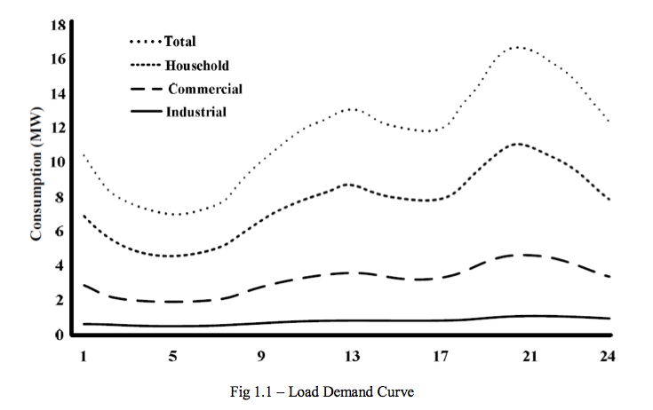curve.

BDC proposes to smoothen out stressful load demands within the grid, especially in time slots when grid power is at its peak. It also provides ancillary service to alleviate grid consumption. BDC utilises battery as an energy source during peak time, and when the grid is of peak, the battery of DC grid is charged.

# 1.3. BDC advantages

They are suitable for peak shaving application. For this application, the batteries act as energy storage units. Energy is stored in the batteries during night time when the cost of electricity is at its lowest. During peak hours, unused energy are drawn from them to put power back to the grid. With this scheme, EV owners could produce revenue. They charge their batteries while electricity is cheap, and use them to put power back to the grid during peak hours. Utilities could also benefit from this by having increased system flexibility. They could use this as energy storage for intermittent renewable energy sources such as wind and solar. BDC is also suitable for regulating frequency fluctuations caused by system imbalances. Trough bidirectional converters, regulation is made possible by allowing the grid to absorb/release small quantities of energy from/to the batteries.

There are various advantages offered by DC grids to end-consumers, utilities and society, such as: improved energy efficiency, minimized overall energy consumption, reduced greenhouse gases and pollutant emissions, improved service quality and reliability, cost efficient electricity infrastructure replacement.

Technical challenges linked with the operation and controls of DC grids are immense. Ensuring stable operation during network disturbances, maintaining stability and power quality in the islanding mode of operation necessitates the improvement of sophisticated control strategies for DC grid’s inverters in order to provide stable frequency and voltage in the presence of arbitrarily varying loads. In light of these, the DC grid concept has stimulated many researchers and attracted the attention of governmental organizations in Europe, USA and Japan. Nevertheless, there are various technical issues associated with the integration and operation of DC grids.

# 1.4 Overall Bidirectional Topology

AC Grid Single Phase

**Fig 1.2: Grid Power System**

**Chapter – 2**

Methodology

In recent years, due to the growing concern over energy shortage and environmental pollution, the concepts of distributed generation (DG), and dc-ac based hybrid power systems have become progressively more popular with the decreasing costs of various clean renewable energy sources. Under small-scale power distribution system, such as house, commercial buildings, bi-directional single-phase PWM converters perform as key components to fulfill the following modes of operation.

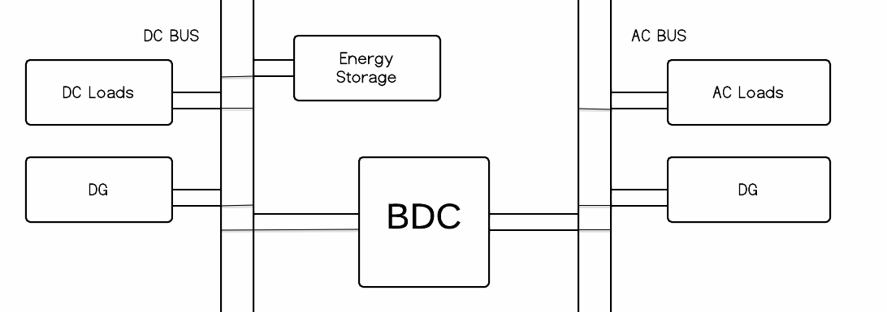

**Figure 2.1: Flow Diagram**

# 2.1 Stand Alone Inverter Mode

When the grid is lost, the converter regulates the ac bus voltage and frequencies feeding the ac loads while the renewable energy sources or energy storage on the dc side to provide power. The ac side renewable energy resources would act as current sources.

# 2.2 Grid Tied Inverter Mode

When the grid is connected, the converter acts as a current source injecting or sinking power from the grid to balance the power flow between the dc and ac subsystems, while one of the dc resources regulates the dc bus voltage.

# 2.3 Grid Tied Rectifier Mode

When the grid is present, the converter regulates the dc bus voltage to sustain the dc loads while all dc side energy sources operate as current sources.

# 2.4 Grid Tied Charger Mode

When the grid is present, the converter charges the energy storage elements, such as batteries.

By applying the modeling methodology of semi-conductor switches, the switching, average and small signal models of the converter are derived under different modes of operation.

// to search more on these topics

**Chapter – 3**

Hardware Implementation of Single Phase Inverter

# 3.1 Power Circuit

Power circuit was fabricated using MOSFETs (IRF460) as basic switching devices. As discussed in previous chapters, standard H-bridge has been used. MOSFETs have been fitted on a module which receives the TTL gate pulses from pulse generator circuit and various components as discussed below performs the task of protection and isolation of devices.

## 3.1.1 Snubber Circuit:

It protects semiconductor devices by:

* Limiting device voltages during turn-off transients
* Limiting device currents during turn-on transients
* Limiting rate of rise of currents through semiconductor device at device turn-on
* Limiting rate of rise of voltages through semiconductor device at device turn-off
* Shaping the switching trajectory of the device as it turns on/off



**Figure 3.1 – Snubber Circuit**

Values of capacitance to be used can be calculated as under:

## 3.1.2 Pulse Amplification and Isolation Circuit

Pulse amplification and isolation circuits first isolate the pulses coming from TTL sources from the power circuits and then pulses are amplified. Whole process of amplifying and isolation is carried out by MCT2E along with npn transistors and separate DC supply created using standard 12-0-12 transformer and voltage regulator-7812. Separate DC supply is must for each module as the pulses have to be given with respect to the source of each mosfet, hence we need separate ref. point for each pulse.



**Figure 3.2 – Pulse Amplification Circuit schematic and its actual implementation**

# 3.2 Control Circuits

Control Circuit has been made up of different components fabricated as separate PCB’s. Each PCB is a unique module in itself which performs a unique function. Various Components of control circuit have been discussed as under:

## 3.2.1 Voltage sensing circuit

Voltage sensing was performed using a standard AD-202 circuit as shown in figure below.AD-202 performs the task of isolation and stepping down of input signal. It was ensured that peak of voltage reaching the input terminals of AD202 is less than 5 volts. This was ensured by using a stepping down circuit using resistors.

Voltage sensing module was directly supplied with 230V RMS AC supply and following waveform was obtained as output which was then used as input signal to MPPT module and PLL module.

## 3.2.2 SPWM Pulses Generation and deadband Module

This module has the function of generating uses following sub-modules:

* Triangular wave generation
* SPWM core circuit

### 3.2.2.1 Triangular Wave Generator

Since the required frequency has to be greater than 18Khz as per IEEE standards as mentioned in previous chapters, a minimum slew rate of 50V/us is required. Hence the op-amp used is a quad-opamp LF347n and a standard triangular wave generation circuit was followed to obtain a unity triangular wave of frequency 25 KHz.The circuit, schematic.and output has been shown in below figures.

// DIAGRAM

### 3.2.2.2 SPWM Core Circuit

// FROM FINLA BTP

## 3.2.3 Current Sensing Circuit

Current sensing circuit is fabricated using HALL Effect sensor, buffer and amplifier.

//FROM

## 3.2.4 PI Controller Circuit (Analog)

# 3.3 Power Supplies

Here is the standard dual power supply using the Positive and Negative Voltage regulator ICs. It can give +12 volt and – 12 volt DC with a common ground. This power supply is ideal to power amplifier circuits that require well regulated dual power supply. It can give 1 ampere current to the circuit. 14-0-14 volt 1 Ampere step down transformer is used to drop 230 volt AC to 14 volt DC which is then rectified using the standard full wave bridge rectifier comprising D1 through D4.Smoothing capacitors C1 and C2 remove the ripples from low volt AC. Two regulator ICs are used to generate + 12 volt and – 12 volt DC. IC1 is 7812 positive regulator giving +12 volt regulated output.IC2 is 7912 negative regulator and its pins are slightly different from 7812. See the connection in the diagram. Regulated outputs from the regulator ICs are available from pin 3 which can be used to power the circuit. Capacitors (C3 and C4) act as noise filters to give clean DC.

7805 is a 5V fixed three terminal positive voltage regulator IC. The IC has features such as safe operating area protection, thermal shut down, internal current limiting which makes the IC very rugged. Output currents up to 1A can be drawn from the IC provided that there is a proper heat sink. A 9V transformer steps down the main voltage, 1A bridge rectifies it and capacitor C1 filters it and 7805 regulates it to produce a steady 5Volt DC. The circuit schematic is given below.



**Figure 3.3.1: +- 12V Supply Circuit schematic [7]**



**Figure 3.3.2: +-5V Supply schematic**

**Chapter – 4**

Experimental Setup and Results

Whole project was setup as per the strategies discussed in previous chapters. A connection diagram of overall project has been shown as under.

**Chapter – 5**

Future Scope

This single-phase converter can be easily extended to a three phase converter by tripling the two-leg configuration and connecting the neutral points together. This will open the possibilities of the following:

* Integration of DC microgrids to improve efficiency of energy storage and generation systems. For instance,a dedicated DC grid for electric vehicles in a city which also acts as energy storage system for the AC grid.
* Power sharing between isolated micro-grids through DC interconnection.
* Development of reliable, high quality grid may be feasible for small isolated industrial plants with both PV systems and wind turbine generator as the major power supply.

References

[1]. Rashid. M.H, “Power Electronics circuits devices and applications”, PHI 3rd edition, 2004 edition, New Delhi.

[2]. Bimbhra .P.S "Power Electronics" Khanna Publishers, New Delhi, 2003. 4th Edition

[3]. S. Bose, Y. Liu, K. Bahei-Eldin, J.de Bedout, and M. Adamiak, “Tie line Controls in DC grid Applications,” in iREP Symposium Bulk Power System Dynamics and Control VII, Revitalizing Operational Reliability, pp. 1-9, Aug. 2007.

[4] R.H.Lasseter, “DC grids,”inProc.IEEE-PES’02, pp.305-308, 2002.

[5] Michael Angelo Pedraza and Ted Spooner, “A Survey of Techniques Used to Control  DC grid Generation and Storage during Island Operation,” in AUPEC, 2006.

[6] F. D. Kanellos, A. I. Tsouchnikas, and N. D. Hatziargyriou, “DC grid Simulation during Grid-Connected and Islanded Mode of Operation,” in Int. Conf. Power Systems Transients (IPST’05), June. 2005.

[7] Ming Li, Dong Dai & Xikui Ma, *"Slow-Scale and Fast-Scale Instabilities in Voltage- Mode Controlled Full-Bridge Inverter"* Journal: Circuits Systems and Signal Processing - CIRC SYST SIGNAL PROCESS , vol. 27, no. 6, pp. 811-831, 2008.

APPENDIX-A

A.1 IRFP-460 MOSFET specifications

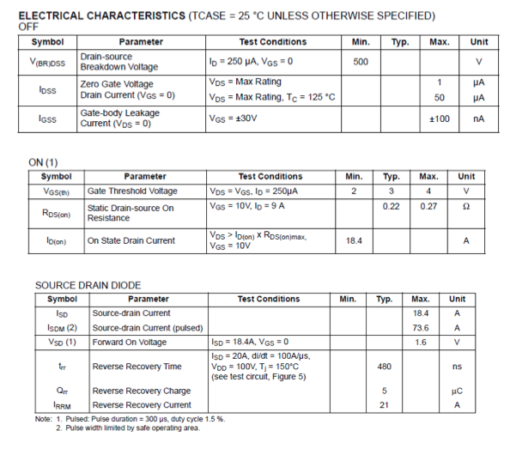

A.2 AD-202, Isolation Amplifier Specifications

