Project Name: Currency Convertor

Date: <15/06/2022>

Copyright Notice
This document contains proprietary information of HCL Technologies Ltd. No part of this document may be reproduced, stored, copied, or transmitted in any form or by means of electronic, mechanical, photocopying or otherwise, without the express consent of HCL Technologies. This document is intended for internal circulation only and not meant for external distribution.

Revision History
Version No | Date | Prepared by / Modified by | Significant Changes
1 | 20-06-22 | Mohit Barkhade | MB

Table Of Contents

1.1 Project Overview 3
1.2 Scope 3
1.3 Out of Scope 3
1.4 Intended Audience 3
1.5 High Level Use Cases 3
1.6 Use Cases detailed 3
1.7 User Interface Modules 3
1.8 Technical Architecture 3
1.9 Technical Detailed Description 3
1.10 Sequence Diagram 3
1.11 Database Entity Relationship Diagram 3
1.12 Standards 3
1.13 Non Functional Requirements 3

Project Overview
The purpose of this project is to create an application for converting currencies like Rupees, Dollar, Pound, Euro and Kuwaiti dinar into each other.

Scope
Converting Currency for one currency to another.

Out of Scope
Username
login

Intended Audience
The person who is searching for the Converting Currency. We use Currency Converter for Converting One Currency to another.

High Level Use Cases
User will open the application
and enter number of the currency they want to convert
and then the amount they want to convert
and then click on enter then the output currencies will be displayed.

Use Cases detailed
Currency converter is a mini project in Java Programming. It provides a web-based interface for exchanging money from one currency to another currency. In this document, we’ll see how to make a currency converter which includes conversion between Rupees, Dollar, Pound, Euro and Kuwaiti dinar.

User Interface Modules

Technical Architecture

Technical Detailed Description

Sequence Diagram
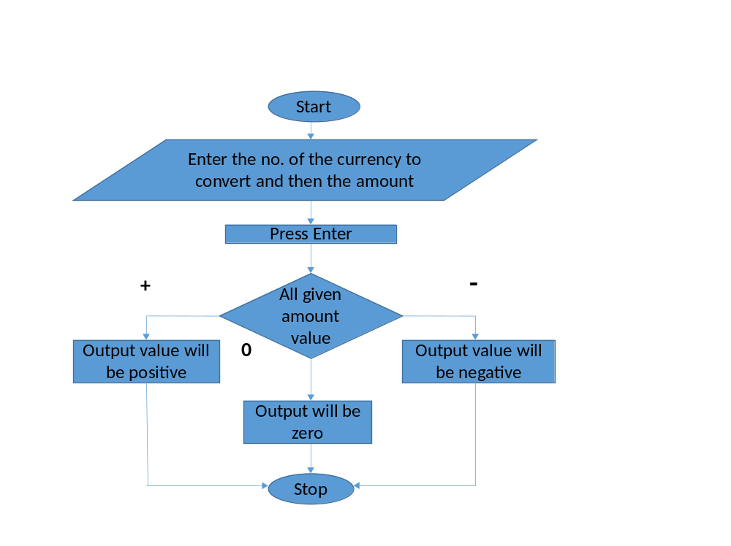

Database Entity Relationship Diagram

Standards

Non Functional Requirements

