Sales Performance Analysis Project Report
Author: Mohit Bhilala
Business Analyst Internship - Codec Technologies India

Project Overview
This project analyzes the Sample Superstore dataset to evaluate sales performance, profitability, customer behavior, and regional trends. Python was used for data preparation and Power BI for creating an interactive dashboard.

Objectives
• Analyze historical sales
• Build KPI metrics
• Identify top-performing products and regions
• Develop an interactive dashboard
• Generate business insights

Dataset
Sample Superstore dataset with 9,994 records containing orders, products, customers, sales, profit, discount, quantity, category, region and shipping details.

Tools & Technologies
Python (Pandas)
Power BI
SQL
Microsoft Excel
GitHub

Data Preparation
Converted date columns, created Year/Month fields, checked data quality, and prepared metrics for dashboard development.

Dashboard KPIs
Total Sales: 2.30M
Total Profit: 286.40K
Total Orders: 5,009
Total Customers: 793
Average Order Value: 458.61
Profit Margin: 12.47%

Dashboard Features
KPI Cards
Monthly Sales Trend
Sales by Category
Sales by Region
Top 10 Products
Interactive slicers

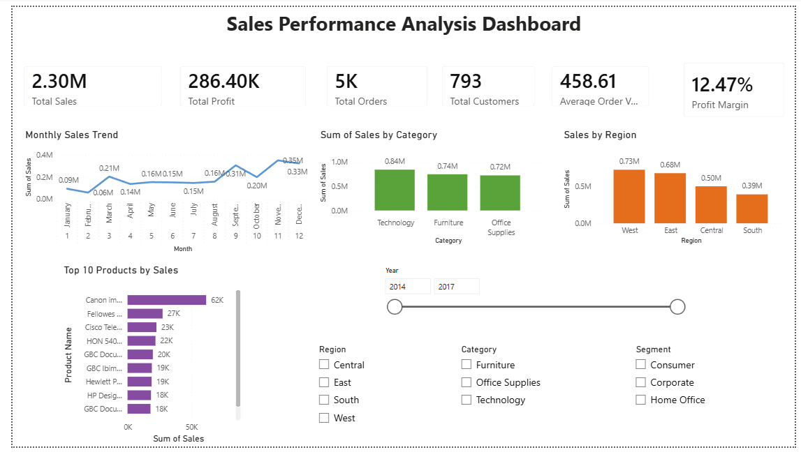

Business Insights
Technology generated the highest sales.
West region recorded the highest revenue.
Sales varied across months.
Top products contributed significantly to total sales.

Recommendations
Increase inventory for top products.
Improve sales strategies in low-performing regions.
Use trends for forecasting and planning.

Conclusion
The project demonstrates end-to-end Business Analysis using Python, SQL, and Power BI, helping decision-makers monitor performance and support data-driven decisions.
🐙 GitHub:
https://github.com/mohitbhilala005

