Wes Darvin

Mohit Deshpande

Eric Hemphill

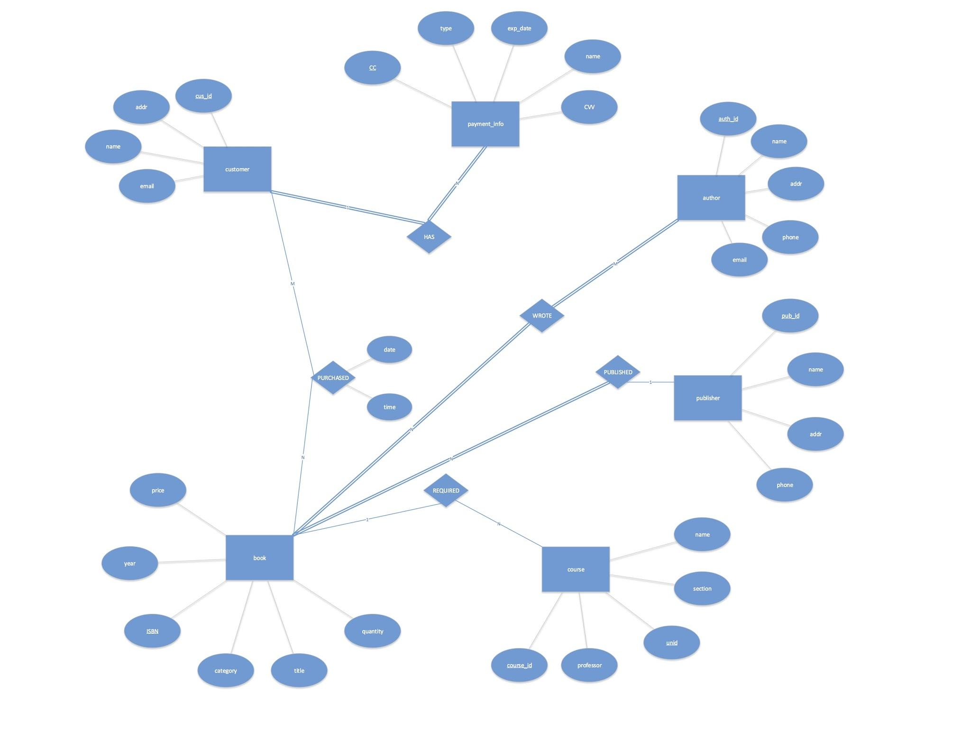Nick Meyer

