1: Single layer LSTM

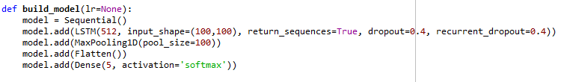

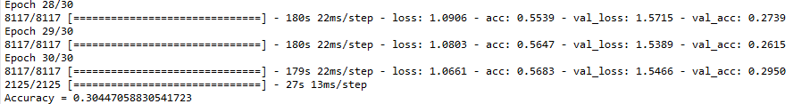

2: 2-layer LSTM

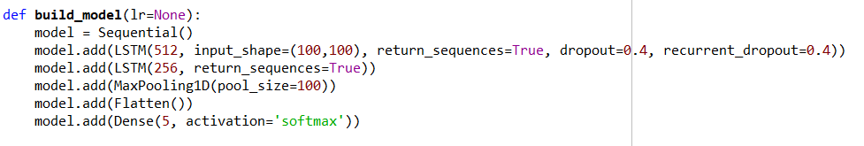

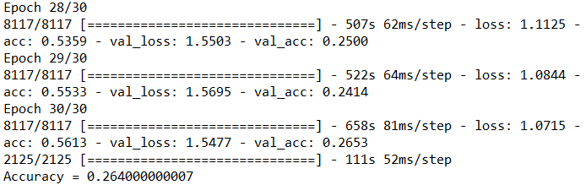

3: 1-layer GRU

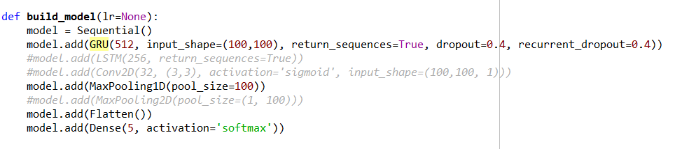

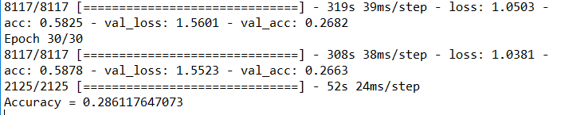

4: 2-layer GRU

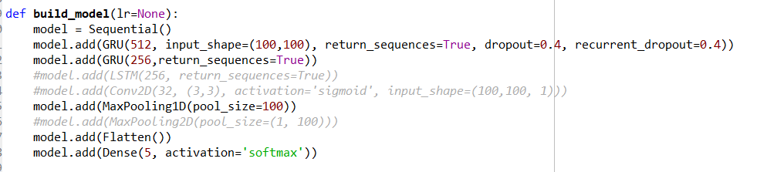

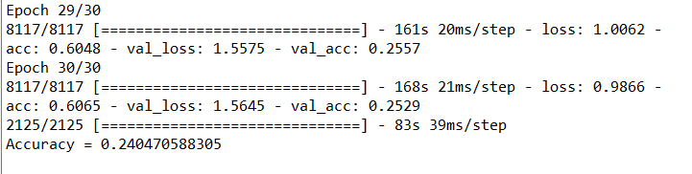

5: 1-layer LSTM-256

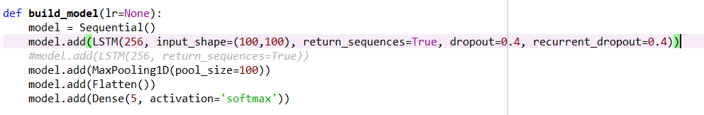

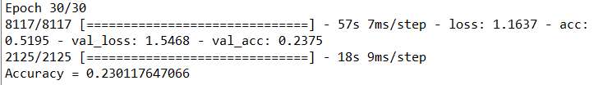

6: 1 layer LSTM-1024

