Name: Mohit Vijay Dhumal
Roll No: 2601051

Q1 - Write a program to read a file and count how many vowels are present in its content.
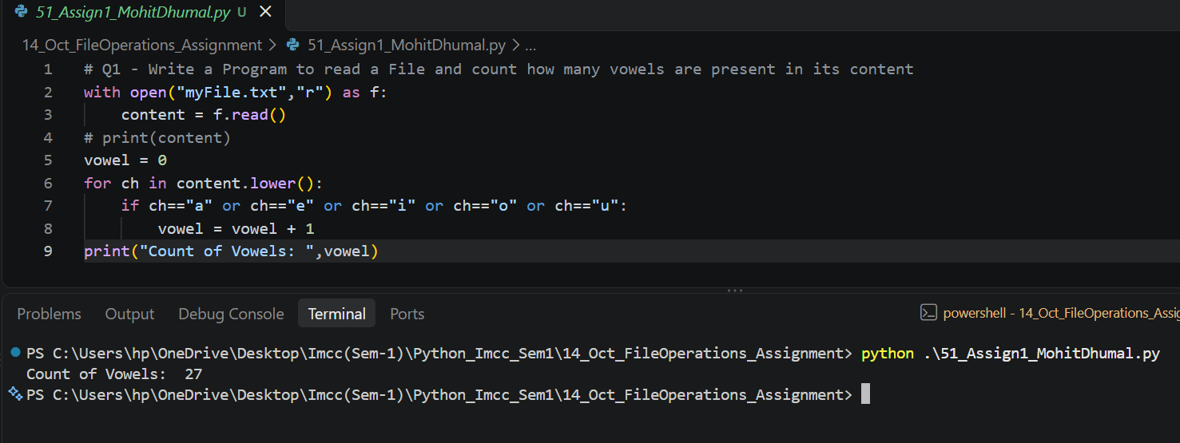

Q2- Read all lines from a file into a list. Print the total number of lines and display the 2nd and 4th line.
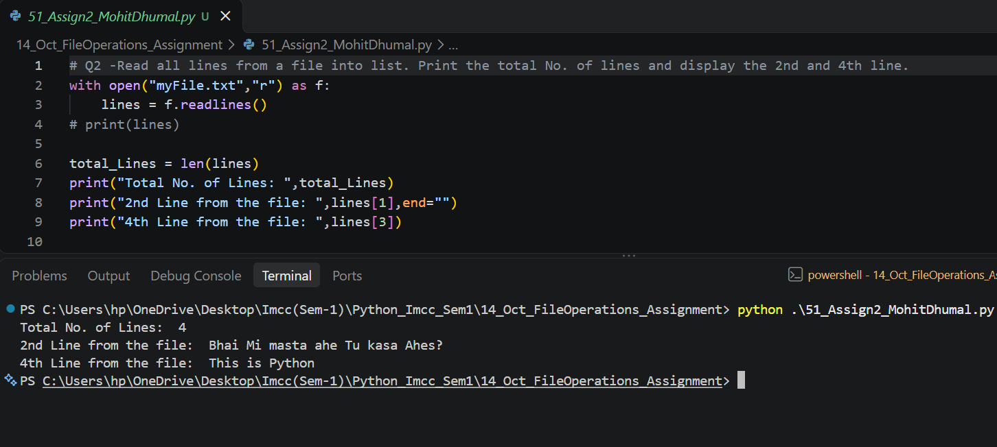

Q3 - Take a sentence from the user, split it into words, and store them in a list. Print the longest word.
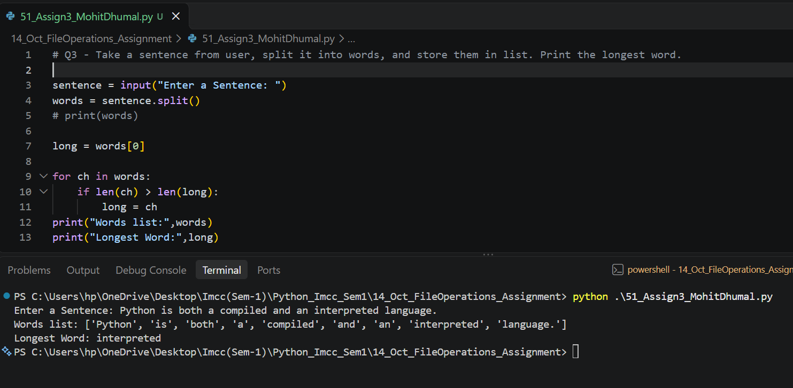

Q4 - Read a file, split its content into words, and store them in a list.
    - Print the total number of words.
    - Print all unique words.

