**Name : MOHIT DILIP MAKWANA ID : 2020A7PS0048P Sec/ Class : CHEM-F110-P22**

**Expt–1: DETERMINATION OF THE pH CURVE OF ACID BASE TITRATION**

**Observations:**

Record your observation and report your results as shown as below:

Volume of oxalic acid solution = 10 ml

Strength of the acid solution = 0.25N x 60 gm = 15 gm/l

**Table 1: Standardization of NaOH Solution (data to be provided by the instructor)**

|  |  |  |  |
| --- | --- | --- | --- |
| **Entry** | **Initial burette reading (mL)** | **Final burette reading (mL)** | **Volume of base added (mL)** |
| **1.** | 0.1 ml | 13.5 ml | 13.4 ml |
| **2.** | 13.5 ml | 26.6 ml | 13.1 ml |
| **3.** | 26.6 ml | 40.0 ml | 13.4 ml |
| **4.** |  |  |  |
| **5.** |  |  |  |
|  |  |  |  |

Concordent reading = 13.4 ml

**Calculation of strength of the base (NaOH)**  **[1 Mark]**

Strength of NaOH solution = 7.4627 gm/l

We know, for Acid, N1 = 0.25 N and V1 = 10 ml

For Base, V2 = 13.4 ml

Now since, N1V1 = N2V2 ;

(0.25 N) x (10 ml) = (N2) x (13.4 ml)

Hence, N2 = 0.1866 N

Therefore, the strength of NAOH solution is (0.1866 N) x (40gm) = 7.4627 gm/l

Volume of the weak acid taken = 25 ml

**Table 2: Data for weak acid-strong base titration using pH meter (the volume and pH data to be provided by instructor; pH/V to be calculated by students) [3 mark]**

|  |  |  |  |  |  |  |  |  |
| --- | --- | --- | --- | --- | --- | --- | --- | --- |
| Entry | Vol (V) of NaOH added, mL | pH | pH/V |  | Entry | Vol (V) of NaOH added, mL | pH | pH/V |
| 1 | 0 | 2.82 |  | 26 | 11.5 | 5.74 |  |
|  | 0.50 |  | 0.72 |  | 11.55 |  | 0.20 |
| 2 | 1 | 3.54 |  | 27 | 11.6 | 5.76 |  |
|  | 1.50 |  | 0.51 |  | 11.65 |  | 0.40 |
| 3 | 2 | 4.05 |  | 28 | 11.7 | 5.80 |  |
|  | 2.50 |  | 0.18 |  | 11.75 |  | 0.40 |
| 4 | 3 | 4.23 |  | 29 | 11.8 | 5.84 |  |
|  | 3.50 |  | 0.06 |  | 11.85 |  | 0.50 |
| 5 | 4 | 4.29 |  | 30 | 11.9 | 5.89 |  |
|  | 4.50 |  | 0.17 |  | 11.95 |  | 0.40 |
| 6 | 5 | 4.46 |  | 31 | 12 | 5.93 |  |
|  | 5.50 |  | 0.14 |  | 12.05 |  | 1.60 |
| 7 | 6 | 4.60 |  | 32 | 12.1 | 6.09 |  |
|  | 6.50 |  | 0.16 |  | 12.15 |  | 0.90 |
| 8 | 7 | 4.76 |  | 33 | 12.2 | 6.18 |  |
|  | 7.50 |  | 0.13 |  | 12.25 |  | 0.90 |
| 9 | 8 | 4.89 |  | 34 | 12.3 | 6.27 |  |
|  | 8.5 |  | 0.20 |  | 12.35 |  | 1.00 |
| 10 | 9 | 5.09 |  | 35 | 12.4 | 6.37 |  |
|  | 9.5 |  | 0.20 |  | 12.45 |  | 1.40 |
| 11 | 10 | 5.29 |  | 36 | 12.5 | 6.51 |  |
|  | 10.05 |  | 0.20 |  | 12.55 |  | 1.50 |
| 12 | 10.1 | 5.31 |  | 37 | 12.6 | 6.66 |  |
|  | 10.15 |  | 0.30 |  | 12.65 |  | 2.20 |
| 13 | 10.2 | 5.34 |  | 38 | 12.7 | 6.88 |  |
|  | 10.25 |  | 0.20 |  | 12.75 |  | 2.60 |
| 14 | 10.3 | 5.36 |  | 39 | 12.8 | 7.14 |  |
|  | 10.35 |  | 0.30 |  | 12.85 |  | 7.60 |
| 15 | 10.4 | 5.39 |  | 40 | 12.9 | 7.90 |  |
|  | 10.45 |  | 0.10 |  | 12.95 |  | 12.40 |
| 16 | 10.5 | 5.40 |  | 41 | 13 | 9.14 |  |
|  | 10.55 |  | 0.20 |  | 13.05 |  | 6.40 |
| 17 | 10.6 | 5.42 |  | 42 | 13.1 | 9.78 |  |
|  | 10.65 |  | 0.10 |  | 13.15 |  | 3.00 |
| 18 | 10.7 | 5.43 |  | 43 | 13.2 | 10.08 |  |
|  | 10.75 |  | 0.30 |  | 13.25 |  | 2.70 |
| 19 | 10.8 | 5.46 |  | 44 | 13.3 | 10.35 |  |
|  | 10.85 |  | 0.30 |  | 13.35 |  | 1.10 |
| 20 | 10.9 | 5.49 |  | 45 | 13.4 | 10.46 |  |
|  | 10.95 |  | 0.40 |  | 13.45 |  | 2.10 |
| 21 | 11 | 5.53 |  | 46 | 13.5 | 10.67 |  |
|  | 11.05 |  | 0.30 |  | 13.55 |  | 3.30 |
| 22 | 11.1 | 5.56 |  | 47 | 13.6 | 11.00 |  |
|  | 11.15 |  | 0.20 |  | 13.65 |  | 2.50 |
| 23 | 11.2 | 5.58 |  | 48 | 13.7 | 11.25 |  |
|  | 11.25 |  | 0.50 |  | 13.75 |  | 1.10 |
| 24 | 11.3 | 5.63 |  | 49 | 13.8 | 11.36 |  |
|  | 11.35 |  | 0.40 |  | 13.85 |  | 0.60 |
| 25 | 11.4 | 5.67 |  | 50 | 13.9 | 11.42 |  |
|  | 11.45 |  | 0.70 |  |  |  |  |  |

**(i) Plot** pH vs. V of titrant added, and locate the stoichiometric equivalence point

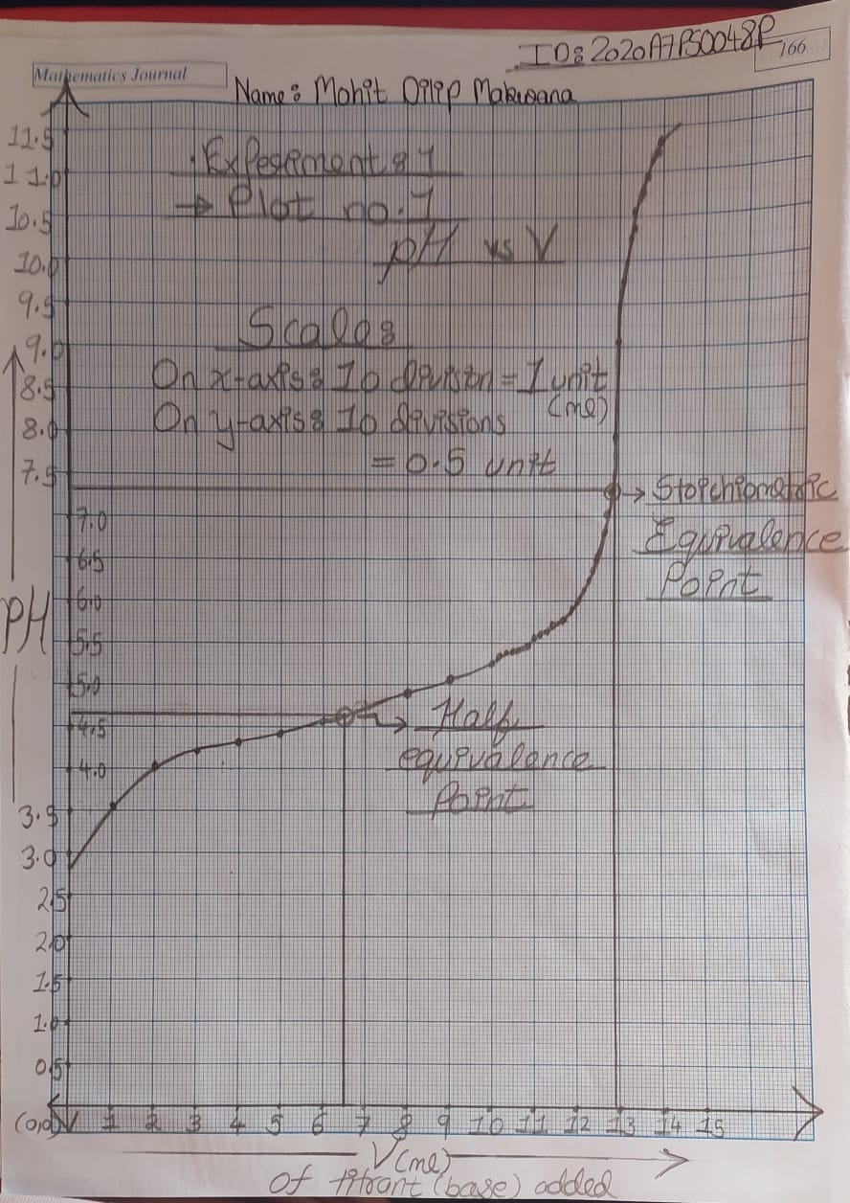

**(ii) Derivative plot:** (ΔpH/ΔV) vs. total volume of titrant added V. [where (ΔpH) is change in pH betweentwo successive additions and ΔV is the incremental volume of titrant added]

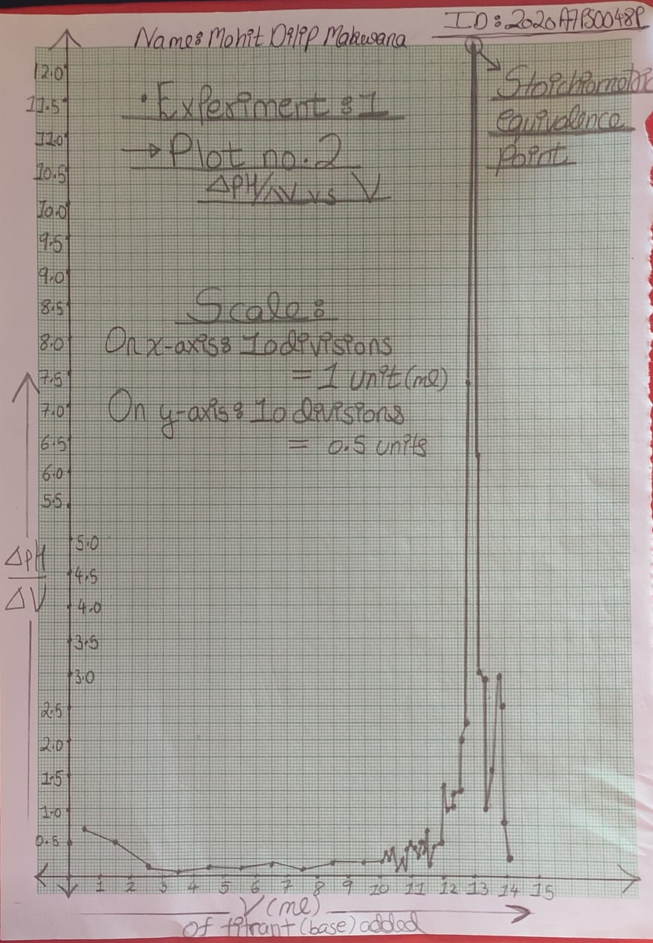

**[4 Marks collectively, for the two plots]**

**(iii) Calculation of pKa from Plot (i) and (ii)** **[2 Mark]**

Calculations should be shown clearly, else no marks will be awarded.

For finding pKa of the given weak acid , we know :

* At the Half Equivalence Point of the titration, concentration of Acid in the solution equals the concentration of Acid Anion, i.e : [HA] = [A-] .
* By Henderson Equation, we know: pH = pKa + log10( [A-] / [HA] )

Hence at Half Equivalence Point: pH = pKa

Therefore we can obtain the value of pH at half equivalence point by finding the volume at half equivalence point. To find it, we need to obtain the volume at Stoichiometric equivalence point.

* At the equivalence point, the variation in pH relative to small change in volume is highest, therefore, it corresponds to the highest point in Derivative Plot.

Thus, from Plot 2: at equivalence point, volume is : Veq = 12.95 ml.

Since the half equivalence point volume: V = Veq/2 = 12.95/2 ml

Thus, V = 6.475 ml.

* Now we can find the pH at half equivalence point using Plot 1. So value of pH corresponding to V = 6.475 ml is : pH = 4.67

Thus pKa = pH (at half equivalence point ) = 4.67

So pKa = 4.67.

Hence the value of pKa of given weak acid is 4.67.

For Finding the Molarity of Weak Acid :

* We know Volume taken of weak acid, V1 = 25 ml.
* Volume of base required to reach equivalence point, V2 = 12.95 ml.
* Normarity of the base, N2 = 0.1866 N
* Let the Normality of weak acid be N1. Since at equivalence point, equivalents of acid and base are equal,

N1V1 = N2V2

Thus, (N1)(25 ml) = (0.1866 N)(12.95 ml)

Therefore N1 = 0.9667 N.

* Since Molarity = Normality/n-factor ,

And n-factor of weak acid = 1

Thus, Molarity = 0.9667/1 = 0.9667

Hence, the Molarity of the Weak Acid is 0.9667 M.

**Results: [2 mark]**

Volume of the base required to reach equivalence = 12.95 ml

Molarity of the given acid solution = 0.9667 M

pKa of the given acid = 4.67