**1-a)** Make another directory inside the **unixstuff** directory called **backups**

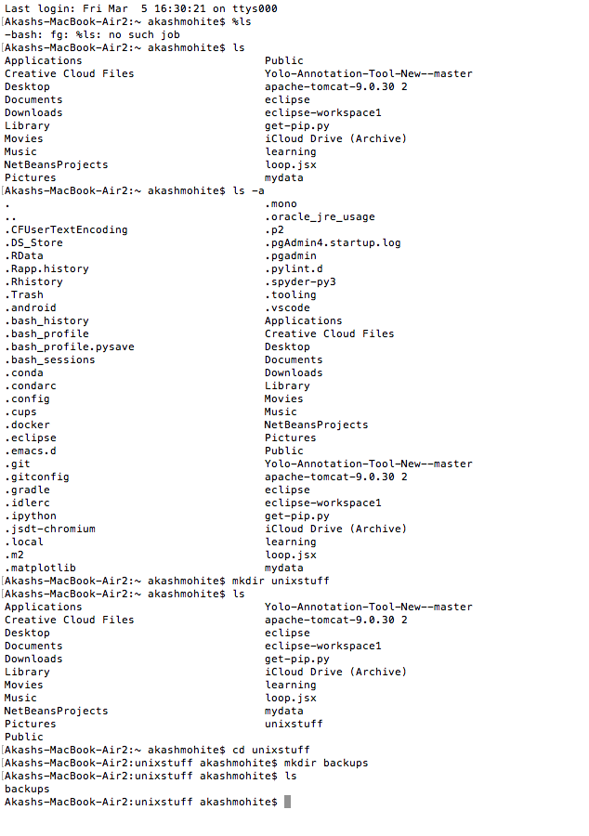

**1-b)** Use the commands **cd,** **ls** and **pwd** to explore the file system.

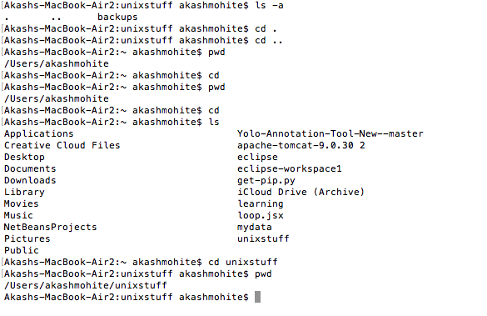

2-a) Create a backup of your **science.txt** file by copying it to a file called **science.bak**

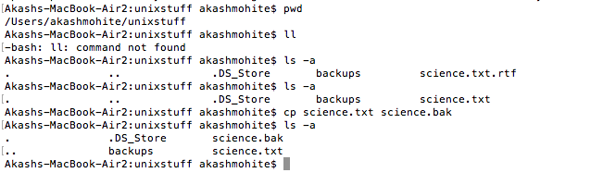

2-b) Create a directory called **tempstuff** using **mkdir** , then remove it using the **rmdir** command.

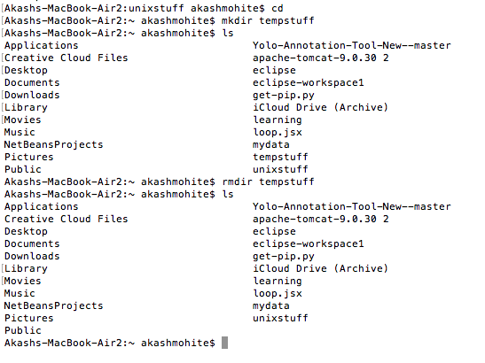

**3-a)** Using the above method, create another file called **list2** containing the following fruit: orange, plum, mango, grapefruit. Read the contents of **list2**

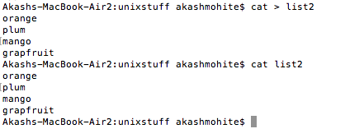

**3-b)**Using pipes, display all lines of **list1** and **list2** containing the letter 'p', and sort the result.

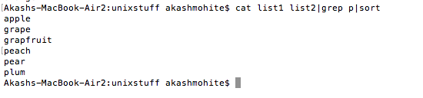

**5-a)** Try changing access permissions on the file **science.txt** and on the directory **backups** Use **ls -l** to check that the permissions have changed.

