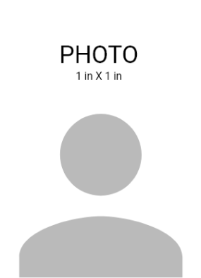



123 Anywhere Street, City, +1 241-654-7890
FIRST, LAST NAME
DESIGNATION

CARD EXPIRY: MAR 2018

