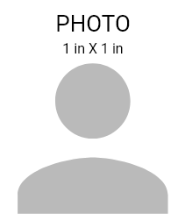




novage.ms
EXP.
01-01-2018
01-08-1985
D.O.B
FIRST, LAST NAME
DESIGNATION
+1 844 844 0038

123 ANYWERE STREET, CITY
XYZ SECURITY

