Dehaze Results done on HSTS(synthetic) dataset

|  |  |  |  |  |  |  |  |  |  |  |
| --- | --- | --- | --- | --- | --- | --- | --- | --- | --- | --- |
|  | DCP | FVR | BCCR | GRM | NLD | DehazeNet | MSCNN | AOD-Net | CAE | LCA-Net |
| PSNR | 14.84 | 14.48 | 15.08 | 18.54 | 18.92 | **24.48** | 18.64 | 20.55 | 20.08 | 23.6259 |
| SSIM | 0.7609 | 0.7624 | 0.7382 | 0.8184 | 0.7411 | **0.9153** | 0.8168 | 0.8973 | 0.8169 | 0.8834 |
| Time/Image | 1.62 | 6.79 | 3.85 | 83.96 | 9.89 | 2.51 | 2.60 | 0.65 | 1.13 | **0.3546** |

Dehaze Results done on SOTS(indoor) dataset

|  |  |  |  |  |  |  |  |  |  |  |
| --- | --- | --- | --- | --- | --- | --- | --- | --- | --- | --- |
|  | DCP | FVR | BCCR | GRM | NLD | DehazeNet | MSCNN | AOD-Net | CAE | LCA-Net |
| PSNR | 16.62 | 15.72 | 16.88 | 18.86 | 17.29 | 21.14 | 17.57 | 19.06 | **24.56** | 18.2252 |
| SSIM | 0.8179 | 0.7483 | 0.7913 | 0.8553 | 0.7489 | 0.8472 | 0.8102 | 0.8504 | **0.9126** | 0.7808 |

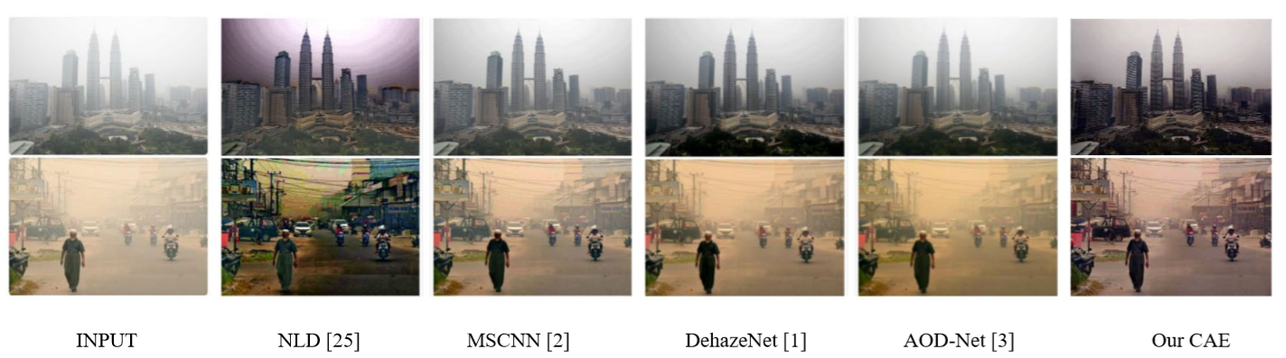

|  |  |  |  |  |  |  |  |  |  |
| --- | --- | --- | --- | --- | --- | --- | --- | --- | --- |
|  | 8325testwt1 | 8325testwt2 | 8325testwt3 | 8325testwt4 | 8325testwt5 | 8325testwt6 | 8325model7.h5 | 9171_1 | 9171_2 |
| PSNR(hsts) | 22.5513 | 23.7412 | 20.9513 | 21.4603 | 22.9569 | 23.6259 | 23.003 | 21.8969 | 23.2694 |
| SSIM(hsts) | 0.8879 | 0.8733 | 0.8609 | 0.8706 | 0.8885 | 0.8834 | 0.8909 | 0.8508 | 0.8733 |
| PSNR(sots) | 19.918 | 17.4 | 19.7594 | 18.8816 | 18.6589 | 18.2252 | 18.9182 | 20.0394 | 19.8165 |
| SSIM(sots) | 0.808 | 0.7832 | 0.7959 | 0.7973 | 0.7883 | 0.7808 | 0.7915 | 0.8156 | 0.8261 |

Testing Set : 8325 images from OTS (5 haze settings X 1665 unique)

Validation Set : 492 unique images from SOTS/outdoor

Dehaze Results done on SOTS(outdoor) dataset

|  |  |  |  |  |  |  |  |  |  |
| --- | --- | --- | --- | --- | --- | --- | --- | --- | --- |
|  | DCP | FVR | BCCR | GRM | NLD | DehazeNet | MSCNN | AOD-Net | LCA-Net |
| PSNR | 18.54 | 16.61 | 17.71 | 20.77 | 19.52 | **26.84** | 21.73 | 24.08 | 22.3625 |
| SSIM | 0.7100 | 0.7236 | 0.7409 | 0.7617 | 0.7328 | 0.8264 | 0.8313 | **0.8726** | 0.8652 |

|  |  |  |  |  |
| --- | --- | --- | --- | --- |
|  |  | 18th epoch |  |  |
| PSNR |  | 24.734 |  |  |
| SSIM |  | 0.8951 |  |  |

|  |  |  |  |  |
| --- | --- | --- | --- | --- |
|  |  | 18TH EPOCH |  |  |
| PSNR |  | 23.37 |  |  |
| SSIM |  | 0.876 |  |  |
| PSNR |  | 17.2 |  |  |
| SSIM |  | 0.78 |  |  |

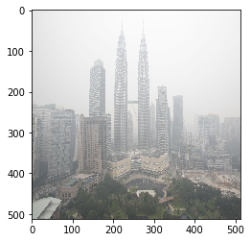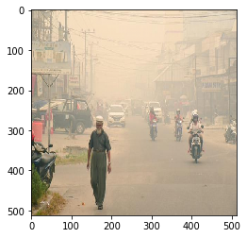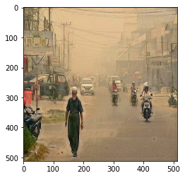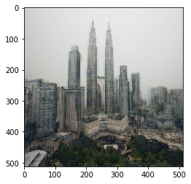

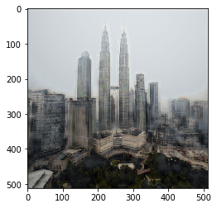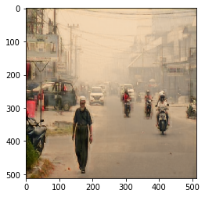

8325_4

Original 8325_5 8325_6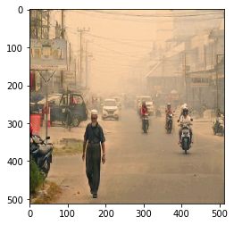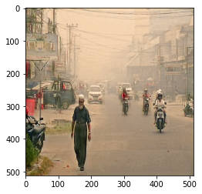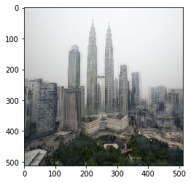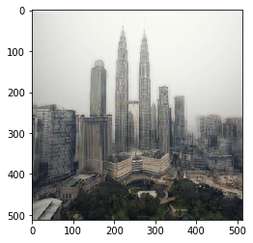

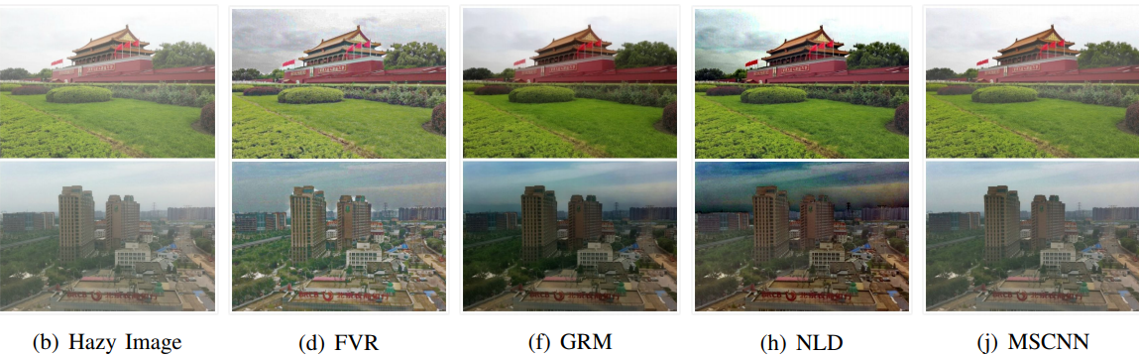

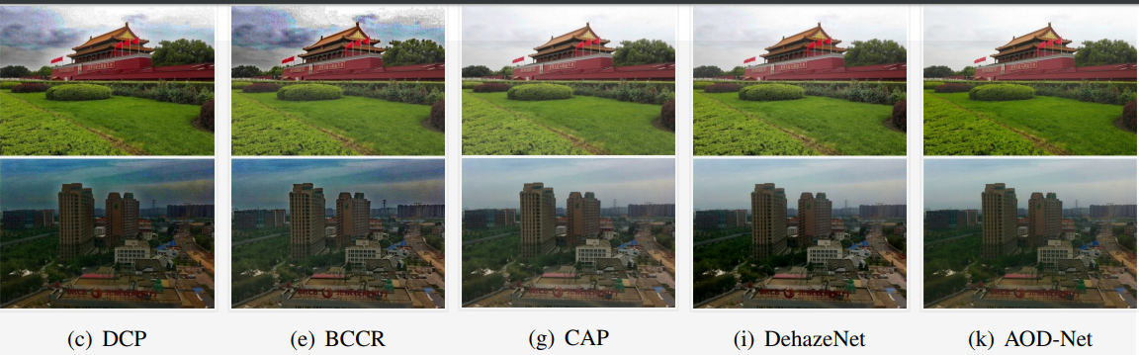

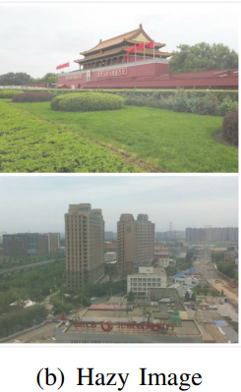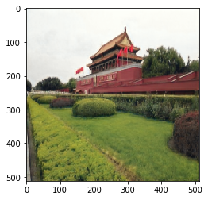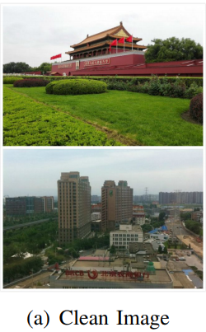

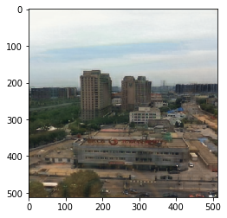

(c)  
 (**C)Dehazed Image**





Possible References:

B. Li et al., "RESIDE: A benchmark for single image dehazing," arXiv preprint arXiv:1712.04143, 2017.

B. Li et al., “Benchmarking single-image dehazing and beyond”, IEEE Transactions on Image Processing,2018

D. P. Kingma and J. Ba, "ADAM: A method for stochastic optimization," 3rd International Conference on Learning Representations (ICLR), 2015

<https://arxiv.org/pdf/1712.04143.pdf> //V4