Project 6 — Cloud Automation Scripting
The Cloud Automation Scripting is a Python-based automation platform designed for managing AWS cloud resources. It provides a unified command-line interface (CLI) for orchestrating EC2, S3, Lambda, and IAM operations with built-in safety mechanisms, comprehensive logging, and intelligent alerting capabilities.

Scope
This documentation covers:
- Installation and configuration of the AWS automation framework
- Automated creation and deletion of AWS resources EC2, S3, Lambda.
- Scheduling and task automation
- Email notifications and alerting

Covered Resources
- EC2 Instances - Virtual compute resources
- S3 Buckets - Object storage
- Lambda Functions - Serverless compute functions

Overview

What This Tool Does
Cloud Automation Scripting is a Python-based automation framework that enables you to:
1. Automatically Provision AWS infrastructure resources with a single command
2. Manage Lifecycle of resources from creation to destruction
3. Schedule Operations for specific times (useful for testing, demo environments)
4. Send Notifications via email when resources are created or destroyed
5. Maintain Logs for audit trails and troubleshooting
6. Support Flexible Configurations to adapt to different AWS environments

Prerequisites & Requirements

System Requirements
- Operating System: Linux or Windows
- Python Version: 3.9 or higher
- RAM: Minimum 256GB

AWS Requirements
1. AWS Account with appropriate permissions
2. AWS CLI installed and configured
3. IAM Permissions for the following services:
  - EC2 (describe, run, terminate instances)
  - S3 (create, list, delete buckets)
  - Lambda (create, delete functions, manage roles)
  - IAM (for role management)
  - SNS (for email notifications)

Required AWS Resources (Pre-configured)
- EC2 Key Pair - for SSH access to instances
- IAM Role - for Lambda execution permissions
- SNS Topic - for email notifications (auto-created if missing)

Software Dependencies

Boto3

Aws cli

Installation Guide

Step 1: Verify Prerequisites
# Check Python version (should be 3.11 or more)
python --version
# Verify AWS CLI is installed
aws --version
# Check AWS credentials are configured
aws sts get-caller-identity

Expected output for AWS identity check:
{
"UserId": "AIDAI1234567890ABCDE",
"Account": "123456789012",
"Arn": "arn:aws:iam::123456789012:user/your-username"
}

Step 2: Clone Repository
# Clone the repository

git clone https://github.com/mohith-bacha/cloud-automation-script

# Navigate to project directory

cd cloud-automation-scripting

Step 3: Set Up Virtual Environment (Recommended)
Windows:
# Create virtual environment
python -m venv venv
# Activate virtual environment
venv\Scripts\activate

Step 4: Install Dependencies
# Install Python packages from requirements.txt
pip install -r requirements.txt

Step 5: Verify Installation

# Check if boto3 is installed

python -c "import boto3; print(f'boto3 version: {boto3.__version__}')"

# Verify directory structure

ls -la

# Should show: scripts/, logs/, run_automation.py, USAGE.md, requirements.txt

Configuration Guide
All runtime settings are centralized in `scripts/config.py`. This file controls:
- AWS region and resource IDs
- EC2 instance specifications
- S3 naming conventions
- Lambda function details
- Email notification settings
- Resource lifecycle timing

Configuration Parameters Explained

AWS Region
AWS_REGION = "ap-south-1" # Mumbai region
Common Regions:
- ap-south-1 - Asia Pacific (Mumbai)
- us-east-1 - US East (N. Virginia)
- eu-west-1 - Europe (Ireland)
- ap-southeast-1 - Asia Pacific (Singapore)

EC2 Configuration

EC2_KEY_NAME = "lab-key" # SSH key pair name

EC2_INSTANCE_TYPE = "t3.micro" # Instance family

EC2_AMI_ID = "ami-0f5ee92e2d63afc18" # Amazon Machine Image

EC2_SUBNET_ID = "subnet-04fd3b7a98bd59b53" # VPC Subnet

EC2_SECURITY_GROUP_ID = "sg-0b0ea5476e0bcdd13" # Security Group
EC2 Instance Types (free tier eligible):

Type | vCPU | Memory | Use Case
t3.micro | 2 | 1 GB | General purpose, testing
t3.small | 2 | 2 GB | Light workloads
t3.medium | 2 | 4 GB | Small applications

S3 Configuration

S3_BUCKET_BASE_NAME = "script-automation-sprint"

# Final bucket name: script-automation-sprint-abc123 (random suffix added)

Lambda Configuration

LAMBDA_FUNCTION_BASE_NAME = "sprint-automation-lambda"

LAMBDA_EXECUTION_ROLE_ARN = "arn:aws:iam::075991853676:role/service-role/mohith-lambda-role-cn9t7ak9"

# Final function name: sprint-automation-lambda-xyz789 (random suffix added)

Email & Notification
ADMIN_EMAIL = "mohithbacha1@gmail.com" # Email to receive alerts
SNS_TOPIC_NAME = "Automation-Error-Alerts" # SNS topic name

Timing Configuration
WAIT_TIME_SECONDS = 15 # Default wait between provisioning and cleanup

Step-by-Step Configuration

1. Identify Your AWS Resources

# List available EC2 key pairs

aws ec2 describe-key-pairs --region ap-south-1

# Get your IAM role ARN

aws iam list-roles | grep lambda

2. Update Configuration File
# Open config.py in your preferred editor
nano scripts/config.py
# or
code scripts/config.py # VS Code

3. Modify Each Section
Replace the following values with your environment:

# AWS Region
AWS_REGION = "ap-south-1" # Change if needed
# EC2 - Get from AWS Console or CLI commands above
EC2_KEY_NAME = "your-actual-keypair-name"
EC2_SUBNET_ID = "subnet-xxxxxxxxxxxxxxxx"
EC2_SECURITY_GROUP_ID = "sg-xxxxxxxxxxxxxxx"
# S3 - Customize the bucket name
S3_BUCKET_BASE_NAME = "my-organization-automation"
# Lambda - Update with your role ARN
LAMBDA_EXECUTION_ROLE_ARN = "arn:aws:iam::YOUR-ACCOUNT-ID:role/your-lambda-role"
# Email
ADMIN_EMAIL = "your-email@company.com"
# Timing
WAIT_TIME_SECONDS = 300 # Wait 5 minutes before cleanup

4. Verify Configuration
# Test AWS credentials with configured region
aws sts get-caller-identity --region ap-south-1
# Verify EC2 resources exist
aws ec2 describe-instances --region ap-south-1 | grep -c "InstanceId"

Quick Start Guide

30-Second Setup & Run
# 1. Install dependencies (one time)
pip install -r requirements.txt
# 2. Edit configuration with your AWS details
scripts/config.py
# 3. Run the full automation
python run_automation.py

Expected log output:
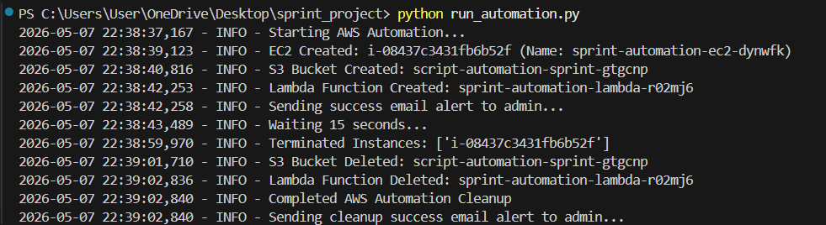

Command Reference

Main Entrypoint
python run_automation.py [OPTIONS]

Resource Selection Flags

Flag | Description | Example
--ec2 | Create/delete EC2 only | python run_automation.py --ec2
--s3 | Create/delete S3 only | python run_automation.py --s3
--lambda-func | Create/delete Lambda only | python run_automation.py --lambda-func
(no flags) | Create/delete all resources | python run_automation.py

Timing & Scheduling Flags

Flag | Format | Description | Example
--start-time | HH:MM or HH:MM:SS | Schedule start time | --start-time 19:30:00
--stop-time | HH:MM or HH:MM:SS | Schedule cleanup time | --stop-time 20:00:00
--wait | Seconds (integer) | Wait duration before cleanup | --wait 600

Command Examples

1. Run All Resources Immediately
python run_automation.py
Provisions EC2, S3, Lambda → Waits 15 sec → Deletes all
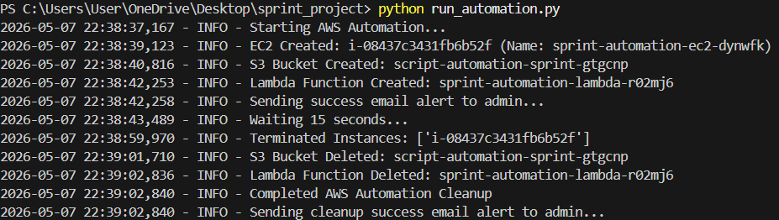

2. EC2 Only with 5-Minute Wait
python run_automation.py --ec2 --wait 10
Provisions EC2 → Waits 10 seconds → Deletes EC2
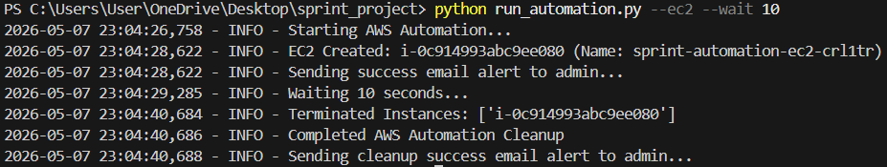

3. Schedule at Specific Time
python run_automation.py --start-time 14:30:00
Waits until 2:30 PM → Provisions all resources → Cleanup

4. Multiple Resources with Scheduling
python run_automation.py --ec2 --s3 --start-time 20:00:00 --wait 1200
Provisions EC2 & S3 at 8 PM → Waits 20 minutes → Cleanup
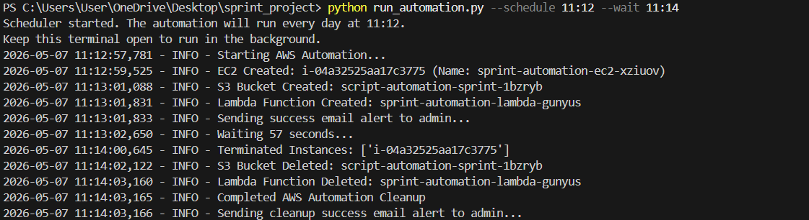

Scheduling Setup

Understanding Scheduling Options

Option 1: Start-Time Scheduling
python run_automation.py --start-time HH:MM
- Script waits until specified time
- Then provisions resources
- Uses default wait time for cleanup (15 seconds)
Output
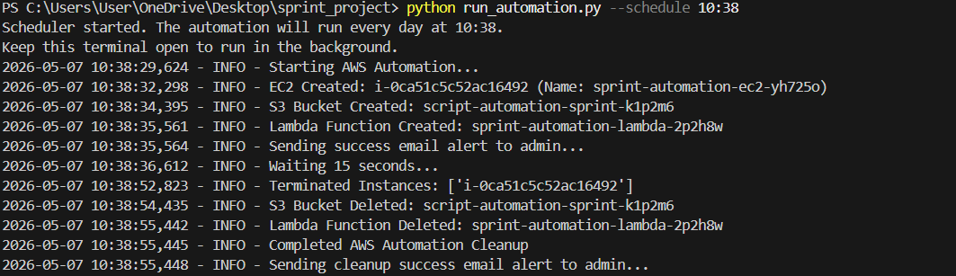

Option 2: Wait Duration
python run_automation.py --wait SECONDS
- Resources stay active for specified duration
- Then automatically cleaned up
- Useful for testing/demos
Output
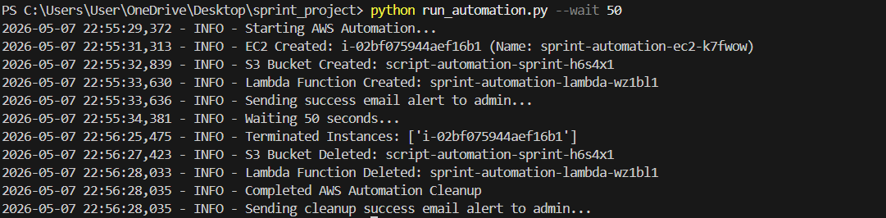

Option 3: Stop-Time Scheduling
python run_automation.py --stop-time HH:MM:SS
- Schedules cleanup at specific time

Option 4: Combined Scheduling
python run_automation.py --start-time 23:00 --wait 50
- Start provisioning at 11:00 PM
- Keep resources for 50 seconds
- Cleanup at 11:50 PM

Logging & Monitoring

Log Location
logs/automation.log

Log Format
TIMESTAMP - LEVEL - MESSAGE
Example:
2026-05-07 14:30:15,123 - INFO - Starting AWS Automation script (scheduler ready)...
2026-05-07 14:30:16,234 - INFO - EC2 Created: i-0123456789abcdef0 (Name: sprint-automation-ec2-abc123)

Log Levels

Level | Meaning | Example
INFO | Informational message | Resource created successfully
ERROR | Error occurred | Failed to provision EC2
WARNING | Warning condition | Low disk space

Viewing Logs
View entire log file:
logs/automation.log
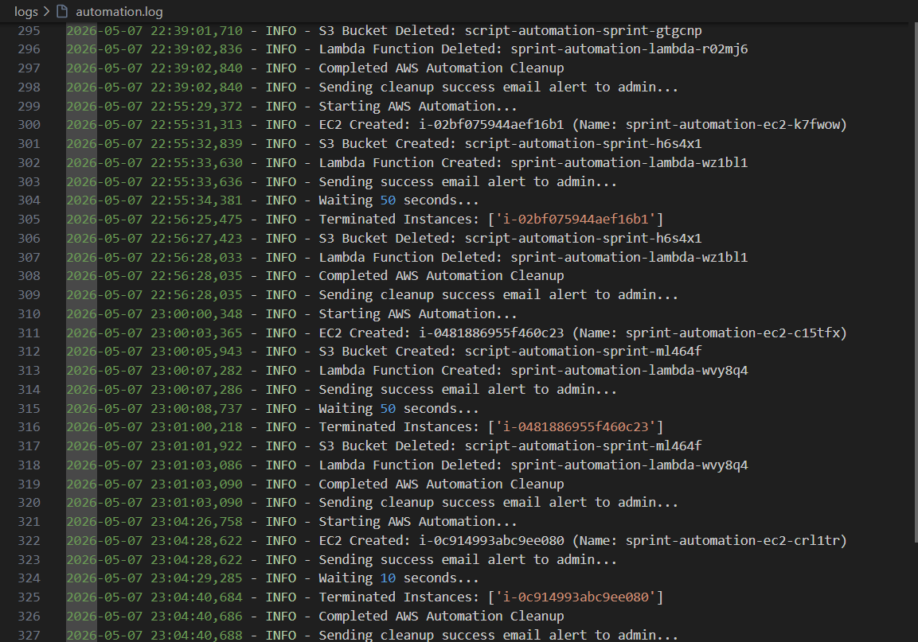

Monitoring Best Practices
1. Review logs regularly# Check logs daily
tail -100 logs/automation.log
2. Set up email alerts
  - Configure admin email in config.py
  - Tool automatically sends alerts on success/failure
3. Monitor AWS Console
  - EC2 Dashboard: Check instance states
  - S3 Dashboard: Verify bucket creation
  - Lambda Dashboard: Confirm function deployment
  - CloudWatch: Monitor logs in AWS
4. Track costs
  - Monitor resource usage
  - Review AWS bills for unexpected charges

5. Maintenance Best Practices
Keep Dependencies Updated:
# Check for boto3 updates
pip list --outdated
# Update packages safely
pip install --upgrade boto3

Version Control:
# Use git to track changes
git init
git add -A
git commit -m "Initial automation setup"

