LAB – 1
1)AIM: A rocket launch system displays a countdown before launch. Instead of using a loop implement the countdown using recursion .write a recursion python program to display a countdown from n to 1 followed by “launch”.
PROGRAM:
def launch(n):
for i in range(n,-1,-1):
if i==0:
print("launch")
else:
print(i)
n=int(input("enter no. of seconds to launch:"))
launch(n)
OUTPUT:
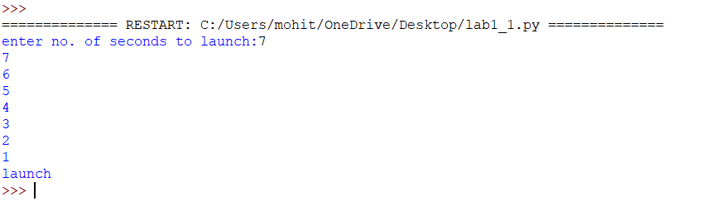
EXPLANATION:
This program displays a countdown from n to 1 and finally prints 'launch'. Although the aim mentions recursion, the given code uses a loop.
ERROR TABLE:
Error | Cause | Solution
Indentation Error | Incorrect indentation | Align blocks properly
Name Error | Variable not defined | Define before use
Value Error | Non-integer input | Enter valid integer

2)AIM: banks calculate the growth of an investment using compoundinterest the formula requires calculating powers. Which can be implemented recursively. Write a recursive program to calculate p^n(power),where p=principal growth factor, n= number of years.
PROGRAM:
def intrest(p,n):
if n==0:
return 1
else:
return p*intrest(p,n-1)
n=int(input("enter no.of years:"))
p=int(input("enter a number:"))
res=intrest(p,n)
print(res)
OUTPUT:
EXPLANATION:
This program recursively calculates p^n by multiplying p until n becomes 0.
ERROR TABLE:
Error | Cause | Solution
Recursion error | Very large value of n | Reduce input
Value Error | Non-integer input | Enter valid integer

3)AIM: An HR department stores employee ID’s in a list. Develop a recursive program to search for a given employee ID .write a recursive function to search for an employee ID in a list.
PROGRAM:
def search(m):
key=m
for i in range(n-1):
if arr[i]==key:
return i
n=int(input("enter no.of employees to add:"))
arr=[]
for i in range(n):
a=int(input("enter a value:"))
arr.append(a)
print(arr)
m=int(input("enter a element to search:"))
result=search(m)
if result==-1:
print(“element is not found”)
else:
print("employee id is stored at the index:",result)
OUTPUT:
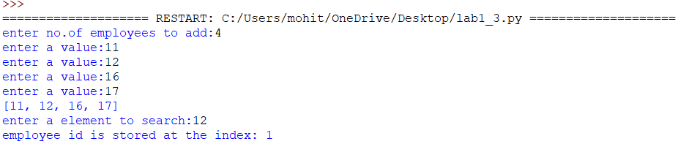
EXPLANATION:
This program searches for an employee ID in a list and returns its index if found.
ERROR TABLE:
Error | Cause | Solution
Syntax error | Wrong quotes/brackets | Correct syntax
Logic error | Returns None instead of -1 | Return -1 when not found

4)AIM: In a logistics company the number of possible ways to arrange n different parcels is calculated using the factorial formula(n!). develop a recursive program to calculate the factorial of a given number.
PROGRAM:
def fact(n):
fact=1
for i in range(1,n+1):
fact=fact*i
return fact
n=int(input("enter a number to find its factorial:"))
result=fact(n)
print(result)
OUTPUT:
EXPLANATION:
This program calculates the factorial of a number using iteration (not recursion).
ERROR TABLE:
Error | Cause | Solution
Overflow/large input | Large input value | Give smaller input
Value error | Invalid input | Even integer

5)AIM: write a recursive python program to print the first n terms of the Fibonacci series.
PROGRAM:
def fib(n):
if n==0:
return 0
elif n==1:
return 1
else:
return fib(n-1)+fib(n-2)
n=int(input("enter no of terms:"))
if n<=-1:
print("invalid input")
else:
for i in range(n):
print(fib(i),end=" ")
OUTPUT:
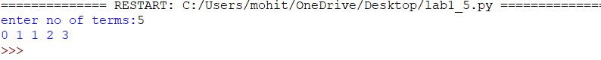
EXPLANATION:
The program uses recursion to generate Fibonacci numbers. fib (0)=0 and fib (1) =1 are the base cases. For every other term, fib(n)=fib(n-1) + fib(n-2). The loop prints the first n terms.
ERROR TABLE:
Error | Cause | Solution
Recursion error | Large value of n | Use iteration
Invalid input | Negative value of n | Validate input
Slow execution | Repeated recursive calls | Use dynamic programming

