PROJECT REPORT

Hereditary Disease Prediction in Eukaryote DNA

Muffakham Jah College of Engineering and Technology,
Banjara Hills, Hyderabad – 500034

PROJECT BY:
SAI MOHITH CHINNARI (1604-18-735-086)
DARAPANENI ANUTHAM SIVA KRISHNA (1604-18-735-083)
MOHAMMAD RIAZ (1604-18-735-079)

UNDER THE GUIDANCE OF:
MRS.KAMALA KUMARI
&
MRS.G.PRASHANTHI
Assistant Professor, ECED
MJCET, Hyderabad

MUFFAKHAM JAH
COLLEGE OF ENGINEERING & TECHNOLOGY
(Est. by Sultan-Ul-Uloom Education Society in 1980)
(Affiliated to Osmania University, Hyderabad)
Approved by the AICTE & Accredited by NBA

CERTIFICATE

This is to certify that the dissertation titled in ‘Hereditary Disease Prediction in Eukaryote DNA’ submitted by Sai Mohith Chinnari (1604-18-735-086), Darapaneni Anutham Siva Krishna (1604-18-735-083) and Mohammad Riaz (1604-18-735-079) partial fulfillment of the requirements for the award of the Degree of Bachelor of Engineering in Electronics and Communication is a bonafide record of work carried out by them under my guidance and supervision during the year 2021-2022.The results embodied in this report have not been submitted to any University or Institute for the award of Degree or Diploma.

Mrs. Kamala Kumari Dr. ArifuddinSohel
Project Supervisor Professor and HOD
Assistant Professor, ECED Department of ECE
MJCET, Hyderabad MJCET, Hyderabad

ACKNOWLEDGMENT

We would like to acknowledge our indebtedness and render our warmest thanks to our project guide, Mrs. Kamala Kumari, Assistant Professor, Department of Electronics and Communication Engineering MJCET, who made this work possible. Her immense knowledge, profound experience and professional expertise has enabled us to complete this project successfully. We are grateful for her constant support and encouragement even during the tough times of pandemic. The doubts and the queries we had were attended with a great deal of patience. Her friendly guidance and expert advice have been invaluable throughout all stages of the work.

We would also wish to express our gratitude to Dr. Kaleem Fatima, Professor, ECED, MJCET and Mr. Jaideep Kumar Nag, Associate Professor, ECED, MJCET for taking regular appraisals and extended discussions. The valuable suggestions have greatly contributed to the improvement of the project.

We would like to thank Dr. Arifuddin Sohel, Head of the Department of Electronics and Communication Engineering, MJCET for his generous help, guidance, and encouragement in the successful completion of our project. We also thank the other faculty members and the entire non-teaching staff of the Department of Electronics and Communication Engineering for their valuable suggestions in the project reviews and support throughout our engineering.

Also, we are immensely thankful to our Parents for their over whelming and wholehearted support and understanding without which this project would not have been possible.

Sai Mohith Chinnari
Darapaneni Anutham Siva Krishna
Mohammad Riaz

TABLE OF CONTENTS:

- Title of Project
- Abstract
- Introduction
- DNA Structure
- Signal Processing
- Literature Survey
- Problems in proposed Area
- Design Methodology
- Block Diagram
- EIIP Mapping
- Adaptive Filter
- Mean Square Error
- Objectives completed & Objectives to be Achieved
- References

1.ABSTRACT:
Hereditary disease prediction in eukaryotic DNA using signal processing approaches is an incredible work in bioinformatics. Researchers of various fields are trying to put forth a non-invasive approach to forecast the disease-related genes. As diseased genes are more random than the healthy ones, in this work, a comparison of the diseased gene is made against the
healthy ones. An adaptive signal processing method like functional link artificial neural network-based Levenberg–Marquardt filter has been proposed in this regard. Here, disease genes are discriminated from healthy ones based on the magnitude of mean square error (MSE),which is calculated through the adaptive filter. The performance of the algorithm is inspected by computing some evaluation parameters. Since accuracy is the prime concern, authors in this work have taken an attempt to improve the accuracy level compared to the existing methods. Taking the reference gene as healthy, the overall process is accomplished by categorizing the diseased and healthy targets with MSE value at a threshold of 0.012. The proposed technique predicts the test gene sets successfully.

2.INTRODUCTION:

The existing clinical detection techniques of disease genes are rather insufficient in terms of accuracy concern, cost, time consumption, and sometimes harmful also. Hence researchers from different backgrounds are looking for an alternative way. The literature of the DNA nucleotide sequence suggests valuable information in support of the irregularity present in a diseased gene. A mutational disease is caused due to alteration in the normal sequencing of nucleotides in DNA. If those alterations can be recognized, the disease-associated genes can be identified perfectly.

Functional link artificial neural network (FLANN) is a single-layered structure with simple operations to conquer the MLP. To boost up the input pattern, nonlinear functions are applied to the FLANN structure. By integrating the FLANN structure with adaptive filters, improved performance is obtained. FLANN filter offers trigonometric expansion of the input sequences which reduces the error to minimum value at faster rate. Here, diseased genes are distinguished from healthy genes based on amount of normalized mean square error, which is estimated through adaptive filter.

Currently, neurodegenerative diseases are diagnosis done by Micro-Electro-Mechanical Systems sensors. Lots of nice researches have been done for exon detection, so that the first exon location is perfectly identified before mutation detection. Several algorithms have been developed for mutational disease assessment. The multilayer perceptron (MLP) algorithm is popularly used due to its superior accuracy

Recent advances in genetic research have made it possible to identify the genetic basis for human diseases, opening the door to individualized prevention strategies and early detection and treatment. These advances hold much promise for improving health.
Unprecedented progress in identifying and understanding the 50,000 to 100,000 or so genes that make up the human genome provides an opportunity for scientists to develop strategies to prevent or reduce the effects of genetic disease. Scientists have shown that straightforward inherited errors in our genes are responsible for an estimated 3,000 to 4,000 diseases, including Huntington's disease, cystic fibrosis, neurofibromatosis, and Duchenne muscular dystrophy. More complex inheritance of multiple genetic errors also can increase an individual's risk of developing common disorders such as cancer, heart disease, and diabetes. Genetic technologies, such as simple DNA tests, increasingly are becoming available to identify people who might have an increased likelihood of developing a disorder.

The existing FLANN-based LMS adaptive filter is used to distinguish between healthy and diseased (cancer) genes. This gene detection principle is applied to HD (healthy and disease) dataset in this work. AUC for the proposed technique is higher than that of the existing one, proves its supremacy in identifying disease genes. It is observed that the proposed PSO-tuned Levenberg–Marquardt adaptive filter algorithm gives superior performance. The proposed method could distinguish the diseased genes more correctly resulting in privileged evaluation parameters.

Besides, the curve is plotted for receiver operating characteristics (ROC) using TPR and FPR
as shown. The number of truly predicted genes is indicated by TPR and the number of false predicted genes is indicated by FPR are ROC curve for the existing and proposed method. NUCLEOSIDES, NUCLEOTIDES AND NUCLEIC ACIDS 1195 evaluated for both proposed and existing algorithms. The area under the ROC curve is more near about 0.5 (reference line) for the existing method than that of the proposed one.

The literature of the DNA nucleotide sequence suggests valuable information in support of the irregularity present in a diseased gene. A mutational disease is caused due to alteration in the normal sequencing of nucleotides in DNA. If those alterations can be recognized, the disease-associated genes can be identified perfectly.

Adaptive filter has its extensive application in identifying an unknown system by comparing its distinctiveness with a known system. In this work, all the diseased as well as healthy genes are regarded as unknown signals and are evaluated against one of the healthy genes which is taken to be the reference signal. The diseased (mutated) genes are detected by the proposed method as they are dissimilar comparing with a healthy one due to the mutation causing the disturbance in a normal run.

BASIC BACKGROUND:

- DNA STRUCTURE:
Each strand of DNA is a polynucleotide composed of units called nucleotides. A nucleotide has three components: a sugar molecule, a phosphate group, and a nitrogenous base.
The sugar in DNA’s nucleotides is called deoxyribose—DNA is an abbreviation for deoxyribonucleic acid The bases adenine (A), cytosine (C), guanine (G), and thymine (T) are the four main components that make up DNA. These bases can form pairs and link together to create the double helix structure of DNA.DNA is a macromolecule consisting of two strands that twist around a common axis in a shape called a double helix. Cytosine forms three hydrogen bonds with guanine, and adenine forms two hydrogen bonds with thymine.
Guanine and cytosine make up a nitrogenous base pair because their available hydrogen bond donors and hydrogen bond acceptors pair with each other in space.

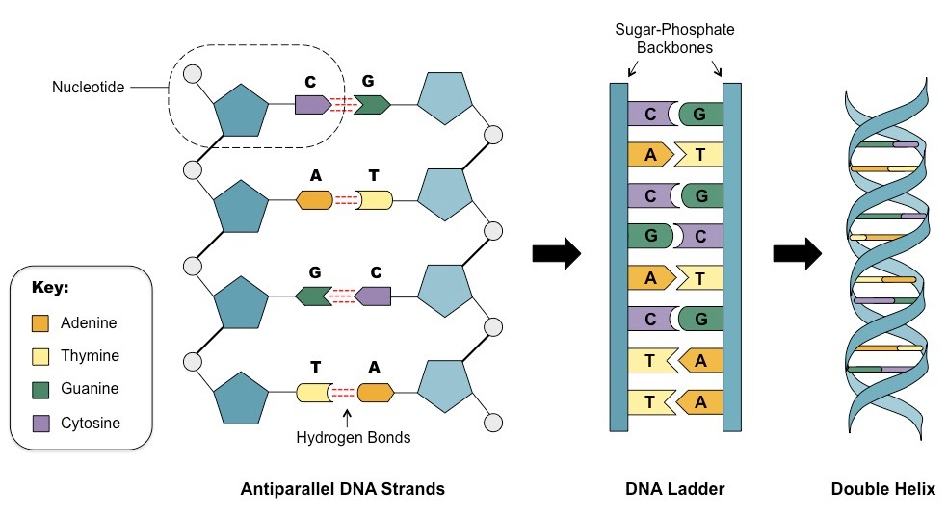
The mutation may be of different types like addition, deletion, duplication, substitution, and many more. As a result, the normal order of the nucleotide sequence gets disturbed and hence, the codons corresponding to amino acid is misrepresented so that the protein coding region (exon) which is responsible for producing amino acids behaves inharmoniously.

This results in different diseases. One example of such a type of mutation is represented in Figure 1. Here, the mutation is due to the repeated addition of trinucleotide (CAG) in the original DNA code for an amino acid sequence. This exceptional type of mutation leads to the popular HD.

- SIGNAL PROCESSING:

Signal processing condenses measurements to extract information about some distant state of nature. Signal processing can be described from different perspectives. To an acoustician, it is a tool to turn measured signals into useful information.
Signal processing is the analysis, interpretation and manipulation of signals. Signals of interest include sound, images, biological signals such as ECG, radar signals, and many others.Processing of such signals includes storage and reconstruction, separation of information from noise (e.g., aircraft identification by radar),compression (e.g., image compression), and feature extraction (e.g., converting text to speech).

LITERATURE SURVEY:
- Survey of Different Papers:
DSP based entropy estimation for identification and classification of Homo sapiens cancer genes.
(Springer-Verlag Berlin Heidelberg 2016) Joyshri Das, Soma Barman

GSP basically processes genes, proteins and DNA sequences using various signal processing methodologies to extract the information hidden in it. Genes are composed of amino acids; therefore, gene identification based on amino acids level is more responsive according to medical research reports. Genes are very random in nature, difficult to extract hidden information resides in it. To reveal the hidden information content of genes, entropy is estimated.
In the present paper, the crucial job of gene identification and classification is attempted. Statistical methods like entropy estimation and mutual information calculation are adopted along with DSP technique. Rayleigh distribution of estimated entropy of gene is treated as identifier of healthy and cancerous Homo sapiens. Once the cancer genes are identified, mutual information estimator based on their minimum entropy is used as classifier to detect different types of cancer genes.
The work is successfully examined on prostate, breast and colon genes collected from NCBI homepage. The work may further be extended in other types of cancer genes.

A non-invasive cancer gene detection technique using FLANN based adaptive filter
(Saikat Singha Roy, Soma Barman)

In recent years advancement in cross field technologies lead the world to the new era of genomic research. Several new technologies have been developed for early detection of critical genetic disease like cancer. Since the conventional morphological and clinical tests are invasive in nature and harmful to human body, researchers are intending to find a noninvasive way to predict cancer associated genes. They find accuracy as a major concern to be taken care of in disease gene identification system. Therefore the authors in this paper made an effort to raise the accuracy level compare to existing technique. Cancer is caused by changes in deoxyribonucleic acid sequence. If those changes can be identified,diseased gene can therefore be recognized exactly. Hence the authors compared the diseased gene with the healthy ones to capture the differences. In order to search such disparity more efficiently and accurately, functional link artificial neural network (FLANN) based adaptive filter with least mean squares algorithm is attempted in the present paper. FLANN filter offers trigonometric expansion of the input sequences which reduces the error to minimum value at faster rate. Here, cancer genes are distinguished from healthy genes based on amount of normalized mean square error, which is estimated through adaptive filter. 131 Genes are used to train the identifier and the proposed technique successfully identifies 369 test dataset.The database is collected from National Center for Biotechnology Information genbank. The performance of the overall system is investigated by measuring sensitivity, specificity and accuracy. The proposed algorithm achieves 86.85% accuracy compared to existing entropy based identifier. Overall system performance of the proposed FLANN based adaptive filter is displayed in receiver operating characteristic curve.

Ross, C. A.; Tabrizi, S. J. Huntington’s Disease: From Molecular Pathogenesis to Clinical Treatment. Lancet Neurol.
Huntington's disease is a progressive, fatal, neurodegenerative disorder caused by an expanded CAG repeat in the huntingtin gene, which encodes an abnormally long polyglutamine repeat in the huntingtin protein. Huntington's disease has served as a model for the study of other more common neurodegenerative disorders, such as Alzheimer's disease and Parkinson's disease. These disorders all share features including: delayed onset; selective neuronal vulnerability, despite widespread expression of disease-related proteins during the whole lifetime; abnormal protein processing and aggregation; and cellular toxic effects involving both cell autonomous and cell-cell interaction mechanisms. Pathogenic pathways of Huntington's disease are beginning to be unravelled, offering targets for treatments. Additionally, predictive genetic testing and findings of neuroimaging studies show that, as in some other neurodegenerative disorders, neurodegeneration in affected individuals begins many years before onset of diagnosable signs and symptoms of Huntington's disease, and it is accompanied by subtle cognitive, motor, and psychiatric changes (so-called prodromal disease). Thus, Huntington's disease is also emerging as a model for strategies to develop therapeutic interventions, not only to slow progression of manifest disease but also to delay, or ideally prevent, its onset.

Akhtar, M.; Epps, J.; Ambikairajah, E. Signal Processing in Sequence Analysis Advances in Eukaryotic Gene Prediction. IEEE J. Sel. Top. Signal Process.
Genomic sequence processing has been an active area of research for the past two decades and has increasingly attracted the attention of digital signal processing researchers in recent years. A challenging open problem in deoxyribonucleic acid (DNA) sequence analysis is maximizing the prediction accuracy of eukaryotic gene locations and thereby protein coding regions. In this paper, DNA symbolic-to-numeric representations are presented and compared with existing techniques in terms of relative accuracy for the gene and exon prediction problem. Novel signal processing-based gene and exon prediction methods are then evaluated together with existing approaches at a nucleotide level using the Burset/Guigo1996, HMR195, and GENSCAN standard genomic datasets. A new technique for the recognition of acceptor splice sites is then proposed, which combines signal processing-based gene and exon prediction methods with an existing data-driven statistical method. By comparison with the acceptor splice site detection method used in the gene-finding program GENSCAN, the proposed DSP-statistical hybrid technique reveals a consistent reduction in false positives at different levels of sensitivity, averaging a 43% reduction when evaluated on the GENSCAN test set

PROBLEMS IN PROPOSED AREA:
The existing clinical detection techniques of disease genes are rather insufficient in terms of accuracy concern, cost, time consumption.
Algorithms such as Multilayer perceptron (MLP) have greater accuracy but have a slow rate of convergence and high computational price.
Performance issues.

DESIGN METHODOLOGY:
MATLAB:

MATLAB is a programming and numeric computing platform used by millions of engineers and scientists to analyze data, develop algorithms, and create models.
In this project EIIP Mapping is performed using Matlab

BLOCK DIAGRAM:
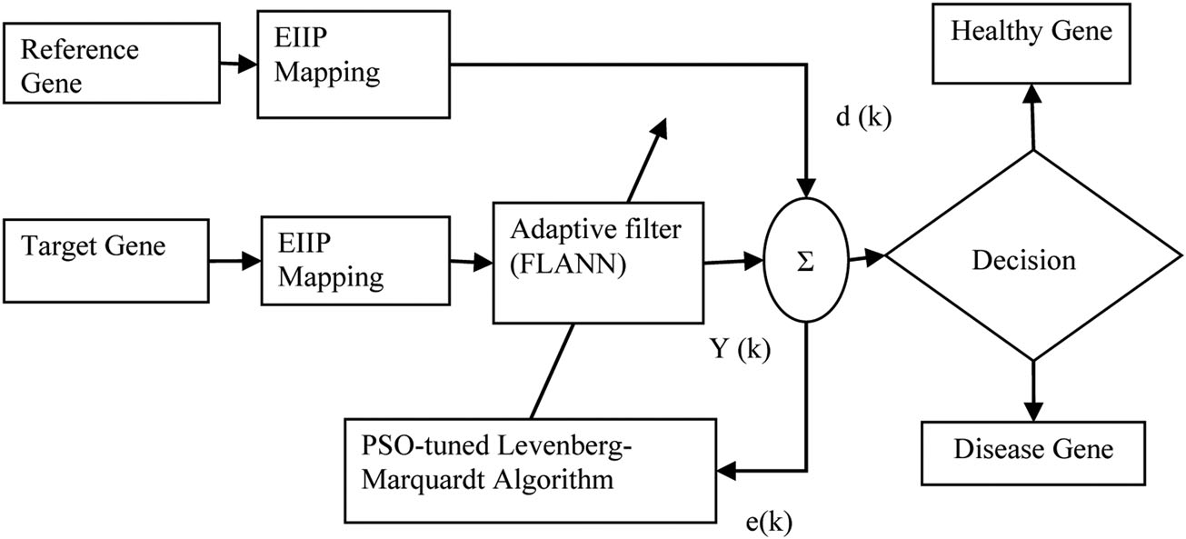
1.EIIP MAPPING:
The collected gene set is a DNA sequence comprised of four characters (A,C, G, and T) arranged in a particular manner. For example, a collected DNA sequence x(n) of length n characters, is in a form shown.
X(n)= {CTGAACCTGGG… } (1)
The numeric values (EIIP) assigned to the respective nucleotides

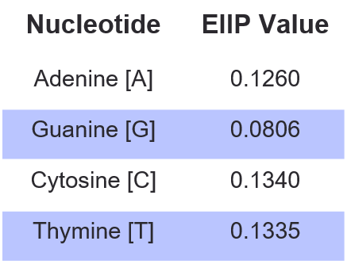
The resulting numerical sequence corresponding to (1) is in the form of (2).
X(n)= {0:134 0:1335 0:0806 0:126 0:f 126 0:134 0:134 0:1335 0:0806 0:0806 0:0806 … } (2)
Thus, all the collected nucleotide sequences are mapped into the corresponding numerical sequences.

2.ADAPTIVE FILTER:

At first the weight of the adaptive filter is set to zero. With this initial condition the adaptive filter measures the NMSE between input and desired signal. Now the weight
of the adaptive filter is adjusted to reduce the NMSE.
If the unknown input is a healthy gene, the estimated NMSE will reduce faster compared to a cancerous input gene. Since two similar type genes are more biologically related, the estimated error between two healthy genes is less compared to the error estimated between one healthy and one cancer gene. Therefore depending on the amount of estimated error, the adaptive filter decides whether the unknown input gene is healthy or cancerous. These steps are shown. The adaptive filter with zero initial conditions is chosen for gene identification because of its simplicity and inherent stability. The LMS algorithm is employed to adjust the coefficients of the FIR estimator to reduce mean squared error (MSE), which is a measure of the accuracy of the
estimated signal.
The estimation error can be found as:
e(k) = d(k) - y(k)
d(k) = h(k) * x(k)

where e(k) is the error value, d(k) is the known gene signal, y(k) is the adaptive filtered response of unknown gene signal, h(k) is the weight vector, x(k) is the unknown gene signal, and * denotes convolution.

Generally, the tuning of the learning parameter is done using hit and trial method. But because the learning rates are not most appropriate, the best dynamic performance might not be achieved.
Therefore, authors have introduced the “PSO-tuned algorithm” to achieve the best dynamic performance of the model which provides us the optimal learning rates. For fast convergence, the optimum value is selected by applying the “PSO-tuned algorithm” as shown in the following section. Because of this reason, a function called cost function in is defined which will be optimized in the “PSO algorithm” to obtain the best value of g.
Here the “cost function” is defined as follows:

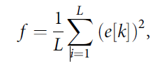
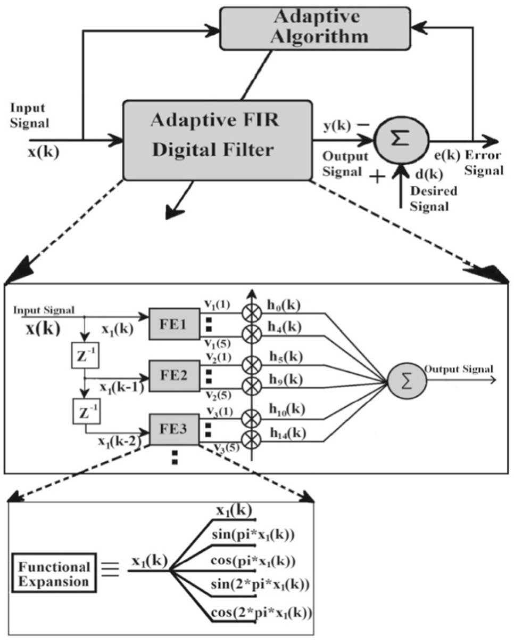
3.MEAN SQUARE ERROR:
The MSE formula is represented as follows:

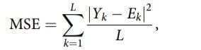
Where:
L is the length of the signal anticipated, Yk is the desired signal, and
Ek is the estimated test signal of the k-th element of the signal.

During the entire iterations, it is observed that in case of a healthy gene, the error decreases much faster than the diseased one. This entails that as the target gene is like reference, that is, healthy, error attains zero in a small number of iterations, whereas the target gene is unlike, that is, diseased one; more iterations are taken to reach to zero. Hence the MSE acts as a signature for the disease gene identification.

OBJECTIVES COMPLETED AND OBJECTIVES TO BE ACHIEVED:

- OBJECTIVES COMPLETED:
Study of DNA structure
Study of Research Papers
EIIP Mapping
Working with Adaptive Filter
Theoretical calculation

- OBEJECTIVES TO BE ACHIEVED:

Simulation

REFERENCES:

- Ross, C. A.; Tabrizi, S. J. Huntington’s Disease: From Molecular Pathogenesis to Clinical Treatment. Lancet Neurol.
- Ambrose, C. M.; Duyao, M. P.; Barnes, G.; Bates, G. P.; Lin, C. S.; Srinidhi, J;Baxendale, S; Hummerich, H; Lehrach, H.; Altherr, M; et al. Structure and Expression of the Huntington’s Disease Gene: Evidence Against Simple Inactivation due to an Expanded CAG Repeat. Somat. Cell Mol. Genet.
- Akhtar, M.; Epps, J.; Ambikairajah, E. Signal Processing in Sequence Analysis Advances in Eukaryotic Gene Prediction. IEEE J. Sel. Top. Signal Process.
- https://www.ncbi.nlm.nih.gov/nucleotide/
- Roy, S. S.; Barman, S. A Non-Invasive Cancer Gene Detection Technique Using FLANN Based Adaptive Filter. Microsyst. Technol. 2018, 1–16.
- Ahmad, M.; Jung, L. T.; Bhuiyan, A.-A. From DNA to Protein: Why Genetic Code Context of Nucleotides for DNA Signal Processing? a Review. Biomed. Signal Process. Control 2017, 34, 44–63. DOI: 10.1016/j.bspc.2017.01.004.
- Shakya, D. K.; Saxena, R.; Sharma, S. N. An Adaptive Window Length Strategy for Eukaryotic CDS Prediction. IEEE/ACM Trans. Comput. Biol. Bioinform. 2013, 10,1241–1252. DOI: 10.1109/TCBB.2013.76.
- Das, L.; Kumar, A.; Das, J.; Nanda, K. S. Modified Gabor Wavelet Transform in Prediction of Cancerous Genes. Int. J. Eng. Adv. Technol. 2019, 19, 902–907
- Cameron A et al (2016) MAPS: a quantitative radiomics approach for prostate cancer detection. IEEE Trans Biomed Eng 63(6):1145–1156
- Abdelmaksoud-Damak R et al (2015) Expression and mutation pattern of b-catenin and adenomatous polyposis coli in colorec-tal cancer patients. Arch Med Res 46(1):54–62
- Putluri, S.; Rahman, M. Z. U.; Fathima, S. Y. Cloud-Based Adaptive Exon Prediction for DNA Analysis. Healthc. Technol. Lett. 2018, 5, 25–30

