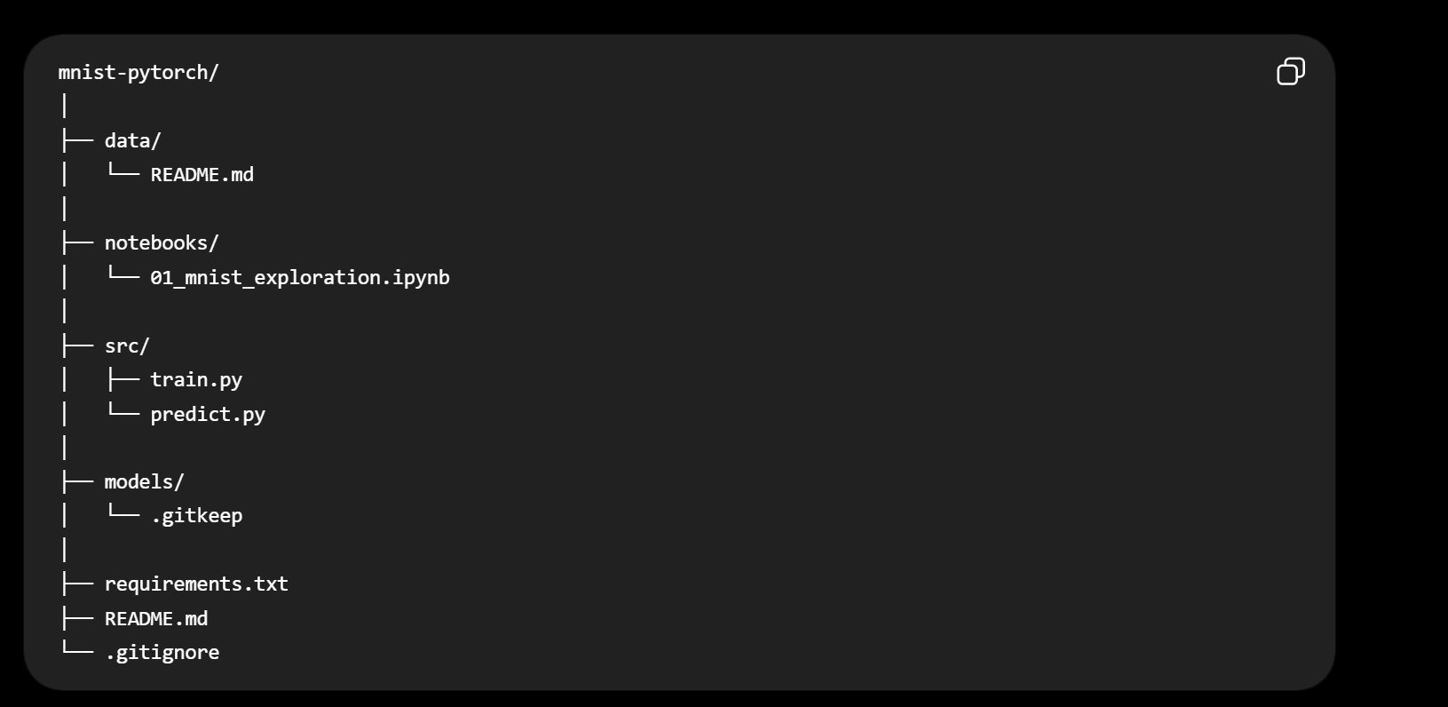
AFTER FINISHING WORK ON IMPROVING THE MODEL
- TRY DIVING INTO 3 SETS: VALIDATION SET AND SEE DIFFERENT MODELS
- Finding baseline performance and comparing with other errors
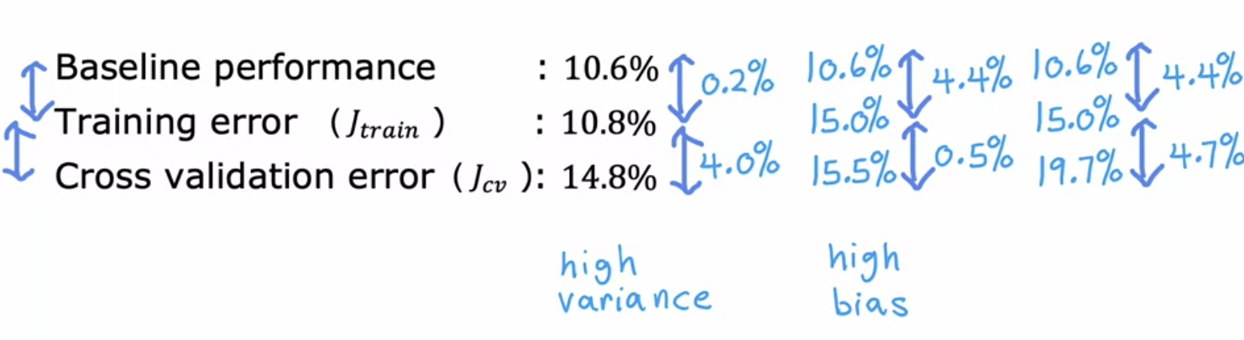
- TRY SEEING WHETHER ITS HIGH BIAS OR HIGH VARIANCE AND SORT IT OUT

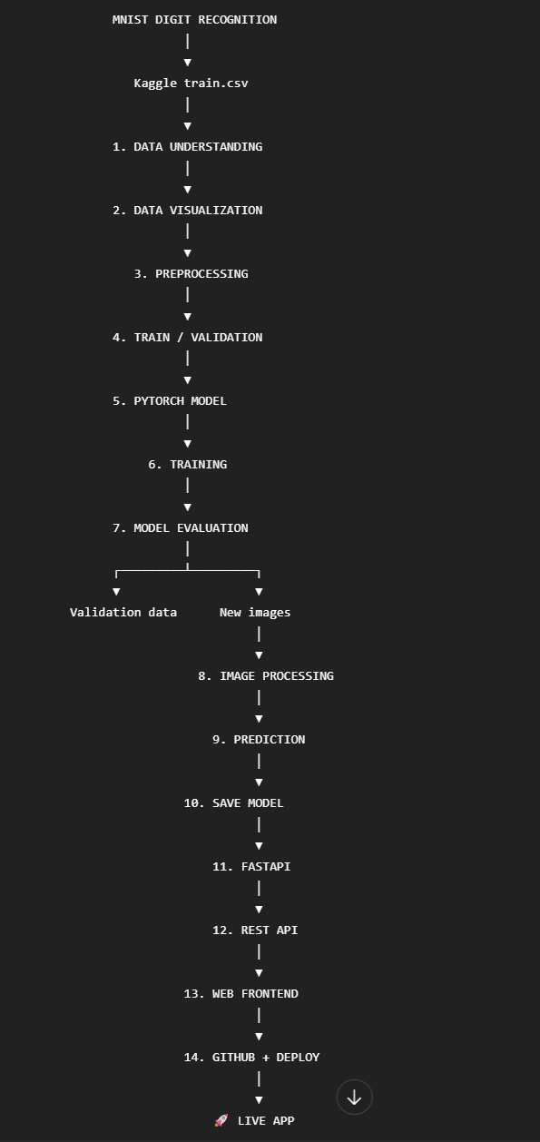
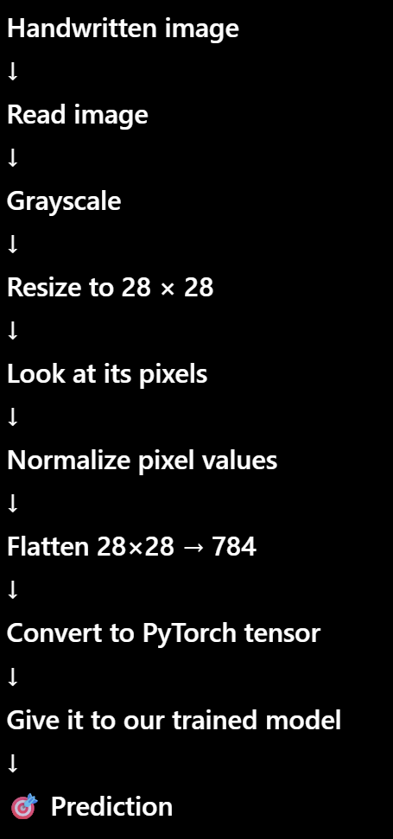

NOTES:
- Always to read csv use pandas – pd.read_csv()
- df.shape gives (row,column) where rows are training examples
- for information about dataset, we use df.info(), df.head()
- always plot and check whether the dataset contains examples for every class almost equally, i.e no class is underrepresented
- now extract X and y
- then split into test and train
- after splitting, while converting these to tensors, remember
- if X is 2D numpy array, directly use torch.tensor(X,dtype)
- if X is dataframe, torch.tensor(X.values,dtype)
- create the model

Training Validation

Underfitting LOW LOW more layers
Good fit HIGH HIGH
Overfitting HIGH LOW regularization

- define loss fn, optimizer, then train the model
- then check the loss for every iteration
- now switch to testing mode using model.eval()
- find probabilities=torch.softmax() and predictions=torch.argmax() and then find the accuracy of the model.

correct=(predictions==y_test).sum()
acc=correct/len(y_test)
print(f"Test Accuracy: {acc.item()*100:.2f }%")

Visualise actual value VS predicted using CONFUSION MATRIX

- then we add new image. First, understand the image – size(width,height), mode, etc
- Resize, change mode
- NOW, convert image pixels into numpy array (array contains 28 rows and 28 colums where each cell contains the pixel brightness number/intensity ranging from 255 (white) to 0 (black))
- Then predict
- Now save the model(i.e store the weights in another file as they will be erased when the program is closed)

torch.save(model.state_dict(), "models/mnist_model.pth")
print("Model saved!")

FastAPI is a Python framework used to build APIs.
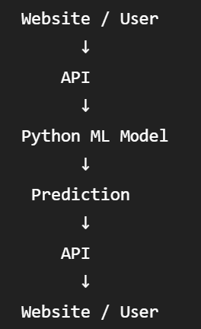
@app.get("/") : by default the system address is http://127.0.0.1:8000/ where 8000 is port number. In get() we mention only the path that comes after the port number which is ‘/’ here.

FastAPI = tool/framework we use to build the API.
REST API = the way our frontend and backend communicate.

HTTP Methods:
GET → check API / get information
POST → send image → get prediction
PUT to update information

@app.post("/predict")

http://127.0.0.1:8000/docs - this contains the get and post(for testing)

