SKILL EXP -2 : HIBERNATE CRUD OPERATIONS

STEP -1 :
create a database fsad_s5 and no need to create any tables manually as hibernate creates it automatically
STEP-2 :
In Eclipse menu:
->File → New → Maven Project
->Click Next
->Select maven-archetype-quickstart
->Enter the group id and arifact-id
->groupid : com.klu
-> ArtifactId: FSAD-skill-exp-2-hibernate-crud-operations
->then click on create
->after this you will observe BUILD SUCCESS in your console then you are in the right path

STEP -3 :

->add the required dependencies to pom.xml:
dependencies>
<dependency>
<groupId>junit</groupId>
<artifactId>junit</artifactId>
<version>3.8.1</version>
<scope>test</scope>
</dependency>
<dependency>
<groupId>org.hibernate</groupId>
<artifactId>hibernate-core</artifactId>
<version>5.6.15.Final</version>
</dependency>

<!-- MySQL Driver -->
<dependency>
<groupId>mysql</groupId>
<artifactId>mysql-connector-java</artifactId>
<version>8.0.33</version>
</dependency>

<!-- JPA API -->
<dependency>
<groupId>javax.persistence</groupId>
<artifactId>javax.persistence-api</artifactId>
<version>2.2</version>
</dependency>
</dependencies>

STEP-4 :
We need to create the resource path -> go to src->main->right click->new folder ->resources ->then click save then src/main/resources will appear if not update the maven project.
STEP-5 : Create the required packages and files as shown in the following image:
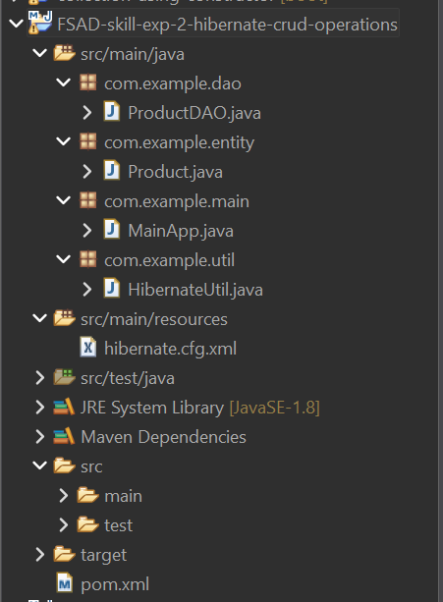
Src/main/java ->com.example.dao->ProductDAO.java
package com.example.dao;
import com.example.entity.Product;
import com.example.util.HibernateUtil;
import org.hibernate.Session;
import org.hibernate.Transaction;
import java.util.List;
public class ProductDAO
{
public void saveProduct(Product p)
{
Transaction tx = null;
try (Session session = HibernateUtil.getFactory().openSession())
{
tx = session.beginTransaction();
session.save(p);
tx.commit();
System.out.println("Product saved successfully.");
}
}

public Product getProduct(int id)
{
try (Session session = HibernateUtil.getFactory().openSession())
{
return session.get(Product.class, id);
}
}

public List<Product> getAllProducts()
{
try (Session session = HibernateUtil.getFactory().openSession())
{
return session.createQuery("from Product", Product.class).list();
}
}
public void updateProduct(Product p)
{
Transaction tx = null;
try (Session session = HibernateUtil.getFactory().openSession())
{
tx = session.beginTransaction();
session.update(p);
tx.commit();
System.out.println("Product updated successfully.");
}
}

public void deleteProduct(int id)
{
Transaction tx = null;
try (Session session = HibernateUtil.getFactory().openSession())
{
Product p = session.get(Product.class, id);
if (p == null)
{
System.out.println("Product not found.");
return;
}
tx = session.beginTransaction();
session.delete(p);
tx.commit();
System.out.println("Product deleted successfully.");
}
}
}
Src/main/java ->com.example.entity->Product.java
package com.example.entity;
import javax.persistence.*;
@Entity
@Table(name = "Products")
public class Product
{
@Id
@GeneratedValue(strategy = GenerationType.AUTO)
private int id;
private String name;
private String description;
private double price;
private int quantity;
public Product()
{
}
public Product(String name, String description, double price, int quantity)
{
this.name = name;
this.description = description;
this.price = price;
this.quantity = quantity;
}
public int getId() {
return id;
}
public String getName() {
return name;
}
public void setName(String name) {
this.name = name;
}
public String getDescription() {
return description;
}
public void setDescription(String description) {
this.description = description;
}
public double getPrice() {
return price;
}
public void setPrice(double price) {
this.price = price;
}
public int getQuantity() {
return quantity;
}
public void setQuantity(int quantity) {
this.quantity = quantity;
}
}
Src/main/java ->com.example.main->MainApp.java
package com.example.main;
import com.example.dao.ProductDAO;
import com.example.entity.Product;
import java.util.List;
import java.util.Scanner;
public class MainApp
{
public static void main(String[] args)
{
Scanner sc = new Scanner(System.in);
ProductDAO dao = new ProductDAO();
int choice;
do
{
System.out.println("\n CRUD USING HIBERNATE MENU ");
System.out.println("1. Insert Product");
System.out.println("2. Get Product Details by ID");
System.out.println("3. Get All Products Details");
System.out.println("4. Update Product");
System.out.println("5. Delete Product");
System.out.println("6. Exit");
System.out.print("Enter choice: ");
choice = sc.nextInt();
sc.nextLine();
switch (choice)
{
case 1:
System.out.print("Enter Product Name: ");
String name = sc.nextLine();
System.out.print("Enter Description: ");
String desc = sc.nextLine();
System.out.print("Enter Price: ");
double price = sc.nextDouble();
System.out.print("Enter Quantity: ");
int qty = sc.nextInt();
Product p = new Product(name, desc, price, qty);
dao.saveProduct(p);
break;
case 2:
System.out.print("Enter Product ID: ");
int id = sc.nextInt();
Product pr = dao.getProduct(id);
if (pr != null)
{
System.out.println("ID: " + pr.getId());
System.out.println("Name: " + pr.getName());
System.out.println("Description: " + pr.getDescription());
System.out.println("Price: " + pr.getPrice());
System.out.println("Quantity: " + pr.getQuantity());
}
else
{
System.out.println("Product not found.");
}
break;
case 3:
List<Product> list = dao.getAllProducts();
if (list.isEmpty())
{
System.out.println("No products found.");
}
else
{
for (Product prod : list)
{
System.out.println(prod.getId() + " | " +
prod.getName() + " | " +
prod.getDescription() + " | " +
prod.getPrice() + " | " +
prod.getQuantity());
}
}
break;
case 4:
System.out.print("Enter Product ID to Update: ");
int uid = sc.nextInt();
sc.nextLine();
Product up = dao.getProduct(uid);
if (up != null)
{
System.out.print("Enter New Name: ");
up.setName(sc.nextLine());
System.out.print("Enter New Description: ");
up.setDescription(sc.nextLine());
System.out.print("Enter New Price: ");
up.setPrice(sc.nextDouble());
System.out.print("Enter New Quantity: ");
up.setQuantity(sc.nextInt());
dao.updateProduct(up);
}
else
{
System.out.println("Product not found.");
}
break;
case 5:
System.out.print("Enter Product ID to Delete: ");
int did = sc.nextInt();
dao.deleteProduct(did);
break;
case 6:
System.out.println("Exiting Application");
break;
default:
System.out.println("Invalid choice!");
}
} while (choice != 6);
sc.close();
}
}
Src/main/java ->com.example.util->HibernateUtil.java
package com.example.util;
import org.hibernate.SessionFactory;
import org.hibernate.cfg.Configuration;
public class HibernateUtil
{
private static SessionFactory factory;
static
{
try
{
factory = new Configuration().configure().buildSessionFactory();
}
catch (Exception e)
{
e.printStackTrace();
}
}
public static SessionFactory getFactory()
{
return factory;
}
}
Src/main/resources -> hibernate.cfg.xml
<?xml version="1.0" encoding="UTF-8"?>
<!DOCTYPE hibernate-configuration PUBLIC
"-//Hibernate/Hibernate Configuration DTD 3.0//EN"
"https://raw.githubusercontent.com/hibernate/hibernate-orm/main/hibernate-configuration-3.0.dtd">
<hibernate-configuration>
<session-factory>
<property name="hibernate.connection.driver_class">com.mysql.cj.jdbc.Driver</property>
<property name="hibernate.connection.url">jdbc:mysql://localhost:3306/fsad_s5</property>
<property name="hibernate.connection.username">root</property>
<property name="hibernate.connection.password">venki</property>
<property name="hibernate.dialect">org.hibernate.dialect.MySQL8Dialect</property>
<property name="hibernate.hbm2ddl.auto">update</property>
<property name="show_sql">true</property>
<mapping class="com.example.entity.Product"/>
</session-factory>
</hibernate-configuration>

OUTPUT: : 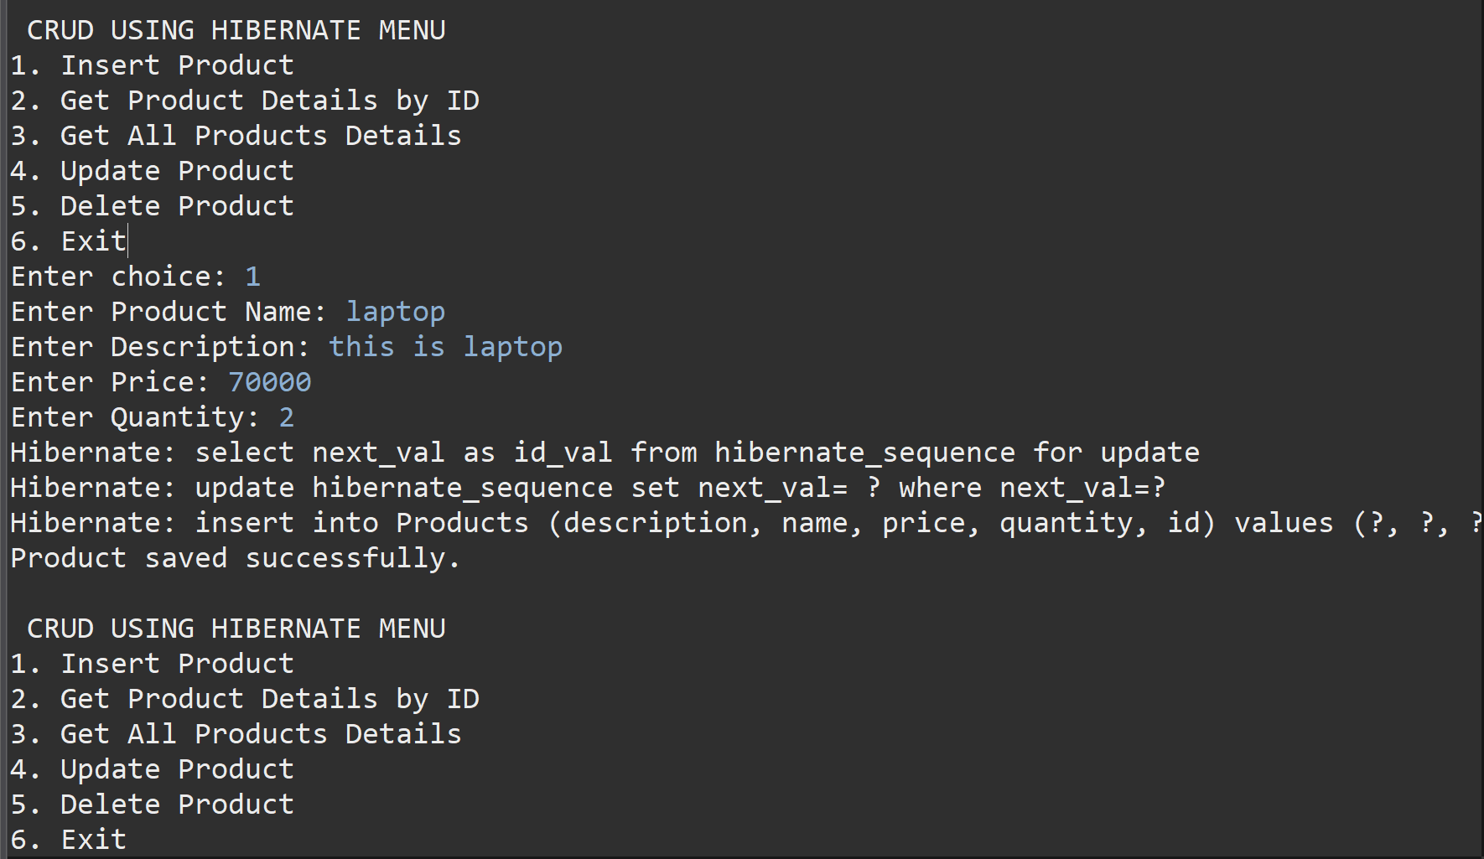
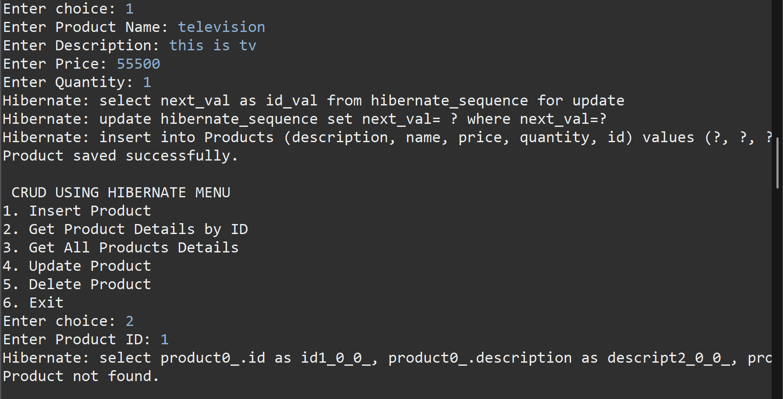
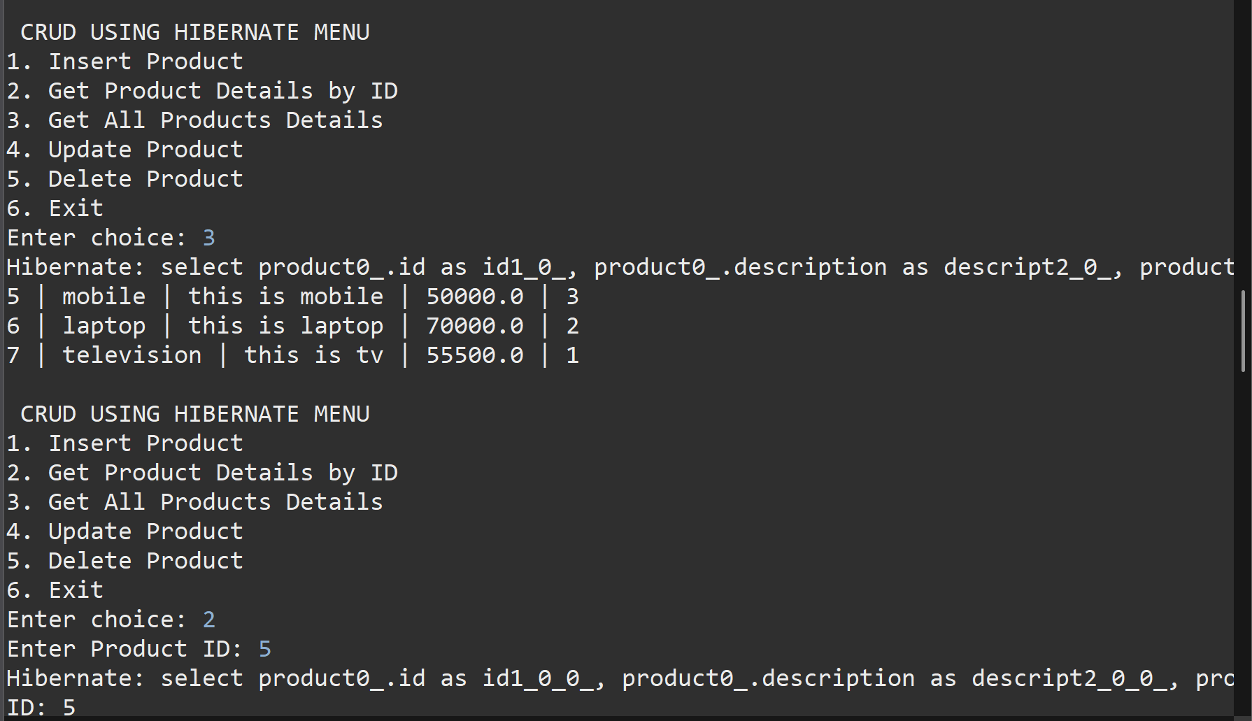
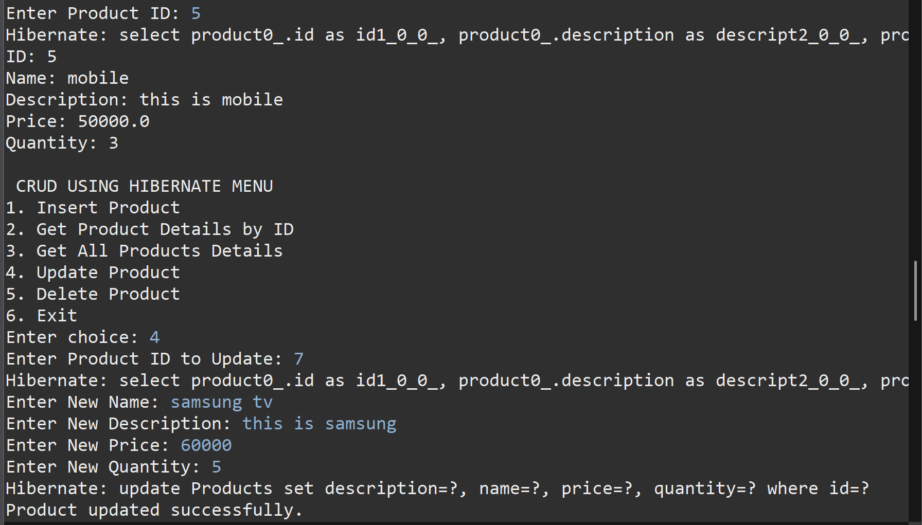
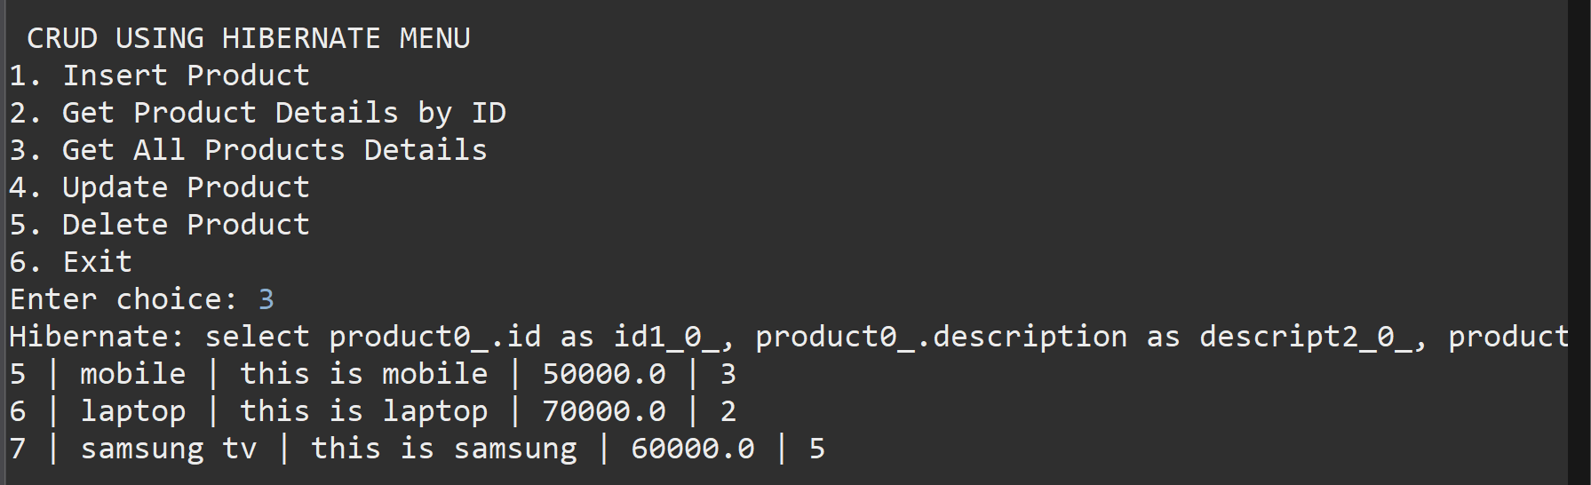
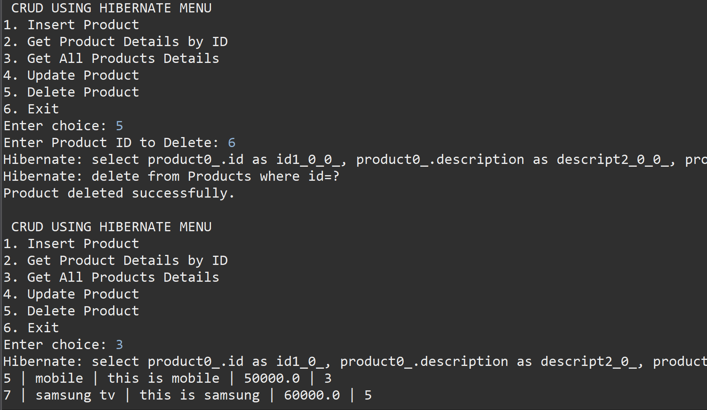

FLOW OF EXECUTION :
1.MainApp.java
Starts the program and calls methods to perform CRUD operations.
2.HibernateUtil.java
Loads hibernate.cfg.xml, creates and provides the SessionFactory needed to connect to the database.
3.ProductDAO.java
Opens a Hibernate Session, starts a transaction, and calls Hibernate methods to perform CRUD operations.
4.Product.java (Entity Class)
Defines the table structure. Each Product object represents one record in the database.
->Hibernate Execution
Hibernate converts Java operations into SQL, runs them on the database, saves changes, and returns results to the program.

->the above program is executed using : @GeneratedValue(strategy = GenerationType.AUTO)

