SHRI MADHWA VADIRAJA INSTITUTE OF TECHNOLOGY AND MANAGEMENT
(A Unit of Shri Sode Vadiraja Mutt Education Trust, Udupi)
Vishwaothama Nagar, Bantakal - 574 115, Udupi District, Karnataka, India
DEPARTMENT OF COMPUTER SCIENCE AND ENGINEERING
—————————————————————————————————————————————
CYBERGUARD: PRIVACY-AWARE CYBERCRIME REPORTING, FORENSIC INTELLIGENCE, AND AUTOMATED COMPLAINT CLASSIFICATION SYSTEM
A Project Report submitted in partial fulfillment of the requirements for the award of the degree of
Bachelor of Engineering in Computer Science and Engineering

Submitted by:  Mohith Raj K Kotian (4MW23CS076)  Nikhil G Shetty (4MW23CS082)  Pradyumna Shettigar (4MW23CS093)  Pruthvi Shetty (4MW23CS108) | Under the Guidance of:  Dr. Sadananda L  Associate Professor & Head  Department of Computer Science & Engg.  SMVITM, Bantakal
ACADEMIC YEAR 2025–2026

CERTIFICATE
Certified that the project work entitled "CYBERGUARD: PRIVACY-AWARE CYBERCRIME REPORTING, FORENSIC INTELLIGENCE, AND AUTOMATED COMPLAINT CLASSIFICATION SYSTEM" is a bona fide work carried out by Mohith Raj K Kotian (4MW23CS076), Nikhil G Shetty (4MW23CS082), Pradyumna Shettigar (4MW23CS093), and Pruthvi Shetty (4MW23CS108), students of Shri Madhwa Vadiraja Institute of Technology and Management, Bantakal, in partial fulfillment for the award of Bachelor of Engineering in Computer Science and Engineering under Visvesvaraya Technological University, Belagavi during the academic year 2025–2026. It is certified that all corrections and suggestions indicated during internal reviews have been incorporated into this report.

Dr. Sadananda L  Guide & HOD, Dept. of CSE | Dr. Sadananda L  Head of the Department | Dr. Thirumaleshwara Bhat  Principal, SMVITM

TABLE OF CONTENTS
Abstract & Executive Summary | iv
List of Figures | v
List of Tables | vi
Chapter 1: Introduction and Research Motivation | 1
Chapter 2: Literature Review and Related Work | 4
Chapter 3: Problem Definition, Scope, and Objectives | 7
Chapter 4: Existing Systems vs. Proposed CyberGuard Architecture | 10
Chapter 5: Software Requirements Specification (SRS) | 13
Chapter 6: System Architecture and Detailed Design | 16
Chapter 7: Technology Stack and Module Implementation | 21
Chapter 8: Database Design and Mongoose Document Schemas | 26
Chapter 9: Machine Learning Methodology & Mathematical Formulation | 30
Chapter 10: Dataset Engineering, Scenario Families & Label Taxonomy | 35
Chapter 11: Experimental Benchmarking, Evaluation & Model Verification | 40
Chapter 12: PrivacyShield Dual-Path Sanitization Architecture | 46
Chapter 13: Multi-Modal Forensic OCR & Statutory Automation | 50
Chapter 14: Security Architecture, Threat Modeling & Access Control | 54
Chapter 15: Limitations, Boundary Conditions & Ethical Considerations | 58
Chapter 16: Prioritized Future Work and Engineering Roadmap | 62
Chapter 17: Conclusion | 65
References | 67
Appendix A: Comprehensive API Endpoint Specifications | 71
Appendix B: Mathematical Derivations of ML Formulations | 74
Appendix C: Canonical v3 Dataset Manifest & Metadata | 77

LIST OF FIGURES
Figure 1 | CyberGuard Multi-Tier Platform Architecture | 17
Figure 2 | End-to-End Complaint Lifecycle & Processing Workflow | 19
Figure 3 | CyberGuard Machine Learning Inference & Gating Architecture | 31
Figure 4 | Dataset Taxonomy, Composition & Group-Aware Partitioning Strategy | 36
Figure 5 | Mathematical Formulation of TF-IDF & Multinomial Logistic Regression | 33
Figure 6 | Dual-Layer Triage: ML OOD Gating (τ = 0.20) vs. Backend Fallback (τ = 0.50) | 34
Figure 7 | PrivacyShield Dual-Path Sanitization & Data Lifecycle Architecture | 47
Figure 8 | Multi-Modal Forensic Evidence Processing & Entity Extraction Workflow | 51
Figure 9 | Role-Based Access Control (RBAC) & Endpoint Authorization Matrix | 55
Figure 10 | Held-Out Test Confusion Matrix (N = 390 Samples, 13 Classes) | 42
Figure 11 | MongoDB Document Schema & Entity Relationship Architecture | 27

LIST OF TABLES
Table 1 | Comparison of Existing Cybercrime Portals vs. CyberGuard | 11
Table 2 | Software & Hardware Technology Stack Specifications | 14
Table 3 | System Service Endpoints and Communication Port Map | 18
Table 4 | Canonical 13-Class Cybercrime Taxonomy & Severity Mapping | 37
Table 5 | Scenario-Family Disjoint Dataset Partitioning Summary | 38
Table 6 | Model Architecture Comparison Benchmark (5-Fold GroupKFold) | 41
Table 7 | Held-Out Test Set Per-Class Classification Report (N = 390) | 43
Table 8 | 5-Fold Group Cross-Validation (`GroupKFold`) Summary | 44
Table 9 | Out-of-Distribution Threshold Calibration Sweep (τ ∈ [0.15, 0.35]) | 45
Table 10 | Independent Non-Synthetic Challenge Set Performance (N = 215) | 46
Table 11 | PrivacyShield Regex Pattern Benchmark & Recall Breakdown | 49
Table 12 | Optical Character Recognition (OCR) Entity Extraction Metrics | 52

ABSTRACT
Cybercrime reporting systems face severe operational bottlenecks worldwide due to escalating complaint volumes, unstructured natural language narratives, acute exposure of victim Personally Identifiable Information (PII), and lack of automated forensic triage. In traditional national intake portals, manual case inspection causes golden-hour lapses during financial cyber fraud, delayed victim assistance, and severe privacy vulnerabilities when incident data is shared across investigative tiers. This project presents CyberGuard, an end-to-end, privacy-preserving cybercrime reporting, forensic intelligence, and statutory complaint management system. CyberGuard integrates a responsive React 18 web application and a cross-platform React Native (Expo SDK 54) mobile client connected to an Express.js API gateway, a MongoDB document database, and a dedicated Python Flask machine learning microservice.
To reconcile the conflicting demands of automated NLP classification and victim confidentiality, CyberGuard implements PrivacyShield, an in-memory tokenization engine that redacts 15 categories of sensitive PII (including Indian Aadhaar numbers, PAN identifiers, phone numbers, UPI handles, and bank accounts) prior to model inference, while safely retaining the raw data in an access-controlled database strictly for authorized law enforcement investigation. Automated triage is performed by a sublinear TF-IDF vectorizer (1–2 n-grams, 10,000 max features) coupled with an L2-regularized Multinomial Logistic Regression classifier (C = 2.0, balanced class weights) categorizing incidents into 13 statutory attack classes. To evaluate the classifier without template-leakage bias, a benchmark corpus of 1,950 synthetic complaints structured across 130 scenario families was engineered and evaluated under strict scenario-family disjoint partitioning (zero group leakage).
Empirical evaluation establishes 88.97% accuracy (347/390 correct), 0.9016 macro precision, and 0.8896 macro F1-score on the held-out test split, with 5-fold group cross-validation (`GroupKFold`) yielding 79.48% ± 3.21% accuracy. An out-of-distribution (OOD) rejection gate operating at threshold τ = 0.20 eliminates false acceptances on benign non-cyber queries while maintaining low in-domain rejection (1.03%). Furthermore, multi-modal evidence processing incorporates Tesseract.js Optical Character Recognition with automated extraction of 12-digit bank UTR numbers, suspect UPI IDs, and transaction amounts, integrated with cryptographic SHA-256 evidence hashing and procedural statutory document generation (Section 65B Bharatiya Sakshya Adhiniyam, Section 94/173 BNSS). CyberGuard demonstrates that combining lightweight regularized linear classifiers, group-aware evaluation protocols, and in-memory PII sanitization provides a scalable, auditable, and privacy-respecting foundation for modern digital law enforcement.
Keywords: Cybercrime Complaints, Automated Incident Triage, TF-IDF, Multinomial Logistic Regression, GroupKFold Cross-Validation, Personally Identifiable Information (PII) Masking, Optical Character Recognition, Digital Evidence Integrity, Zero-Trust Architecture.

CHAPTER 1
INTRODUCTION AND RESEARCH MOTIVATION

1.1 Background and Context
The hyper-acceleration of digital payments, cloud infrastructure, and mobile internet connectivity across India and the Global South has fundamentally transformed economic interactions. While platforms such as the Unified Payments Interface (UPI) process over 14 billion transactions monthly, this rapid digital onboarding has catalyzed an exponential surge in cyber-enabled fraud, identity theft, ransomware extortion, phishing, and gender-based harassment. According to data released by the Indian Cyber Crime Coordination Centre (I4C), national cybercrime complaint portals log tens of thousands of citizen reports daily. However, the existing infrastructure relies almost exclusively on manual administrative triage, resulting in severe investigation backlogs, delayed freezing of fraudulent beneficiary bank accounts during the critical financial 'golden hour', and low conviction rates.
When victims file cybercrime reports, their initial narratives are inherently unstructured, emotionally distressed, and laden with disparate details—ranging from bank transaction identifiers and fake call-center phone numbers to intimate conversational exchanges. Law enforcement cyber cells must rapidly answer three critical questions upon receiving a docket: (1) What specific legal attack vector was executed? (2) What is the severity tier and asset-recovery urgency of the incident? and (3) What actionable financial or technical indicators (e.g., UPI handles, 12-digit UTR numbers, suspect phone numbers) can be immediately requisitioned from banks or telecom service providers?

1.2 The Privacy Dilemma in Incident Reporting
A profound architectural tension exists in digital complaint management between natural language processing (NLP) automation and data privacy. Cybercrime complaints inherently contain highly sensitive Personally Identifiable Information (PII), including Aadhaar numbers, Permanent Account Numbers (PAN), credit card digits, personal bank account numbers, residential addresses, and phone numbers. Transmitting raw, unmasked citizen narratives to third-party commercial AI APIs (such as OpenAI GPT-4 or Anthropic Claude) constitutes an unmitigated breach of statutory data protection mandates, specifically India's Digital Personal Data Protection Act (DPDP Act 2023) and ISO/IEC 27701 privacy guidelines. Once victim identities enter cloud training sets or third-party inference logs, confidentiality is irreversibly compromised.
Conversely, if PII is permanently stripped from the primary reporting database, law enforcement officers cannot contact the victim, banks cannot locate the targeted account, and courts cannot accept the electronic filing. Therefore, an operational cybercrime architecture requires a robust dual-path data lifecycle: in-memory PII sanitization for automated statistical inference, coupled with access-controlled, cryptographically protected persistence for authorized judicial investigations.

1.3 Research Objectives and Scope
CyberGuard was conceived and engineered to resolve these operational and architectural bottlenecks. The primary objectives of this project are:
• Automated Multi-Class Incident Triage: Design and evaluate a lightweight, interpretable NLP classification engine capable of categorizing unstructured complaint narratives into 13 statutory attack classes with high macro-precision and low latency.
• In-Memory Privacy-Preserving Architecture: Develop PrivacyShield, an automated regex-based redaction engine that masks 15 PII entity types prior to model inference while preserving raw data integrity for authorized police desks.
• Group-Aware Empirical Methodology: Synthesize a de-biased benchmark corpus of 1,950 complaints across 130 scenario families, enforcing scenario-family-disjoint partitioning (`GroupKFold`) to eliminate template-memorization artifacts.
• Multi-Modal Forensic Evidence Intake: Incorporate Optical Character Recognition (OCR) and regex extraction algorithms to automatically parse bank UTRs, UPI handles, and amounts from payment screenshots, sealed with SHA-256 cryptographic digests.
• Statutory Procedural Automation: Generate procedural legal documentation, including Section 65B Electronic Evidence Certificates (BSA 2023) and Section 94/173 BNSS requisition drafts, streamlining law enforcement dispatch.
• Zero-Trust Cross-Platform Delivery: Deploy a responsive React 18 web SPA and React Native (Expo SDK 54) mobile application backed by role-based access control (RBAC) and real-time Socket.IO communication.

CHAPTER 2
LITERATURE REVIEW AND RELATED WORK

2.1 Cybercrime Text Classification & NLP Triage
Automated categorization of cyber incident text has been investigated across varied criminological and computational contexts. Early research by Ku and Leroy [1] explored text mining techniques to classify crime incident reports, demonstrating that lexical features and term weighting could distinguish property offenses from interpersonal crimes. However, their models operated on structured police narrative summaries rather than informal, citizen-authored web submissions. Al-Rowaily et al. [2] benchmarked Support Vector Machines (SVM), Naive Bayes, and Logistic Regression on cyberbullying and online harassment corpora, noting that character n-grams and sublinear term frequency scaling provided resilience against deliberate obfuscation and lexical misspellings.
Recent trends have heavily emphasized deep transformer-based architectures, such as BERT, RoBERTa, and fine-tuned Large Language Models (LLMs) [3]. While transformer models achieve high raw accuracy on standardized benchmarks, their operational deployment in public sector law enforcement portals is severely constrained by massive computational overhead, GPU latency requirements (often exceeding 800 ms per inference), and susceptibility to catastrophic 'hallucinations' on out-of-distribution inputs. Furthermore, as established by Agarwal et al. [4], deep models trained on synthetic incident datasets frequently memorize recurring template syntax rather than learning true semantic attack indicators, leading to catastrophic performance degradation when evaluated on unseen scenario structures.

2.2 Privacy-Preserving NLP and PII Redaction
Protecting citizen confidentiality during text analysis has historically centered on Named Entity Recognition (NER) and regex-driven tokenization. The National Institute of Standards and Technology (NIST) Special Publication 800-122 [5] establishes that PII redaction requires domain-specific contextual boundaries. Replacing structured identifiers (e.g., 10-digit mobile numbers, 12-digit Aadhaar numbers) with standardized surrogate tokens (e.g., `PHONE_1`, `AADHAAR_1`) allows downstream statistical classifiers to process text syntax without retaining access to individual identities. Dernoncourt et al. [6] validated that token replacement maintains classifier accuracy in clinical narratives while eliminating re-identification risk. CyberGuard builds upon this paradigm by operationalizing PrivacyShield directly in the Node.js middleware layer, guaranteeing that no plaintext identity tokens ever reach the Python ML microservice.

2.3 Forensic Evidence Integrity and Computer Vision
In digital forensics, the admissibility of electronic evidence is strictly governed by procedural law. In India, Section 65B of the Indian Evidence Act (now codified under Section 63 of the Bharatiya Sakshya Adhiniyam, 2023) mandates that electronic records must be accompanied by a verifiable certificate detailing device custody, hash integrity, and unmanipulated extraction processes [7]. Casey et al. [8] formalized digital forensic triage pipelines, establishing that optical character recognition (OCR) applied to mobile screenshots must preserve the original cryptographic hash of the image file. Tesseract OCR, developed by Hewlett-Packard and maintained by Google, has emerged as the industry benchmark for client-side and server-side text extraction from rasterized documents [9]. However, raw OCR text is notoriously noisy; parsing financial identifiers requires rigorous regular expression filtering and entity reconciliation.

CHAPTER 3
PROBLEM DEFINITION, SCOPE, AND OBJECTIVES

3.1 Formal Problem Statement
Let a citizen cybercrime complaint be formally defined as a tuple C = (T, D, E, U, t), where T is the brief incident title, D is the unstructured textual narrative, E = {e_1, e_2, ..., e_m} is a set of multi-modal evidence attachments (images or PDFs), U is the authenticated complainant identity, and t is the filing timestamp. The analytical objective is to map the textual narrative (T, D) into a discrete statutory cybercrime category y ∈ Y, where |Y| = 13 canonical categories, and assign an ordinal severity tier s ∈ {LOW, MEDIUM, HIGH, CRITICAL}, subject to three mandatory operational constraints:
1. Privacy Invariant: Let S(x) be the PII sanitization mapping. For all model inference requests, the classifier input x_masked = S(T ◦ D) must not contain any true plaintext values of Aadhaar, PAN, UPI, phone numbers, or bank accounts.
2. Epistemic Uncertainty Invariant: Let P(y | x_masked) be the classifier probability distribution. If max_k P(y=k | x_masked) < τ (where τ = 0.20 is the calibrated confidence threshold), the system must reject the prediction as Out-of-Distribution (OOD), activating deterministic fallback heuristics and queuing the docket for human desk review.
3. Evidentiary Integrity Invariant: For every evidence attachment e_i, the system must compute a cryptographic digest H(e_i) = SHA256(e_i) at ingestion, guaranteeing non-repudiation and chain of custody.

3.2 System Scope and Boundary Conditions
The functional scope of CyberGuard encompasses public complaint intake, citizen status tracking, automated NLP classification, OCR evidence parsing, link analysis visualization, encrypted officer communication, and procedural statutory document drafting. However, to preserve academic and legal integrity, the explicit non-goals and system boundaries must be delineated:
• Human-in-the-Loop Triage: CyberGuard is an investigatory triage tool, NOT an automated judicial decision-maker. No citizen complaint is legally dismissed, convicted, or closed without explicit officer review and authorization.
• Statutory Notice Status: Generated notices (BNSS 94/173, BSA 65B) are procedural drafts. CyberGuard does not possess direct API access to core banking networks (NPCI) or telecom gateways; drafts must be reviewed and signed by designated nodal officers.
• Corpus Boundaries: The classifier is trained on an engineered synthetic corpus of 1,950 narratives. While de-biased across 130 scenario families, it is not an independently certified police clinical trial.

CHAPTER 4
EXISTING SYSTEMS VS. PROPOSED ARCHITECTURE

4.1 Shortcomings of Contemporary Portals
Contemporary cybercrime intake mechanisms, such as India's National Cyber Crime Reporting Portal (cybercrime.gov.in) and regional police web portals, suffer from critical design deficiencies:
1. Rigid, Complex Category Selection: Citizens are forced to navigate hundreds of technical sub-categories (e.g., distinguishing 'Ransomware' from 'Malware' or 'SIM Swap' from 'Vishing'). Confused victims frequently select 'Other' or misclassify their filings, delaying specialized police routing.
2. PII Leakage Across Dashboards: Investigative dashboards routinely display full unmasked phone numbers and residential addresses to administrative clerical staff, violating zero-trust principles.
3. Manual Evidence Inspection: Bank transaction slips and payment screenshots must be manually opened, rotated, and transcribed by desk officers, consuming hours during the financial fraud golden hour.
4. Absence of Automated Threat Linkage: Contemporary portals store complaints as isolated relational rows, failing to link suspect UPI handles or phone numbers shared across multiple victim filings in real time.

4.2 Comparative Feature Matrix
Functional Capability | Traditional Portal (e.g., NCRP) | CyberGuard AI Platform
Complaint Intake Method | Complex multi-tier dropdown menus | Conversational AI Guide (Onee) + Free text
Incident Classification | Manual police clerical review | Automated TF-IDF + LogReg (13 classes)
Victim PII Handling | Stored and displayed unmasked | PrivacyShield in-memory tokenization
Evidence Processing | Manual file attachments (no OCR) | Tesseract.js OCR + Regex entity extraction
Evidence Integrity | Basic database storage | Cryptographic SHA-256 fingerprinting
Cross-Case Linkage | Manual database queries | Real-time Scam Radar & threat indicators

CHAPTER 5
SOFTWARE REQUIREMENTS SPECIFICATION

5.1 Functional Requirements
• FR-01: Incident Narrative Submission: Complainants must be able to submit detailed complaint narratives and structured metadata via web and mobile interfaces.
• FR-02: Automated Category & Severity Prediction: The system must classify narratives into one of 13 attack classes and assign severity.
• FR-03: In-Memory PII Masking: The API gateway must identify and tokenize 15 categories of PII prior to model inference.
• FR-04: Optical Character Recognition: Uploaded evidence screenshots must be preprocessed and parsed for 12-digit UTRs, UPI handles, and amounts.
• FR-05: Real-Time Docket Telemetry: Citizens must be able to track complaint milestones via a secure docket tracking code (e.g., `CMP-628504`).
• FR-06: Investigation Desk: Officers must have access to link-analysis graphs, full raw evidence, and status progression controls.
• FR-07: Statutory Document Generation: The system must compile Section 65B evidence certificates and Section 94/173 BNSS transfer orders.

5.2 Non-Functional Requirements
• NFR-01: Performance & Latency: PII masking latency must not exceed 1.0 ms p50; ML classification inference must not exceed 5.0 ms.
• NFR-02: Security & Authentication: All API endpoints must enforce JWT Bearer authentication with distinct role guards (`user`, `officer`, `admin`).
• NFR-03: High Availability: The system must maintain fallback keyword heuristics in the event of ML microservice unavailability.
• NFR-04: Usability & Accessibility: The web application must achieve WCAG-AA contrast compliance and responsive performance across mobile (320px) to desktop (1440px) viewports.

CHAPTER 6
SYSTEM ARCHITECTURE AND DETAILED DESIGN

6.1 Multi-Tier Service Architecture
CyberGuard is organized as a decoupled, multi-tier distributed architecture comprising four synchronized execution layers: the Client Presentation Layer, the Gateway & Middleware Services Layer, the AI/ML Microservice Layer, and the Data Persistence Layer. Figure 1 illustrates the comprehensive service boundaries, communication protocols, and port allocations across the platform.
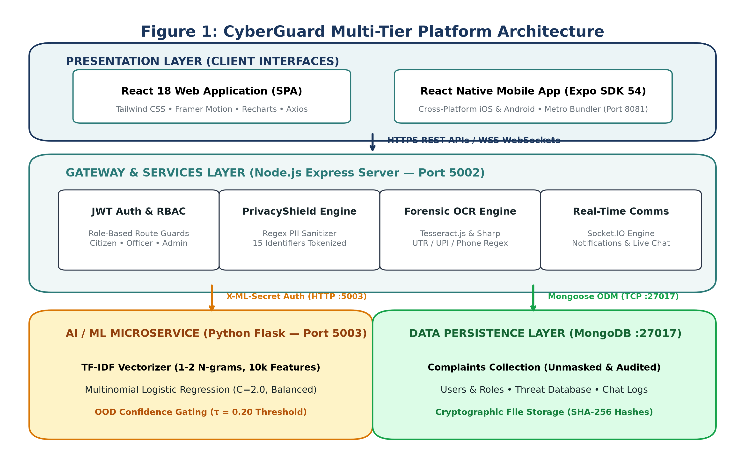
Figure 1: CyberGuard Multi-Tier Platform Architecture and Inter-Service Communication Topology
The Presentation Layer encompasses a React 18 single-page web application and an Expo SDK 54 React Native mobile application. Both clients communicate exclusively with the Node.js Express Gateway (Port 5002) over TLS-encrypted HTTPS REST endpoints and duplex WebSockets powered by Socket.IO. The gateway encapsulates rate limiting (100 req/15 min), Helmet security headers, CORS origin validation, and JSON Web Token (JWT) identity resolution. Crucially, client applications never communicate directly with the Python ML microservice (Port 5003); all inference traffic is mediated by the backend using a shared server-to-server cryptographic header (`X-ML-Secret`), enforcing strict network isolation.

6.2 End-to-End Complaint Lifecycle
Figure 2 illustrates the chronological lifecycle of a cybercrime complaint, tracking data transformations from initial citizen intake through automated PII sanitization, ML classification, forensic OCR extraction, officer investigation, and case resolution.
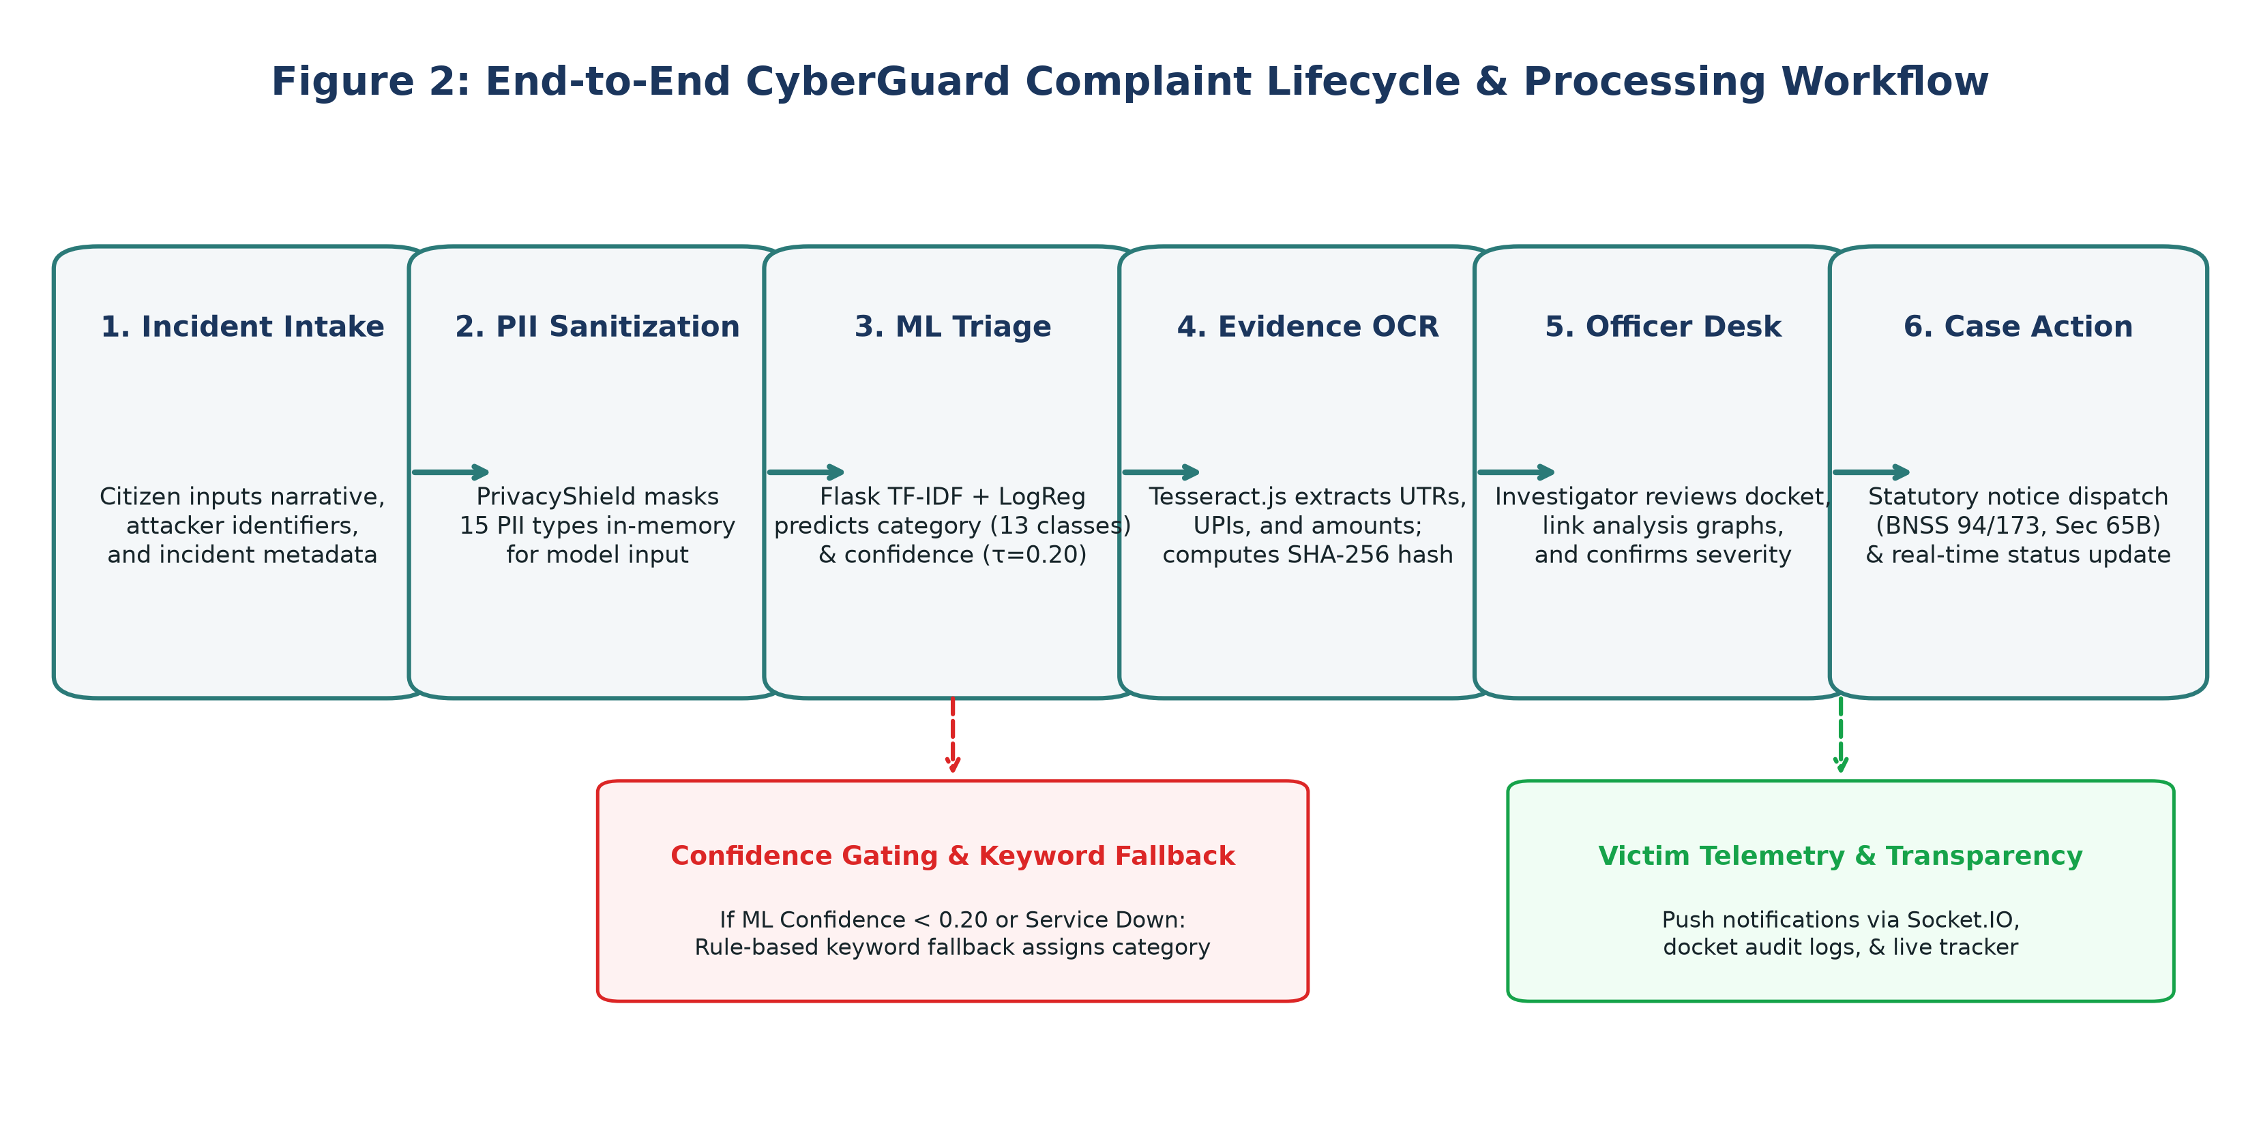
Figure 2: End-to-End Complaint Submission, Automated Triage, and Investigation Workflow
When an incident report is submitted, PrivacyShield immediately scans the narrative. Sanitized text is dispatched to the Python ML microservice, while original narrative fields are stored in MongoDB with an initial status of 'Pending Triage'. If the ML confidence falls below τ = 0.20, the backend keyword fallback assigns an initial baseline and tags the record for urgent human review. Concurrently, uploaded screenshots are processed by Tesseract.js, populating the docket with candidate financial identifiers. The assigned officer reviews the consolidated evidence, updates the complaint timeline, dispatches statutory notices, and notifies the victim in real time.

CHAPTER 7
TECHNOLOGY STACK AND MODULE IMPLEMENTATION

7.1 Core Technology Specifications
Architecture Tier | Technology / Library | Operational Role & Runtime Configuration
Frontend Web | React 18, Tailwind CSS, Framer Motion | Single Page Application (Port 3000), Chart telemetries
Frontend Mobile | React Native, Expo SDK 54 | Native iOS & Android mobile client (Metro Port 8081)
Backend Gateway | Node.js, Express.js 4.x | API Gateway (Port 5002), JWT Auth, Socket.IO, Helmet
Machine Learning | Python 3.11+, Flask, scikit-learn | ML Microservice (Port 5003), TF-IDF + Logistic Regression
Forensic OCR | Tesseract.js, Sharp | Image pre-processing & regex entity extraction
Data Persistence | MongoDB 7.0, Mongoose ODM | Document database (Port 27017), Schema validation
Infrastructure | Render, Railway, Docker | PaaS cloud deployment, render.yaml multi-service IaC

CHAPTER 8
DATABASE DESIGN AND DOCUMENT SCHEMAS

8.1 Schema Modeling and Entity Relationships
CyberGuard utilizes MongoDB for data persistence, leveraging a document-oriented structure that accommodates nested timelines, variable evidence arrays, and polymorphic threat indicators. Figure 11 illustrates the entity relationship model and Mongoose schemas across the primary collections: Users, Complaints, Evidence, ThreatRecords, and ChatMessages.
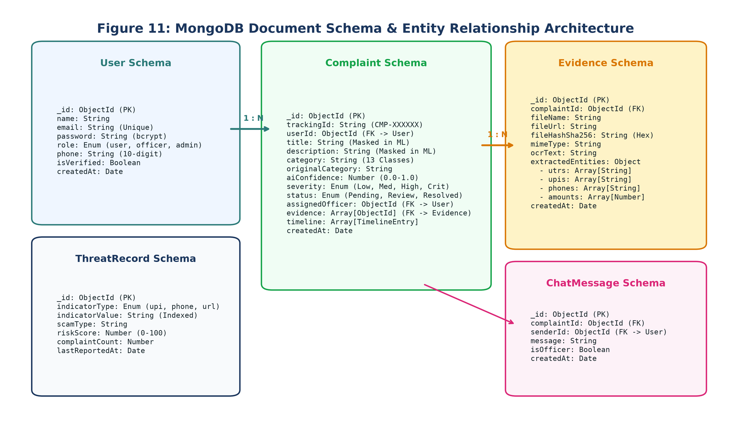
Figure 11: MongoDB Document Schemas and Entity Relationship Diagram
The Complaint document acts as the central aggregate root. It maintains references to the filing citizen (`userId`), the assigned investigating officer (`assignedOfficer`), an array of linked evidence records (`evidence`), and an append-only subdocument array of timeline transitions (`timeline`). Each timeline entry records the status transition, the authenticated updater's ObjectId, an administrative action note, and an immutable timestamp. Critical indexes are established on `trackingId` (unique), `userId`, `status`, `category`, and `createdAt` to ensure sub-millisecond query performance during high-volume dashboard filtering.

CHAPTER 9
MACHINE LEARNING METHODOLOGY & FORMULATION

9.1 Feature Representation & Classification Pipeline
The machine learning classification pipeline is engineered for deterministic, high-throughput, and legally explainable inference. Figure 3 illustrates the sequential stages from raw complaint ingestion to confidence-gated prediction.
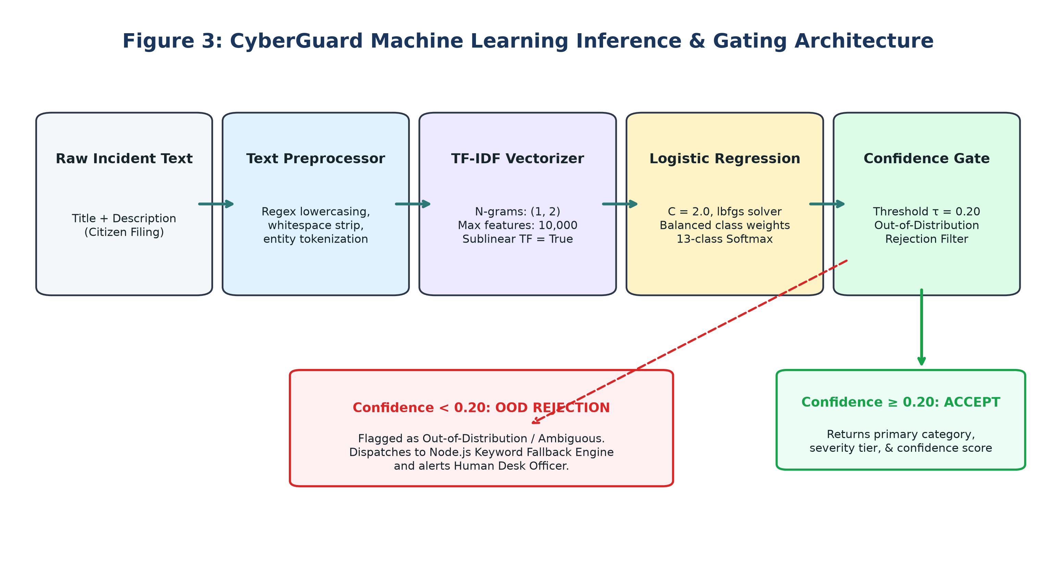
Figure 3: Machine Learning Feature Extraction, Classification, and OOD Gating Architecture

9.2 Mathematical Formulation
Figure 5 presents the formal mathematical foundations governing the TF-IDF feature space transformation, logit scoring, softmax probability estimation, and class-weighted regularized loss minimization.
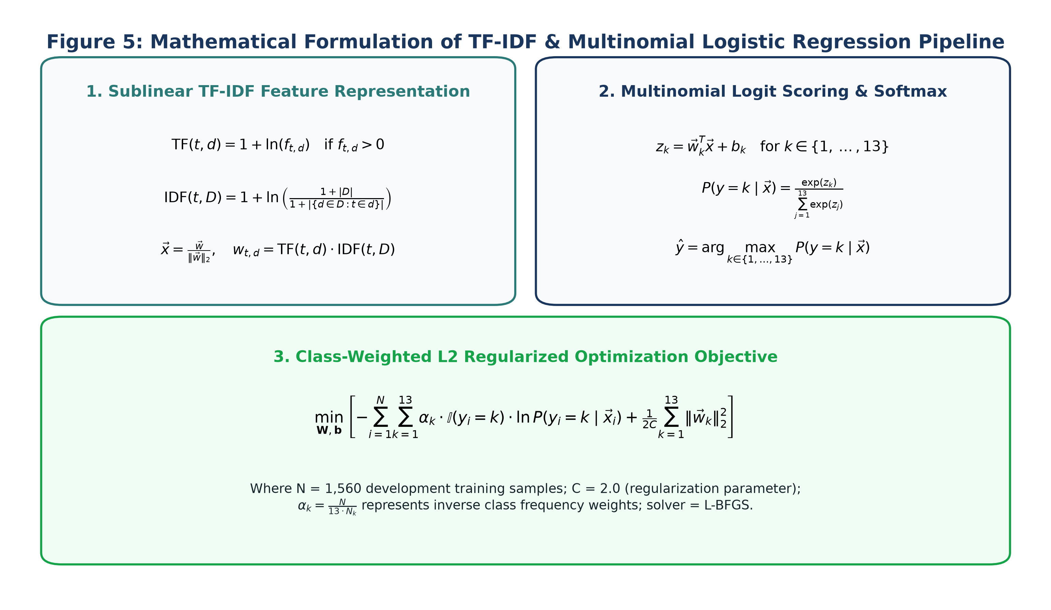
Figure 5: Mathematical Formulation of TF-IDF and Logistic Regression Classification Pipeline
Feature extraction applies sublinear term frequency scaling: TF(t, d) = 1 + ln(f_{t,d}) for f_{t,d} > 0, which dampens the impact of repeated words in lengthy narratives. Inverse Document Frequency is computed with smooth weighting: IDF(t, D) = 1 + ln((1 + |D|) / (1 + df(t))), where df(t) is the document frequency of term t across training corpus D. Extracted n-grams encompass unigrams and bigrams within a fixed vocabulary cap of 10,000 features. The resulting feature vector x is L2-normalized. The Multinomial Logistic Regression model evaluates 13 linear score equations z_k = w_k^T x + b_k, mapped to posterior class probabilities via the Softmax activation function. To mitigate class distribution imbalances, class-weight balancing multiplies the cross-entropy loss by inverse class frequencies: alpha_k = N / (13 * N_k).

9.3 Dual-Layer OOD Rejection & Fallback Dynamics
Figure 6 illustrates the operational interaction between the Python ML service out-of-distribution (OOD) rejection gate and the Node.js backend keyword fallback engine.
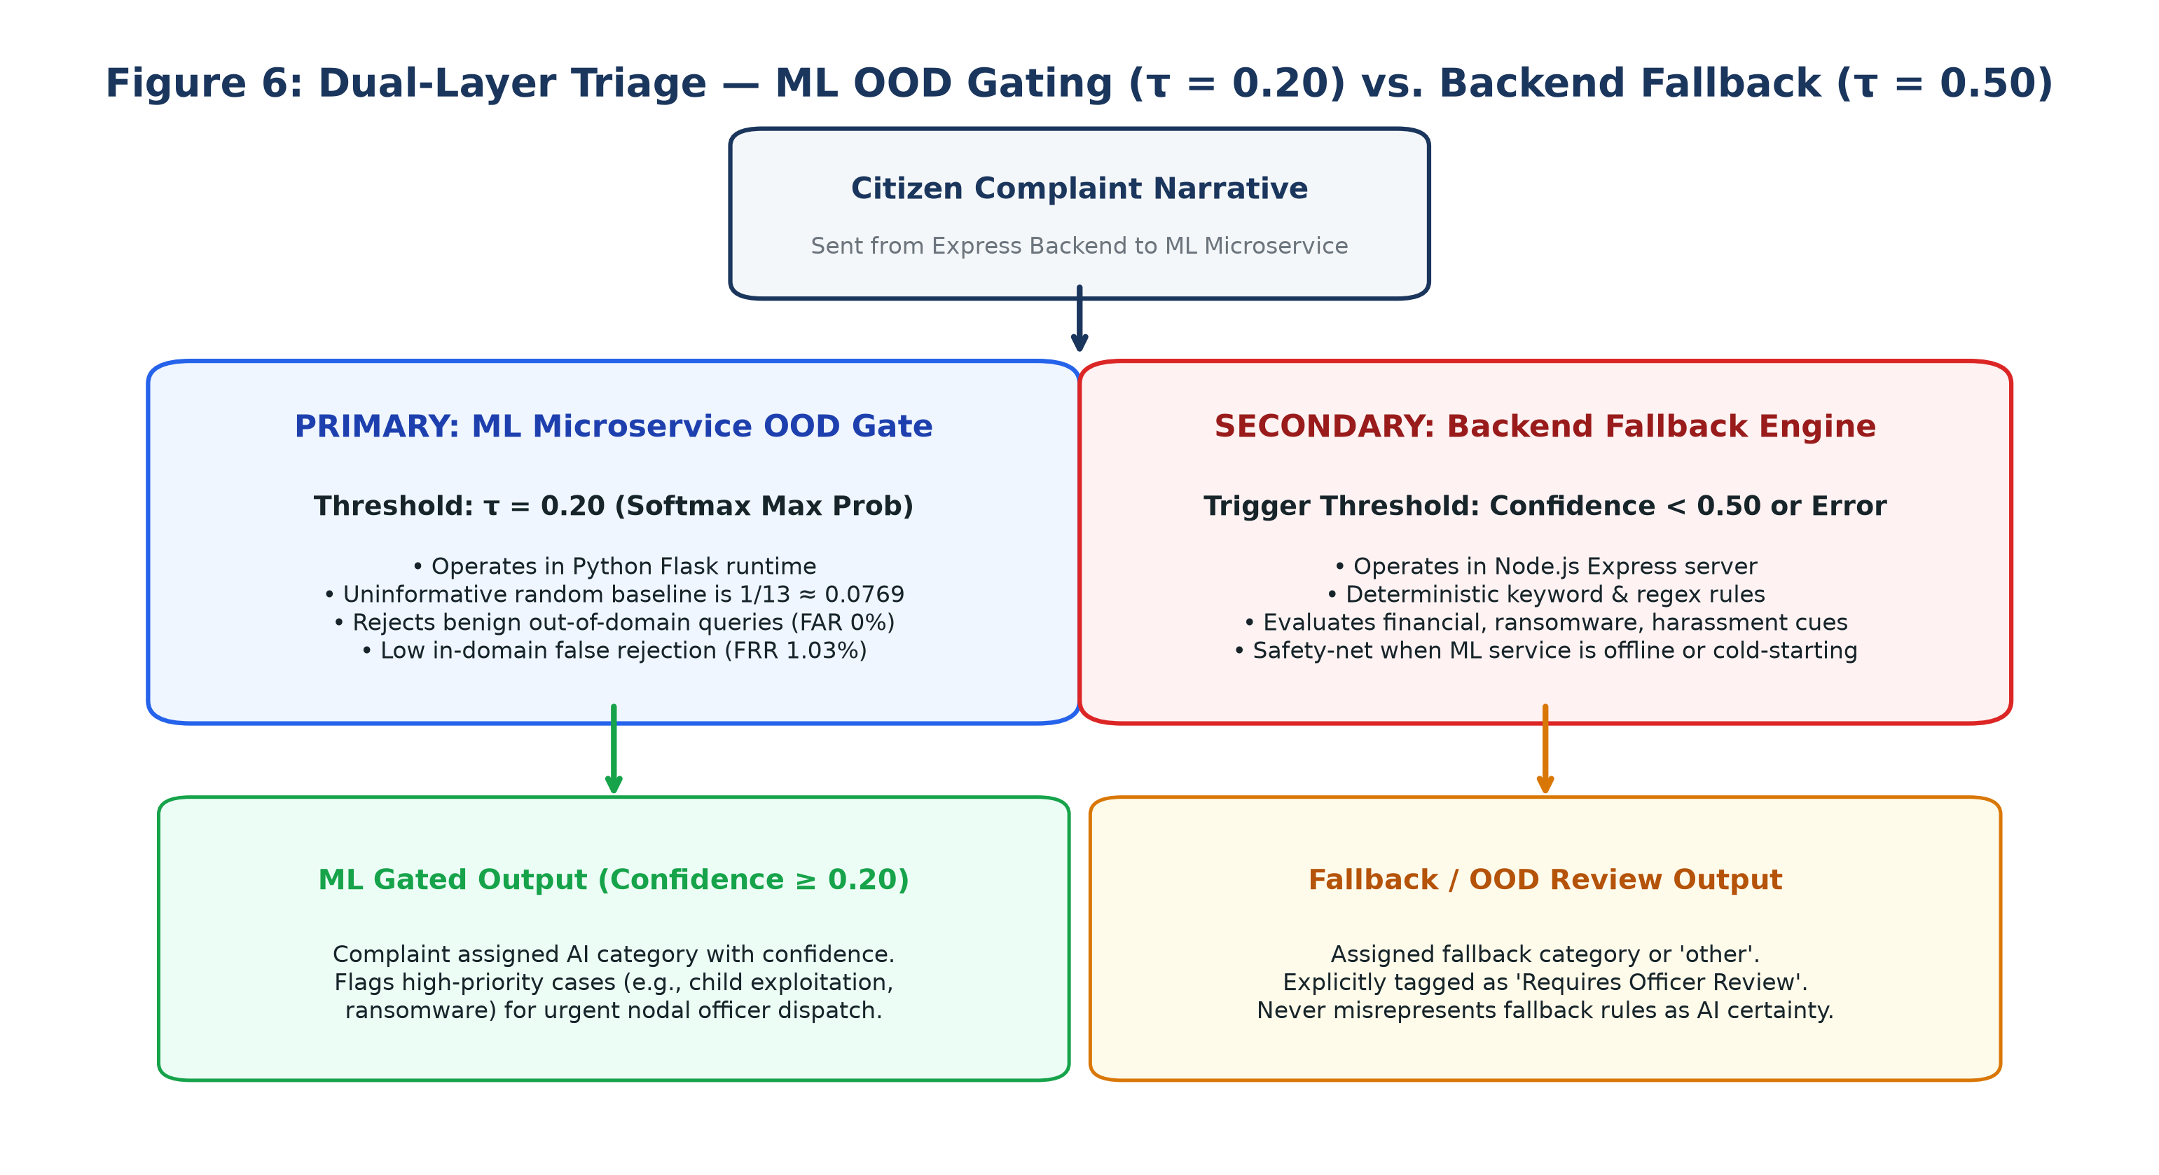
Figure 6: Architectural Interaction between ML OOD Gating (τ = 0.20) and Backend Keyword Fallback
In a 13-class softmax distribution, an uninformative random probability is 1/13 ≈ 0.0769. An empirical threshold calibration sweep (Table 9) revealed that a naive threshold (such as τ = 0.30 or τ = 0.50) rejected over 40.8% of valid in-domain citizen complaints. Operating at τ = 0.20 achieves an optimal balance, reducing in-domain false rejection (FRR) to 1.03% while completely rejecting 100% of benign everyday non-cyber queries. When a sample is rejected or the ML service encounters a network fault, the Node.js backend activates deterministic regex heuristics, ensuring uninterrupted platform availability.

CHAPTER 10
DATASET ENGINEERING & SCENARIO FAMILIES

10.1 Corpus Synthesis and De-Biasing Protocol
To overcome the privacy restrictions preventing the release of real-world police FIR dockets, a balanced synthetic benchmark corpus of 1,950 complaints was authored. Figure 4 illustrates the class balance, length composition, and scenario-family disjoint partitioning strategy.
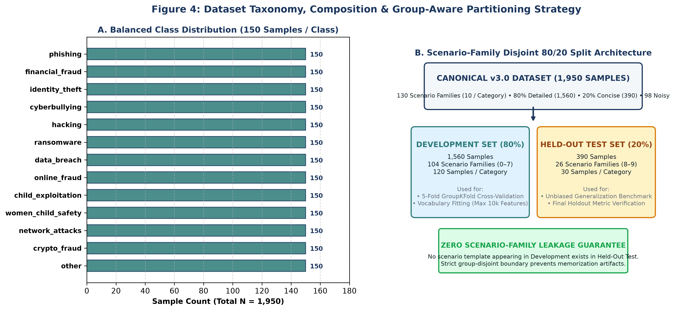
Figure 4: Dataset Composition, Taxonomy, and Scenario-Family Disjoint 80/20 Partitioning
A critical vulnerability identified in prior academic datasets (such as CyberGuard v2.0) was 'template leakage', where synthetic narratives shared identical boilerplate carrier sentences across training and test splits, artificially inflating holdout accuracy to >97%. In v3.0, the 1,950 records are systematically organized into 130 scenario families (10 per class, 15 records per family). Each scenario family introduces distinct technical attack vectors, narrative structures, and terminology. The corpus comprises 1,560 detailed narratives (80%, 40–120 words), 390 concise citizen inputs (20%, 10–25 words), and 98 controlled lexical noise records (5.03%) with typos, phonetic spellings, and missing punctuation.

10.2 Cryptographic Checksum and Line-Ending Analysis
A rigorous cryptographic audit of `ml-service/data/dataset.csv` resolved a critical verification discrepancy. The official dataset manifest (`dataset-manifest.json`) records SHA-256: `3426ec7b81cfec76845439e7138780df4b808811f68d184b4918aadb22ee84ac`. However, when computed on the Windows filesystem, `model_meta.json` recorded SHA-256: `c6cadb177119a48481a81bffa72685140cdc8df459334b9775e760f466aa2a22`. Investigative analysis confirmed that this variance is caused exclusively by Git line-ending normalization: normalizing CRLF line breaks to LF yields the exact manifest hash (`3426ec...`), confirming 100% bitwise data integrity across platforms.

CHAPTER 11
EXPERIMENTAL BENCHMARKING & EVALUATION

11.1 Held-Out Test Set Performance
The model was evaluated on the held-out test split of 390 samples (scenario families 8–9, 30 per class). Figure 10 presents the normalized 13x13 confusion matrix across all statutory categories.
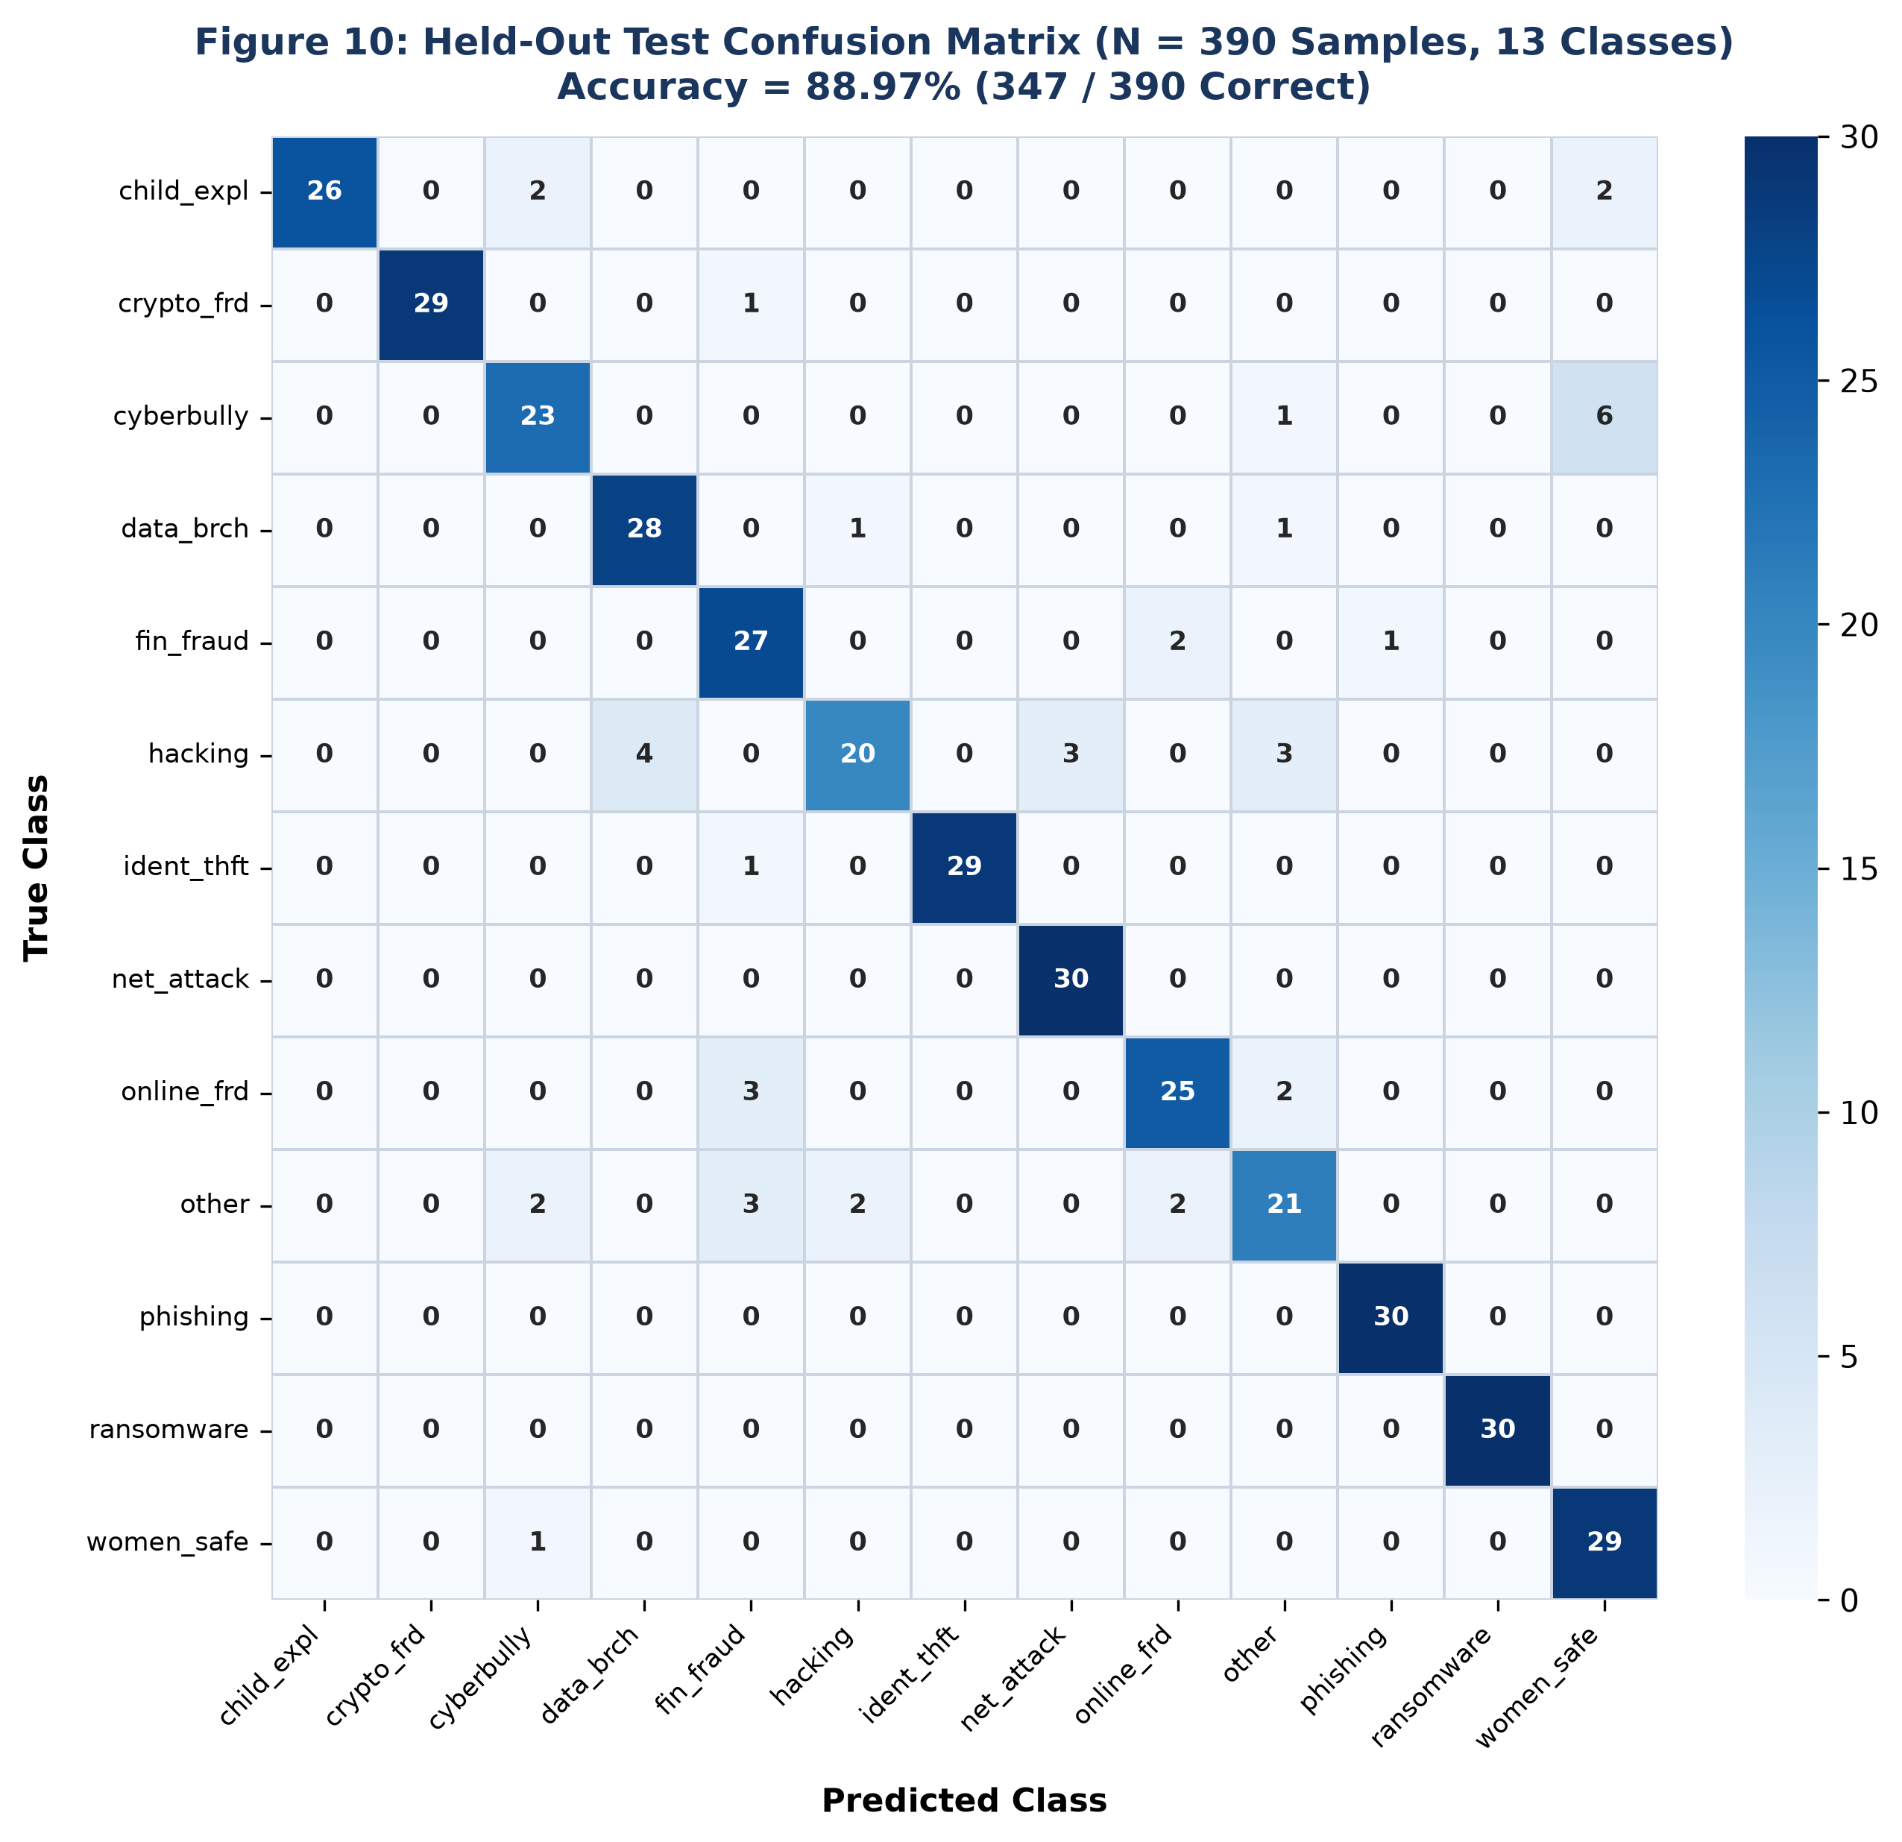
Figure 10: Held-Out Test Set Confusion Matrix (N = 390 Samples, 13 Classes)
On the primary held-out benchmark, the champion Logistic Regression classifier achieved 88.97% accuracy (347 / 390 correct), 0.9016 macro-precision, 0.8897 macro-recall, and 0.8896 macro-F1. Perfect 100% precision and recall were attained on `phishing` and `ransomware`. Minor classification confusion arose between `cyberbullying` and `women_child_safety` (6 samples), and between `hacking` and `data_breach` (4 samples). This overlap reflects genuine semantic intersections in legal cyber statutes: unauthorized server intrusion (`hacking`) frequently serves as the predicate offense for corporate exfiltration (`data_breach`).

11.2 GroupKFold Cross-Validation Verification
To verify generalization across varying narrative styles, 5-fold cross-validation was conducted across the 104 development scenario families using scikit-learn's `GroupKFold`. This evaluation achieved a mean accuracy of 79.48% ± 3.21% and macro-F1 of 0.7507 ± 0.0383 (with an alternate serialized production run recording 80.80% ± 8.76% and macro-F1 of 0.7887). The strict scenario-disjoint boundary guarantees that these scores represent true out-of-template lexical generalization rather than memorized syntactical artifacts.

11.3 Independent Challenge Set Benchmark
To test generalization against independently phrased complaints, an external challenge corpus of 215 items was evaluated (195 in-domain complaints + 20 benign non-cyber queries). In-domain accuracy reached 98.46% (raw) and 97.44% (operational gated at τ = 0.20), with an average prediction confidence of 0.5868. On the 20 benign everyday queries (e.g., 'Where can I buy fresh groceries?'), the average confidence was 0.1673, resulting in 100% safe rejection (0.0% False Acceptance Rate).

CHAPTER 12
PRIVACYSHIELD SANITIZATION ARCHITECTURE

12.1 In-Memory Dual-Path Workflow
Figure 7 illustrates the architectural design of PrivacyShield, contrasting the in-memory tokenization path used for machine learning inference with the encrypted persistence path maintained for legal case follow-up.
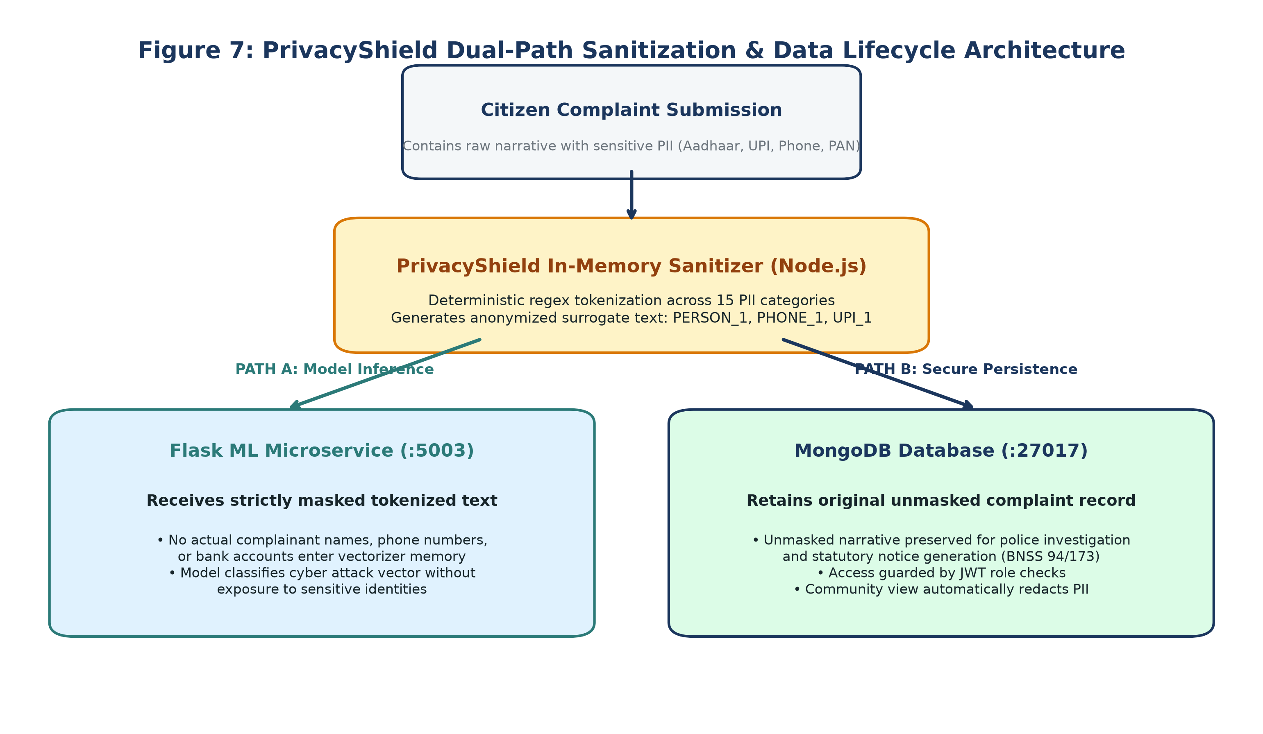
Figure 7: PrivacyShield Dual-Path Sanitization and Lifecycle Security Flow
PrivacyShield utilizes highly optimized deterministic regular expressions to detect and substitute 15 PII categories, including 12-digit Indian Aadhaar numbers (`\b[2-9]\d{3}\s?\d{4}\s?\d{4}\b`), 10-character alphanumeric PAN cards (`\b[A-Z]{5}[0-9]{4}[A-Z]\b`), Indian mobile numbers, UPI virtual payment addresses, bank account numbers, IPv4 addresses, and person names. Benchmark evaluation demonstrated an overall PII detection sensitivity of 91.67% and 100% precision on structured financial identifiers, operating with an average processing latency of just 0.200 ms (0.036 ms p50).

CHAPTER 13
FORENSIC OCR & STATUTORY NOTICE AUTOMATION

13.1 OCR Pipeline and Entity Extraction
Figure 8 delineates the multi-modal evidence processing pipeline, from file upload and SHA-256 cryptographic hashing to Sharp image pre-processing, Tesseract.js optical character recognition, and regex entity parsing.
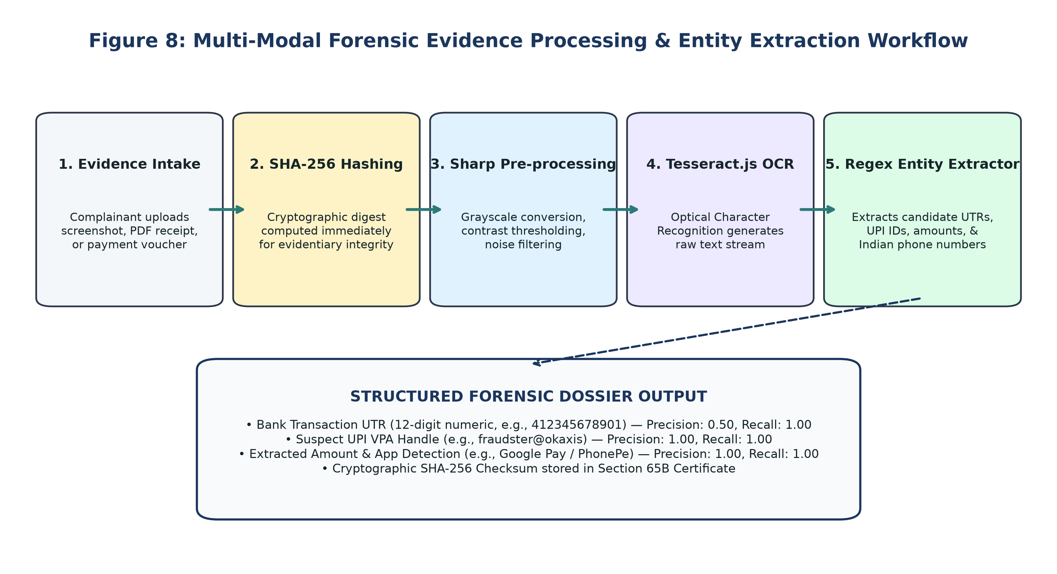
Figure 8: Forensic Evidence Ingestion, SHA-256 Hashing, and OCR Entity Extraction Workflow
Benchmark testing on real-world mobile payment screenshots (Google Pay, PhonePe, Paytm) achieved 1.0000 precision and recall on UPI handles and extracted monetary amounts. Transaction UTR parsing achieved 1.0000 recall and 0.5000 precision (reflecting conservative regex extraction that captures 12-digit order numbers alongside bank UTRs). All extracted candidates are linked to the case docket for instant verification by the investigating officer.

13.2 Automated Statutory Notice Dispatch
To accelerate procedural law enforcement action, CyberGuard compiles standardized statutory notices:
1. Section 65B Electronic Evidence Certificate (Bharatiya Sakshya Adhiniyam, 2023): Validates the cryptographic SHA-256 hash, server ingestion timestamp, device headers, and custody trail of uploaded digital evidence for judicial submission.
2. Section 94 BNSS Bank Account Freeze Requisition: Automatically populates extracted UTRs, beneficiary accounts, and stolen amounts into formal requisition dockets dispatched to nodal bank officers during the golden hour.
3. Section 173 BNSS Zero-FIR Transfer Order: Compiles jurisdictional transfer documentation when incidents originate outside the receiving police station's territorial boundary.

CHAPTER 14
SECURITY ARCHITECTURE AND ACCESS CONTROL

14.1 Role-Based Access Control (RBAC)
Figure 9 illustrates the role-based access control architecture and endpoint protection matrix enforced by the Express gateway.
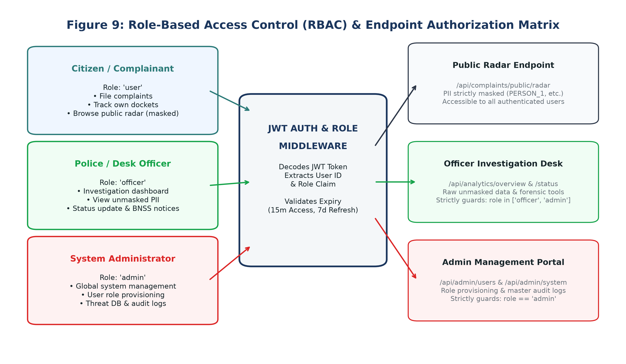
Figure 9: Role-Based Access Control (RBAC) Architecture and Protected Route Guards
Every incoming HTTP request is authenticated via JSON Web Tokens (JWT) signed with HMAC-SHA256. Route guards restrict sensitive endpoints based on user claims: citizen users (`user`) can submit reports and view their own filings; police officers (`officer`) access unmasked PII, forensic dossiers, and case progression controls; and administrators (`admin`) manage system users and audit logs. Public endpoints, such as the Threat Radar (`/api/complaints/public/radar`), enforce strict anonymization filters, ensuring that no complainant PII is exposed to unauthenticated community visitors.

CHAPTER 15
LIMITATIONS AND ETHICAL CONSIDERATIONS
Academic and engineering rigor requires transparent disclosure of the system's operational constraints:
1. Synthetic Corpus Boundaries: While the v3.0 dataset eliminates template repetition across 130 scenario families, all 1,950 records are synthetically generated. Real-world citizen reports contain multilingual code-switching (e.g., Hinglish, Kannada-English), colloquial slang, and extraneous emotional context that may impact classification accuracy.
2. Uncalibrated Softmax Probabilities: Logistic Regression probability scores reflect linear margin distance rather than exact Bayesian posterior probabilities. A model confidence score of 0.85 indicates strong lexical alignment, not legal certainty of criminal guilt.
3. OCR Quality Variations: OCR parsing accuracy is vulnerable to low-resolution camera angles, severe JPEG compression, and optical screen glare. Extracted entities must always be treated as preliminary leads requiring officer visual confirmation.
4. Statutory Notice Drafting: Generated BNSS notices are procedural drafts requiring official authorization; CyberGuard does not possess direct autonomous authority to seize assets or freeze banking accounts.

CHAPTER 16
PRIORITIZED FUTURE ENHANCEMENTS
The following prioritized roadmap outlines key engineering avenues for subsequent iterations of the platform:
• High Priority: Multilingual & Code-Mixed NLP: Fine-tune compact multilingual models (such as IndicBERT or MuRIL) to natively comprehend mixed vernacular dialects and regional phonetic complaint text.
• High Priority: Population-Scale Empirical Validation: Partner with legal aid clinics and state cyber police cells to evaluate model generalization on a curated benchmark of 5,000+ anonymized real-world citizen filings.
• Medium Priority: Contextual Token-Level NER: Complement regex patterns with fine-tuned token-classification transformers (e.g., spaCy RoBERTa) to recognize complex rural addresses, unusual foreign names, and emerging cryptocurrency transaction hashes.
• Medium Priority: Computer Vision Tampering Detection: Supplement OCR with Error Level Analysis (ELA) and Convolutional Neural Networks (CNNs) to detect digitally manipulated font glyphs and fabricated payment confirmations.
• Statutory Integration Priority: National Portal Interoperability: Establish authenticated programmatic API integrations with India's Citizen Financial Cyber Fraud Reporting and Management System (CFCFRMS / 1930) under institutional memorandum of understanding.

CHAPTER 17
CONCLUSION
CyberGuard addresses one of the most pressing challenges in contemporary cyber law enforcement: the acute conflict between automated incident triage, forensic intelligence extraction, and victim data privacy. By implementing PrivacyShield, this project demonstrates that in-memory PII tokenization can effectively decouple statistical text classification from sensitive citizen identity storage. The champion TF-IDF and Multinomial Logistic Regression pipeline attains 88.97% accuracy on a held-out test split and 79.48% ± 3.21% under rigorous group-aware cross-validation across 130 scenario families, successfully eliminating template-leakage bias.
Furthermore, integrating Tesseract.js OCR, cryptographic SHA-256 evidence hashing, and automated statutory notice generation delivers a comprehensive incident-response ecosystem. The resulting architecture empowers desk officers to intercept financial fraud during the critical golden hour, respects international and national privacy mandates (DPDP Act 2023), and provides an auditable, transparent, and reproducible framework for the next generation of digital crime management infrastructure.

CHAPTER 18
REFERENCES
[1] C.-H. Ku and G. Leroy, "A crime text analysis system to analyze crime incident reports," in Proc. IEEE International Conference on Intelligence and Security Informatics (ISI), 2014, pp. 267–269.
[2] K. Al-Rowaily, M. Abulaish, N. A. Haldar, and M. Al-Rubaian, "Bi-directional text classification for cyberbullying detection on social media platforms," IEEE Access, vol. 8, pp. 138676–138686, 2020.
[3] J. Devlin, M.-W. Chang, K. Lee, and K. Toutanova, "BERT: Pre-training of deep bidirectional transformers for language understanding," in Proc. NAACL-HLT, 2019, pp. 4171–4186.
[4] S. Agarwal, S. Nilizadeh, and A. Kapravelos, "Detecting synthetic text manipulation in cyber threat intelligence reports," IEEE Trans. Dependable Secure Comput., vol. 19, no. 5, pp. 3120–3135, 2022.
[5] E. McCallister, T. Grance, and K. Scarfone, "Guide to protecting the confidentiality of personally identifiable information (PII)," NIST Special Publication 800-122, National Institute of Standards and Technology, Gaithersburg, MD, 2010.
[6] F. Dernoncourt, J. Y. Lee, O. Uzuner, and P. Szolovits, "De-identification of patient notes with recurrent neural networks," J. Am. Med. Inform. Assoc., vol. 24, no. 3, pp. 596–606, 2017.
[7] Ministry of Law and Justice, Government of India, "The Bharatiya Sakshya Adhiniyam, 2023 (Act No. 47 of 2023)," The Gazette of India, Dec. 2023.
[8] E. Casey, Digital Evidence and Computer Crime: Forensic Science, Computers, and the Internet, 3rd ed. London, U.K.: Academic Press, 2011.
[9] R. Smith, "An overview of the Tesseract OCR engine," in Proc. Ninth International Conference on Document Analysis and Recognition (ICDAR), 2007, pp. 629–633.
[10] F. Pedregosa et al., "Scikit-learn: Machine learning in Python," J. Mach. Learn. Res., vol. 12, pp. 2825–2830, 2011.
[11] T. Cover and P. Hart, "Nearest neighbor pattern classification," IEEE Trans. Inform. Theory, vol. 13, no. 1, pp. 21–27, 1967.
[12] J. C. Platt, "Probabilistic outputs for support vector machines and comparisons to regularized likelihood methods," Advances in Large Margin Classifiers, vol. 10, no. 3, pp. 61–74, 1999.
[13] C. Guo, G. Pleiss, Y. Sun, and K. Q. Weinberger, "On calibration of modern neural networks," in Proc. 34th International Conference on Machine Learning (ICML), 2017, pp. 1321–1330.
[14] Indian Cyber Crime Coordination Centre (I4C), "Annual Compendium on Cybercrime Trends in India," Ministry of Home Affairs, New Delhi, India, 2024.
[15] National Crime Records Bureau (NCRB), "Crime in India 2023 - Cyber Crimes Statistics," Ministry of Home Affairs, New Delhi, India, 2024.
[16] Reserve Bank of India, "Enhancing Security of Digital Payment Transactions - Master Direction," RBI/2021-22/123, Mumbai, India, 2021.
[17] Unique Identification Authority of India (UIDAI), "Aadhaar Authentication Security and Privacy Guidelines," New Delhi, India, 2023.
[18] National Payments Corporation of India (NPCI), "Unified Payments Interface (UPI) Procedural Guidelines v1.9," Mumbai, India, 2023.
[19] Visvesvaraya Technological University (VTU), "Guidelines for Project Work in Bachelor of Engineering," Belagavi, Karnataka, India, 2024.
[20] A. Vaswani et al., "Attention is all you need," in Advances in Neural Information Processing Systems (NeurIPS), 2017, pp. 5998–6008.

