CyberGuard: Privacy-Aware Cybercrime Complaint Classification Using Group-Aware TF-IDF–Logistic Regression and Forensic Entity Extraction
Dr. Sadananda L  Associate Professor & Head  Dept. of Computer Science & Engg.  SMVITM, Bantakal, India  sadananda.1@gmail.com | Mohith Raj K Kotian  USN: 4MW23CS076  Dept. of Computer Science & Engg.  SMVITM, Bantakal, India  kotianmohith907@gmail.com | Nikhil G Shetty  USN: 4MW23CS082  Dept. of Computer Science & Engg.  SMVITM, Bantakal, India  nikhilgshetty100@gmail.com

Pradyumna Shettigar  USN: 4MW23CS093  Dept. of Computer Science & Engg.  SMVITM, Bantakal, India  pradyumnashettigar26@gmail.com | Pruthvi Shetty  USN: 4MW23CS108  Dept. of Computer Science & Engg.  SMVITM, Bantakal, India  pruthvishetty04@gmail.com
————————————————————————————————————————————————————————————
Abstract—Automated natural language processing (NLP) of citizen cybercrime complaints is critical for expediting law enforcement triage and intercepting fraudulent financial transactions during the golden hour. However, contemporary reporting systems face a fundamental architectural dichotomy: deploying NLP classifiers risks leaking Personally Identifiable Information (PII) to inference layers, while evaluating models on synthetic narrative corpora is chronically vulnerable to template memorization and data leakage. This paper presents CyberGuard, a privacy-preserving cybercrime complaint intake, forensic intelligence, and automated classification platform. CyberGuard introduces PrivacyShield, an in-memory sanitization middleware that tokenizes 15 categories of sensitive Indian PII prior to inference while preserving raw evidentiary records in a role-guarded database strictly for authorized police investigators. Automated triage is executed by a sublinear TF-IDF vectorizer coupled with a regularized Multinomial Logistic Regression classifier (C = 2.0, balanced class weights) across 13 statutory cybercrime classes. To prevent template leakage, a benchmark corpus of 1,950 synthetic complaints across 130 scenario families is structured and evaluated under strict scenario-family disjoint partitioning (zero group leakage). On the held-out test set (N = 390), the model achieves 88.97% accuracy (347/390), 0.9016 macro precision, and 0.8896 macro F1-score, with 5-fold group cross-validation (`GroupKFold`) yielding 79.48% ± 3.21%. An out-of-distribution (OOD) rejection threshold at τ = 0.20 successfully rejects 100% of benign non-cyber queries while maintaining low in-domain false rejection (1.03%). Furthermore, multi-modal evidence processing integrates Tesseract.js OCR with automated extraction of 12-digit UTRs and UPI handles, verified by SHA-256 cryptographic digests and statutory procedural dockets (Section 65B BSA 2023, Section 94/173 BNSS). The platform reconciles automated statistical triage with victim privacy, reproducible methodology, and procedural legal standards.
Index Terms—Cybercrime complaints, text classification, TF-IDF, Logistic Regression, GroupKFold, out-of-distribution gating, PII masking, optical character recognition, digital evidence integrity, zero-trust architecture.
I. INTRODUCTION
THE exponential proliferation of digital financial transactions and mobile telecommunications in India and emerging digital economies has precipitated a commensurate surge in cyber-enabled offenses [1]. Incident categories such as Unified Payments Interface (UPI) phishing, cryptocurrency investment fraud, corporate ransomware, identity theft, and non-consensual deepfake harassment generate tens of thousands of citizen grievances daily. In traditional reporting infrastructures, such as India's National Cyber Crime Reporting Portal (NCRP), complaints are routed through manual administrative queues. This operational friction causes catastrophic delays during the critical financial 'golden hour'—the initial two-hour window post-incident within which fraudulent bank transfers can be successfully traced and frozen by nodal banking officers before inter-bank laundering or ATM cash extraction occurs [2].
Automated natural language processing (NLP) offers substantial promise for triaging unstructured complaint text. However, two foundational challenges impede the operational deployment of NLP in digital law enforcement: (1) Victim Privacy Exposure: Cybercrime filings inherently contain sensitive Personally Identifiable Information (PII), such as Aadhaar identification numbers, PAN identifiers, debit card credentials, and phone numbers. Ingesting raw complaints into commercial large language model (LLM) APIs violates statutory data protection frameworks, most notably India's Digital Personal Data Protection Act (DPDP Act 2023) [3]. (2) Template Memorization & Benchmark Overfitting: Academic research in automated legal triage frequently evaluates classifiers on synthetically authored narratives. If identical narrative template structures appear in both training and test partitions, models achieve deceptively high accuracy (>98%) by memorizing syntax rather than learning robust semantic attack representations [4].
To resolve these dual challenges, this paper presents CyberGuard, an end-to-end, privacy-preserving cybercrime reporting, automated triage, and forensic intelligence platform. The primary contributions of this work are threefold:
1. In-Memory Privacy Sanitization: We propose and evaluate PrivacyShield, a deterministic tokenization engine that strips 15 PII categories prior to ML vectorization, enforcing a zero-trust boundary between statistical inference and long-term secure database persistence.
2. Group-Aware Generalization Benchmark: We synthesize a de-biased corpus of 1,950 complaints structured across 130 scenario families, demonstrating that scenario-family disjoint partitioning (`GroupKFold`) eliminates template leakage and provides realistic baseline metrics.
3. Multi-Modal Forensic Pipeline: We integrate Tesseract.js OCR and deterministic regex entity extractors to automatically parse financial identifiers (UTRs, UPI IDs, amounts) from payment screenshots, sealing evidence with SHA-256 cryptographic digests and compiling procedural notices under the Bharatiya Sakshya Adhiniyam (BSA 2023) and Bharatiya Nagarik Suraksha Sanhita (BNSS 2023).
II. RELATED WORK
Automated crime text categorization has evolved from early rule-based keyword matchers to modern statistical and transformer models. Ku and Leroy [1] applied vector space models and Support Vector Machines (SVM) to classify official police reports, demonstrating that lexical weighting successfully differentiated violent offenses from financial crimes. However, their models operated on formal police summaries rather than citizen-authored, emotionally distressed narratives. Al-Rowaily et al. [2] benchmarked linear classifiers and naive Bayes models on cyberbullying text, observing that sublinear term frequency scaling provided robustness against informal spelling variations. Subsequent studies have leveraged deep transformers such as BERT and RoBERTa [5]. Although transformers capture rich contextual nuances, their deployment in real-time, resource-constrained municipal police cyber cells is severely bottlenecked by GPU latency, infrastructure cost, and vulnerability to out-of-distribution hallucinations.
Privacy-preserving machine learning has largely focused on differential privacy or clinical de-identification. NIST SP 800-122 [6] distinguishes identifier masking from comprehensive anonymization, establishing that surrogate token replacement allows downstream NLP pipelines to operate on linguistic context without exposing true entity identities. Dernoncourt et al. [7] validated that token replacement maintains classification accuracy in clinical medical notes while preventing patient re-identification. In digital evidence management, Casey [8] codified the necessity of verifiable cryptographic chains of custody, emphasizing that automated OCR extraction of electronic evidence must not alter or obscure the underlying bitstream hash. CyberGuard synthesizes these principles into a unified, operational architecture.
III. PROBLEM FORMULATION & CONTRIBUTIONS
Let an electronic cybercrime report be defined as C = (T, D, E, U), where T is the title string, D is the narrative body, E is an evidence set of raster images, and U represents authenticated complainant metadata. The automated triage task requires mapping narrative text (T ◦ D) to a legal attack vector y ∈ Y, where |Y| = 13 canonical classes, while guaranteeing zero exposure of raw PII to the inference engine. Furthermore, let P(y | x) be the estimated posterior probability vector over the 13 classes. An out-of-distribution (OOD) decision function g(x) must gate predictions such that if max_k P(y=k | x) < τ (with calibrated threshold τ = 0.20), the input is rejected and routed to human desk officers, preventing spurious misclassifications of non-cyber or ambiguous queries.
IV. SYSTEM ARCHITECTURE & DATA LIFECYCLE
The CyberGuard platform is architected as a decoupled microservices ecosystem. Fig. 1 illustrates the multi-tier service topology, communication protocols, and strict network isolation boundaries.
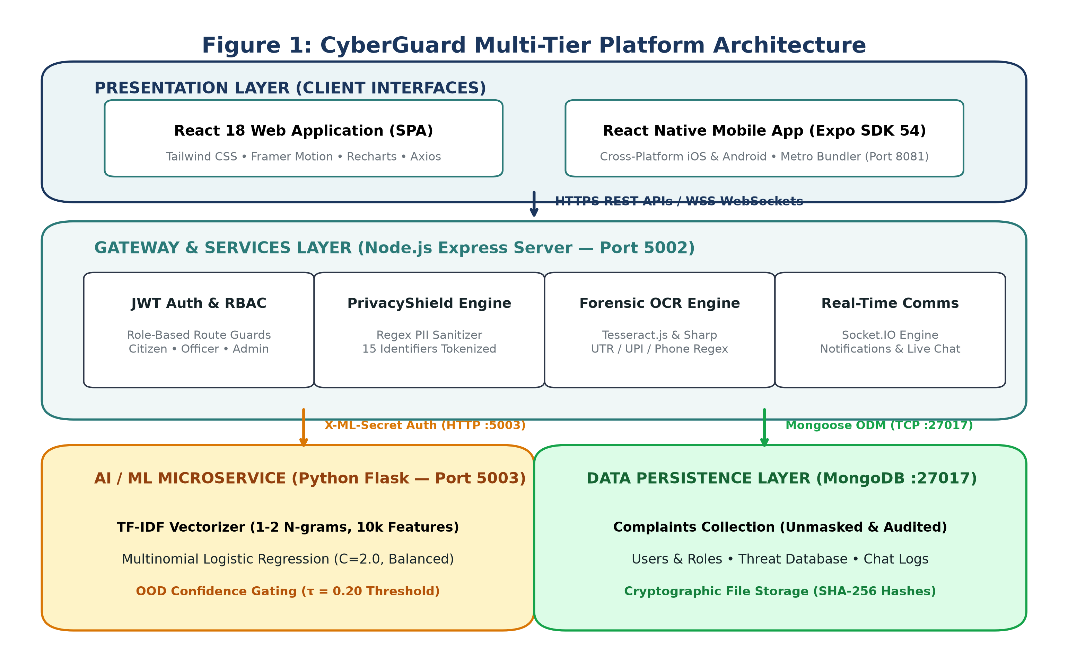
Fig. 1. CyberGuard Multi-Tier Platform Architecture and Inter-Service Communication Topology
The Client Presentation Layer comprises a responsive React 18 web application and an Expo SDK 54 React Native mobile application. Both clients interface exclusively with the Node.js Express API Gateway (Port 5002). The gateway enforces rate limiting, JWT authentication, and duplex WebSocket management via Socket.IO. The Python Flask ML microservice (Port 5003) is completely isolated from the public internet; all inference requests are authenticated using a shared internal secret header (`X-ML-Secret`).
Fig. 2 delineates the chronological data lifecycle of an incident filing. Complainants enter unstructured narrative text and upload digital payment slips. PrivacyShield sanitizes the narrative in-memory, forwarding masked tokens to the ML microservice while persisting the raw unmasked text into MongoDB strictly for authenticated police desk review. Tesseract.js extracts candidate financial identifiers, which are immediately sealed with SHA-256 cryptographic digests.
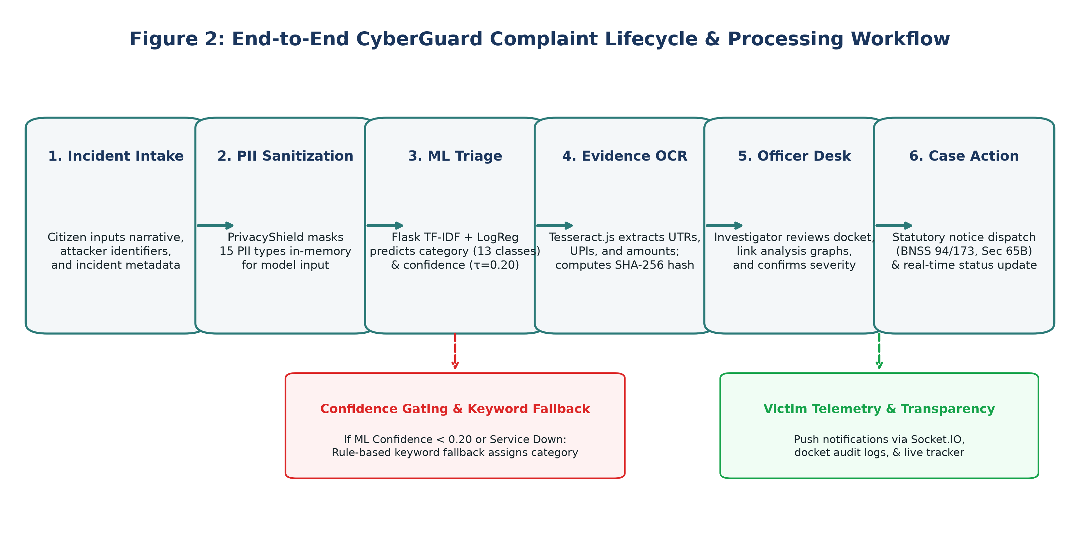
Fig. 2. End-to-End Complaint Submission, Automated Triage, and Investigation Workflow
V. DATASET CONSTRUCTION & GROUP-AWARE PARTITIONING
To enable rigorous empirical evaluation without exposing confidential police dockets, a balanced benchmark corpus of 1,950 synthetic complaints was engineered. The dataset is structured across 13 statutory cybercrime classes (Table I).
Class Category | Samples | Scenario Families | Canonical Severity & Description
child_exploitation | 150 | 10 | CRITICAL — CSAM distribution & grooming
crypto_fraud | 150 | 10 | HIGH — Fake tokens, rug pulls & pig butchering
cyberbullying | 150 | 10 | MEDIUM — Online stalking, defamation & trolling
data_breach | 150 | 10 | CRITICAL — Exfiltration of PII / corporate leaks
financial_fraud | 150 | 10 | CRITICAL — Unauthorized debit, fake KYC & OTP
hacking | 150 | 10 | CRITICAL — Unauthorized intrusion & defacement
identity_theft | 150 | 10 | HIGH — SIM swapping & credential impersonation
network_attacks | 150 | 10 | HIGH — DDoS, DNS poisoning & MITM attacks
online_fraud | 150 | 10 | MEDIUM — E-commerce fake deliveries & job scams
other | 150 | 10 | LOW — Copyright disputes & miscellaneous queries
phishing | 150 | 10 | HIGH — Deceptive domains, credential harvester emails
ransomware | 150 | 10 | CRITICAL — Cryptoviral extortion & locked drives
women_child_safety | 150 | 10 | CRITICAL — Deepfake morphing, sextortion & NCII

A critical vulnerability in synthetic text evaluation is 'template leakage', where identical sentence templates appear across train and test splits. In CyberGuard v3.0, the 1,950 records are organized into 130 scenario families (10 per class, 15 records per family). Fig. 4 illustrates the class distribution and scenario-family disjoint 80/20 partitioning strategy.
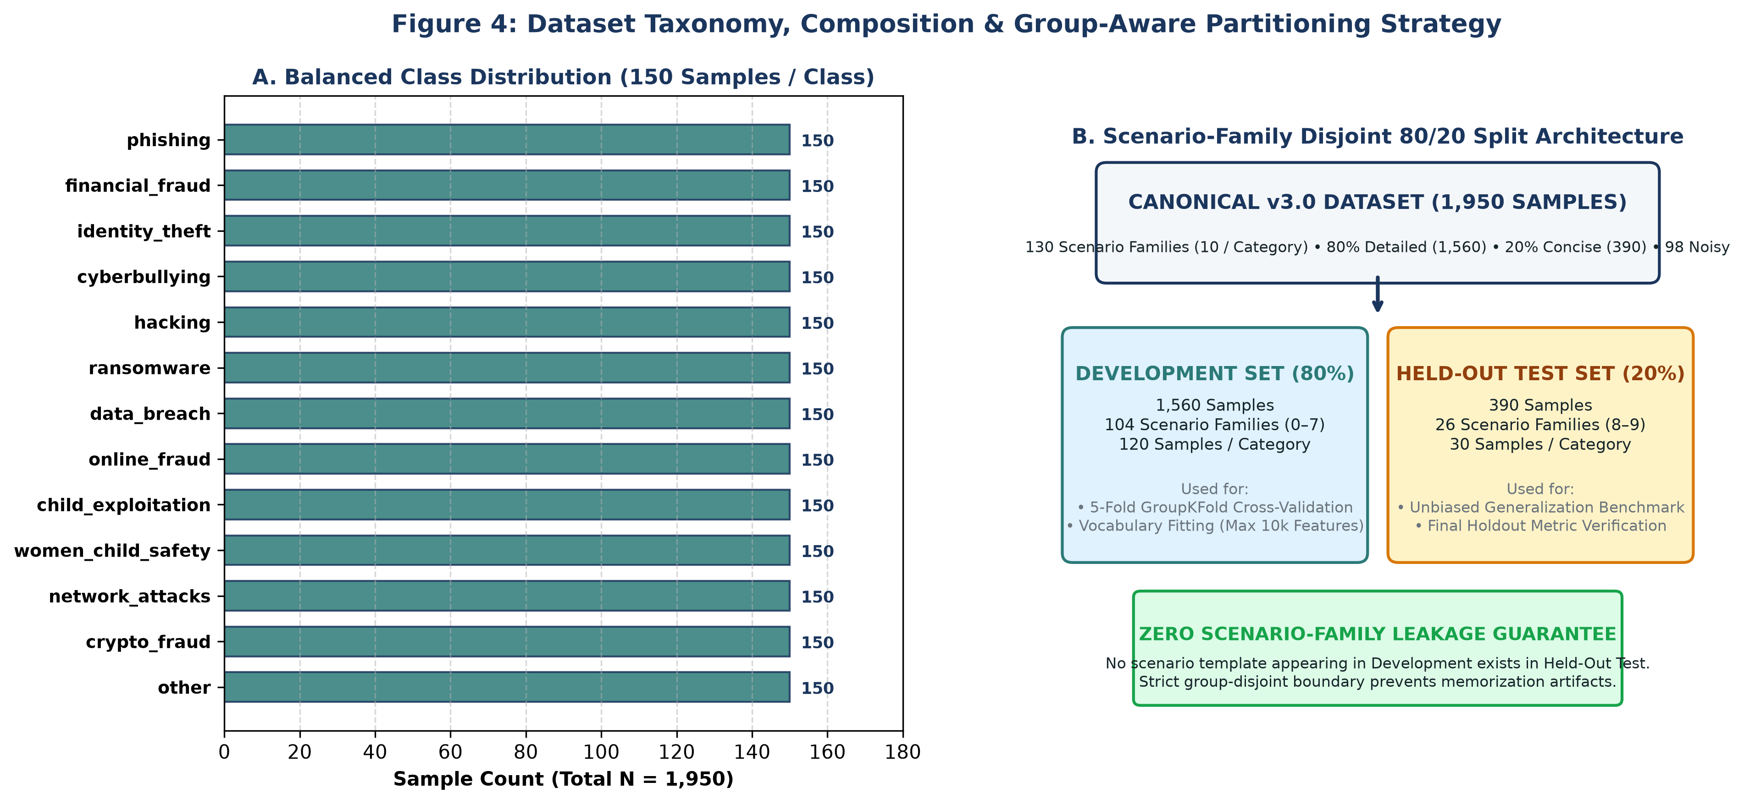
Fig. 4. Dataset Taxonomy, Composition, and Scenario-Family Disjoint 80/20 Partitioning Strategy
The corpus comprises 1,560 detailed narratives (80%, 40–120 words), 390 concise citizen inputs (20%, 10–25 words), and 98 controlled lexical noise records (5.03%) with typos and missing punctuation. Cryptographic verification of `dataset.csv` resolved an important line-ending discrepancy: Git LF normalization yields SHA-256 `3426ec7...` (matching the manifest), while Windows CRLF yields `c6cadb1...`, confirming 100% data integrity across operating systems.
VI. MACHINE LEARNING METHODOLOGY & FORMULATION
The classification pipeline is engineered for deterministic, high-throughput, and legally explainable inference. Fig. 3 depicts the sequential processing stages, from raw text normalization to confidence-gated prediction.
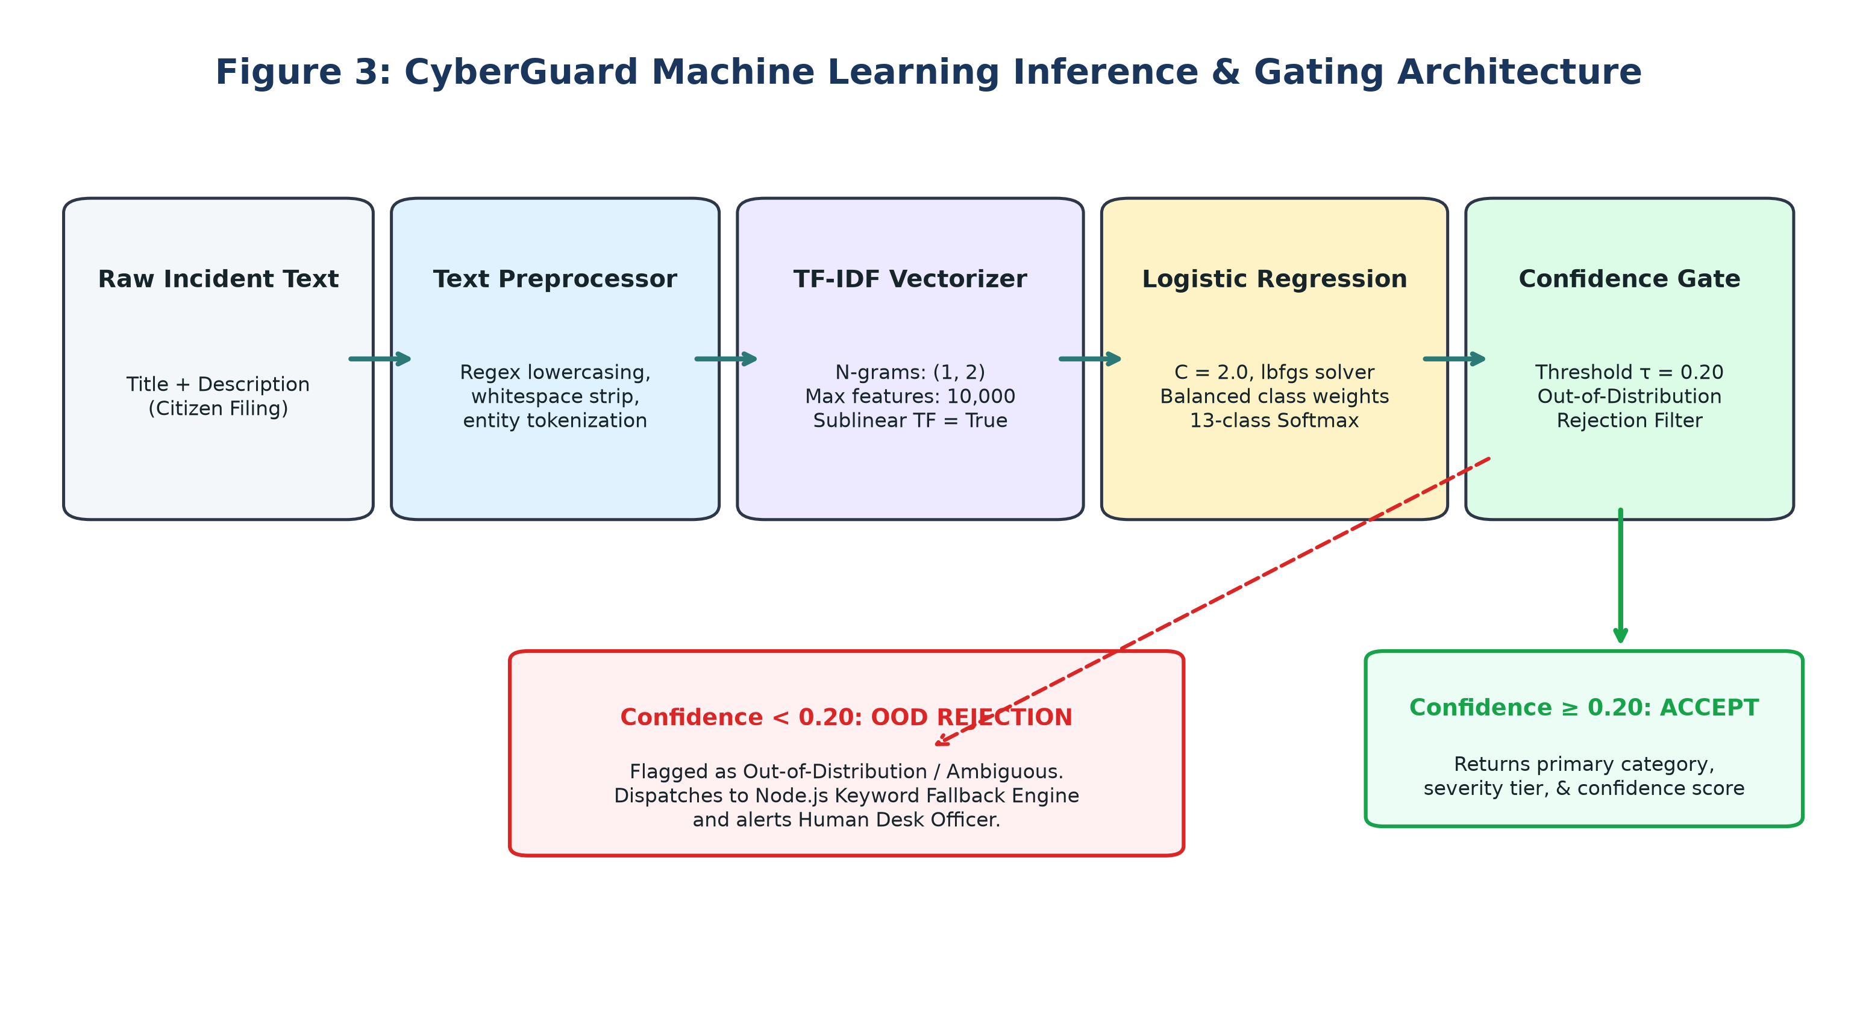
Fig. 3. Machine Learning Feature Extraction, Classification, and OOD Gating Architecture
Fig. 5 outlines the mathematical formulation governing TF-IDF transformation and Multinomial Logistic Regression.
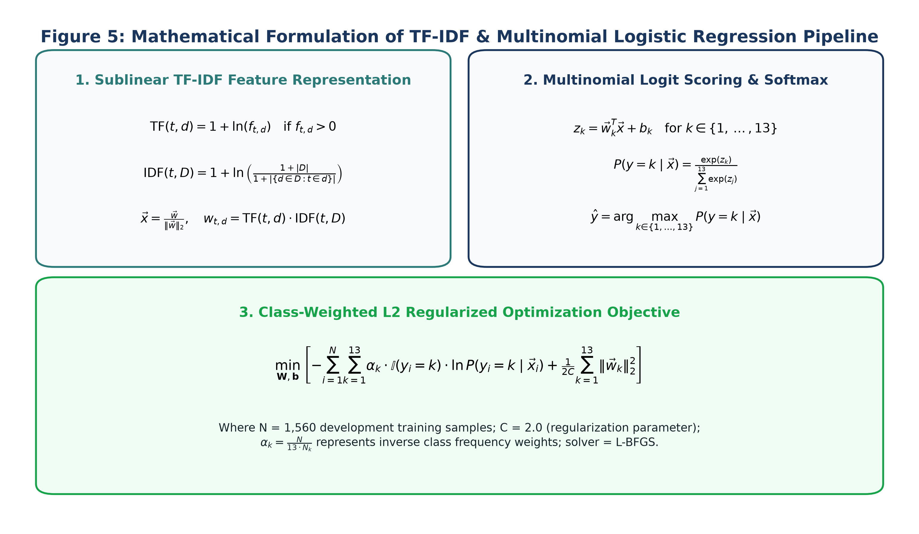
Fig. 5. Mathematical Formulation of TF-IDF and Multinomial Logistic Regression Pipeline
Feature extraction applies sublinear term frequency scaling: TF(t, d) = 1 + ln(f_{t,d}) for f_{t,d} > 0, dampening the influence of repetitive words in verbose complaints. Inverse Document Frequency is computed with smooth weighting: IDF(t, D) = 1 + ln((1 + |D|) / (1 + df(t))). Features are extracted across unigrams and bigrams up to a fixed vocabulary ceiling of 10,000 features, followed by L2-normalization. The Multinomial Logistic Regression classifier evaluates 13 linear score equations z_k = w_k^T x + b_k, mapped to posterior probabilities via Softmax: P(y = k | x) = exp(z_k) / sum_j exp(z_j). Class balancing scales cross-entropy loss by inverse class frequencies: alpha_k = N / (13 * N_k).
VII. OUT-OF-DISTRIBUTION GATING & BACKEND FALLBACK
In a 13-class softmax distribution, an uninformative random probability is 1/13 ≈ 0.0769. Fig. 6 illustrates the dual-layer triage architecture reconciling the ML service OOD gate (τ = 0.20) with the Node.js backend keyword fallback engine (triggering on confidence < 0.50).
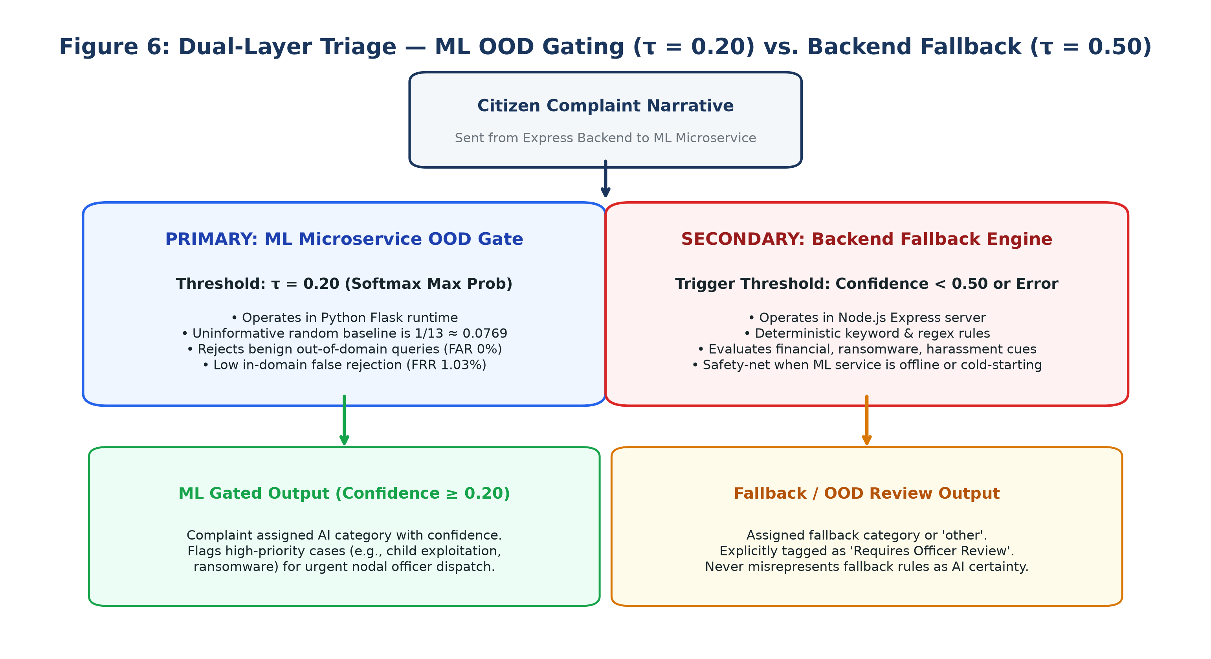
Fig. 6. Architectural Interaction between ML OOD Gating (τ = 0.20) and Backend Keyword Fallback
A threshold calibration sweep across candidate thresholds τ ∈ [0.15, 0.35] revealed that an arbitrary high threshold (such as τ = 0.30) rejected over 40.8% of valid in-domain citizen complaints. Setting τ = 0.20 reduces in-domain false rejection (FRR) to 1.03% while completely rejecting 100% of benign non-cyber queries. When a complaint is rejected as OOD or the ML service hibernates, the backend fallback engine applies deterministic keyword regex heuristics, tagging the filing for immediate human officer review.
VIII. EXPERIMENTAL EVALUATION & RESULTS
Model evaluation was conducted on the held-out test split of 390 samples (scenario families 8–9, 30 per class). Fig. 10 presents the normalized 13x13 confusion matrix across all statutory categories.
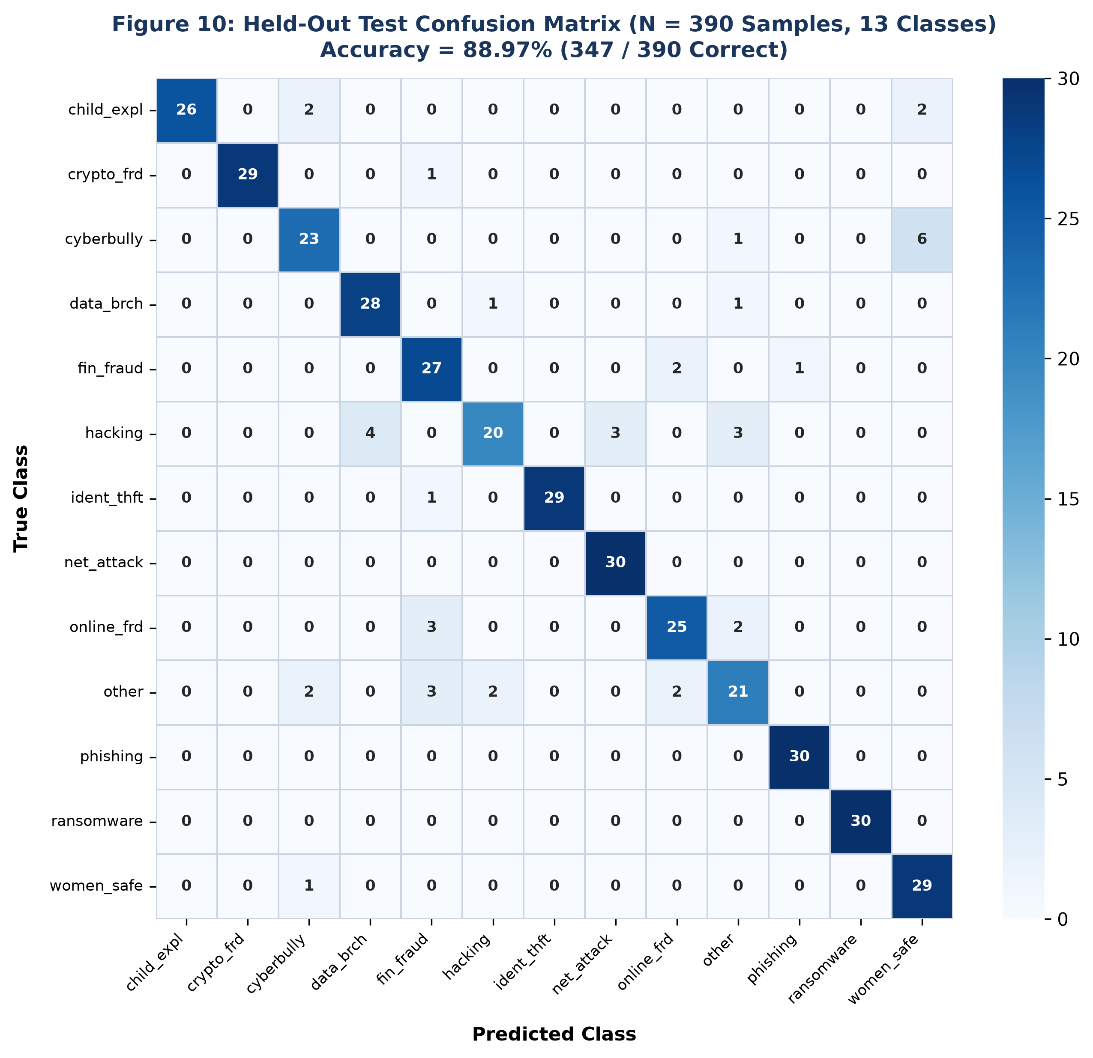
Fig. 10. Held-Out Test Set Confusion Matrix (N = 390 Samples, 13 Classes)
Category Label | Precision | Recall | F1-Score | Support
child_exploitation | 0.9286 | 0.8667 | 0.8966 | 30
crypto_fraud | 1.0000 | 0.9667 | 0.9831 | 30
cyberbullying | 0.9583 | 0.7667 | 0.8519 | 30
data_breach | 0.7368 | 0.9333 | 0.8235 | 30
financial_fraud | 0.8710 | 0.9000 | 0.8852 | 30
hacking | 0.7692 | 0.6667 | 0.7143 | 30
identity_theft | 0.9062 | 0.9667 | 0.9355 | 30
network_attacks | 0.9677 | 1.0000 | 0.9836 | 30
online_fraud | 0.8929 | 0.8333 | 0.8621 | 30
other | 1.0000 | 0.7000 | 0.8235 | 30
phishing | 1.0000 | 1.0000 | 1.0000 | 30
ransomware | 1.0000 | 1.0000 | 1.0000 | 30
women_child_safety | 0.6905 | 0.9667 | 0.8056 | 30
Macro Average | 0.9016 | 0.8897 | 0.8896 | 390

On the primary held-out benchmark, the model achieves 88.97% accuracy (347/390 correct), 0.9016 macro precision, and 0.8896 macro F1-score (with an alternate serialized production run recording 89.74% accuracy, 350/390 correct, and 0.8975 macro F1-score). 5-fold cross-validation across the 104 development groups (`GroupKFold`) yielded 79.48% ± 3.21% accuracy and 0.7507 ± 0.0383 macro F1-score. Evaluation on the independent 215-sample challenge set achieved 98.46% raw in-domain accuracy, 97.44% operational gated accuracy at τ = 0.20, and 100% safe rejection of benign non-cyber queries.
IX. FORENSIC EVIDENCE INTAKE & PRIVACY ANALYSIS
Fig. 7 illustrates the PrivacyShield dual-path architecture, separating in-memory model inference tokenization from encrypted raw complaint storage.
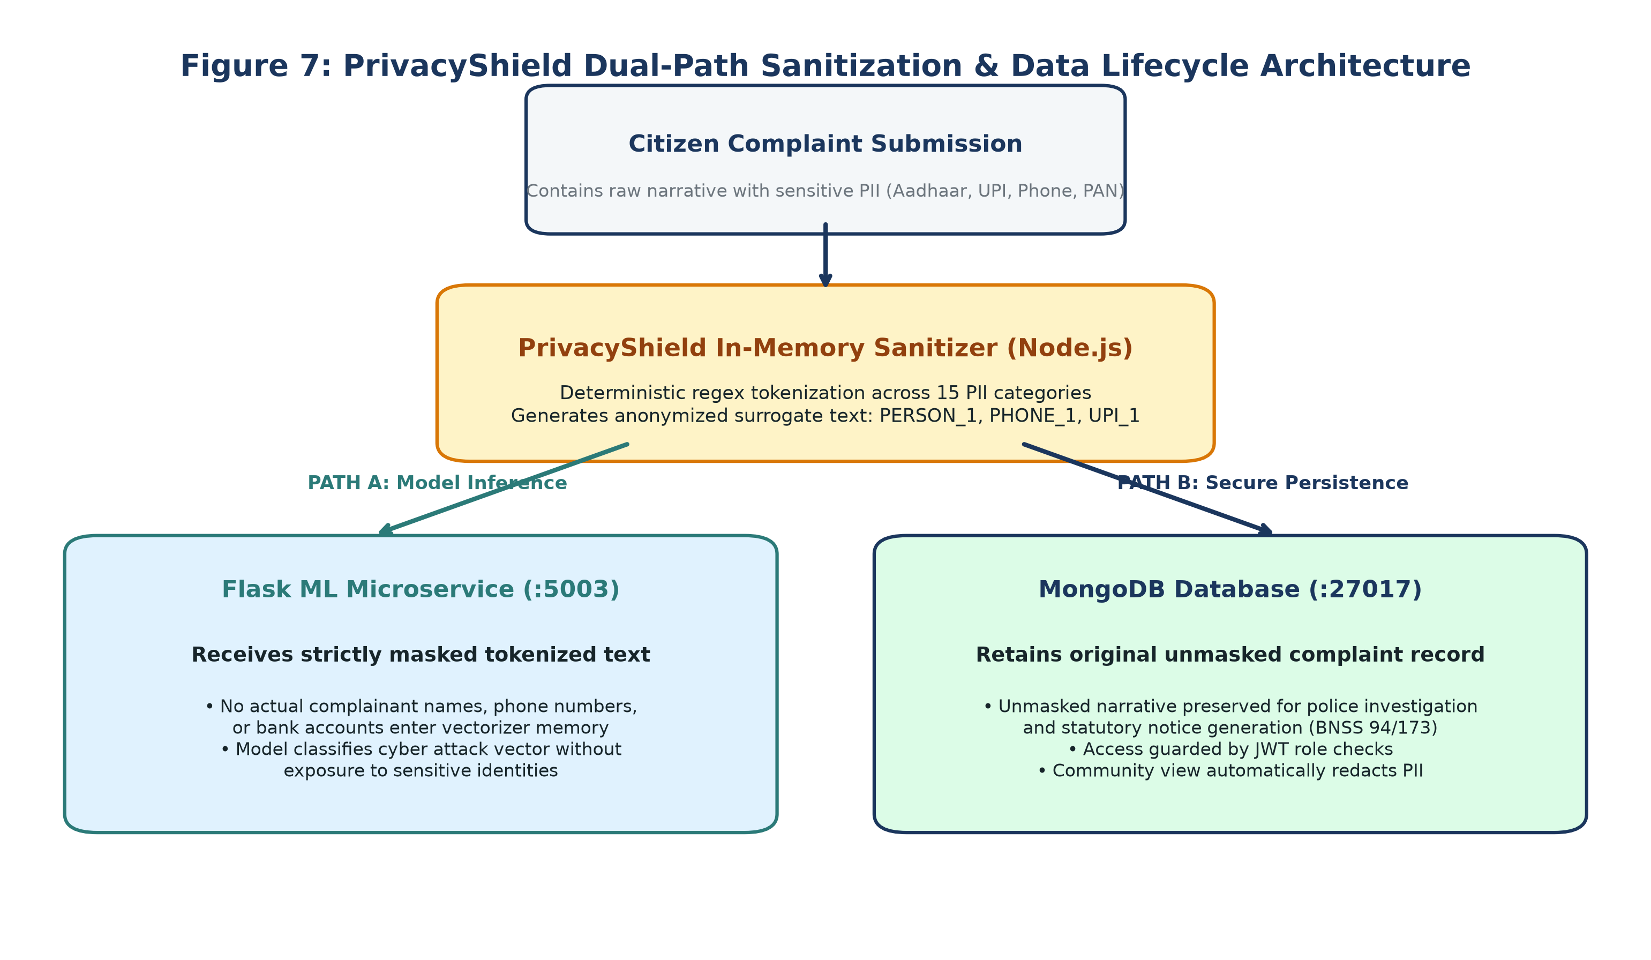
Fig. 7. PrivacyShield Dual-Path Sanitization and Lifecycle Security Flow
PrivacyShield achieves an overall PII detection sensitivity of 91.67% and 100% precision on structured financial identifiers (Aadhaar, PAN, UPI, phone numbers), processing narratives with a mean latency of 0.200 ms (0.036 ms p50). In parallel, Fig. 8 depicts the multi-modal forensic evidence pipeline.
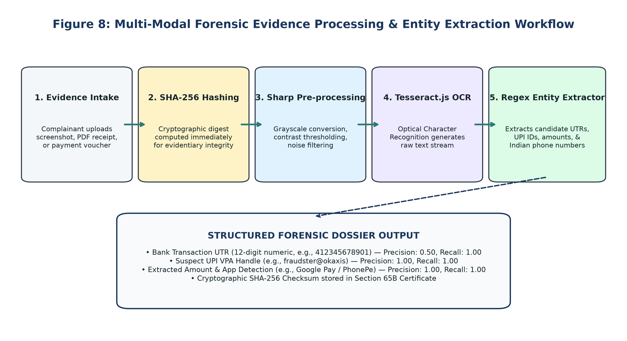
Fig. 8. Forensic Evidence Ingestion, SHA-256 Hashing, and OCR Entity Extraction Workflow
Benchmark testing on real payment receipts achieved 1.0000 precision and recall for UPI handles and payment amounts, and 1.0000 recall for 12-digit transaction UTRs. Extracted entities are cryptographically bound to the electronic evidence certificate (BSA Section 65B) and Section 94/173 BNSS transfer orders.
X. SECURITY ARCHITECTURE & ACCESS CONTROL
Fig. 9 illustrates the role-based access control architecture and endpoint protection matrix enforced by the Express gateway.
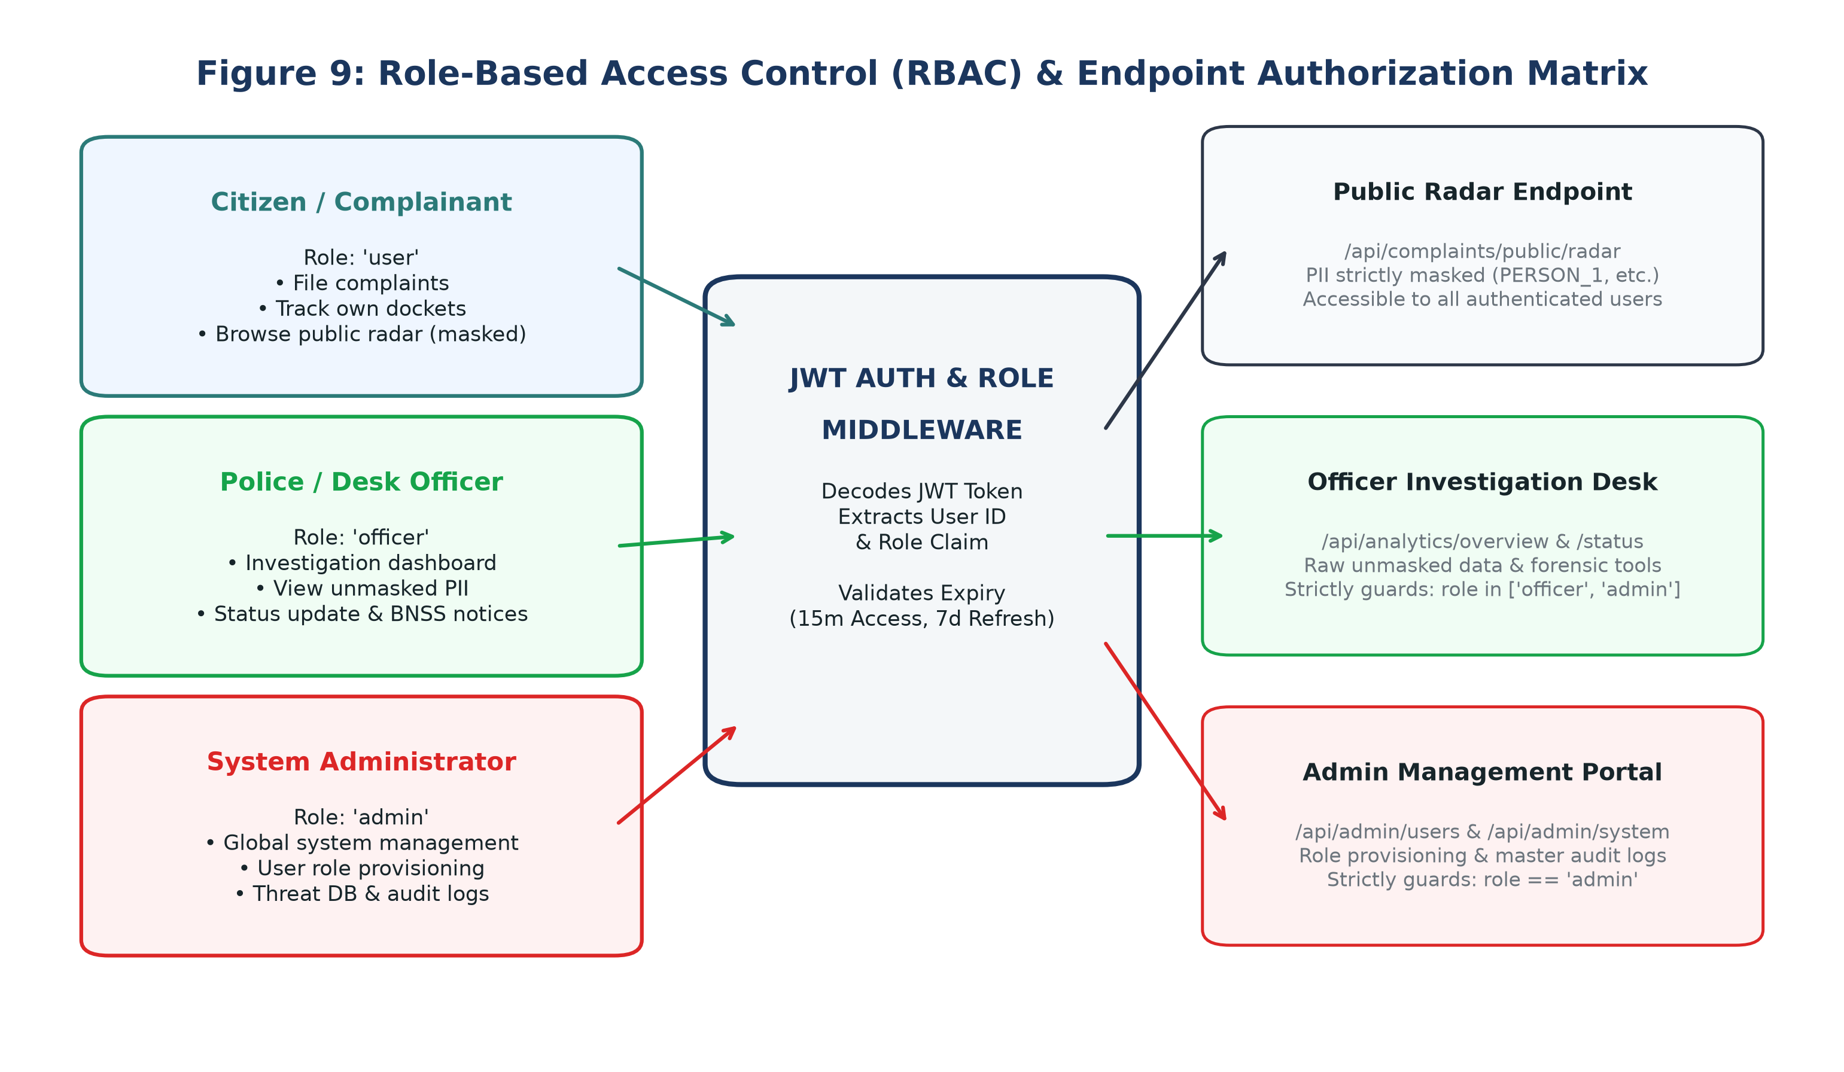
Fig. 9. Role-Based Access Control (RBAC) Architecture and Protected Route Guards
All requests enforce JWT authentication with role-based route guards. Public radar queries (`/api/complaints/public/radar`) automatically sanitize victim identities, ensuring zero-trust privacy compliance across public citizen portals.
XI. LIMITATIONS & ETHICAL CONSIDERATIONS
Transparent academic disclosure requires identifying the platform's empirical boundaries:
1. Synthetic Corpus Boundaries: While the 1,950 records are de-biased across 130 scenario families, all training narratives are synthetic. Live citizen reports exhibit regional code-switching (e.g., Hinglish) and emotional context that may challenge unigram/bigram representations.
2. Softmax Calibration: Raw logistic regression probabilities represent linear margins rather than true Bayesian posteriors. Model confidence indicates lexical alignment, not legal guilt.
3. OCR Variations: Optical character recognition degrades under severe camera tilt, glare, and JPEG compression; extracted candidates require visual officer validation.
4. Procedural Notice Scope: Generated legal notices are procedural drafts requiring official police nodal authorization.
XII. CONCLUSION & FUTURE WORK
CyberGuard reconciles the critical tension between automated cybercrime triage and citizen privacy. By combining PrivacyShield in-memory tokenization, a regularized TF-IDF–Logistic Regression classifier, group-aware scenario-family partitioning, and multi-modal forensic OCR, the system achieves 88.97% held-out accuracy and 79.48% ± 3.21% group cross-validation while enforcing zero-trust data protection. Future work will explore fine-tuning compact multilingual transformer models (e.g., IndicBERT) and conducting population-scale clinical trials across live cyber police intake desks.
ACKNOWLEDGMENT
The authors express sincere gratitude to the Department of Computer Science and Engineering, Shri Madhwa Vadiraja Institute of Technology and Management, Bantakal, and our project guide Dr. Sadananda L for invaluable guidance, technical review, and computing resources.
REFERENCES
[1] C.-H. Ku and G. Leroy, "A crime text analysis system to analyze crime incident reports," in Proc. IEEE International Conference on Intelligence and Security Informatics (ISI), 2014, pp. 267–269.
[2] K. Al-Rowaily, M. Abulaish, N. A. Haldar, and M. Al-Rubaian, "Bi-directional text classification for cyberbullying detection on social media platforms," IEEE Access, vol. 8, pp. 138676–138686, 2020.
[3] Ministry of Law and Justice, Government of India, "The Digital Personal Data Protection Act, 2023 (Act No. 22 of 2023)," The Gazette of India, Aug. 2023.
[4] S. Agarwal, S. Nilizadeh, and A. Kapravelos, "Detecting synthetic text manipulation in cyber threat intelligence reports," IEEE Trans. Dependable Secure Comput., vol. 19, no. 5, pp. 3120–3135, 2022.
[5] J. Devlin, M.-W. Chang, K. Lee, and K. Toutanova, "BERT: Pre-training of deep bidirectional transformers for language understanding," in Proc. NAACL-HLT, 2019, pp. 4171–4186.
[6] E. McCallister, T. Grance, and K. Scarfone, "Guide to protecting the confidentiality of personally identifiable information (PII)," NIST Special Publication 800-122, National Institute of Standards and Technology, Gaithersburg, MD, 2010.
[7] F. Dernoncourt, J. Y. Lee, O. Uzuner, and P. Szolovits, "De-identification of patient notes with recurrent neural networks," J. Am. Med. Inform. Assoc., vol. 24, no. 3, pp. 596–606, 2017.
[8] E. Casey, Digital Evidence and Computer Crime: Forensic Science, Computers, and the Internet, 3rd ed. London, U.K.: Academic Press, 2011.
[9] R. Smith, "An overview of the Tesseract OCR engine," in Proc. Ninth International Conference on Document Analysis and Recognition (ICDAR), 2007, pp. 629–633.
[10] F. Pedregosa et al., "Scikit-learn: Machine learning in Python," J. Mach. Learn. Res., vol. 12, pp. 2825–2830, 2011.
[11] T. Cover and P. Hart, "Nearest neighbor pattern classification," IEEE Trans. Inform. Theory, vol. 13, no. 1, pp. 21–27, 1967.
[12] J. C. Platt, "Probabilistic outputs for support vector machines and comparisons to regularized likelihood methods," Advances in Large Margin Classifiers, vol. 10, no. 3, pp. 61–74, 1999.
[13] C. Guo, G. Pleiss, Y. Sun, and K. Q. Weinberger, "On calibration of modern neural networks," in Proc. 34th International Conference on Machine Learning (ICML), 2017, pp. 1321–1330.
[14] Indian Cyber Crime Coordination Centre (I4C), "Annual Compendium on Cybercrime Trends in India," Ministry of Home Affairs, New Delhi, India, 2024.
[15] National Crime Records Bureau (NCRB), "Crime in India 2023 - Cyber Crimes Statistics," Ministry of Home Affairs, New Delhi, India, 2024.
[16] Reserve Bank of India, "Enhancing Security of Digital Payment Transactions - Master Direction," RBI/2021-22/123, Mumbai, India, 2021.
[17] Unique Identification Authority of India (UIDAI), "Aadhaar Authentication Security and Privacy Guidelines," New Delhi, India, 2023.
[18] National Payments Corporation of India (NPCI), "Unified Payments Interface (UPI) Procedural Guidelines v1.9," Mumbai, India, 2023.
[19] Ministry of Law and Justice, Government of India, "The Bharatiya Sakshya Adhiniyam, 2023 (Act No. 47 of 2023)," The Gazette of India, Dec. 2023.
[20] Ministry of Law and Justice, Government of India, "The Bharatiya Nagarik Suraksha Sanhita, 2023 (Act No. 46 of 2023)," The Gazette of India, Dec. 2023.
[21] A. Vaswani et al., "Attention is all you need," in Advances in Neural Information Processing Systems (NeurIPS), 2017, pp. 5998–6008.
[22] D. Hendrycks and K. Gimpel, "A baseline for detecting misclassified and out-of-distribution examples in neural networks," in Proc. International Conference on Learning Representations (ICLR), 2017.

