LAB EXPERIMENT RECORD
SET 4: PRODUCT INVENTORY MANAGEMENT
Department | AI & DS
Course Code / Course Name | DSA0602 / Data Handling and Visualization
Experiment | Data Visualization using R
Name | P.Mohith Kumar Reddy
Register Number | 192524223
Date | 01 October 2026
Day | Thursday
SET 4: PRODUCT INVENTORY MANAGEMENT
Dataset: Product Inventory
Product ID | Product Name | Quantity Available
1 | Product A | 250
2 | Product B | 175
3 | Product C | 300
4 | Product D | 200
5 | Product E | 220
PROGRAM 1: Product Inventory Bar Chart
Create a bar chart to visualize the quantity of each product in the inventory. Label the axes and title the chart.
# Dataset
product_id <- c(1, 2, 3, 4, 5)
product_name <- c("Product A", "Product B", "Product C", "Product D", "Product E")
quantity <- c(250, 175, 300, 200, 220)
inventory <- data.frame(product_id, product_name, quantity)
# Bar Chart
barplot(inventory$quantity,
names.arg = inventory$product_name,
main = "Product Inventory",
xlab = "Product Name",
ylab = "Quantity Available")
Output 1: Product Inventory Bar Chart
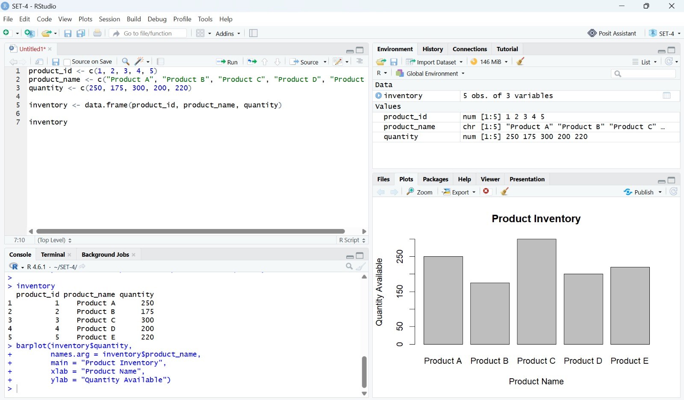
Observation: The bar chart compares the quantity available for Products A to E.
PROGRAM 2: Inventory by Product Category
Generate a stacked bar chart to show the quantity of each product within different product categories.
# Product categories
inventory$category <- c("Electronics",
"Electronics",
"Furniture",
"Furniture",
"Electronics")
# Stacked Bar Chart
category_data <- xtabs(quantity ~ category + product_name,
data = inventory)
barplot(category_data,
main = "Inventory by Product Category",
xlab = "Product",
ylab = "Quantity Available",
col = c("skyblue", "orange"),
legend.text = TRUE)
Output 2: Inventory by Product Category
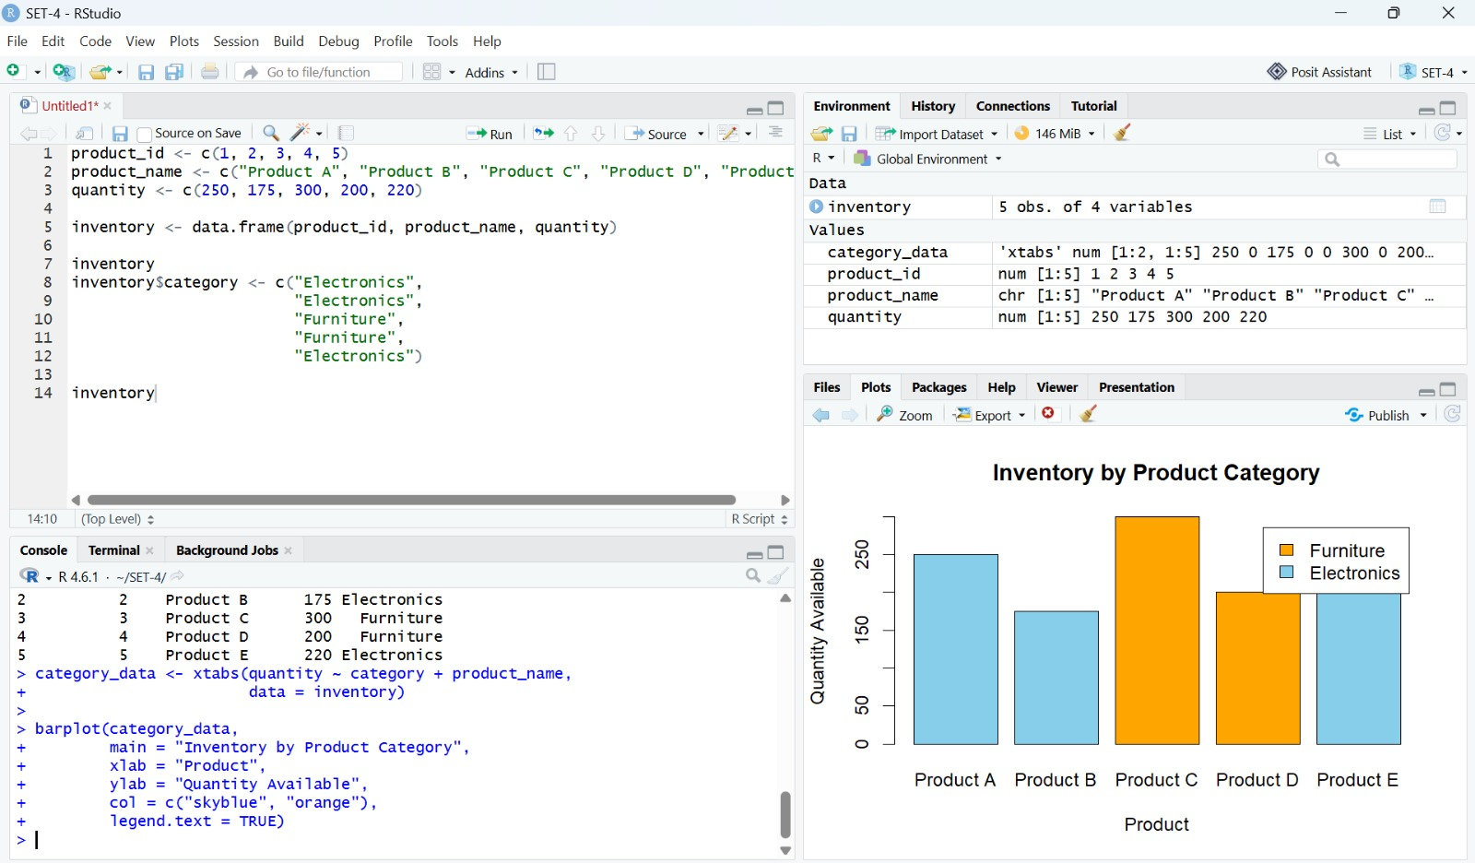
Observation: The stacked bar chart shows the product quantities separated by Electronics and Furniture categories.
PROGRAM 3: Product Price vs Quantity Available
Build a scatter plot to explore the relationship between product price and quantity available. Explain the findings.
# Product prices
inventory$price <- c(500, 750, 400, 600, 550)
# Scatter Plot
plot(inventory$price,
inventory$quantity,
main = "Product Price vs Quantity Available",
xlab = "Product Price",
ylab = "Quantity Available",
pch = 19)
Output 3: Product Price vs Quantity Available
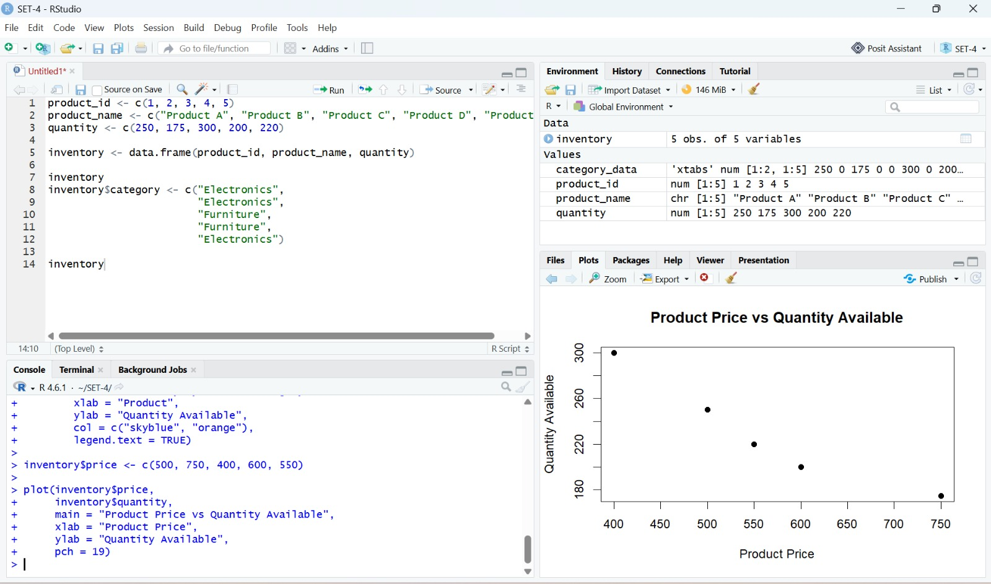
Observation: The plotted points show that quantity available varies across product prices; the highest quantity is associated with the lowest price in the supplied data, while the highest price has the lowest quantity.
PROGRAM 4: Tableau Dashboard
Develop a Tableau dashboard with the bar chart and stacked bar chart to allow users to interact with the data.
Note: The supplied solution screenshots show the R visualizations for Set 4; no separate Tableau dashboard screenshot was included.
Set 4 Procedure
1. Create the product inventory data with product ID, product name, and quantity available.
2. Use barplot() to visualize the quantity of each product.
3. Add product categories and use xtabs() with barplot() to create the stacked category chart.
4. Add product prices and use plot() to explore price versus quantity available.
5. Use the prepared bar chart and stacked bar chart as the visualizations for the Tableau dashboard.
Set 4 Result
The product inventory data was visualized using a bar chart, stacked bar chart, and scatter plot. The supplied screenshots document the R-based visualizations.

