UNIVERSITY ACADEMIC MANAGEMENT SYSTEM
A DBMS Capstone Project Report submitted in partial fulfillment of the requirements for the award of the degree of
BACHELOR OF TECHNOLOGY
in
ARTIFICIAL INTELLIGENCE AND MACHINE LEARNING

Submitted By
KOSANAM BALA ADITYA – 25B11AI581
MUDAY MOHITH NAIK – 25B11AI765
GOPIREDDY DILEEP – 25B11AI361

Under the esteemed guidance of
Mr. T.Srinivasulu M.Tech, (Ph.D.)
Assistant Professor



DEPARTMENT OF ARTIFICIAL INTELLIGENCE AND MACHINE LEARNING
ADITYA UNIVERSITY
(Formerly Aditya Engineering College (A))
Aditya Nagar, ADB Road, Surampalem, Andhra Pradesh, India
2026 – 2027

Aditya Nagar, ADB Road, Surampalem, Andhra Pradesh, India
DEPARTMENT OF ARTIFICIAL INTELLIGENCE AND MACHINE LEARNING
CERTIFICATE
This is to certify that the DBMS Capstone Project report entitled “UNIVERSITY ACADEMIC MANAGEMENT SYSTEM” is being submitted by KOSANAM BALA ADITYA (Roll No. 25B11AI581), MUDAY MOHITH NAIK (Roll No. 25B11AI765) and GOPIREDDY DILEEP (Roll No. 25B11AI361) in partial fulfillment of the requirements for the award of the B.Tech. degree in Artificial Intelligence and Machine Learning. The work documented in this report was carried out as part of the Capstone Project for the course Database Management Systems (2501IT05) during the academic year 2026–2027, and records the database design, implementation, and documentation undertaken by the team.

Project Guide Head of the Department
Mr. T. Srinivasulu, M.Tech, (Ph.D.) Dr. K. Naga Bhargavi, M.Tech,
Assistant Professor Associate Professor & HOD

External Examiner

DECLARATION
We hereby declare that the DBMS Capstone Project entitled “ UNIVERSITY ACADEMIC MANAGEMENT SYSTEM ” is a genuine work carried out by us. The database design, SQL implementation, queries and documentation presented in this report are our own work, completed under the guidance of Mr. T. Srinivasulu, M.Tech, (Ph.D.), Department of ARTIFICIAL INTELLIGENCE AND MACHINE LEARNING, Aditya University, Surampalem. We further declare that this work has not been submitted, in full or in part, for the award of any degree of this or any other educational institution.

Project Associates
KOSANAM BALA ADITYA ( 25B11AI581 )
MUDAY MOHITH NAIK ( 25B11AI765 )
GOPIREDDY DILEEP ( 25B11AI361 )

Date: 20 September 2026
Place: Surampalem

ACKNOWLEDGEMENT
It is with immense pleasure that we express our indebted gratitude to our project guide Mr. T. Srinivasulu, M.Tech, (Ph.D.), Department of ARTIFICIAL INTELLIGENCE AND MACHINE LEARNING, who guided us throughout the capstone project. We are thankful for the constant encouragement and valuable suggestions received at every review stage.
We are grateful to Dr. K. Naga Bhargavi, M.Tech, Ph.D , Head of the Department, for inspiring us and for arranging the facilities and resources needed for this project.
We extend our sincere thanks to the Management, Dr. M. Sreenivasa Reddy, Deputy Pro-Chancellor, Dr. M. B. Srinivas, Vice-Chancellor, and Dr. A. Ramesh, Pro Vice-Chancellor (Engineering & Sciences), for providing an excellent academic environment.
Not to forget, we thank the Teaching and Non-Teaching Staff, our parents and our friends, who have directly or indirectly supported us in completing this project on time.

Project Associates
KOSANAM BALA ADITYA Regd. No. 25B11AI581
MUDAY MOHITH NAIK Regd. No. 25B11AI765
GOPIREDDY DILEEP Regd. No. 25B11AI361

ABSTRACT
The University Academic Management System is a centralized database solution designed to manage and streamline the academic operations of a university. It efficiently handles critical administrative and academic data, including departmental details, faculty assignments, student profiles, course registrations, and examination results. By replacing fragmented, manual record-keeping with a robust relational database structure, the system eliminates data redundancy and enhances data integrity. Major entities such as Department, Faculty, Student, Course, Enrollment, Exam, and Result interact seamlessly to support the core functionalities of the institution. The outcomes of this project include automated tracking of student enrollments, structured management of multi-valued contact information, strict validation of academic constraints (such as credit limits and valid grading), and the ability to generate instantaneous insights regarding academic performance and faculty allocation.

INDEX

Chapter | Title | Page No.
 | Certificate | 1
 | Declaration | 2
 | Acknowledgement | 3
 | Abstract | 4
 | List of Figures | 5
 | List of Tables | 6
1 | Introduction | 7
 | 1.1 Background | 7
 | 1.2 Problem Statement | 7
 | 1.3 Purpose of the Database | 7
 | 1.4 Objectives of the Project | 7
 | 1.5 Organization of the Report | 7
2 | System Study and Tools | 8
 | 2.1 Existing System and Its Limitations | 8
 | 2.2 Proposed Database System | 8
 | 2.3 Tools and Technologies Used | 8
 | 2.4 Software and Hardware Requirements | 9
3 | Database Design | 10
 | 3.1 Identified Entities | 10
 | 3.2 Entity Attributes and Attribute Types | 10
 | 3.3 ER Diagram | 12
 | 3.4 Relationships and Cardinality | 12
 | 3.5 Relational Database Schema | 12
 | 3.6 Primary Keys and Foreign Keys | 14
 | 3.7 Normalization up to 3NF | 14
4 | Database Implementation | 16
 | 4.1 Database and Table Creation – DDL | 16
 | 4.2 Sample Data Insertion – DML | 17
 | 4.3 Constraints and Data Integrity | 19
 | 4.4 Data Validation Rules | 19
5 | SQL Operations and Queries | 20
 | 5.1 DQL and DML – Basic Retrieval and Modification Queries | 20
 | 5.2 Join Operations | 20
 | 5.3 Aggregate Functions, GROUP BY and HAVING | 20
 | 5.4 Nested and Correlated Subqueries | 21
 | 5.5 Views | 21
6 | Modules and Functionalities | 22
7 | Results – Sample Outputs and Screenshots | 23
8 | GitHub Repository and Team Contribution | 24
 | 8.1 Repository Details | 24
 | 8.2 Team Responsibilities and Contribution | 24
9 | Conclusion and Future Enhancements | 25
 | 9.1 Conclusion | 25
 | 9.2 Future Enhancements | 25
 | References | 26
 | Appendix A – Complete SQL Script | 27
LIST OF FIGURES
Figure No. | Title of the Figure | Page No.
3.1 | ER Diagram of the University Academic Management System | 12
3.2 | Relational Schema Diagram | 14
4.1 | Student Table – Sample Data | 17
4.2 | Department Table – Sample Data | 17
4.3 | Course Table – Sample Data | 18
4.4 | Faculty Table – Sample Data | 18
4.5 | Enrollment Table – Sample Data | 18
4.6 | Results Table – Sample Data | 19
7.1 | Number of Courses Offered by Each Department (Q5) | 23
7.2 | Count of Faculty Members by Qualification (Q7) | 23
LIST OF TABLES
Table No. | Title of the Table | Page No.
2.1 | Tools and Technologies Used | 8
2.2 | Software and Hardware Requirements | 9
3.1 | Entities Identified for the Selected Domain | 10
3.2 | Attributes of Each Entity | 10
3.3 | Relationships and Cardinality | 12
3.4 | Relational Database Schema | 12
3.5 | Primary Key and Foreign Key Definitions | 14
3.6 | Normalization Steps | 15
4.1 | Sample Data Summary | 17
4.2 | Constraints and Data Integrity Rules | 19
5.1 | Basic Retrieval and Modification Queries | 20
5.2 | Join Operations | 20
5.3 | Aggregate and GROUP BY Queries | 20
5.4 | Subqueries | 21
5.5 | Views | 21
6.1 | Modules and Their Functionalities | 22
8.1 | Team Responsibilities | 24

CHAPTER 1: INTRODUCTION

1.1 Background
Universities handle vast amounts of data daily, ranging from student admissions and faculty hiring to course scheduling and examination grading. Traditionally, institutions relied on decentralized files or basic spreadsheets, which are prone to inconsistencies and data loss. A Relational Database Management System (RDBMS) is required to securely store, link, and query this complex web of relationships, ensuring that department heads, faculty, and administrators have access to accurate, up-to-date information.

1.2 Problem Statement
Existing manual or decentralized academic tracking systems suffer from data duplication, high risk of entry errors, and significant delays in retrieving cross-departmental information. Maintaining data integrity—such as ensuring a student does not enroll in invalid courses, or that exam marks do not exceed maximum limits—is difficult without automated constraints. This proposed database system addresses these limitations by enforcing strict relational schemas, normalization, and integrity constraints, allowing for instantaneous, accurate data retrieval.

1.3 Purpose of the Database
The purpose of this database is to provide a single source of truth for the university's academic records. It solves the problem of disjointed academic tracking by mapping out exact relationships between students, their enrolled courses, the faculty teaching those courses, and the eventual exam results. It is designed to be used by university administrators, department heads, and academic staff to manage schedules, track academic progress, and maintain official departmental records.

1.4 Objectives of the Project
- Objective 1: To centralize data storage for departments, faculty, students, and courses to eliminate redundancy and maintain data consistency.
- Objective 2: To securely manage and track student course enrollments across different academic semesters and years.
- Objective 3: To implement a robust examination and result-tracking module that maps student performance directly to specific courses and exams.
- Objective 4: To handle multi-valued attributes efficiently, such as managing multiple primary and alternate phone numbers for students without violating normalization principles.
- Objective 5: To maintain data integrity across related academic tables.

1.5 Organization of the Report
This report is organized into nine chapters: system study and tools (2), database design (3), implementation (4), SQL operations (5), modules (6), sample outputs (7), GitHub repository and team contribution (8), and conclusion with future enhancements (9). The complete SQL script is given in Appendix A.

CHAPTER 2: SYSTEM STUDY AND TOOLS

2.1 Existing System and Its Limitations
The existing system relies on manual or decentralized academic records such as separate files and basic spreadsheets. Its primary limitations are:
- Data Duplication: The same student, faculty, and department details are stored repeatedly across files, causing inconsistencies.
- Entry Errors: Without automated validation, invalid values such as incorrect grades or marks above the maximum can be recorded.
- Slow Retrieval: Cross-departmental information, such as faculty allocation or student performance, takes significant time to compile.
- Data Loss: Decentralized files are prone to loss and offer no single source of truth.

2.2 Proposed Database System
The proposed relational database system stores departments, faculty, students, courses, enrollments, exams and results in linked tables.
- Eliminates redundancy and anomalies through a normalized structure (up to 3NF).
- Guarantees data integrity using PRIMARY KEY, FOREIGN KEY, UNIQUE, CHECK, DEFAULT and NOT NULL constraints.
- Handles multi-valued data (student phone numbers) in a separate table without violating normalization.
- Provides instantaneous, accurate retrieval of academic performance and faculty allocation through SQL queries and views.

2.3 Tools and Technologies Used
Table 2.1: Tools and Technologies Used
Category | Tool / Technology Used | Remarks
Database Server | Oracle SQL Developer | Used to create the schema, load data and run queries.
Query / Admin Tool | SQL Command Line / Workbench | Script execution and result verification.
Front-end (if any) | Not used | The project is implemented at the database level (SQL only).
Operating System | Windows 11 | Development and demonstration platform.
Version Control | GitHub | Hosts the SQL scripts and project documentation.

2.4 Software and Hardware Requirements
Table 2.2: Software and Hardware Requirements
Requirement Type | Specification
Operating System | Windows 10/11 (64-bit)
Database Platform | Oracle SQL Developer with a connected database instance
Processor | Intel Core i3 / AMD Ryzen 3 or higher
RAM (Memory) | Minimum 4 GB (8 GB recommended)
Disk Storage | Minimum 500 MB free space

CHAPTER 3: DATABASE DESIGN

3.1 Identified Entities
Table 3.1: Entities Identified for the Selected Domain
S.No | Entity Name | Description
1 | STUDENT | Stores personal and academic details of each student, such as roll number, name, contact information, and the department they belong to.
2 | DEPARTMENT | Represents an academic department of the university, such as CSE or ECE. It groups together the students, faculty, and courses that belong to it.
3 | FACULTY | Stores details of teaching staff, such as name, designation, and contact information. Each faculty member is attached to a department and handles one or more courses.
4 | COURSE | Represents a subject offered by a department, with its course code, title, and credits. It is taught by a faculty member and taken by students.
5 | ENROLLMENT | Records which student is registered for which course in a given semester or academic year. It links STUDENT and COURSE, resolving their many-to-many relationship.
6 | RESULTS | Records the marks, percentage and grade obtained by a student for an enrollment, together with the exam date.

3.2 Entity Attributes and Attribute Types
Table 3.2: Attributes of Each Entity
Entity | Attribute | Data Type | Key (PK / FK / —) | Attribute Type
STUDENT | Student_id | INT | PK | Simple
 | first_name | VARCHAR(50) | — | Simple
 | last_name | VARCHAR(50) | — | Simple
 | dob | DATE | — | Simple
 | age | INT | — | Derived
 | email | VARCHAR(100) | — | Simple
 | phone_numbers | TEXT | — | Multi-valued
 | address | TEXT | — | Composite
 | dept_id | INT | FK | Simple
DEPARTMENT | Dept_id | INT | PK | Simple
 | dept_name | VARCHAR(100) | — | Simple
 | hod_id | INT | FK (Faculty_id) | Simple
 | established_year | YEAR | — | Simple
FACULTY | Faculty_id | INT | PK | Simple
 | first_name | VARCHAR(50) | — | Composite part
 | last_name | VARCHAR(50) | — | Composite part
 | designation | VARCHAR(50) | — | Simple
 | dept_id | INT | FK | Simple
 | email | VARCHAR(100) | — | Simple
 | qualifications | TEXT | — | Multi-valued
COURSE | Course_id | INT | PK | Simple
 | course_name | VARCHAR(100) | — | Simple
 | course_code | VARCHAR(20) | — | Simple
 | credits | INT | — | Simple
 | dept_id | INT | FK | Simple
 | faculty_id | INT | FK | Simple
ENROLLMENT | Enrollment_id | INT | PK | Simple
 | student_id | INT | FK | Simple
 | course_id | INT | FK | Simple
 | semester | VARCHAR(20) | — | Simple
 | enrollment_date | DATE | — | Simple
RESULTS | Result_id | INT | PK | Simple
 | enrollment_id | INT | FK | Simple
 | marks_obtained | DECIMAL(5,2) | — | Simple
 | total_marks | DECIMAL(5,2) | — | Simple
 | percentage | DECIMAL(5,2) | — | Derived
 | grade | CHAR(2) | — | Simple
 | exam_date | DATE | — | Simple
Attribute Type: Simple / Composite / Multi-valued / Derived

3.3 ER Diagram
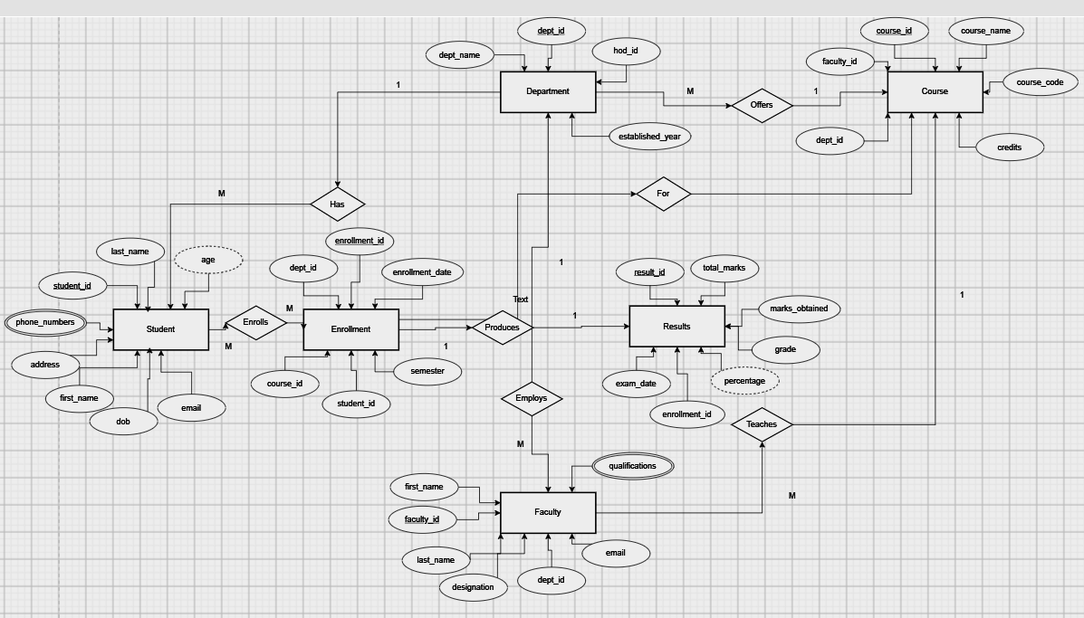
Fig. 3.1: ER Diagram of the University Academic Management System

3.4 Relationships and Cardinality
Table 3.3: Relationships and Cardinality
Entity 1 | Relationship | Entity 2 | Cardinality (1:1 / 1:N / M:N)
STUDENT | belongs to | DEPARTMENT | M:1
FACULTY | belongs to | DEPARTMENT | M:1
COURSE | offered by | DEPARTMENT | M:1
COURSE | handled by | FACULTY | M:1
STUDENT | enrolls in | COURSE | M:N
ENROLLMENT | has | RESULTS | 1:1

3.5 Relational Database Schema
Table 3.4: Relational Database Schema
Table Name | Column Name | Data Type | Key (PK / FK / —) | Constraints
DEPARTMENT | dept_id | INT | PK | AUTO_INCREMENT
 | dept_name | VARCHAR(100) | — | NOT NULL, UNIQUE
 | established_year | YEAR | — | —
 | hod_id | INT | — | Faculty_id of the HOD
FACULTY | faculty_id | INT | PK | AUTO_INCREMENT
 | first_name | VARCHAR(50) | — | NOT NULL
 | last_name | VARCHAR(50) | — | NOT NULL
 | designation | VARCHAR(50) | — | —
 | email | VARCHAR(100) | — | UNIQUE, NOT NULL
 | dept_id | INT | FK | REFERENCES DEPARTMENT(dept_id)
STUDENT | student_id | INT | PK | AUTO_INCREMENT
 | first_name | VARCHAR(50) | — | NOT NULL
 | last_name | VARCHAR(50) | — | NOT NULL
 | dob | DATE | — | —
 | email | VARCHAR(100) | — | UNIQUE, NOT NULL
 | address | TEXT | — | —
 | dept_id | INT | FK | REFERENCES DEPARTMENT(dept_id)
STUDENT_PHONE | id | INT | PK | AUTO_INCREMENT
 | student_id | INT | FK | NOT NULL, REFERENCES STUDENT(student_id)
 | phone | VARCHAR(15) | — | —
COURSE | course_id | INT | PK | AUTO_INCREMENT
 | course_name | VARCHAR(100) | — | NOT NULL
 | course_code | VARCHAR(20) | — | UNIQUE, NOT NULL
 | credits | INT | — | CHECK (credits BETWEEN 1 AND 6)
 | dept_id | INT | FK | REFERENCES DEPARTMENT(dept_id)
 | faculty_id | INT | FK | REFERENCES FACULTY(faculty_id)
ENROLLMENT | enrollment_id | INT | PK | AUTO_INCREMENT
 | student_id | INT | FK | NOT NULL, REFERENCES STUDENT(student_id)
 | course_id | INT | FK | NOT NULL, REFERENCES COURSE(course_id)
 | semester | VARCHAR(20) | — | —
 | enrollment_date | DATE | — | —
 | (student_id, course_id, semester) | — | — | UNIQUE (composite)
RESULTS | result_id | INT | PK | AUTO_INCREMENT
 | enrollment_id | INT | FK | UNIQUE, NOT NULL, REFERENCES ENROLLMENT(enrollment_id)
 | marks_obtained | DECIMAL(5,2) | — | CHECK (marks_obtained >= 0)
 | total_marks | DECIMAL(5,2) | — | DEFAULT 100
 | grade | CHAR(2) | — | —
 | exam_date | DATE | — | —

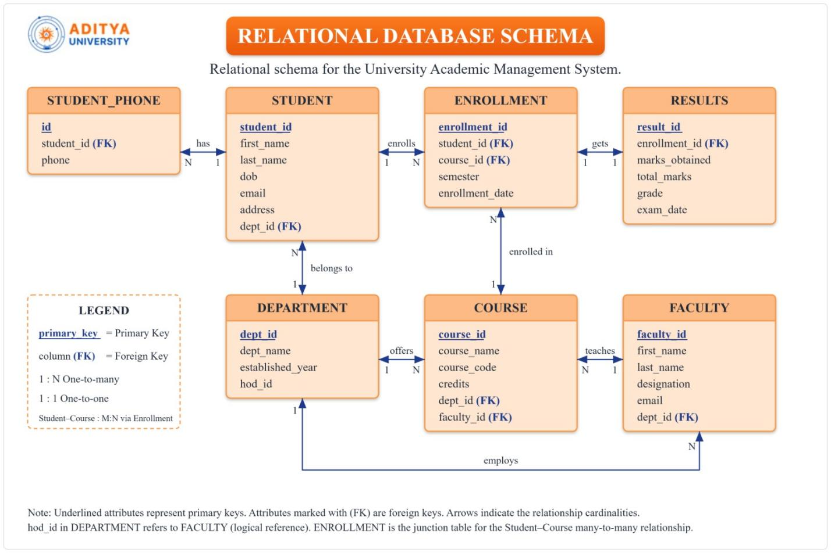
Fig. 3.2: Relational Schema Diagram

3.6 Primary Keys and Foreign Keys
Table 3.5: Primary Key and Foreign Key Definitions
Table | Primary Key | Foreign Key | References (Table.Column)
DEPARTMENT | dept_id | None enforced (hod_id holds the HOD’s faculty_id) | FACULTY(faculty_id) – logical
FACULTY | faculty_id | dept_id | DEPARTMENT(dept_id)
STUDENT | student_id | dept_id | DEPARTMENT(dept_id)
STUDENT_PHONE | id | student_id | STUDENT(student_id)
COURSE | course_id | dept_id, faculty_id | DEPARTMENT(dept_id), FACULTY(faculty_id)
ENROLLMENT | enrollment_id | student_id, course_id | STUDENT(student_id), COURSE(course_id)
RESULTS | result_id | enrollment_id | ENROLLMENT(enrollment_id)

3.7 Normalization up to 3NF
UNF → 1NF → 2NF → 3NF
- 1NF: All attributes are atomic; multi-valued phone numbers are moved to the Student_Phone table.
- 2NF: No partial dependencies — all non-key attributes depend on the full primary key.
- 3NF: No transitive dependencies — grade is determined by marks_obtained, but stored as a convenience; percentage is derived (computed in a view), not stored redundantly.
Table 3.6: Normalization Steps
Normal Form | Condition Satisfied / Action Taken
1NF | All attributes are atomic; multi-valued phone numbers moved to the Student_Phone table.
2NF | No partial dependencies — all non-key attributes depend on the full primary key.
3NF | No transitive dependencies — percentage is derived (computed in a view), not stored redundantly.

CHAPTER 4: DATABASE IMPLEMENTATION

4.1 Database and Table Creation – DDL
CREATE TABLE Department (
dept_id INT PRIMARY KEY AUTO_INCREMENT,
dept_name VARCHAR(100) NOT NULL UNIQUE,
established_year YEAR,
hod_id INT
);

CREATE TABLE Faculty (
faculty_id INT PRIMARY KEY AUTO_INCREMENT,
first_name VARCHAR(50) NOT NULL,
last_name VARCHAR(50) NOT NULL,
designation VARCHAR(50),
email VARCHAR(100) UNIQUE NOT NULL,
dept_id INT,
FOREIGN KEY (dept_id) REFERENCES Department(dept_id)
);

CREATE TABLE Student (
student_id INT PRIMARY KEY AUTO_INCREMENT,
first_name VARCHAR(50) NOT NULL,
last_name VARCHAR(50) NOT NULL,
dob DATE,
email VARCHAR(100) UNIQUE NOT NULL,
address TEXT,
dept_id INT,
FOREIGN KEY (dept_id) REFERENCES Department(dept_id)
);

CREATE TABLE Student_Phone (
id INT PRIMARY KEY AUTO_INCREMENT,
student_id INT NOT NULL,
phone VARCHAR(15),
FOREIGN KEY (student_id) REFERENCES Student(student_id)
);

CREATE TABLE Course (
course_id INT PRIMARY KEY AUTO_INCREMENT,
course_name VARCHAR(100) NOT NULL,
course_code VARCHAR(20) UNIQUE NOT NULL,
credits INT CHECK (credits BETWEEN 1 AND 6),
dept_id INT,
faculty_id INT,
FOREIGN KEY (dept_id) REFERENCES Department(dept_id),
FOREIGN KEY (faculty_id) REFERENCES Faculty(faculty_id)
);

CREATE TABLE Enrollment (
enrollment_id INT PRIMARY KEY AUTO_INCREMENT,
student_id INT NOT NULL,
course_id INT NOT NULL,
semester VARCHAR(20),
enrollment_date DATE,
UNIQUE (student_id, course_id, semester),
FOREIGN KEY (student_id) REFERENCES Student(student_id),
FOREIGN KEY (course_id) REFERENCES Course(course_id)
);

CREATE TABLE Results (
result_id INT PRIMARY KEY AUTO_INCREMENT,
enrollment_id INT UNIQUE NOT NULL,
marks_obtained DECIMAL(5,2) CHECK (marks_obtained >= 0),
total_marks DECIMAL(5,2) DEFAULT 100,
grade CHAR(2),
exam_date DATE,
FOREIGN KEY (enrollment_id) REFERENCES Enrollment(enrollment_id)
);

4.2 Sample Data Insertion – DML
Table 4.1: Sample Data Summary
S.No | Table Name | No. of Records Inserted | Sample Data / Screenshot Reference
1 | STUDENT | 10 | Student profiles across departments (Fig. 4.1)
2 | DEPARTMENT | 10 | Academic departments with HOD and office (Fig. 4.2)
3 | COURSE | 10 | Courses with credits, semester and faculty (Fig. 4.3)
4 | FACULTY | 10 | Teaching staff with qualifications (Fig. 4.4)
5 | ENROLLMENT | 10 | Student course registrations (Fig. 4.5)
6 | RESULTS | 10 | Marks and grades per exam (Fig. 4.6)
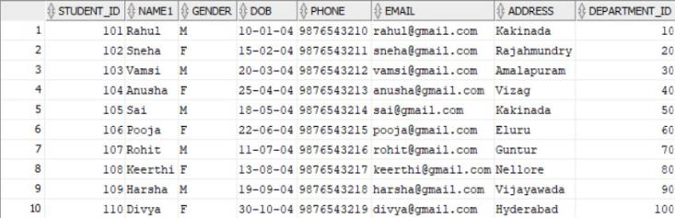
Fig. 4.1: Student Table – Sample Data
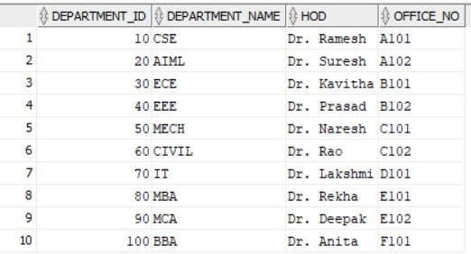
Fig. 4.2: Department Table – Sample Data
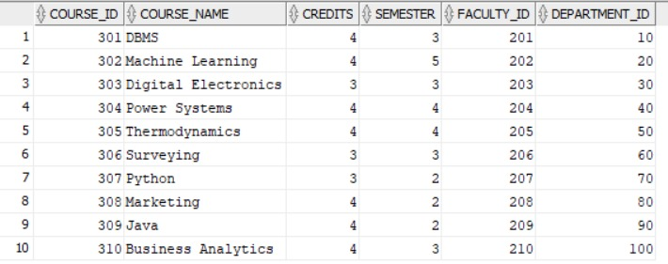
Fig. 4.3: Course Table – Sample Data
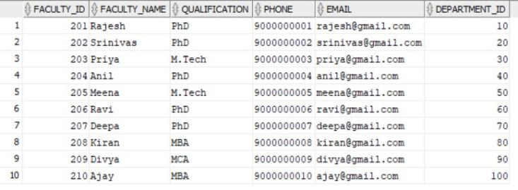
Fig. 4.4: Faculty Table – Sample Data
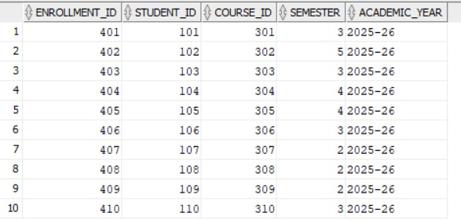
Fig. 4.5: Enrollment Table – Sample Data
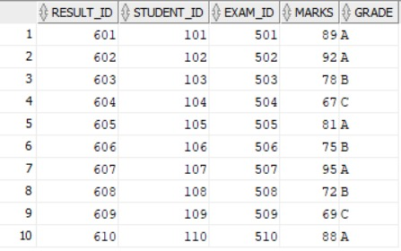
Fig. 4.6: Results Table – Sample Data

4.3 Constraints and Data Integrity
Table 4.2: Constraints and Data Integrity Rules
Constraint / Validation | Applied On | Purpose
PRIMARY KEY | All Tables (e.g., Student_ID) | Ensures no duplicate records exist for core entities.
UNIQUE | Department_Name, Email, Phone | Prevents duplication of sensitive/identifying information.
FOREIGN KEY | e.g., Department_ID in Student | Maintains referential integrity, preventing orphan records.
CHECK | Gender IN ('M', 'F') | Ensures only valid categorical data is inserted.
CHECK | Marks BETWEEN 0 AND 100 | Prevents invalid exam scores from being recorded.
DEFAULT | Maximum_Marks DEFAULT 100 | Automatically populates standard exam criteria.
NOT NULL | Core attributes (e.g., Name, HOD) | Ensures mandatory fields are never left blank.

4.4 Data Validation Rules
Data accuracy is maintained by the constraints listed above. FOREIGN KEY constraints ensure that every student, faculty member, course and enrollment refers to an existing parent record, so orphan records cannot be created. CHECK constraints reject invalid values such as marks outside 0–100 or gender values other than M and F, UNIQUE constraints prevent duplicate identifiers such as e-mail addresses and department names, and NOT NULL constraints ensure that mandatory fields are always supplied.

CHAPTER 5: SQL OPERATIONS AND QUERIES

5.1 DQL and DML – Basic Retrieval and Modification Queries
Table 5.1: Basic Retrieval and Modification Queries
Q.No | Purpose of the Query | SQL Statement
Q1 | SELECT (DQL): Fetch all students in the CSE department. | SELECT Name, Email FROM Student WHERE Department_ID = 10;
Q2 | UPDATE (DML): Update a faculty member's qualification. | UPDATE Faculty SET Qualification = 'PhD' WHERE Faculty_ID = 217;
Q3 | DELETE (DML): Remove a specific alternate phone record. | DELETE FROM Student_Phone WHERE ID = 740;

5.2 Join Operations
Table 5.2: Join Operations
Q.No | Purpose of the Query | SQL Statement
Q4 | JOIN: View student names and their respective department names. | SELECT s.Name, d.Department_Name  FROM Student s  JOIN Department d  ON s.Department_ID = d.Department_ID;

5.3 Aggregate Functions, GROUP BY and HAVING
Table 5.3: Aggregate and GROUP BY Queries
Q.No | Function Used | SQL Statement | Output Ref.
Q5 | GROUP BY: Count the number of courses offered by each department. | SELECT Department_ID, COUNT(Course_ID)  FROM Course  GROUP BY Department_ID; | Fig. 7.1
Q6 | AGGREGATE: Find the maximum marks obtained in exam 501. | SELECT MAX(Marks)  FROM Result  WHERE Exam_ID = 501; | —
Q7 | GROUP BY: Count the faculty members for each qualification. | SELECT Qualification,  COUNT(*) AS Count_Of_Qualifications  FROM Faculty  GROUP BY Qualification; | Fig. 7.2

5.4 Nested and Correlated Subqueries
Table 5.4: Subqueries
Q.No | Type (Nested / Correlated) | SQL Statement
Q8 | Basic (Nested) Subquery: Find the names of all faculty members who belong to the 'CSE' department. | SELECT Faculty_Name  FROM Faculty  WHERE Department_ID = (  SELECT Department_ID  FROM Department  WHERE Department_Name = 'CSE'  );

5.5 Views
Table 5.5: Views
Q.No | View / Purpose | SQL Statement
Q9 | Student Results View (complex join): a virtual table that simplifies querying a student’s performance by joining the Student, Result, Exam and Course tables, hiding the complex joins from the end user. | CREATE VIEW Student_Results_View AS  SELECT s.Name AS Student_Name,  c.Course_Name, e.Exam_Type,  r.Marks, r.Grade  FROM Student s  JOIN Result r ON s.Student_ID = r.Student_ID  JOIN Exam e ON r.Exam_ID = e.Exam_ID  JOIN Course c ON e.Course_ID = c.Course_ID;  SELECT * FROM Student_Results_View  WHERE Grade = 'A';

CHAPTER 6: MODULES AND FUNCTIONALITIES
Table 6.1: Modules and Their Functionalities
S.No | Module Name | Functionality | Tables Involved
1 | Administration & Dept Module | Manages high-level structures (Department). Sets up foundational data like Department IDs, Names, and HODs. | DEPARTMENT
2 | Faculty Management Module | Tracks teaching staff (Faculty), mapping them to departments and validating contact/email information. | FACULTY, DEPARTMENT
3 | Student & Enrollment Module | Handles admissions, demographic data (Student), multiple contact numbers (Student_Phone), and course registrations (Enrollment). | STUDENT, STUDENT_PHONE, ENROLLMENT
4 | Academic & Curriculum Module | Organizes the curriculum (Course), allocating specific credits, semesters, and assigning responsible faculty members. | COURSE, FACULTY
5 | Examination & Results Module | Schedules assessments (Exam) and securely records grades and marks (Result) tied to specific students and exams. | EXAM, RESULT

CHAPTER 7: RESULTS – SAMPLE OUTPUTS AND SCREENSHOTS
The following screenshots show the execution of representative queries together with their output.
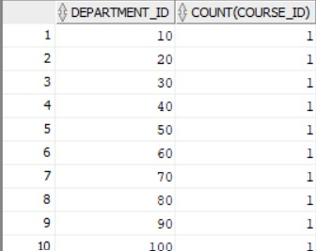
Fig. 7.1: Number of Courses Offered by Each Department (Q5)
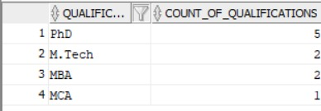
Fig. 7.2: Count of Faculty Members by Qualification (Q7)

CHAPTER 8: GITHUB REPOSITORY AND TEAM CONTRIBUTION

8.1 Repository Details
GitHub Repository Link: https://github.com/mohithnaik112-ctrl/university-academic-management

8.2 Team Responsibilities and Contribution
Table 8.1: Team Responsibilities
S.No | Student Name | Roll Number | Role / Responsibility | Contribution Status
1 | K. Bala Aditya | 25B11AI581 | ER Diagram, Entities & Attributes, Relational Schema | Completed
2 | M. Mohith Naik | 25B11AI765 | Database Creation, Tables, Primary Key, Foreign Key, Constraints | Completed
3 | G. Dileep | 25B11AI361 | DDL / DML / DQL, CRUD Queries, Documentation | Completed

CHAPTER 9: CONCLUSION AND FUTURE ENHANCEMENTS

9.1 Conclusion
The University Academic Management System project successfully transformed standard academic operations into a streamlined, highly structured relational database. By identifying key entities—Department, Faculty, Student, Course, Exam, and Results—and mapping their intricate relationships, the system eliminated data redundancy through strict normalization up to the 3rd Normal Form (3NF). The extensive use of primary keys, foreign keys, and check constraints ensures robust data integrity, preventing scenarios such as invalid grades, duplicate contacts, or unassigned courses. Ultimately, this database effectively satisfies the core objectives, providing a scalable and reliable data backbone for university administration.

9.2 Future Enhancements
The current database establishes a solid foundation for academic management. Future enhancements to scale the system include:
- Authentication and Authorization: Introducing user roles (Admin, Faculty, Student) with encrypted passwords and login logs.
- Web/Mobile Interface: Connecting the DBMS to a front-end framework for seamless GUI interactions.
- Timetable Management: Creating a scheduling module to manage classroom allocations and lecture times.
- Automated Reports & Dashboard: Integrating views for generating real-time transcripts and performance analytics.
- Backup and Recovery & Improved Security: Implementing scheduled SQL dumps and advanced role-based access control (RBAC).

REFERENCES
- Elmasri, R., & Navathe, S. B. (2015). Fundamentals of Database Systems (7th ed.). Pearson.
- Silberschatz, A., Korth, H. F., & Sudarshan, S. (2019). Database System Concepts (7th ed.). McGraw-Hill Education.
- Aditya University, Department of AI & ML, DBMS Course Curriculum & Capstone Project Guidelines, Academic Year 2025–2026.

APPENDIX A – COMPLETE SQL SCRIPT
CREATE TABLE Department (
Department_ID INTEGER PRIMARY KEY,
Department_Name VARCHAR(50) NOT NULL UNIQUE,
HOD VARCHAR(50) NOT NULL,
Office_No VARCHAR(10) NOT NULL
);

INSERT INTO Department VALUES
(10, 'CSE', 'Dr. Ramesh', 'A101'),
(20, 'AIML', 'Dr. Suresh', 'A102'),
(30, 'ECE', 'Dr. Kavitha', 'B101'),
(40, 'EEE', 'Dr. Prasad', 'B102'),
(50, 'MECH', 'Dr. Naresh', 'C101'),
(60, 'CIVIL', 'Dr. Rao', 'C102'),
(70, 'IT', 'Dr. Lakshmi', 'D101'),
(80, 'MBA', 'Dr. Rekha', 'E101'),
(90, 'MCA', 'Dr. Deepak', 'E102'),
(100, 'BBA', 'Dr. Anita', 'F101');

CREATE TABLE Faculty (
Faculty_ID INTEGER PRIMARY KEY,
Faculty_Name VARCHAR(50) NOT NULL,
Qualification VARCHAR(30),
Phone VARCHAR(10) UNIQUE,
Email VARCHAR(60) UNIQUE,
Department_ID INTEGER NOT NULL,
CONSTRAINT FK_Faculty_Department
FOREIGN KEY (Department_ID) REFERENCES Department(Department_ID)
);

INSERT INTO Faculty VALUES
(201, 'Rajesh', 'PhD', '9000000001', 'rajesh@gmail.com', 10),
(202, 'Srinivas', 'PhD', '9000000002', 'srinivas@gmail.com', 10),
(203, 'Priya', 'M.Tech', '9000000003', 'priya@gmail.com', 20),
(204, 'Anil', 'PhD', '9000000004', 'anil@gmail.com', 20),
(205, 'Meena', 'M.Tech', '9000000005', 'meena@gmail.com', 30),
(206, 'Ravi', 'PhD', '9000000006', 'ravi@gmail.com', 30),
(207, 'Deepa', 'PhD', '9000000007', 'deepa@gmail.com', 40),
(208, 'Kiran', 'M.Tech', '9000000008', 'kiran@gmail.com', 40),
(209, 'Divya', 'M.Tech', '9000000009', 'divya@gmail.com', 50),
(210, 'Ajay', 'PhD', '9000000010', 'ajay@gmail.com', 50),
(211, 'Lakshmi', 'PhD', '9000000011', 'lakshmi@gmail.com', 60),
(212, 'Mohan', 'M.Tech', '9000000012', 'mohan@gmail.com', 60),
(213, 'Sita', 'PhD', '9000000013', 'sita@gmail.com', 70),
(214, 'Vijay', 'M.Tech', '9000000014', 'vijay@gmail.com', 70),
(215, 'Rekha', 'MBA', '9000000015', 'rekha@gmail.com', 80),
(216, 'Arun', 'PhD', '9000000016', 'arun@gmail.com', 80),
(217, 'Deepak', 'MCA', '9000000017', 'deepak@gmail.com', 90),
(218, 'Kavya', 'MCA', '9000000018', 'kavya@gmail.com', 90),
(219, 'Anita', 'MBA', '9000000019', 'anita@gmail.com', 100),
(220, 'Manoj', 'MBA', '9000000020', 'manoj@gmail.com', 100);

CREATE TABLE Student (
Student_ID INTEGER PRIMARY KEY,
Name VARCHAR(50) NOT NULL,
Gender CHAR(1),
DOB DATE,
Email VARCHAR(60) UNIQUE,
Address VARCHAR(100),
Department_ID INTEGER NOT NULL,
CONSTRAINT CHK_Student_Gender CHECK (Gender IN ('M', 'F')),
CONSTRAINT FK_Student_Department
FOREIGN KEY (Department_ID) REFERENCES Department(Department_ID)
);

INSERT INTO Student VALUES
(101, 'Rahul', 'M', '2004-01-10', 'rahul@gmail.com', 'Kakinada, Andhra Pradesh', 10),
(102, 'Sneha', 'F', '2004-02-15', 'sneha@gmail.com', 'Rajahmundry, Andhra Pradesh', 20),
(103, 'Vamsi', 'M', '2004-03-20', 'vamsi@gmail.com', 'Amalapuram, Andhra Pradesh', 30),
(104, 'Anusha', 'F', '2004-04-25', 'anusha@gmail.com', 'Visakhapatnam, Andhra Pradesh', 40),
(105, 'Sai', 'M', '2004-05-18', 'sai@gmail.com', 'Kakinada, Andhra Pradesh', 50),
(106, 'Pooja', 'F', '2004-06-22', 'pooja@gmail.com', 'Eluru, Andhra Pradesh', 60),
(107, 'Rohit', 'M', '2004-07-11', 'rohit@gmail.com', 'Guntur, Andhra Pradesh', 70),
(108, 'Keerthi', 'F', '2004-08-13', 'keerthi@gmail.com', 'Nellore, Andhra Pradesh', 80),
(109, 'Harsha', 'M', '2004-09-19', 'harsha@gmail.com', 'Vijayawada, Andhra Pradesh', 90),
(110, 'Divya', 'F', '2004-10-30', 'divya@gmail.com', 'Tirupati, Andhra Pradesh', 100),
(111, 'Arjun', 'M', '2004-01-21', 'arjun@gmail.com', 'Ongole, Andhra Pradesh', 10),
(112, 'Manasa', 'F', '2004-02-26', 'manasa@gmail.com', 'Chittoor, Andhra Pradesh', 20),
(113, 'Kiran', 'M', '2004-03-14', 'kiran.student@gmail.com', 'Srikakulam, Andhra Pradesh', 30),
(114, 'Lavanya', 'F', '2004-04-09', 'lavanya@gmail.com', 'Anantapur, Andhra Pradesh', 40),
(115, 'Naveen', 'M', '2004-05-27', 'naveen@gmail.com', 'Kadapa, Andhra Pradesh', 50),
(116, 'Sravani', 'F', '2004-06-16', 'sravani@gmail.com', 'Machilipatnam, Andhra Pradesh', 60),
(117, 'Teja', 'M', '2004-07-23', 'teja@gmail.com', 'Tenali, Andhra Pradesh', 70),
(118, 'Bhavya', 'F', '2004-08-05', 'bhavya@gmail.com', 'Vizianagaram, Andhra Pradesh', 80),
(119, 'Charan', 'M', '2004-09-28', 'charan@gmail.com', 'Proddatur, Andhra Pradesh', 90),
(120, 'Aishwarya', 'F', '2004-10-12', 'aishwarya@gmail.com', 'Bhimavaram, Andhra Pradesh', 100);

-- Phone numbers are stored separately so each student can have alternate numbers.
-- Values use India's +91 country code followed by ten digits.
CREATE TABLE Student_Phone (
ID INTEGER PRIMARY KEY,
Student_ID INTEGER NOT NULL,
Phone VARCHAR(13) NOT NULL,
Phone_Type VARCHAR(10) NOT NULL,
CONSTRAINT FK_Student_Phone_Student
FOREIGN KEY (Student_ID) REFERENCES Student(Student_ID),
CONSTRAINT CHK_Student_Phone_Type CHECK (Phone_Type IN ('Primary', 'Alternate'))
);

INSERT INTO Student_Phone VALUES
(701, 101, '+919876540001', 'Primary'), (702, 101, '+919876540002', 'Alternate'),
(703, 102, '+919876540003', 'Primary'), (704, 102, '+919876540004', 'Alternate'),
(705, 103, '+919876540005', 'Primary'), (706, 103, '+919876540006', 'Alternate'),
(707, 104, '+919876540007', 'Primary'), (708, 104, '+919876540008', 'Alternate'),
(709, 105, '+919876540009', 'Primary'), (710, 105, '+919876540010', 'Alternate'),
(711, 106, '+919876540011', 'Primary'), (712, 106, '+919876540012', 'Alternate'),
(713, 107, '+919876540013', 'Primary'), (714, 107, '+919876540014', 'Alternate'),
(715, 108, '+919876540015', 'Primary'), (716, 108, '+919876540016', 'Alternate'),
(717, 109, '+919876540017', 'Primary'), (718, 109, '+919876540018', 'Alternate'),
(719, 110, '+919876540019', 'Primary'), (720, 110, '+919876540020', 'Alternate'),
(721, 111, '+919876540021', 'Primary'), (722, 111, '+919876540022', 'Alternate'),
(723, 112, '+919876540023', 'Primary'), (724, 112, '+919876540024', 'Alternate'),
(725, 113, '+919876540025', 'Primary'), (726, 113, '+919876540026', 'Alternate'),
(727, 114, '+919876540027', 'Primary'), (728, 114, '+919876540028', 'Alternate'),
(729, 115, '+919876540029', 'Primary'), (730, 115, '+919876540030', 'Alternate'),
(731, 116, '+919876540031', 'Primary'), (732, 116, '+919876540032', 'Alternate'),
(733, 117, '+919876540033', 'Primary'), (734, 117, '+919876540034', 'Alternate'),
(735, 118, '+919876540035', 'Primary'), (736, 118, '+919876540036', 'Alternate'),
(737, 119, '+919876540037', 'Primary'), (738, 119, '+919876540038', 'Alternate'),
(739, 120, '+919876540039', 'Primary'), (740, 120, '+919876540040', 'Alternate');

CREATE TABLE Course (
Course_ID INTEGER PRIMARY KEY,
Course_Name VARCHAR(60) NOT NULL,
Credits INTEGER CHECK (Credits BETWEEN 1 AND 5),
Semester INTEGER CHECK (Semester BETWEEN 1 AND 8),
Faculty_ID INTEGER NOT NULL,
Department_ID INTEGER NOT NULL,
CONSTRAINT FK_Course_Faculty
FOREIGN KEY (Faculty_ID) REFERENCES Faculty(Faculty_ID),
CONSTRAINT FK_Course_Department
FOREIGN KEY (Department_ID) REFERENCES Department(Department_ID)
);

INSERT INTO Course VALUES
(301, 'Database Management Systems', 4, 3, 201, 10),
(302, 'Machine Learning', 4, 5, 203, 20),
(303, 'Digital Electronics', 3, 3, 205, 30),
(304, 'Power Systems', 4, 4, 207, 40),
(305, 'Thermodynamics', 4, 4, 209, 50),
(306, 'Surveying', 3, 3, 211, 60),
(307, 'Python Programming', 3, 2, 213, 70),
(308, 'Marketing', 4, 2, 215, 80),
(309, 'Java Programming', 4, 2, 217, 90),
(310, 'Business Analytics', 4, 3, 219, 100),
(311, 'Data Structures', 4, 3, 202, 10),
(312, 'Artificial Intelligence', 4, 5, 204, 20),
(313, 'Communication Systems', 3, 4, 206, 30),
(314, 'Electrical Machines', 4, 5, 208, 40),
(315, 'Manufacturing Processes', 3, 3, 210, 50),
(316, 'Structural Engineering', 4, 5, 212, 60),
(317, 'Web Technologies', 3, 4, 214, 70),
(318, 'Financial Management', 4, 4, 216, 80),
(319, 'Software Engineering', 4, 5, 218, 90),
(320, 'Principles of Management', 3, 2, 220, 100);

CREATE TABLE Enrollment (
Enrollment_ID INTEGER PRIMARY KEY,
Student_ID INTEGER NOT NULL,
Course_ID INTEGER NOT NULL,
Semester INTEGER,
Academic_Year VARCHAR(10),
CONSTRAINT FK_Enroll_Student
FOREIGN KEY (Student_ID) REFERENCES Student(Student_ID),
CONSTRAINT FK_Enroll_Course
FOREIGN KEY (Course_ID) REFERENCES Course(Course_ID)
);

INSERT INTO Enrollment VALUES
(401, 101, 301, 3, '2025-26'), (402, 102, 302, 5, '2025-26'),
(403, 103, 303, 3, '2025-26'), (404, 104, 304, 4, '2025-26'),
(405, 105, 305, 4, '2025-26'), (406, 106, 306, 3, '2025-26'),
(407, 107, 307, 2, '2025-26'), (408, 108, 308, 2, '2025-26'),
(409, 109, 309, 2, '2025-26'), (410, 110, 310, 3, '2025-26'),
(411, 111, 311, 3, '2025-26'), (412, 112, 312, 5, '2025-26'),
(413, 113, 313, 4, '2025-26'), (414, 114, 314, 5, '2025-26'),
(415, 115, 315, 3, '2025-26'), (416, 116, 316, 5, '2025-26'),
(417, 117, 317, 4, '2025-26'), (418, 118, 318, 4, '2025-26'),
(419, 119, 319, 5, '2025-26'), (420, 120, 320, 2, '2025-26');

CREATE TABLE Exam (
Exam_ID INTEGER PRIMARY KEY,
Course_ID INTEGER NOT NULL,
Exam_Type VARCHAR(20),
Exam_Date DATE,
Maximum_Marks INTEGER DEFAULT 100,
CONSTRAINT FK_Exam_Course
FOREIGN KEY (Course_ID) REFERENCES Course(Course_ID)
);

INSERT INTO Exam (Exam_ID, Course_ID, Exam_Type, Exam_Date, Maximum_Marks) VALUES
(501, 301, 'Mid', '2026-02-10', 100), (502, 302, 'Mid', '2026-02-11', 100),
(503, 303, 'Mid', '2026-02-12', 100), (504, 304, 'Mid', '2026-02-13', 100),
(505, 305, 'Mid', '2026-02-14', 100), (506, 306, 'Mid', '2026-02-15', 100),
(507, 307, 'Mid', '2026-02-16', 100), (508, 308, 'Mid', '2026-02-17', 100),
(509, 309, 'Mid', '2026-02-18', 100), (510, 310, 'Mid', '2026-02-19', 100),
(511, 311, 'Mid', '2026-02-20', 100), (512, 312, 'Mid', '2026-02-21', 100),
(513, 313, 'Mid', '2026-02-22', 100), (514, 314, 'Mid', '2026-02-23', 100),
(515, 315, 'Mid', '2026-02-24', 100), (516, 316, 'Mid', '2026-02-25', 100),
(517, 317, 'Mid', '2026-02-26', 100), (518, 318, 'Mid', '2026-02-27', 100),
(519, 319, 'Mid', '2026-02-28', 100), (520, 320, 'Mid', '2026-03-01', 100);

CREATE TABLE Result (
Result_ID INTEGER PRIMARY KEY,
Student_ID INTEGER NOT NULL,
Exam_ID INTEGER NOT NULL,
Marks INTEGER CHECK (Marks BETWEEN 0 AND 100),
Grade CHAR(2),
CONSTRAINT FK_Result_Student
FOREIGN KEY (Student_ID) REFERENCES Student(Student_ID),
CONSTRAINT FK_Result_Exam
FOREIGN KEY (Exam_ID) REFERENCES Exam(Exam_ID)
);

INSERT INTO Result VALUES
(601, 101, 501, 89, 'A'), (602, 102, 502, 92, 'A'),
(603, 103, 503, 78, 'B'), (604, 104, 504, 67, 'C'),
(605, 105, 505, 81, 'A'), (606, 106, 506, 75, 'B'),
(607, 107, 507, 95, 'A'), (608, 108, 508, 72, 'B'),
(609, 109, 509, 69, 'C'), (610, 110, 510, 88, 'A'),
(611, 111, 511, 84, 'A'), (612, 112, 512, 91, 'A'),
(613, 113, 513, 76, 'B'), (614, 114, 514, 63, 'C'),
(615, 115, 515, 86, 'A'), (616, 116, 516, 79, 'B'),
(617, 117, 517, 94, 'A'), (618, 118, 518, 71, 'B'),
(619, 119, 519, 68, 'C'), (620, 120, 520, 90, 'A');

