Installations:-
Nodejs and visual studio code
Playwright Intro:-
Playwright is an open‑source test automation framework used for end‑to‑end testing of modern web applications.
It was developed by Microsoft and first released in January 2020.
It allows you to automate and test web apps across Chromium, Firefox, and WebKit using one unified API.
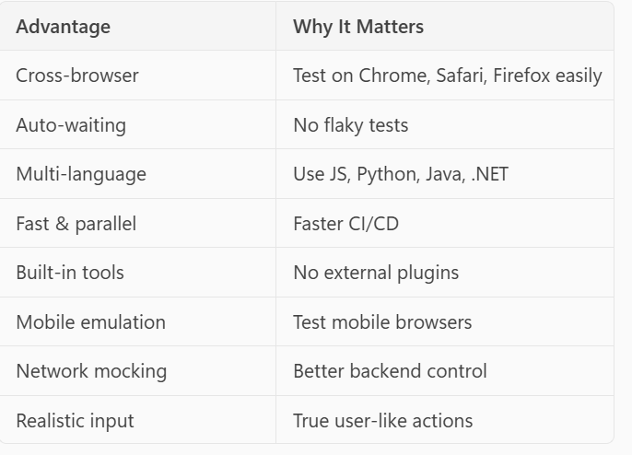
API:- Application Programming Interface
It allows two software systems to communicate with each other.
API testing:- API Testing is a type of software testing where you test the backend of an application

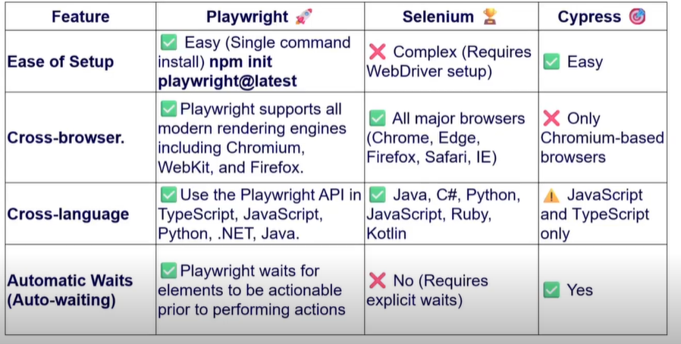
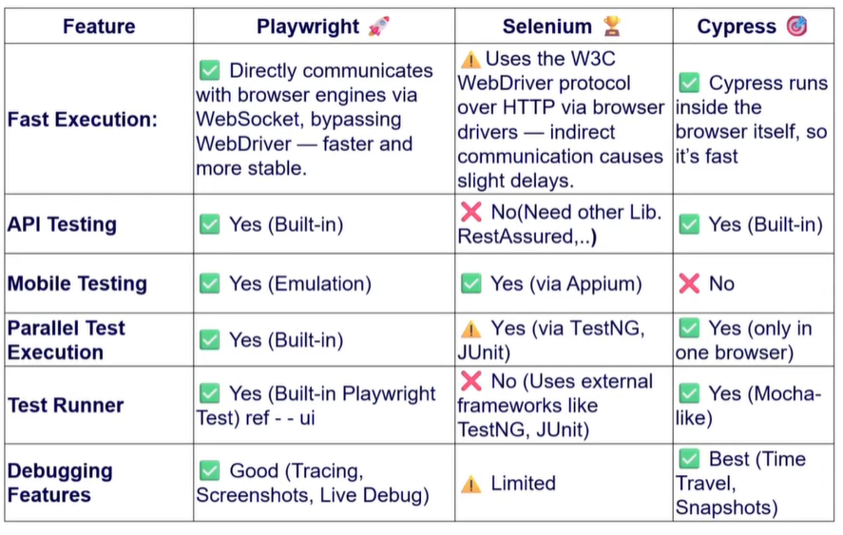
Playwright use web socket connection means one initial hand shake connect is enough and all the data can the transfer by the same connection but selenium use http request but everytime a new request must be established.

