**Project Specification Report**

**Of Airbnb**

**Submitted By:**

**Mohit Jain (18200991)**

**Ankur Dilip Ghogale (19193866)**

**Dipanshu Chaudhary (19193092)**

**Abstract**

Business Intelligence systems delivers high benefits that can be very useful to gain high profitability in all the departments of business on the basis of company data. It combines all the data with the business analytical tools to convert it into key business information which can be very useful for planners and management to make more intelligent decision. The paper aims at summarizing processes of building business intelligence and analytics system and it is mostly focused on business analytics and business customer service.

**Background Information:**

Joe Gebbia, Brian Chesky, and Nathan Blecharczyk developed the business in 2008 initially with the name Air Bed and Breakfast to make a few extra bucks to pay rent. The startup experienced several ups and down and it went through numerous rejections from the investors. However, finally a venture capitalist, Paul Graham invested in the company in exchange for the percentage of the company. Later, in 2009, the name Air Bed and Breakfast was changed to Airbnb and that was the turning point of the company. Recent figure shows the valuation of the home sharing company has grown to $35 billion and it’s grown from helping 21,000 users to find a place to helping 6 millions per year and currently has listed around 800000 properties in 34000 cities across 90 different countries. At this point Airbnb has more listings than the top major hotel brands combined. [1]

**Marketplace:**

Airbnb is an online market place which acts as an intermediary between those who want to rent out space and who are looking for places to stay for a short term. It does not own properties. It takes 3% commission from host and between 6% to 12% from guests. For booking, the user has to first create an account by giving the required information and once the information is fed, the user is asked to agree to its terms and conditions regarding religion, racism, sex and other factors. Once you agree, your account is active. The users are provided with two options i.e. guest or host.

**Scope of Processes:**

* **Customer Feedback Survey:**

Once the customer checks out, a feedback form will be sent to his email as well as his Airbnb account. Then the user will be asked to tick out all the services and amenities that he found below standard. Along with it, there is a rating option to rate the overall experience and a description box to send the brief description of the problem faced. There is also a review option for the user to post their responses. All the negative reviews will be raised as tickets in customer service CRM and the feedbacks with low ratings and problem description mentioned will be raised as ticket on high priority. The priority of the feedback will be set according to the rating given. If the rating given is low then that ticket will be set on high priority and assigned to costumer service representative who will work on resolving the same.

* **Holiday package deal:**

A complete holiday package deal will be given to the guests who are planning to visit different parts of the country. This package is mostly intended for the people who plans their long vacations individually or with family. They will be asked to fill an online form consisting information about their destinations, dates and the type of property they would like to rent and accordingly recommendations will be made with a complete package deal. If they like the deal they can opt for it .

**System Design:**

In a System Design, the process of implementing the business solution is discussed. Above flow diagram shows the brief explanation of how this systems works.

* **Setting Business Goals**: In this step, we will setup business idea and implementation of that idea.
* **CRM implementation**: This is implemented to support and prioritize the customers according to their request.
* **Visualization and Analysis**: This helps in analysing the market after implementing our business idea, also it gives us the practical way to implement the Idea.
* **Power BI dashboards**: It help us in visualizing the previous market pattern and trend, which could help us in functioning the further process.
* **Business Solution**: It brief the overall solution we are planning to implement on the market.

Type of System Design:

* *Architectural Design*: This deals with the overall structure of the system, which includes models, views and behaviour of the system.
* *Logical Design*: It shows how data flows through an entire system, in our case we are visualizing it through the ER diagram.
* *Physical Design*: It involve how we will deals with customers and their request with in system, and what are the measures taken to response it. [2]

**Database Design:**

Database design is a collection of processes that facilitate the designing, development, implementation and maintenance of enterprise data management system. It is one important part of analysis and data management phase to create an effective business application software. Properly designed database are easy to maintain, improves data consistency and saves money in terms of storage space. The database designer decides how the data interrelates and what data must be stored. For implementing business analysis different datasets are integrated and joined with the help of relatable columns as below:

* **Property:** This dataset contains brief information about 18 types of properties along with its room type and rent. It has six columns namely: Listing ID, Property name, Property type, latitude, longitude and price.
* **Host:** This dataset table consists of brief information about the host and their responses on their property page. This table is attached to property table by listing ids. It has six columns namely: host_id, host_name, Listing ID, is host a superhost?, host response rate and Host list count.
* **Listing:** It gives brief information about the number of availabilities of the property and its neighbourhood. It contains foreign keys to join it to property and host table. This table has total 8 columns: Listing ID, host_id, neighbourhood_group, room_type, price, number of reviews and availability_365.
* **Reviews:** This dataset is used to keep record of all the responses and ratings given by user about the property. It contains foreign keys from property and customer tables. This dataset contains four fields: Listing ID, Customer ID, reviewer_name and Review rating.
* **Customer:** This dataset table contains information about the customer which can be used to communicate with the customer in case of any situation. The table consists of six columns: Customer ID, First_Name, Last_Name, email, gender, and Age.

**Entity Relationship Model:** It will show how all the datasets are correlated and what are the links correlating them. Below is the ER diagram:

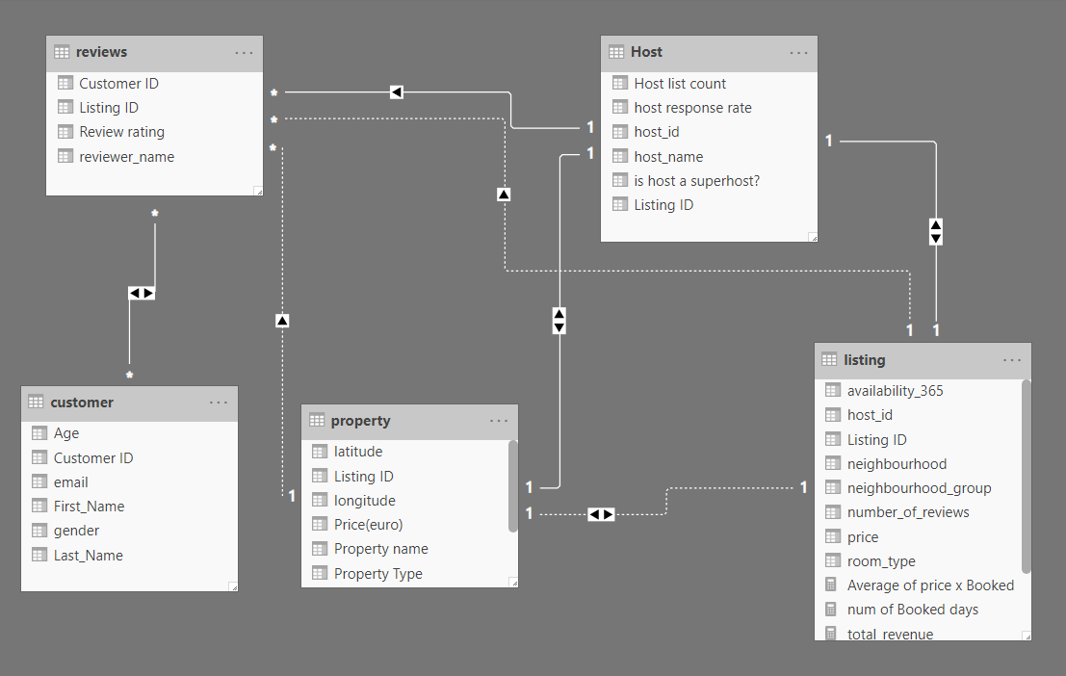

**Data Dictionary:** A data dictionary also called as data definition matrix, contains metadata i.e. data about the database. It is very important as it provides information such as what is in the dataset and where is this dataset stored physically. Below are the data dictionaries used in this project:

|  |  |  |
| --- | --- | --- |
| Property | Datatype | Description |
| Listing ID | int | Primary Key |
| Property name | varchar | Name of the property |
| Property Type | varchar | Which type of property it is |
| latitude | float | Location of the property |
| longitude | float | Location of the property |
| Price(euro) | int | Price of the property |

|  |  |  |
| --- | --- | --- |
| Host | Datatype | Description |
| host_id | int | Primary Key |
| host_name | varchar | Name of the host |
| Listing ID | int | Foreign Key |
| is host a superhost | Boolean | whether a host is a superhost or not |
| host response rate | float | how much time does host takes to responds |
| Host list count | int | total listing that one host has |

|  |  |  |
| --- | --- | --- |
| Customer | Data_Type | Description |
| Customer ID | int | Primary Key |
| First_Name | varchar | first name of the Airbnb customer |
| Last_Name | varchar | last name of the Airbnb customer |
| gender | Boolean | Gender of the customer |
| email | varchar | Email id of the customer |
| Age | int | Age of the customer |
| Phone Number | int | Mobile Number of the customer |

|  |  |  |
| --- | --- | --- |
| Listing | Data_Type | Description |
| Listing ID | int | Primary Key |
| host_id | int | Foreign Key |
| neighbourhood_group | varchar | neighbourhood group of the property |
| neighbourhood | varchar | neighbourhood of the property |
| room_type | varchar | which type of room it is |
| number_of_reviews | int | total number of reviews in last year |
| availability_365 | int | total number of days on which room is available in last year |

|  |  |  |
| --- | --- | --- |
| Review | Data_type | Description |
| Customer_id | int | Primary Key |
| Listing ID | int | Foreign Key |
| reviewer_name | varchar | customer name who gave the review |
| Review rating | float | rating given by customer |

**Test data:** The Airbnb data was taken from Kaggle for reference and then new columns were added using mockaroo.com [3] as per business requirements. Later this data was used for Power BI and Dynamics 365 CRM (Customer service).

Data Source link:

* **Property:**

* **Host:**

* **Listing:**



* **Reviews:**

* **Customer:**

**Customer Integration:**

Customers are important entity of this system. Customer integration is the part of customer relationship management which uses technology that allows customer to raise their issues and get in direct contact of the organisation in case of any concerns or queries. A good customer integration system acts as middlemen to reduce the company’s cost on human resources.

Effective customer integration will help to achieve following goals:

* Enhanced tracking of customer needs.
* Improvement in customer satisfaction
* An improvement in brand value.
* Increase in customer loyalty and retention.
* Improved targeted marketing.

**Reference:**

**[1] Business Insider. 2020. *How 3 Guys Turned Renting Air Mattresses In Their Apartment Into A $31 Billion Company, Airbnb*. [Online] Available at: <https://www.businessinsider.com/how-airbnb-was-founded-a-visual-history-2016-2?r=US&IR=T> [Accessed 4 April 2020].**

**[2] Tutorialspoint.com. 2020. *System Analysis And Design - Overview - Tutorialspoint*.[online]Availableat:https://www.tutorialspoint.com/system_analysis_and_design/system_analysis_and_design_overview.htm> [Accessed 10 April 2020].**

**[3] Mockaroo.com. 2020. Mockaroo - Random Data Generator And API Mocking Tool | JSON/CSV/SQL / Excel. [online] Available at: <https://www.mockaroo.com/schemas/new> [Accessed 12 April 2020].**