**Project Implementation Report**

**Of Airbnb**

**Submitted By:**

**Mohit Jain (18200991)**

**Ankur Dilip Ghogale (19193866)**

**Dipanshu Chaudhary (19193092)**

**Introduction**

The development of the business is focused on enhancing customer satisfaction by solving their issues, providing user’s value for their stay and introducing customer’s package deals at a lower cost. The various models and frameworks used in helping to grow the business are discussed with the insights that were obtained to support the decision.

**Balance Scorecard**

This model is used to evaluate our business on the basis of measures which include financial perspective, learning and growth perspective, customer perspective and business process perspective. The balance scorecard is generally used by an organization to implement strategy to see whether the values added are up to the mark.

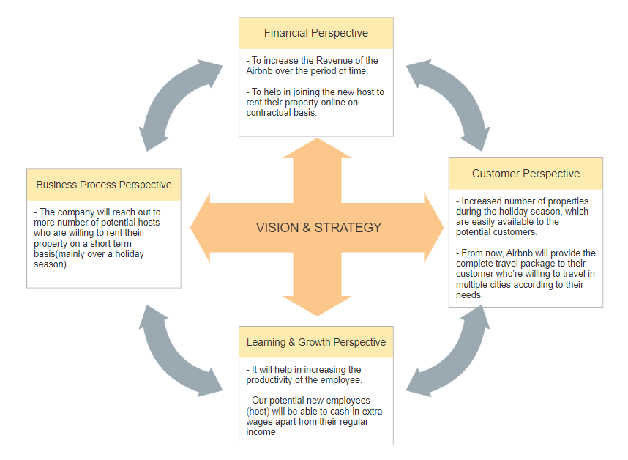

For Airbnb, the balance score card contains four parameters which are mention on the diagram above:

Four perspective of this scorecard are:

1. Financial
2. Customer
3. Learning and Growth
4. Business Process

This scorecard helps in analysing the necessary strategies required to grow our business.

1. **Financial Perspective**

As our business proposal, the main objective behind this is to increase the revenue of the Airbnb, and with the help of new hosts, who will join the Airbnb to rent their properties on a tenure basis or whenever it seems convenient for the host to put their listing back on rent.

1. **Customer Perspective**

By increasing the contract based accommodation, the accommodation will be increased in the busy region when it require the most.

Airbnb are going to provide tour packages for travellers who want to travel across the country.

1. **Learning and Growth Perspective**

Airbnb will help in increasing the productivity of the employee, also the potential host could also cash-in some extra income by renting their property.

1. **Business Process Perspective**

To increase the host in an Airbnb, the company will reach out to the people who has the property and are interested in renting either on temporary or permanent based.

**Implementation in Dynamic CRM**

Customer Relationship Management is an important aspect for today business to gain growth in this competitive environment. It is a tool to streamline and accelerate all the customer support activities of the company. It is vital for every business to make sure that there existing and new customers are satisfied with your service.

After the check-out of the guest, a feedback form is sent to costumer for knowing their experience. This form would give customer the authority to rate the amenities given and highlight the points which are needed to be improved. Then depending upon the ratings of every amenity and the issue description a ticket will be raised in the system and the priority of it will depend upon the overall level of satisfaction.

Below are the points which should be considered while using CRM to deliver better customer service:

* **Collect Information:** Information of customers are necessary to provide good customer service. This information is needed to be collected, stored and tracked to know the needs of customer. If a customer is not happy with any amenity or service his issue will be raised as ticket and will be assigned further to any customer service representative who shall be asked to get in touch with the customer. This fields are called cases in CRM terms.

* **Handle customer complain:** The most important aspect of CRM is to deliver fast response to the customers. As soon as the feedback form filled is submitted, all the data about the customer is stored in CRM, but if the overall experience is dissatisfying then a ticket will be raised and depending upon the availability of associates the ticket will be assigned. From the below it can be seen that on the right hand side there is information like who has been assigned the ticket, the priority, time when the ticket was raised and its status. The case flow starts with identifying the issue and then doing research about the issue and when it is solved and communicated to customer its status changes to resolve and the case becomes inactive.

The below figures show all the active cases which are not dealt with yet and the case which is resolved. The cases has to be solved as soon as possible to make a better customer service.

* **Analysing the tickets raised:** CRM collects all the important data about the tickets raised which can be used to analyse costumer requirements and predict costumer behaviour to make future business strategies. This helps to maximize customer satisfaction and improve business profit.

The below dashboard shows comparison of various factors like cases resolution trend, count of all cases depending upon their status and dates they raised on.

**Power BI implementation**

Power BI is a visualization which is widely used in cooperate world. It helps in visualizing the pattern and trend of any market in the world, if we have a sufficient data to analyse it. For this project we have imported the Berlin Airbnb Dataset with the help of which we are analysing the different perspective of this business organisation in Berlin. We have done several analysis using this visualization tool which are mentioned below:

**Total Booked Property in Last Year:**

This diagram show an average of what type of property does traveller usually prefers, in this scenario in the last year among all the boat type properties 321 days are booked, which is highest in berlin and apartment type properties is the second popular property type which on average 225 days are booked.

**Price versus Property**

This graph shows the price of the property which are mentioned on the Airbnb Berlin, and the plot is arranged in the descending order. Through this graph we can see that the price range of properties in berlin range from 10 to 2500 euros, and the most expensive property is the penthouse.

**Total Revenue**

The total revenue is calculated by measuring per night price of the each property with the total no of days booked in the last year. So the total revenue generated from the Berlin Airbnb in the last year is 29.01 million euros

**Geographical Representation (Property Type)**

This help us in visualizing which area of berlin have a specific property type and which neighbourhood is busy for Airbnb.

**Availability of House (Neighbourhood Group):**

This Pie chart represent the availability of the accommodation in the neighbourhood group in Berlin with help of which we can get to know that these neighbourhood group requires endorsement or changes to make it likeable among traveller.

**Top Property in Berlin**

Above mentioned are top 5 most rated property in Berlin, this shows which are the property that we can highlight during the marketing.

**Business Goals**

To increase the revenue and expand the Airbnb market we are planning to implement the few ideas which help in growing their business.

* For the Airbnb, we are planning to give the holiday package to the customer who are planning to visit various parts of the country, it attracts a vast amount of audience who pays to some other entity and to plan and book their accommodation.
* To increase the revenue, we are planning to increase the popular property types having high demands in the respective neighbourhood for example: traveller usually prefer penthouse or cottage property in a county side area, but in a city traveller usually prefer apartment type property.
* To expand the market, we will try to contact more host to join the Airbnb on the contract or temporary based, which would be feasible for the host and also the traveller who may not found the property at that time because of the unavailability, with the help of this we are not only benefitting the customer but also the host which allows them to earn some extra wages apart from their regular income.

**Team work:**

In this Project we all have worked to achieve a single goal which is to help Airbnb in increasing its revenue and to expand its audience, which eventually helps Airbnb to grow their market.

Business Idea- Mohit Jain and Ankur Dilip Ghogale has worked on the profitable business idea.

Power BI- Mohit Jain has worked on the visualization through Power BI.

Customer Feedback- Ankur Dilip Ghogale has worked on the Customer Feedback, which improves the traveller experience.

CRM- Mohit Jain and Ankur Dilip Ghogale both worked on the CRM model, in which we have shown the customer feedback and the query raised by them, also what are the action taken to resolve those issue.

Report- Mohit Jain and Ankur Dilip Ghogale worked together on the implementation and specification document.