CR23532 – Cyber and Digital Forensics Lab

Experiment 1

Aim
To study computer forensics and the different tools used for forensic investigation.

Tools Overview
Tool | Purpose
EnCase Forensic | Commercial suite; most widely used by law enforcement
FTK (Forensic Tool Kit) | Commercial suite by AccessData; includes free FTK Imager
ProDiscover | Commercial forensic suite
The Sleuth Kit (TSK) | Free, open-source forensic suite
Helix | Free incident response and forensic live CD
Knoppix | Free forensic-capable live Linux
Autopsy | GUI for The Sleuth Kit; investigates what happened on a computer
FTK Imager | Forensic disk imager and file recovery
Log Parser Lizard GUI | Flexible log file parser
Noxcivis Field Toolkit | Collects information from a computer in the field
Active@ Partition Recovery | Recovers deleted partitions

Procedure
- Understand digital forensics: finding who is responsible for a digital intrusion or computer crime.
- Note the basic idea: the perpetrator always leaves traces – log entries, registry changes, malware, remnants of deleted files.
- Study the three major commercial suites: EnCase Forensic, FTK and ProDiscover.
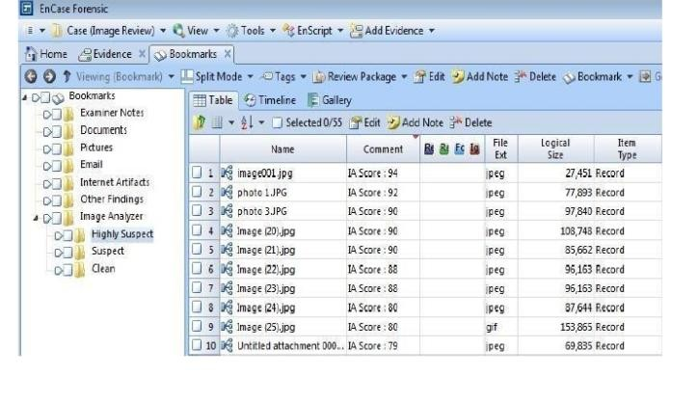
Fig. 1.1 – EnCase Forensic – Image Analyzer bookmarks view
- Study the free open-source suites: The Sleuth Kit, Helix and Knoppix.
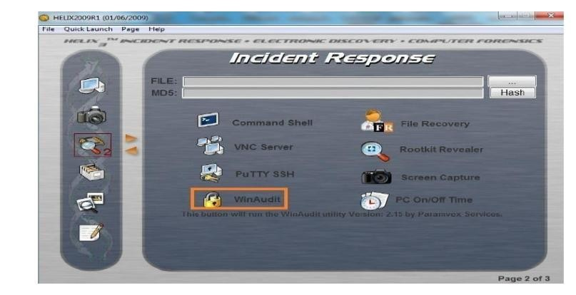
Fig. 1.2 – Helix – Incident Response screen
- Open the Forensics menu in BackTrack/Kali and locate Forensic Suites (autopsy, ptk, sleuthkit).
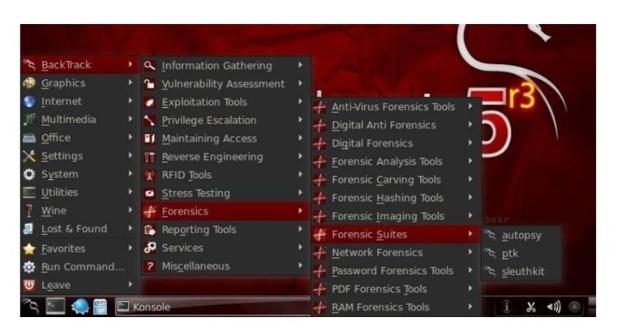
Fig. 1.3 – BackTrack – Forensics > Forensic Suites
- Note other BackTrack tools:
- sleuthkit, truecrypt, hexedit, autopsy, iphoneanalyzer
- rifiuti2, ptk, exiftool, evtparse.pl, fatback
- scalpel, dc3dd, driftnet, timestomp
- Study the field tools: FTK Imager, Log Parser Lizard GUI, Noxcivis Field Toolkit, Active@ Partition Recovery and Autopsy.

Result
The forensic tools were studied and their use in capturing and analysing evidence was understood.

