CR23532 – Cyber and Digital Forensics Lab

Experiment 2

Aim
To carry out a live forensics case investigation using Autopsy.

Tools Used
Autopsy (disk image: Pendrive image.001)

Procedure
- Download and install Autopsy, then launch it and click New Case.
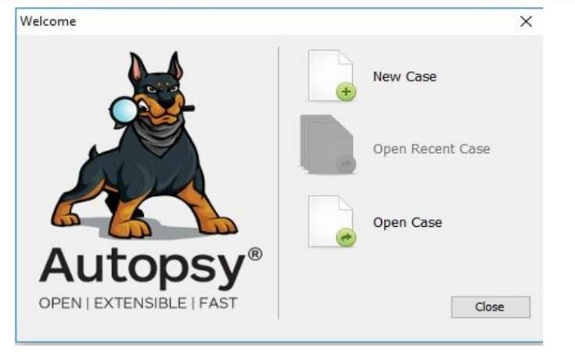
Fig. 2.1 – Autopsy welcome screen
- Enter the Case Name and Base Directory (report location), keep Case Type as Single-user, click Next.
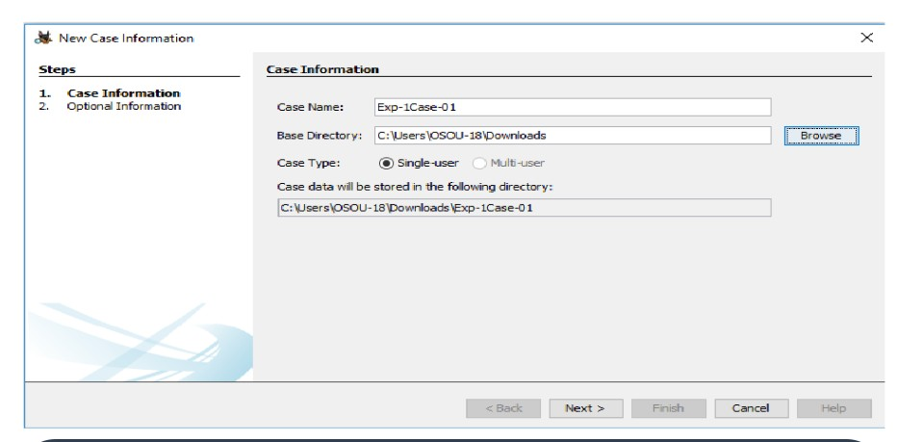
Fig. 2.2 – New Case Information
- Enter the Case Number and Examiner details, click Finish.
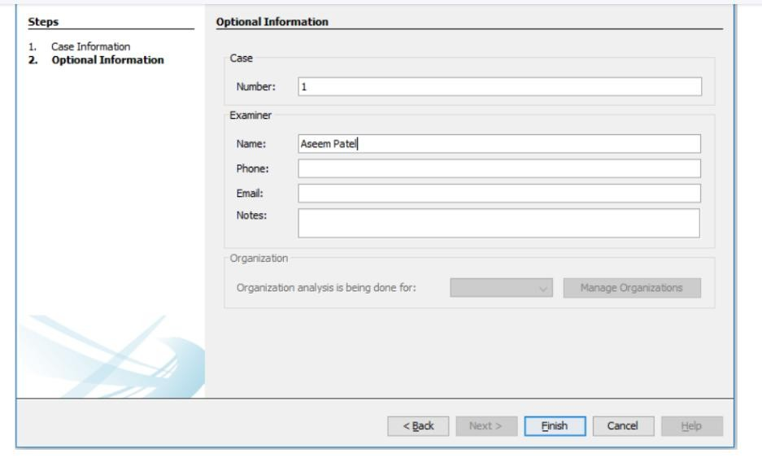
Fig. 2.3 – Optional Information – case number and examiner
- In Add Data Source, select Disk Image or VM File.
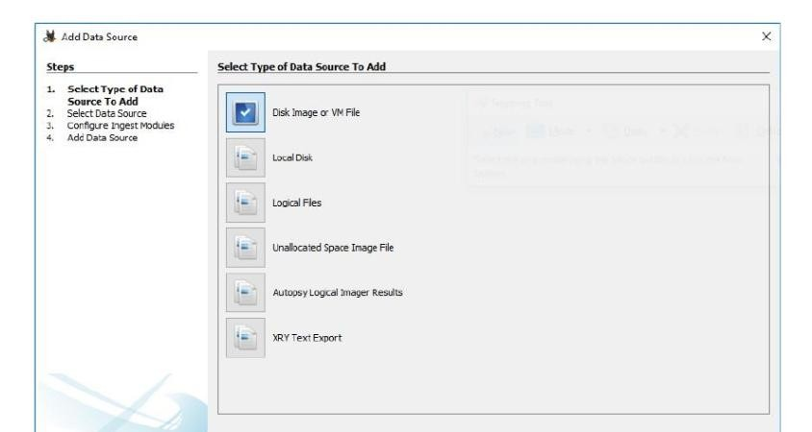
Fig. 2.4 – Select type of data source
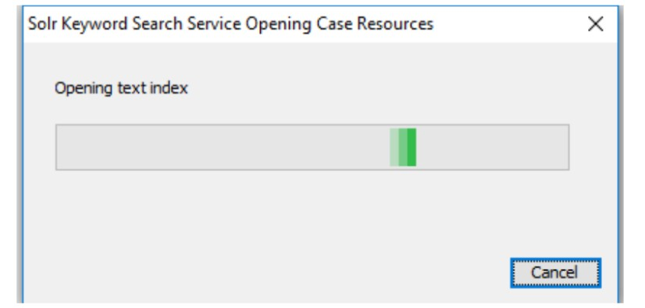
Fig. 2.5 – Solr keyword search service opening case resources
- Browse to the image file path, set the time zone (GMT+5:30 Asia/Calcutta) and sector size (Auto Detect), click Next.
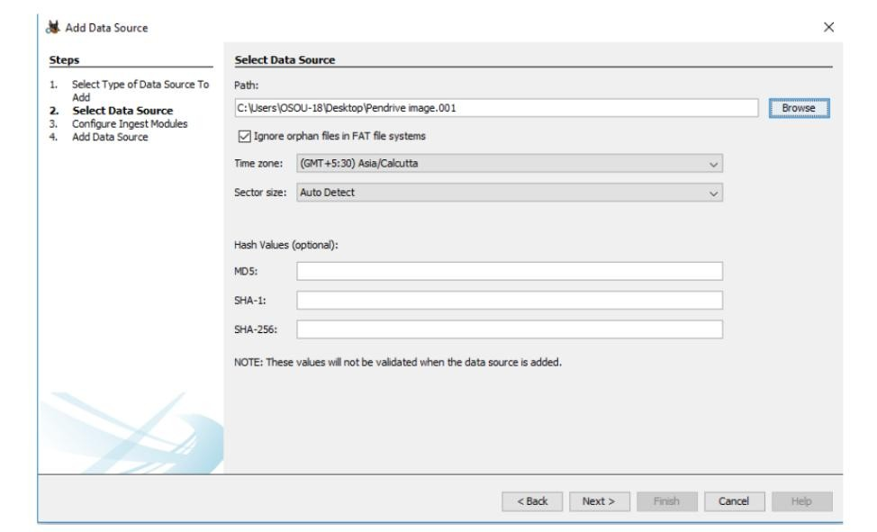
Fig. 2.6 – Select data source – image path
- Tick all ingest modules to get complete information, click Next.
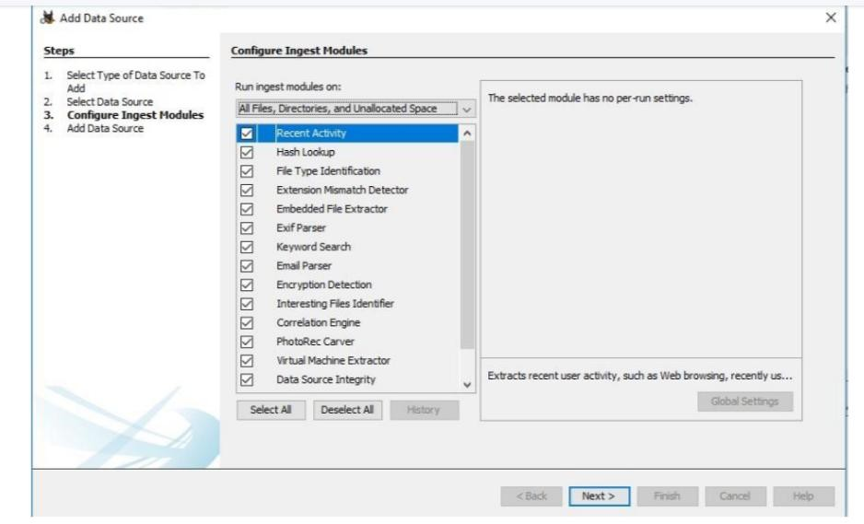
Fig. 2.7 – Configure ingest modules
- Click Finish; the data source is added to the local database and files are analysed.
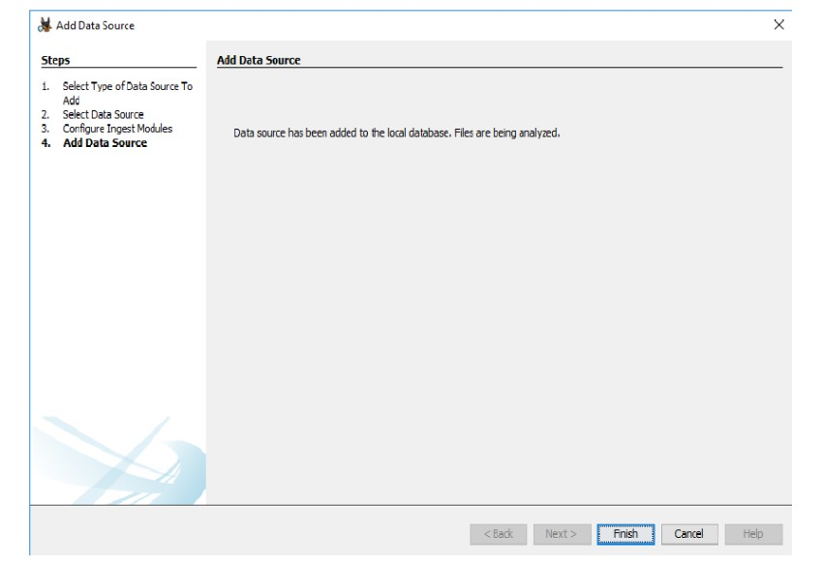
Fig. 2.8 – Data source added and being analysed
- Review results from the left tree:
- Devices Attached, EXIF Metadata, Installed Programs
- Operating System Information and User Accounts
- Recent Documents
- Web Bookmarks, Cookies, Downloads, History, Web Search
- Email Addresses

Output Screenshots
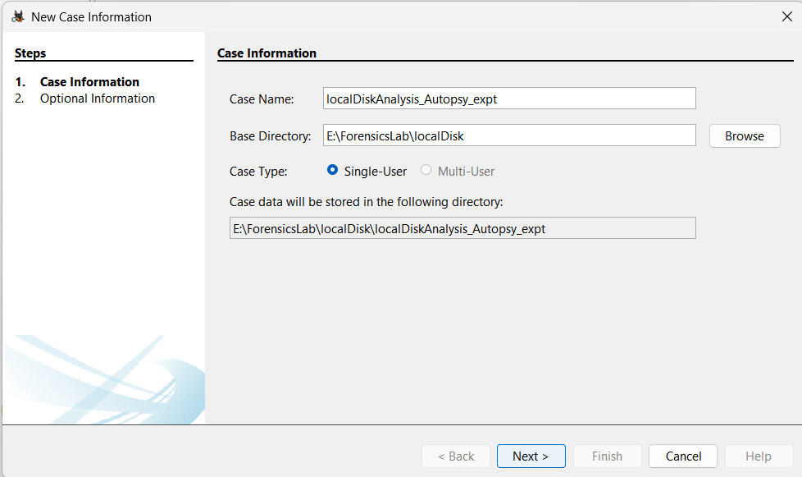
Fig. 2.9 – New case created in Autopsy
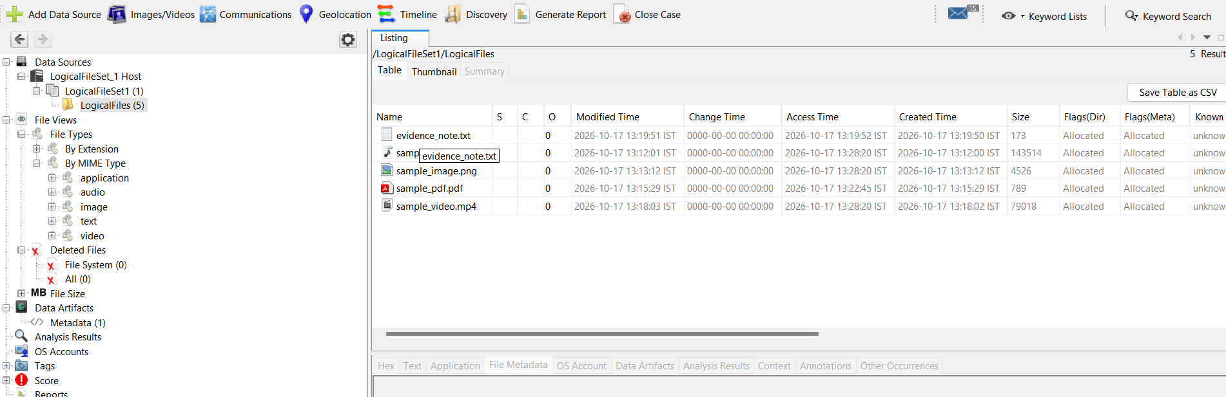
Fig. 2.10 – Autopsy results tree with analysed data source
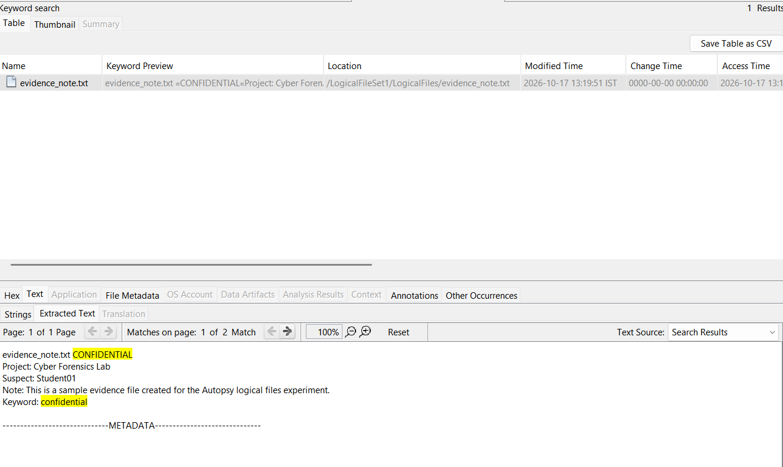
Fig. 2.11 – Keyword search / file metadata results

Result
The disk image was analysed in Autopsy and the evidence (devices, accounts, documents, web and email artifacts) was extracted.

