CR23532 – Cyber and Digital Forensics Lab

Experiment 3

Aim
To recover deleted files from a flash drive using forensic tools.

Tools Used
Notepad, FTK Imager, RecoverMyFiles

Procedure
- Create a text file named malicious.txt in Notepad and save it on the flash drive.

Fig. 3.1 – malicious.txt created in Notepad
- Right-click malicious.txt on the flash drive and select Delete.
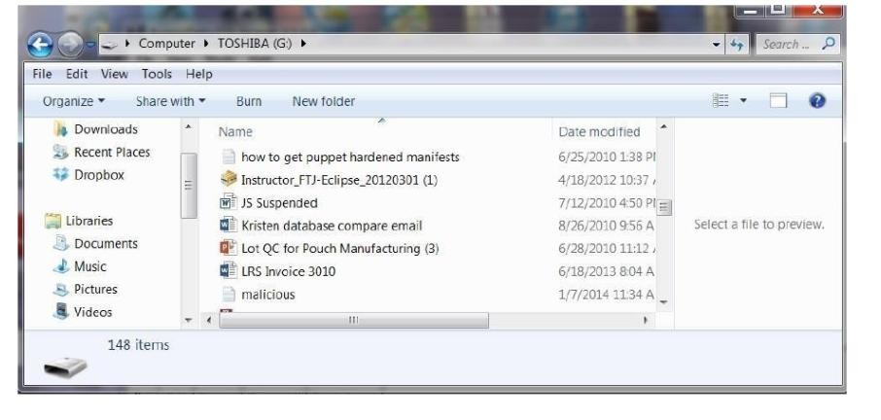
Fig. 3.2 – File listed on the flash drive before deletion
- Open FTK Imager and choose File > Create Image.
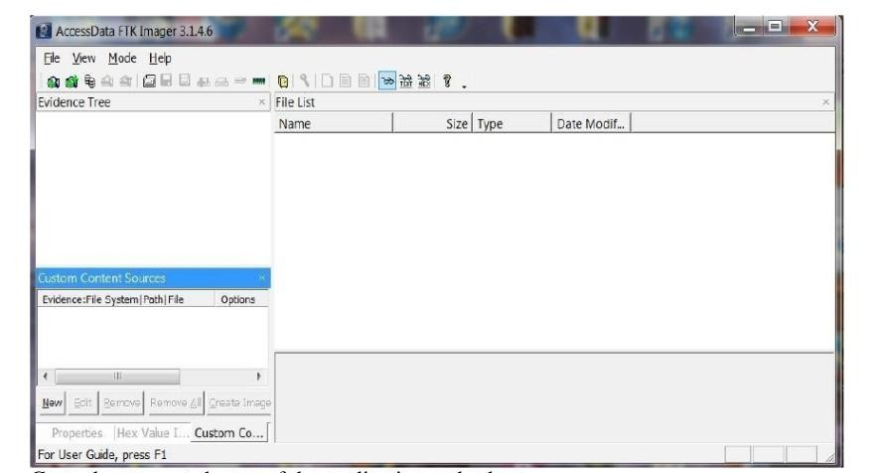
Fig. 3.3 – FTK Imager main window
- Enter case number, evidence number and examiner name; select the physical drive, destination folder and image name.
- Start imaging; FTK Imager creates a bit-by-bit image of the flash drive.
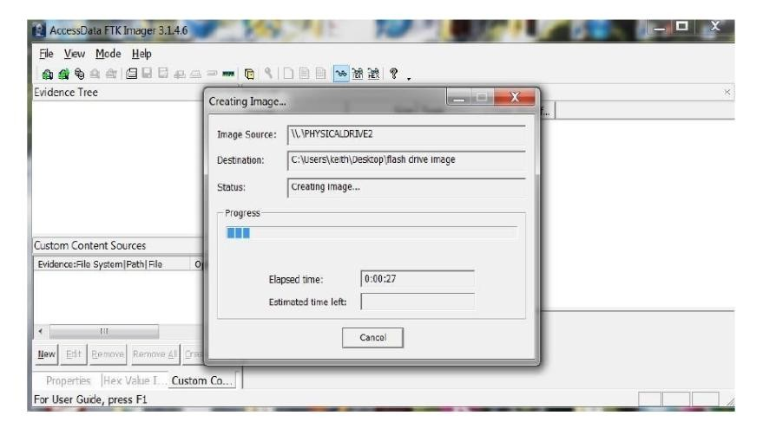
Fig. 3.4 – FTK Imager creating the image
- Open RecoverMyFiles, click Start Recovery and select Recover a Drive.
- Click Add Image and select the FTK image file.
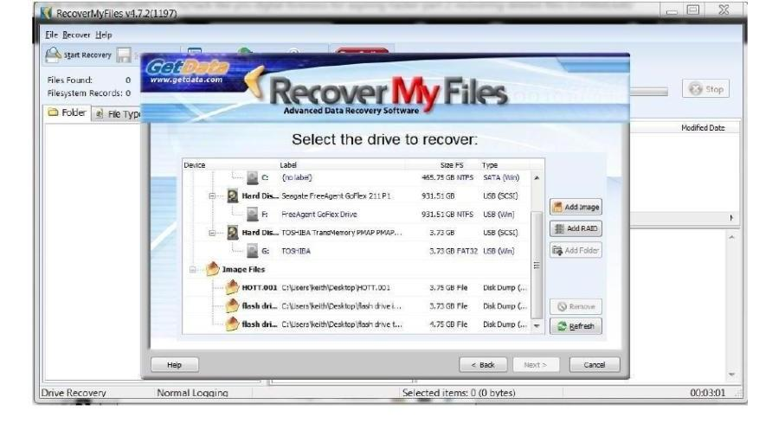
Fig. 3.5 – RecoverMyFiles – select the drive to recover
- Start automatic recovery and wait for the scan to complete.
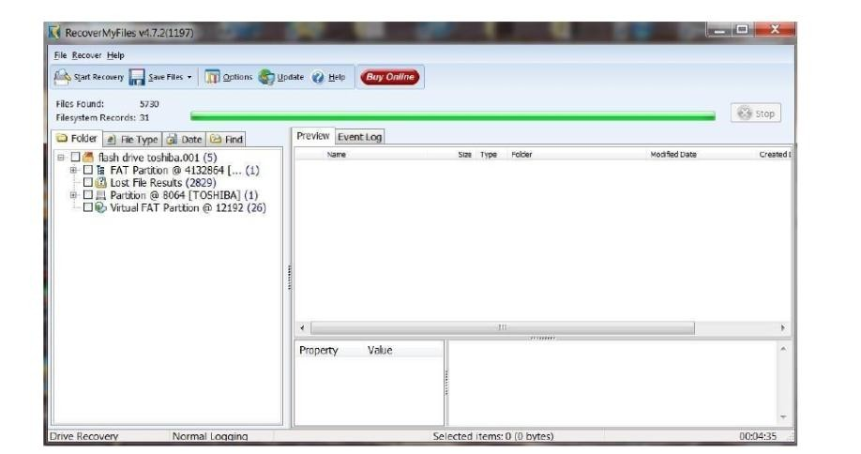
Fig. 3.6 – RecoverMyFiles scan results
- Open the File Type tab and select Text UTF-16 (158 files).
- Locate malicious.txt in the file list – it is recovered with its contents.
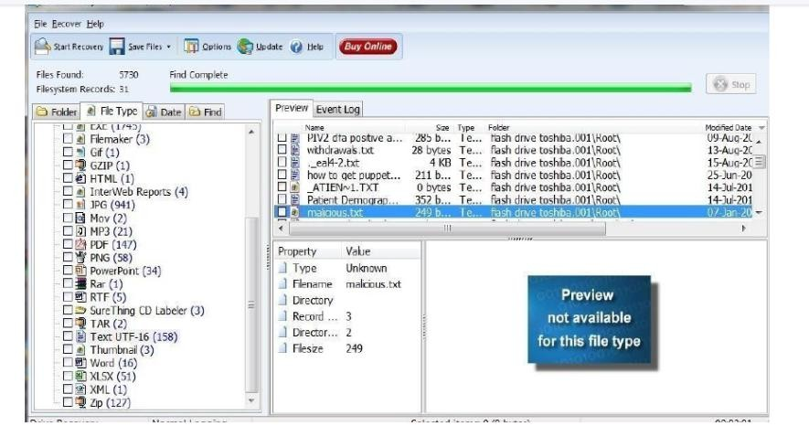
Fig. 3.7 – malicious.txt found among recovered files

Output Screenshots
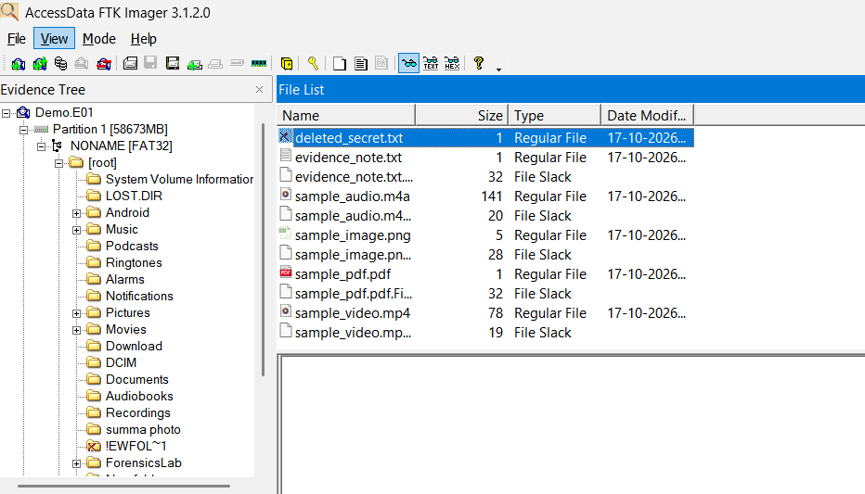
Fig. 3.8 – FTK Imager – evidence tree of the imaged drive
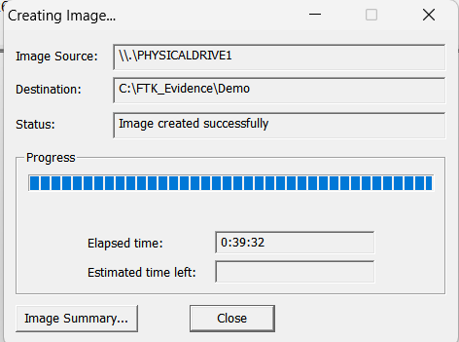
Fig. 3.9 – FTK Imager – image created successfully
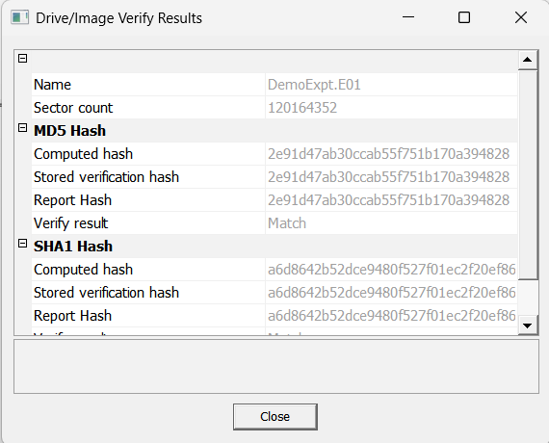
Fig. 3.10 – Image hash verification (MD5 / SHA1 match)

Result
The deleted file was recovered from the forensic image of the flash drive.

