CR23532 – Cyber and Digital Forensics Lab

Experiment 4

Aim
To find the last connected USB devices on a system using USBDeview.

Tools Used
USBDeview (NirSoft)

Procedure
- Download and run USBDeview.
- View the list of all USB devices – currently connected and previously used.
- Note the details shown for each device:
- Device name / description and device type
- Serial number (mass storage devices)
- VendorID, ProductID
- Date/time the device was added or last plugged/unplugged
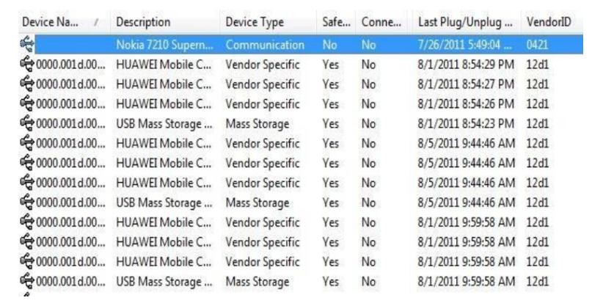
Fig. 4.1 – USBDeview device list
- Sort by Last Plug/Unplug time to identify the most recently connected device.
- Double-click a device to open its full properties.
- Optional: uninstall, disconnect, enable or disable a USB device; USBDeview also works on a remote PC with admin login.

Output Screenshots
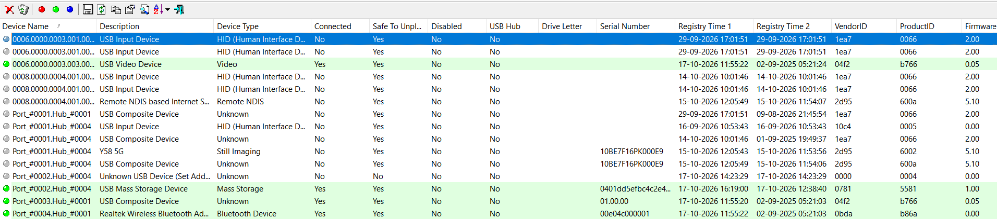
Fig. 4.2 – USBDeview – USB history on the system
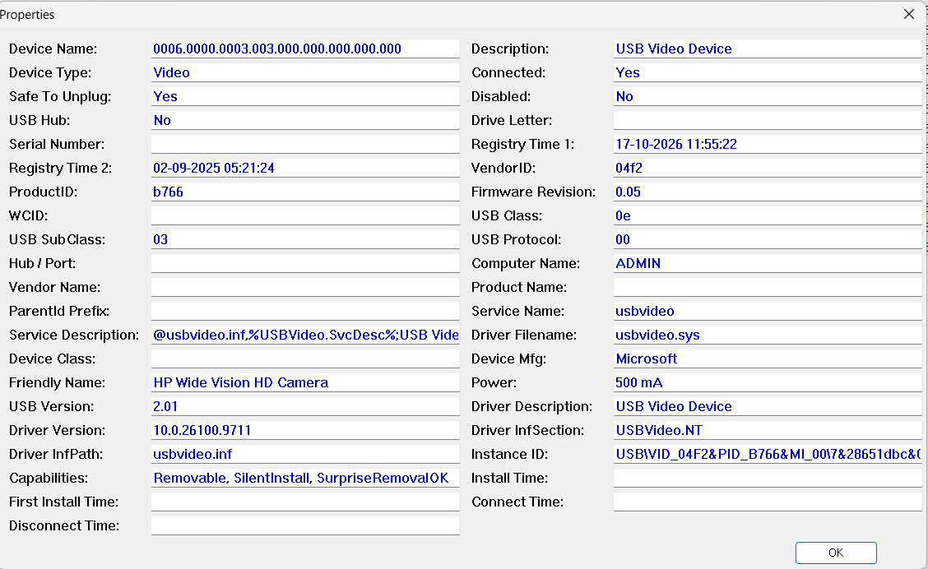
Fig. 4.3 – USB device properties

Result
The USB devices connected to the system, with their last plug/unplug times, were identified.

